1. Non top 10 Medal winning countries -- player under 19 (Summer Olympic)

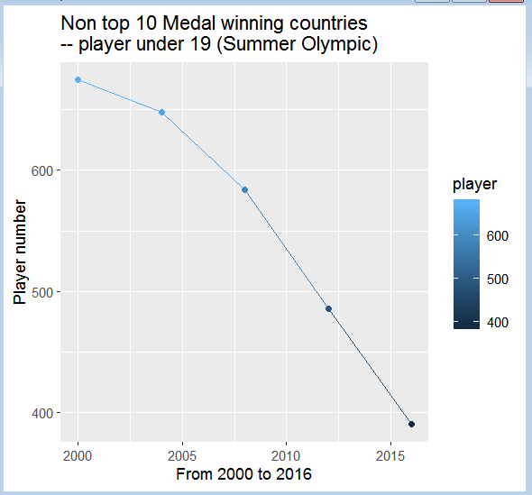

2. Line chart - Medal winning second tier countries - Summer Olympic player under 19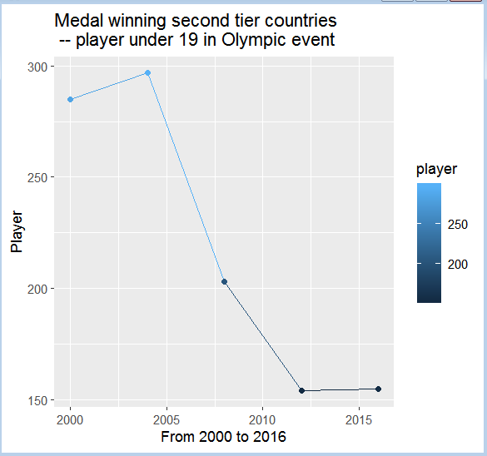

3. Player barchart - Medal winning second tier countries - Summer Olympic player under 19

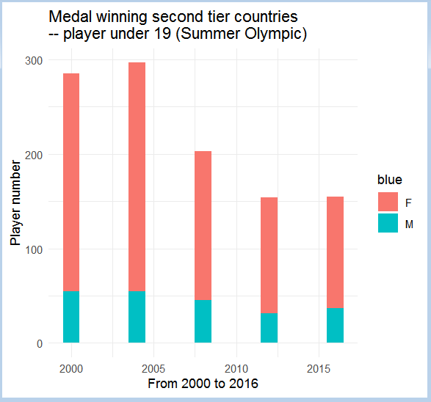

4. Player barchart - Medal winning second tier countries - Winter Olympic player under 19

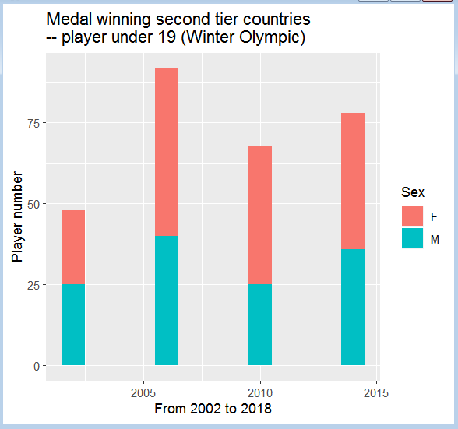

5. Country barchart - Medal winning second tier countries - Winter Olympic

