Introduction
A full range of HVAC configurations are supported by the WebBrick Systems Heating module:
- Single Heatsource
- Multiple Heatsource
- Combinations of Heatsources
- Ground Source
- Solar
- Cooling and Heat Recovery
A range of ancillary plant can be controlled including:
- Pumps, fixed and variable
- Fans fixed and variable
- Zone Valves, fixed, variable, drive-open-close
- Actuators (wax etc)

Default configuration supports 16 Zones, 5 Zone Groups and a range of heatsources including boilers, ground source and solar (both single and multiple panel sets). The overall configuration can be extended to 64 Zones by simple definition in the HVAC configuration file.
Schedules and Occupancy
The heating module provides for individual schedules for each zone. Each Zone can be set to follow Occupancy, this means that if the house occupancy is set to 'vacated' then the Zone will provide heat at the configured 'Lowest Temperature'.
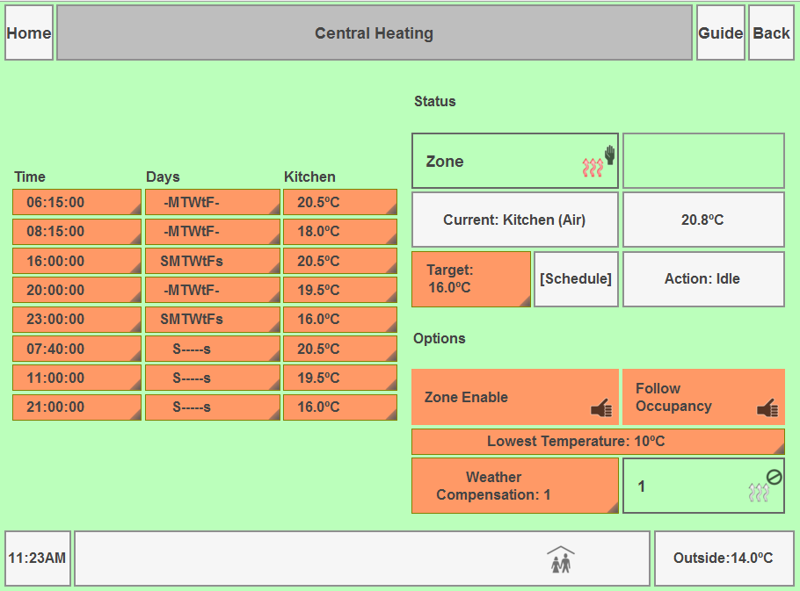
Early Start Package
A 'tomorrow only' package of heating can be set at the Gateway. This allows for busy lifestyles where a home follows a general schedule but with some home users having different starting times.

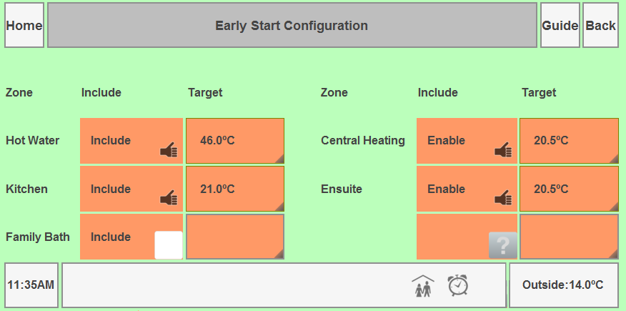
Basic Principles
Areas or utilities to be temperature controlled are organised into Zones. A Zone could cover a utility like hot water or an area such as a room. Where rooms are open plan multiple Zones are perfectly reasonable as long as they are configured to operate in harmony.

Zones draw their heating/cooling from a ZoneGroup, this is typically manifolds, valves, circulation pumps that connect the Zones to Heatsources.

ZoneGroups are configured to use HeatSources according to priority, which is generally to use the cheapest available HeatSource first.

HeatSources are the providers of heating/cooling. These are characterised by available delta (difference in temperature) and running cost. Some HeatSources are configured as multiple units, for example a bank of three boilers. In this case, the Gateway HeatSource implementation organises that the boiler with the lowest running hours is brought on first and that the next lowest running hours unit is brought on if demand requires. Running hours are evaluated on a weekly basis.

Solar HeatSources can be either single or multiple collectors. Multiple collectors are used in homes with different aspects available so that one panel is near the optimum aspect as the sun tracks across the sky.

Zones can be defined for heat energy stores. These Zones will be driven when surplus energy is available from HeatSources such as solar and in some cases ground source.

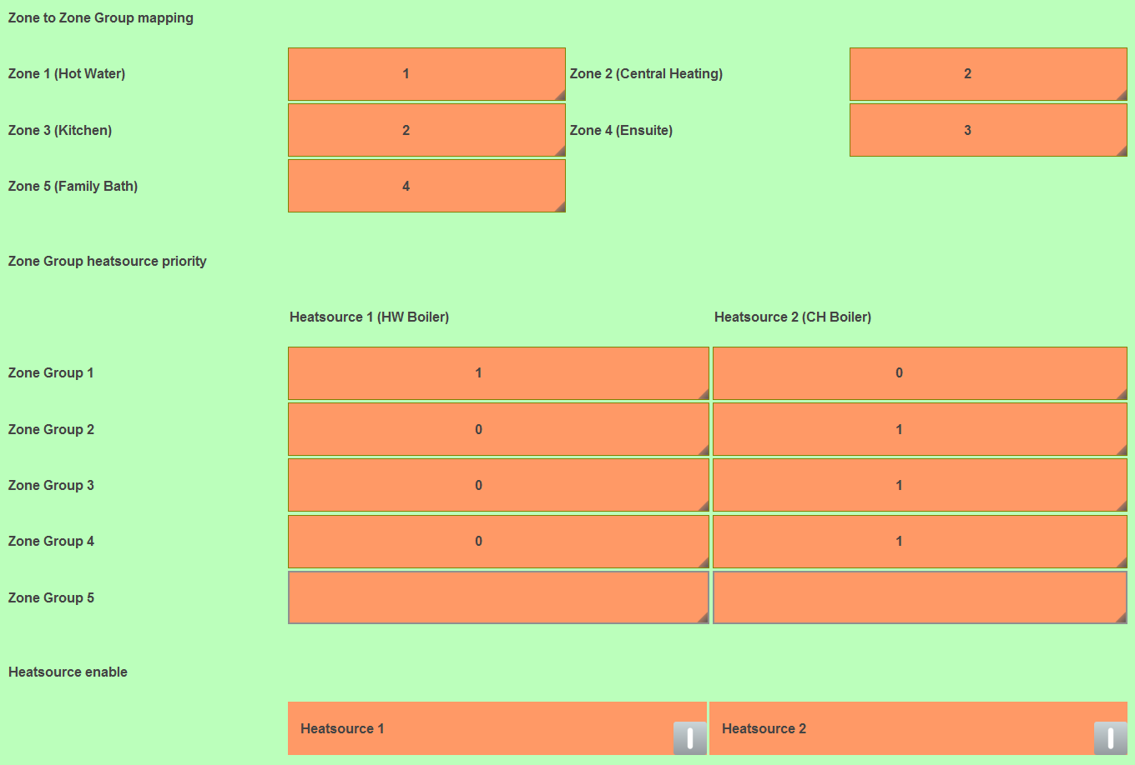
Zones either provide heating or cooling, where a heating Zone and a cooling Zone serve the same area they can be interlocked.
Working with Zones
As far as possible you should implement a Zone to be controlled across a single WebBrick.

So for Hot Water, the following items should be controlled from the same WebBrick:
- Zone Valve
- Circulation Pump
- Temperature Sensor
- If implemented, HW Boiler

This approach allows for the Gateway to deliver a set point to the WebBrick and from then until the next set point the WebBrick will control the water temperature locally.

UFH

In this case the following items should be connected to the same WebBrick:
- Temperature Sensors (per area)
- Manifold valve and circulation pump
- Actuators

In general the circulation pump should not start until the manifold valve is open. This can be organised in two ways, either through the contacts on the valve, or through the WebBrick. The advantages of organising the connections through the WebBrick is that you have some feedback that the valve has opened. If the stepper motor fails the Gateway can see that the valve never opens. This event can be used to let the installer and home owner know that some maintenance is required.

UFH Operation

Underfloor heating is characterised by lower deltas and longer time periods. Therefore full local control by the WebBrick is possible, but crude.

A better approach is to allow the Gateway to calculate the 'Dwell' time for each of the actuators and then pass this to the WebBrick for action.

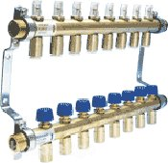
A single manifold will likely serve several rooms. This means that the Manifold Valve and Circulation Pump are configured to be part of a 'ZoneGroup'. The ZoneGroup listens to its associated Zones, if any are in a demand state it will action the valves/pumps, when all the Zones are in an Idle state, the ZoneGroup will shut down the valves/pumps in accordance with any minimum run-times.

Wax Actuators

These are commonly used on UFH manifolds. They fall into two general types:
- 24V
- 240V

Both can be driven from the 8SSR product. Be aware that Wax Actuators operating parameters are often quoted once the wax has expanded. The initial current draw is typically twice the quoted value.

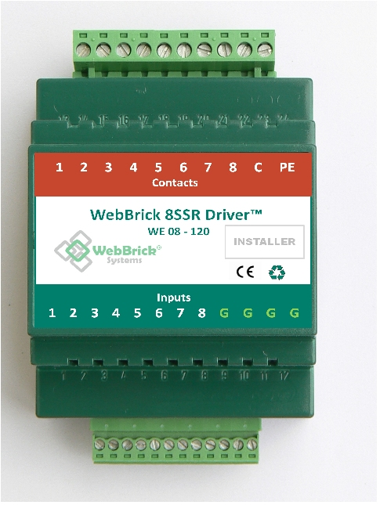

Simple Radiator Solution

At the other end of the scale from UFH we have radiators, often organised into just two zones, upstairs and downstairs. This kind of implementation is often found in development housing or homes that have very low µ values for the outside shell so that heat is distributed within the rooms by natural conduction and convection.

In this case we organise for all the temperature sensors in an area to feed one Zone. This Zone then operates the zone valve that then allows the heat into all the radiators for that area.

It is not required to have the sensors and zone valve on the same WebBrick. If you can it makes the Gateway configuration slightly easier but no real overall advantage.

Operation

All temperatures in the Zone are compared against the Target, if any are below this, then the Zone goes into Demand and a ZoneGroup is called. In this scenario the ZoneGroup does not action any plant but calls upon its configured HeatSources based on priority and availability.

Solar Solutions

These consist of collector panel(s) that transfer heat into a liquid which is pumped around circuits to deliver the heat energy where needed. In the simplest form the energy is delivered to a lower coil in a DHW calorifier. A simple Zone and HeatSource is configured so that the circulation occurs whenever there is a positive delta between panel and lower calorifier(default 8°C).

More sophisticated solutions can deliver heat to both a calorifier and heat store. The Zones are organised so that the calorifier has the greater priority.

Liability Disclaimer
These notes are intended for individuals that are familiar with working with mains voltage and are aware of taking the necessary precautions. All WebBrick Application Notes are to be seen as guidelines only. WebBrick Systems cannot take any responsibility for the wiring carried out by individuals, or damage caused as a result of incorrect wiring.

