Design note 003
CAT 5E/6 Cabling within rooms

Introduction
People often think about flood wiring a domestic property with CAT5E/6 cables. The initial thoughts may well be based around network applications although CAT5E/6 is useful for much more than networking. This design note discusses usages and placement.

Networking
This is the obvious use of CAT5E/6 with RJ45 outlets. This is where you need to think about applications that will need wired networking. These are typically:
- Media Boxes, in particular video, although wireless looks like it can handle the bandwidth, it can rarely do so smoothly
- Sonos Boxes, where you have multiple Sonos boxes it is better to rely on a wired network and let the Sonos Remotes use wireless
- Cameras, although these use video at lower bandwidth, a wired connection is always better, remember many of the current cameras can use PoE (Powered over Ethernet) so the cable performs two functions
- Servers, there are so many 'Micro Servers' around these days, for example NAS boxes, these don't need to go in the central area, but it really helps if they have a wired connection.
As a background note, in a residential situation it is possible to run 1Gb networking over CAT5E. This is currently enough for any of the HD video formats in current use. CAT6 can take you to 10Gb networking although the backbone switches are more expensive

Switching
This is the next most common application for the CAT5E/6 cable. At WebBrick we make switch plates that are designed to connect using RJ45 connectors and be patch through to the WebBricks at the other end. Here are some design guides:

- Plates should be between 400mm and 1200mm high
- There should be a plate for entry and egress of each area
- There should be a plate to handle lighting over stairways from below and above
- You may need extra plates in kitchens, for extractors etc
- You may need extra plates at bedsides for both room and reading light control
- Have you got enough CAT5 in place to handle additional drapery functions should they be required in the future.
- Some lighting can work on simple door switches (then use dayphase to decide if the light should come on or not)
- PIRs work well at ceiling level.
- Room Controllers work well at this height.

Drapery
This is often planned in as a future addition, particularly if budgets are tight. Most drapery can be signalled using CAT5E/6, some of the lighter motors can be driven using a 24V system over CAT5E/6. Note that the 1A maximum current per pair limit applies and do consider the I2R losses in longer cable runs.
Mains Curtain motors are more powerful and reliable with an expense to match.
Plates should be placed where they will be hidden by the curtains, most systems can be 'handed' on site.
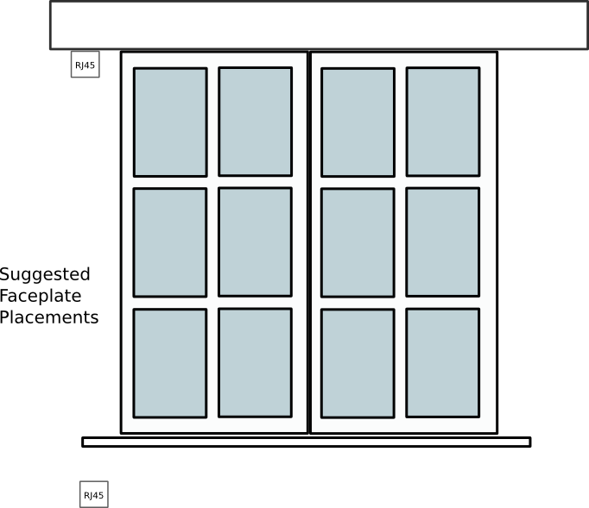

Audio
With special drivers it is possible to drive audio over CAT5E/6, unless the audio is transmitted in the IP domain there will always be some loss of quality. The judgement here regards what quality is required in the first place.
For many years most multi-room multimedia systems were sub CD quality, there is a drive to provide better quality sources on-line. Here are some design guidelines:
- Use proper audio cables where HiFi sound is required
- Use proper speaker cables for speakers (some speakers are PoE in the IP domain – these will use CAT5E/6)

