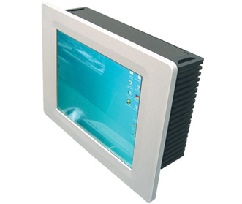
Part No. PX22363F

Description

This fan less Panel PC from LEX can easily be wall mounted and only protrudes 9mm. Combined with the built in touch screen, which allows this PC to be controlled without the need for a keyboard or mouse, it is the ideal interface for controlling the WebBrick Gateway. Unlike most other touch screens on the market LEX Panel PCs are fitted with a ruggedized front panel, composed of an aluminium frame and a robust glass screen. This ensures that the front panel of the PC, which protrudes into the room, is water proof and less affected by unintentional knocks.

Features

- VIA C7 1Ghz Nano BGA2 Embedded CPU
- VIA CX700M Chipset
- Onboard Graphics Memory up to 128MB (From system memory)
- Memory: 1 x DDR2 533Mhz RAM
- 40Gb 2.5” HD
- Integrated HDTV encoder
- Realtek 10/100 LAN
- Resolution: XGA 1024x768
- Brightness (cd/m2): 143
- Contrast Ratio: 250:1
- Fan less operation
- Low power consumption
- Water proof front panel
- Robust Glass – ideal for house hold environments

Functionality

It is possible to preload the PC with a customized Linux based operating system that is optimised for the use with the WebBrick Gateway. When booted this leads to the WebBrick Gateway interface automatically being loaded, without the user having to open a web-browser or having to take any other actions.

Package Contents

- 12.1” Panel PC
- AC100~240V to 12V power adaptor
- User’s manual
- Assembly Guide
- CD driver for the touch screen

External Connections

All connections are on the bottom of the PC, and sufficient space has to be available behind the face of the wall for connectors.

Mandatory connections are the power supply connector and the Ethernet cable.

Note: Remember to allow space for the power adaptor, at least 130(W) x 65(H) x 35(D) mm (Power adaptor sizes may vary!).

Measurements

Panel: 360(W) x 280(H) x 9(D) mm

PC & Screen Case: 336(W) x 255(H) x 101(D) mm

Installation Notes

Depending on the mounting option that is chosen we advice to allow room for a cutout of at least the following dimensions: 337(W) x 260(H) x min 105(D) mm. Around the cutout a 20mm wide flat surface is required for the front panel of the screen to sit against.

To mount the screen secure in the wall there are 3 possible mounting options.

- If access to the rear of the panel can be obtained, the screen can be mounted using 8 M3 screws. (2 on each side of the front panel). Threaded holes are 6mm inside of the outer edge of the aluminum frame. On the sides the 2 holes are 85mm and 195mm down from the top of the front panel. On the top and bottom side the holes are 75mm in from either side of the panel.

- The Panel PC conforms to VESA75 and VESA100 mounting specifications and can be mounted with either on the back of the cutout. The holes of the VESA mounts are directly centered on the back panel of the PC case. Please note that this mounting option adds extra depth to the cutout and depending on the VESA mount used may require access to the back of the Panel PC when being mounted.

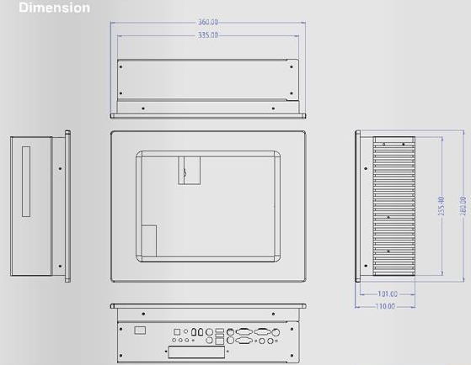

- If rear access to the panel is restricted and the extra depth of a VESA mount is unacceptable, the screen can be mounted using the 4 keyhole slots on the rear panel of the PC case. The slots are located 59mm and 149mm down measured from the top of the back panel and 122mm in from the side of the back panel.

Note: Screws need to be put ‘radius of screw’ lower down in the wall, to achieve secure mounting when using keyholes.

Related Documents

DS101 – 8.4” Panel PC with Touch Screen

DS102 – 10.4” Panel PC with Touch Screen

DS104 – 17.1” Panel PC with Touch Screen

