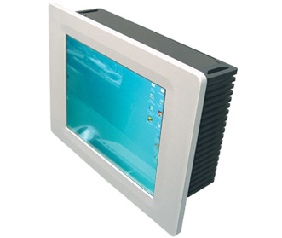
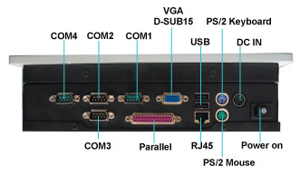
Part No. XXXXXXX

Description

This fanless Panel PC from LEX can easily be wall mounted and only protrudes 9mm. Combined with teh built in touch screen, which allows this PC to be controlled without the need for a keyboard or mouse, it is the ideal interface for controlling the WebBrick Gateway.

Features

- VIA C7 1Ghz Nano BGA2 Embedded CPU
- VIA CX700M Chipset
- Onboard Graphics Memory up to 128MB (From system memory)
- Memory: 1 x DDR2 533Mhz RAM
- 40Gb 2.5” HD
- Integrated HDTV encoder
- Realtek 10/100 LAN
- Resolution: WSXGA+ 1280x1024
- Brightness (cd/m2): 300
- Contrast Ratio: 800:1

Functionality

The PC is delivered preloaded with a Linux based operating system that is optimised for the use with the WebBrick Gateway. When booted the WebBrick Gateway interface is automatically loaded, without the user having to open a web-browser or having to take any other actions.

Measurements

Panel: 452(W) x 356(H) x 9(D) mm

Screen Case: 424(W) x 340(H) x 23(D) mm

PC Case: 424(W) x 268(H) x 77(D) mm

Note: Minimum depth of the housing for this Panel PC is the combined depth of the screen case and the PC case, i.e. 100 mm.

Package Contents

- 17.1” Panel PC
- AC100~240V to 12V power adaptor
- User’s manual
- Assembly Guide
- CD driver for the touch screen

External Connections

All connections are on the bottom of the PC, and 72mm of space is available for cable routing. If VGA or DVI connectors are used please allow extra space for these connectors.

Mandatory connections are the power supply connector and the Ethernet cable.

Note: Remember to allow space for the power adaptor, at least 130(W) x 65(H) x 35(D) mm.
Installation Notes

Depending on the mounting opetion that is chosen the cutout has to measure 424(W) x 340(H) x 100(D) mm. Around the cutout a 20mm wide flat surface is required for the Panel of the screen to sit against.

To mount the screen secure in the wall there are 3 possible mounting options.

- If access to the rear of the panel can be obtained, the screen can be mounted using 8 M3 screws. (2 on each side on the rear of the panel).

- The Panel conforms to VESA75 and VESA100 mounting specifications and can be mounted with either on the back of the cutout. Please note that this mounting option adds extra depth to the cutout and depending on the VESA mount used may require access to the back of the Panel PC when being mounted.

Figure 1: CAD Drawing

- If rear access to the panel is restricted and the extra depth of a VESA mount is unacceptable the screen can be mounted using the 4 keyhole slots on the rear panel, which are located on the corners of a 90 x90 mm square.

Related Documents

DS101 – 8.4” Panel PC with Touch Screen

DS102 – 10.4” Panel PC with Touch Screen

DS103 – 12.1” Panel PC with Touch Screen

