Lawrence Linnell

Southern New Hampshire University

CS-499-T3254 Computer Science Capstone 21EW3

February 7, 2021

Milestone Four: Enhancement Three

Databases

The enhanced artifact comes from the final project “Rest.py” from CS-340 Advanced Programming which is based on a client server model utilizing MongoDB and implementing Restful services using Python in conjunction with PyMongo. This Python program queries a Mongo database using SQL to retrieve stock market information. This assignment was chosen to highlight my knowledge of the Python language in conjunction with my ability to design and implement enhanced functionality of a NoSQL database. The enhancement that I plan to facilitate involves expanding the restful API that I designed in Python to include more advanced SQL commands for aggregating a list of the top ten performing stocks from the database based on a user provided industry. This allows the user to query the database for ticker symbols of the top 10 performing stocks of any industry.

As you can see from the following screenshot the API now supports a command called “industryTopTen” and returns the top ten stocks of any given industry. The following example shows the top 10 stocks in the “Trucking” industry sorted from best to least good which is accessed with the shown URI.

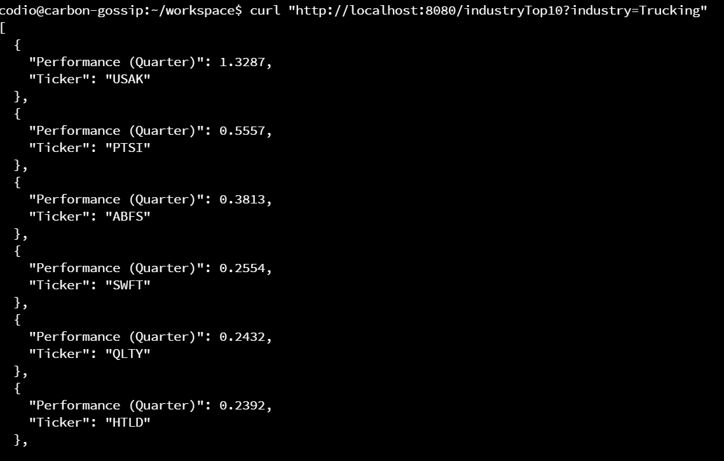

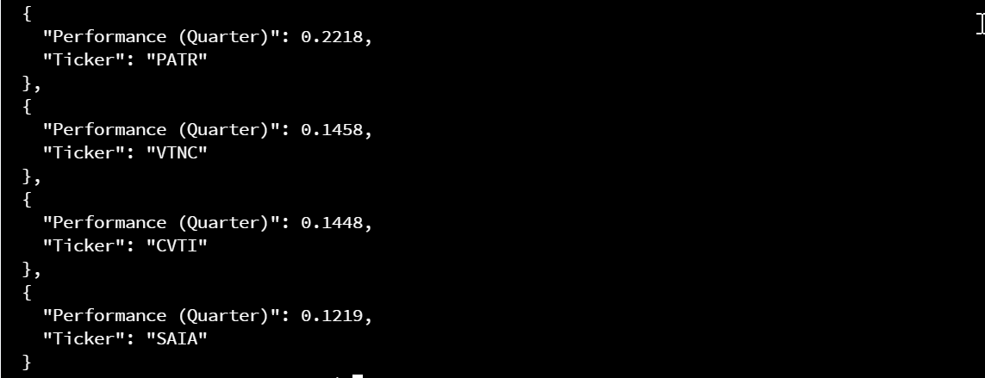

This is accomplished by first sorting the data in descending order and then limiting the results to only the top ten.

One update that I would like to implement in the future is to automatically update the database with daily stock market closing values while also recording the date and time information. This would allow for comparing past and present stock market information to show performance results over time. I would implement this feature using Python to scrape the internet for stock market data from public exchanges. Prior to any data scraping campaign it would be necessary to research the legalities of state and federal regulations.

Although I did not run into any major problems with this assignment, I was a little rusty at first. Fortunately, I save all of my assignments from classes that I study. After reading up on a few commands and reviewing the implementation procedure for setting up a mongo database I was up and running in no time. YouTube was also a great resource for refreshing my memory on how to configure a mongo database. One thing that I discovered while trying to set up a mongo database was that mongo DB provides a free cloud service called Atlas which allows users to host their database in the cloud to better serve distributed teams (MongoDB, 2021).

References

MongoDB. (2021). *MongoDB Atlas*. Retrieved from MongoDB: https://www.mongodb.com/cloud/atlas/lp/try2?utm_source=bing&utm_campaign=bs_americas_united_states_search_brand_atlas_desktop&utm_term=mongodb&utm_medium=cpc_paid_search&utm_ad=e&utm_ad_campaign_id=355813668&msclkid=70518fe324e619c4dc36effc0c5c220d