PNG NISIT HR PORTAL
Applicant and Non-Staff Guide
From registration to application tracking
Read this first This is a practical task guide. Complete one step at a time. Names of buttons and menus match the portal. Screenshots in this edition are clean examples only; they do not show error messages.

Guide map
Use this guide when you need to… | Open this module
Create or regain access | Sign in / Forgot password
Search and save a job | Job Vacancies
Start, save or submit an application | Job vacancy > Apply Now
Check progress after submission | My Applications
Change account details | My Account

1. Create your account and protect it
Use one personal email address. It is how the portal identifies your applications and sends updates.
- Open the portal and select Register as applicant.
- Enter your legal name as it appears on your documents. Enter an email address you can access.
- Create a strong password and complete registration.
- Sign in. Check the top-right welcome area: it should show your name and email.
- If you cannot sign in, select Forgot password? Do not repeatedly guess your password.
Good practice Never share your password. On a shared computer, always select Sign out when you finish.

2. Find a suitable vacancy
- Select Job Vacancies in the left menu.
- Use search to enter a job title, location or keyword. Use filters where available.
- Open a vacancy by selecting its title.
- Read the overview, responsibilities, qualifications, location, employment type, salary information (if shown), required documents and closing date.
- Only apply when the vacancy is Open or Published and the closing date has not passed.
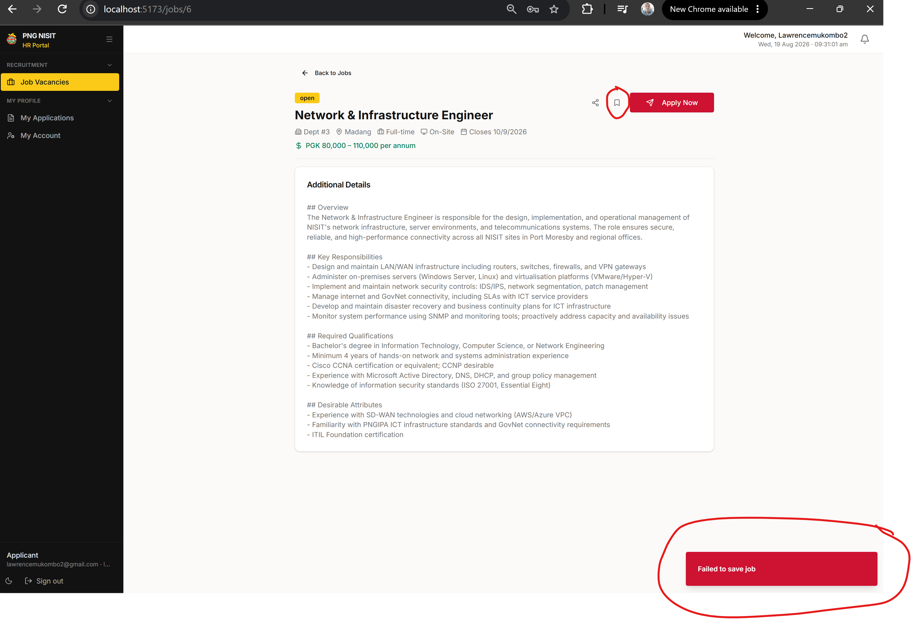
Figure: A clean job detail page. Select Apply Now after reviewing the vacancy.

3. Apply - complete every section
The wizard can be completed in more than one sitting. Use Save Draft after meaningful progress. A draft is not submitted and is not visible to recruiters as an application.
Wizard section | What to do before moving on
Personal | Use your legal names and correct personal details.
Contact | Confirm your email and phone number; include a current address where requested.
Availability | State when and where you can work honestly.
Education and experience | Add relevant records; use real dates and institution/employer names.
Skills | List skills that you can demonstrate.
Documents | Upload your CV and the supporting documents requested for that vacancy.
Screening | Answer every required question clearly and truthfully.
Declarations | Read each declaration before confirming it.
Diversity | Optional. Leaving this section blank does not block submission.

Upload your CV and evidence
- Open the Documents step.
- Select Click to upload CV. Choose PDF, DOC or DOCX, up to 10 MB.
- Wait until the document has finished uploading before selecting Next.
- For certificates, choose a document type under Additional Documents, then upload the matching file.
- Check the displayed file name before continuing.
If upload does not complete Keep the wizard open. Check that the file is PDF/DOC/DOCX and below 10 MB. Retry once after confirming your internet connection. If it still fails, contact support with the file type, size and a screenshot.

4. Submit and track
- At the final step, review the summary and declarations.
- Select Submit Application once. Wait for confirmation; do not refresh or click repeatedly.
- Open My Applications to see the application status and timeline.
- Read portal notifications and email for requests, interview invitations or updates.
- Update My Account if your email or phone number changes.

5. Common questions
Message or situation | What it means / what to do
Job is not accepting applications | The vacancy is closed, withdrawn or no longer public. Select another vacancy.
You already applied | Open My Applications instead of creating a duplicate.
Document upload failed | Check type, size and connection. Keep a copy of the file; contact support if it continues.
Forgot password | Use Forgot password? and follow the reset email.
No update yet | Recruitment stages take time. Check My Applications and notifications regularly.

6. Before you leave
- Confirm the application appears in My Applications.
- Keep original documents ready for verification if requested.
- Do not send documents to unofficial email addresses.
- Sign out if you are using a shared device.

