PNG NISIT HR PORTAL
Staff User Guide
Employee self-service, approvals and workforce workflows
Read this first This is a practical task guide. Complete one step at a time. Names of buttons and menus match the portal. Screenshots in this edition are clean examples only; they do not show error messages.

Guide map
Routine task | Module
Update personal account / notification preferences | My Account
Apply for leave or review leave | Leave & Absence
Clock attendance | Attendance Clock
Access authorised records | Document Vault / HR Letters
Manage people and contracts (per role) | Employees / Contracts / Onboarding / Offboarding
Review recruitment | Job Vacancies / Applications / Recruitment Workflow
Export information | Any portal table with Export

1. Start each day
- Sign in with your staff account.
- Check the welcome panel for your full name, email, date and live time.
- Open the notification bell and clear or act on urgent items.
- Use the grouped navigation menu; expand only the area you need.
- Select My Account to verify your contact details and profile settings.

2. Use tables correctly
The portal uses the same table controls in operational modules. They help you find records without losing your current view.
- Use Search for a quick keyword search.
- Select Filters for a field-specific search, then Clear filters when done.
- Select a column heading to sort ascending; select again to reverse it.
- Select Columns to hide, show or reset columns. Resize a column by dragging its right edge.
- Use the checkbox column to select records. Use Actions only when your role permits the chosen action.
- Use Export to download CSV, TSV or JSON. Export only data you are authorised to handle.
- Use Rows per page, the page box and navigation arrows for long lists.

3. Employee self-service

Leave and absence
- Open Leave & Absence.
- Select Apply for Leave.
- Choose the correct leave category.
- Enter a start date and an end date. The end date cannot be before the start date.
- Enter a concise reason and handover details.
- Select Submit Application, then monitor the status until it is approved, returned or rejected.

Attendance, documents and letters
- Use Attendance Clock only for your own work time unless you have a specific authorised role.
- Use Document Vault to view documents you are allowed to access. Use View Document in the portal rather than relying on broken external links.
- Use HR Letters for available letters. Keep downloaded files secure.

4. Supervisor, HR and manager workflows
Workflow | Minimum safe sequence
Recruitment | Create/publish vacancy; review applications; record assessment/interview outcomes; move candidates only through valid stages; keep notes factual.
Employee records | Verify identity and contact details; use an employable date of birth; set department, position, supervisor, appointment date and status correctly.
Onboarding | Create workflow; assign owners and dates; complete tasks and upload required evidence; monitor outstanding items.
Contracts | Use dates only for time-bound contracts; record renewals before expiry; upload or replace signed versions through the portal.
Offboarding | Initiate separation; assign clearance tasks; complete assets, access, final pay and records steps before closure.
Approvals | Review the request, documents and dates; approve, return or reject with a clear comment; honour approved delegation periods.

5. Organisation, dashboard and reports
- Open Dashboard and select a card/chart to drill into the underlying records.
- Open Org Hierarchy to view filled and vacant positions. Use the filters before interpreting headcount.
- Open Standard Reports; choose the report, apply appropriate dates and filters, then export or print.
- Do not treat empty or non-applicable dates as a renewal/expiry. Confirm whether the record is a time-bound contract first.
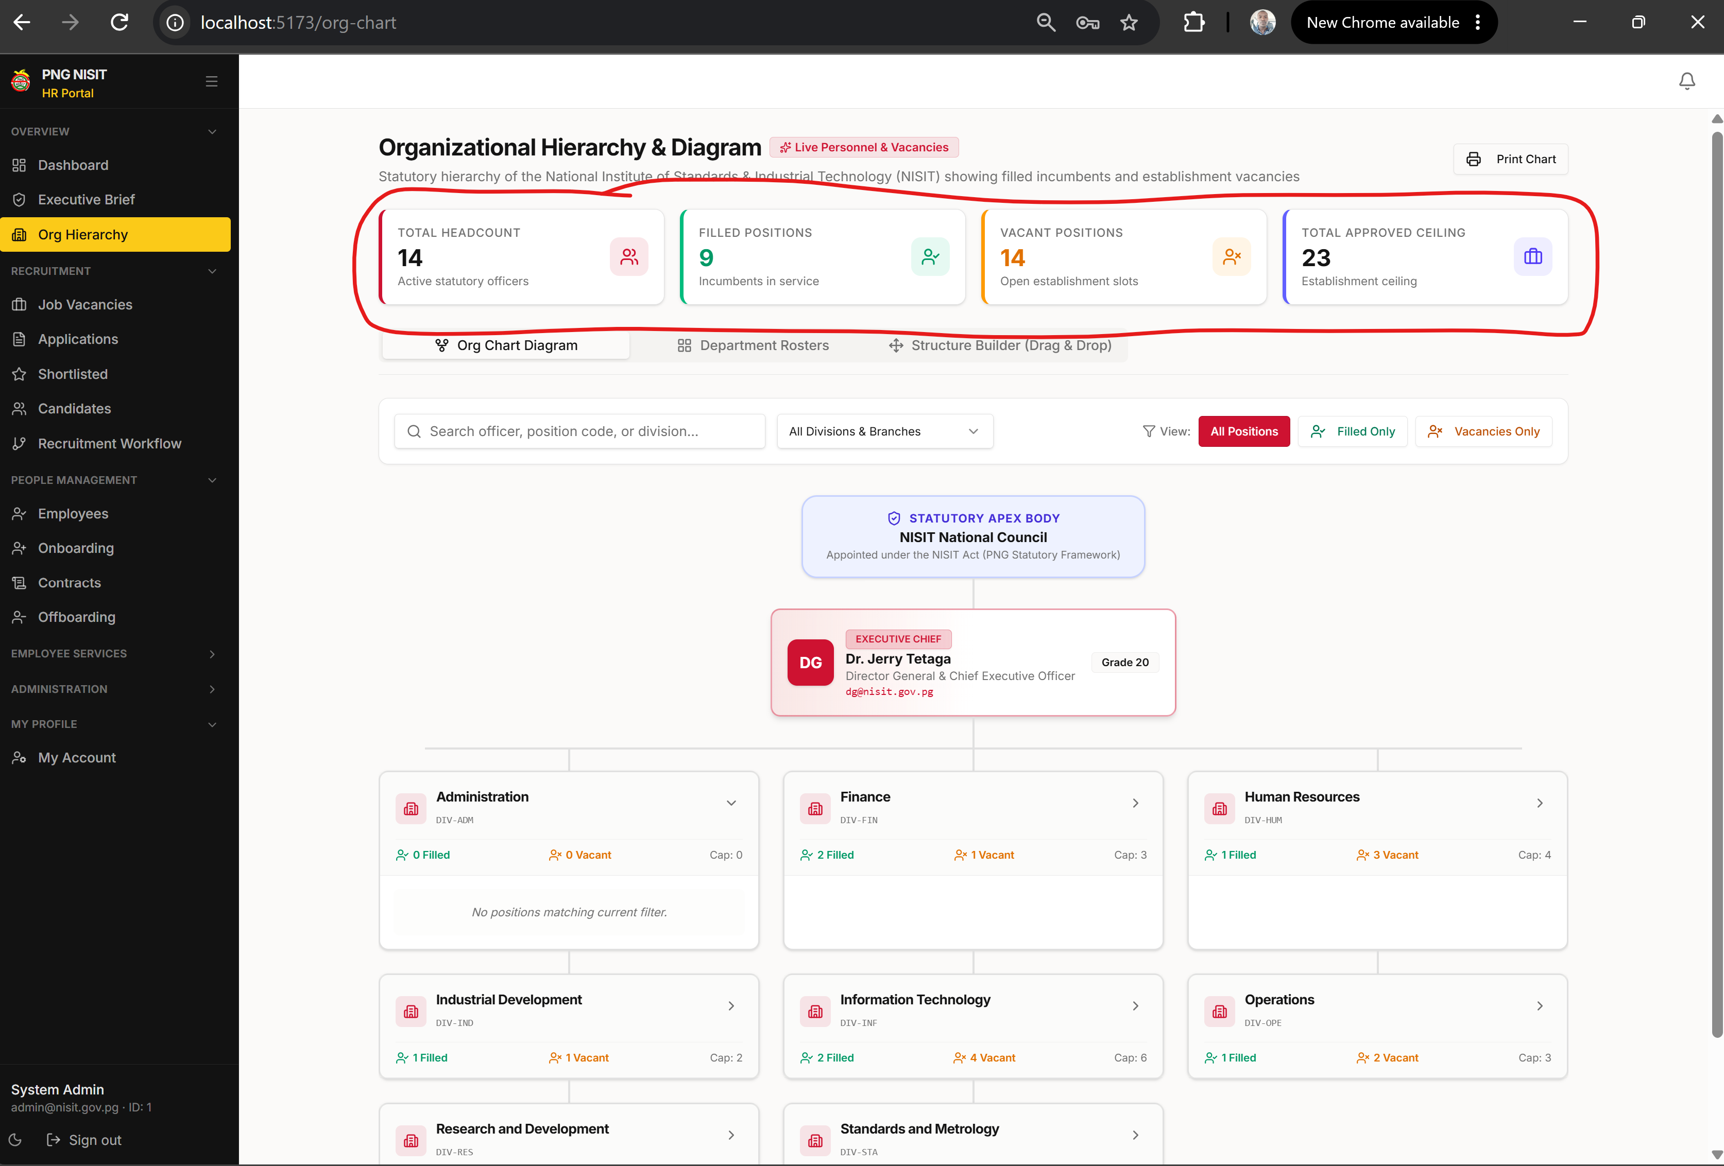
Figure: Organisation hierarchy with filled/vacant cards and filters.

6. Data protection and error handling
- Only access records that your role allows.
- Use accurate, real dates. Do not use placeholder dates for birth, appointment, renewal or separation fields.
- Do not email exports or personal documents to unauthorised recipients.
- Read error messages before retrying. Save your work or take a screenshot before refreshing.
- Report a fault with the module name, record reference, time, steps taken and a screenshot.

7. End-of-task checklist
- The record status is correct.
- All applicable dates are logical and complete.
- Required evidence/document uploads show as complete.
- Any approval comment is clear and professional.
- Sensitive information is not left open on a shared computer.

