PNG NISIT HR Portal
Simple User Guide
For applicants, employees, managers and HR staff
This guide explains the most common tasks using clear, simple steps. Use the left menu to move between modules. Your available menu items depend on your role.

Quick tip
Look for the red action buttons (for example, Apply Now, Submit Application and Save). The top-right welcome area shows your name, email, current date and live time.

1. Sign in and get around

Sign in
- Open the HR Portal and enter your email address and password.
- Select Sign in.
- If you forget your password, select Forgot password? and follow the email instructions.

Use the menu
- Select any menu heading on the left to open or close a group.
- Select your name/profile area or My Account to review your account details.
- Use the bell icon to view notifications.
What you want to do | Where to go
Find a job | Recruitment > Job Vacancies
Track an application | My Profile > My Applications
Apply for leave | Employee Services > Leave & Absence
View documents | Employee Services > Document Vault
Get help | My Profile > Help & User Guide

2. Apply for a vacancy
Applicants can apply to an Open or Published vacancy. You only need to apply once for each vacancy.

Apply in 5 simple steps
- Open Job Vacancies and select the vacancy title.
- Read the job details, closing date and required documents.
- Select Apply Now.
- Complete each section in the application wizard. Use Save Draft if you need to finish later.
- On the final page, select Submit Application. You will see a confirmation message and can track progress in My Applications.
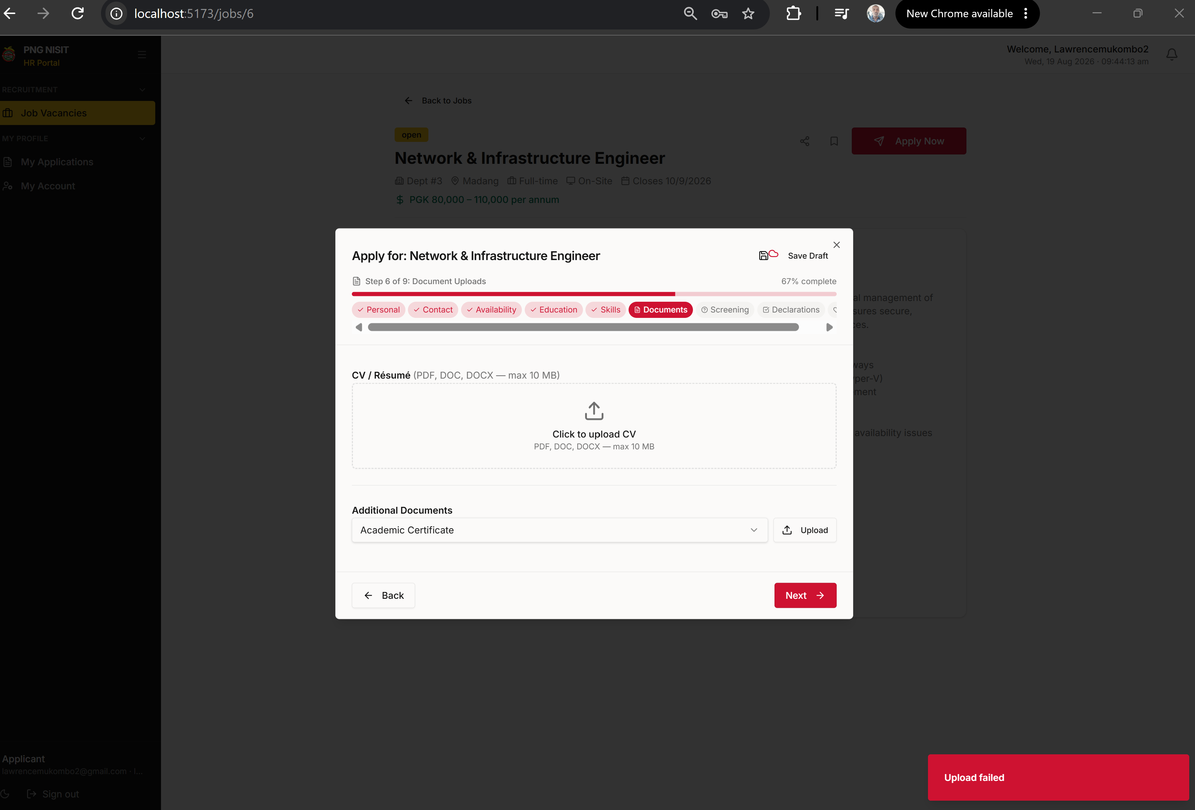
Screenshot: select Apply Now from an open vacancy.

3. Complete your application
The application wizard guides you through Personal details, Contact, Availability, Education, Skills, Documents, Screening, Declarations and optional Diversity information.

Upload documents
- Go to Documents in the wizard.
- Select Click to upload CV and choose a PDF, DOC or DOCX file (maximum 10 MB).
- Use Additional Documents to add certificates or other supporting files.
- Wait for the “Document uploaded” message before selecting Next.
Important: use documents that belong to you. If an upload fails, read the message shown and try a smaller PDF or Word document. Do not close the wizard while a file is uploading.
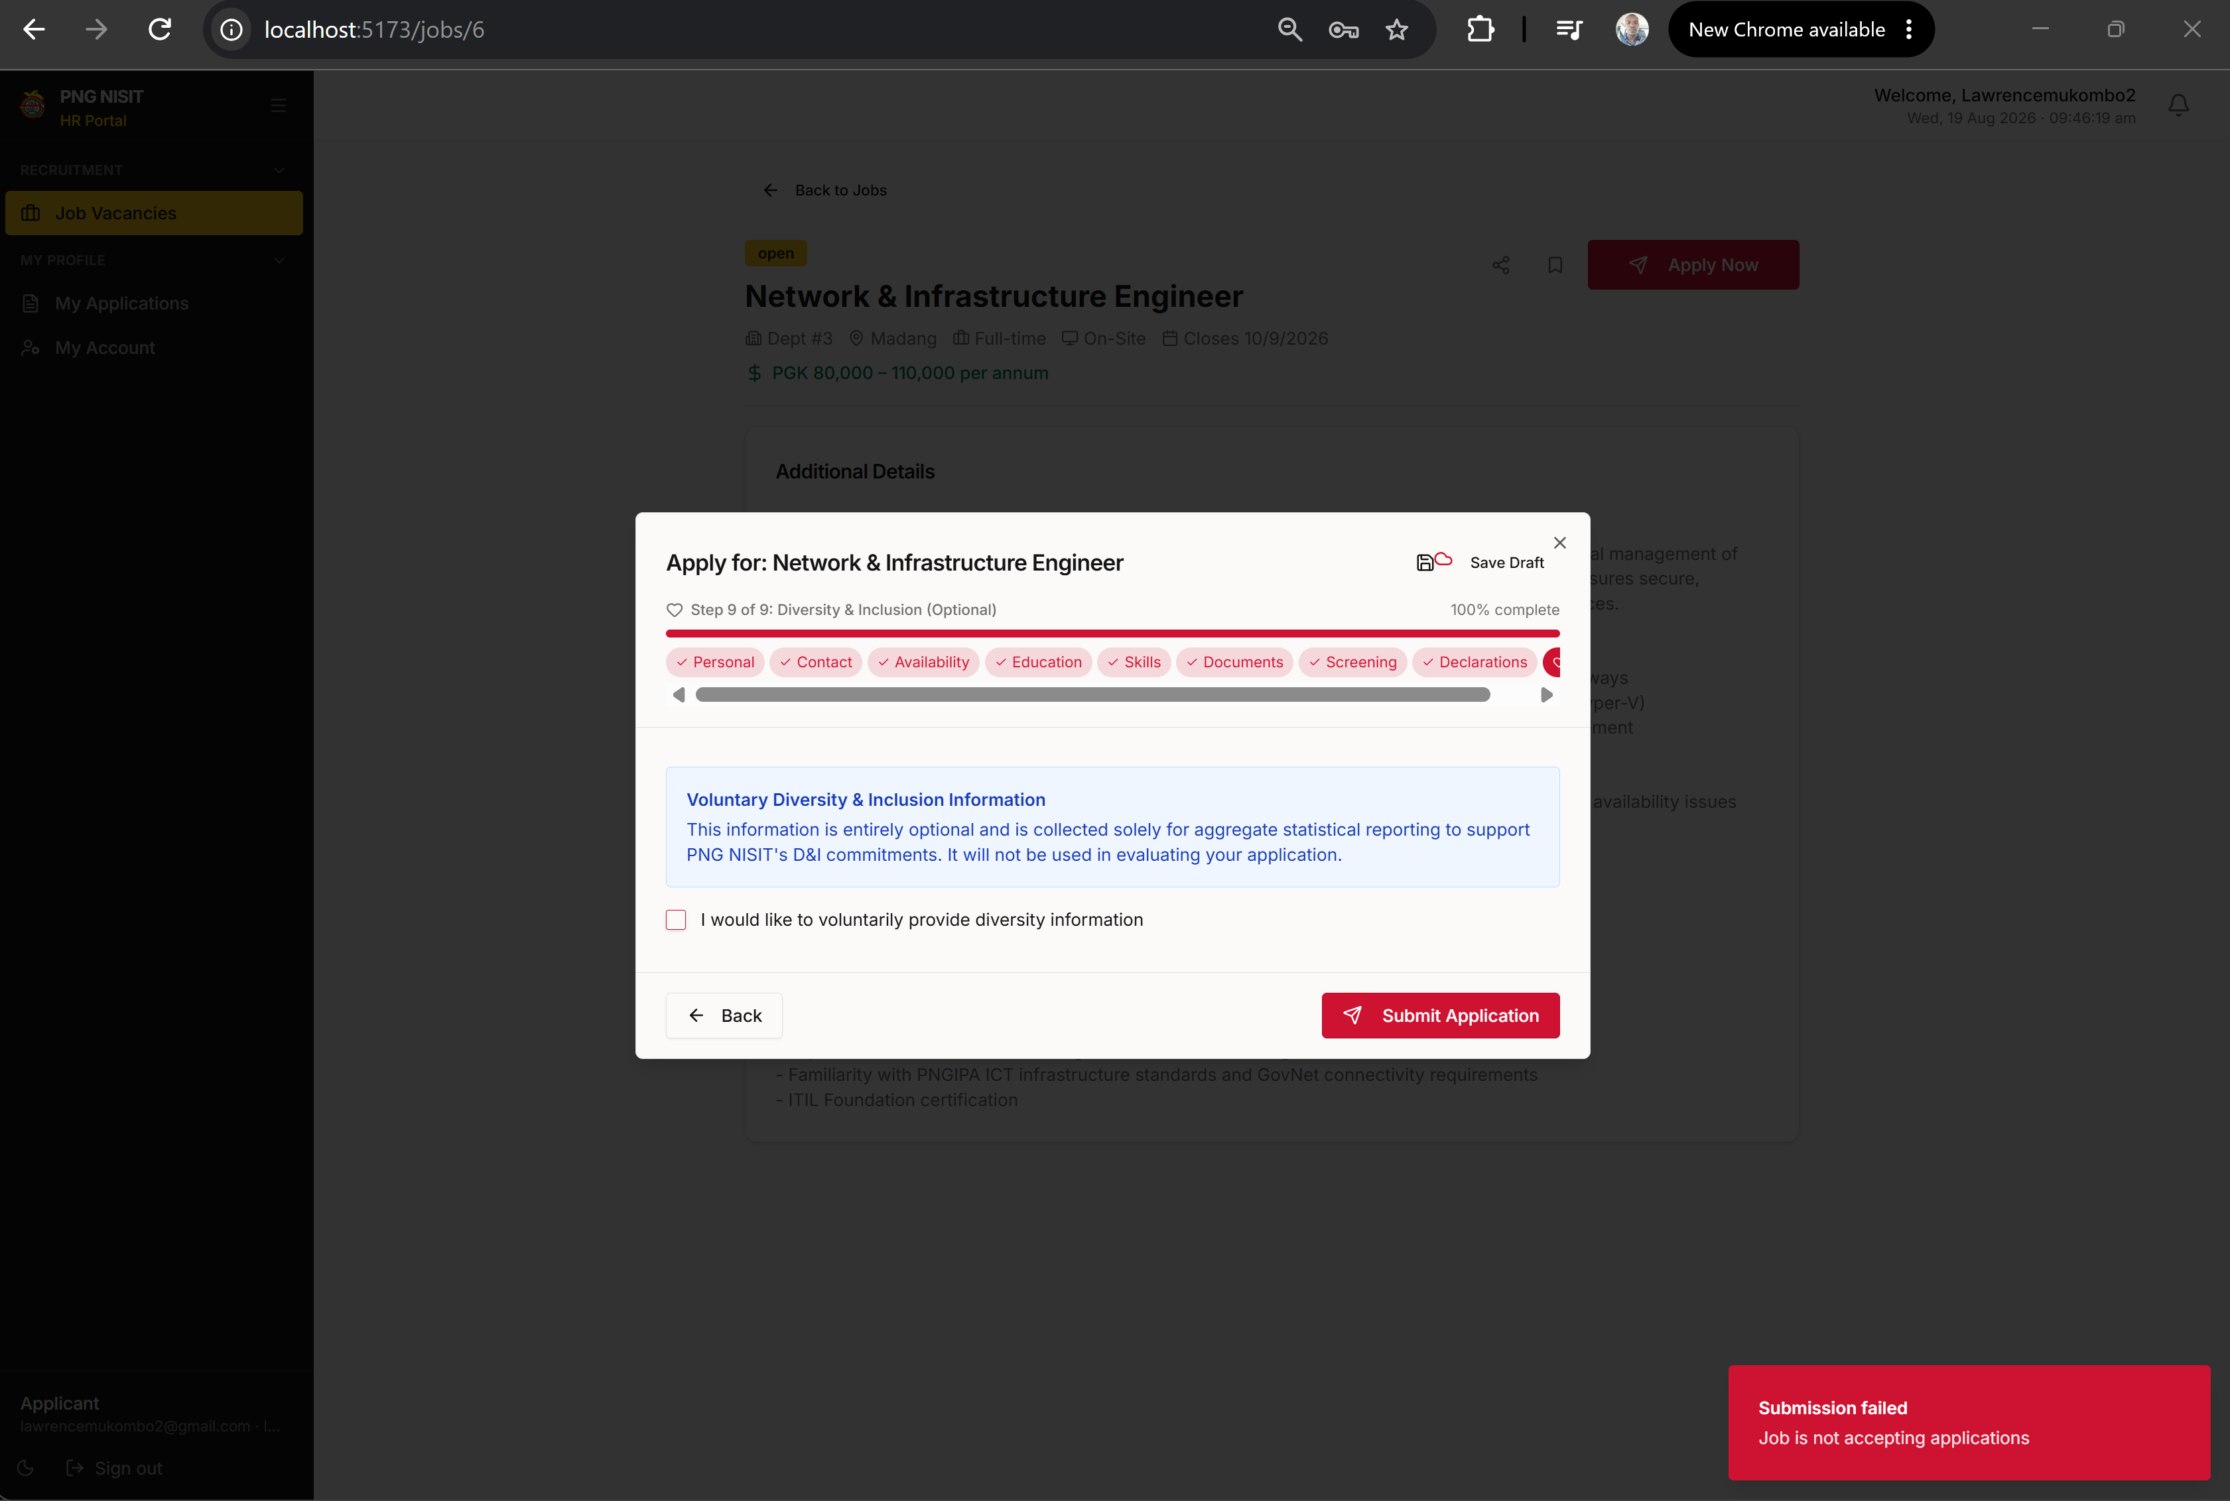
Screenshot: the final application step and Submit Application button.

4. Everyday employee tasks

Leave and attendance
- Open Leave & Absence and select Apply for Leave.
- Choose the leave category, enter a sensible start and end date, add a reason, then submit.
- Open Attendance Clock to clock in or clock out.

Your records
- Open My Account to review your own profile and preferences.
- Open Document Vault to view authorised employment documents.
- Open HR Letters for available HR correspondence.

5. HR, manager and administrator tasks

Review and manage work
- Use Applications and Recruitment Workflow to review candidates and move them through the recruitment stages.
- Use Employees to maintain employee records. Dates of birth and employment dates must be valid and appropriate.
- Use Onboarding, Contracts and Offboarding to complete each workforce workflow.
- Use User Management (administrators) to create, update, activate or deactivate users according to your organisation’s policy.
Tables across the portal include search, filtering, sortable columns, show/hide columns, page controls, selection and exports. Select a column heading to sort. Use Filters for a detailed search and Columns to customise your view.

6. Getting help
If something does not work:
- Check your internet connection and refresh the page once.
- Read the message shown on screen; it often explains what is missing.
- Do not share your password or access token with anyone.
- Contact your HR administrator or the NISIT IT support team with a screenshot, the page name and the time the issue happened.

