PNG NISIT HR Portal
Enterprise End-to-End User Handbook | Staff, applicants, managers, HR and executives
  - Version 1.0 | August 2026
Purpose This handbook is the authoritative operational companion for everyday use of the portal. It is written in clear language but uses enterprise controls: responsible roles, completion checks, data-quality rules and escalation paths.

Document control and how to use this handbook
Control point | What good looks like
Audience | Applicants/non-staff, employees, supervisors, hiring managers, HR officers, executives and system administrators.
Use | Read the role-specific chapters first, then use the workflow and troubleshooting chapters when completing work.
Evidence standard | Use only portal records and authorised documents. Do not use screenshots, exported files or verbal requests as a substitute for an approved record.
Support standard | When escalating an issue, provide the module, record reference, date/time, what you tried and a clean screenshot.

Guide structure
Parts I–II establish safe access and navigation. Parts III–VI cover applicant, employee, manager and HR workflows. Parts VII–VIII cover reporting, data protection, troubleshooting and appendices. Each chapter ends with a completion check.

Contents
- Part I: Access, navigation and shared controls
- Part II: Applicant and non-staff journey
- Part III: Employee self-service
- Part IV: Recruitment and manager journey
- Part V: HR workforce lifecycle
- Part VI: Executive, organisation and reporting
- Part VII: Data, security and support
- Part VIII: Appendices, checklists and glossary
The following 40 operating chapters are designed to be read independently when completing the associated task.

1. Portal orientation
The home experience presents a role-aware menu, a profile/welcome area and notifications. The same portal is used by different audiences, but permissions determine what each person can see and change.

Workflow at a glance
1. Sign in with your own account. → 2. Confirm the welcome panel shows the correct name and email. → 3. Open the navigation group needed for your task. → 4. Use Help & User Guide when you need a role guide.

Standard operating steps
- Sign in with your own account.
- Confirm the welcome panel shows the correct name and email.
- Open the navigation group needed for your task.
- Use Help & User Guide when you need a role guide.

Quality, security and completion checks
Control point | What good looks like
Identity | The name and email match the signed-in user.
Navigation | Only use modules relevant to the current task.
Sign-out | Sign out when using a shared device.
Role note Only actions permitted by the signed-in role are visible. If a menu item or action is missing, request access from the appropriate HR administrator rather than sharing accounts.

2. Authentication and password recovery
Account protection is the first control in every workflow. A valid account is required before the portal can enforce permissions and show records.

Workflow at a glance
1. Enter your registered email and password. → 2. If credentials are rejected, select Forgot password? → 3. Use only the reset link sent to your own email. → 4. Sign in again and verify the welcome panel.

Standard operating steps
- Enter your registered email and password.
- If credentials are rejected, select Forgot password?
- Use only the reset link sent to your own email.
- Sign in again and verify the welcome panel.

Quality, security and completion checks
Control point | What good looks like
Password | Never share it or store it in a browser on public devices.
Lockout | Stop repeated attempts; use password recovery.
Access issue | Escalate to HR/IT with your email and time of attempt.
Role note Only actions permitted by the signed-in role are visible. If a menu item or action is missing, request access from the appropriate HR administrator rather than sharing accounts.

3. Profile, welcome panel and notifications
The welcome panel identifies the active user and the notification bell carries actionable reminders.

Workflow at a glance
1. Open My Account to review your profile. → 2. Keep email and phone details current. → 3. Open the notification bell at the beginning and end of a work session. → 4. Follow notification links only after checking the record context.

Standard operating steps
- Open My Account to review your profile.
- Keep email and phone details current.
- Open the notification bell at the beginning and end of a work session.
- Follow notification links only after checking the record context.

Quality, security and completion checks
Control point | What good looks like
Identity | Use your legal/current name.
Notifications | Do not ignore approval or expiry alerts.
Privacy | Do not expose profile details on shared screens.
Role note Only actions permitted by the signed-in role are visible. If a menu item or action is missing, request access from the appropriate HR administrator rather than sharing accounts.

4. Navigation and role-based access
The sidebar is grouped so users can find work by purpose. Missing options are normally a permission decision, not a fault.

Workflow at a glance
1. Expand a group heading to reveal its modules. → 2. Select the module label, not an unrelated dashboard card, for a full workflow. → 3. Use My Profile for personal tools. → 4. Request role access through the authorised user-management process.

Standard operating steps
- Expand a group heading to reveal its modules.
- Select the module label, not an unrelated dashboard card, for a full workflow.
- Use My Profile for personal tools.
- Request role access through the authorised user-management process.

Quality, security and completion checks
Control point | What good looks like
Least privilege | Do not use another person’s account.
Role clarity | Ask HR which role owns a blocked task.
Auditability | Use the assigned role for all changes.
Role note Only actions permitted by the signed-in role are visible. If a menu item or action is missing, request access from the appropriate HR administrator rather than sharing accounts.

5. Universal table controls
Operational tables use a consistent standard for discovery, selection and export.

Workflow at a glance
1. Use Search for a keyword. → 2. Use Filters for field-specific search. → 3. Select a heading to sort; select again to reverse sort. → 4. Use Columns to show/hide/reset; resize columns where needed. → 5. Use page controls, selection and Actions only after reviewing selected rows. → 6. Export only the minimum authorised dataset.

Standard operating steps
- Use Search for a keyword.
- Use Filters for field-specific search.
- Select a heading to sort; select again to reverse sort.
- Use Columns to show/hide/reset; resize columns where needed.
- Use page controls, selection and Actions only after reviewing selected rows.
- Export only the minimum authorised dataset.

Quality, security and completion checks
Control point | What good looks like
Filters | Clear filters before reporting an empty result.
Bulk actions | Confirm selection count and target status.
Exports | Store exports securely and delete local copies when no longer needed.
Role note Only actions permitted by the signed-in role are visible. If a menu item or action is missing, request access from the appropriate HR administrator rather than sharing accounts.

6. Job vacancy discovery
Applicants and staff can view publicly available vacancies.

Workflow at a glance
1. Open Job Vacancies. → 2. Search by title, location, division or keyword. → 3. Open the vacancy detail. → 4. Confirm status and closing date before action. → 5. Save a job only when you plan to return to it.

Standard operating steps
- Open Job Vacancies.
- Search by title, location, division or keyword.
- Open the vacancy detail.
- Confirm status and closing date before action.
- Save a job only when you plan to return to it.

Quality, security and completion checks
Control point | What good looks like
Eligibility | Read required qualifications first.
Status | Open and Published vacancies are applicant-facing.
Closing date | Do not apply after the advertised close.
Role note Only actions permitted by the signed-in role are visible. If a menu item or action is missing, request access from the appropriate HR administrator rather than sharing accounts.

7. Job detail review
The job detail provides the authoritative vacancy description.

Workflow at a glance
1. Read role overview and responsibilities. → 2. Review qualifications, skills, work arrangement and location. → 3. Check required documents and salary visibility. → 4. Use Share only when sharing an approved public vacancy. → 5. Select Apply Now only after the review.

Standard operating steps
- Read role overview and responsibilities.
- Review qualifications, skills, work arrangement and location.
- Check required documents and salary visibility.
- Use Share only when sharing an approved public vacancy.
- Select Apply Now only after the review.

Quality, security and completion checks
Control point | What good looks like
Accuracy | Do not rely on a copied or outdated job description.
Documents | Prepare only documents requested.
Decision | Save the job if you need time before applying.
Role note Only actions permitted by the signed-in role are visible. If a menu item or action is missing, request access from the appropriate HR administrator rather than sharing accounts.

Clean reference screen: vacancy detail
This clean example shows a public vacancy with the Apply Now action. It intentionally excludes errors, warning banners and annotated marks.
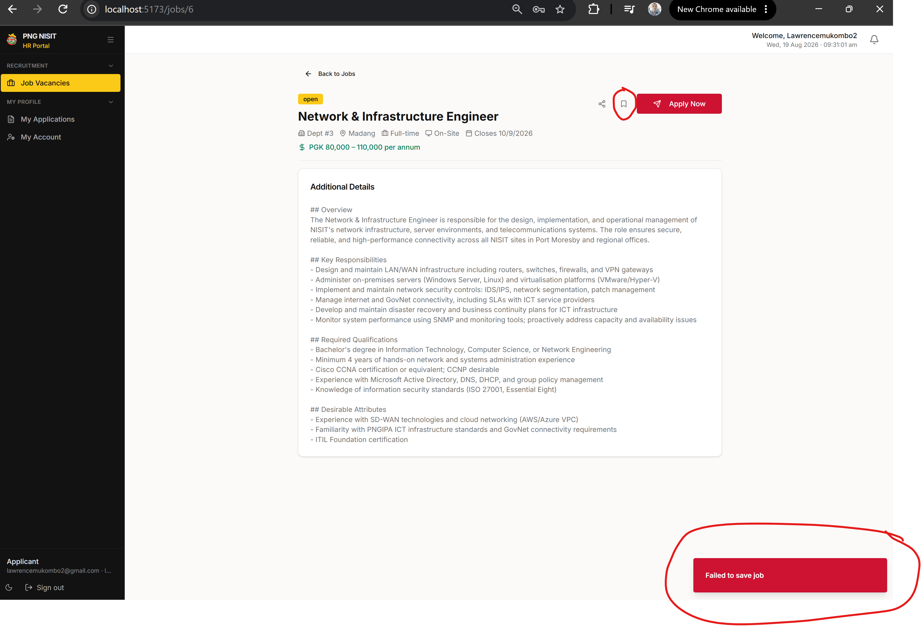
Figure 1. Vacancy detail reference screen.

8. Applicant registration
External users register an applicant account before applying.

Workflow at a glance
1. Select Register as applicant. → 2. Enter legal name, email and a strong password. → 3. Verify information before submission. → 4. Sign in and complete your account/profile when prompted.

Standard operating steps
- Select Register as applicant.
- Enter legal name, email and a strong password.
- Verify information before submission.
- Sign in and complete your account/profile when prompted.

Quality, security and completion checks
Control point | What good looks like
Email | Use an address you can access.
Name | Use official identity spelling.
Duplicate account | Do not create multiple accounts for the same person.
Role note Only actions permitted by the signed-in role are visible. If a menu item or action is missing, request access from the appropriate HR administrator rather than sharing accounts.

9. Applicant application wizard
The application wizard creates a structured application and should be completed deliberately.

Workflow at a glance
1. Select Apply Now. → 2. Complete Personal, Contact and Availability sections. → 3. Add Education, Experience, Skills and Languages. → 4. Upload documents, answer screening questions and read declarations. → 5. Submit only after final review.

Standard operating steps
- Select Apply Now.
- Complete Personal, Contact and Availability sections.
- Add Education, Experience, Skills and Languages.
- Upload documents, answer screening questions and read declarations.
- Submit only after final review.

Quality, security and completion checks
Control point | What good looks like
Draft | A saved draft is not a submitted application.
Required fields | Complete all required answers before proceeding.
Truthfulness | Enter information that can be verified.
Role note Only actions permitted by the signed-in role are visible. If a menu item or action is missing, request access from the appropriate HR administrator rather than sharing accounts.

10. Applicant document uploads
Documents form part of the application evidence record.

Workflow at a glance
1. Upload CV as PDF/DOC/DOCX up to 10 MB. → 2. Select the correct type for extra documents. → 3. Wait for the completed upload state. → 4. Review file names before next step.

Standard operating steps
- Upload CV as PDF/DOC/DOCX up to 10 MB.
- Select the correct type for extra documents.
- Wait for the completed upload state.
- Review file names before next step.

Quality, security and completion checks
Control point | What good looks like
File type | Use permitted formats only.
Size | Keep under 10 MB.
Failure | Keep the wizard open and follow the displayed message.
Role note Only actions permitted by the signed-in role are visible. If a menu item or action is missing, request access from the appropriate HR administrator rather than sharing accounts.

11. Applicant submission and tracking
Submission places the application in the recruitment workflow.

Workflow at a glance
1. Select Submit Application once. → 2. Wait for confirmation. → 3. Open My Applications. → 4. Review status history and notifications. → 5. Respond to requests by their due date.

Standard operating steps
- Select Submit Application once.
- Wait for confirmation.
- Open My Applications.
- Review status history and notifications.
- Respond to requests by their due date.

Quality, security and completion checks
Control point | What good looks like
Duplicate prevention | Do not submit twice for the same vacancy.
Monitoring | Check portal and email regularly.
Withdrawal | Use the portal process if withdrawal is available.
Role note Only actions permitted by the signed-in role are visible. If a menu item or action is missing, request access from the appropriate HR administrator rather than sharing accounts.

12. Leave application
Leave requests must have a valid category, period and handover reason.

Workflow at a glance
1. Open Leave & Absence. → 2. Select Apply for Leave. → 3. Choose category and valid start/end dates. → 4. Enter reason and handover. → 5. Submit and monitor status.

Standard operating steps
- Open Leave & Absence.
- Select Apply for Leave.
- Choose category and valid start/end dates.
- Enter reason and handover.
- Submit and monitor status.

Quality, security and completion checks
Control point | What good looks like
Dates | End date cannot precede start date.
Balance | Review entitlement where displayed.
Approval | Do not assume leave is approved until status says so.
Role note Only actions permitted by the signed-in role are visible. If a menu item or action is missing, request access from the appropriate HR administrator rather than sharing accounts.

13. Attendance clock
Attendance actions record work time and must be used honestly.

Workflow at a glance
1. Open Attendance Clock. → 2. Clock in at the start of duty. → 3. Clock out at the end. → 4. Review entries and report corrections promptly.

Standard operating steps
- Open Attendance Clock.
- Clock in at the start of duty.
- Clock out at the end.
- Review entries and report corrections promptly.

Quality, security and completion checks
Control point | What good looks like
Ownership | Record your own time only unless authorised.
Accuracy | Do not backdate or invent time.
Correction | Use the authorised correction path.
Role note Only actions permitted by the signed-in role are visible. If a menu item or action is missing, request access from the appropriate HR administrator rather than sharing accounts.

14. Document vault and HR letters
Authorised documents are available in secure employee-service modules.

Workflow at a glance
1. Open Document Vault or HR Letters. → 2. Search/filter to locate a record. → 3. Use View Document from inside the portal. → 4. Download only where permitted.

Standard operating steps
- Open Document Vault or HR Letters.
- Search/filter to locate a record.
- Use View Document from inside the portal.
- Download only where permitted.

Quality, security and completion checks
Control point | What good looks like
Access | Do not attempt to access another person’s record.
Storage | Keep downloaded files secure.
Version | Use the latest signed/versioned document.
Role note Only actions permitted by the signed-in role are visible. If a menu item or action is missing, request access from the appropriate HR administrator rather than sharing accounts.

15. Recruitment workflow
Hiring users move applications through controlled stages.

Workflow at a glance
1. Open Applications or Recruitment Workflow. → 2. Open candidate/application detail. → 3. Review evidence and notes. → 4. Move only to an appropriate next stage. → 5. Record outcome and required communication.

Standard operating steps
- Open Applications or Recruitment Workflow.
- Open candidate/application detail.
- Review evidence and notes.
- Move only to an appropriate next stage.
- Record outcome and required communication.

Quality, security and completion checks
Control point | What good looks like
Fairness | Apply consistent criteria.
Stage history | Do not skip controls without reason.
Notes | Keep factual and professional.
Role note Only actions permitted by the signed-in role are visible. If a menu item or action is missing, request access from the appropriate HR administrator rather than sharing accounts.

16. Candidate review and shortlist
Shortlisting turns evaluation into an accountable decision.

Workflow at a glance
1. Review qualifications against the published criteria. → 2. Check documents and screening answers. → 3. Use shortlist/workflow tools permitted to your role. → 4. Record selection rationale.

Standard operating steps
- Review qualifications against the published criteria.
- Check documents and screening answers.
- Use shortlist/workflow tools permitted to your role.
- Record selection rationale.

Quality, security and completion checks
Control point | What good looks like
Conflict | Declare conflicts of interest.
Evidence | Base decisions on application evidence.
Privacy | Do not export candidate information unnecessarily.
Role note Only actions permitted by the signed-in role are visible. If a menu item or action is missing, request access from the appropriate HR administrator rather than sharing accounts.

17. Interview and assessment
Assessment outcomes must be recorded consistently.

Workflow at a glance
1. Schedule through the approved process. → 2. Use the agreed panel/rubric. → 3. Record scores and notes promptly. → 4. Update stage only after required approval.

Standard operating steps
- Schedule through the approved process.
- Use the agreed panel/rubric.
- Record scores and notes promptly.
- Update stage only after required approval.

Quality, security and completion checks
Control point | What good looks like
Consistency | Use the same criteria for comparable candidates.
Confidentiality | Limit notes to authorised reviewers.
Decision | Ensure score and recommendation align.
Role note Only actions permitted by the signed-in role are visible. If a menu item or action is missing, request access from the appropriate HR administrator rather than sharing accounts.

18. Offer and onboarding handoff
A successful candidate moves from recruitment to employment setup.

Workflow at a glance
1. Confirm approval for offer. → 2. Record offer status and required documents. → 3. Start onboarding workflow after acceptance. → 4. Assign tasks and dates to owners.

Standard operating steps
- Confirm approval for offer.
- Record offer status and required documents.
- Start onboarding workflow after acceptance.
- Assign tasks and dates to owners.

Quality, security and completion checks
Control point | What good looks like
Separation of duties | Use appropriate approvals.
Dates | Use agreed start date.
Handoff | Do not mark onboarding complete before tasks close.
Role note Only actions permitted by the signed-in role are visible. If a menu item or action is missing, request access from the appropriate HR administrator rather than sharing accounts.

19. Employee master records
Employee records are the source for workforce and contract workflows.

Workflow at a glance
1. Open Employees and find the record. → 2. Verify legal identity, contacts, department, position and supervisor. → 3. Use an employable date of birth. → 4. Save and verify the updated record.

Standard operating steps
- Open Employees and find the record.
- Verify legal identity, contacts, department, position and supervisor.
- Use an employable date of birth.
- Save and verify the updated record.

Quality, security and completion checks
Control point | What good looks like
DOB | Never use a future or non-employable date.
Appointment | Use effective appointment date.
Status | Match personnel status to employment reality.
Role note Only actions permitted by the signed-in role are visible. If a menu item or action is missing, request access from the appropriate HR administrator rather than sharing accounts.

20. Onboarding workflow
Onboarding coordinates the first-day and pre-start controls.

Workflow at a glance
1. Create/select the employee workflow. → 2. Assign each task to an accountable owner. → 3. Set realistic due dates. → 4. Upload evidence where required. → 5. Monitor outstanding tasks to completion.

Standard operating steps
- Create/select the employee workflow.
- Assign each task to an accountable owner.
- Set realistic due dates.
- Upload evidence where required.
- Monitor outstanding tasks to completion.

Quality, security and completion checks
Control point | What good looks like
Owner | Every task has one clear owner.
Due date | Avoid arbitrary past dates.
Completion | Only close with evidence where required.
Role note Only actions permitted by the signed-in role are visible. If a menu item or action is missing, request access from the appropriate HR administrator rather than sharing accounts.

21. Contract management
Contracts capture employment terms and expiry controls.

Workflow at a glance
1. Create/select the contract. → 2. Choose contract type and applicable period. → 3. Use an end date only for time-bound contracts. → 4. Upload signed document/version through the portal. → 5. Monitor expiry and renewal action.

Standard operating steps
- Create/select the contract.
- Choose contract type and applicable period.
- Use an end date only for time-bound contracts.
- Upload signed document/version through the portal.
- Monitor expiry and renewal action.

Quality, security and completion checks
Control point | What good looks like
Permanent roles | Do not show non-applicable expiry dates.
Renewal | Act before the end date.
Signed evidence | Replace superseded signed versions clearly.
Role note Only actions permitted by the signed-in role are visible. If a menu item or action is missing, request access from the appropriate HR administrator rather than sharing accounts.

22. Offboarding and clearance
Offboarding protects people, assets, access and records at separation.

Workflow at a glance
1. Initiate workflow using confirmed separation details. → 2. Assign IT, asset, finance and HR clearances. → 3. Set realistic separation and due dates. → 4. Track unresolved items. → 5. Close only after required clearances.

Standard operating steps
- Initiate workflow using confirmed separation details.
- Assign IT, asset, finance and HR clearances.
- Set realistic separation and due dates.
- Track unresolved items.
- Close only after required clearances.

Quality, security and completion checks
Control point | What good looks like
Access | Revoke at the approved time.
Assets | Record return evidence.
Finalisation | Do not close with missing mandatory clearances.
Role note Only actions permitted by the signed-in role are visible. If a menu item or action is missing, request access from the appropriate HR administrator rather than sharing accounts.

23. Organisation hierarchy
The organisation view maps positions, filled roles and vacancies.

Workflow at a glance
1. Open Org Hierarchy. → 2. Use division and position filters. → 3. Select cards for relevant roster detail. → 4. Interpret filled/vacant totals with filters in mind.

Standard operating steps
- Open Org Hierarchy.
- Use division and position filters.
- Select cards for relevant roster detail.
- Interpret filled/vacant totals with filters in mind.

Quality, security and completion checks
Control point | What good looks like
Headcount | Use approved position data.
Vacancy | Distinguish vacant positions from open job advertisements.
Print | Review current filters before printing.
Role note Only actions permitted by the signed-in role are visible. If a menu item or action is missing, request access from the appropriate HR administrator rather than sharing accounts.

Clean reference screen: organisation hierarchy
This clean reference shows the organisational view, its headcount cards and available filters.
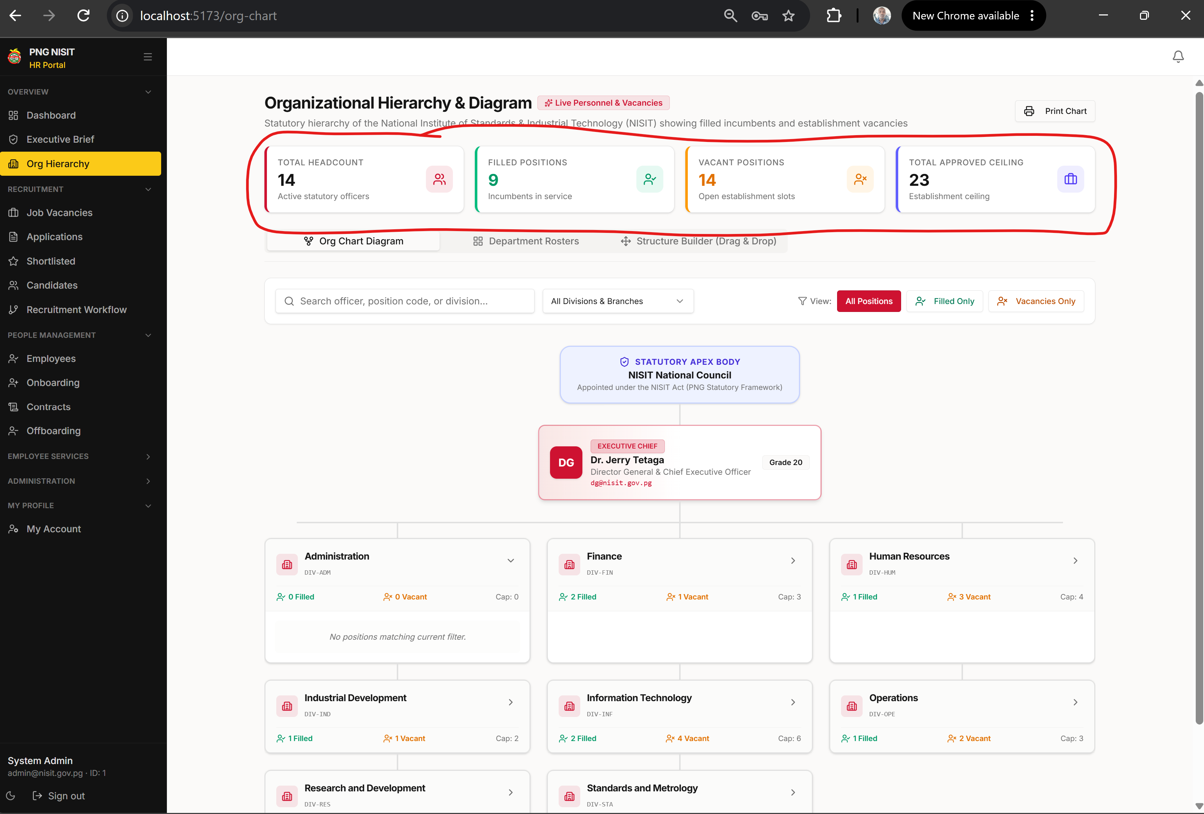
Figure 2. Organisation hierarchy reference screen.

24. Dashboard drilldowns
Dashboard cards and charts are starting points, not final evidence.

Workflow at a glance
1. Select a metric card or chart. → 2. Review source records in the drilldown. → 3. Apply filters where available. → 4. Open the operational record before action.

Standard operating steps
- Select a metric card or chart.
- Review source records in the drilldown.
- Apply filters where available.
- Open the operational record before action.

Quality, security and completion checks
Control point | What good looks like
Evidence | Use source records for decisions.
Counts | Check filters and date scope.
Empty result | Confirm access and filters before escalation.
Role note Only actions permitted by the signed-in role are visible. If a menu item or action is missing, request access from the appropriate HR administrator rather than sharing accounts.

25. Standard reports and exports
Reports turn filtered operational data into controlled outputs.

Workflow at a glance
1. Open Standard Reports. → 2. Select report and date range. → 3. Apply only relevant filters. → 4. Review rows before export. → 5. Use CSV/TSV/JSON or Print as required.

Standard operating steps
- Open Standard Reports.
- Select report and date range.
- Apply only relevant filters.
- Review rows before export.
- Use CSV/TSV/JSON or Print as required.

Quality, security and completion checks
Control point | What good looks like
Period | Use a defensible reporting date range.
Export | Apply data classification rules.
Retention | Delete local copies when no longer needed.
Role note Only actions permitted by the signed-in role are visible. If a menu item or action is missing, request access from the appropriate HR administrator rather than sharing accounts.

26. Approval delegation and escalation
Delegation and escalation maintain timely decisions when approvers are unavailable.

Workflow at a glance
1. Confirm the delegated approver and authority. → 2. Set an applicable start/end period. → 3. Review escalated item context and evidence. → 4. Approve, return or reject with a clear comment.

Standard operating steps
- Confirm the delegated approver and authority.
- Set an applicable start/end period.
- Review escalated item context and evidence.
- Approve, return or reject with a clear comment.

Quality, security and completion checks
Control point | What good looks like
Delegation | Do not delegate outside authority.
Dates | Use actual availability period.
Audit | Comments explain the decision.
Role note Only actions permitted by the signed-in role are visible. If a menu item or action is missing, request access from the appropriate HR administrator rather than sharing accounts.

27. User management overview
Administrators maintain access without bypassing accountability.

Workflow at a glance
1. Open User Management. → 2. Search existing user before creating another. → 3. Assign the correct role, agency and status. → 4. Save and verify access outcome.

Standard operating steps
- Open User Management.
- Search existing user before creating another.
- Assign the correct role, agency and status.
- Save and verify access outcome.

Quality, security and completion checks
Control point | What good looks like
Uniqueness | Avoid duplicate email accounts.
Role | Use least privilege.
Change log | Ensure the action is auditable.
Role note Only actions permitted by the signed-in role are visible. If a menu item or action is missing, request access from the appropriate HR administrator rather than sharing accounts.

28. Notifications and reminders
Notifications connect events to action.

Workflow at a glance
1. Review daily. → 2. Open source record. → 3. Complete/acknowledge the action. → 4. Escalate if blocked.

Standard operating steps
- Review daily.
- Open source record.
- Complete/acknowledge the action.
- Escalate if blocked.

Quality, security and completion checks
Control point | What good looks like
Timeliness | Act before due date.
Context | Never action from notification text alone.
History | Keep records current.
Role note Only actions permitted by the signed-in role are visible. If a menu item or action is missing, request access from the appropriate HR administrator rather than sharing accounts.

29. Data quality rules
Good data keeps dashboard, workflow and reports trustworthy.

Workflow at a glance
1. Use real names, dates and references. → 2. Leave non-applicable fields blank rather than inventing data. → 3. Correct detected errors promptly. → 4. Check saved values after update.

Standard operating steps
- Use real names, dates and references.
- Leave non-applicable fields blank rather than inventing data.
- Correct detected errors promptly.
- Check saved values after update.

Quality, security and completion checks
Control point | What good looks like
Dates | No future DOB; no expiry date for permanent contract.
Status | Reflect actual workflow state.
Duplicates | Search before creating records.
Role note Only actions permitted by the signed-in role are visible. If a menu item or action is missing, request access from the appropriate HR administrator rather than sharing accounts.

30. Security and privacy
Personnel information requires careful handling.

Workflow at a glance
1. Use your own account only. → 2. Lock/sign out from shared devices. → 3. Export minimum data. → 4. Store documents only in approved locations. → 5. Report suspected unauthorised access immediately.

Standard operating steps
- Use your own account only.
- Lock/sign out from shared devices.
- Export minimum data.
- Store documents only in approved locations.
- Report suspected unauthorised access immediately.

Quality, security and completion checks
Control point | What good looks like
Credentials | Never share token/password.
Documents | Use authorised recipients only.
Incident | Preserve details for support.
Role note Only actions permitted by the signed-in role are visible. If a menu item or action is missing, request access from the appropriate HR administrator rather than sharing accounts.

31. Troubleshooting and support
A good support request allows rapid diagnosis.

Workflow at a glance
1. Read the exact message. → 2. Confirm connectivity and refresh once after saving work. → 3. Retry only when safe. → 4. Capture clean screenshot. → 5. Report module, record ID, time and steps.

Standard operating steps
- Read the exact message.
- Confirm connectivity and refresh once after saving work.
- Retry only when safe.
- Capture clean screenshot.
- Report module, record ID, time and steps.

Quality, security and completion checks
Control point | What good looks like
Do not | Repeatedly submit forms or create duplicates.
Screenshot | Exclude sensitive content when possible.
Escalation | Use HR/IT support channel.
Role note Only actions permitted by the signed-in role are visible. If a menu item or action is missing, request access from the appropriate HR administrator rather than sharing accounts.

32. Glossary and final checklist
Common terms help users communicate precisely.

Workflow at a glance
1. Review the glossary when unsure of status or workflow term. → 2. Use the final checklist before completing high-impact work. → 3. Return to Help & User Guide for role-specific manuals.

Standard operating steps
- Review the glossary when unsure of status or workflow term.
- Use the final checklist before completing high-impact work.
- Return to Help & User Guide for role-specific manuals.

Quality, security and completion checks
Control point | What good looks like
Applicant | External user applying for a vacancy.
Workflow | Controlled sequence of tasks/stages.
Audit trail | Recorded history of accountable actions.
Role note Only actions permitted by the signed-in role are visible. If a menu item or action is missing, request access from the appropriate HR administrator rather than sharing accounts.

33. Role-to-module reference
This reference helps users identify the normal owner of a task before creating a request or escalating an issue.

Workflow at a glance
1. Confirm whether you are acting as applicant, employee, manager, HR officer, executive or administrator. → 2. Open the module associated with the task. → 3. If a control is unavailable, request an authorised role review.

Standard operating steps
- Confirm whether you are acting as applicant, employee, manager, HR officer, executive or administrator.
- Open the module associated with the task.
- If a control is unavailable, request an authorised role review.

Quality, security and completion checks
Control point | What good looks like
Applicants | Jobs, My Applications, My Account.
Employees | Employee services and own profile.
Managers/HR | Recruitment and assigned workforce workflows.
Role note Only actions permitted by the signed-in role are visible. If a menu item or action is missing, request access from the appropriate HR administrator rather than sharing accounts.

34. Date and status reference
Dates and statuses are used by dashboards, alerts, reports and workflow decisions.

Workflow at a glance
1. Use a date of birth that reflects an employable adult. → 2. Use appointment, contract and separation dates from approved records. → 3. Use contract expiry/renewal dates only for time-bound contracts. → 4. Confirm status before reporting counts.

Standard operating steps
- Use a date of birth that reflects an employable adult.
- Use appointment, contract and separation dates from approved records.
- Use contract expiry/renewal dates only for time-bound contracts.
- Confirm status before reporting counts.

Quality, security and completion checks
Control point | What good looks like
Permanent employment | No artificial expiry date.
Renewal | New period begins only after approved renewal.
Closed workflow | All mandatory steps completed.
Role note Only actions permitted by the signed-in role are visible. If a menu item or action is missing, request access from the appropriate HR administrator rather than sharing accounts.

35. Document and version reference
Documents should remain traceable from upload through replacement.

Workflow at a glance
1. Name supporting files clearly before upload. → 2. Upload the signed/current version through its associated workflow. → 3. Replace superseded versions only when authorised. → 4. Use portal viewing links, not unverified external URLs.

Standard operating steps
- Name supporting files clearly before upload.
- Upload the signed/current version through its associated workflow.
- Replace superseded versions only when authorised.
- Use portal viewing links, not unverified external URLs.

Quality, security and completion checks
Control point | What good looks like
Current version | Clearly identifiable and authorised.
Retention | Follow NISIT retention policy.
Access | Restricted to permitted users.
Role note Only actions permitted by the signed-in role are visible. If a menu item or action is missing, request access from the appropriate HR administrator rather than sharing accounts.

36. Export and print reference
Exports are operational records and need the same care as portal screens.

Workflow at a glance
1. Filter to the smallest necessary dataset. → 2. Review columns before exporting. → 3. Use the appropriate format for the receiving process. → 4. Store only in approved locations. → 5. Remove local copies when work is complete.

Standard operating steps
- Filter to the smallest necessary dataset.
- Review columns before exporting.
- Use the appropriate format for the receiving process.
- Store only in approved locations.
- Remove local copies when work is complete.

Quality, security and completion checks
Control point | What good looks like
CSV/TSV | Structured spreadsheet processing.
JSON | System/data integration use.
Print | Review current filters and page range first.
Role note Only actions permitted by the signed-in role are visible. If a menu item or action is missing, request access from the appropriate HR administrator rather than sharing accounts.

37. Escalation reference
Escalation is used when work cannot proceed safely or in time.

Workflow at a glance
1. Document the issue and impacted record. → 2. State what action has already been attempted. → 3. Attach a clean, non-sensitive screenshot where useful. → 4. Send to the designated HR/IT owner. → 5. Keep the workflow open until the outcome is confirmed.

Standard operating steps
- Document the issue and impacted record.
- State what action has already been attempted.
- Attach a clean, non-sensitive screenshot where useful.
- Send to the designated HR/IT owner.
- Keep the workflow open until the outcome is confirmed.

Quality, security and completion checks
Control point | What good looks like
Urgent | Access, separation, payroll or security impact.
Normal | Data correction or usability question.
Evidence | Time, module, record reference and steps.
Role note Only actions permitted by the signed-in role are visible. If a menu item or action is missing, request access from the appropriate HR administrator rather than sharing accounts.

Enterprise completion checklist
☐ Correct user and role confirmed
☐ Correct module and record selected
☐ All applicable dates logical and complete
☐ Supporting documents uploaded/verified where required
☐ Status and comments accurately reflect the action
☐ Sensitive data handled according to policy
☐ Outcome saved and verified
Next document The separate Administrator Technical Guide will cover configuration, integrations, security administration, API operations, database/seed procedures and technical troubleshooting.

