

VaxPlan User Manual
Health Microplanning Platform | Application Guide with Screenshots
Prepared for | VaxPlan users, Ministry of Health teams, district/facility staff, ICT officers, programme managers, M&E officers, partners, and support teams
Example workspace | Republic of Zambia Ministry of Health
Source evidence | Live VaxPlan application screenshots captured from localhost:5000 and reviewed route/module structure
Prepared date | 18 July 2026
Security note | User credentials are not included in this manual. Passwords must never be shared in documentation.
Purpose: This manual explains what each VaxPlan module is for, how users should work through common tasks, and what the screenshots demonstrate. It is written for both public-health and non-public-health technical users.

Table of Contents
Use Word's References > Table of Contents command to insert an automatic table of contents if required.
1. Introduction
2. Accessing VaxPlan and Signing In
3. Dashboard Overview
4. GIS Map View
5. Facilities and Catchments
6. Facility Editing Workspace
7. Population Planning
8. Routine Microplans
9. Campaign Microplans
10. Session Planning
11. All Sessions and Session History
12. Stock Ledger and Vaccine Logistics Linkage
13. Reports and Dashboards
14. Supervision
15. Field Readiness
16. Notifications and Workflow Follow-up
17. User Management and Role-Based Access
18. Settings
19. Settlements, Communities, and Client Registry
20. Data Sources and Standards Alignment
21. Help and User Support
22. Recommended Operating Procedures
Appendix A. Additional Module Screenshots

How to Read This Manual
- Each module section explains the purpose of the screen, who typically uses it, practical steps, and the evidence shown in the screenshot.
- The screenshots are evidence from the working VaxPlan application and are intended to help users recognize screens and workflows.
- Role-based access means screenshots may show options that are hidden from some users.
- Use the latest local or deployed application behavior as the authoritative workflow where it differs from static screenshots.

Core Concepts
Concept | Plain-language meaning
Microplanning | A bottom-up process that starts at health facility catchment areas and identifies populations, communities, service delivery points, session plans, resources, gaps, and follow-up actions.
Catchment area | The geographic area and communities normally served by a health facility or service delivery team.
Session | A planned immunization service activity, such as a fixed, outreach, mobile, or campaign session.
Unserved or missed place | A community or settlement that may not yet be adequately covered by planned services and therefore needs review.
Role-based access control | A security model where each user sees and edits only the data allowed for their role and geographic scope.
Offline-first sync | Application behavior that supports continued work during weak connectivity and synchronizes changes when the connection is restored, depending on module capability and permissions.

1. Introduction

Purpose
VaxPlan is a health microplanning platform for immunization teams. It brings together maps, population denominators, facilities, communities, session plans, vaccine and logistics information, supervision, reports, and approval workflows in one digital workspace.

Primary Users
National, provincial, district, facility, partner, monitoring and evaluation, ICT, logistics, and programme management users.

Typical Workflow
- Use this manual as a practical guide to navigate the system and understand what each module is used for.
- Screenshots use the Republic of Zambia Ministry of Health workspace as the example country context.
- Because VaxPlan is role-based, some users may see fewer menu items than those shown in this manual.

Application View and What It Shows
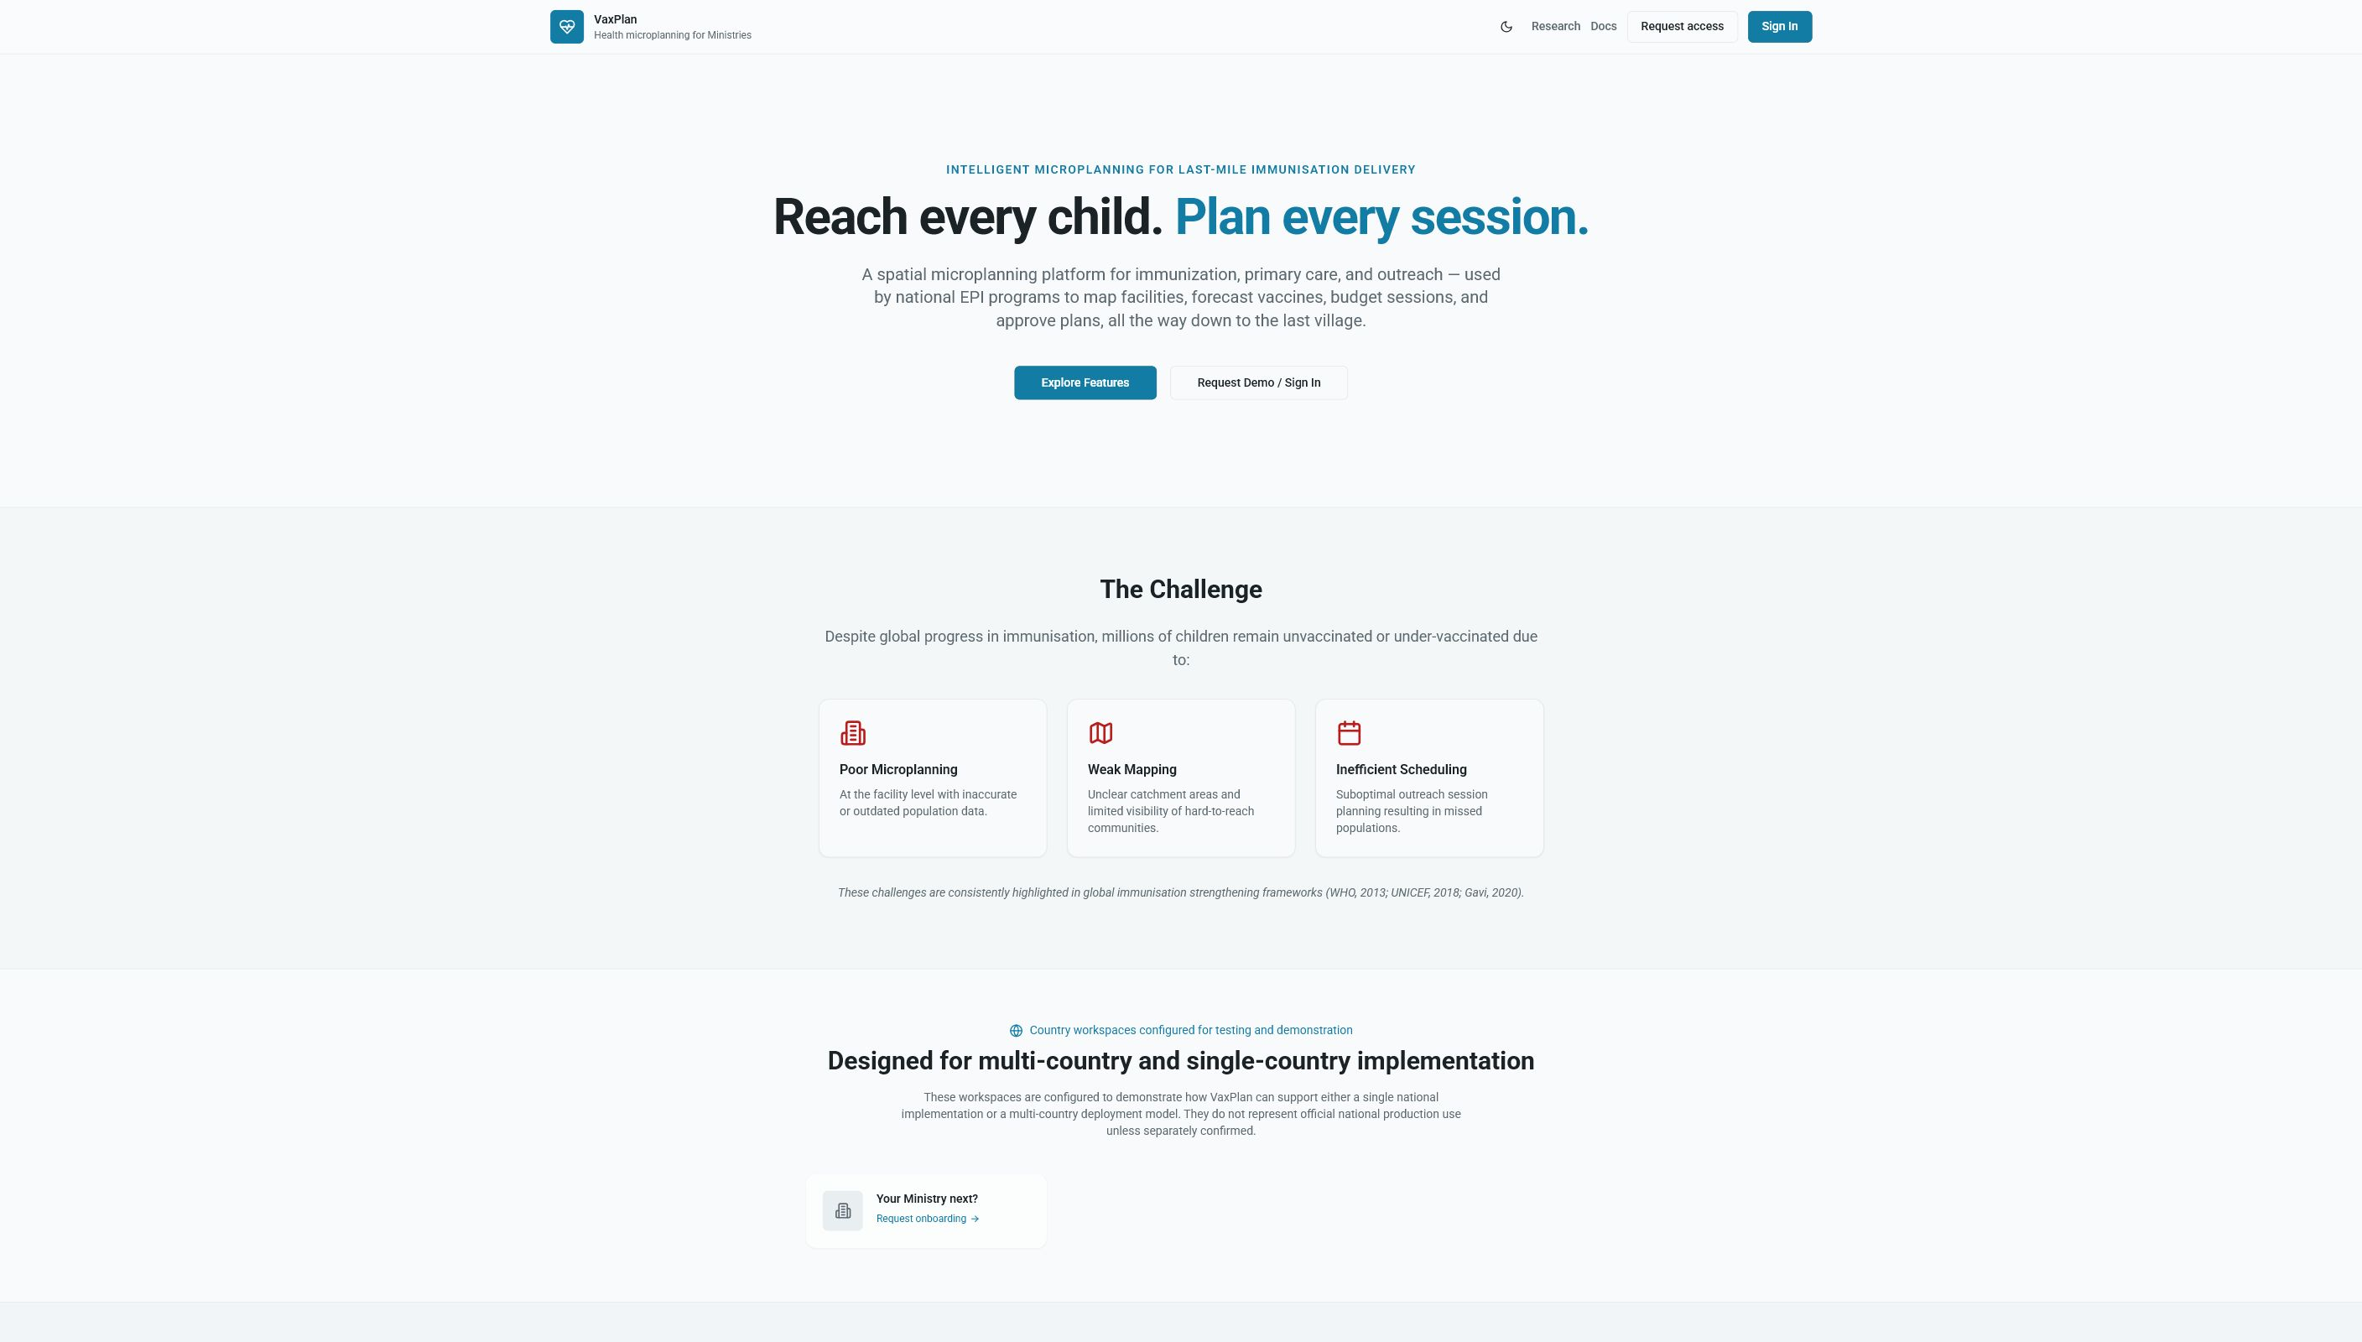
Public landing page: introduces VaxPlan as a GIS-enabled immunization microplanning platform before sign-in.

2. Accessing VaxPlan and Signing In

Purpose
Users access VaxPlan through the web application, select their country or ministry workspace, and sign in with an approved account. Authentication protects national planning data and applies role-based access controls after login.

Primary Users
All users.

Typical Workflow
- Open the VaxPlan URL in a supported browser.
- Select the correct country or ministry workspace, for example Republic of Zambia Ministry of Health.
- Enter the approved work email and password, then select Sign in.
- Do not share passwords. If access fails, use the account recovery process or contact a system administrator.

Application View and What It Shows
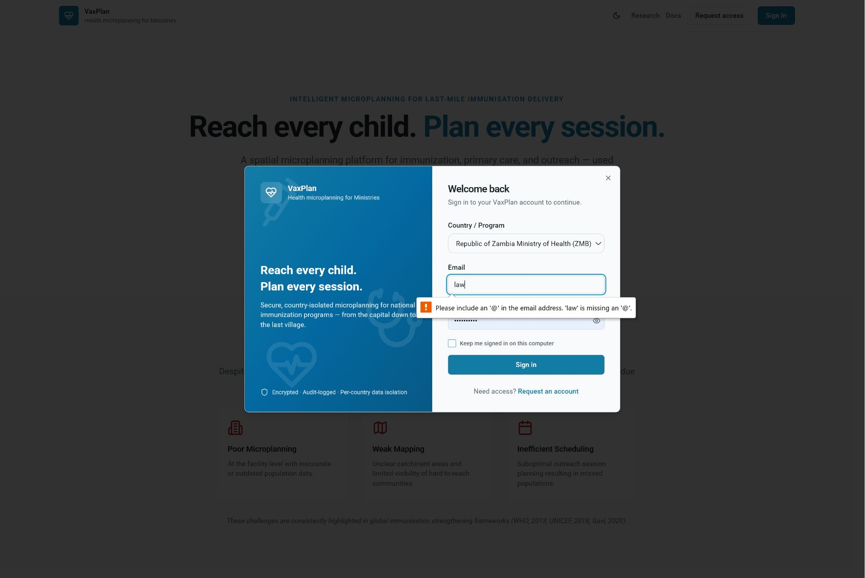
Login dialog: shows country selection, email, password, account request, and password recovery entry points.
Security reminder: The example account used to capture screenshots is not printed here. Users should protect credentials, avoid shared accounts, and report suspicious access immediately.

3. Dashboard Overview

Purpose
The dashboard is the operational starting point. It summarizes active planning period, facility context, microplanning progress, alerts, and key programme indicators for quick management review.

Primary Users
Programme managers, district officers, facility managers, M&E officers, and partners.

Typical Workflow
- Confirm the active year, quarter, country, and facility context at the top of the page.
- Review progress cards and alerts before opening detailed modules.
- Use dashboard indicators to identify where follow-up is needed.

Application View and What It Shows
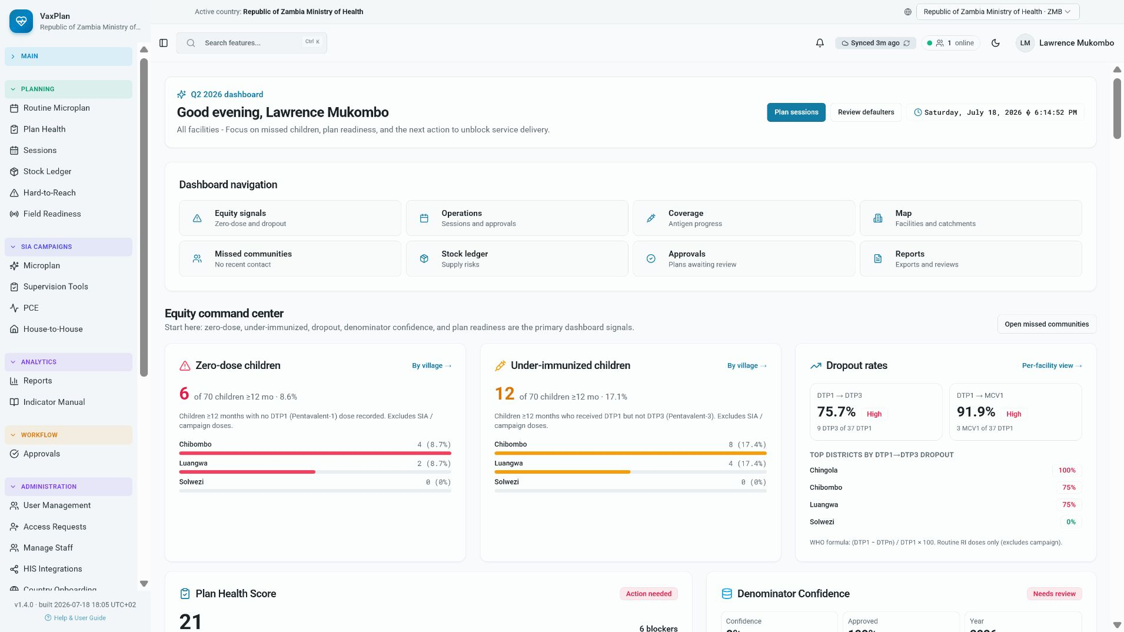
Dashboard: provides a high-level view of planning status and programme performance for the selected Zambia context.

4. GIS Map View

Purpose
The GIS map is used to visualize facilities, communities, catchment areas, administrative boundaries, planned sessions, missed or unserved places, and relevant custom layers. It supports geographic review of equity gaps and service reach.

Primary Users
GIS users, immunization officers, district teams, facility teams, supervisors, and planners.

Typical Workflow
- Use the search box to find facilities, settlements, wards, or districts.
- Toggle layers to compare health facilities, communities, boundaries, sessions, and population layers.
- Zoom into a district or facility catchment before interpreting settlement-level markers.
- Use map evidence to identify communities that need outreach, catchment revision, or follow-up.

Application View and What It Shows
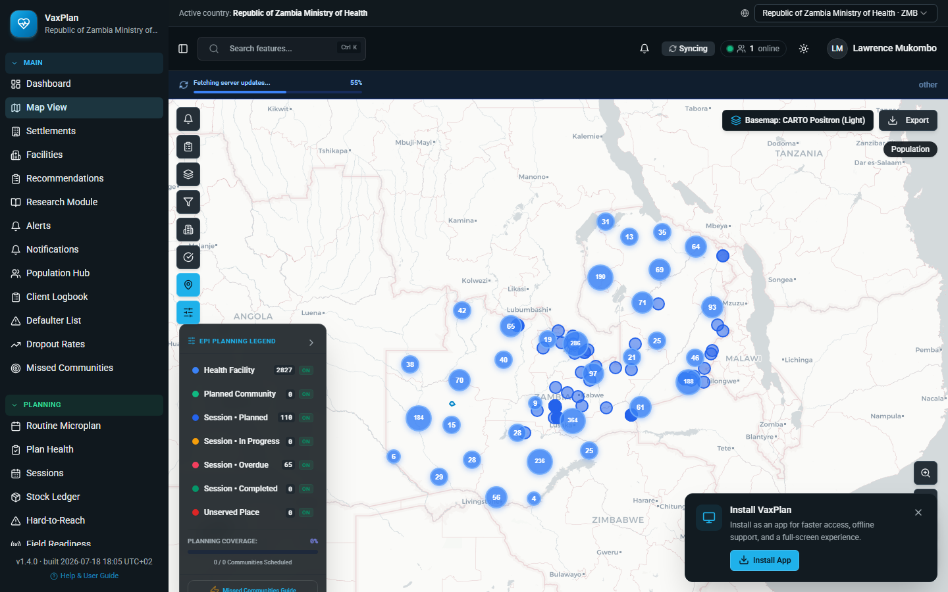
GIS map view: demonstrates Zambia facility/community mapping and planning layers used for microplanning decisions.
Map interpretation: At low zoom levels, markers may cluster or appear dense. Zoom to district, ward, facility, or settlement level before making operational decisions.

5. Facilities and Catchments

Purpose
The facilities module manages health facility records and their catchment relationships. It supports facility profile updates, assigned communities, staff, equipment, facility location, and catchment polygon editing.

Primary Users
Facility staff, district officers, GIS administrators, and system administrators.

Typical Workflow
- Search or filter the facility list to find the correct facility.
- Open the facility record to review general details, catchment area, served communities, staff roster, and cold chain information.
- Only save changes that reflect verified facility or catchment information.
- If location or polygon edits are blocked, confirm that the user role has permission for the target district/facility.

Application View and What It Shows
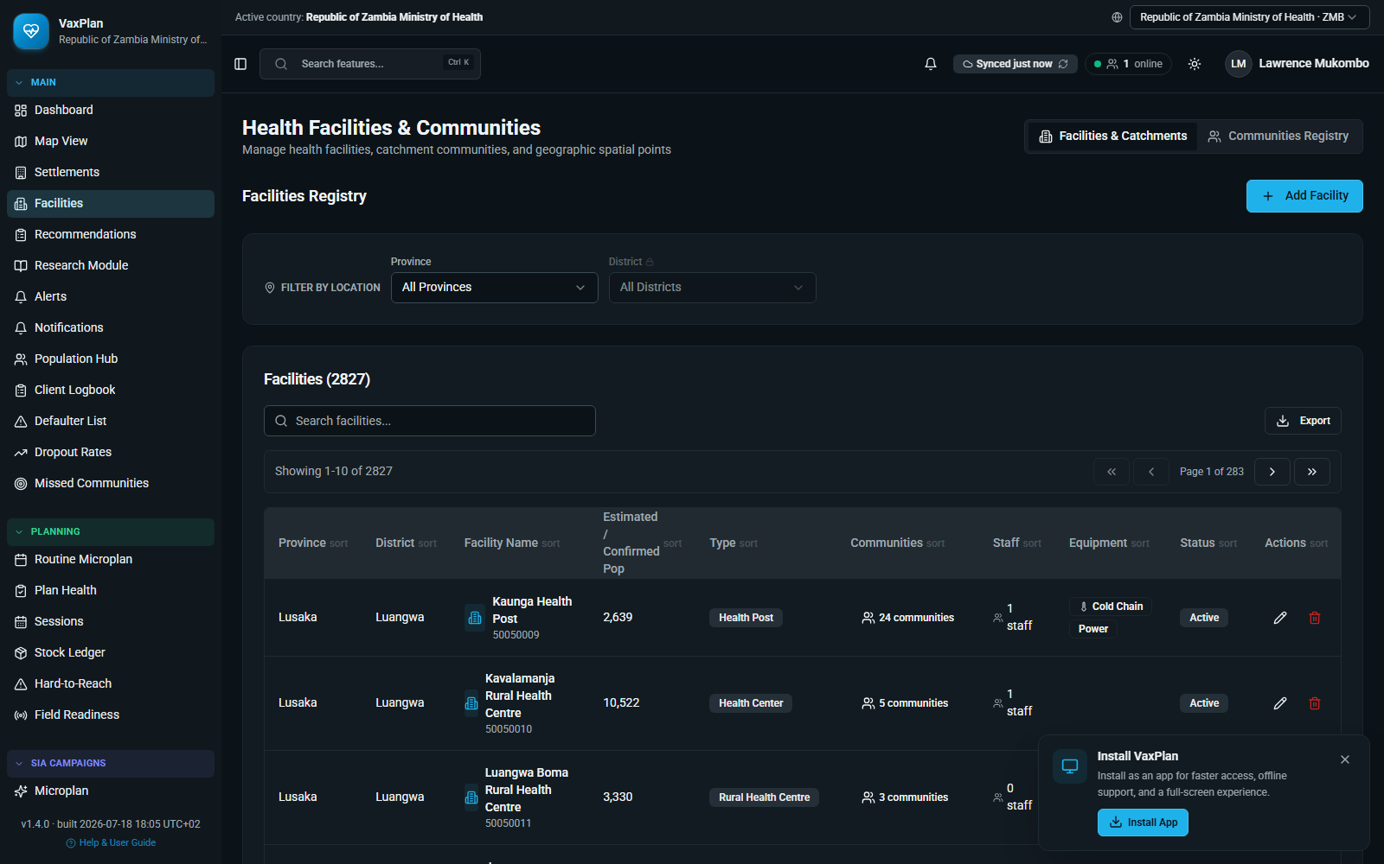
Facilities list: shows facility records, status, staff, equipment, and actions for facility/catchment management.

6. Facility Editing Workspace

Purpose
The facility editing workspace brings together data entry and GIS editing. Facility staff and managers can review demographics, move facility pins, draw catchments, manage served communities, and maintain operational details where permissions allow.

Primary Users
Facility staff, district officers, GIS officers, and administrators.

Typical Workflow
- Use General & Catchment Area to update facility details and map location.
- Use Communities Served to maintain linked communities and settlements.
- Use Polygon Drawing to create or refine catchment boundaries.
- Save only after verifying the facility is within the correct administrative boundary.

Application View and What It Shows
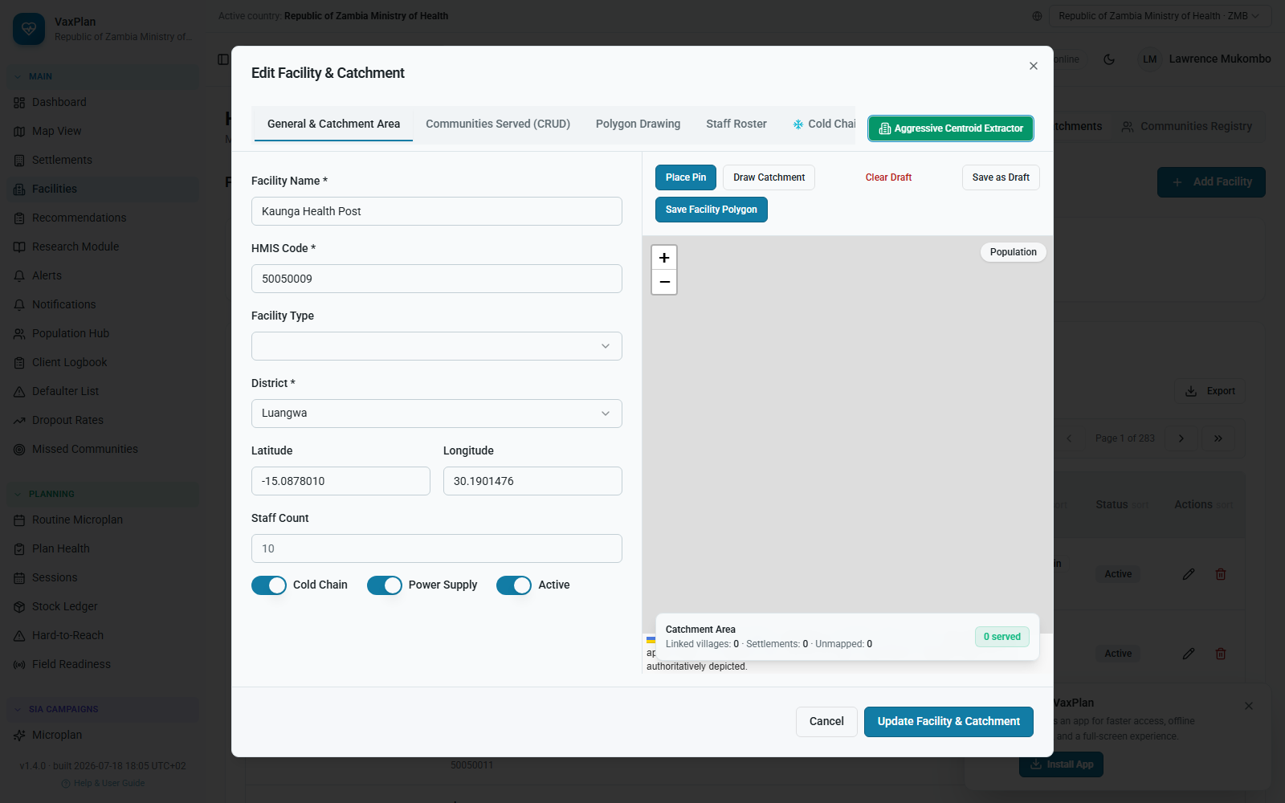
Facility edit workspace: combines facility data fields with map-based catchment management.

7. Population Planning

Purpose
Population planning manages denominators used to estimate target populations, service needs, and vaccine requirements. It helps planners understand how many people are expected to need services in each catchment or administrative area.

Primary Users
M&E officers, district planners, programme managers, and data managers.

Typical Workflow
- Review the current population assumptions and planning year.
- Check imported grids, settlement data, or demographic estimates before using them for plans.
- Use population outputs to support session planning, vaccine forecasting, and gap analysis.

Application View and What It Shows
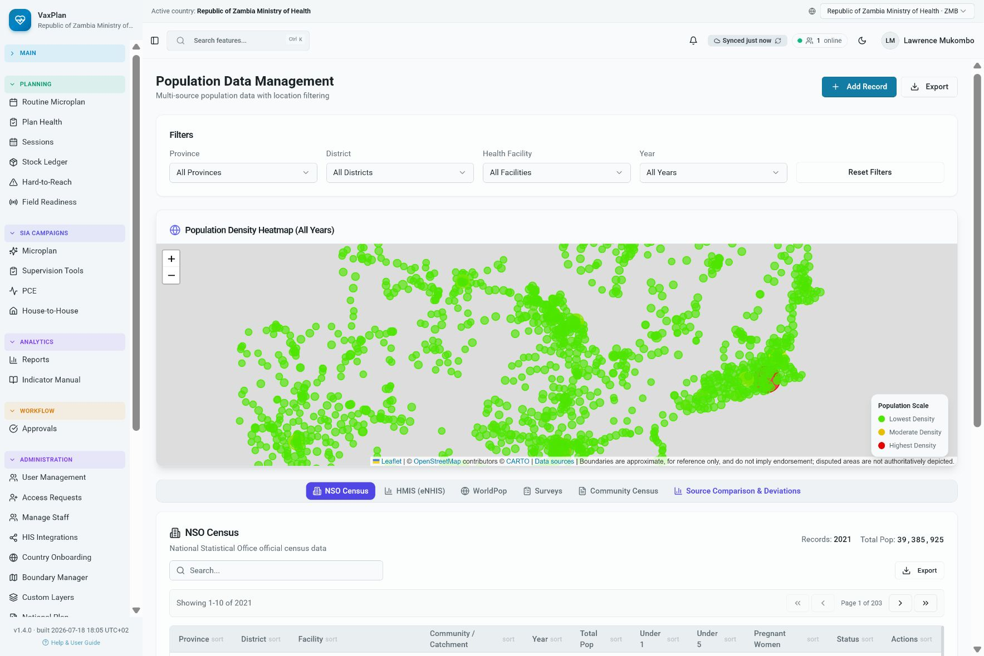
Population planning: shows denominator and population planning tools used to support immunization microplans.

8. Routine Microplans

Purpose
Routine microplans translate facility and community data into practical immunization plans. A microplan typically includes catchment populations, service delivery points, session schedules, resource needs, risks, gaps, and follow-up actions.

Primary Users
Facility teams, district immunization officers, programme managers, and supervisors.

Typical Workflow
- Open or create the microplan for the correct planning period.
- Review catchment communities, session strategy, required resources, and readiness information.
- Submit the microplan for review when data are complete.
- Use comments or workflow actions to resolve gaps before approval.

Application View and What It Shows
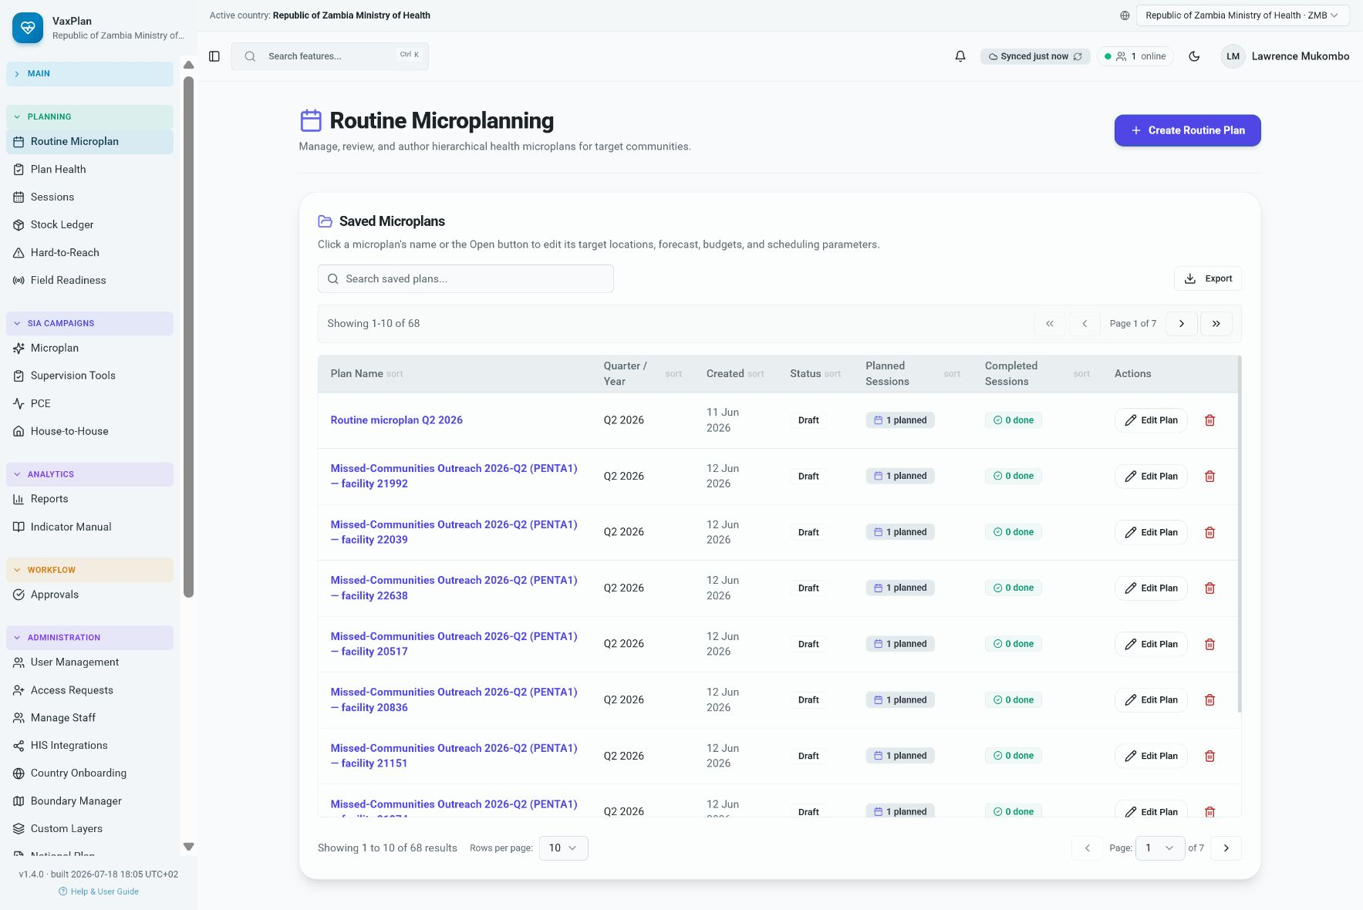
Routine microplans: list and status view for facility-based routine immunization planning.

9. Campaign Microplans

Purpose
Campaign microplans support time-bound activities such as supplementary immunization activities, outbreak response, or special campaigns. They use similar planning logic but focus on campaign geography, teams, target groups, and short implementation windows.

Primary Users
Campaign managers, district teams, partner coordinators, and supervisors.

Typical Workflow
- Select the correct campaign and planning level.
- Review targeted areas, teams, sessions, logistics, and supervision requirements.
- Use approval workflows to track readiness before implementation.

Application View and What It Shows
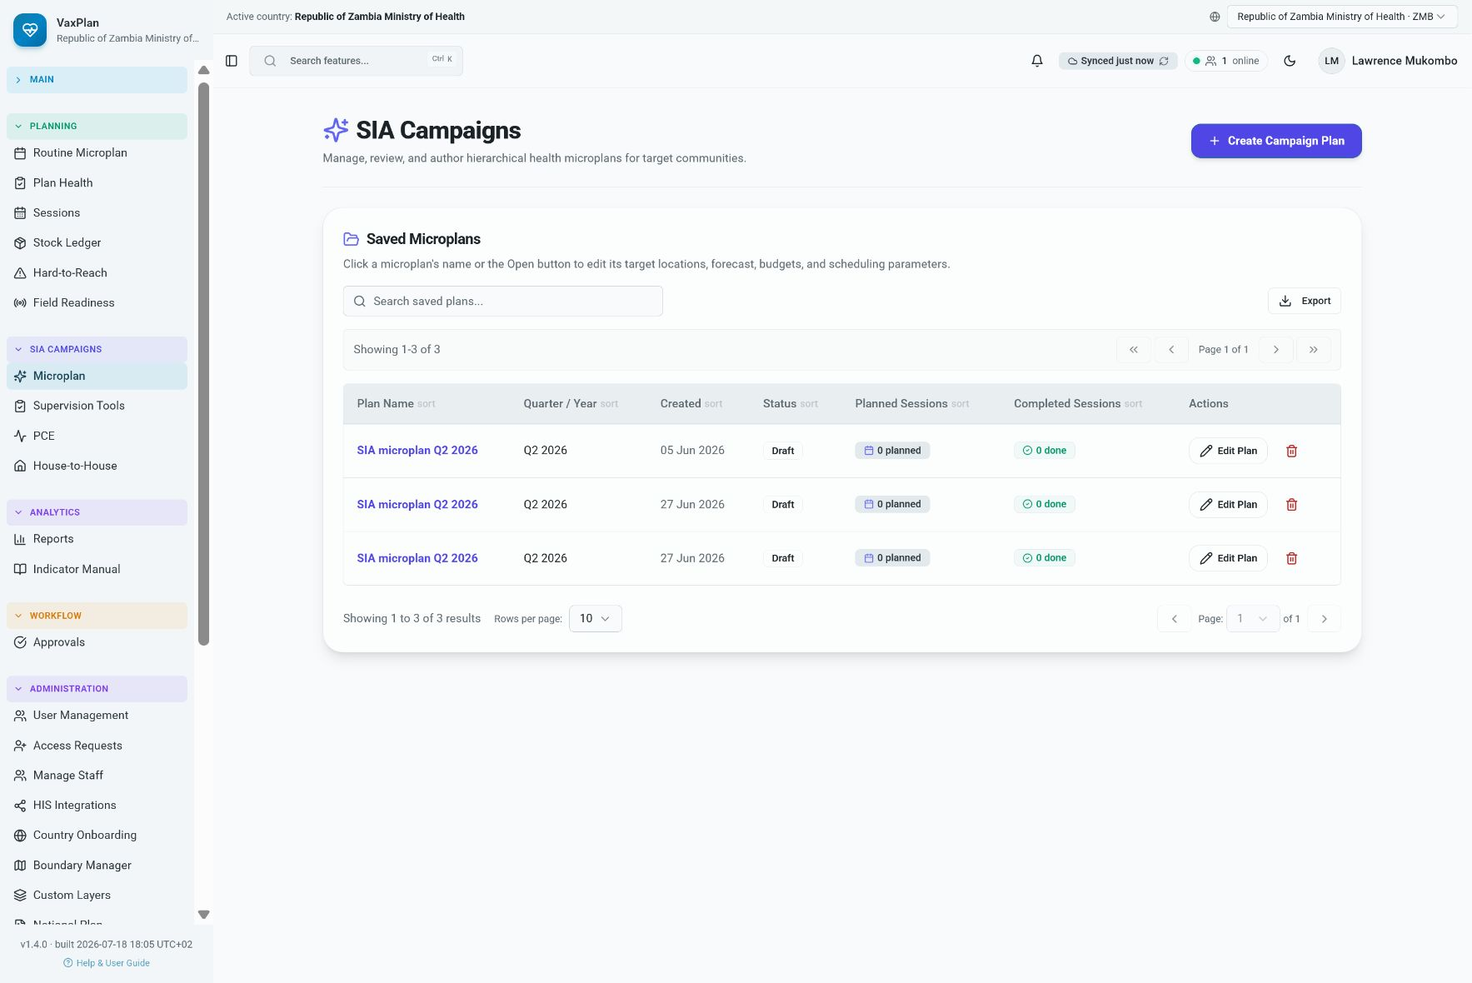
Campaign microplans: supports structured planning for campaign-specific immunization activities.

10. Session Planning

Purpose
Session planning converts the microplan into scheduled service delivery sessions. It helps teams decide where and when vaccination will occur, who will staff the session, what supplies are required, and which communities are targeted.

Primary Users
Facility staff, district officers, outreach coordinators, and supervisors.

Typical Workflow
- Create sessions for fixed, outreach, mobile, or campaign activities as required.
- Assign session date, location, team, target communities, and expected workload.
- Review session history and day plans to monitor execution and missed activities.

Application View and What It Shows
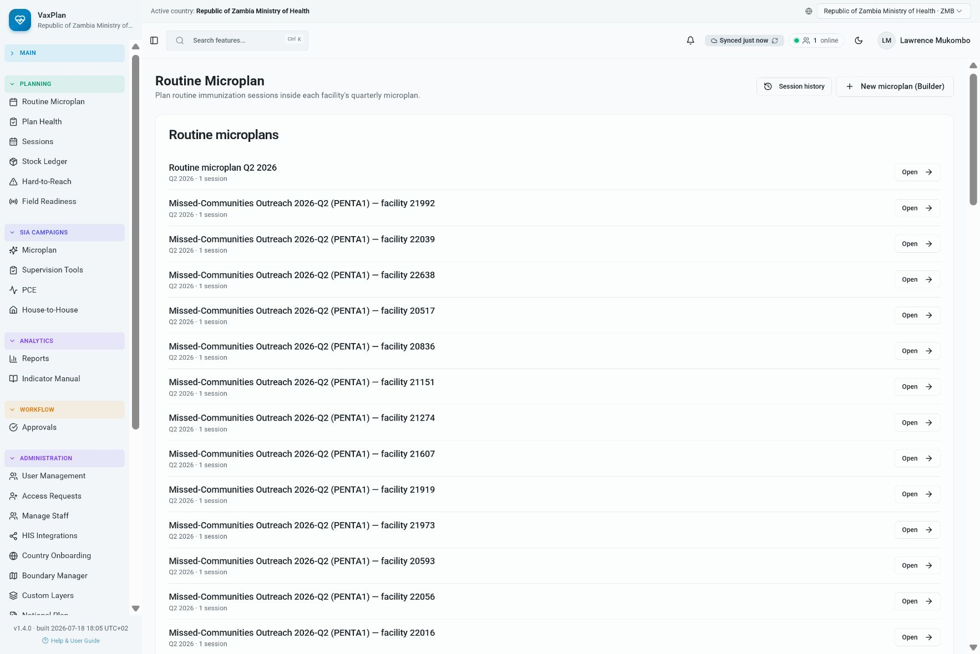
Session planning: shows how planned immunization service delivery activities are organized.

11. All Sessions and Session History

Purpose
The all-sessions view gives managers a broader view of planned, completed, missed, or overdue sessions. This helps teams coordinate follow-up and review service delivery consistency.

Primary Users
District managers, M&E officers, supervisors, and programme teams.

Typical Workflow
- Filter sessions by period, facility, status, or session type.
- Open session records to review planned activity details and completion status.
- Use the information during weekly or monthly review meetings.

Application View and What It Shows
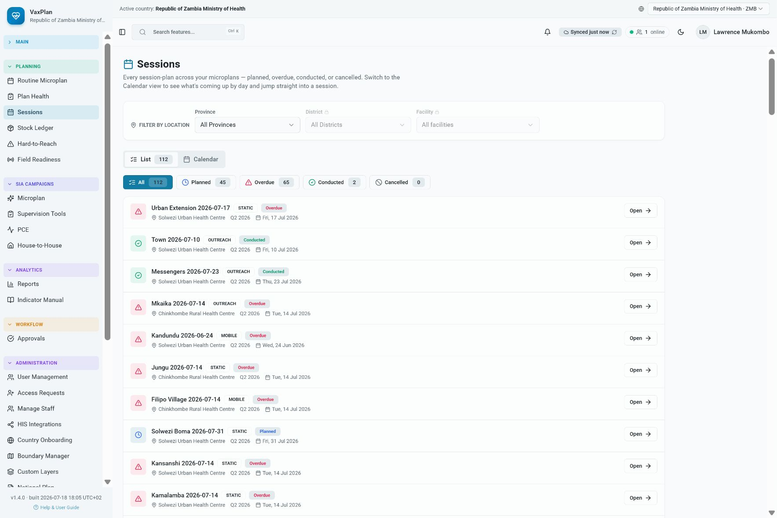
All sessions: provides a consolidated view of immunization activities across facilities or planning areas.

12. Stock Ledger and Vaccine Logistics Linkage

Purpose
The stock module links planning to vaccine and logistics information. It supports stock visibility, ledger review, reconciliation, and identification of possible supply gaps that can affect service delivery.

Primary Users
Logistics officers, facility staff, district cold chain officers, and programme managers.

Typical Workflow
- Review stock balances and ledger movements for the selected facility or period.
- Check whether planned sessions have adequate vaccines and supplies.
- Escalate stock gaps before session dates to reduce missed opportunities.

Application View and What It Shows
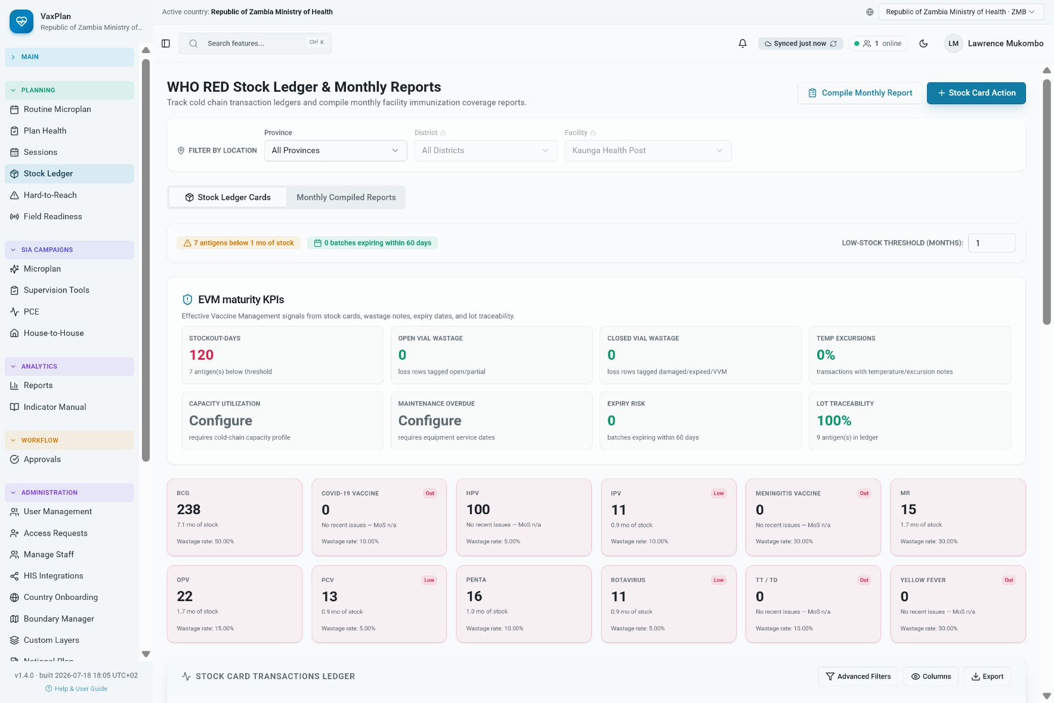
Stock ledger: connects vaccine logistics visibility to microplanning and session readiness.

13. Reports and Dashboards

Purpose
Reports convert operational data into outputs for review, accountability, and decision-making. Reports can support district meetings, national programme reviews, partner coordination, and evidence-based follow-up.

Primary Users
Programme managers, M&E officers, national officers, district teams, and partners.

Typical Workflow
- Select the relevant report or dashboard view.
- Apply filters such as year, quarter, district, facility, campaign, or status.
- Export or share outputs where authorized by data governance rules.

Application View and What It Shows
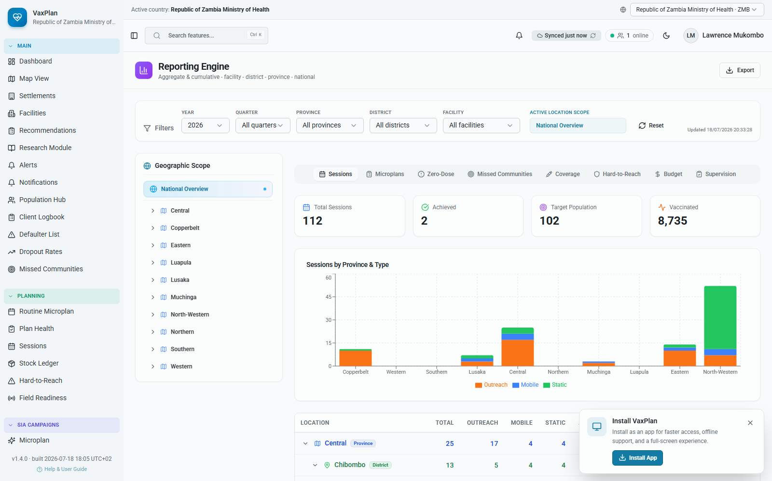
Reports dashboard: provides structured reporting and programme review outputs.

14. Supervision

Purpose
The supervision module supports field supervision planning, checklist use, review of findings, and follow-up of corrective actions. It strengthens accountability by linking observations to facilities, sessions, teams, and dates.

Primary Users
Supervisors, district officers, programme managers, and facility teams.

Typical Workflow
- Open supervision activities or templates for the relevant period.
- Record findings using the approved checklist or tool.
- Assign actions and follow up until issues are resolved.

Application View and What It Shows
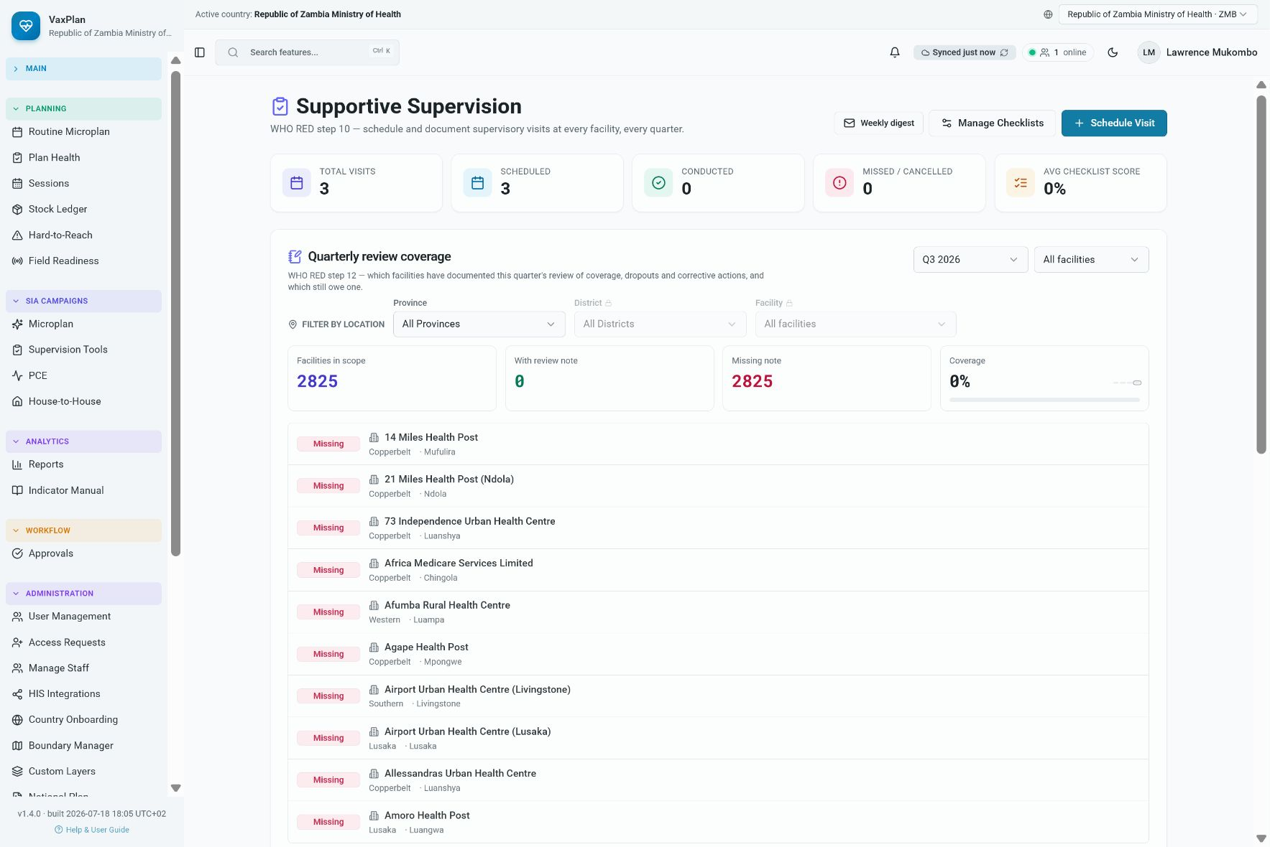
Supervision: supports structured field review and corrective action tracking.

15. Field Readiness

Purpose
Field readiness helps teams assess whether required inputs are available before sessions or campaigns. It can include staffing, transport, cold chain, supplies, data tools, supervision arrangements, and community mobilization readiness.

Primary Users
Campaign teams, facility teams, district officers, supervisors, and partners.

Typical Workflow
- Review readiness indicators before implementation.
- Identify missing inputs early and assign follow-up responsibility.
- Use readiness status to decide whether a session, outreach, or campaign area is ready to proceed.

Application View and What It Shows
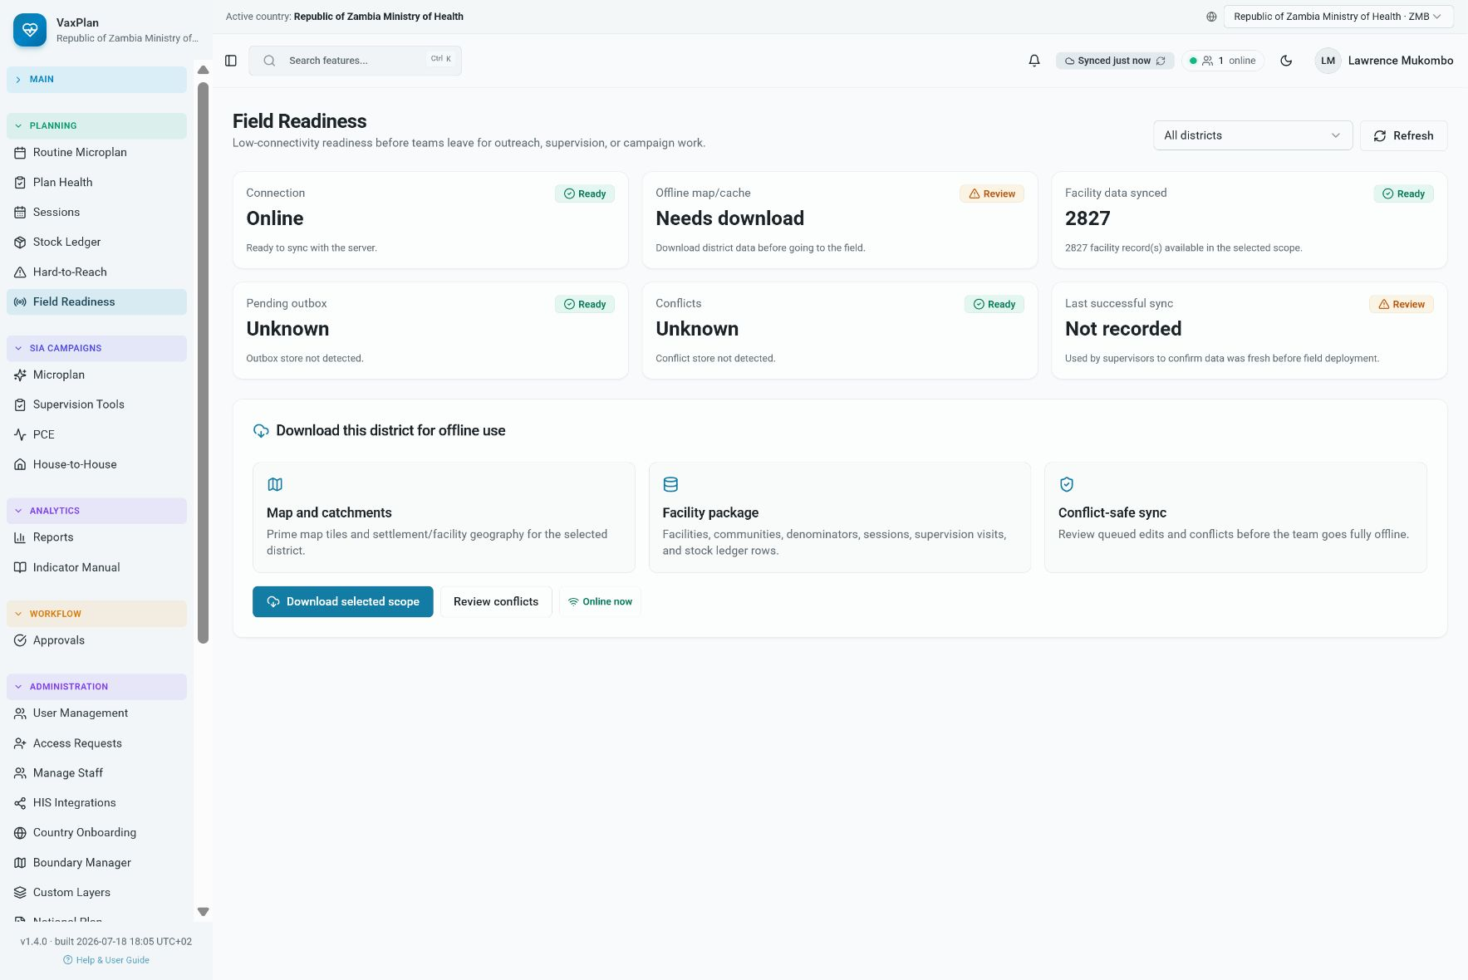
Field readiness: helps teams prepare for field implementation and reduce preventable delivery gaps.

16. Notifications and Workflow Follow-up

Purpose
Notifications alert users to pending tasks, workflow changes, approvals, sync events, or items requiring attention. They help users avoid missing time-sensitive actions.

Primary Users
All authenticated users.

Typical Workflow
- Open notifications regularly after login.
- Review pending approvals, comments, assigned actions, or sync messages.
- Act on urgent items before beginning new planning work.

Application View and What It Shows
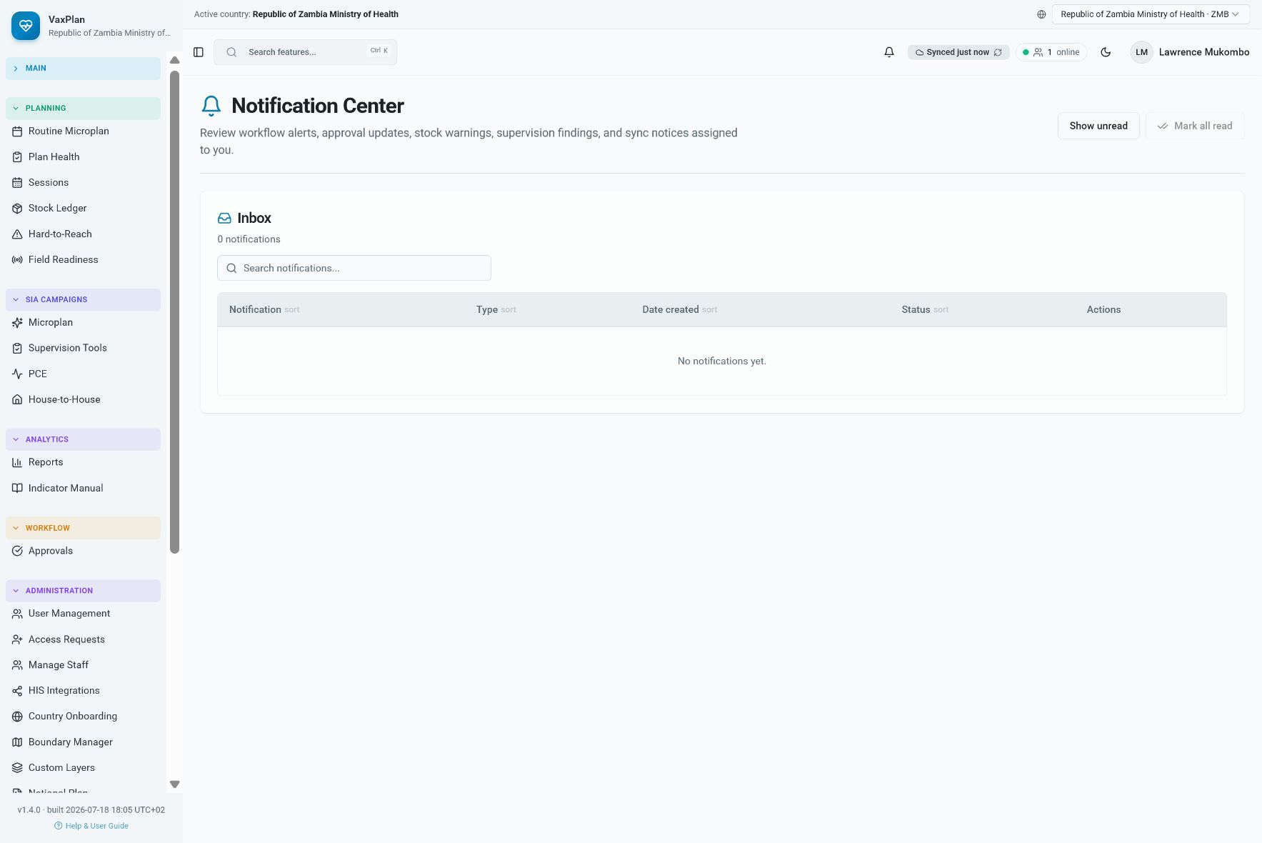
Notifications: centralizes user-specific alerts and workflow messages.

17. User Management and Role-Based Access

Purpose
User management controls who can access VaxPlan and what they can do. Roles should match job responsibilities and geographic scope, such as national, provincial, district, facility, partner, or administrator access.

Primary Users
System administrators, national administrators, and authorized ICT officers.

Typical Workflow
- Create or approve users only after verifying their organizational role.
- Assign the minimum role and geographic scope needed for the user to perform their work.
- Review inactive or transferred users regularly and disable access when needed.

Application View and What It Shows
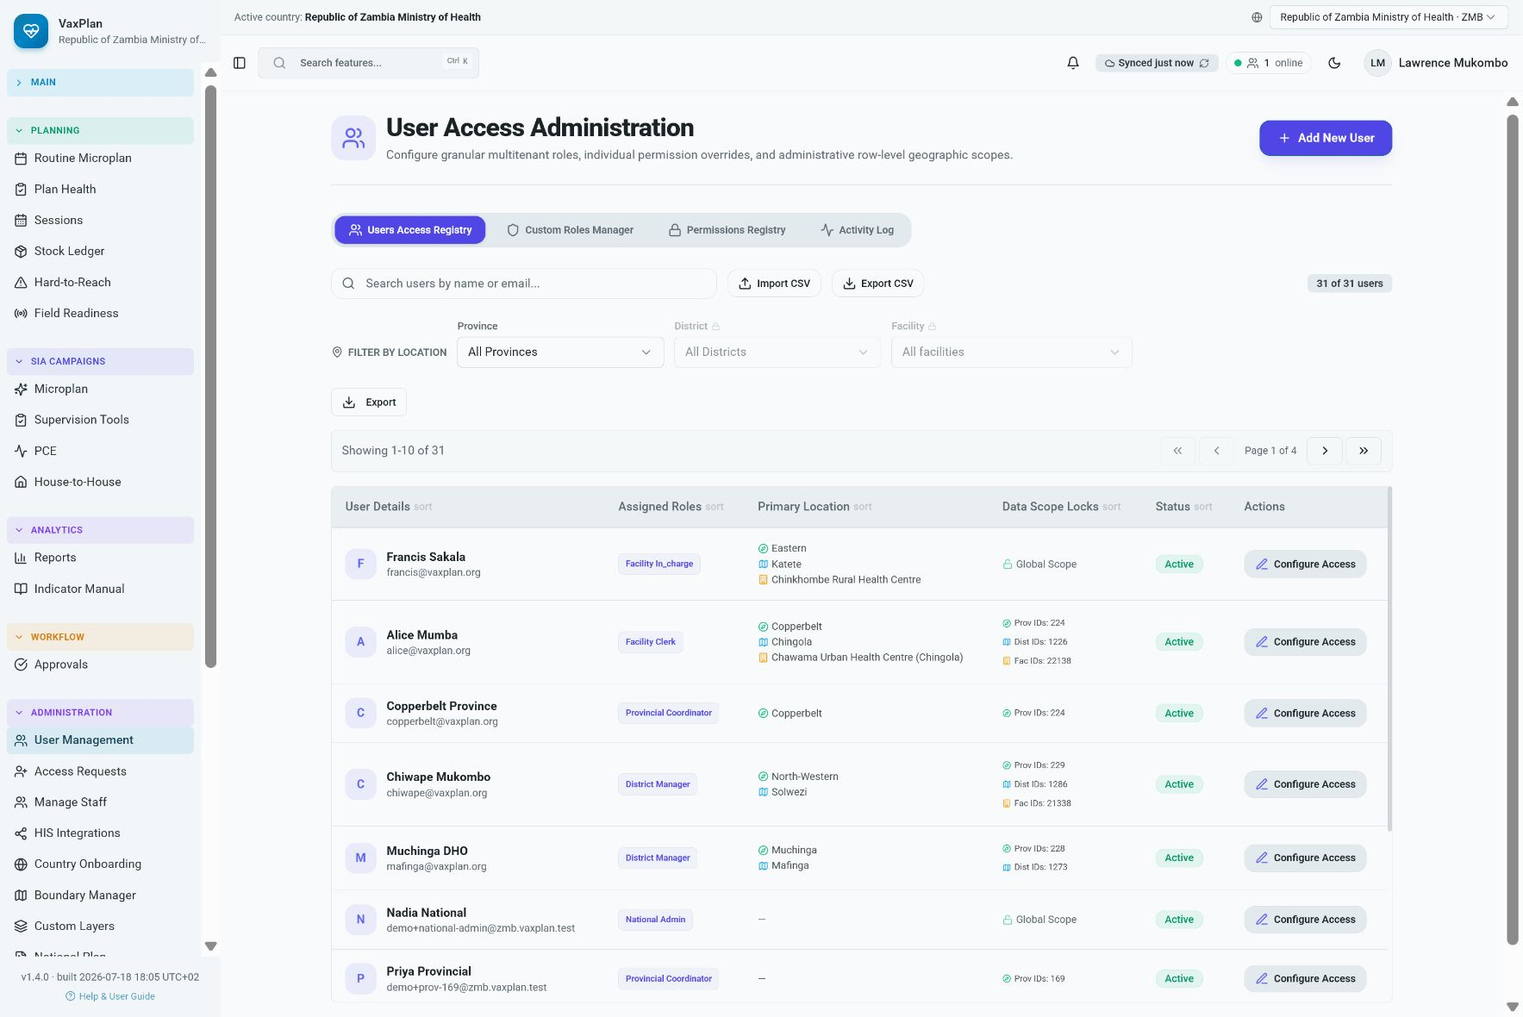
User management: supports role-based access control and administrative oversight.
Access principle: Assign the least privilege needed for the user role and geographic scope. Review permissions periodically.

18. Settings

Purpose
Settings contain user preferences, account information, configuration options, and system-level controls depending on the user role. They support personalization and administrative configuration.

Primary Users
All users for personal settings; administrators for system settings.

Typical Workflow
- Review profile and account settings after first login.
- Use administrator settings carefully because they can affect many users.
- Report configuration issues to the system administrator.

Application View and What It Shows
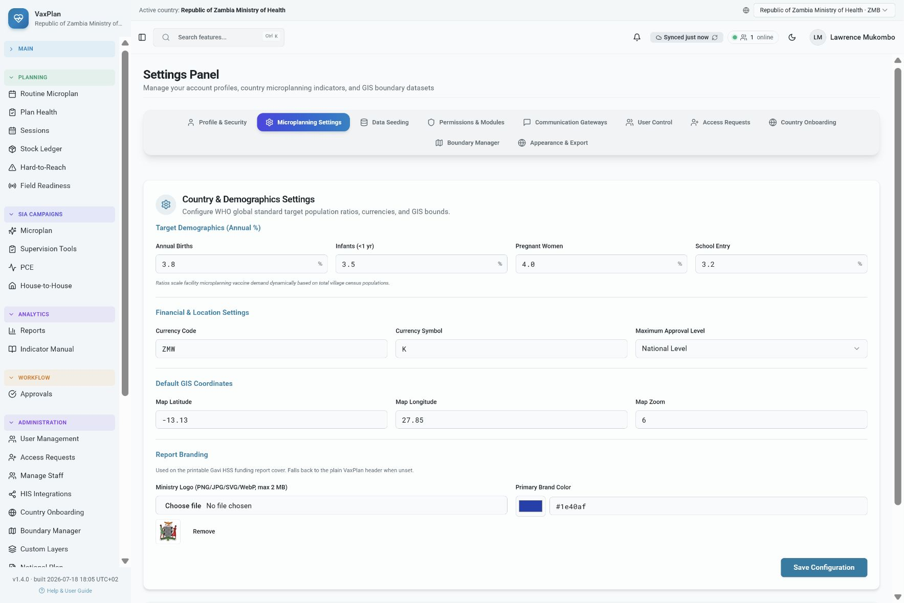
Settings: provides account, preference, and configuration options based on user permissions.

19. Settlements, Communities, and Client Registry

Purpose
Settlement and client views support identification of communities, service points, clients, defaulters, zero-dose children, and other operational lists used for follow-up. These modules connect geographic planning to service delivery monitoring.

Primary Users
Facility staff, community health workers, M&E officers, and district teams.

Typical Workflow
- Use settlement records to verify community names, locations, and catchment assignments.
- Use client or defaulter lists for follow-up according to national data protection rules.
- Update records only when the information has been verified by authorized staff.

Application View and What It Shows
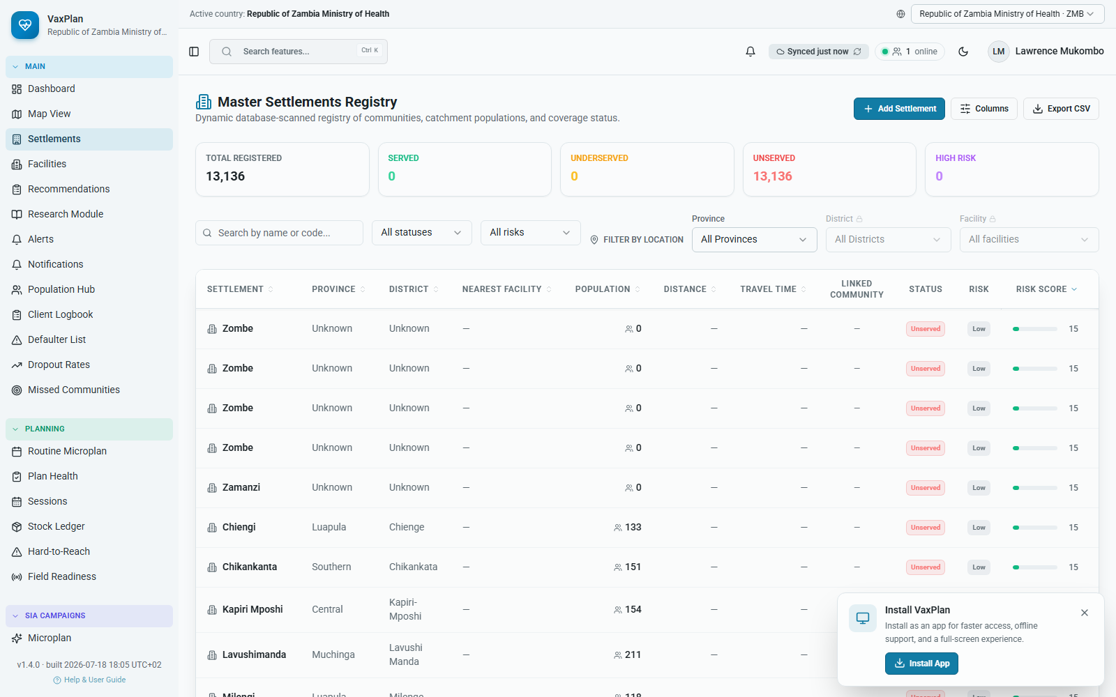
Settlements view: supports community-level planning and catchment verification.

20. Data Sources and Standards Alignment

Purpose
Data sources and standards pages document where planning data come from and how VaxPlan aligns with recognized immunization and digital health practices. This helps technical teams review interoperability, provenance, and governance.

Primary Users
ICT officers, data managers, system architects, M&E officers, programme managers, and partners.

Typical Workflow
- Review data sources before using imported datasets for planning decisions.
- Check standards alignment when discussing interoperability, reporting, and programme governance.
- Document any data quality assumptions or limitations during implementation.

Application View and What It Shows
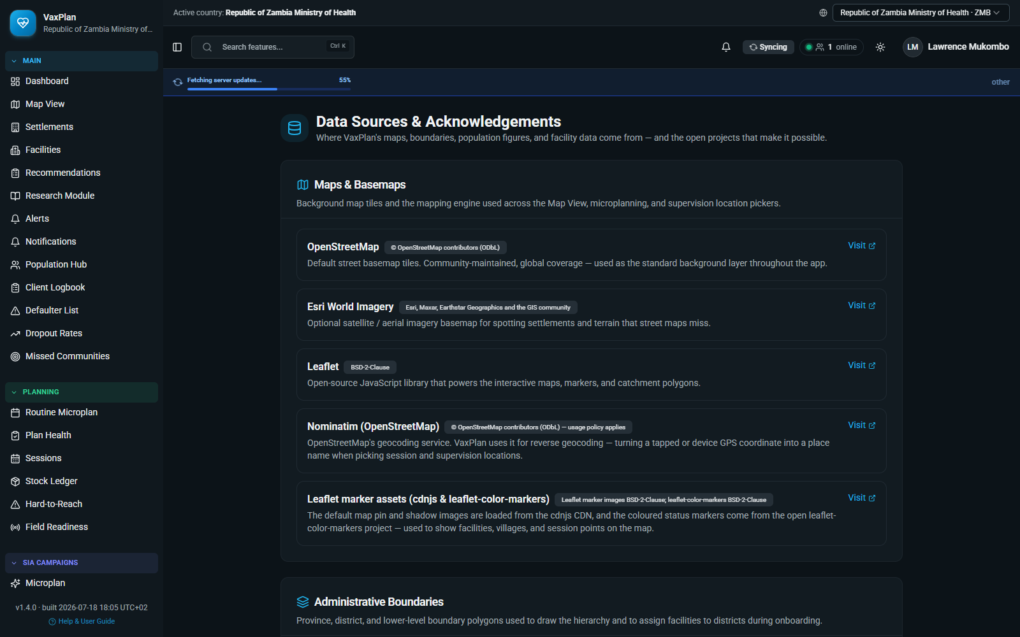
Data sources: shows reference datasets and integrations used to support planning and reporting.

21. Help and User Support

Purpose
The help area provides user guidance, support content, and reference material. It should be the first place users check for common questions before escalating to administrators.

Primary Users
All users.

Typical Workflow
- Open Help when unsure about a feature or workflow.
- Use support guidance before submitting a support request.
- Share unclear or missing guidance with the VaxPlan support team so the manual can be improved.

Application View and What It Shows
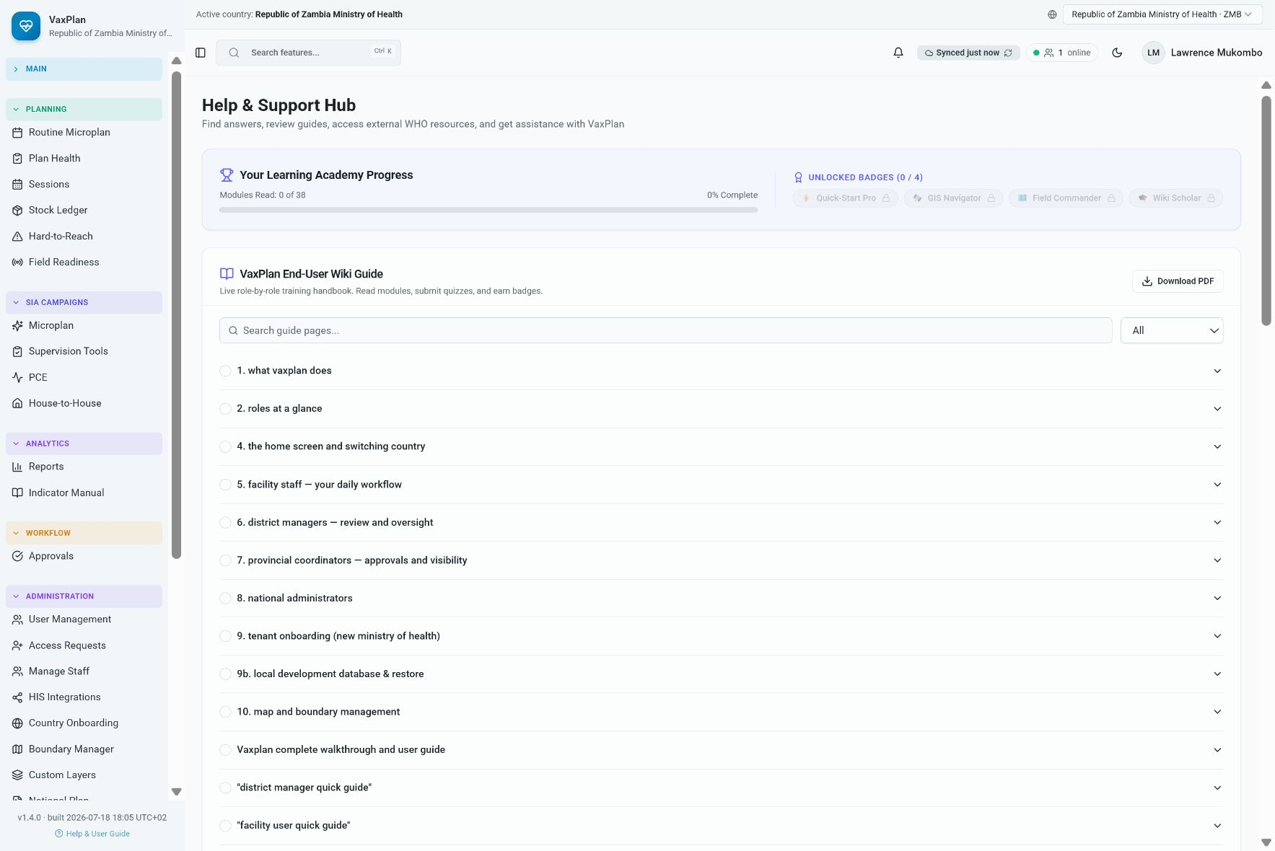
Help: provides in-app guidance and support resources.

22. Recommended Operating Procedures

Daily Use
- Sign in and confirm the active country, planning period, district, and facility context.
- Review dashboard alerts, notifications, and pending workflow items.
- Update only records for which the user has verified information and authority.
- Synchronize work before closing the browser or device where offline work has been used.

Microplanning Review Cycle
- Facility teams update catchment communities, population assumptions, service points, and planned sessions.
- District teams review completeness, identify missed communities, and check vaccine/logistics readiness.
- Supervisors and managers document findings, assign actions, and monitor completion.
- Approved microplans become the reference for implementation, review, and reporting.

Data Quality Checks
- Verify facility coordinates and ensure catchment polygons remain within the correct country and administrative boundary.
- Review community names, settlement counts, and population denominators before using outputs for planning.
- Check that session locations and target communities match the facility catchment.
- Investigate unusually high or low population, stock, or session counts before approval.

Troubleshooting
Issue | Likely cause | Suggested action
Cannot sign in | Wrong workspace, expired password, inactive account, or network issue | Confirm country selection, retry credentials, use password recovery, or contact administrator.
Save button does not update record | Insufficient role permission, invalid required field, boundary restriction, or offline sync pending | Review required fields, confirm geographic scope, check notifications/errors, and escalate if permission is incorrect.
Map layer looks too dense | Map is zoomed out or many layers are enabled | Zoom in and switch off layers that are not needed for the current task.
Facility pin or polygon cannot be moved | Role scope does not allow edits or new location is outside the permitted district/country | Confirm the facility district/country and request administrator review if the role scope is wrong.
Reports show unexpected numbers | Filter mismatch, incomplete microplans, missing denominators, or pending sync | Check filters, sync status, denominator sources, and approval status.

Appendix A. Additional Module Screenshots
The following screenshots provide extra evidence of modules that may be visible to users depending on their role and country configuration.

Client registry
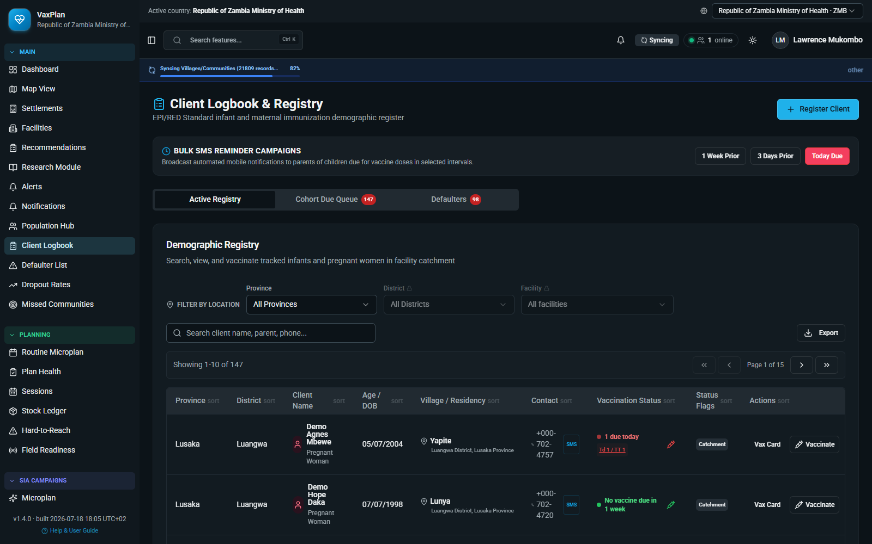
Client registry: additional VaxPlan module screenshot captured from the working application.

Approvals
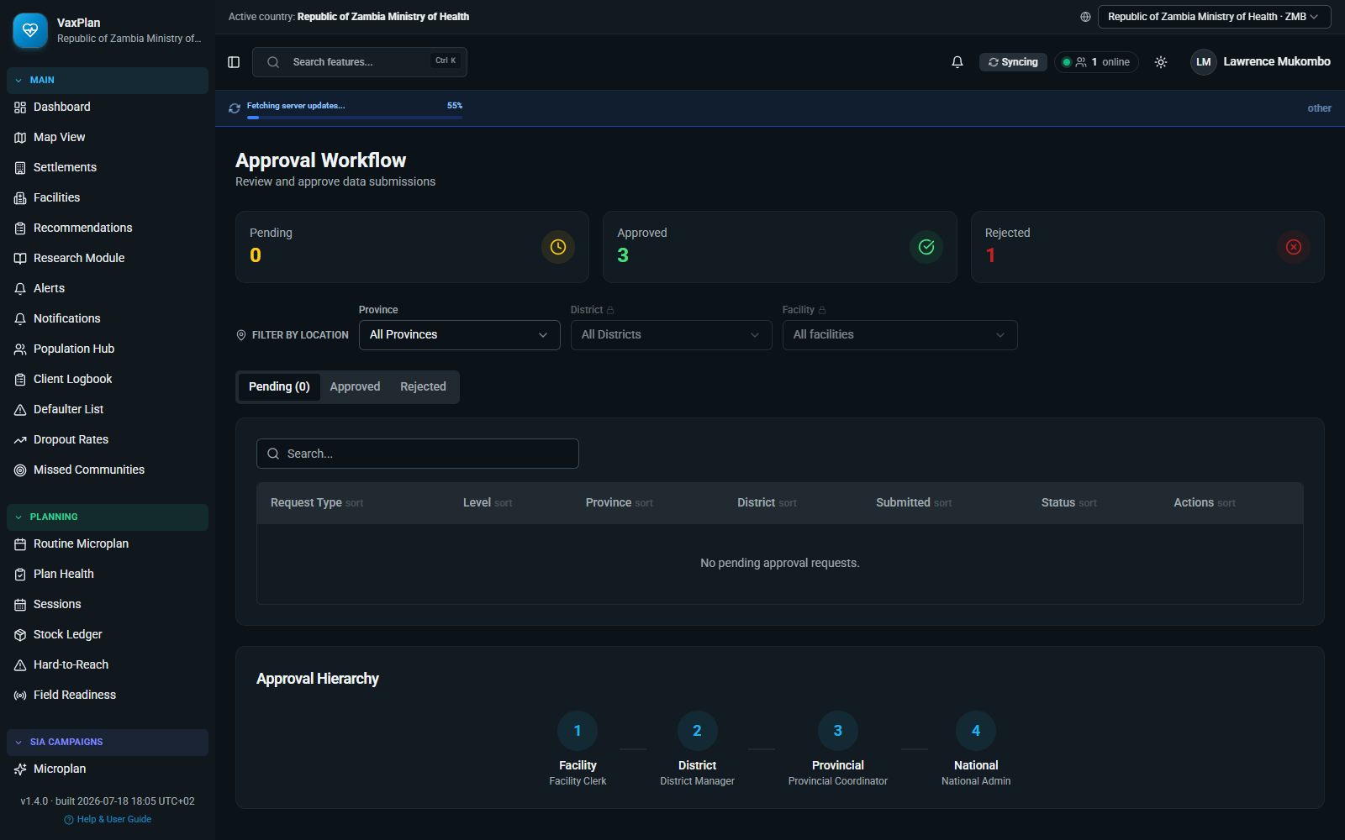
Approvals: additional VaxPlan module screenshot captured from the working application.

Standards alignment
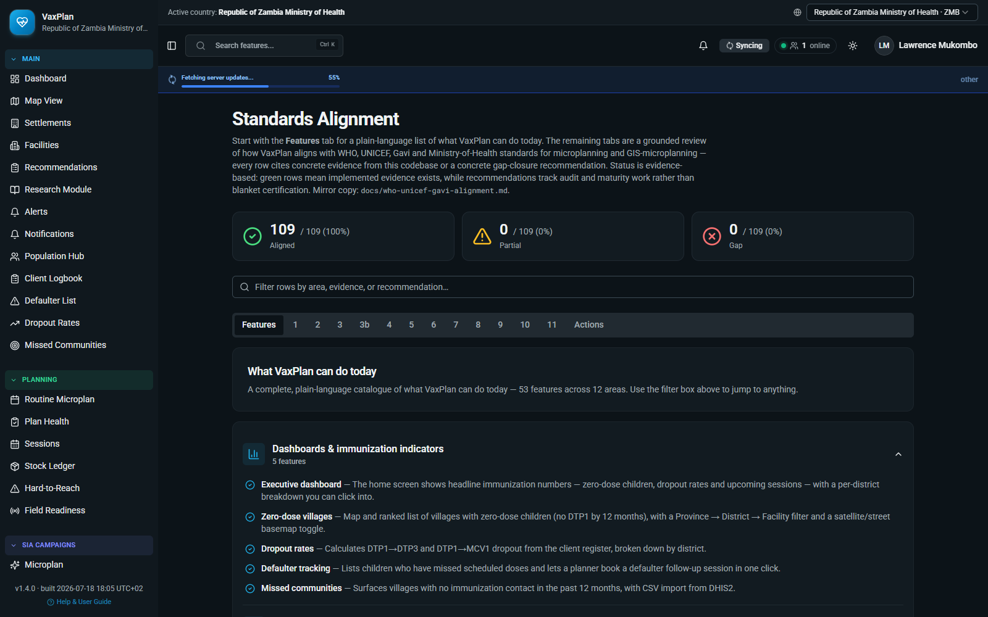
Standards alignment: additional VaxPlan module screenshot captured from the working application.

HIS integrations
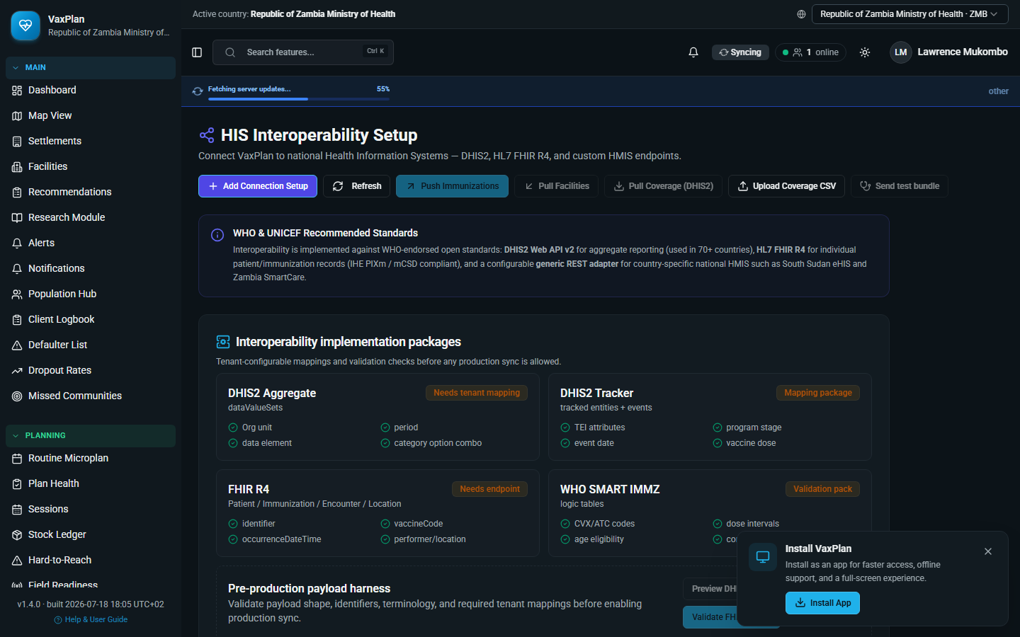
HIS integrations: additional VaxPlan module screenshot captured from the working application.

Expanded Light-Theme Evidence and Advanced Workflows
This chapter expands the user manual with a second screenshot pass captured after longer page-settle waits and with the application forced into light theme. It focuses on the full microplanning wizard and the advanced operational features that make VaxPlan more than a map: route intelligence, catchment review, hard-to-reach prioritization, supportive supervision, readiness review, and VPD surveillance.

A. Complete 12-Step Microplanning Wizard
The Microplanning Wizard guides facility and district teams through a structured WHO RED/Gavi RED-Q aligned planning flow. Users can open any step from the left step navigator, save draft work, and return to the plan later. The screenshots below show each canonical step.

Step 1. Coverage & denominators
Review prior-year DTP/MCV coverage, denominator scenario, dropout, stockout, AEFI, and planned versus held sessions.
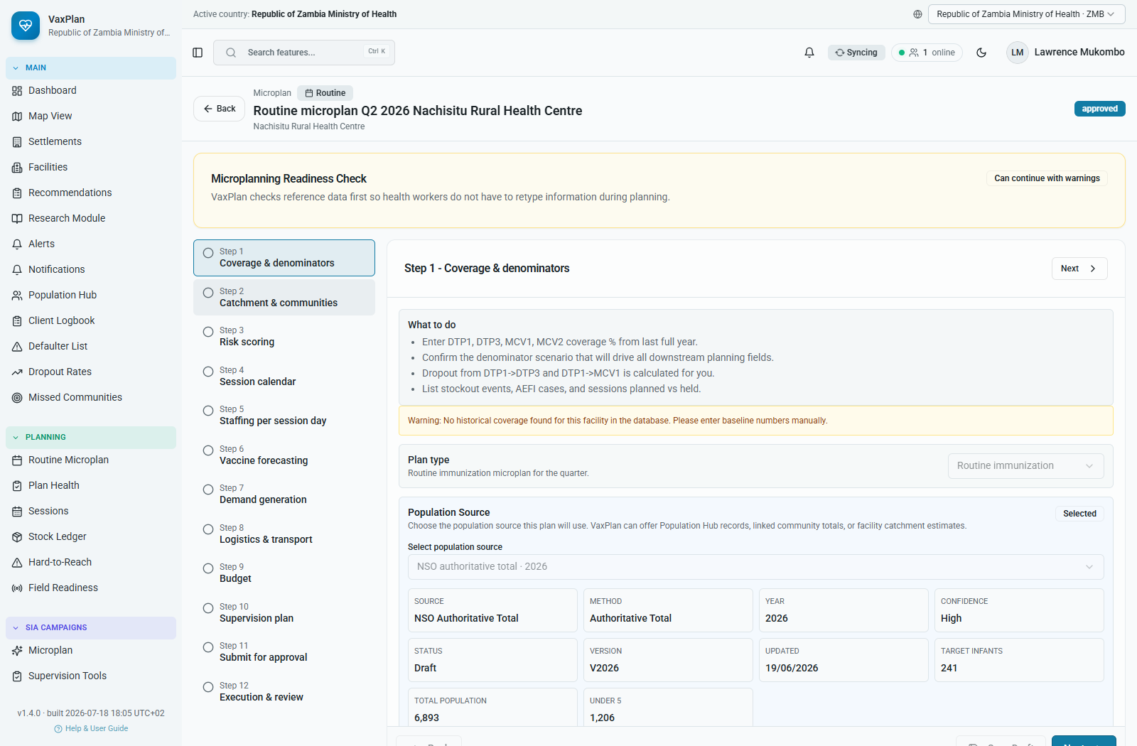
Microplanning Wizard Step 1: Coverage & denominators.

Step 2. Catchment & communities
List the communities served by the facility, target populations, population source, and delivery strategy.
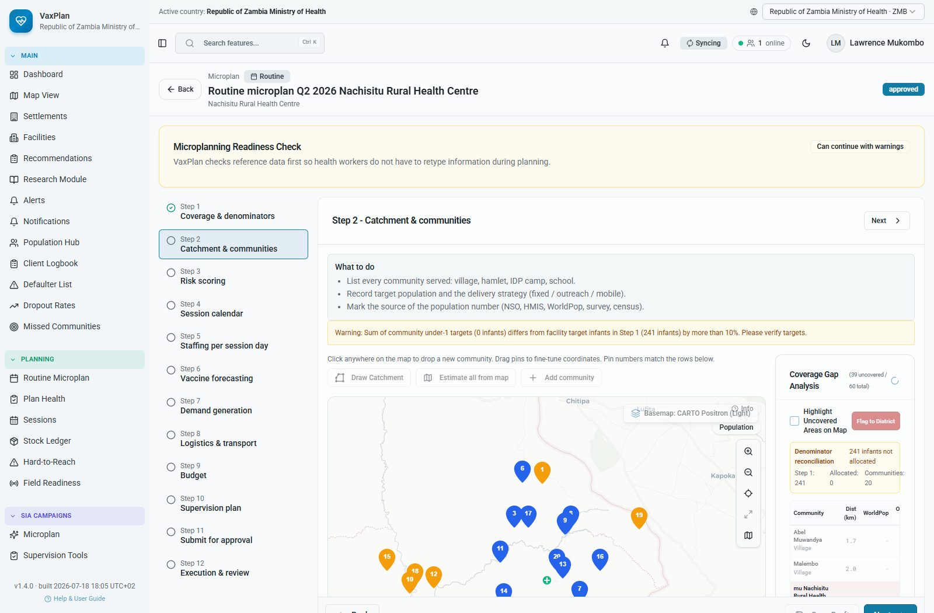
Microplanning Wizard Step 2: Catchment & communities.

Step 3. Risk scoring
Score communities for distance, terrain, seasonality, insecurity, missed status, and zero-dose hotspot risk.
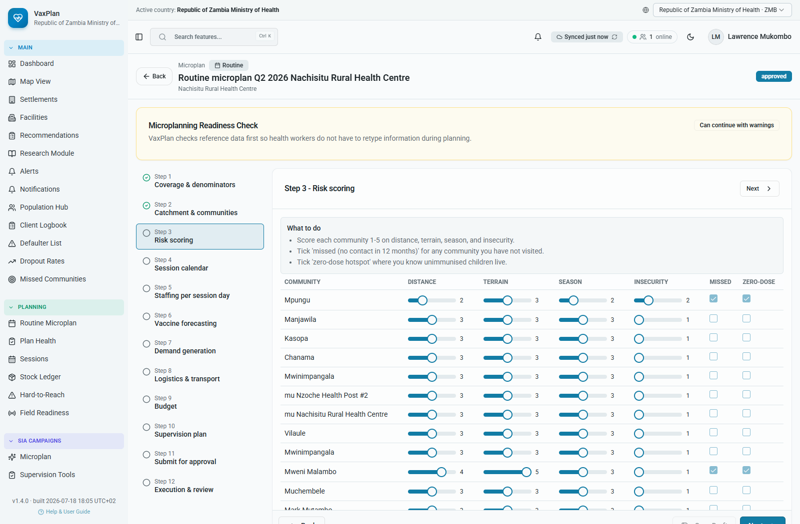
Microplanning Wizard Step 3: Risk scoring.

Step 4. Session calendar
Plan fixed, outreach, mobile, or campaign sessions by community and month, including catch-up rows where needed.
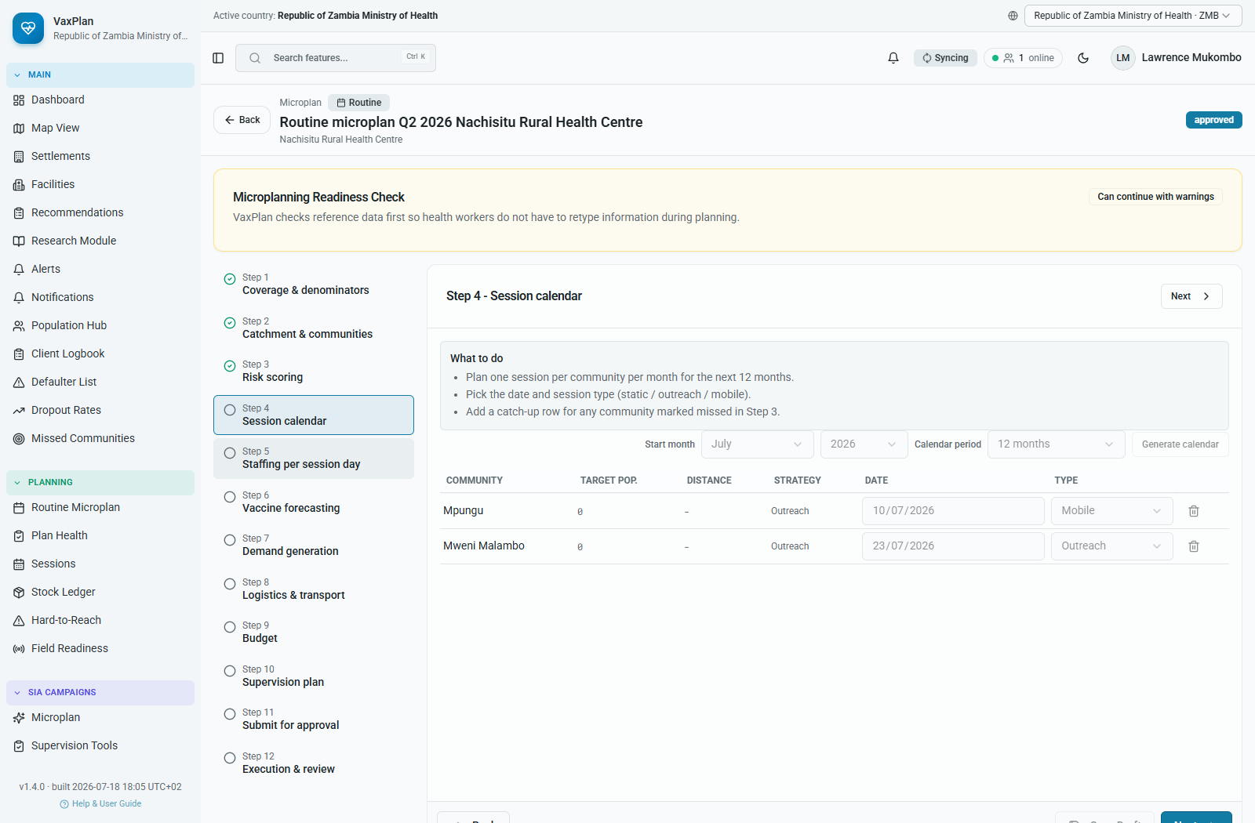
Microplanning Wizard Step 4: Session calendar.

Step 5. Staffing per session day
Assign vaccinator, recorder, supervisor, team type, daily target, and per-diem inputs for each session day.
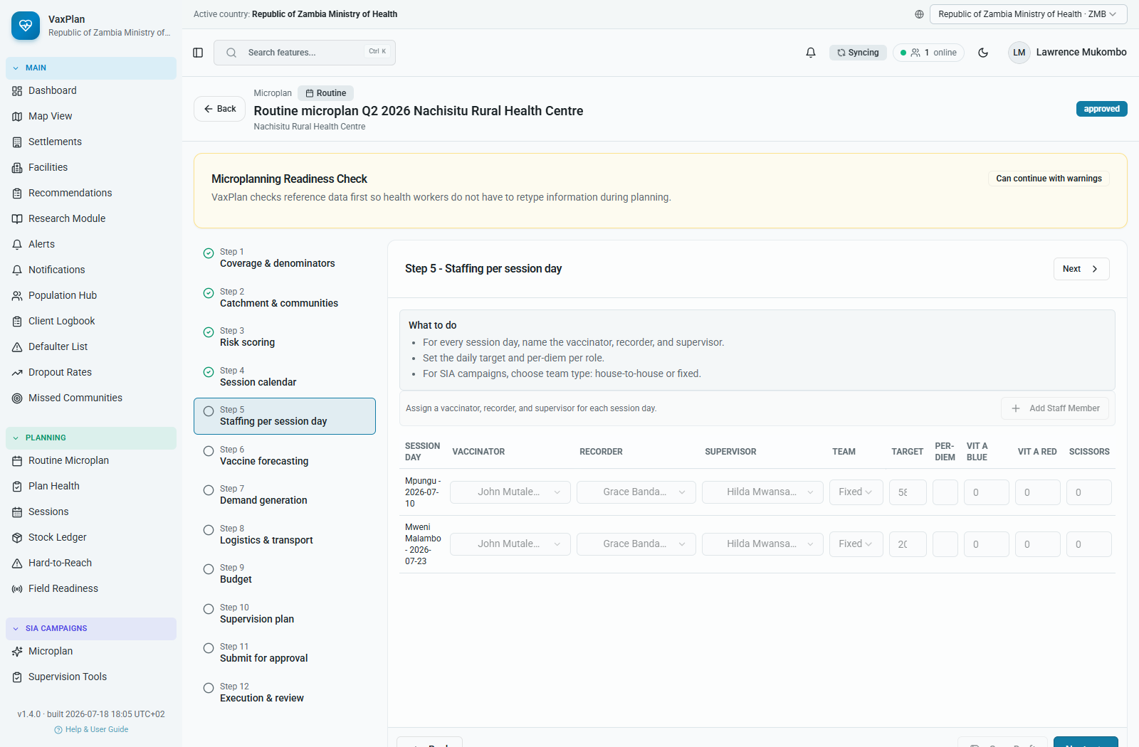
Microplanning Wizard Step 5: Staffing per session day.

Step 6. Vaccine forecasting
Calculate antigen needs, doses, wastage, vials, syringes, safety boxes, and cold-chain support.
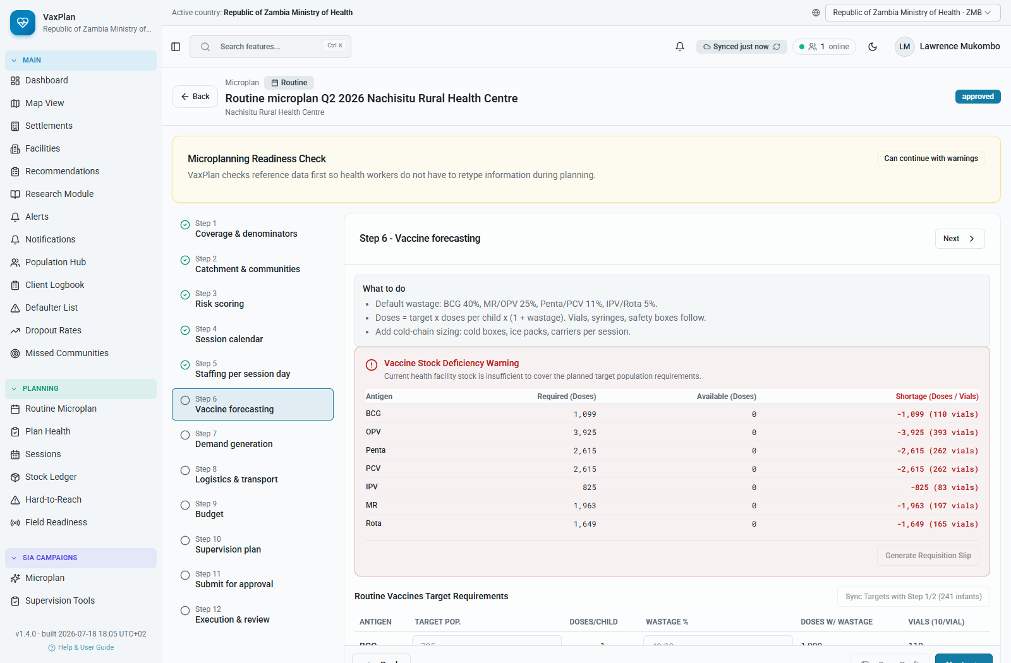
Microplanning Wizard Step 6: Vaccine forecasting.

Step 7. Demand generation
Plan mobilization channels, focal persons, health facility committee readiness, and community volunteer readiness.
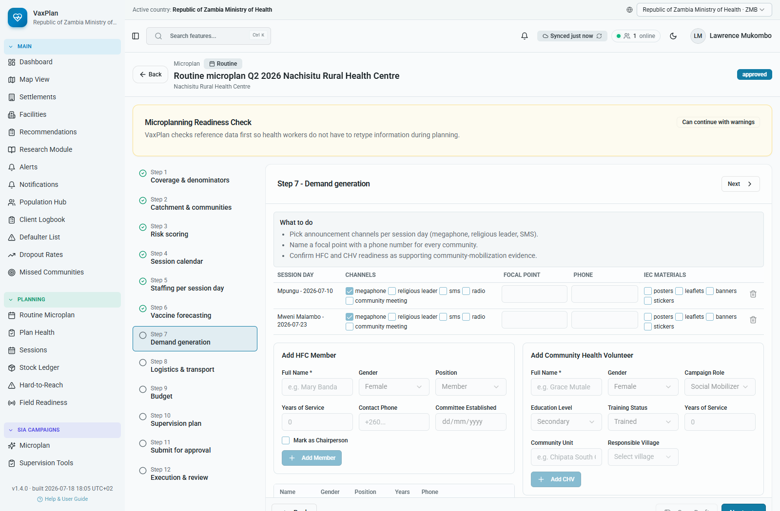
Microplanning Wizard Step 7: Demand generation.

Step 8. Logistics & transport
Record transport mode, distance in km, estimated fuel, security clearance, and movement support requirements.
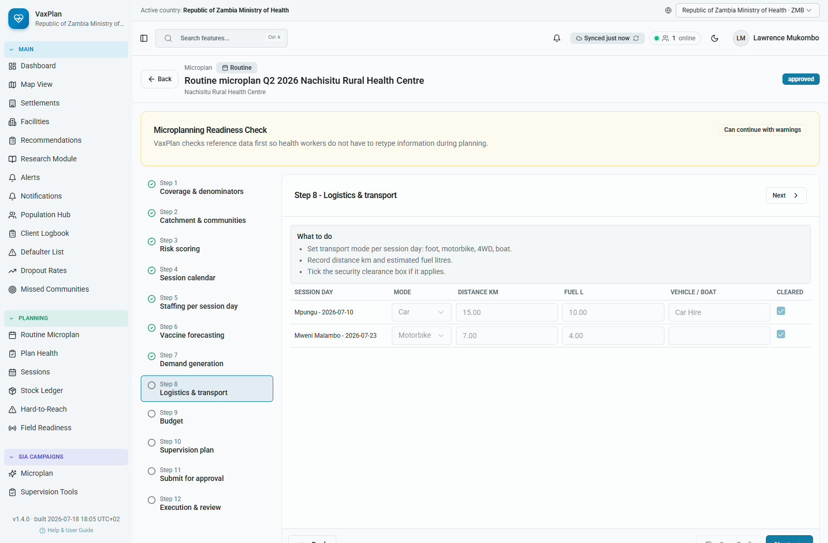
Microplanning Wizard Step 8: Logistics & transport.

Step 9. Budget
Build budget lines for personnel, transport, supplies, per diem, cold chain, training, and communication.
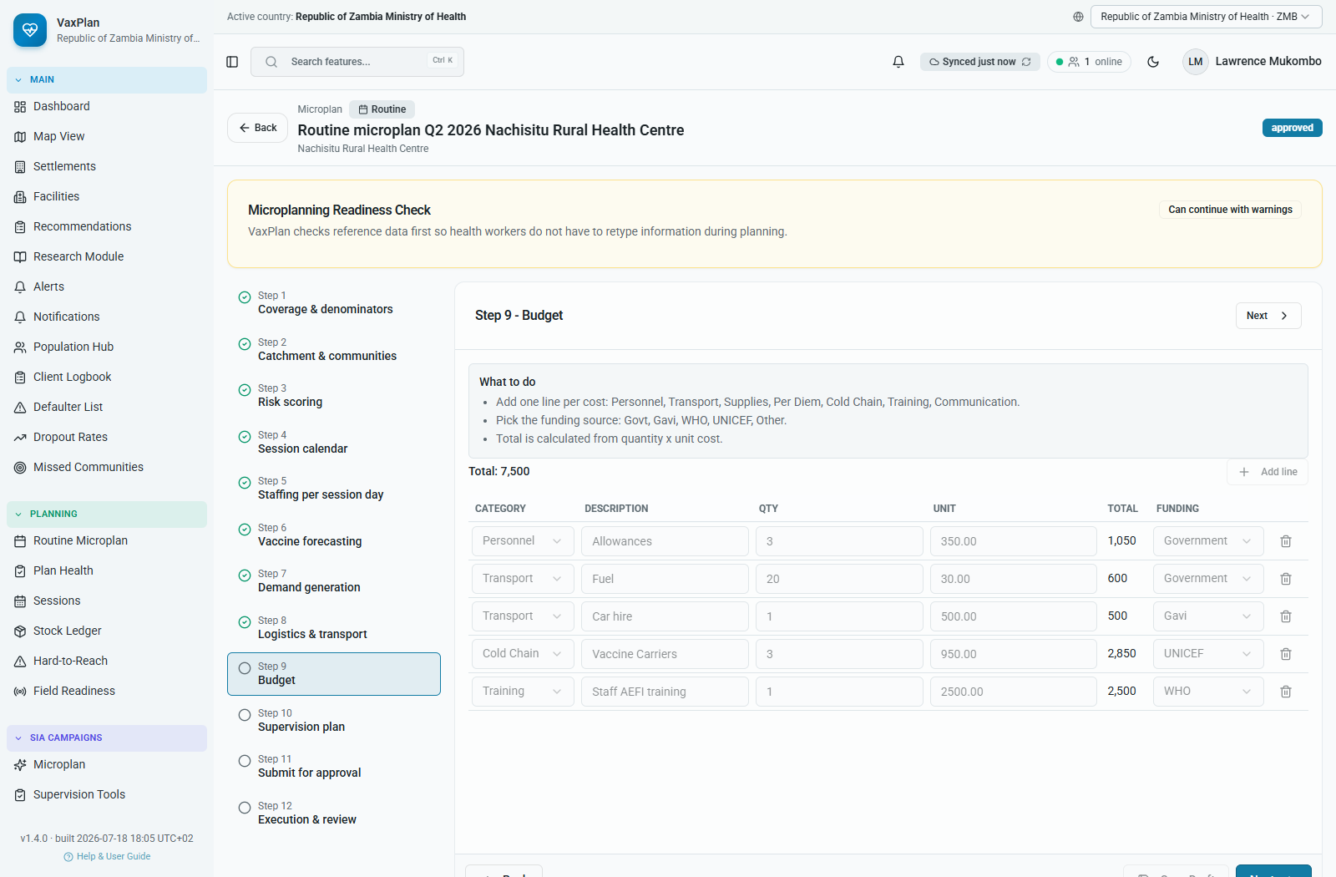
Microplanning Wizard Step 9: Budget.

Step 10. Supervision plan
Schedule supportive supervision visits, supervisors, checklist use, and follow-up actions.
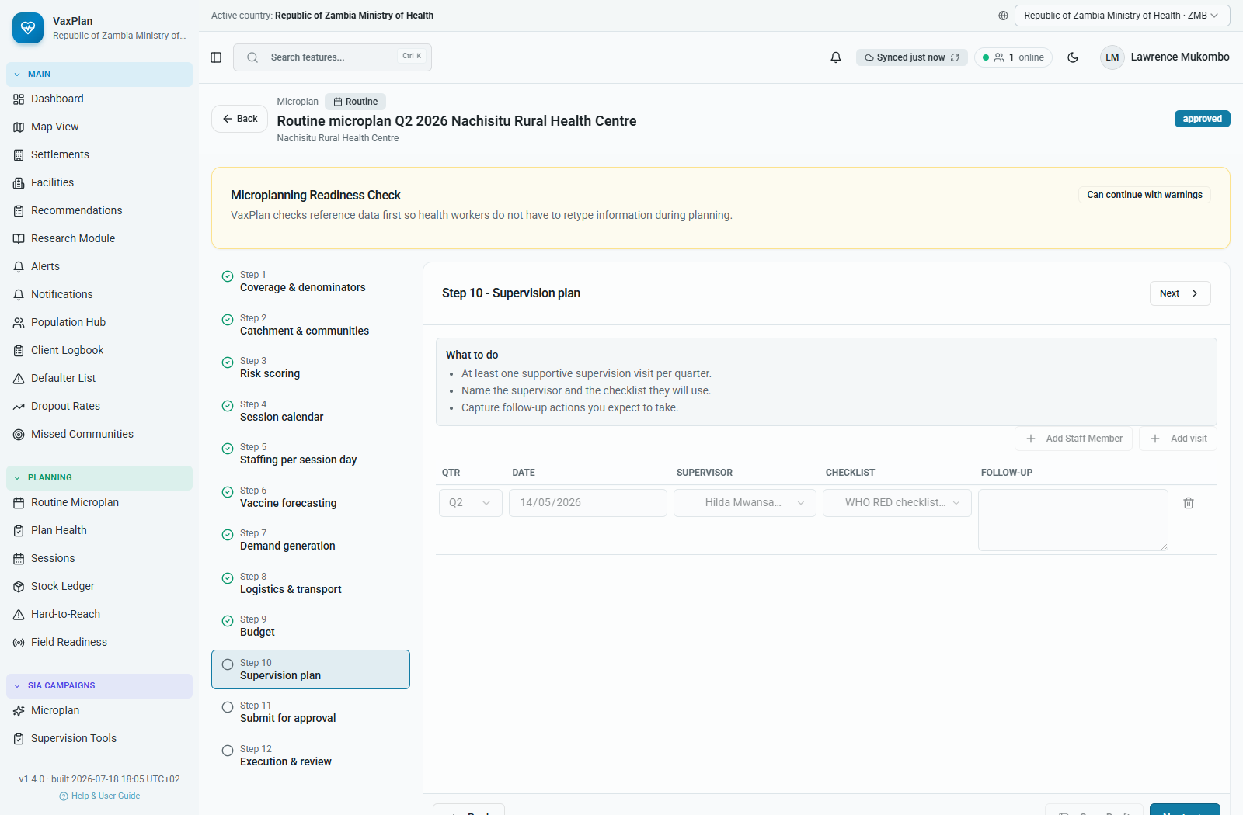
Microplanning Wizard Step 10: Supervision plan.

Step 11. Submit for approval
Review the summary and route the microplan through district, provincial, and national approval where configured.
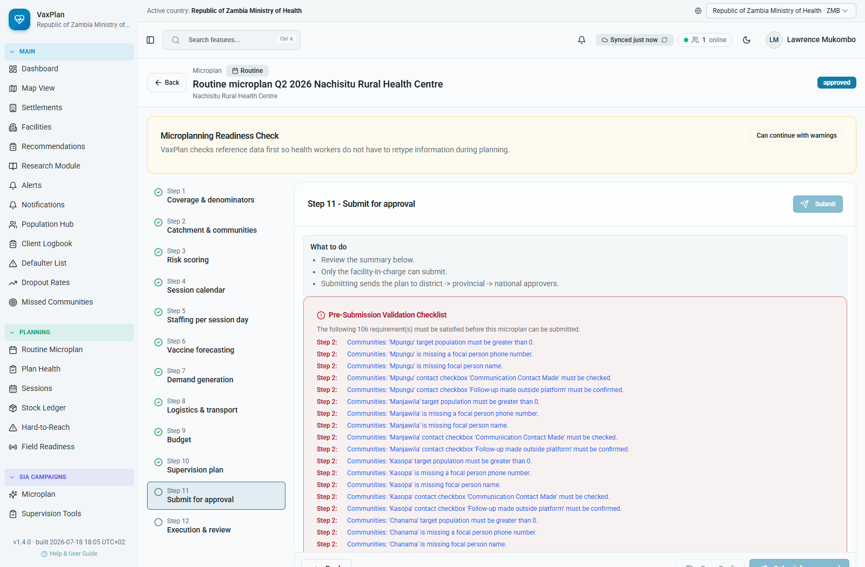
Microplanning Wizard Step 11: Submit for approval.

Step 12. Execution & review
Use live execution evidence, doses given, defaulters, missed communities, and review findings to feed the next cycle.
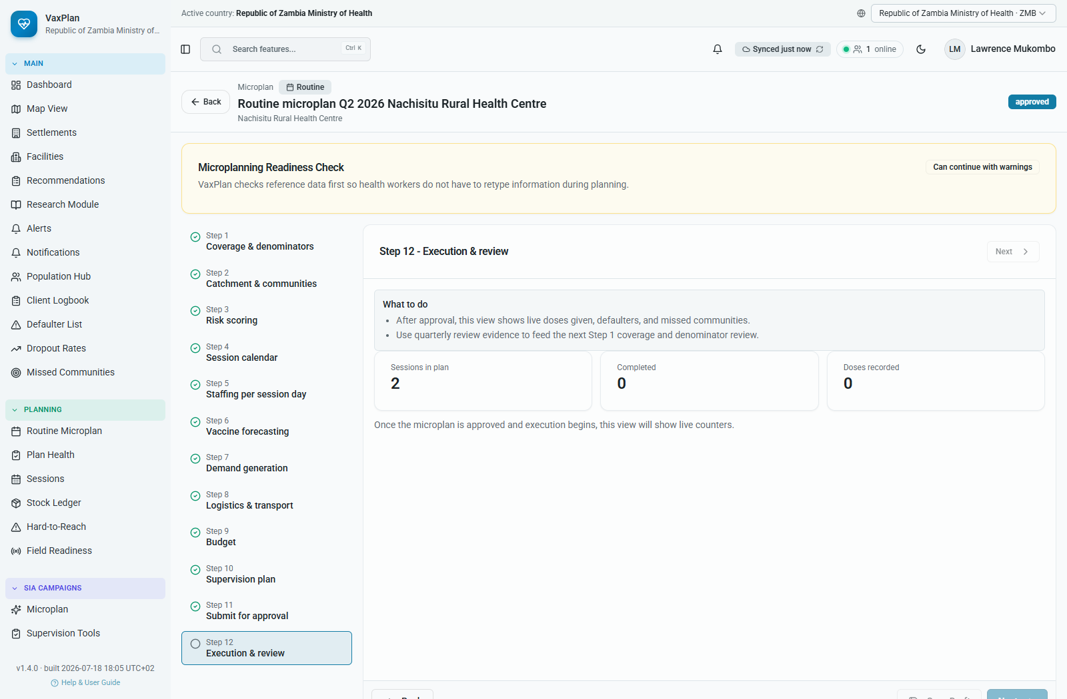
Microplanning Wizard Step 12: Execution & review.

B. Advanced GIS, Routes, Distance, and ETTT
The GIS module supports national and district planning by combining administrative boundaries, facilities, settlements, unserved places, session status, population layers, and facility catchment evidence. Route intelligence links facilities to communities and exposes practical planning metrics.
- Facility-to-community route analytics use the selected facility and assigned or nearest communities to calculate road distance, fallback straight-line distance, route geometry, driving time, walking time, transport mode, seasonal accessibility, accessibility score, and referral route.
- ETTT, used here as Estimated Travel Time to Target, is represented in the app by driving-time and walking-time estimates. These help planners decide whether fixed, outreach, mobile, or special transport strategies are realistic.
- The map also supports visual measurement, point intelligence, population and settlement overlays, HTR outreach buffers, session status markers, and exportable geospatial evidence.
- Map interpretation should happen at district, ward, facility, or community scale. Dense national views are useful for patterns, but local operational decisions require zoomed context.
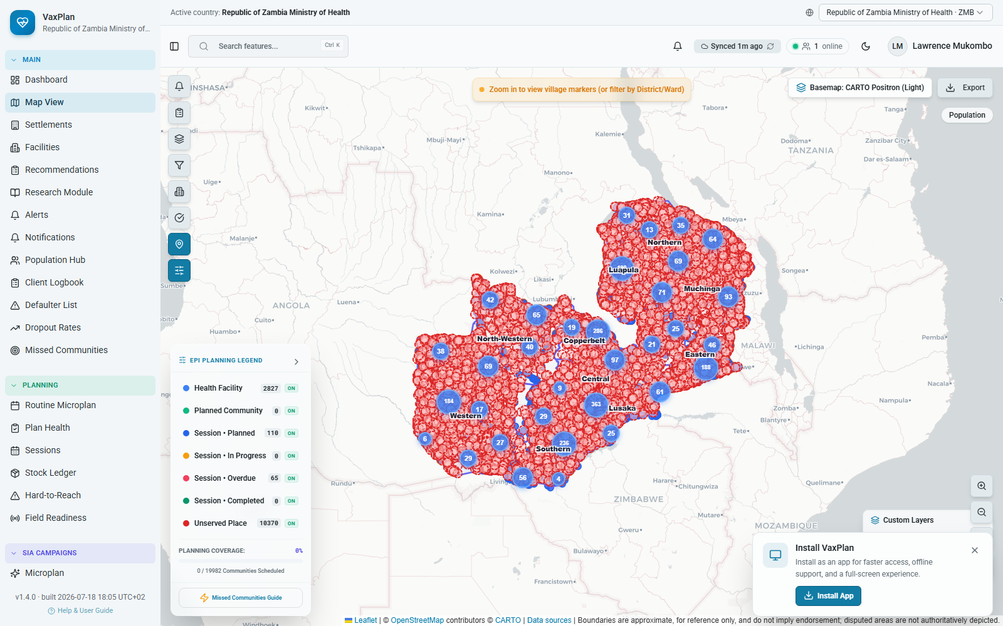
Light-theme Zambia map showing planning layers, administrative boundaries, unserved places, and legend context.
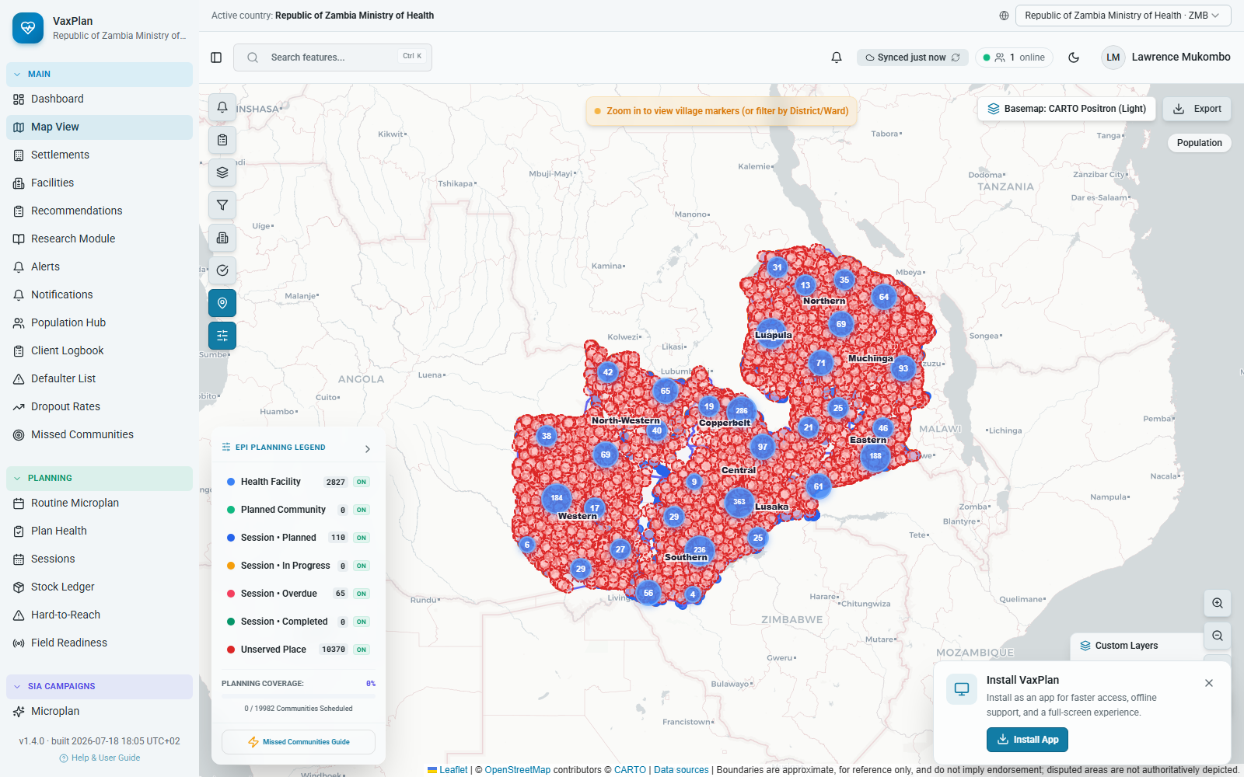
Map evidence for facility/community planning context. Route analytics are available when a facility is focused and communities are assigned or nearest-community fallback is used.

Current loaded map workspace used for distance, route, population, and planning context review.
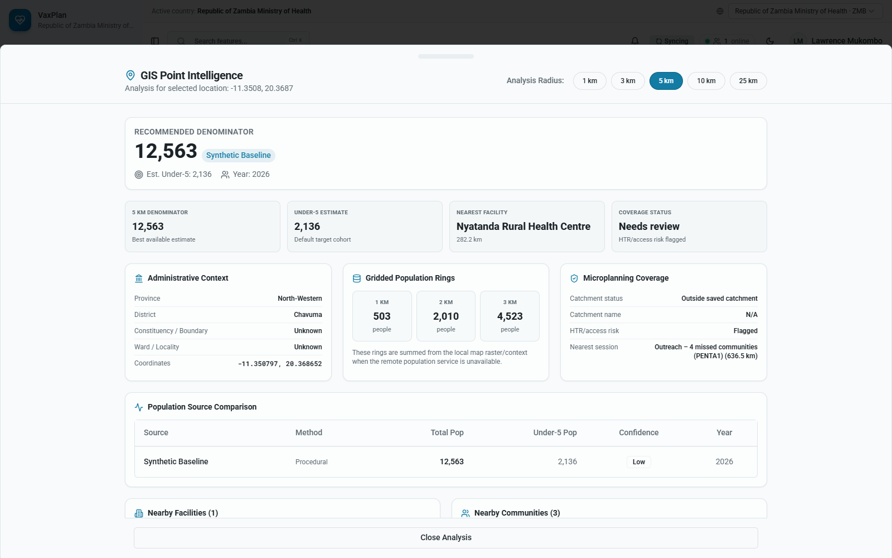
Point intelligence state used to review nearby facility, community, distance, and travel-time context.

C. Hard-to-Reach and Missed Communities
VaxPlan helps teams prioritize places that are likely to be missed by routine delivery. HTR and missed-community workflows combine facility/community data, population evidence, distance, terrain, seasonality, and coverage signals so that teams can plan targeted outreach and follow-up.
- Hard-to-reach scoring weights distance, terrain, seasonal access, insecurity, and coverage evidence.
- Missed communities are ranked so district teams can focus on the places where additional sessions or catchment corrections are most needed.
- These tools help move microplanning from static lists to evidence-based prioritization.
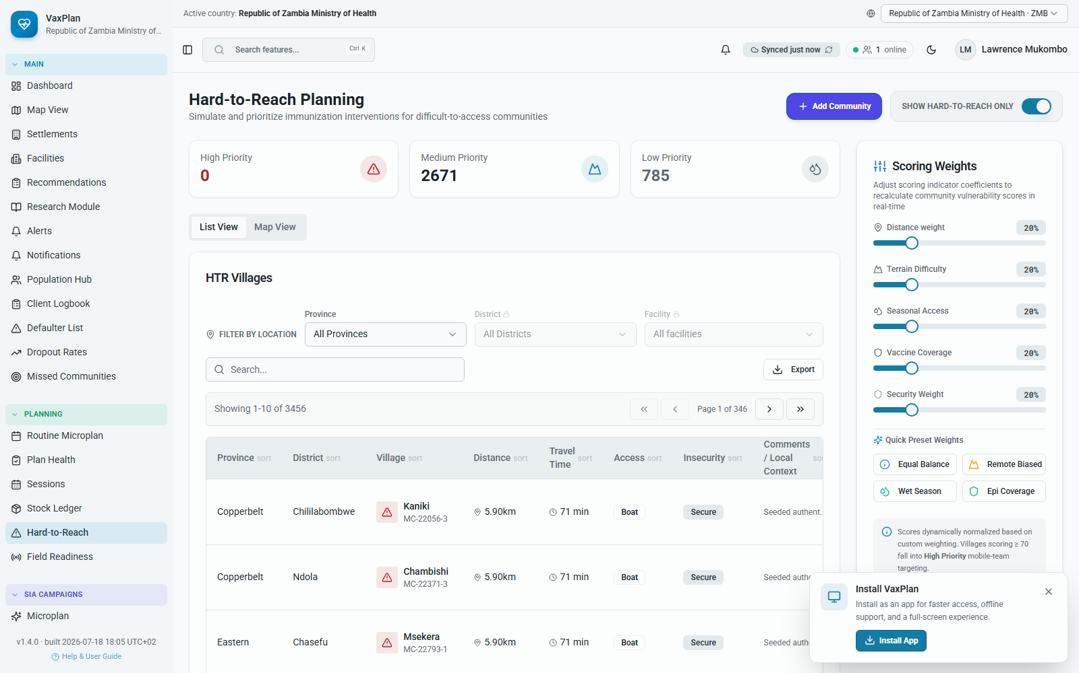
Hard-to-reach scoring page with distance and access factors used to prioritize communities.
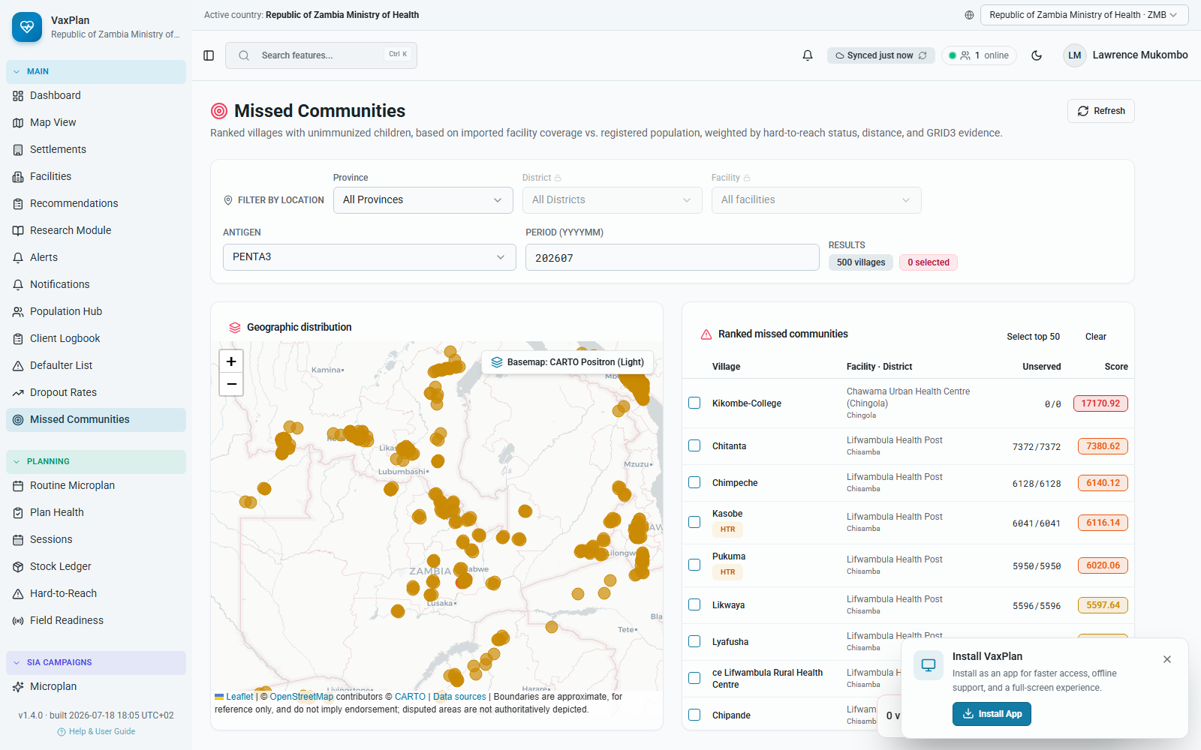
Missed communities prioritization view for reviewing unserved or under-served places.
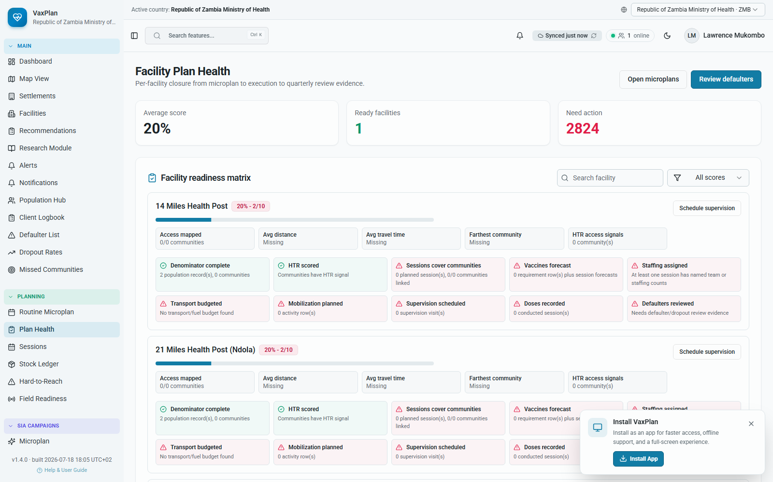
Plan Health readiness view showing cross-module completeness and operational readiness signals.

D. Supportive Supervision and Field Accountability
Supportive supervision in VaxPlan connects plans to field accountability. Supervisors can schedule visits, use configured checklists, record findings, generate scores, and track follow-up actions.
- The supervision dashboard shows scheduled, conducted, missed, and cancelled visits and average checklist score.
- Checklist templates can be configured by national administrators and can include yes/no, choice, rating, number, date, photo, and GPS-style questions depending on configuration.
- PCE and house-to-house workflows extend supervision into campaign and post-campaign evidence collection.
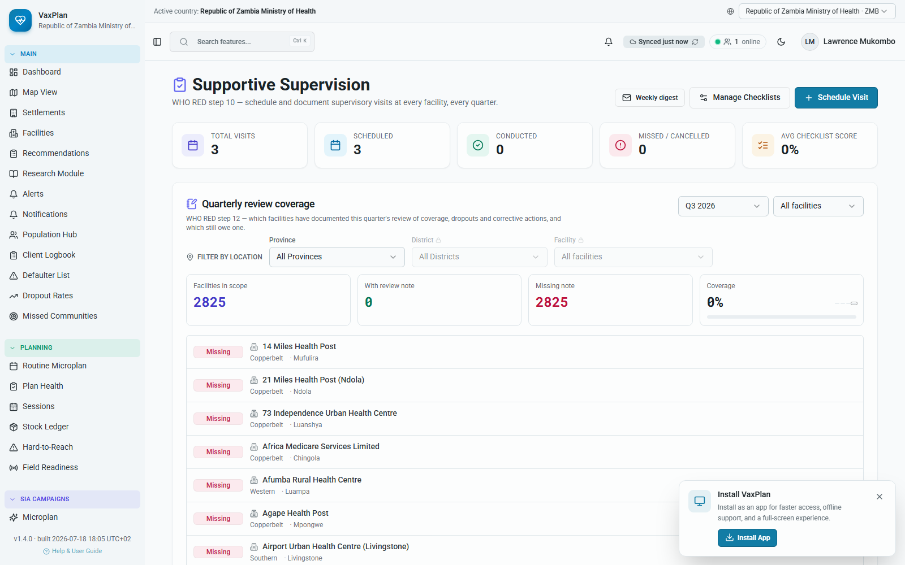
Supportive supervision dashboard for planned visits, findings, and follow-up status.
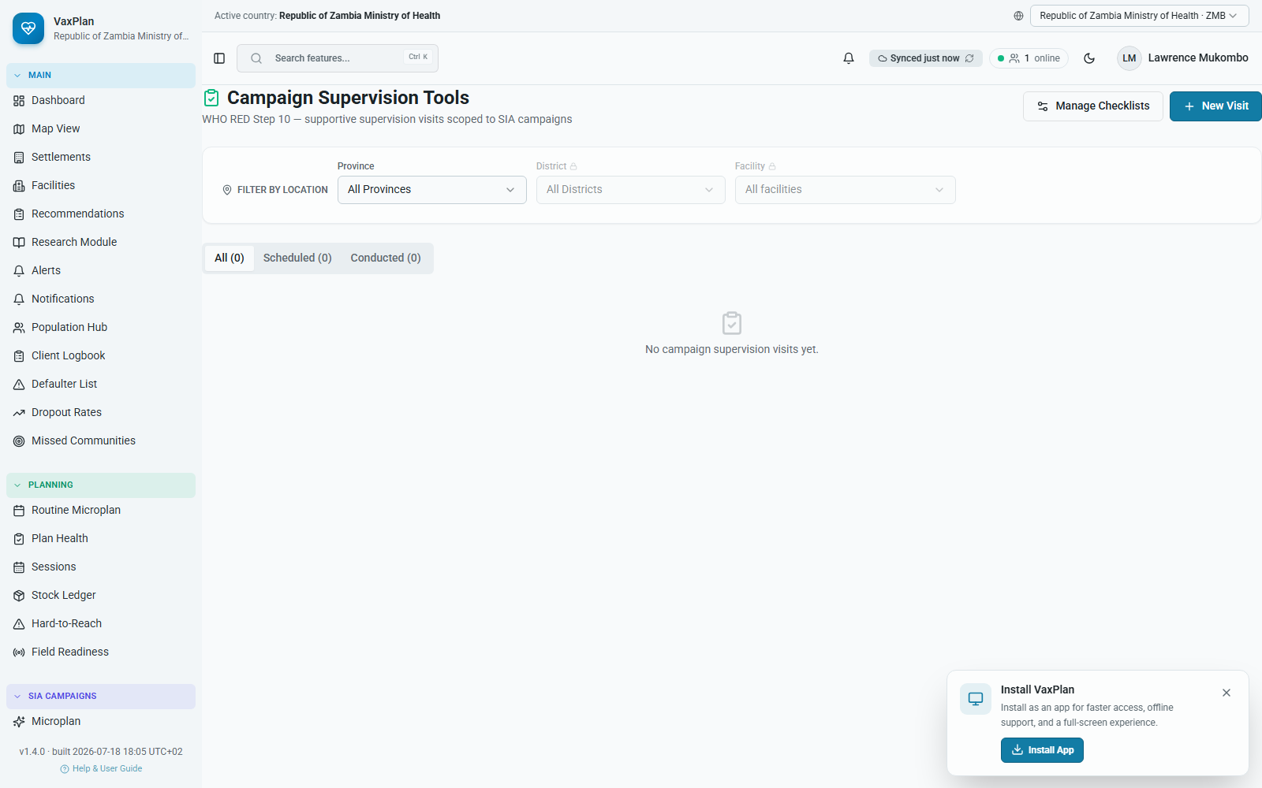
Supervision tools page for operational checklists and supervision resources.
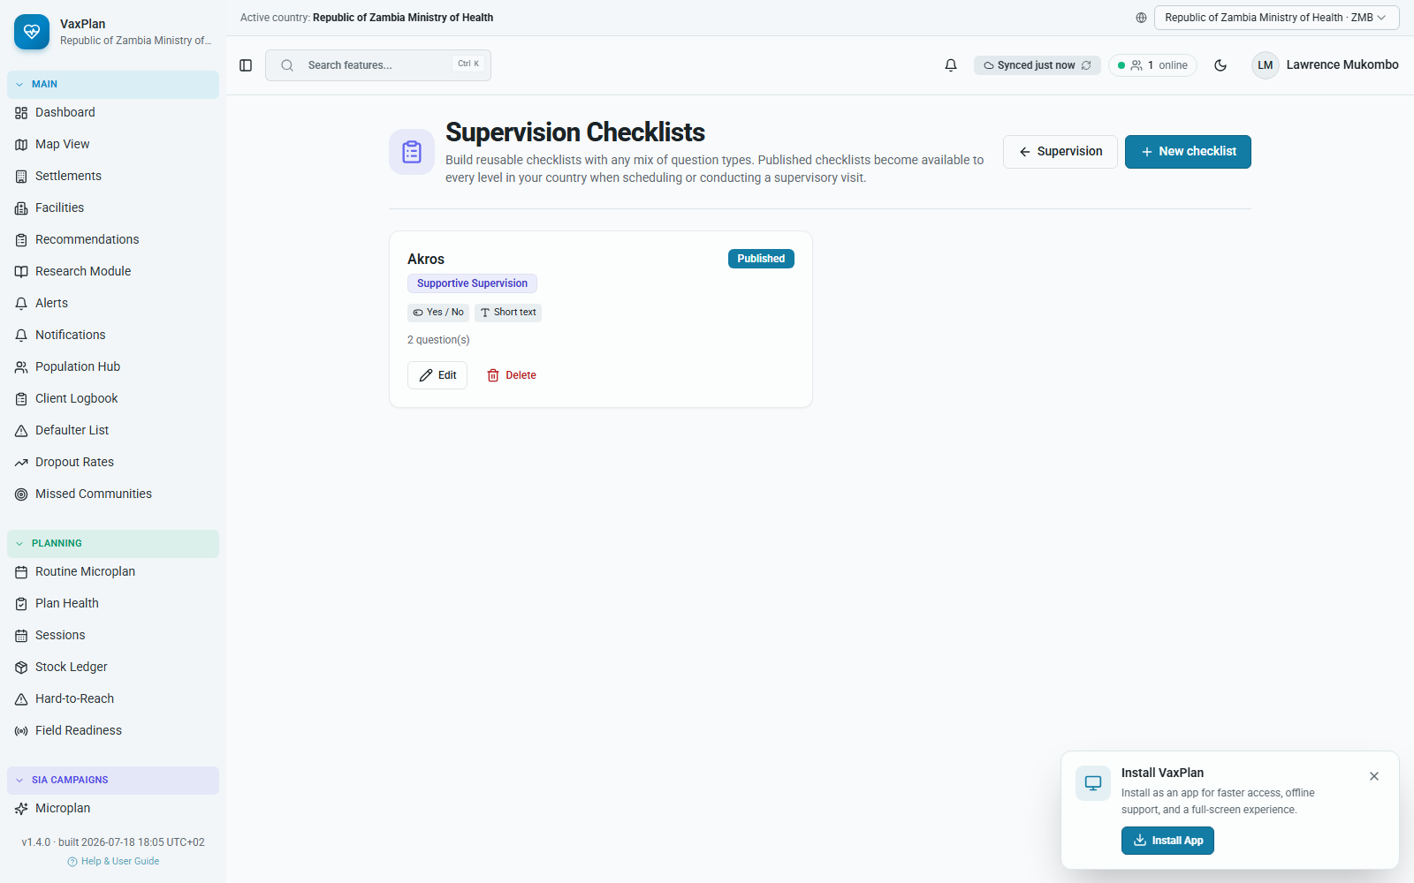
Checklist builder for national or administrator-defined supervision templates.
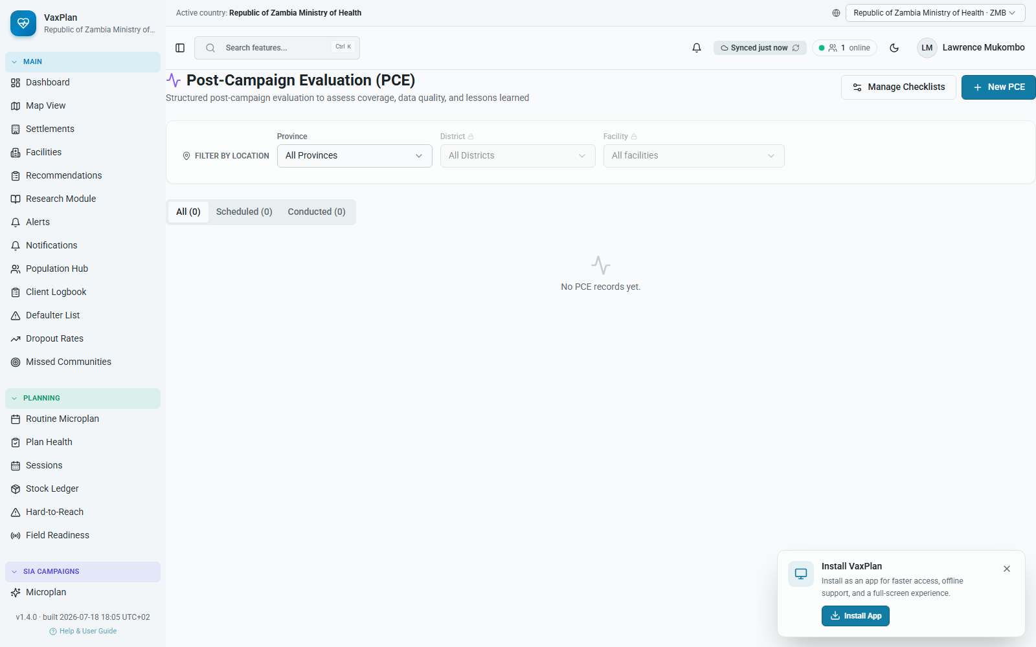
Post-campaign evaluation supervision workspace.
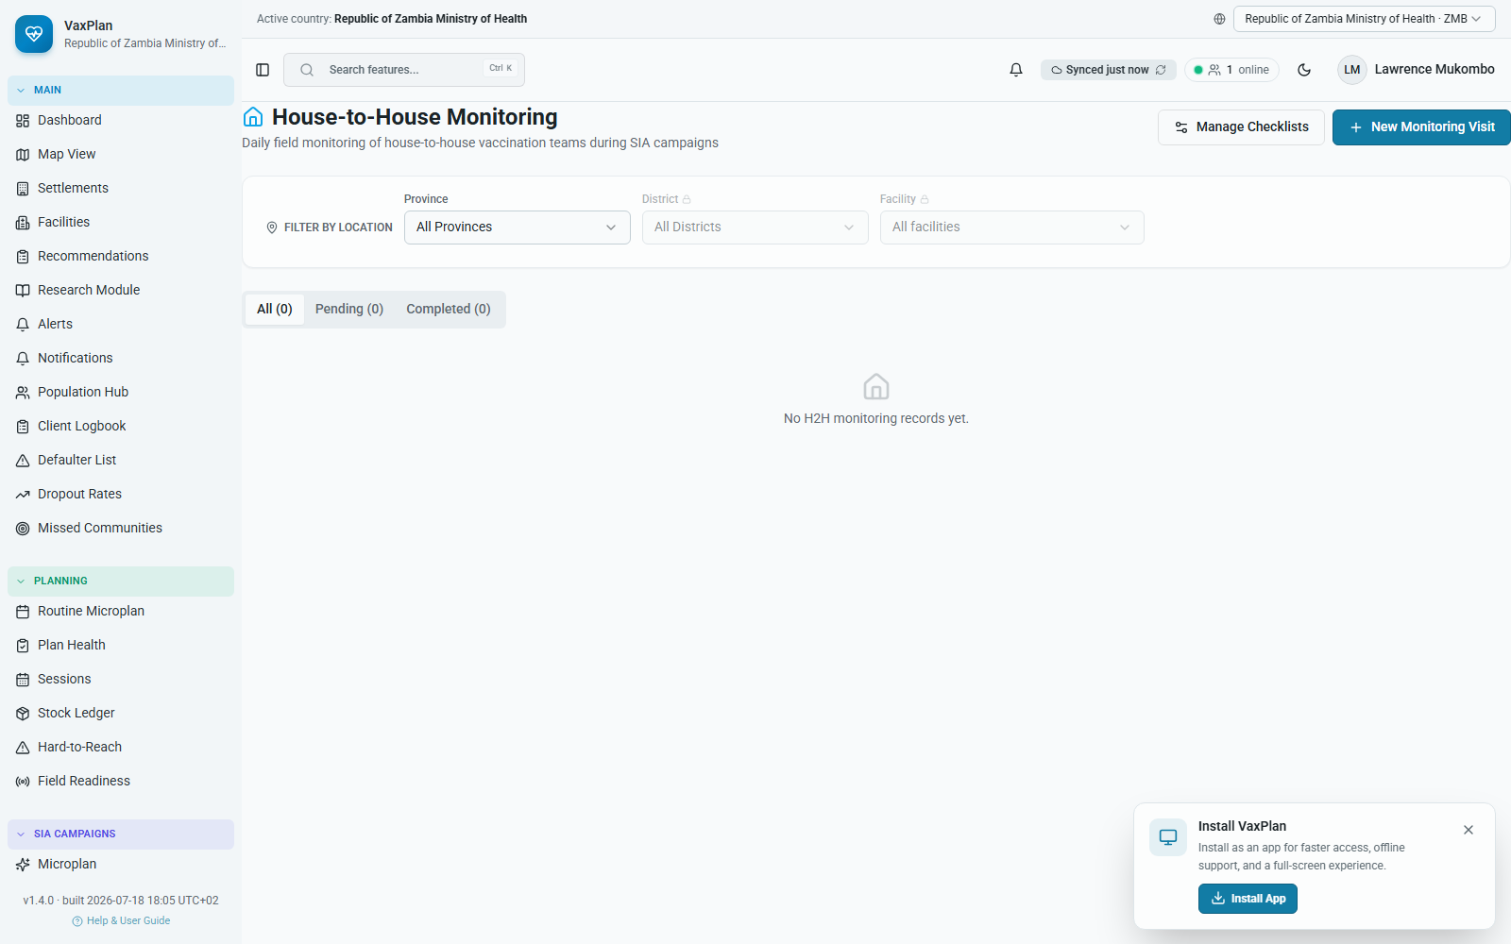
House-to-house campaign supervision and monitoring workspace.

E. VPD Surveillance
The VPD Surveillance module allows teams to report, track, map, and configure alerts for vaccine-preventable disease events. It supports case linelists, spatial review, case reporting, and configuration of alert thresholds and reporting workflows.
- The dashboard summarizes total cases, AFP rate, measles incidence, pending investigations, and surveillance quality metrics.
- The case linelist provides searchable and filterable records for investigation and follow-up.
- The spatial view maps cases and reporting facilities to support outbreak investigation and geographic review.
- Configuration controls support alert thresholds and notification roles for diseases such as AFP, measles, neonatal tetanus, yellow fever, cholera, COVID-19, and other VPDs where configured.
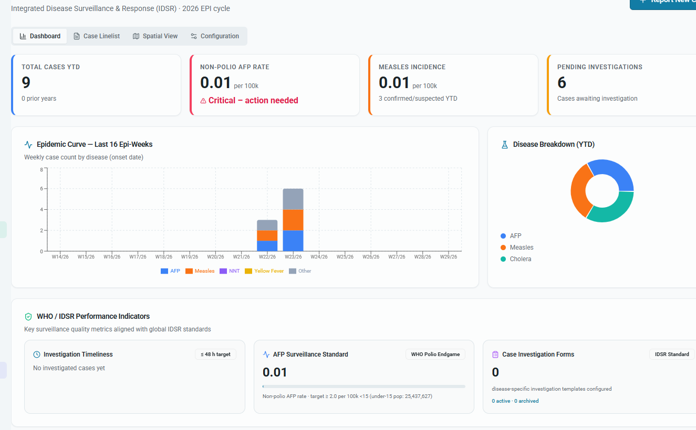
VPD surveillance dashboard with key surveillance indicators.
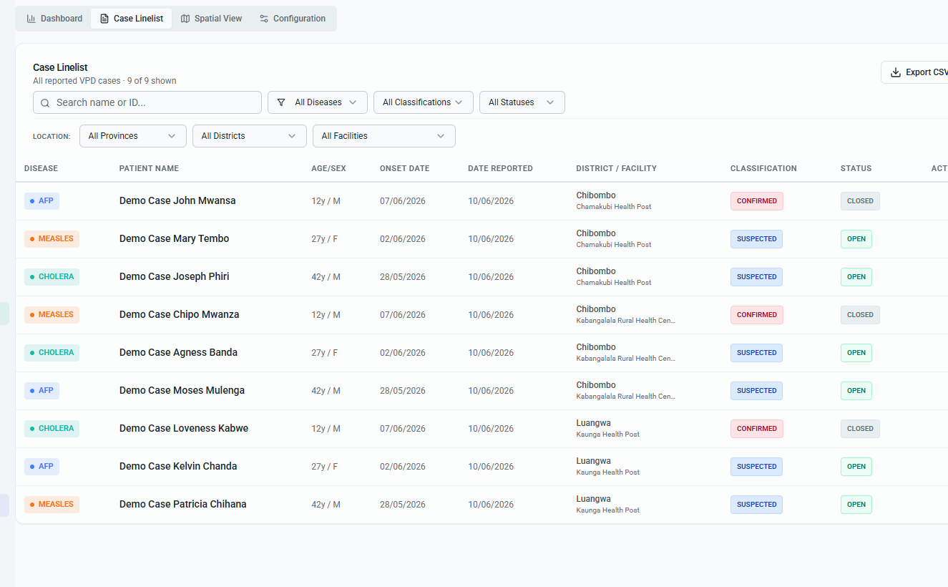
VPD case linelist for investigation and follow-up tracking.
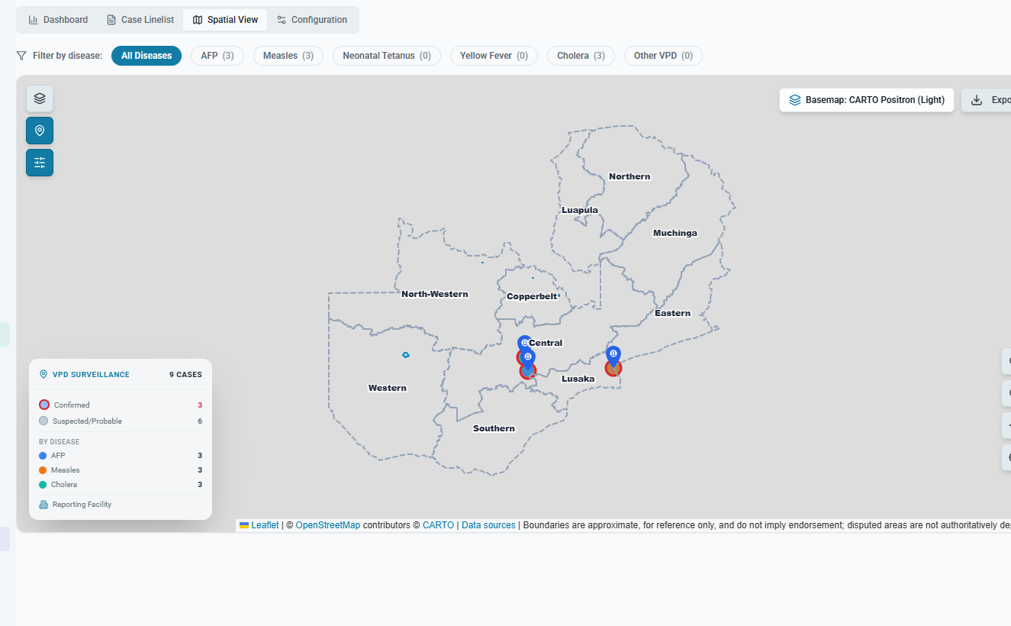
VPD spatial view for mapping cases and reporting facilities.
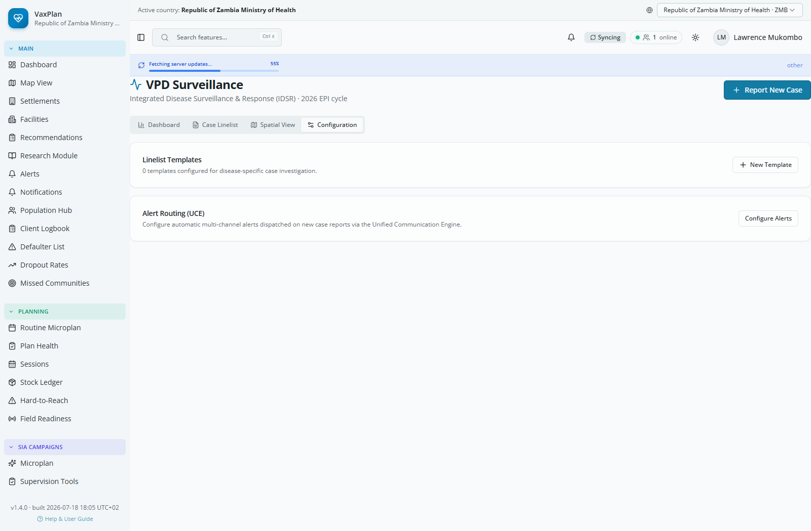
VPD alert configuration for thresholds and notification roles.
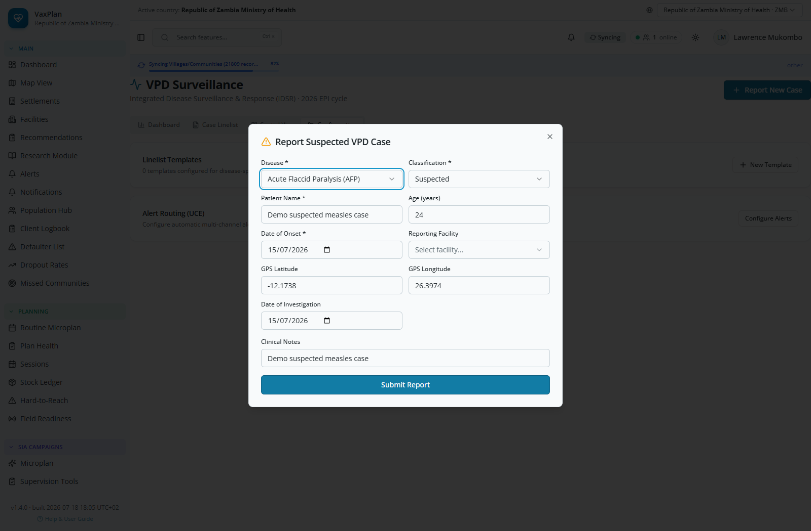
VPD case reporting form for new suspected or confirmed events.

F. Practical Tips for Demonstrations
- Use light theme during demonstrations and screenshots so tables, maps, and form fields remain readable in projectors and printed documents.
- For maps, zoom into a district or facility before showing unserved places, communities, and route overlays.
- When demonstrating route intelligence, select a facility with assigned communities so the route panel can display distance, estimated travel time, transport mode, seasonal accessibility, and referral route.
- Use the 12-step wizard to show that VaxPlan is a planning, logistics, supervision, approval, and review platform, not only a mapping tool.
- Use VPD surveillance and supervision screenshots to show how VaxPlan supports programme accountability beyond microplan creation.

