Student Portfolio
for the Subject
Web Systems & Technologies
Submitted by
JAYMAR V. BAUTISTA
BSIT – 3A

Submitted to
MR. LEO GABRIEL VILLANUEVA

2025 – 2026

TABLE OF CONTENTS

Case Study 1: Using PHP 3
Case Study 2 : Student Grading System (URL Input) 8
Case Study 3: Using looping 12
Case Study 4 : Biodata 17
Finals: DTR System 21
Finals: Enrollment System 27
Finals: Thesis Archives System 34
Midterm Written Examination 42
Finals: Endterm Requirement 44


STUDENT PORTFOLIO
Web Systems & Technologies 1
1st Term, A.Y. 2025-2026

Name: Bautista, Jaymar V. Year & Section: BSIT 3A-WM
Activity: Case Study 1: Using PHP Subject: WebSys1

Description
For this activity, I developed a project that transforms a standard static resume into a dynamic web application by utilizing PHP to manage personal details and technical credentials. Instead of manually typing information directly into the HTML structure. This approach significantly improves data organization and efficiency; if I need to update my contact information or add a new skill—such as my specialization in Web & Mobile Application Development—I only have to modify the variable at the top of the script, and the change automatically reflects throughout the site.
The website features a professional UI designed with modern CSS, incorporating a blue-themed header and a structured grid system for personal info to ensure a clean, professional look. I focused on logic integration by using PHP "echo" statements to output my stored data into the HTML framework, creating a professional-looking digital resume. This project has been a great way to practice the fundamentals of back-end development while building a practical tool that represents my growth as an IT student at Pangasinan State University.

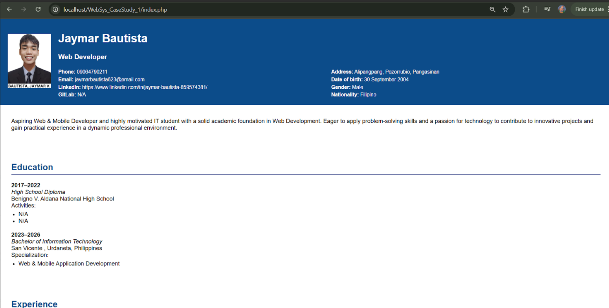
Screenshot

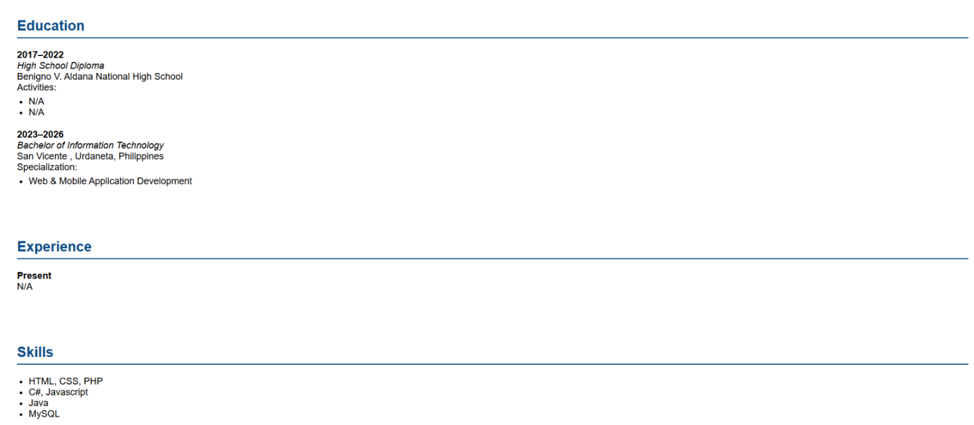

GitHub URL: https://github.com/jaymarBautista/WEB_SYSTEM_JAYMAR_BAUTISTA.git

Source Code

<?php
// JAYMAR PERSONAL INFO
$name = "Jaymar Bautista";
$title = "Web Developer";
$phone = "09064790211";
$email = "jaymarbautista623@email.com";
$linkedin = "https://www.linkedin.com/in/jaymar-bautista-859574381/";
$gitlab = "N/A";
$address = "Alipangpang, Pozorrubio, Pangasinan";
$dob = "30 September 2004";
$gender = "Male";
$nationality = "Filipino";

// MY HIGHSCHOOL
$edu1_years = "2017–2022";
$edu1_degree = "High School Diploma";
$edu1_institution = "Benigno V. Aldana National High School";
$edu1_score = "CBSE: 88%";
$edu1_activity1 = "N/A";
$edu1_activity2 = "N/A";

// COLLEGE LIFE
$edu2_years = "2023–2026";
$edu2_degree = "Bachelor of Information Technology";
$edu2_institution = "San Vicente , Urdaneta, Philippines";
$edu2_score = "CGPA: N/A";
$edu2_specialization = "Web & Mobile Application Development";

// EXPERIENCE
$exp_date = "Present";
$exp_info = "N/A";

// MY SKILLS
$skill1 = "HTML, CSS, PHP";
$skill2 = "C#, Javascript ";
$skill3 = "Java";
$skill4 = "MySQL";
?>

<!DOCTYPE html>
<html>
<head>

<style>
body {
font-family: Arial, sans-serif;
margin: 0;
background: #fff;
}
.header {
background: #0c4c8a;
color: white;
padding: 20px;
display: flex;
align-items: center;
}
.header img {
height: 150px;
border-radius: 1px;
margin-right: 20px;
}
.info {
display: flex;
flex-wrap: wrap;
margin-top: 10px;
font-size: 14px;
}
.info div {
width: 50%;
margin-top: 5px;
}
.section {
padding: 20px 30px;
}
.section h2 {
color: #0c4c8a;
border-bottom: 2px solid #0c4c8a;
padding-bottom: 5px;
margin-top: 30px;
}
.education, .experience, .skills {
margin-top: 15px;
}
.edu-entry, .exp-entry {
margin-bottom: 20px;
}
.edu-entry p, .exp-entry p, ul {
margin: 5px 0;
}
ul {
padding-left: 20px;
}
</style>
</head>
<body>

<div class="header">
<img src="jaymarbautista.jpg" alt="Profile Picture">
<div>
<h1><?php echo $name; ?></h1>
<h3><?php echo $title; ?></h3>
<div class="info">
<div><strong>Phone:</strong> <?php echo $phone; ?></div>
<div><strong>Address:</strong> <?php echo $address; ?></div>
<div><strong>Email:</strong> <?php echo $email; ?></div>
<div><strong>Date of birth:</strong> <?php echo $dob; ?></div>
<div><strong>LinkedIn:</strong> <?php echo $linkedin; ?></div>
<div><strong>Gender:</strong> <?php echo $gender; ?></div>
<div><strong>GitLab:</strong> <?php echo $gitlab; ?></div>
<div><strong>Nationality:</strong> <?php echo $nationality; ?></div>
</div>
</div>
</div>

<div class="section">
<p>Aspiring Web & Mobile Developer and highly motivated IT student with a solid academic foundation in Web Development. Eager to apply problem-solving skills and a passion for technology to contribute to innovative projects and gain practical experience in a dynamic professional environment.</p>
</div>

<div class="section">
<h2>Education</h2>
<div class="education">
<div class="edu-entry">
<strong><?php echo $edu1_years; ?></strong><br>
<em><?php echo $edu1_degree; ?></em><br>
<?php echo $edu1_institution; ?><br>

Activities:
<ul>
<li><?php echo $edu1_activity1; ?></li>
<li><?php echo $edu1_activity2; ?></li>
</ul>
</div>

<div class="edu-entry">
<strong><?php echo $edu2_years; ?></strong><br>
<em><?php echo $edu2_degree; ?></em><br>
<?php echo $edu2_institution; ?><br>
Specialization:
<ul>
<li><?php echo $edu2_specialization; ?></li>
</ul>
</div>
</div>
</div>

<div class="section">
<h2>Experience</h2>
<div class="experience">
<div class="exp-entry">
<strong><?php echo $exp_date; ?></strong><br>
<?php echo $exp_info; ?><br>
</ul>
</div>
</div>
</div>

<div class="section">
<h2>Skills</h2>
<ul class="skills">
<li><?php echo $skill1; ?></li>
<li><?php echo $skill2; ?></li>
<li><?php echo $skill3; ?></li>
<li><?php echo $skill4; ?></li>
</ul>
</div>

</body>
</html>

STUDENT PORTFOLIO
Web Systems & Technologies 1
1st Term, A.Y. 2025-2026

Name: Bautista, Jaymar V. Year & Section: BSIT 3A-WM
Activity: Case Study 2: Student Grading System (URL Input) Subject: WebSys1

Description
In this activity, I transitioned from a static digital resume to building a dynamic, logic-driven web application using PHP. The project features a professional Job Portal (CAREERPATH) with a modular architecture that separates the Admin backend for job approvals from the Employer Site for profile and post management. By centralizing settings in config.php and utilizing reusable headers, I ensured a clean and maintainable file structure.
To demonstrate back-end functionality, I developed a Student Grade Checker that uses conditional logic to process real-time data. By retrieving inputs via the $_GET superglobal, the script evaluates scores through a multi-tiered if-elseif-else structure—assigning grades like "B (Very Good)" and custom remarks such as "Great Job!" for a score of 90. The system also includes robust validation to ensure scores fall between 0 and 100 while using htmlspecialchars() to safely render data.

Screenshot

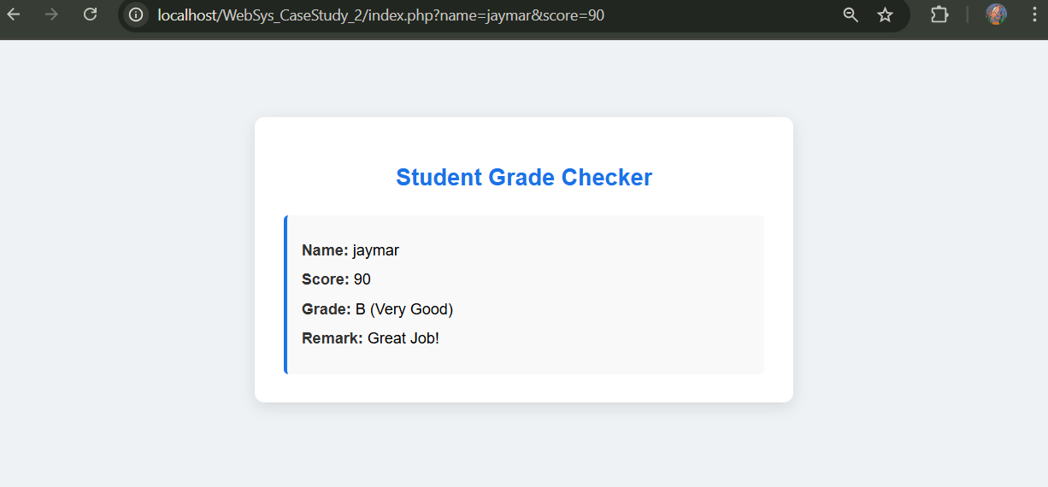

GitHub URL: https://github.com/jaymarBautista/WEB_SYSTEM_JAYMAR_BAUTISTA.git

Source Code

<?php
$student_name = isset($_GET['name']) ? $_GET['name'] : '';
$student_score = isset($_GET['score']) ? $_GET['score'] : '';
$student_grade = "";
$grade_remark = "";

if ($student_name !== '' && $student_score !== '') {
if (is_numeric($student_score) && $student_score >= 0 && $student_score <= 100) {

if ($student_score >= 95) {
$student_grade = "A (Excellent)";
$grade_remark = "Outstanding Performance!";
} elseif ($student_score >= 90) {
$student_grade = "B (Very Good)";
$grade_remark = "Great Job!";
} elseif ($student_score >= 85) {
$student_grade = "C (Good)";
$grade_remark = "Good effort, keep it up!";
} elseif ($student_score >= 75) {
$student_grade = "D (Needs Improvement)";
$grade_remark = "Work harder next time.";
} else {
$student_grade = "F (Failed)";
$grade_remark = "You need to improve.";
}

} else {
$student_grade = "Invalid Score";
$grade_remark = "Please enter a number between 0 and 100.";
}
}
?>

<!DOCTYPE html>
<html>
<head>
<title>Student Grade Checker</title>
<style>
body {
font-family: Arial, sans-serif;
background-color: #eef2f5;
margin: 0;
padding: 0;
}

.box {
background-color: white;
width: 500px;
margin: 80px auto;
padding: 30px;
border-radius: 10px;
box-shadow: 0 5px 15px rgba(0,0,0,0.1);
}

h2 {
color: #1a73e8;
text-align: center;
}

p {
font-size: 16px;
margin: 12px 0;
}

.label {
font-weight: bold;
color: #333;
}

.message {
margin-top: 25px;
background-color: #f9f9f9;
padding: 15px;
border-left: 4px solid #1a73e8;
border-radius: 5px;
}

.error {
color: red;
text-align: center;
margin-top: 20px;
font-weight: bold;
}

code {
background: #f2f2f2;
padding: 2px 4px;
border-radius: 4px;
font-family: monospace;
}
</style>
</head>
<body>

<div class="box">
<h2>Student Grade Checker</h2>

<?php if ($student_name === '' || $student_score === ''): ?>
<div class="error">
Please provide both <code>name</code> and <code>score</code> in the URL.<br><br>
Example: <code>?name=Maria%20Santos&score=85</code>
</div>
<?php else: ?>
<div class="message">
<p><span class="label">Name:</span> <?php echo htmlspecialchars($student_name); ?></p>
<p><span class="label">Score:</span> <?php echo htmlspecialchars($student_score); ?></p>
<p><span class="label">Grade:</span> <?php echo $student_grade; ?></p>
<p><span class="label">Remark:</span> <?php echo $grade_remark; ?></p>
</div>
<?php endif; ?>
</div>

</body>
</html>

STUDENT PORTFOLIO
Web Systems & Technologies 1
1st Term, A.Y. 2025-2026

Name: Bautista, Jaymar V. Year & Section: BSIT 3A-WM
Activity: Case Study 3: Using Looping Subject: WebSys1

Description
I implemented a Dynamic Multiplication Table to practice loops and nested logic. As seen in the provided images and code, this tool uses a POST form to collect row and column counts, then utilizes nested for loops to generate a grid. A key feature of this implementation is the conditional styling: the code checks if a number is odd using the modulus operator ($value % 2 !== 0) and automatically highlights those cells in yellow with bold text. This effectively demonstrates how PHP can control both the structure and the visual presentation of data based on specific mathematical conditions.

Screenshot
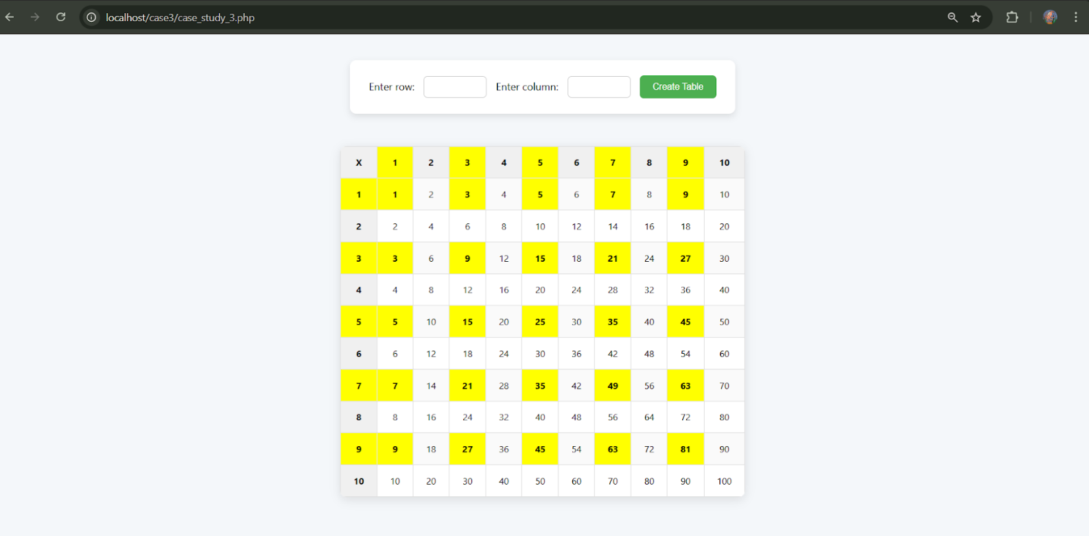

GitHub URL: https://github.com/jaymarBautista/WEB_SYSTEM_JAYMAR_BAUTISTA.git

Source Code

<!DOCTYPE html>
<html lang="en">
<head>
<meta charset="UTF-8">
<title>Multiplication Table</title>
<style>
body {
font-family: 'Segoe UI', Tahoma, Geneva, Verdana, sans-serif;
background: #f4f7fa;
margin: 0;
padding: 40px;
display: flex;
flex-direction: column;
align-items: center;
}

h1 {
margin-bottom: 20px;
color: #333;
}

form {
background: #fff;
padding: 20px 30px;
border-radius: 10px;
box-shadow: 0px 4px 10px rgba(0,0,0,0.1);
margin-bottom: 30px;
}

form input[type="text"] {
padding: 8px;
margin: 5px 10px;
border: 1px solid #ccc;
border-radius: 6px;
width: 80px;
font-size: 14px;
}

form input[type="submit"] {
padding: 10px 20px;
background: #4CAF50;
color: white;
border: none;
border-radius: 6px;
cursor: pointer;
font-size: 14px;
}

form input[type="submit"]:hover {
background: #45a049;
}

table {
border-collapse: collapse;
margin-top: 20px;
background: white;
border-radius: 10px;
overflow: hidden;
box-shadow: 0px 4px 15px rgba(0,0,0,0.1);
}

td, th {
border: 1px solid #ddd;
padding: 15px 20px;
text-align: center;
font-size: 14px;
}

th {
background: #f0f0f0;
}

tr:nth-child(even) td {
background: #fafafa;
}

td:hover {
background: #f9f9d1;
}
</style>
</head>
<body>

<form method="post">
Enter row: <input type="text" id="row" name="row">
Enter column: <input type="text" id="col" name="col">
<input type="submit" name="submit" value="Create Table">
</form>

<?php

$row = "";
$col = "";

if(isset($_POST['submit'])){

$row = $_POST['row'];
$col = $_POST['col'];

if($row == ''){
echo 'Enter row number!';
}
if($col == ''){
echo 'Enter column number!';
}
else {

echo "<table>";
echo "<tr><th>X</th>";

for ($c = 1 ; $c <= $col ; $c++){
if($c % 2 !== 0){
echo "<th style ='background-color: yellow; font-weight: bold;'>" . $c ."</th>";
} else {
echo "<th>". $c ."</th>";
}
}
echo "</tr>";

for($r = 1 ; $r <= $row ; $r++){
if ($r % 2 !== 0){
echo "<tr><th style='background-color:yellow; font-weight:bold'>". $r ."</th>";
}else {
echo "<tr><th>". $r ."</th>";
}

for($c = 1; $c <= $col ; $c++){
$value = $r * $c;
if ($value % 2 !== 0){
echo"<td style='background-color:yellow; font-weight:bold;'>". $value."</td>";
} else{
echo"<td>". $value."</td>";

}
}
echo "</tr>";
}
echo"</table>";
}
}

?>

STUDENT PORTFOLIO
Web Systems & Technologies 1
1st Term, A.Y. 2025-2026

Name: Bautista, Jaymar V. Year & Section: BSIT 3A-WM
Activity: Case Study 4: Biodata Subject: WebSys1

Description
I developed a Dynamic Bio-Data Generator to master form handling and file uploads. This application consists of a comprehensive HTML form that captures personal, educational, and employment data, as well as a profile photo. The backend processes this multipart data, moves the uploaded image to a server directory, and uses PHP's $_POST array to generate a formatted, professional bio-data document in real-time. Together, these projects showcase my growth at Pangasinan State University, bridging the gap between professional UI design and sophisticated back-end logic.

Screenshot
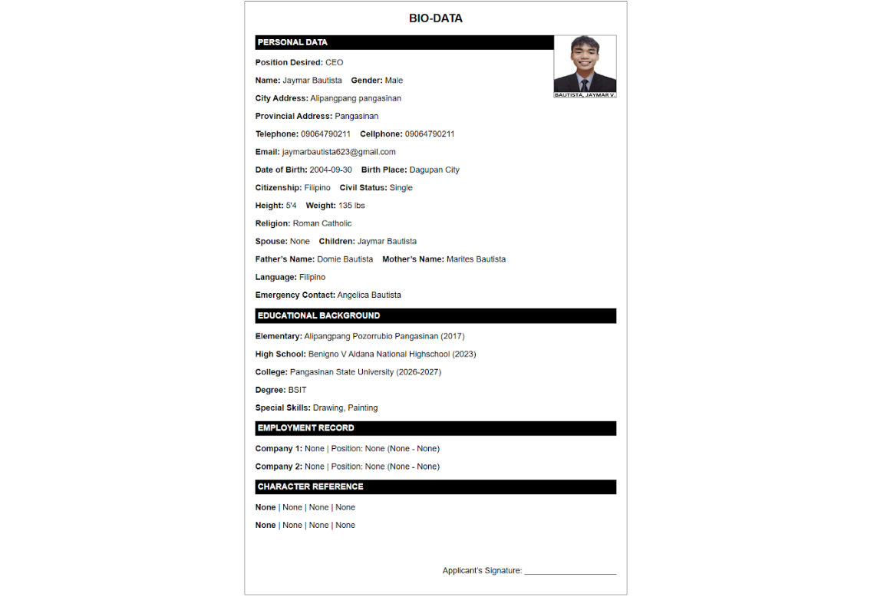

GitHub URL: https://github.com/jaymarBautista/WEB_SYSTEM_JAYMAR_BAUTISTA.git

Source Code

<!DOCTYPE html>
<html>
<head>
<title>Bio-Data Form</title>
<style>
body { font-family: Arial, sans-serif; }
.container { width: 700px; margin: auto; border: 1px solid black; padding: 20px; }
.header { text-align: center; font-size: 22px; font-weight: bold; margin-bottom: 20px; }
table { width: 100%; border-collapse: collapse; }
td { padding: 5px; vertical-align: top; }
.section-title { background: black; color: white; padding: 5px; font-weight: bold; }
</style>
</head>
<body>
<div class="container">
<div class="header">BIO-DATA</div>

<form action="direct.php" method="POST" enctype="multipart/form-data">
<label>Upload Image:</label><br>
<input type="file" name="photo" required><br><br>

<div class="section-title">PERSONAL DATA</div>
Position Desired: <input type="text" name="position"><br>
Name: <input type="text" name="name"><br>
Gender: <input type="text" name="gender"><br>
City Address: <input type="text" name="city"><br>
Provincial Address: <input type="text" name="provincial"><br>
Telephone: <input type="text" name="telephone"><br>
Cellphone: <input type="text" name="cellphone"><br>
Email: <input type="email" name="email"><br>
Date of Birth: <input type="date" name="dob"><br>
Birth Place: <input type="text" name="birthplace"><br>
Citizenship: <input type="text" name="citizenship"><br>
Height: <input type="text" name="height"><br>
Weight: <input type="text" name="weight"><br>
Religion: <input type="text" name="religion"><br>
Civil Status: <input type="text" name="civil"><br>
Spouse: <input type="text" name="spouse"><br>
Name of Children: <input type="text" name="children"><br>
Father’s Name: <input type="text" name="father"><br>
Mother’s Name: <input type="text" name="mother"><br>
Language: <input type="text" name="language"><br>
Person to contact in emergency: <input type="text" name="emergency"><br><br>

<div class="section-title">EDUCATIONAL BACKGROUND</div>
Elementary: <input type="text" name="elementary"> Year Graduated: <input type="text" name="elem_year"><br>
High School: <input type="text" name="highschool"> Year Graduated: <input type="text" name="hs_year"><br>
College: <input type="text" name="college"> Year Graduated: <input type="text" name="college_year"><br>
Degree: <input type="text" name="degree"><br>
Special Skills: <input type="text" name="skills"><br><br>

<div class="section-title">EMPLOYMENT RECORD</div>
Company Name: <input type="text" name="company1"> Position: <input type="text" name="position1"> From: <input type="text" name="from1"> To: <input type="text" name="to1"><br>
Company Name: <input type="text" name="company2"> Position: <input type="text" name="position2"> From: <input type="text" name="from2"> To: <input type="text" name="to2"><br><br>

<div class="section-title">CHARACTER REFERENCE</div>
Name: <input type="text" name="ref1"> Position: <input type="text" name="refpos1"> Company: <input type="text" name="refcomp1"> Contact: <input type="text" name="refcon1"><br>
Name: <input type="text" name="ref2"> Position: <input type="text" name="refpos2"> Company: <input type="text" name="refcomp2"> Contact: <input type="text" name="refcon2"><br><br>

<input type="submit" value="Generate Bio-Data">
</form>
</div>
</body>
</html>

<!DOCTYPE html>
<html>
<head>
<title>Bio-Data Output</title>
<style>
body { font-family: Arial, sans-serif; }
.container { width: 700px; margin: auto; border: 1px solid black; padding: 20px; }
.header { text-align: center; font-size: 22px; font-weight: bold; margin-bottom: 20px; }
table { width: 100%; border-collapse: collapse; }
td { padding: 5px; vertical-align: top; }
.section-title { background: black; color: white; padding: 5px; font-weight: bold; }
.photo { float: right; width: 120px; height: 120px; border: 1px solid black; }
</style>
</head>
<body>
<div class="container">
<div class="header">BIO-DATA</div>

<?php
if(isset($_FILES['photo'])){
$photo = "uploads/" . basename($_FILES["photo"]["name"]);
move_uploaded_file($_FILES["photo"]["tmp_name"], $photo);
echo "<img src='$photo' class='photo'>";
}
?>

<div class="section-title">PERSONAL DATA</div>
<p><b>Position Desired:</b> <?= $_POST['position'] ?></p>
<p><b>Name:</b> <?= $_POST['name'] ?> &nbsp;&nbsp; <b>Gender:</b> <?= $_POST['gender'] ?></p>
<p><b>City Address:</b> <?= $_POST['city'] ?></p>
<p><b>Provincial Address:</b> <?= $_POST['provincial'] ?></p>
<p><b>Telephone:</b> <?= $_POST['telephone'] ?> &nbsp;&nbsp; <b>Cellphone:</b> <?= $_POST['cellphone'] ?></p>
<p><b>Email:</b> <?= $_POST['email'] ?></p>
<p><b>Date of Birth:</b> <?= $_POST['dob'] ?> &nbsp;&nbsp; <b>Birth Place:</b> <?= $_POST['birthplace'] ?></p>
<p><b>Citizenship:</b> <?= $_POST['citizenship'] ?> &nbsp;&nbsp; <b>Civil Status:</b> <?= $_POST['civil'] ?></p>
<p><b>Height:</b> <?= $_POST['height'] ?> &nbsp;&nbsp; <b>Weight:</b> <?= $_POST['weight'] ?></p>
<p><b>Religion:</b> <?= $_POST['religion'] ?></p>
<p><b>Spouse:</b> <?= $_POST['spouse'] ?> &nbsp;&nbsp; <b>Children:</b> <?= $_POST['children'] ?></p>
<p><b>Father’s Name:</b> <?= $_POST['father'] ?> &nbsp;&nbsp; <b>Mother’s Name:</b> <?= $_POST['mother'] ?></p>
<p><b>Language:</b> <?= $_POST['language'] ?></p>
<p><b>Emergency Contact:</b> <?= $_POST['emergency'] ?></p>

<div class="section-title">EDUCATIONAL BACKGROUND</div>
<p><b>Elementary:</b> <?= $_POST['elementary'] ?> (<?= $_POST['elem_year'] ?>)</p>
<p><b>High School:</b> <?= $_POST['highschool'] ?> (<?= $_POST['hs_year'] ?>)</p>
<p><b>College:</b> <?= $_POST['college'] ?> (<?= $_POST['college_year'] ?>)</p>
<p><b>Degree:</b> <?= $_POST['degree'] ?></p>
<p><b>Special Skills:</b> <?= $_POST['skills'] ?></p>

<div class="section-title">EMPLOYMENT RECORD</div>
<p><b>Company 1:</b> <?= $_POST['company1'] ?> | Position: <?= $_POST['position1'] ?> (<?= $_POST['from1'] ?> - <?= $_POST['to1'] ?>)</p>
<p><b>Company 2:</b> <?= $_POST['company2'] ?> | Position: <?= $_POST['position2'] ?> (<?= $_POST['from2'] ?> - <?= $_POST['to2'] ?>)</p>

<div class="section-title">CHARACTER REFERENCE</div>
<p><b><?= $_POST['ref1'] ?></b> | <?= $_POST['refpos1'] ?> | <?= $_POST['refcomp1'] ?> | <?= $_POST['refcon1'] ?></p>
<p><b><?= $_POST['ref2'] ?></b> | <?= $_POST['refpos2'] ?> | <?= $_POST['refcomp2'] ?> | <?= $_POST['refcon2'] ?></p>

</div>
</body>
</html>

STUDENT PORTFOLIO
Web Systems & Technologies 1
1st Term, A.Y. 2025-2026

Name: Bautista, Jaymar V. Year & Section: BSIT 3A-WM
Activity: Finals - DTR System Subject: WebSys1

Description
Building upon the foundation of dynamic web logic, I developed a full-scale Daily Time Record (DTR) System that integrates secure user authentication with real-time database management. The system features a robust account creation process where user passwords are encrypted using password_hash() and profile pictures are handled via multipart form uploads stored in a dedicated server directory. Once authenticated through a secure login module, users can access a personalized dashboard to perform "Time In" and "Time Out" actions, which dynamically record the exact system time and date into a MySQL attendance table. This data is then immediately rendered into an attendance history table, providing users with a transparent log of their work hours.
To ensure complete administrative control, I implemented an Admin Panel that allows for high-level user management, including the ability to search, sort, and delete accounts. The backend is designed with a "clean-up" logic; when an administrator or user deletes an account, the system automatically removes all associated attendance records and utilizes the unlink() function to delete the physical image file from the server, maintaining optimal storage efficiency. This project bridges professional UI design with sophisticated backend operations, demonstrating a comprehensive understanding of session handling, database persistence, and secure file management.

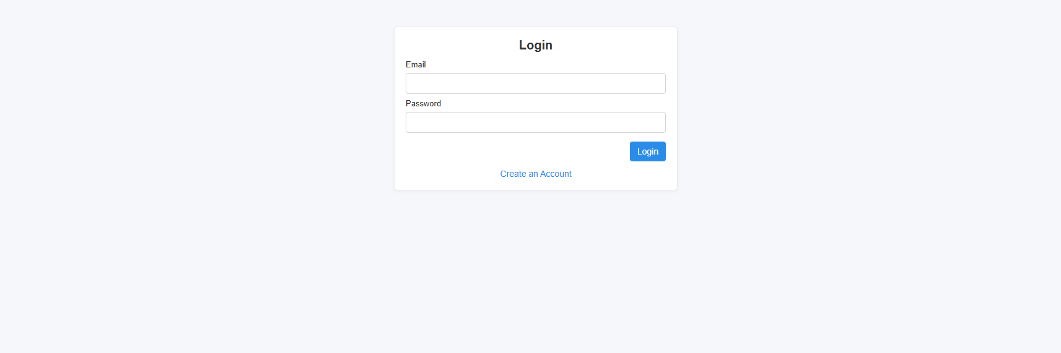
Screenshot

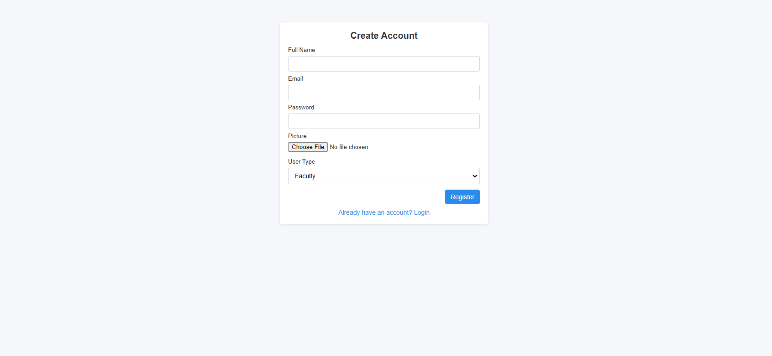

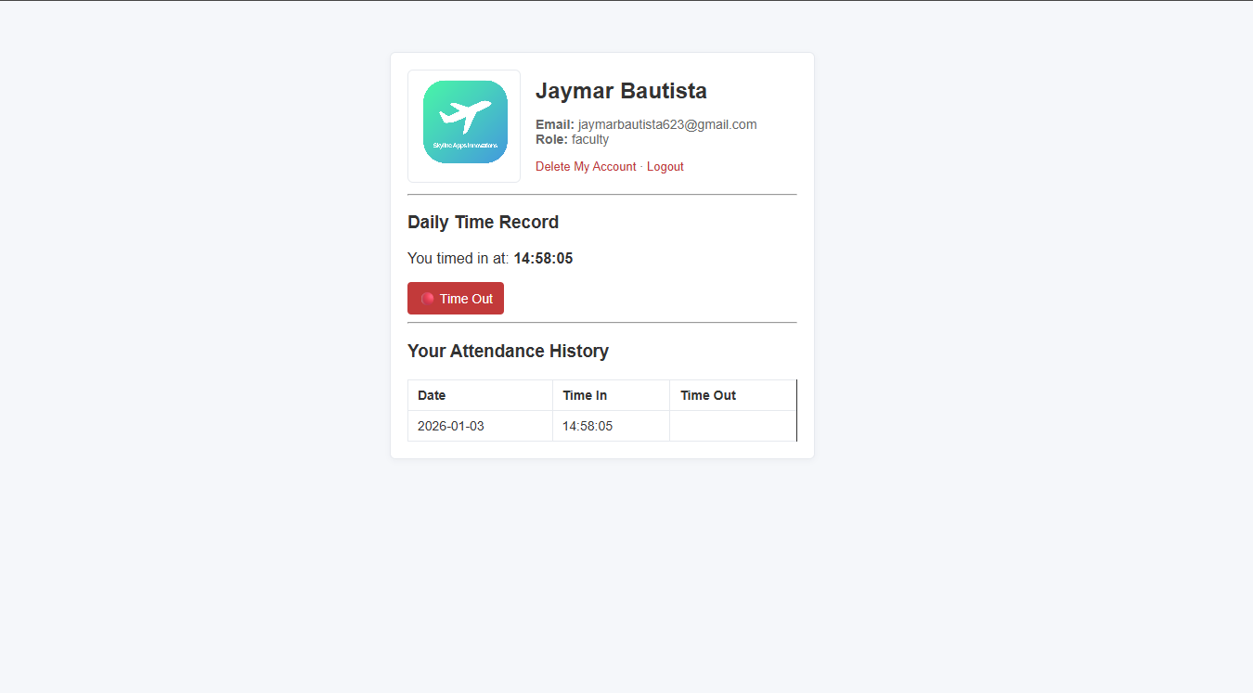

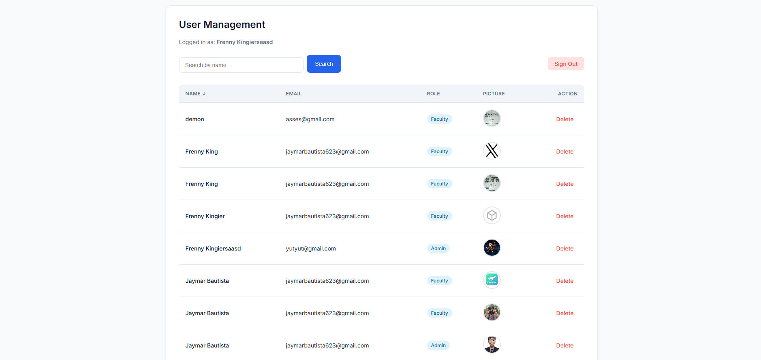

GitHub URL: https://github.com/jaymarBautista/WEB_SYSTEM_JAYMAR_BAUTISTA.git

Source Code

<?php
session_start();
include "db.php";

if (!isset($_SESSION['user']) || $_SESSION['user']['usertype'] != "admin") {
header("Location: login.php");
exit;
}

$search = $_GET['search'] ?? "";
$sort = $_GET['sort'] ?? "fullname";

$search_esc = mysqli_real_escape_string($conn, $search);
$allowed_sorts = ['fullname','email','usertype','id'];
if (!in_array($sort, $allowed_sorts)) {
$sort = 'fullname';
}

$sql = "SELECT * FROM users WHERE fullname LIKE '%$search_esc%' ORDER BY $sort ASC";
$result = mysqli_query($conn, $sql);
?>
<!doctype html>
<html lang="en">
<head>
<meta charset="utf-8">
<title>Admin Panel</title>
<link rel="stylesheet" href="assets/style.css">
<style>
table { width: 100%; border-collapse: collapse; margin-top: 12px; }
th, td { padding: 8px 10px; border: 1px solid #e6e9ee; font-size: 14px; text-align: left; }
th a { color: #2b8be8; text-decoration: none; }
img.avatar { border-radius: 4px; display: block; }
.top-actions { display:flex; justify-content:space-between; align-items:center; gap:10px; margin-top:8px; }
.search-inline { display:flex; gap:8px; }
.link-logout { color:#8a1f1f; text-decoration:none; font-size:14px; }
</style>
</head>
<body>
<div class="container">
<h2>Admin Panel</h2>
<p>Logged in as: <?= htmlspecialchars($_SESSION['user']['fullname']) ?></p>

<div class="top-actions">
<form method="GET" class="search-inline" style="margin:0;">
<input type="text" name="search" placeholder="Search user..." value="<?= htmlspecialchars($search) ?>">
<button type="submit">Search</button>
</form>
<a class="link-logout" href="logout.php">Logout</a>
</div>

<table>
<tr>
<th><a href="?sort=fullname&search=<?= urlencode($search) ?>">Name</a></th>
<th><a href="?sort=email&search=<?= urlencode($search) ?>">Email</a></th>
<th><a href="?sort=usertype&search=<?= urlencode($search) ?>">User Type</a></th>
<th>Picture</th>
<th>Action</th>
</tr>

<?php while ($row = mysqli_fetch_assoc($result)) { ?>
<tr>
<td><?= htmlspecialchars($row['fullname']) ?></td>
<td><?= htmlspecialchars($row['email']) ?></td>
<td><?= htmlspecialchars($row['usertype']) ?></td>
<td>
<img class="avatar" src="uploads/<?= htmlspecialchars($row['picture']) ?>" width="50" alt="avatar">
</td>
<td><a href="remove.php?id=<?= (int)$row['id'] ?>" style="color:#c23a3a">Delete</a></td>
</tr>
<?php } ?>
</table>
</div>
</body>
</html>
<?php
$conn = mysqli_connect("localhost", "root", "", "dtr_system");

if (!$conn) {
die("Connection failed: " . mysqli_connect_error());
}
?>
<?php
session_start();
include "db.php";

if (empty($_SESSION['user']['id'])) {
header("Location: login.php");
exit;
}

$user_id = (int)$_SESSION['user']['id'];

if ($_SERVER['REQUEST_METHOD'] === 'POST') {

$res = mysqli_query($conn, "SELECT picture FROM users WHERE id = $user_id");
$row = mysqli_fetch_assoc($res);
$picture = $row['picture'] ?? '';

mysqli_query($conn, "DELETE FROM attendance WHERE user_id = $user_id");

mysqli_query($conn, "DELETE FROM users WHERE id = $user_id");

if (!empty($picture)) {
$file = __DIR__ . '/uploads/' . basename($picture);
if (is_file($file)) {
@unlink($file);
}
}

session_unset();
session_destroy();
header("Location: login.php");
exit;
}
?>
<!doctype html>
<html lang="en">
<head>
<meta charset="utf-8">
<title>Delete Account</title>
<link rel="stylesheet" href="assets/style.css">
</head>
<body>
<div class="container">
<h2>Delete Account</h2>
<p>Are you sure you want to delete your account? This cannot be undone.</p>

<form method="POST" style="display:inline;">
<button type="submit" style="background:#c23a3a;color:#fff;padding:8px 12px;border:none;border-radius:4px;cursor:pointer;">
Yes, delete my account
</button>
</form>

<a href="profile.php" style="margin-left:12px;color:#2b8be8;text-decoration:none;">Cancel</a>
</div>
</body>
</html>
<?php
session_start();
include "db.php";

if ($_SERVER["REQUEST_METHOD"] == "POST") {
$email = trim($_POST['email'] ?? '');
$password = $_POST['password'] ?? '';

if ($email === '' || $password === '') {
$login_error = "Provide email and password.";
} else {
$stmt = mysqli_prepare($conn, "SELECT id, fullname, email, password, usertype, picture FROM users WHERE email = ?");
mysqli_stmt_bind_param($stmt, "s", $email);
mysqli_stmt_execute($stmt);
$res = mysqli_stmt_get_result($stmt);
$user = mysqli_fetch_assoc($res);
mysqli_stmt_close($stmt);

if ($user && password_verify($password, $user['password'])) {
session_regenerate_id(true);
unset($user['password']);
$_SESSION["user"] = $user;

if ($user["usertype"] == "admin") {
header("Location: admin.php");
exit;
} else {
header("Location: profile.php");
exit;
}
} else {
$login_error = "Invalid Email or Password!";
}
}
}
?>

<!doctype html>
<html lang="en">
<head>
<meta charset="utf-8">
<title>Login</title>
<link rel="stylesheet" href="assets/style.css">
</head>
<body>
<div class="container">
<h1>Login</h1>

<?php if (!empty($login_error)): ?>
<div class="alert"><?= htmlspecialchars($login_error) ?></div>
<?php endif; ?>

<form method="POST" class="form">
<label for="email">Email</label>
<input id="email" type="email" name="email" required>

<label for="password">Password</label>
<input id="password" type="password" name="password" required>

<div class="actions">
<button type="submit">Login</button>
</div>
</form>

<div class="form-footer">
<a href="register.php">Create an Account</a>
</div>
</div>
</body>
</html>
<?php
session_start();
session_destroy();
header("Location: login.php");

<?php
session_start();
include "db.php";

if (!isset($_SESSION['user'])) {
header("Location: login.php");
exit;
}

$user = $_SESSION['user'];
$user_id = (int)$user['id'];

$today = date("Y-m-d");
$check = mysqli_query($conn, "SELECT * FROM attendance WHERE user_id=$user_id AND date='$today'");
$attendance = mysqli_fetch_assoc($check);
?>

<!doctype html>
<html lang="en">
<head>
<meta charset="utf-8">
<title>Profile</title>
<link rel="stylesheet" href="assets/style.css">
<style>
.profile-header { display:flex; gap:16px; align-items:center; margin-bottom:12px; }
.profile-header img { border-radius:6px; width:120px; height:120px; object-fit:cover; border:1px solid #e6e9ee; }
.muted { color:#666; font-size:14px; }
.attendance-actions { margin-top:10px; }
table.attendance { width:100%; border-collapse:collapse; margin-top:12px; }
table.attendance th, table.attendance td { padding:8px 10px; border:1px solid #e6e9ee; font-size:14px; text-align:left; }
.link-danger { color:#c23a3a; text-decoration:none; }
.small-note { font-size:13px; color:#666; margin-top:6px; }
.btn { background:#2b8be8; color:#fff; border:none; padding:8px 12px; border-radius:4px; cursor:pointer; }
.btn-logout { background:#c23a3a; }
</style>
</head>
<body>
<div class="container">
<div class="profile-header">
<img src="uploads/<?= htmlspecialchars($user['picture'] ?? '') ?>" alt="avatar">
<div>
<h2 style="margin:0;"><?= htmlspecialchars($user['fullname']) ?></h2>
<p class="muted"><b>Email:</b> <?= htmlspecialchars($user['email']) ?><br>
<b>Role:</b> <?= htmlspecialchars($user['usertype']) ?></p>
<div class="small-note">
<a class="link-danger" href="delete_account.php">Delete My Account</a> ·
<a href="logout.php" class="link-danger">Logout</a>
</div>
</div>
</div>

<hr>

<h3>Daily Time Record</h3>

<?php if (!$attendance) { ?>
<form method="POST" action="time_in.php" class="attendance-actions">
<button type="submit" class="btn">🟢 Time In</button>
</form>
<?php } elseif (!empty($attendance['time_in']) && empty($attendance['time_out'])) { ?>
<p>You timed in at: <b><?= htmlspecialchars($attendance['time_in']) ?></b></p>
<form method="POST" action="time_out.php" class="attendance-actions">
<button type="submit" class="btn btn-logout">🔴 Time Out</button>
</form>
<?php } else { ?>
<p><b>You already completed today's attendance ✔</b></p>
<p>Time In: <?= htmlspecialchars($attendance['time_in']) ?><br>
Time Out: <?= htmlspecialchars($attendance['time_out']) ?></p>
<?php } ?>

<hr>

<h3>Your Attendance History</h3>

<table class="attendance">
<tr>
<th>Date</th>
<th>Time In</th>
<th>Time Out</th>
</tr>

<?php
$logs = mysqli_query($conn, "SELECT * FROM attendance WHERE user_id=$user_id ORDER BY date DESC");
while($row = mysqli_fetch_assoc($logs)) {
echo "<tr>
<td>" . htmlspecialchars($row['date']) . "</td>
<td>" . htmlspecialchars($row['time_in']) . "</td>
<td>" . htmlspecialchars($row['time_out']) . "</td>
</tr>";
}
?>
</table>

</div>
</body>
</html>
<?php
include "db.php";

if ($_SERVER["REQUEST_METHOD"] == "POST") {

$fullname = $_POST['fullname'];
$email = $_POST['email'];
$password = password_hash($_POST['password'], PASSWORD_DEFAULT);
$usertype = $_POST['usertype'];

$fileName = basename($_FILES["picture"]["name"]);
$temp = $_FILES["picture"]["tmp_name"];
if ($fileName) {
move_uploaded_file($temp, "uploads/" . $fileName);
} else {
$fileName = '';
}

$sql = "INSERT INTO users (fullname, email, password, usertype, picture)
VALUES ('$fullname', '$email', '$password', '$usertype', '$fileName')";

if (mysqli_query($conn, $sql)) {
$success = "Registered Successfully. <a href='login.php'>Login Now</a>";
} else {
$error = "Error: " . mysqli_error($conn);
}
}
?>
<!doctype html>
<html lang="en">
<head>
<meta charset="utf-8">
<title>Register</title>
<link rel="stylesheet" href="assets/style.css">
<style>

.form label { display:block; margin-top:8px; font-size:13px; }
.form input[type="file"] { padding:6px 0; }
.notice { margin-bottom:10px; font-size:13px; }
.notice.success { background:#f0fff4; border:1px solid #d7f5dd; color:#1f6f3a; padding:8px; border-radius:4px; }
.notice.error { background:#fff4f4; border:1px solid #ffd6d6; color:#8a1f1f; padding:8px; border-radius:4px; }
</style>
</head>
<body>
<div class="container">
<h1>Create Account</h1>

<?php if (!empty($success)): ?>
<div class="notice success"><?= $success ?></div>
<?php endif; ?>

<?php if (!empty($error)): ?>
<div class="notice error"><?= htmlspecialchars($error) ?></div>
<?php endif; ?>

<form method="POST" enctype="multipart/form-data" class="form">
<label for="fullname">Full Name</label>
<input id="fullname" type="text" name="fullname" required>

<label for="email">Email</label>
<input id="email" type="email" name="email" required>

<label for="password">Password</label>
<input id="password" type="password" name="password" required>

<label for="picture">Picture</label>
<input id="picture" type="file" name="picture" accept="image/*" required>

<label for="usertype">User Type</label>
<select id="usertype" name="usertype">
<option value="faculty">Faculty</option>
<option value="admin">Admin</option>
</select>

<div class="actions" style="margin-top:12px;">
<button type="submit">Register</button>
</div>
</form>

<div class="form-footer" style="margin-top:10px;">
<a href="login.php">Already have an account? Login</a>
</div>
</div>
</body>
</html>
<?php
include "db.php";

$id = $_GET['id'];
mysqli_query($conn, "DELETE FROM users WHERE id=$id");

header("Location: admin.php");
<?php
session_start();
include "db.php";

$user_id = $_SESSION['user']['id'];
$today = date("Y-m-d");
$time = date("H:i:s");

mysqli_query($conn, "INSERT INTO attendance (user_id, date, time_in) VALUES ($user_id, '$today', '$time')");

header("Location: profile.php");
<?php
session_start();
include "db.php";

$user_id = $_SESSION['user']['id'];
$today = date("Y-m-d");
$time = date("H:i:s");

mysqli_query($conn, "UPDATE attendance SET time_out='$time' WHERE user_id=$user_id AND date='$today'");

header("Location: profile.php");
body {
font-family: Arial, Helvetica, sans-serif;
background: #f5f7fa;
color: #333;
margin: 0;
padding: 0;
}

.container {
max-width: 420px;
margin: 6vh auto;
padding: 18px;
background: #fff;
border: 1px solid #e6e9ee;
border-radius: 6px;
box-shadow: 0 2px 6px rgba(20,30,50,0.04);
}

h1 {
font-size: 20px;
margin: 0 0 12px;
text-align: center;
}

label {
display: block;
font-size: 13px;
margin-top: 8px;
}

input[type="email"],
input[type="password"],
input[type="text"],
select {
width: 100%;
padding: 8px 10px;
margin-top: 6px;
border: 1px solid #d1d5db;
border-radius: 4px;
box-sizing: border-box;
font-size: 14px;
}

.actions {
margin-top: 14px;
text-align: right;
}

button {
background: #2b8be8;
color: #fff;
border: none;
padding: 8px 12px;
border-radius: 4px;
cursor: pointer;
font-size: 14px;
}

button:hover {
background: #246fc6;
}

.form-footer {
text-align: center;
margin-top: 12px;
font-size: 14px;
}

a {
color: #2b8be8;
text-decoration: none;
}

.alert {
background: #fff4f4;
color: #8a1f1f;
border: 1px solid #ffd6d6;
padding: 8px 10px;
border-radius: 4px;
margin-bottom: 10px;
font-size: 13px;
}

STUDENT PORTFOLIO
Web Systems & Technologies 1
1st Term, A.Y. 2025-2026

Name: Bautista, Jaymar V. Year & Section: BSIT 3A-WM
Activity: Finals – Enrollment System Subject: WebSys1
Description
I developed a comprehensive Enrollment System that utilizes a multi-role architecture to manage academic workflows between Students, Faculty, and Administrators. Built with PHP and a MySQL database named enrollment_system, the project features a centralized authentication engine that directs users to role-specific dashboards. The system ensures security by using password_hash() for registrations and maintaining session-based access control across all restricted pages.
The Administrator Dashboard serves as the system's core, allowing for full CRUD (Create, Read, Update, Delete) operations on subject listings and the management of academic logic through a Prerequisite System. This feature uses complex SQL JOIN statements to link subjects together, ensuring that curriculum requirements are digitally enforced. Meanwhile, the Student Dashboard provides a personalized view where learners can enroll in subjects and track their real-time academic status and grades. The Faculty Dashboard rounds out the system by providing instructors with the tools necessary to manage student performance and grade entries.

Screenshot
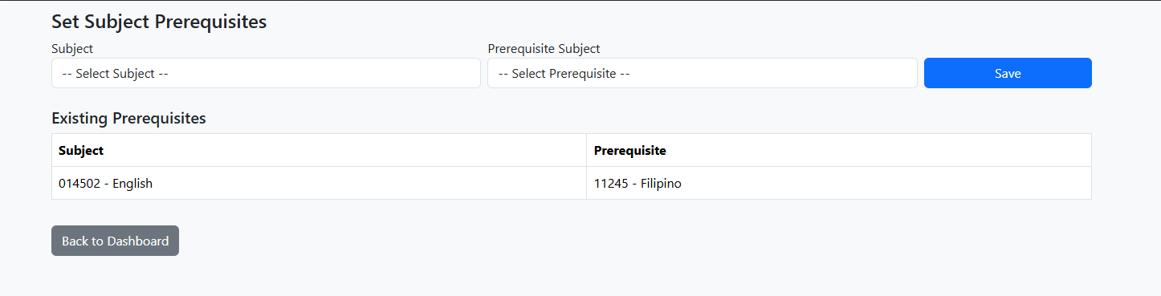

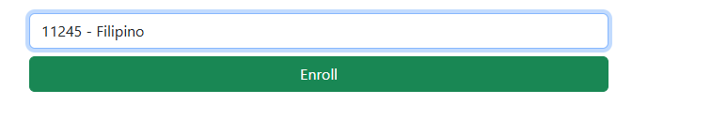

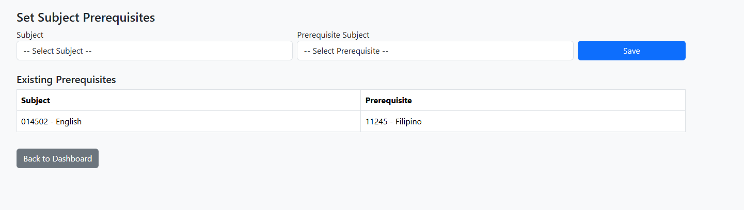

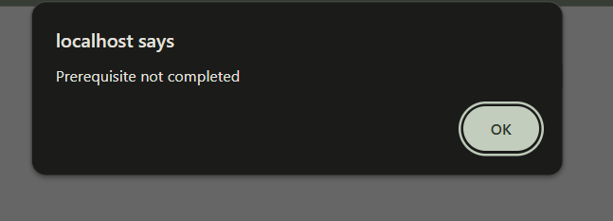

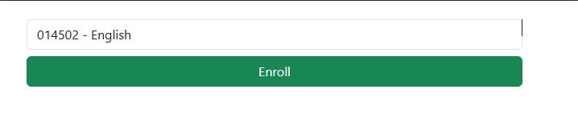

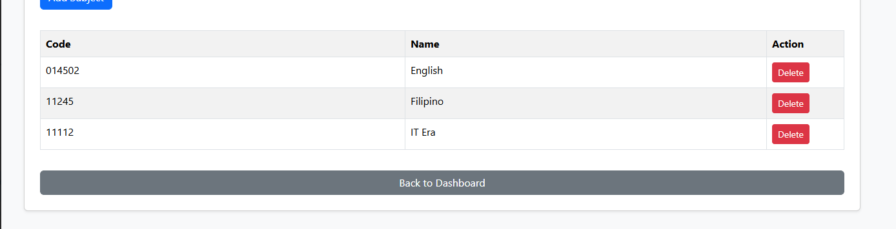

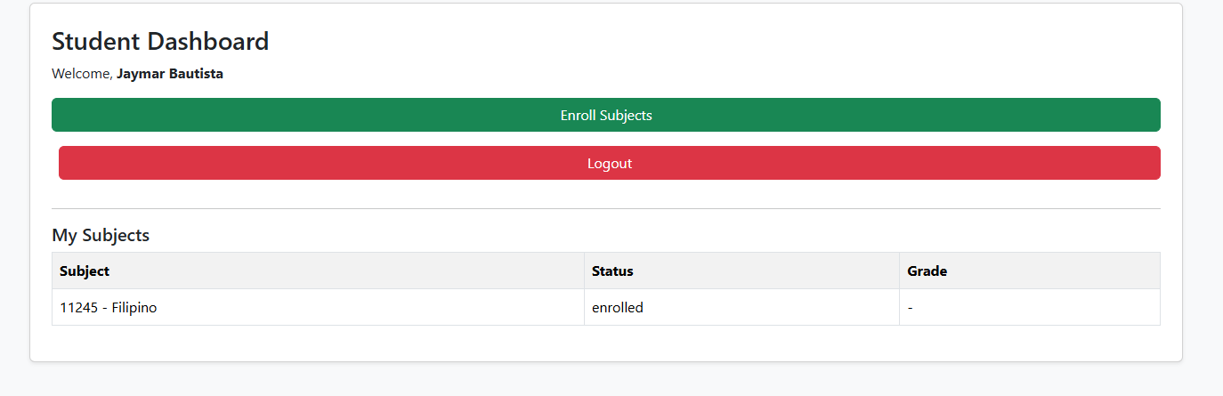

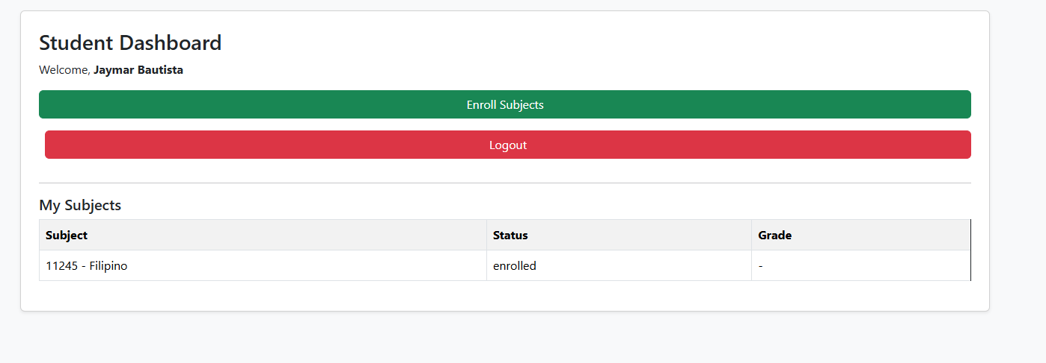

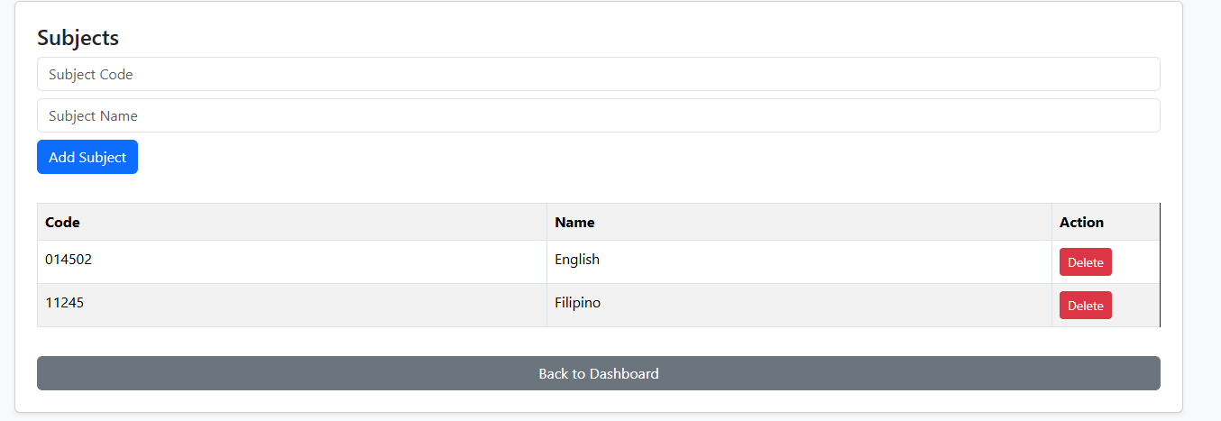

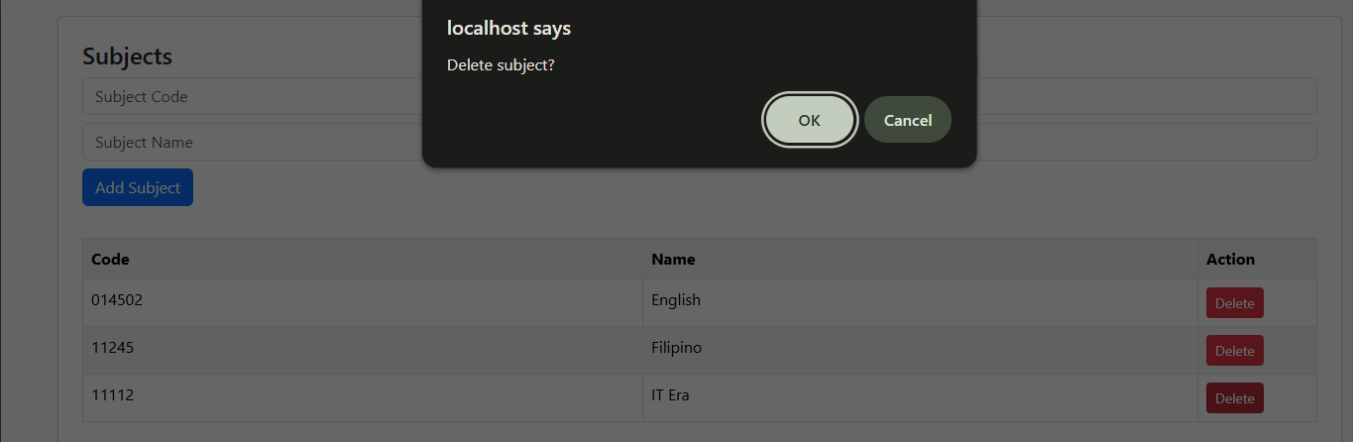

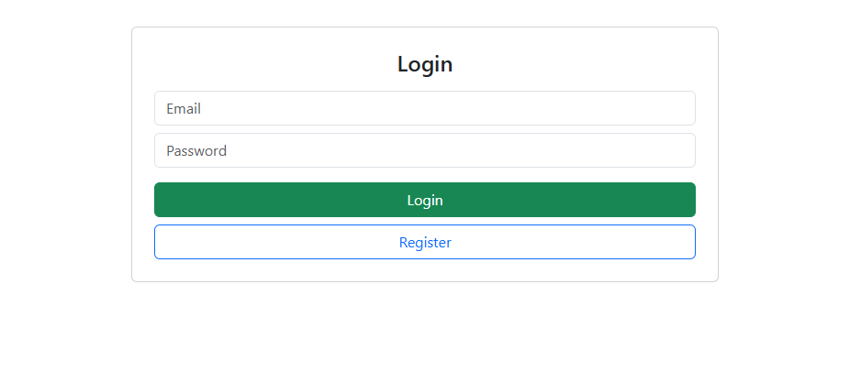

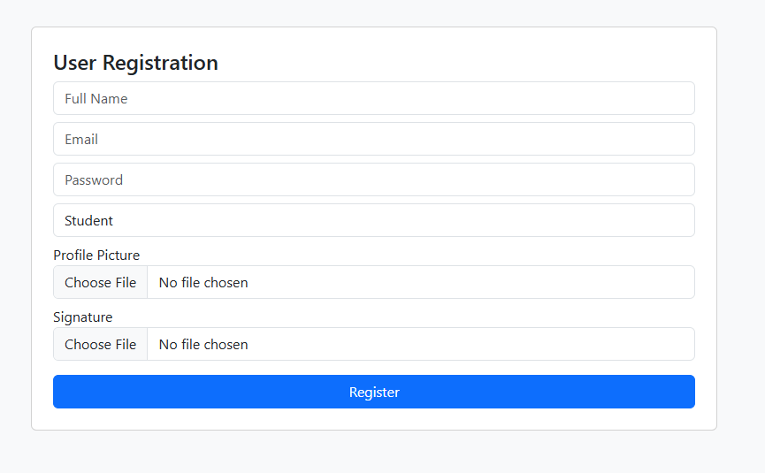

GitHub URL: https://github.com/jaymarBautista/WEB_SYSTEM_JAYMAR_BAUTISTA.git

Source Code

<?php
include 'database.php';

if (!isset($_SESSION['role']) || $_SESSION['role'] !== 'admin') {
header("Location: login.php");
exit;
}

if (isset($_GET['del'])) {
$id = (int)$_GET['del'];
$conn->query("DELETE FROM subjects WHERE id=$id");
}
?>
<!DOCTYPE html>
<html>
<head>
<title>Manage Subjects</title>
<link href="https://cdn.jsdelivr.net/npm/bootstrap@5.3.3/dist/css/bootstrap.min.css" rel="stylesheet">
</head>
<body class="bg-light">

<div class="container mt-4">
<div class="card p-4 shadow-sm">
<h4>Subjects</h4>

<form method="POST" class="mb-3">
<input name="code" class="form-control mb-2" placeholder="Subject Code" required>
<input name="name" class="form-control mb-2" placeholder="Subject Name" required>
<button name="add" class="btn btn-primary">Add Subject</button>
</form>

<?php
if (isset($_POST['add'])) {
$conn->query("INSERT INTO subjects (code,name) VALUES ('$_POST[code]','$_POST[name]')");
}
?>

<table class="table table-bordered table-striped mt-3">
<tr>
<th>Code</th>
<th>Name</th>
<th width="120">Action</th>
</tr>

<?php
$r = $conn->query("SELECT * FROM subjects");
while ($row = $r->fetch_assoc()) {
?>
<tr>
<td><?= htmlspecialchars($row['code']) ?></td>
<td><?= htmlspecialchars($row['name']) ?></td>
<td>
<a href="?del=<?= $row['id'] ?>"
class="btn btn-danger btn-sm"
onclick="return confirm('Delete subject?')">
Delete
</a>
</td>
</tr>
<?php } ?>
</table>

<a href="dashboard_admin.php" class="btn btn-secondary mt-3">
Back to Dashboard
</a>
</div>
</div>

</body>
</html>
<?php include 'database.php'; ?>
<!DOCTYPE html>
<html>
<head>
<link rel="stylesheet" href="bootstrap.min.css">
</head>
<body class="bg-light">
<div class="container col-md-5 mt-5">
<form method="POST" enctype="multipart/form-data" class="card p-4">
<h4>User Registration</h4>
<input name="fullname" class="form-control mb-2" placeholder="Full Name" required>
<input name="email" type="email" class="form-control mb-2" placeholder="Email" required>
<input name="password" type="password" class="form-control mb-2" placeholder="Password" required>
<select name="role" class="form-control mb-2" required>
<option value="student">Student</option>
<option value="faculty">Faculty</option>
<option value="admin">Admin</option>
</select>
<label>Profile Picture</label>
<input type="file" name="profile" class="form-control mb-2" required>
<label>Signature</label>
<input type="file" name="signature" class="form-control mb-3" required>
<button name="save" class="btn btn-primary w-100">Register</button>
</form>
</div>
</body>
</html>

<?php
if(isset($_POST['save'])){
if(!is_dir('uploads_profiles')) mkdir('uploads_profiles');
if(!is_dir('uploads_signatures')) mkdir('uploads_signatures');

$profile = time().$_FILES['profile']['name'];
$signature = time().$_FILES['signature']['name'];

move_uploaded_file($_FILES['profile']['tmp_name'], "uploads_profiles/$profile");
move_uploaded_file($_FILES['signature']['tmp_name'], "uploads_signatures/$signature");

$pass = password_hash($_POST['password'], PASSWORD_DEFAULT);
$conn->query("INSERT INTO users VALUES (NULL,'$_POST[role]','$_POST[fullname]','$_POST[email]','$pass','$profile','$signature')");
header('location:login.php');
}
?>
<?php
include 'database.php';

if (!isset($_SESSION['role']) || $_SESSION['role'] !== 'admin') {
header("Location: login.php");
exit;
}

if (isset($_POST['save'])) {
$subject = $_POST['subject_id'];
$prereq = $_POST['prerequisite_id'];

if ($subject != $prereq) {
$conn->query("INSERT INTO prerequisites (subject_id, prerequisite_id)
VALUES ($subject, $prereq)");
}
}
?>
<!DOCTYPE html>
<html>
<head>
<title>Subject Prerequisites</title>
<link href="https://cdn.jsdelivr.net/npm/bootstrap@5.3.3/dist/css/bootstrap.min.css" rel="stylesheet">
</head>
<body class="bg-light">

<div class="container mt-4">
<h4>Set Subject Prerequisites</h4>

<form method="POST" class="row g-2 mb-4">
<div class="col-md-5">
<label>Subject</label>
<select name="subject_id" class="form-control" required>
<option value="">-- Select Subject --</option>
<?php
$s = $conn->query("SELECT * FROM subjects");
while ($row = $s->fetch_assoc()) {
echo "<option value='{$row['id']}'>
{$row['code']} - {$row['name']}
</option>";
}
?>
</select>
</div>

<div class="col-md-5">
<label>Prerequisite Subject</label>
<select name="prerequisite_id" class="form-control" required>
<option value="">-- Select Prerequisite --</option>
<?php
$p = $conn->query("SELECT * FROM subjects");
while ($row = $p->fetch_assoc()) {
echo "<option value='{$row['id']}'>
{$row['code']} - {$row['name']}
</option>";
}
?>
</select>
</div>

<div class="col-md-2 d-flex align-items-end">
<button name="save" class="btn btn-primary w-100">
Save
</button>
</div>
</form>

<h5>Existing Prerequisites</h5>
<table class="table table-bordered">
<tr>
<th>Subject</th>
<th>Prerequisite</th>
</tr>

<?php
$list = $conn->query("
SELECT
s.code subj_code, s.name subj_name,
p.code pre_code, p.name pre_name
FROM prerequisites pr
JOIN subjects s ON pr.subject_id = s.id
JOIN subjects p ON pr.prerequisite_id = p.id
");

while ($row = $list->fetch_assoc()) {
?>
<tr>
<td><?= $row['subj_code'] ?> - <?= $row['subj_name'] ?></td>
<td><?= $row['pre_code'] ?> - <?= $row['pre_name'] ?></td>
</tr>
<?php } ?>
</table>

<a href="dashboard_admin.php" class="btn btn-secondary mt-3">
Back to Dashboard
</a>
</div>

</body>
</html>
<?php
session_start();
session_destroy();
header("Location: login.php");
exit;
?>
<?php include 'database.php'; ?>

<form method="POST" class="container col-md-4 mt-5 card p-4">
<h4 class="text-center mb-3">Login</h4>

<input name="email" class="form-control mb-2" placeholder="Email" required>
<input name="password" type="password" class="form-control mb-3" placeholder="Password" required>

<button name="login" class="btn btn-success w-100 mb-2">Login</button>

<a href="register.php" class="btn btn-outline-primary w-100">
Register
</a>
</form>

<?php
if (isset($_POST['login'])) {

$email = $conn->real_escape_string($_POST['email']);
$res = $conn->query("SELECT * FROM users WHERE email='$email'");

if ($res->num_rows === 1) {
$u = $res->fetch_assoc();

if (password_verify($_POST['password'], $u['password'])) {
$_SESSION['id'] = $u['id'];
$_SESSION['fullname'] = $u['fullname'];
$_SESSION['role'] = $u['role'];

header("Location: dashboard_{$u['role']}.php");
exit;
}
}

echo "<div class='text-danger text-center mt-2'>Invalid email or password</div>";
}
?>
<head>
<link rel="stylesheet" href="bootstrap.min.css">
</head>
<?php
$conn = new mysqli("localhost", "root", "", "enrollment_system");

if ($conn->connect_error) {
die("DB Error: " . $conn->connect_error);
}

session_start();
?>
<?php
include "database.php";

if (!isset($_SESSION['role']) || $_SESSION['role'] !== 'student') {
header("Location: login.php");
exit;
}
?>
<!DOCTYPE html>
<html>
<head>
<title>Student Dashboard</title>
<!-- USE CDN, NOT LOCAL FILE -->
<link href="https://cdn.jsdelivr.net/npm/bootstrap@5.3.3/dist/css/bootstrap.min.css" rel="stylesheet">
</head>
<body class="bg-light">

<div class="container mt-4">
<div class="card shadow-sm p-4">

<h3>Student Dashboard</h3>
<p>Welcome, <strong><?= htmlspecialchars($_SESSION['fullname']) ?></strong></p>

<a href="enroll.php" class="btn btn-success mb-3">Enroll Subjects</a>
<a href="logout.php" class="btn btn-danger mb-3 ms-2">Logout</a>

<hr>

<h5>My Subjects</h5>
<table class="table table-bordered table-striped">
<tr>
<th>Subject</th>
<th>Status</th>
<th>Grade</th>
</tr>

<?php
$id = (int)$_SESSION['id'];
$r = $conn->query("
SELECT s.code, s.name, e.status, e.grade
FROM enrollments e
JOIN subjects s ON e.subject_id = s.id
WHERE e.student_id = $id
");

if ($r->num_rows == 0) {
echo "<tr><td colspan='3' class='text-center'>No enrolled subjects</td></tr>";
}

while ($row = $r->fetch_assoc()) {
?>
<tr>
<td><?= htmlspecialchars($row['code']) ?> - <?= htmlspecialchars($row['name']) ?></td>
<td><?= htmlspecialchars($row['status'] ?? 'ongoing') ?></td>
<td><?= htmlspecialchars($row['grade'] ?? '-') ?></td>
</tr>
<?php } ?>
</table>

</div>
</div>

</body>
</html>
<?php
include "database.php";

if (!isset($_SESSION['role']) || $_SESSION['role'] !== 'faculty') {
header("Location: login.php");
exit;
}
?>
<!DOCTYPE html>
<html>
<head>
<title>Faculty Dashboard</title>
<link rel="stylesheet" href="bootstrap.min.css">
</head>
<body class="bg-light">

<div class="container mt-4">
<h3>Faculty Dashboard</h3>
<p>Welcome, <strong><?= $_SESSION['fullname'] ?></strong></p>

<a href="grades.php" class="btn btn-primary mb-2">Manage Grades</a>
<br><br>
<a href="logout.php" class="btn btn-danger">Logout</a>
</div>

</body>
</html>
<?php
include "database.php";

if (!isset($_SESSION['role']) || $_SESSION['role'] !== 'admin') {
header("Location: login.php");
exit;
}
?>
<!DOCTYPE html>
<html>
<head>
<title>Admin Dashboard</title>
<link rel="stylesheet" href="bootstrap.min.css">
</head>
<body class="bg-light">

<div class="container mt-4">
<h3>Administrator Dashboard</h3>
<p>Welcome, <strong><?= $_SESSION['fullname'] ?></strong></p>

<a href="subjects.php" class="btn btn-primary mb-2">Manage Subjects</a>
<a href="prerequisites.php" class="btn btn-secondary mb-2">Set Prerequisites</a>
<br><br>
<a href="logout.php" class="btn btn-danger">Logout</a>
</div>

</body>
</html>

STUDENT PORTFOLIO
Web Systems & Technologies 1
1st Term, A.Y. 2025-2026

Name: Bautista, Jaymar V. Year & Section: BSIT 3A-WM
Activity: Finals – Thesis Archives System Subject: WebSys1

Description
I developed the Digital Thesis Archive System, a sophisticated document management platform designed to streamline the lifecycle of academic research from submission to archival. Built with a PHP backend and a MySQL database, the system utilizes a Role-Based Access Control (RBAC) architecture that provides tailored interfaces for Students, Reviewers, and Administrators. This ensures that while students can submit their work and search the archive, only authorized Reviewers can approve or reject submissions, and only Administrators can manage the entire user database. To maintain high security standards, I implemented Prepared Statements to prevent SQL injection and utilized password_hash() for secure credential storage, alongside a unique file-naming convention using system timestamps to manage PDF uploads efficiently.
The user experience is enhanced by a modern, responsive Bootstrap 5 dashboard that features intuitive "icon-boxes" for navigation and real-time status badges. Key functionalities include a robust Search Engine that filters for approved research, a Review Decision Module that logs reviewer comments and actions, and an Admin Control Panel for overseeing account distributions. By combining complex relational database logic with a professional-grade UI, I created a centralized hub that ensures academic integrity through a transparent review process while providing an accessible repository for verified scholarly work.

Screenshot
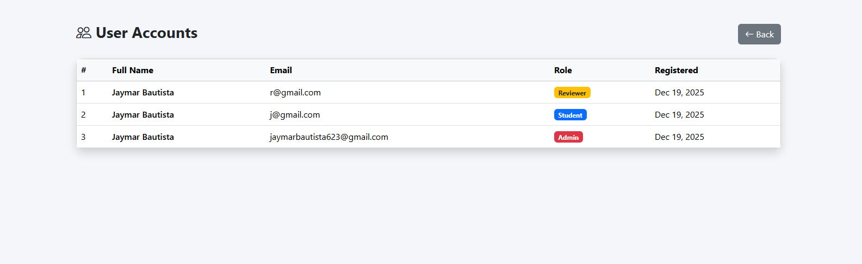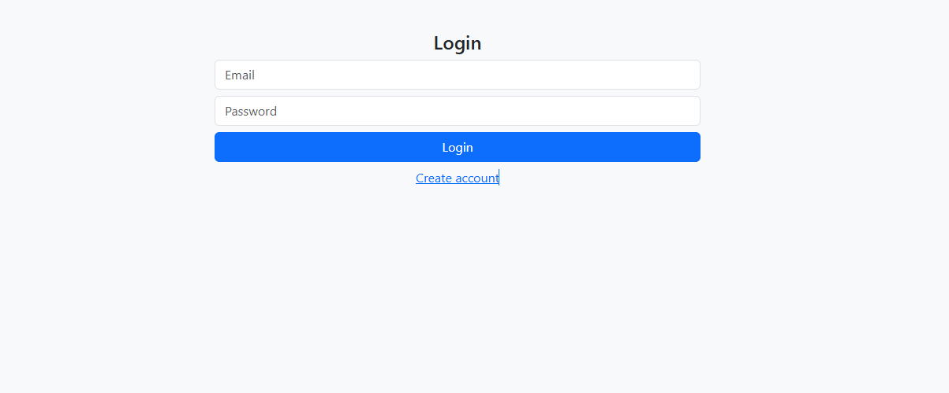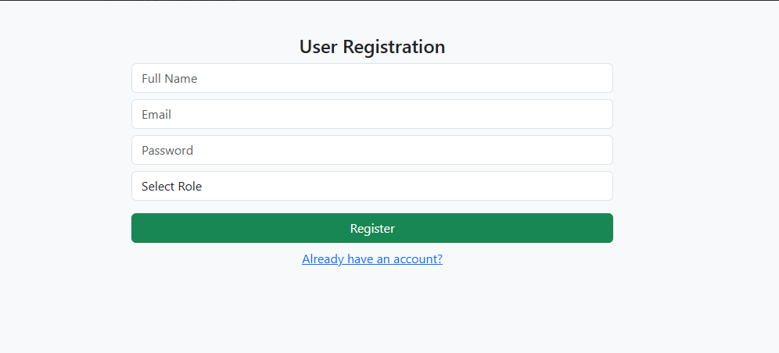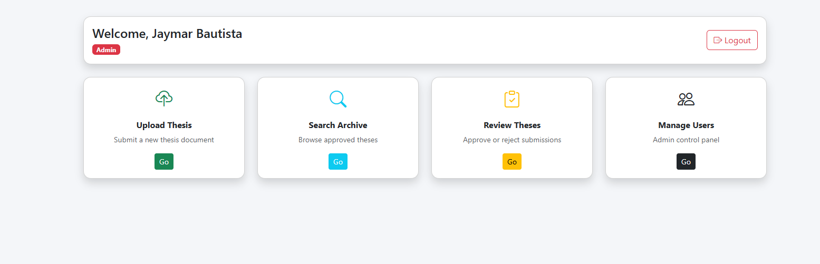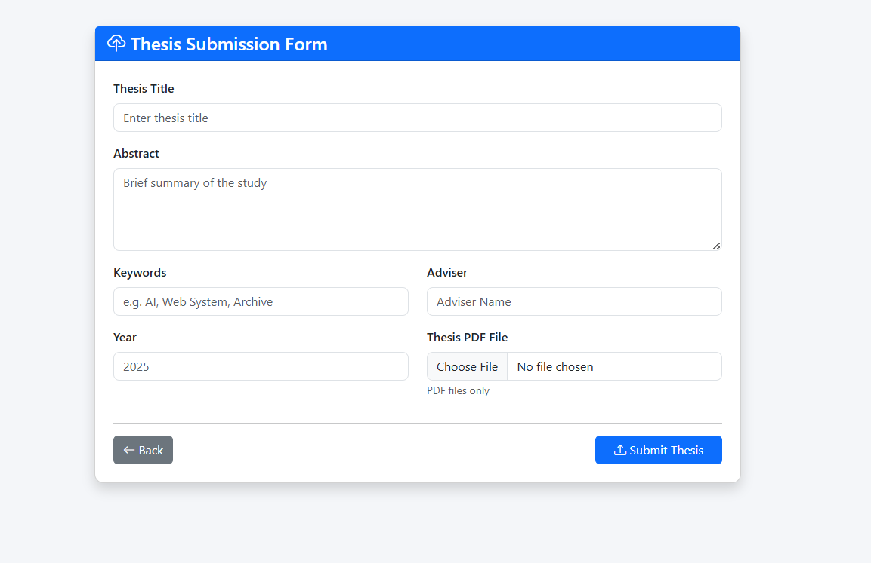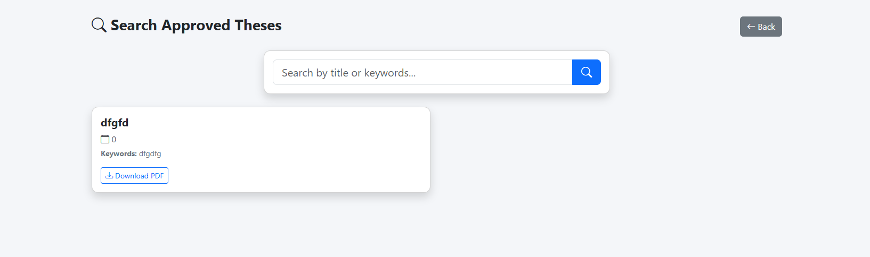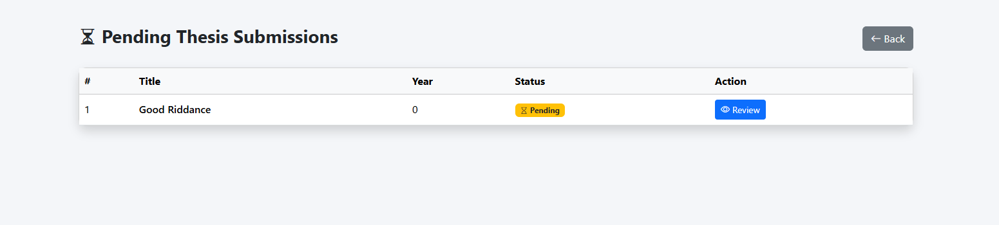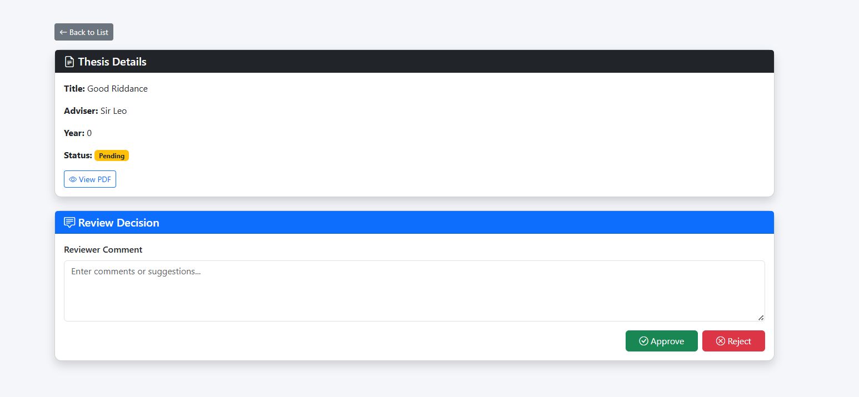

GitHub URL: https://github.com/jaymarBautista/WEB_SYSTEM_JAYMAR_BAUTISTA.git

Source Code

<?php
include 'database.php';
if(!isset($_SESSION['user'])) header('Location: login.php');
?>
<!DOCTYPE html>
<html lang="en">
<head>
<meta charset="UTF-8">
<title>Dashboard</title>
<meta name="viewport" content="width=device-width, initial-scale=1">

<link href="https://cdn.jsdelivr.net/npm/bootstrap@5.3.3/dist/css/bootstrap.min.css" rel="stylesheet">
<link href="https://cdn.jsdelivr.net/npm/bootstrap-icons/font/bootstrap-icons.css" rel="stylesheet">

<style>
body{ background:#f4f6f9; }
.card{ border-radius:14px; transition:.2s; }
.card:hover{ transform:translateY(-4px); }
.icon-box{
font-size:2rem;
}
</style>
</head>

<body>

<div class="container py-5">

<div class="card shadow mb-4">
<div class="card-body d-flex justify-content-between align-items-center">
<div>
<h4 class="mb-1">Welcome, <?= htmlspecialchars($_SESSION['user']['fullname']) ?></h4>
<span class="badge
<?= $_SESSION['user']['role']=='admin' ? 'bg-danger' : ($_SESSION['user']['role']=='reviewer' ? 'bg-warning text-dark' : 'bg-primary') ?>">
<?= ucfirst($_SESSION['user']['role']) ?>
</span>
</div>

<a href="logout.php" class="btn btn-outline-danger">
<i class="bi bi-box-arrow-right"></i> Logout
</a>
</div>
</div>

<div class="row g-4">

<div class="col-md-6 col-lg-3">
<div class="card shadow h-100">
<div class="card-body text-center">
<div class="icon-box text-success mb-3">
<i class="bi bi-cloud-upload"></i>
</div>
<h6 class="fw-bold">Upload Thesis</h6>
<p class="small text-muted">Submit a new thesis document</p>
<a href="upload_thesis.php" class="btn btn-success btn-sm">
Go
</a>
</div>
</div>
</div>

<div class="col-md-6 col-lg-3">
<div class="card shadow h-100">
<div class="card-body text-center">
<div class="icon-box text-info mb-3">
<i class="bi bi-search"></i>
</div>
<h6 class="fw-bold">Search Archive</h6>
<p class="small text-muted">Browse approved theses</p>
<a href="search.php" class="btn btn-info btn-sm text-white">
Go
</a>
</div>
</div>
</div>

<?php if($_SESSION['user']['role']!='student'): ?>

<div class="col-md-6 col-lg-3">
<div class="card shadow h-100">
<div class="card-body text-center">
<div class="icon-box text-warning mb-3">
<i class="bi bi-clipboard-check"></i>
</div>
<h6 class="fw-bold">Review Theses</h6>
<p class="small text-muted">Approve or reject submissions</p>
<a href="review_list.php" class="btn btn-warning btn-sm">
Go
</a>
</div>
</div>
</div>
<?php endif; ?>

<?php if($_SESSION['user']['role']=='admin'): ?>

<div class="col-md-6 col-lg-3">
<div class="card shadow h-100">
<div class="card-body text-center">
<div class="icon-box text-dark mb-3">
<i class="bi bi-people"></i>
</div>
<h6 class="fw-bold">Manage Users</h6>
<p class="small text-muted">Admin control panel</p>
<a href="manage_users.php" class="btn btn-dark btn-sm">
Go
</a>
</div>
</div>
</div>
<?php endif; ?>

</div>

</div>

</body>
</html>
<?php
$conn = new mysqli('localhost','root','','thesis_archive');
if($conn->connect_error){ die('DB Error'); }
session_start();
?>
<?php include 'database.php'; ?>
<!DOCTYPE html>
<html>
<head>
<link href="https://cdn.jsdelivr.net/npm/bootstrap@5.3.3/dist/css/bootstrap.min.css" rel="stylesheet">
</head>
<body class="bg-light">
<div class="container col-md-4 mt-5">
<form method="post">
<h4 class="text-center">Login</h4>
<input class="form-control mb-2" type="email" name="email" placeholder="Email" required>
<input class="form-control mb-2" type="password" name="password" placeholder="Password" required>
<button class="btn btn-primary w-100" name="login">Login</button>
<a href="register.php" class="d-block text-center mt-2">Create account</a>
</form>
<?php
if(isset($_POST['login'])){
$stmt=$conn->prepare("SELECT * FROM users WHERE email=?");
$stmt->bind_param('s',$_POST['email']);
$stmt->execute();
$u=$stmt->get_result()->fetch_assoc();

if($u && password_verify($_POST['password'],$u['password'])){
$_SESSION['user']=$u;
header('Location: dashboard.php');
} else {
echo '<div class="alert alert-danger">Invalid login</div>';
}
}
?>
</div>
</body>
</html>
<?php
session_start();
session_destroy();
header('Location: login.php'); ?>
<?php
include 'database.php';
if(!isset($_SESSION['user']) || $_SESSION['user']['role']!='admin'){
header('Location: dashboard.php');
}
?>
<!DOCTYPE html>
<html lang="en">
<head>
<meta charset="UTF-8">
<title>Manage Users</title>
<meta name="viewport" content="width=device-width, initial-scale=1">

<link href="https://cdn.jsdelivr.net/npm/bootstrap@5.3.3/dist/css/bootstrap.min.css" rel="stylesheet">
<link href="https://cdn.jsdelivr.net/npm/bootstrap-icons/font/bootstrap-icons.css" rel="stylesheet">

<style>
body{ background:#f4f6f9; }
.card{ border-radius:12px; }
</style>
</head>

<body>

<div class="container py-5">

<div class="d-flex justify-content-between align-items-center mb-4">
<h3 class="fw-bold">
<i class="bi bi-people"></i> User Accounts
</h3>
<a href="dashboard.php" class="btn btn-secondary">
<i class="bi bi-arrow-left"></i> Back
</a>
</div>

<div class="card shadow">
<div class="card-body p-0">

<table class="table table-hover align-middle mb-0">
<thead class="table-light">
<tr>
<th>#</th>
<th>Full Name</th>
<th>Email</th>
<th>Role</th>
<th>Registered</th>
</tr>
</thead>
<tbody>

<?php
$res = $conn->query("SELECT * FROM users ORDER BY created_at DESC");
$no = 1;

while($u = $res->fetch_assoc()):
?>

<tr>
<td><?= $no++ ?></td>
<td class="fw-semibold"><?= htmlspecialchars($u['fullname']) ?></td>
<td><?= htmlspecialchars($u['email']) ?></td>
<td>
<span class="badge
<?= $u['role']=='admin' ? 'bg-danger' : ($u['role']=='reviewer' ? 'bg-warning text-dark' : 'bg-primary') ?>">
<?= ucfirst($u['role']) ?>
</span>
</td>
<td><?= date('M d, Y', strtotime($u['created_at'])) ?></td>
</tr>

<?php endwhile; ?>

</tbody>
</table>

</div>
</div>

</div>

</body>
</html>
<?php include 'database.php'; ?>
<!DOCTYPE html>
<html>
<head>
<link href="https://cdn.jsdelivr.net/npm/bootstrap@5.3.3/dist/css/bootstrap.min.css" rel="stylesheet">
</head>
<body class="bg-light">
<div class="container col-md-4 mt-5">

<form method="post">
<h4 class="text-center">User Registration</h4>

<input class="form-control mb-2" name="fullname" placeholder="Full Name" required>

<input class="form-control mb-2" type="email" name="email" placeholder="Email" required>

<input class="form-control mb-2" type="password" name="password" placeholder="Password" required>

<select class="form-control mb-3" name="role" required>
<option value="">Select Role</option>
<option value="student">Student</option>
<option value="reviewer">Reviewer</option>
<option value="admin">Admin</option>
</select>

<button class="btn btn-success w-100" name="register">Register</button>

<a href="login.php" class="d-block text-center mt-2">Already have an account?</a>
</form>

<?php
if(isset($_POST['register'])){
$fullname = $_POST['fullname'];
$email = $_POST['email'];
$role = $_POST['role'];
$hash = password_hash($_POST['password'], PASSWORD_DEFAULT);

$stmt = $conn->prepare(
"INSERT INTO users (fullname,email,password,role) VALUES (?,?,?,?)"
);
$stmt->bind_param('ssss', $fullname, $email, $hash, $role);

if($stmt->execute()){
echo '<div class="alert alert-success mt-2">Registered successfully</div>';
} else {
echo '<div class="alert alert-danger mt-2">Email already exists</div>';
}
}
?>

</div>
</body>
</html>
<?php
include 'database.php';
if(!isset($_SESSION['user']) || $_SESSION['user']['role']=='student'){
header('Location: dashboard.php');
}
?>
<!DOCTYPE html>
<html lang="en">
<head>
<meta charset="UTF-8">
<title>Pending Theses</title>
<meta name="viewport" content="width=device-width, initial-scale=1">

<link href="https://cdn.jsdelivr.net/npm/bootstrap@5.3.3/dist/css/bootstrap.min.css" rel="stylesheet">
<link href="https://cdn.jsdelivr.net/npm/bootstrap-icons/font/bootstrap-icons.css" rel="stylesheet">

<style>
body{
background:#f4f6f9;
}
.card{
border-radius:12px;
}
</style>
</head>

<body>

<div class="container py-5">

<div class="d-flex justify-content-between align-items-center mb-4">
<h3 class="fw-bold">
<i class="bi bi-hourglass-split"></i> Pending Thesis Submissions
</h3>
<a href="dashboard.php" class="btn btn-secondary">
<i class="bi bi-arrow-left"></i> Back
</a>
</div>

<div class="card shadow">
<div class="card-body p-0">

<table class="table table-hover align-middle mb-0">
<thead class="table-light">
<tr>
<th>#</th>
<th>Title</th>
<th>Year</th>
<th>Status</th>
<th>Action</th>
</tr>
</thead>
<tbody>

<?php
$res = $conn->query("SELECT * FROM thesis WHERE status='Pending'");
$no = 1;

if($res->num_rows == 0){
echo "<tr><td colspan='5' class='text-center text-muted py-4'>
No pending submissions
</td></tr>";
}

while($r = $res->fetch_assoc()):
?>

<tr>
<td><?= $no++ ?></td>
<td class="fw-semibold"><?= htmlspecialchars($r['title']) ?></td>
<td><?= $r['year'] ?></td>
<td>
<span class="badge bg-warning text-dark">
<i class="bi bi-hourglass"></i> Pending
</span>
</td>
<td>
<a href="review_thesis.php?id=<?= $r['id'] ?>" class="btn btn-sm btn-primary">
<i class="bi bi-eye"></i> Review
</a>
</td>
</tr>

<?php endwhile; ?>

</tbody>
</table>

</div>
</div>

</div>

</body>
</html>
<?php
include 'database.php';
if(!isset($_SESSION['user']) || $_SESSION['user']['role']=='student'){
header('Location: dashboard.php');
}

$id = intval($_GET['id']);

// fetch thesis info
$thesis = $conn->query("SELECT * FROM thesis WHERE id=$id")->fetch_assoc();
?>
<!DOCTYPE html>
<html lang="en">
<head>
<meta charset="UTF-8">
<title>Review Thesis</title>
<meta name="viewport" content="width=device-width, initial-scale=1">

<link href="https://cdn.jsdelivr.net/npm/bootstrap@5.3.3/dist/css/bootstrap.min.css" rel="stylesheet">
<link href="https://cdn.jsdelivr.net/npm/bootstrap-icons/font/bootstrap-icons.css" rel="stylesheet">

<style>
body{ background:#f4f6f9; }
.card{ border-radius:12px; }
</style>
</head>

<body>

<div class="container py-5">

<div class="mb-3">
<a href="review_list.php" class="btn btn-secondary btn-sm">
<i class="bi bi-arrow-left"></i> Back to List
</a>
</div>

<div class="card shadow mb-4">
<div class="card-header bg-dark text-white">
<h5 class="mb-0">
<i class="bi bi-file-earmark-text"></i> Thesis Details
</h5>
</div>

<div class="card-body">
<p><strong>Title:</strong> <?= htmlspecialchars($thesis['title']) ?></p>
<p><strong>Adviser:</strong> <?= htmlspecialchars($thesis['adviser']) ?></p>
<p><strong>Year:</strong> <?= $thesis['year'] ?></p>
<p>
<strong>Status:</strong>
<span class="badge bg-warning text-dark">Pending</span>
</p>

<a href="<?= $thesis['file'] ?>" target="_blank" class="btn btn-outline-primary btn-sm">
<i class="bi bi-eye"></i> View PDF
</a>
</div>
</div>

<div class="card shadow">
<div class="card-header bg-primary text-white">
<h5 class="mb-0">
<i class="bi bi-chat-square-text"></i> Review Decision
</h5>
</div>

<div class="card-body">

<form method="post">

<div class="mb-3">
<label class="form-label fw-semibold">Reviewer Comment</label>
<textarea class="form-control" name="comment" rows="4" placeholder="Enter comments or suggestions..."></textarea>
</div>

<div class="d-flex justify-content-end gap-2">
<button name="approve" class="btn btn-success px-4">
<i class="bi bi-check-circle"></i> Approve
</button>

<button name="reject" class="btn btn-danger px-4">
<i class="bi bi-x-circle"></i> Reject
</button>
</div>

</form>

</div>
</div>

<?php
if(isset($_POST['approve']) || isset($_POST['reject'])){
$action = isset($_POST['approve']) ? 'Approved' : 'Rejected';
$comment = $conn->real_escape_string($_POST['comment']);
$reviewer = $_SESSION['user']['id'];

$conn->query("UPDATE thesis SET status='$action' WHERE id=$id");
$conn->query(
"INSERT INTO review_logs (thesis_id, reviewer_id, comment, action)
VALUES ($id, $reviewer, '$comment', '$action')"
);

echo '<div class="alert alert-success mt-3">
<i class="bi bi-check-circle"></i> Review submitted successfully
</div>';
}
?>

</div>

</body>
</html>
<?php
include 'database.php';
if(!isset($_SESSION['user'])) header('Location: login.php');

$q = $_GET['q'] ?? '';
?>
<!DOCTYPE html>
<html lang="en">
<head>
<meta charset="UTF-8">
<title>Search Theses</title>
<meta name="viewport" content="width=device-width, initial-scale=1">

<link href="https://cdn.jsdelivr.net/npm/bootstrap@5.3.3/dist/css/bootstrap.min.css" rel="stylesheet">
<link href="https://cdn.jsdelivr.net/npm/bootstrap-icons/font/bootstrap-icons.css" rel="stylesheet">

<style>
body{ background:#f4f6f9; }
.card{ border-radius:12px; }
.search-box{ max-width:650px; margin:auto; }
</style>
</head>

<body>

<div class="container py-5">

<div class="d-flex justify-content-between align-items-center mb-4">
<h3 class="fw-bold">
<i class="bi bi-search"></i> Search Approved Theses
</h3>
<a href="dashboard.php" class="btn btn-secondary">
<i class="bi bi-arrow-left"></i> Back
</a>
</div>

<!-- SEARCH BAR -->
<div class="card shadow mb-4 search-box">
<div class="card-body">
<form method="get" class="input-group input-group-lg">
<input
class="form-control"
name="q"
value="<?= htmlspecialchars($q) ?>"
placeholder="Search by title or keywords..."
>
<button class="btn btn-primary">
<i class="bi bi-search"></i>
</button>
</form>
</div>
</div>

<!-- RESULTS -->
<div class="row">

<?php
$res = $conn->query(
"SELECT * FROM thesis
WHERE status='Approved'
AND (title LIKE '%$q%' OR keywords LIKE '%$q%')
ORDER BY year DESC"
);

if($res->num_rows == 0){
echo '<div class="text-center text-muted mt-5">
<i class="bi bi-journal-x fs-1"></i>
<p class="mt-2">No approved theses found</p>
</div>';
}

while($r = $res->fetch_assoc()):
?>

<div class="col-md-6 mb-4">
<div class="card shadow h-100">
<div class="card-body">

<h5 class="fw-bold">
<?= htmlspecialchars($r['title']) ?>
</h5>

<p class="mb-1 text-muted">
<i class="bi bi-calendar"></i> <?= $r['year'] ?>
</p>

<p class="small text-secondary">
<strong>Keywords:</strong> <?= htmlspecialchars($r['keywords']) ?>
</p>

<a href="<?= $r['file'] ?>" download class="btn btn-outline-primary btn-sm">
<i class="bi bi-download"></i> Download PDF
</a>

</div>
</div>
</div>

<?php endwhile; ?>

</div>

</div>

</body>
</html>
<?php
include 'database.php';
if(!isset($_SESSION['user'])) header('Location: login.php');
?>
<!DOCTYPE html>
<html lang="en">
<head>
<meta charset="UTF-8">
<title>Upload Thesis</title>
<meta name="viewport" content="width=device-width, initial-scale=1">

<link href="https://cdn.jsdelivr.net/npm/bootstrap@5.3.3/dist/css/bootstrap.min.css" rel="stylesheet">
<link href="https://cdn.jsdelivr.net/npm/bootstrap-icons/font/bootstrap-icons.css" rel="stylesheet">

<style>
body{
background: #f4f6f9;
}
.card{
border-radius: 12px;
}
.form-control{
border-radius: 8px;
}
</style>
</head>

<body>

<div class="container py-5">
<div class="row justify-content-center">
<div class="col-lg-8">

<div class="card shadow">
<div class="card-header bg-primary text-white">
<h4 class="mb-0">
<i class="bi bi-cloud-upload"></i> Thesis Submission Form
</h4>
</div>

<div class="card-body p-4">

<form method="post" enctype="multipart/form-data">

<div class="mb-3">
<label class="form-label fw-semibold">Thesis Title</label>
<input class="form-control" name="title" placeholder="Enter thesis title" required>
</div>

<div class="mb-3">
<label class="form-label fw-semibold">Abstract</label>
<textarea class="form-control" name="abstract" rows="4" placeholder="Brief summary of the study"></textarea>
</div>

<div class="row">
<div class="col-md-6 mb-3">
<label class="form-label fw-semibold">Keywords</label>
<input class="form-control" name="keywords" placeholder="e.g. AI, Web System, Archive">
</div>

<div class="col-md-6 mb-3">
<label class="form-label fw-semibold">Adviser</label>
<input class="form-control" name="adviser" placeholder="Adviser Name">
</div>
</div>

<div class="row">
<div class="col-md-6 mb-3">
<label class="form-label fw-semibold">Year</label>
<input class="form-control" type="number" name="year" placeholder="2025">
</div>

<div class="col-md-6 mb-3">
<label class="form-label fw-semibold">Thesis PDF File</label>
<input class="form-control" type="file" name="file" accept="application/pdf" required>
<small class="text-muted">PDF files only</small>
</div>
</div>

<hr>

<div class="d-flex justify-content-between">
<a href="dashboard.php" class="btn btn-secondary">
<i class="bi bi-arrow-left"></i> Back
</a>

<button class="btn btn-primary px-4" name="submit">
<i class="bi bi-upload"></i> Submit Thesis
</button>
</div>

</form>

</div>
</div>

<?php
if(isset($_POST['submit'])){
$file = time().'_'.$_FILES['file']['name'];
move_uploaded_file($_FILES['file']['tmp_name'], $file);

$stmt = $conn->prepare(
"INSERT INTO thesis(title,abstract,keywords,author_id,adviser,year,file)
VALUES(?,?,?,?,?,?,?)"
);
$stmt->bind_param(
'sssssis',
$_POST['title'],
$_POST['abstract'],
$_POST['keywords'],
$_SESSION['user']['id'],
$_POST['adviser'],
$_POST['year'],
$file
);
$stmt->execute();

echo '<div class="alert alert-success mt-3">
<i class="bi bi-check-circle"></i> Thesis submitted successfully
</div>';
}
?>

</div>
</div>
</div>

</body>
</html>

STUDENT PORTFOLIO
Web Systems & Technologies 1
1st Term, A.Y. 2025-2026

Name: Bautista, Jaymar V. Year & Section: BSIT 3A-WM
Activity: Examinations Subject: WebSys1

Midterm Written Exam

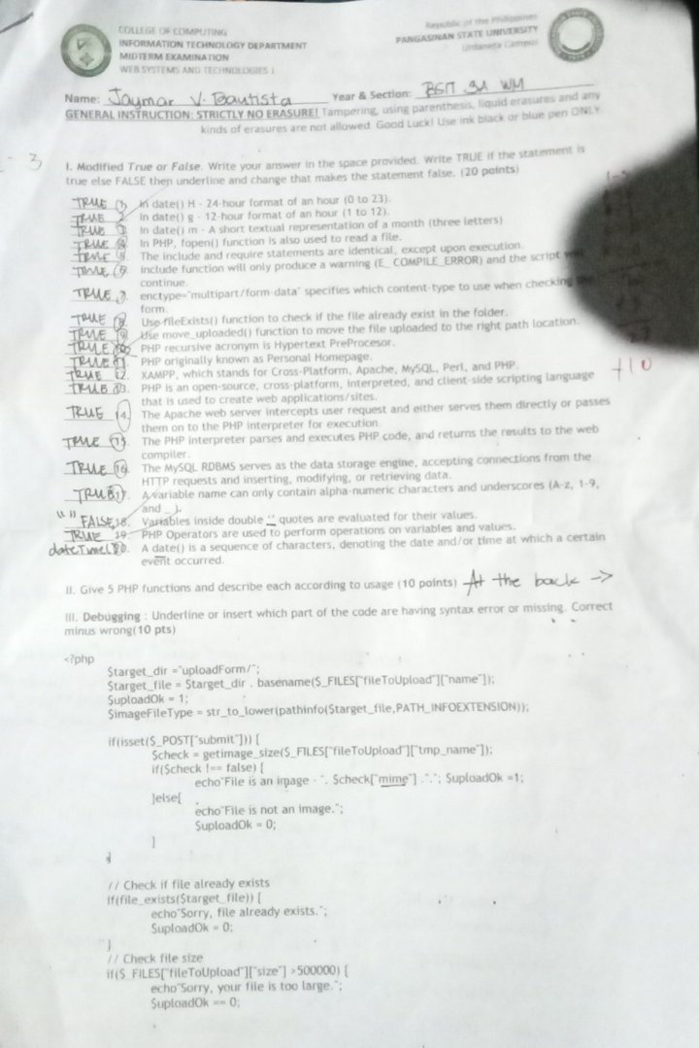

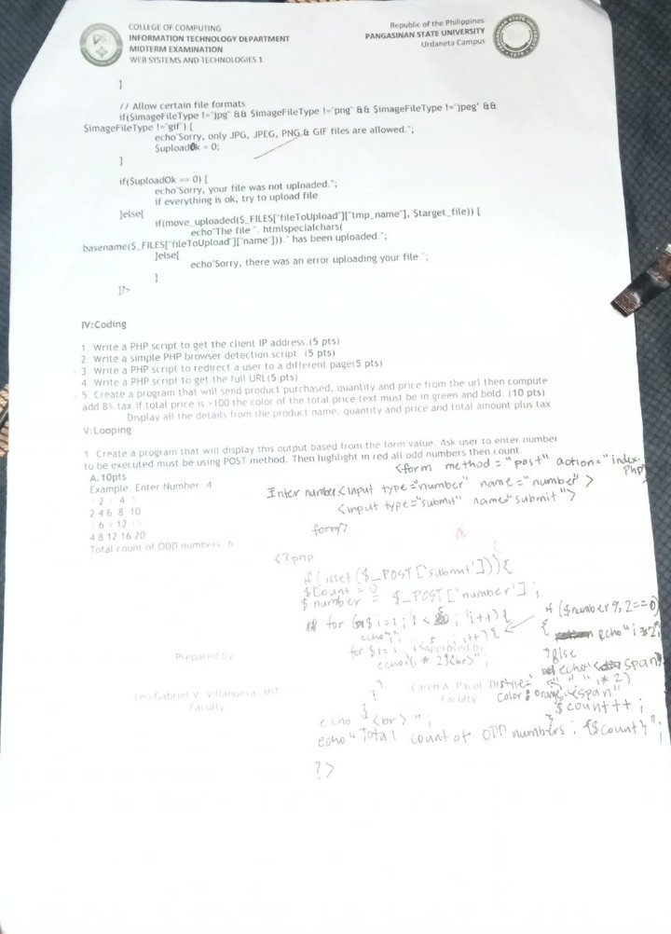

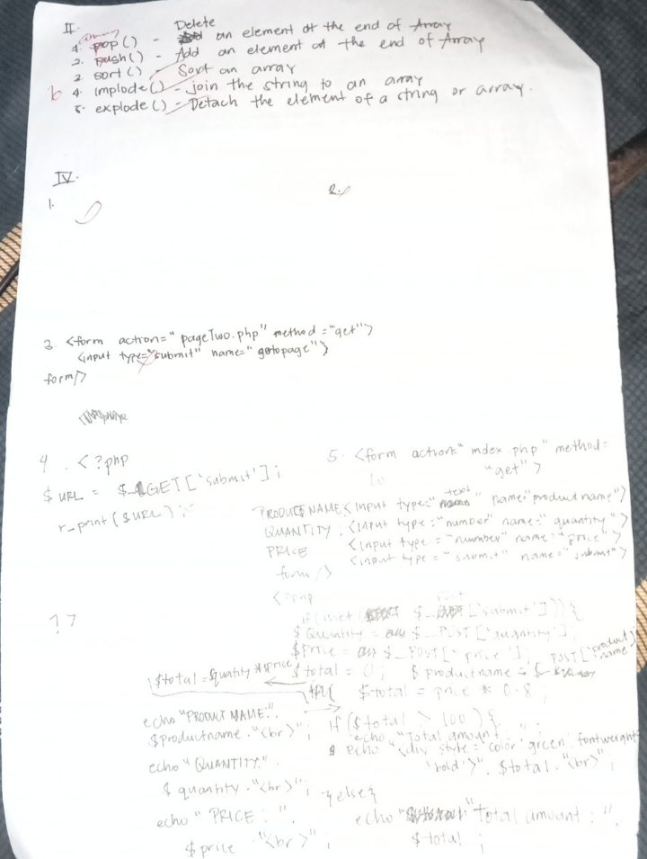

STUDENT PORTFOLIO
Web Systems & Technologies 1
1st Term, A.Y. 2025-2026

Name: Bautista, Jaymar V. Year & Section: BSIT 3A-WM
Activity: Endterm Requirement Subject: WebSys1

Description
In this collaborative project, the team of Eljohn Molina, Jaymar Bautista, and Ruff Lawrenze Buyao engineered a Job Portal System, a full-stack platform designed to automate and professionalize the recruitment process. The development was a coordinated effort where the team integrated a robust PHP backend with a dynamic, AJAX-driven frontend to create a seamless user experience. By implementing a Role-Based Access Control (RBAC) architecture, the team successfully separated the platform into two distinct workflows: a candidate-centric side for job seekers to browse and apply for roles, and a management-centric side for employers to track applicants and oversee the hiring lifecycle.
The technical execution of the project highlights the team's commitment to security and performance. Ruff Lawrenze Buyao and the team focused on backend integrity by utilizing Prepared Statements to prevent SQL injection and BCrypt hashing for secure user authentication. On the frontend, the team developed a custom-built CSS framework that utilizes modern Flexbox and Grid layouts, ensuring a responsive design that scales across all devices. Jaymar Bautista and the developers integrated AJAX modules to allow for real-time job filtering and status updates (such as "Shortlisted" or "Reviewed") without requiring page reloads, significantly enhancing the speed of the interface.
To ensure a high-quality user experience, Eljohn Molina and the group designed an intuitive dashboard featuring a "card-based" job grid and a sophisticated Toast Notification System for instant user feedback. The final system includes specialized features such as a secure resume upload handler, a multi-parameter search engine, and a detailed application tracking module. Through this collective effort, the team delivered a centralized, professional hub that balances complex relational database logic with a clean, scannable UI, effectively bridging the gap between professional talent and modern enterprises.

Screenshots

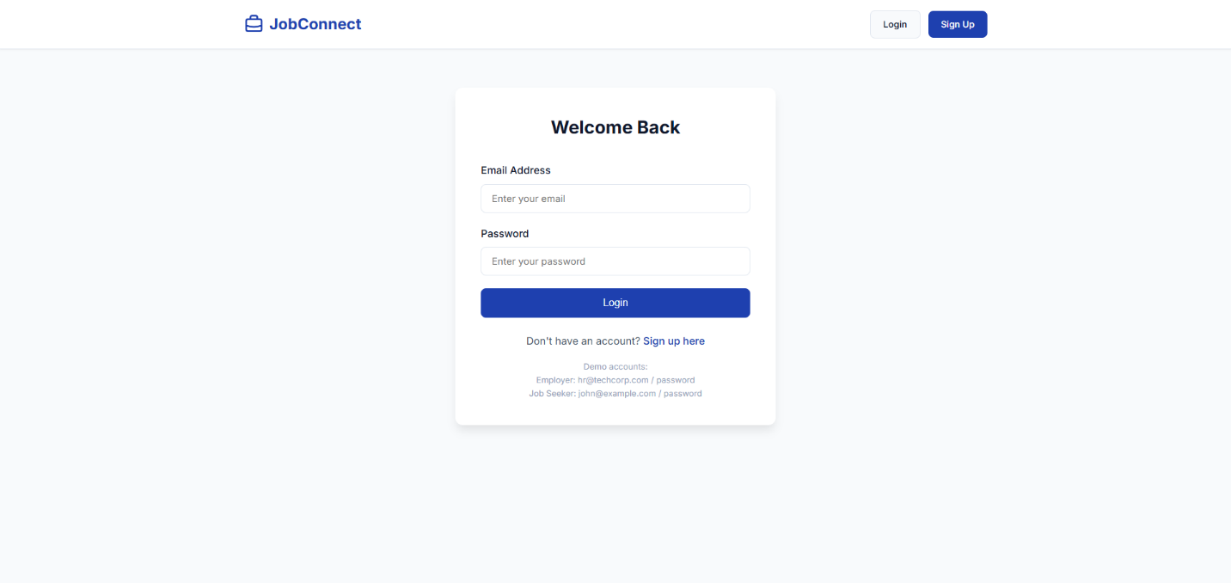

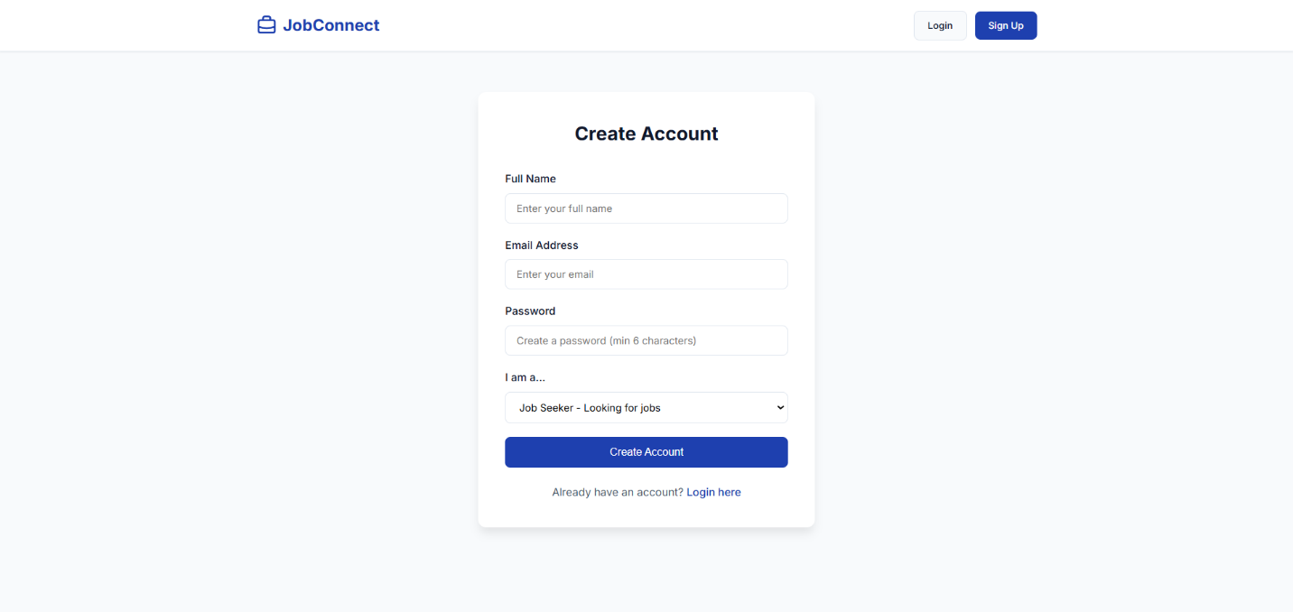

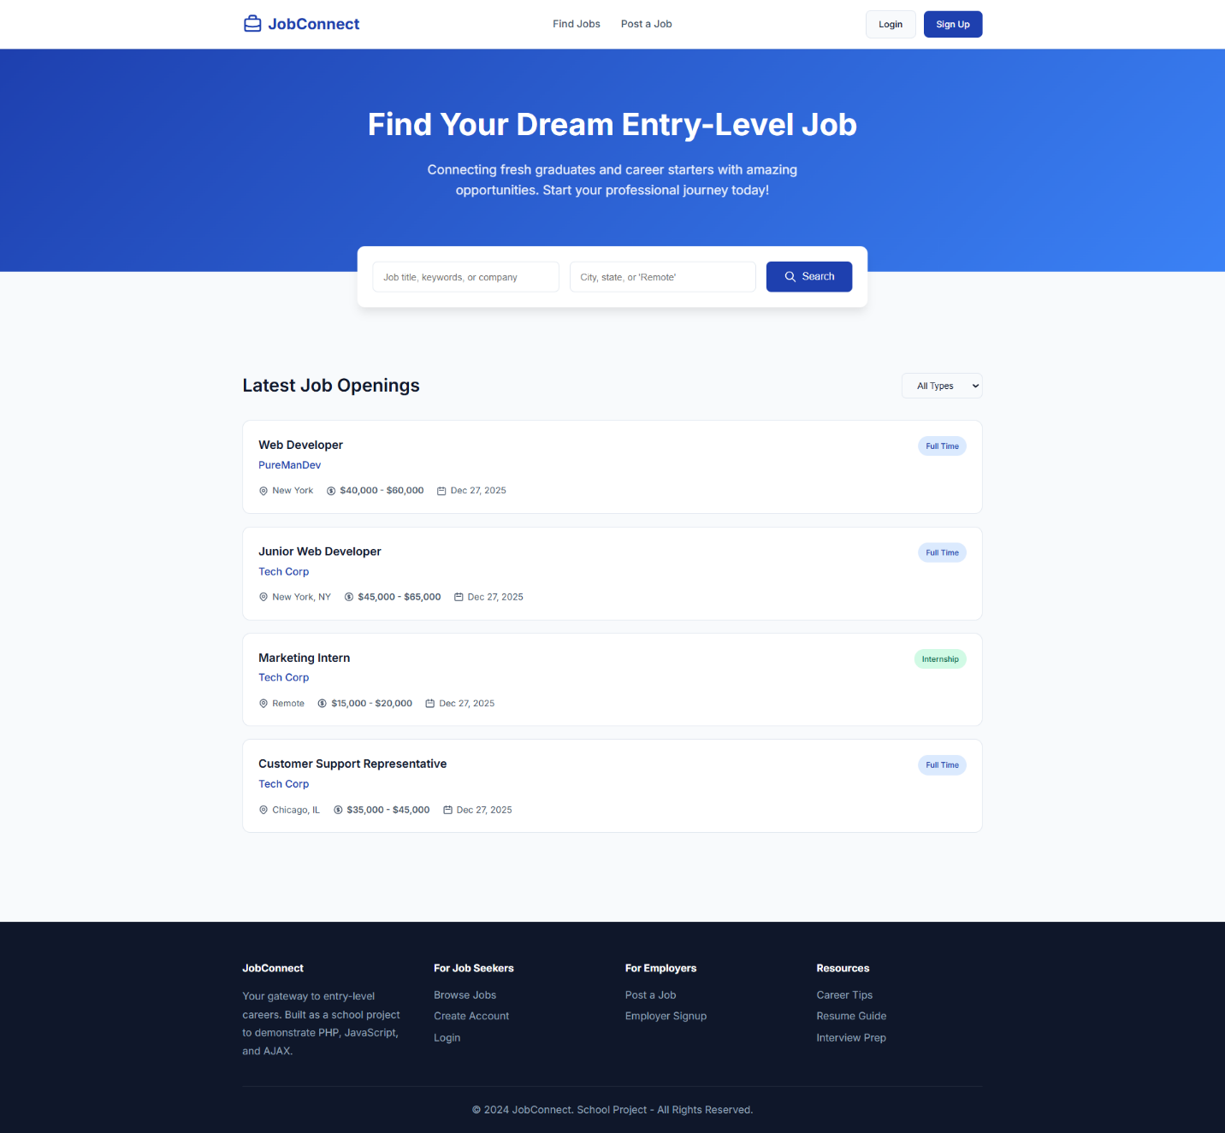

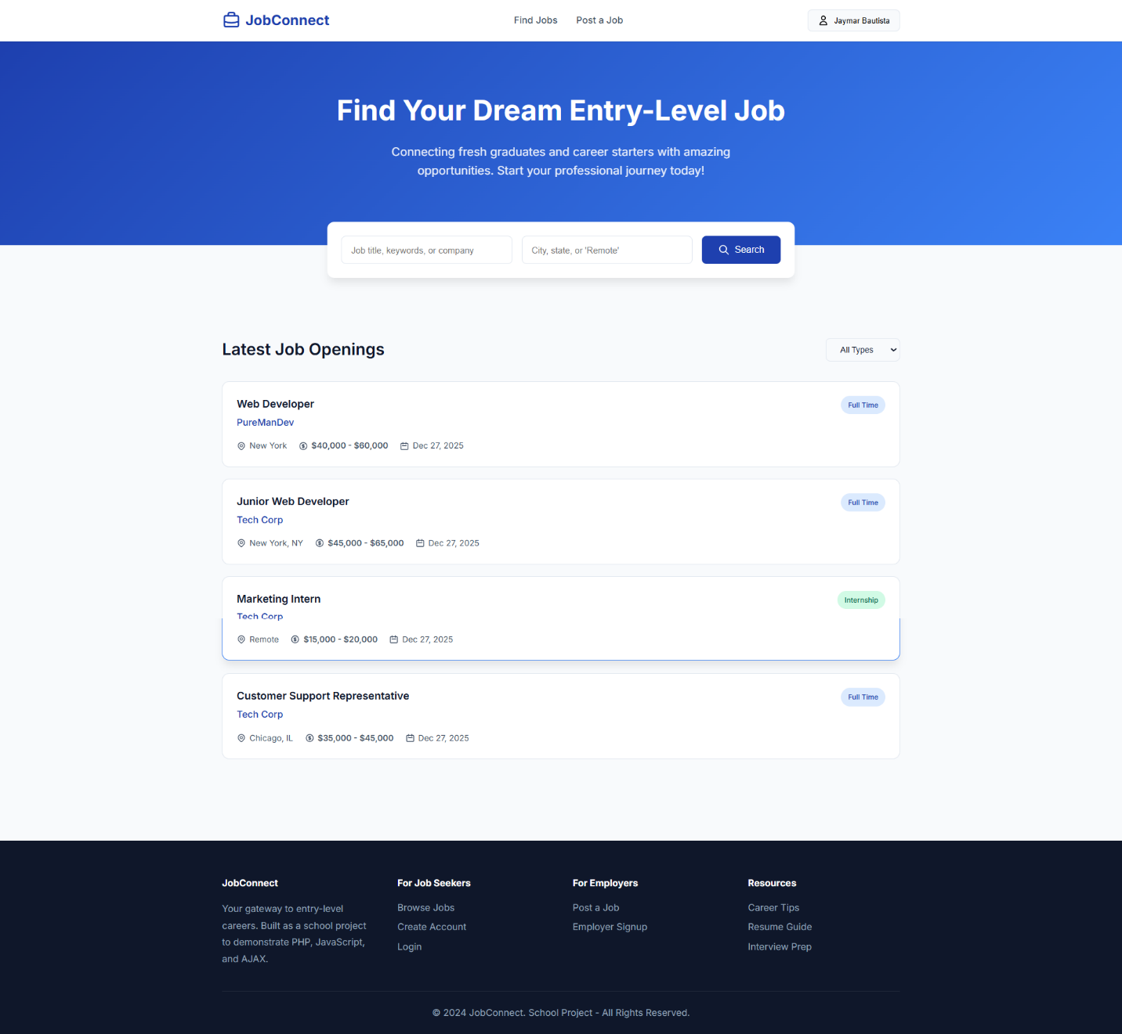

GitHub URL: https://github.com/jaybybautista/web-systems-social-media-app

Source Code

<?php
require_once '../config/database.php';

header('Content-Type: application/json');
header('Access-Control-Allow-Origin: *');
header('Access-Control-Allow-Methods: POST, GET');
header('Access-Control-Allow-Headers: Content-Type');

$action = $_GET['action'] ?? $_POST['action'] ?? '';

switch ($action) {
case 'apply':
applyJob();
break;
case 'my-applications':
getMyApplications();
break;
case 'job-applications':
getJobApplications();
break;
case 'update-status':
updateStatus();
break;
case 'check':
checkApplication();
break;
default:
sendResponse(false, 'Invalid action');
}

function applyJob() {
global $conn;

if (!isset($_SESSION['user_id'])) {
sendResponse(false, 'Please login to apply');
}

if ($_SESSION['user_role'] !== 'job_seeker') {
sendResponse(false, 'Only job seekers can apply');
}

$job_id = intval($_POST['job_id'] ?? 0);
$cover_letter = trim($_POST['cover_letter'] ?? '');

if ($job_id <= 0) {
sendResponse(false, 'Invalid job ID');
}

// Check if job exists
$stmt = $conn->prepare("SELECT id FROM jobs WHERE id = ? AND is_active = 1");
$stmt->bind_param("i", $job_id);
$stmt->execute();
if ($stmt->get_result()->num_rows === 0) {
sendResponse(false, 'Job not found or no longer active');
}

// Check for duplicate application
$stmt = $conn->prepare("SELECT id FROM applications WHERE job_id = ? AND user_id = ?");
$stmt->bind_param("ii", $job_id, $_SESSION['user_id']);
$stmt->execute();
if ($stmt->get_result()->num_rows > 0) {
sendResponse(false, 'You have already applied for this job');
}

// Handle file upload
$resume_path = null;
if (isset($_FILES['resume']) && $_FILES['resume']['error'] === UPLOAD_ERR_OK) {
$upload_dir = '../uploads/resumes/';
if (!is_dir($upload_dir)) {
mkdir($upload_dir, 0777, true);
}

$file_ext = strtolower(pathinfo($_FILES['resume']['name'], PATHINFO_EXTENSION));
$allowed = ['pdf', 'doc', 'docx'];

if (!in_array($file_ext, $allowed)) {
sendResponse(false, 'Only PDF, DOC, DOCX files are allowed');
}

$resume_path = $upload_dir . uniqid('resume_') . '.' . $file_ext;
move_uploaded_file($_FILES['resume']['tmp_name'], $resume_path);
}

$stmt = $conn->prepare("INSERT INTO applications (job_id, user_id, cover_letter, resume_path) VALUES (?, ?, ?, ?)");
$stmt->bind_param("iiss", $job_id, $_SESSION['user_id'], $cover_letter, $resume_path);

if ($stmt->execute()) {
sendResponse(true, 'Application submitted successfully');
} else {
sendResponse(false, 'Failed to submit application');
}
}

function getMyApplications() {
global $conn;

if (!isset($_SESSION['user_id'])) {
sendResponse(false, 'Please login first');
}

$stmt = $conn->prepare("SELECT a.*, j.title, j.company, j.location
FROM applications a
JOIN jobs j ON a.job_id = j.id
WHERE a.user_id = ?
ORDER BY a.created_at DESC");
$stmt->bind_param("i", $_SESSION['user_id']);
$stmt->execute();
$result = $stmt->get_result();

$applications = [];
while ($row = $result->fetch_assoc()) {
$applications[] = $row;
}

sendResponse(true, 'Your applications', $applications);
}

function getJobApplications() {
global $conn;

if (!isset($_SESSION['user_id']) || $_SESSION['user_role'] !== 'employer') {
sendResponse(false, 'Only employers can view applications');
}

$job_id = intval($_GET['job_id'] ?? 0);

// Verify job ownership
$stmt = $conn->prepare("SELECT employer_id FROM jobs WHERE id = ?");
$stmt->bind_param("i", $job_id);
$stmt->execute();
$result = $stmt->get_result();

if ($result->num_rows === 0) {
sendResponse(false, 'Job not found');
}

$job = $result->fetch_assoc();
if ($job['employer_id'] != $_SESSION['user_id']) {
sendResponse(false, 'You can only view applications for your jobs');
}

$stmt = $conn->prepare("SELECT a.*, u.name, u.email, u.phone
FROM applications a
JOIN users u ON a.user_id = u.id
WHERE a.job_id = ?
ORDER BY a.created_at DESC");
$stmt->bind_param("i", $job_id);
$stmt->execute();
$result = $stmt->get_result();

$applications = [];
while ($row = $result->fetch_assoc()) {
$applications[] = $row;
}

sendResponse(true, 'Job applications', $applications);
}

function updateStatus() {
global $conn;

if (!isset($_SESSION['user_id']) || $_SESSION['user_role'] !== 'employer') {
sendResponse(false, 'Only employers can update status');
}

$application_id = intval($_POST['application_id'] ?? 0);
$status = $_POST['status'] ?? '';

$valid_statuses = ['pending', 'reviewed', 'shortlisted', 'rejected'];
if (!in_array($status, $valid_statuses)) {
sendResponse(false, 'Invalid status');
}

// Verify the application belongs to employer's job
$stmt = $conn->prepare("SELECT j.employer_id
FROM applications a
JOIN jobs j ON a.job_id = j.id
WHERE a.id = ?");
$stmt->bind_param("i", $application_id);
$stmt->execute();
$result = $stmt->get_result();

if ($result->num_rows === 0) {
sendResponse(false, 'Application not found');
}

$data = $result->fetch_assoc();
if ($data['employer_id'] != $_SESSION['user_id']) {
sendResponse(false, 'Unauthorized');
}

$stmt = $conn->prepare("UPDATE applications SET status = ? WHERE id = ?");
$stmt->bind_param("si", $status, $application_id);

if ($stmt->execute()) {
sendResponse(true, 'Status updated successfully');
} else {
sendResponse(false, 'Failed to update status');
}
}

function checkApplication() {
global $conn;

if (!isset($_SESSION['user_id'])) {
sendResponse(false, 'Not logged in');
}

$job_id = intval($_GET['job_id'] ?? 0);

$stmt = $conn->prepare("SELECT id, status FROM applications WHERE job_id = ? AND user_id = ?");
$stmt->bind_param("ii", $job_id, $_SESSION['user_id']);
$stmt->execute();
$result = $stmt->get_result();

if ($result->num_rows > 0) {
sendResponse(true, 'Already applied', $result->fetch_assoc());
} else {
sendResponse(false, 'Not applied');
}
}
?>

<?php
require_once '../config/database.php';

header('Content-Type: application/json');
header('Access-Control-Allow-Origin: *');
header('Access-Control-Allow-Methods: POST, GET');
header('Access-Control-Allow-Headers: Content-Type');

$action = $_GET['action'] ?? $_POST['action'] ?? '';

switch ($action) {
case 'register':
register();
break;
case 'login':
login();
break;
case 'logout':
logout();
break;
case 'check':
checkAuth();
break;
default:
sendResponse(false, 'Invalid action');
}

function register() {
global $conn;

$name = trim($_POST['name'] ?? '');
$email = trim($_POST['email'] ?? '');
$password = $_POST['password'] ?? '';
$role = $_POST['role'] ?? 'job_seeker';

// Validation
if (empty($name) || empty($email) || empty($password)) {
sendResponse(false, 'All fields are required');
}

if (!filter_var($email, FILTER_VALIDATE_EMAIL)) {
sendResponse(false, 'Invalid email format');
}

if (strlen($password) < 6) {
sendResponse(false, 'Password must be at least 6 characters');
}

// Check if email exists
$stmt = $conn->prepare("SELECT id FROM users WHERE email = ?");
$stmt->bind_param("s", $email);
$stmt->execute();
if ($stmt->get_result()->num_rows > 0) {
sendResponse(false, 'Email already registered');
}

// Hash password and insert
$hashedPassword = password_hash($password, PASSWORD_DEFAULT);
$stmt = $conn->prepare("INSERT INTO users (name, email, password, role) VALUES (?, ?, ?, ?)");
$stmt->bind_param("ssss", $name, $email, $hashedPassword, $role);

if ($stmt->execute()) {
$_SESSION['user_id'] = $conn->insert_id;
$_SESSION['user_name'] = $name;
$_SESSION['user_role'] = $role;

sendResponse(true, 'Registration successful', [
'id' => $_SESSION['user_id'],
'name' => $name,
'role' => $role
]);
} else {
sendResponse(false, 'Registration failed');
}
}

function login() {
global $conn;

$email = trim($_POST['email'] ?? '');
$password = $_POST['password'] ?? '';

if (empty($email) || empty($password)) {
sendResponse(false, 'Email and password are required');
}

$stmt = $conn->prepare("SELECT id, name, email, password, role FROM users WHERE email = ?");
$stmt->bind_param("s", $email);
$stmt->execute();
$result = $stmt->get_result();

if ($result->num_rows === 0) {
sendResponse(false, 'Invalid email or password');
}

$user = $result->fetch_assoc();

if (!password_verify($password, $user['password'])) {
sendResponse(false, 'Invalid email or password');
}

$_SESSION['user_id'] = $user['id'];
$_SESSION['user_name'] = $user['name'];
$_SESSION['user_role'] = $user['role'];

sendResponse(true, 'Login successful', [
'id' => $user['id'],
'name' => $user['name'],
'role' => $user['role']
]);
}

function logout() {
session_destroy();
sendResponse(true, 'Logged out successfully');
}

function checkAuth() {
if (isset($_SESSION['user_id'])) {
sendResponse(true, 'Authenticated', [
'id' => $_SESSION['user_id'],
'name' => $_SESSION['user_name'],
'role' => $_SESSION['user_role']
]);
} else {
sendResponse(false, 'Not authenticated');
}
}
?>

<?php
require_once '../config/database.php';

header('Content-Type: application/json');
header('Access-Control-Allow-Origin: *');
header('Access-Control-Allow-Methods: POST, GET, DELETE');
header('Access-Control-Allow-Headers: Content-Type');

$action = $_GET['action'] ?? $_POST['action'] ?? '';

switch ($action) {
case 'list':
listJobs();
break;
case 'get':
getJob();
break;
case 'create':
createJob();
break;
case 'update':
updateJob();
break;
case 'delete':
deleteJob();
break;
case 'search':
searchJobs();
break;
case 'my-jobs':
getMyJobs();
break;
default:
sendResponse(false, 'Invalid action');
}

function listJobs() {
global $conn;

$sql = "SELECT j.*, u.name as employer_name
FROM jobs j
JOIN users u ON j.employer_id = u.id
WHERE j.is_active = 1
ORDER BY j.created_at DESC";

$result = $conn->query($sql);
$jobs = [];

while ($row = $result->fetch_assoc()) {
$jobs[] = $row;
}

sendResponse(true, 'Jobs retrieved', $jobs);
}

function getJob() {
global $conn;

$id = intval($_GET['id'] ?? 0);

if ($id <= 0) {
sendResponse(false, 'Invalid job ID');
}

$stmt = $conn->prepare("SELECT j.*, u.name as employer_name, u.email as employer_email
FROM jobs j
JOIN users u ON j.employer_id = u.id
WHERE j.id = ?");
$stmt->bind_param("i", $id);
$stmt->execute();
$result = $stmt->get_result();

if ($result->num_rows === 0) {
sendResponse(false, 'Job not found');
}

sendResponse(true, 'Job retrieved', $result->fetch_assoc());
}

function createJob() {
global $conn;

if (!isset($_SESSION['user_id']) || $_SESSION['user_role'] !== 'employer') {
sendResponse(false, 'Only employers can post jobs');
}

$title = trim($_POST['title'] ?? '');
$company = trim($_POST['company'] ?? '');
$location = trim($_POST['location'] ?? '');
$job_type = $_POST['job_type'] ?? 'full-time';
$salary_min = floatval($_POST['salary_min'] ?? 0);
$salary_max = floatval($_POST['salary_max'] ?? 0);
$description = trim($_POST['description'] ?? '');
$requirements = trim($_POST['requirements'] ?? '');

if (empty($title) || empty($company) || empty($location) || empty($description)) {
sendResponse(false, 'Title, company, location, and description are required');
}

$stmt = $conn->prepare("INSERT INTO jobs (employer_id, title, company, location, job_type, salary_min, salary_max, description, requirements)
VALUES (?, ?, ?, ?, ?, ?, ?, ?, ?)");
$stmt->bind_param("issssddss", $_SESSION['user_id'], $title, $company, $location, $job_type, $salary_min, $salary_max, $description, $requirements);

if ($stmt->execute()) {
sendResponse(true, 'Job posted successfully', ['id' => $conn->insert_id]);
} else {
sendResponse(false, 'Failed to post job');
}
}

function updateJob() {
global $conn;

if (!isset($_SESSION['user_id'])) {
sendResponse(false, 'Please login first');
}

$id = intval($_POST['id'] ?? 0);
$title = trim($_POST['title'] ?? '');
$company = trim($_POST['company'] ?? '');
$location = trim($_POST['location'] ?? '');
$job_type = $_POST['job_type'] ?? 'full-time';
$salary_min = floatval($_POST['salary_min'] ?? 0);
$salary_max = floatval($_POST['salary_max'] ?? 0);
$description = trim($_POST['description'] ?? '');
$requirements = trim($_POST['requirements'] ?? '');
$is_active = isset($_POST['is_active']) ? intval($_POST['is_active']) : 1;

// Verify ownership
$stmt = $conn->prepare("SELECT employer_id FROM jobs WHERE id = ?");
$stmt->bind_param("i", $id);
$stmt->execute();
$result = $stmt->get_result();

if ($result->num_rows === 0) {
sendResponse(false, 'Job not found');
}

$job = $result->fetch_assoc();
if ($job['employer_id'] != $_SESSION['user_id']) {
sendResponse(false, 'You can only edit your own jobs');
}

$stmt = $conn->prepare("UPDATE jobs SET title=?, company=?, location=?, job_type=?, salary_min=?, salary_max=?, description=?, requirements=?, is_active=? WHERE id=?");
$stmt->bind_param("ssssddssii", $title, $company, $location, $job_type, $salary_min, $salary_max, $description, $requirements, $is_active, $id);

if ($stmt->execute()) {
sendResponse(true, 'Job updated successfully');
} else {
sendResponse(false, 'Failed to update job');
}
}

function deleteJob() {
global $conn;

if (!isset($_SESSION['user_id'])) {
sendResponse(false, 'Please login first');
}

$id = intval($_POST['id'] ?? $_GET['id'] ?? 0);

// Verify ownership
$stmt = $conn->prepare("SELECT employer_id FROM jobs WHERE id = ?");
$stmt->bind_param("i", $id);
$stmt->execute();
$result = $stmt->get_result();

if ($result->num_rows === 0) {
sendResponse(false, 'Job not found');
}

$job = $result->fetch_assoc();
if ($job['employer_id'] != $_SESSION['user_id']) {
sendResponse(false, 'You can only delete your own jobs');
}

$stmt = $conn->prepare("DELETE FROM jobs WHERE id = ?");
$stmt->bind_param("i", $id);

if ($stmt->execute()) {
sendResponse(true, 'Job deleted successfully');
} else {
sendResponse(false, 'Failed to delete job');
}
}

function searchJobs() {
global $conn;

$keyword = trim($_GET['keyword'] ?? '');
$location = trim($_GET['location'] ?? '');
$job_type = $_GET['job_type'] ?? '';

$sql = "SELECT j.*, u.name as employer_name
FROM jobs j
JOIN users u ON j.employer_id = u.id
WHERE j.is_active = 1";
$params = [];
$types = "";

if (!empty($keyword)) {
$sql .= " AND (j.title LIKE ? OR j.description LIKE ? OR j.company LIKE ?)";
$keyword = "%$keyword%";
$params[] = $keyword;
$params[] = $keyword;
$params[] = $keyword;
$types .= "sss";
}

if (!empty($location)) {
$sql .= " AND j.location LIKE ?";
$params[] = "%$location%";
$types .= "s";
}

if (!empty($job_type)) {
$sql .= " AND j.job_type = ?";
$params[] = $job_type;
$types .= "s";
}

$sql .= " ORDER BY j.created_at DESC";

$stmt = $conn->prepare($sql);
if (!empty($params)) {
$stmt->bind_param($types, ...$params);
}
$stmt->execute();
$result = $stmt->get_result();

$jobs = [];
while ($row = $result->fetch_assoc()) {
$jobs[] = $row;
}

sendResponse(true, 'Search results', $jobs);
}

function getMyJobs() {
global $conn;

if (!isset($_SESSION['user_id']) || $_SESSION['user_role'] !== 'employer') {
sendResponse(false, 'Only employers can view their jobs');
}

$stmt = $conn->prepare("SELECT * FROM jobs WHERE employer_id = ? ORDER BY created_at DESC");
$stmt->bind_param("i", $_SESSION['user_id']);
$stmt->execute();
$result = $stmt->get_result();

$jobs = [];
while ($row = $result->fetch_assoc()) {
$jobs[] = $row;
}

sendResponse(true, 'Your jobs', $jobs);
}
?>

/* Job Portal - Modern CSS Styles */
@import url('https://fonts.googleapis.com/css2?family=Inter:wght@300;400;500;600;700&display=swap');

:root {
--primary: #1e40af;
--primary-dark: #1e3a8a;
--primary-light: #3b82f6;
--secondary: #64748b;
--success: #10b981;
--warning: #f59e0b;
--danger: #ef4444;
--background: #f8fafc;
--surface: #ffffff;
--text-primary: #0f172a;
--text-secondary: #475569;
--text-muted: #94a3b8;
--border: #e2e8f0;
--shadow-sm: 0 1px 2px 0 rgb(0 0 0 / 0.05);
--shadow: 0 4px 6px -1px rgb(0 0 0 / 0.1);
--shadow-lg: 0 10px 15px -3px rgb(0 0 0 / 0.1);
--radius: 12px;
--radius-sm: 8px;
}

* {
margin: 0;
padding: 0;
box-sizing: border-box;
}

body {
font-family: 'Inter', -apple-system, BlinkMacSystemFont, sans-serif;
background-color: var(--background);
color: var(--text-primary);
line-height: 1.6;
}

/* Container */
.container {
max-width: 1200px;
margin: 0 auto;
padding: 0 20px;
}

/* Navbar */
.navbar {
background: var(--surface);
border-bottom: 1px solid var(--border);
padding: 16px 0;
position: sticky;
top: 0;
z-index: 100;
box-shadow: var(--shadow-sm);
}

.navbar .container {
display: flex;
justify-content: space-between;
align-items: center;
}

.logo {
font-size: 24px;
font-weight: 700;
color: var(--primary);
text-decoration: none;
display: flex;
align-items: center;
gap: 8px;
}

.logo svg {
width: 32px;
height: 32px;
}

.nav-links {
display: flex;
gap: 32px;
align-items: center;
}

.nav-links a {
color: var(--text-secondary);
text-decoration: none;
font-weight: 500;
transition: color 0.2s;
}

.nav-links a:hover {
color: var(--primary);
}

.nav-auth {
display: flex;
gap: 12px;
align-items: center;
}

/* Buttons */
.btn {
display: inline-flex;
align-items: center;
justify-content: center;
gap: 8px;
padding: 10px 20px;
border-radius: var(--radius-sm);
font-weight: 500;
font-size: 14px;
cursor: pointer;
border: none;
transition: all 0.2s;
text-decoration: none;
}

.btn-primary {
background: var(--primary);
color: white;
}

.btn-primary:hover {
background: var(--primary-dark);
transform: translateY(-1px);
box-shadow: var(--shadow);
}

.btn-secondary {
background: var(--background);
color: var(--text-primary);
border: 1px solid var(--border);
}

.btn-secondary:hover {
background: var(--border);
}

.btn-success {
background: var(--success);
color: white;
}

.btn-danger {
background: var(--danger);
color: white;
}

.btn-lg {
padding: 14px 28px;
font-size: 16px;
}

/* Hero Section */
.hero {
background: linear-gradient(135deg, var(--primary) 0%, var(--primary-light) 100%);
color: white;
padding: 80px 0;
text-align: center;
}

.hero h1 {
font-size: 48px;
font-weight: 700;
margin-bottom: 16px;
}

.hero p {
font-size: 20px;
opacity: 0.9;
margin-bottom: 32px;
max-width: 600px;
margin-left: auto;
margin-right: auto;
}

/* Search Box */
.search-box {
background: var(--surface);
padding: 24px;
border-radius: var(--radius);
box-shadow: var(--shadow-lg);
max-width: 800px;
margin: -40px auto 40px;
position: relative;
z-index: 10;
}

.search-form {
display: grid;
grid-template-columns: 1fr 1fr auto;
gap: 16px;
}

.search-form input,
.search-form select {
padding: 14px 16px;
border: 1px solid var(--border);
border-radius: var(--radius-sm);
font-size: 15px;
outline: none;
transition: border-color 0.2s;
}

.search-form input:focus,
.search-form select:focus {
border-color: var(--primary);
}

/* Job Cards */
.jobs-section {
padding: 60px 0;
}

.section-header {
display: flex;
justify-content: space-between;
align-items: center;
margin-bottom: 32px;
}

.section-header h2 {
font-size: 28px;
font-weight: 600;
}

.job-grid {
display: grid;
gap: 20px;
}

.job-card {
background: var(--surface);
border-radius: var(--radius);
padding: 24px;
border: 1px solid var(--border);
transition: all 0.2s;
cursor: pointer;
}

.job-card:hover {
box-shadow: var(--shadow-lg);
transform: translateY(-2px);
border-color: var(--primary-light);
}

.job-card-header {
display: flex;
justify-content: space-between;
align-items: flex-start;
margin-bottom: 16px;
}

.job-card h3 {
font-size: 18px;
font-weight: 600;
color: var(--text-primary);
margin-bottom: 4px;
}

.job-card .company {
color: var(--primary);
font-weight: 500;
}

.job-meta {
display: flex;
gap: 20px;
margin-top: 12px;
flex-wrap: wrap;
}

.job-meta span {
display: flex;
align-items: center;
gap: 6px;
color: var(--text-secondary);
font-size: 14px;
}

.job-type-badge {
padding: 6px 12px;
border-radius: 20px;
font-size: 12px;
font-weight: 500;
text-transform: capitalize;
}

.job-type-badge.full-time { background: #dbeafe; color: #1e40af; }
.job-type-badge.part-time { background: #fef3c7; color: #92400e; }
.job-type-badge.internship { background: #d1fae5; color: #065f46; }
.job-type-badge.contract { background: #ede9fe; color: #5b21b6; }

.salary {
font-weight: 600;
color: var(--success);
}

/* Forms */
.form-container {
max-width: 500px;
margin: 60px auto;
padding: 40px;
background: var(--surface);
border-radius: var(--radius);
box-shadow: var(--shadow-lg);
}

.form-container h2 {
text-align: center;
margin-bottom: 32px;
font-size: 28px;
}

.form-group {
margin-bottom: 20px;
}

.form-group label {
display: block;
margin-bottom: 8px;
font-weight: 500;
color: var(--text-primary);
}

.form-group input,
.form-group select,
.form-group textarea {
width: 100%;
padding: 12px 16px;
border: 1px solid var(--border);
border-radius: var(--radius-sm);
font-size: 15px;
outline: none;
transition: border-color 0.2s;
font-family: inherit;
}

.form-group input:focus,
.form-group select:focus,
.form-group textarea:focus {
border-color: var(--primary);
}

.form-group textarea {
min-height: 120px;
resize: vertical;
}

.form-row {
display: grid;
grid-template-columns: 1fr 1fr;
gap: 16px;
}

.form-footer {
text-align: center;
margin-top: 24px;
color: var(--text-secondary);
}

.form-footer a {
color: var(--primary);
text-decoration: none;
font-weight: 500;
}

/* Job Details Page */
.job-details {
max-width: 800px;
margin: 40px auto;
padding: 0 20px;
}

.job-details-card {
background: var(--surface);
border-radius: var(--radius);
padding: 40px;
box-shadow: var(--shadow);
}

.job-details h1 {
font-size: 32px;
margin-bottom: 8px;
}

.job-details .company-name {
font-size: 20px;
color: var(--primary);
margin-bottom: 24px;
}

.job-info-grid {
display: grid;
grid-template-columns: repeat(auto-fit, minmax(150px, 1fr));
gap: 20px;
padding: 24px 0;
border-top: 1px solid var(--border);
border-bottom: 1px solid var(--border);
margin: 24px 0;
}

.job-info-item {
text-align: center;
}

.job-info-item .label {
font-size: 12px;
color: var(--text-muted);
text-transform: uppercase;
letter-spacing: 0.5px;
margin-bottom: 4px;
}

.job-info-item .value {
font-weight: 600;
color: var(--text-primary);
}

.job-description h3 {
font-size: 18px;
margin: 24px 0 12px;
}

.job-description p,
.job-description ul {
color: var(--text-secondary);
margin-bottom: 16px;
}

.apply-section {
margin-top: 32px;
padding-top: 24px;
border-top: 1px solid var(--border);
}

/* Dashboard */
.dashboard {
padding: 40px 0;
}

.dashboard-header {
margin-bottom: 32px;
}

.dashboard-header h1 {
font-size: 32px;
margin-bottom: 8px;
}

.stats-grid {
display: grid;
grid-template-columns: repeat(auto-fit, minmax(200px, 1fr));
gap: 20px;
margin-bottom: 40px;
}

.stat-card {
background: var(--surface);
padding: 24px;
border-radius: var(--radius);
border: 1px solid var(--border);
}

.stat-card .number {
font-size: 36px;
font-weight: 700;
color: var(--primary);
}

.stat-card .label {
color: var(--text-secondary);
margin-top: 4px;
}

/* Application Status Badges */
.status-badge {
display: inline-block;
padding: 4px 12px;
border-radius: 20px;
font-size: 12px;
font-weight: 500;
}

.status-badge.pending { background: #fef3c7; color: #92400e; }
.status-badge.reviewed { background: #dbeafe; color: #1e40af; }
.status-badge.shortlisted { background: #d1fae5; color: #065f46; }
.status-badge.rejected { background: #fee2e2; color: #991b1b; }

/* Tables */
.table-container {
background: var(--surface);
border-radius: var(--radius);
overflow: hidden;
border: 1px solid var(--border);
}

table {
width: 100%;
border-collapse: collapse;
}

th, td {
padding: 16px;
text-align: left;
border-bottom: 1px solid var(--border);
}

th {
background: var(--background);
font-weight: 600;
color: var(--text-secondary);
font-size: 13px;
text-transform: uppercase;
letter-spacing: 0.5px;
}

tr:hover {
background: var(--background);
}

/* Modal */
.modal-overlay {
position: fixed;
inset: 0;
background: rgba(0, 0, 0, 0.5);
display: flex;
align-items: center;
justify-content: center;
z-index: 1000;
opacity: 0;
visibility: hidden;
transition: all 0.3s;
}

.modal-overlay.active {
opacity: 1;
visibility: visible;
}

.modal {
background: var(--surface);
border-radius: var(--radius);
padding: 32px;
max-width: 500px;
width: 90%;
max-height: 90vh;
overflow-y: auto;
transform: scale(0.9);
transition: transform 0.3s;
}

.modal-overlay.active .modal {
transform: scale(1);
}

.modal-header {
display: flex;
justify-content: space-between;
align-items: center;
margin-bottom: 24px;
}

.modal-header h3 {
font-size: 20px;
}

.modal-close {
background: none;
border: none;
font-size: 24px;
cursor: pointer;
color: var(--text-muted);
}

/* Toast Notifications */
.toast-container {
position: fixed;
top: 20px;
right: 20px;
z-index: 9999;
}

.toast {
background: var(--surface);
padding: 16px 24px;
border-radius: var(--radius-sm);
box-shadow: var(--shadow-lg);
margin-bottom: 12px;
display: flex;
align-items: center;
gap: 12px;
animation: slideIn 0.3s ease;
}

.toast.success { border-left: 4px solid var(--success); }
.toast.error { border-left: 4px solid var(--danger); }
.toast.warning { border-left: 4px solid var(--warning); }

@keyframes slideIn {
from {
transform: translateX(100%);
opacity: 0;
}
to {
transform: translateX(0);
opacity: 1;
}
}

/* Footer */
.footer {
background: var(--text-primary);
color: var(--text-muted);
padding: 60px 0 24px;
margin-top: 80px;
}

.footer-grid {
display: grid;
grid-template-columns: repeat(auto-fit, minmax(200px, 1fr));
gap: 40px;
margin-bottom: 40px;
}

.footer h4 {
color: white;
margin-bottom: 16px;
}

.footer a {
color: var(--text-muted);
text-decoration: none;
display: block;
margin-bottom: 8px;
transition: color 0.2s;
}

.footer a:hover {
color: white;
}

.footer-bottom {
border-top: 1px solid rgba(255,255,255,0.1);
padding-top: 24px;
text-align: center;
}

/* Responsive */
@media (max-width: 768px) {
.nav-links {
display: none;
}

.hero h1 {
font-size: 32px;
}

.search-form {
grid-template-columns: 1fr;
}

.form-row {
grid-template-columns: 1fr;
}

.job-details-card {
padding: 24px;
}
}

/* Loading Spinner */
.spinner {
width: 40px;
height: 40px;
border: 3px solid var(--border);
border-top-color: var(--primary);
border-radius: 50%;
animation: spin 0.8s linear infinite;
margin: 40px auto;
}

@keyframes spin {
to { transform: rotate(360deg); }
}

/* Empty State */
.empty-state {
text-align: center;
padding: 60px 20px;
color: var(--text-muted);
}

.empty-state svg {
width: 80px;
height: 80px;
margin-bottom: 16px;
opacity: 0.5;
}

.empty-state h3 {
color: var(--text-primary);
margin-bottom: 8px;
}

/* User dropdown */
.user-menu {
position: relative;
}

.user-btn {
display: flex;
align-items: center;
gap: 8px;
padding: 8px 16px;
background: var(--background);
border: 1px solid var(--border);
border-radius: var(--radius-sm);
cursor: pointer;
font-weight: 500;
}

.user-dropdown {
position: absolute;
top: 100%;
right: 0;
margin-top: 8px;
background: var(--surface);
border: 1px solid var(--border);
border-radius: var(--radius-sm);
box-shadow: var(--shadow-lg);
min-width: 180px;
display: none;
}

.user-dropdown.active {
display: block;
}

.user-dropdown a {
display: block;
padding: 12px 16px;
color: var(--text-primary);
text-decoration: none;
transition: background 0.2s;
}

.user-dropdown a:hover {
background: var(--background);
}
// Job Portal JavaScript with AJAX

const API_BASE = 'api';

// Toast Notification System
const Toast = {
container: null,

init() {
this.container = document.createElement('div');
this.container.className = 'toast-container';
document.body.appendChild(this.container);
},

show(message, type = 'success') {
const toast = document.createElement('div');
toast.className = `toast ${type}`;
toast.innerHTML = `
<span>${message}</span>
<button onclick="this.parentElement.remove()" style="background:none;border:none;cursor:pointer;font-size:18px;">&times;</button>
`;
this.container.appendChild(toast);
setTimeout(() => toast.remove(), 5000);
}
};

// Initialize toast on page load
document.addEventListener('DOMContentLoaded', () => {
Toast.init();
checkAuth();
});

// AJAX Helper Function
function ajax(url, method = 'GET', data = null) {
return new Promise((resolve, reject) => {
const xhr = new XMLHttpRequest();
xhr.open(method, url, true);
xhr.withCredentials = true;

xhr.onload = function() {
try {
const response = JSON.parse(xhr.responseText);
resolve(response);
} catch (e) {
reject(new Error('Invalid JSON response'));
}
};

xhr.onerror = function() {
reject(new Error('Network error'));
};

if (data instanceof FormData) {
xhr.send(data);
} else if (data) {
xhr.setRequestHeader('Content-Type', 'application/x-www-form-urlencoded');
const params = new URLSearchParams(data).toString();
xhr.send(params);
} else {
xhr.send();
}
});
}

// Authentication Functions
async function checkAuth() {
try {
const response = await ajax(`${API_BASE}/auth.php?action=check`);
if (response.success) {
updateUIForLoggedInUser(response.data);
} else {
updateUIForGuest();
}
} catch (error) {
console.error('Auth check failed:', error);
updateUIForGuest();
}
}

function updateUIForLoggedInUser(user) {
const authContainer = document.getElementById('auth-container');
if (authContainer) {
authContainer.innerHTML = `
<div class="user-menu">
<button class="user-btn" onclick="toggleUserMenu()">
<svg width="20" height="20" fill="none" stroke="currentColor" viewBox="0 0 24 24">
<path stroke-linecap="round" stroke-linejoin="round" stroke-width="2" d="M16 7a4 4 0 11-8 0 4 4 0 018 0zM12 14a7 7 0 00-7 7h14a7 7 0 00-7-7z"/>
</svg>
${user.name}
</button>
<div class="user-dropdown" id="userDropdown">
<a href="dashboard.html">Dashboard</a>
${user.role === 'employer' ? '<a href="post-job.html">Post a Job</a>' : '<a href="my-applications.html">My Applications</a>'}
<a href="#" onclick="logout(); return false;">Logout</a>
</div>
</div>
`;
}

// Store user data
window.currentUser = user;
}

function updateUIForGuest() {
const authContainer = document.getElementById('auth-container');
if (authContainer) {
authContainer.innerHTML = `
<a href="login.html" class="btn btn-secondary">Login</a>
<a href="register.html" class="btn btn-primary">Sign Up</a>
`;
}
window.currentUser = null;
}

function toggleUserMenu() {
const dropdown = document.getElementById('userDropdown');
dropdown.classList.toggle('active');
}

// Close dropdown when clicking outside
document.addEventListener('click', (e) => {
const dropdown = document.getElementById('userDropdown');
const userBtn = document.querySelector('.user-btn');
if (dropdown && !dropdown.contains(e.target) && !userBtn?.contains(e.target)) {
dropdown.classList.remove('active');
}
});

// Register Function
async function register(event) {
event.preventDefault();
const form = event.target;
const formData = new FormData(form);
formData.append('action', 'register');

const submitBtn = form.querySelector('button[type="submit"]');
submitBtn.disabled = true;
submitBtn.textContent = 'Creating Account...';

try {
const response = await ajax(`${API_BASE}/auth.php`, 'POST', formData);
if (response.success) {
Toast.show('Account created successfully!', 'success');
setTimeout(() => {
window.location.href = 'index.html';
}, 1000);
} else {
Toast.show(response.message, 'error');
}
} catch (error) {
Toast.show('Registration failed. Please try again.', 'error');
} finally {
submitBtn.disabled = false;
submitBtn.textContent = 'Create Account';
}
}

// Login Function
async function login(event) {
event.preventDefault();
const form = event.target;
const formData = new FormData(form);
formData.append('action', 'login');

const submitBtn = form.querySelector('button[type="submit"]');
submitBtn.disabled = true;
submitBtn.textContent = 'Logging in...';

try {
const response = await ajax(`${API_BASE}/auth.php`, 'POST', formData);
if (response.success) {
Toast.show('Login successful!', 'success');
setTimeout(() => {
window.location.href = 'index.html';
}, 1000);
} else {
Toast.show(response.message, 'error');
}
} catch (error) {
Toast.show('Login failed. Please try again.', 'error');
} finally {
submitBtn.disabled = false;
submitBtn.textContent = 'Login';
}
}

// Logout Function
async function logout() {
try {
await ajax(`${API_BASE}/auth.php?action=logout`);
Toast.show('Logged out successfully', 'success');
setTimeout(() => {
window.location.href = 'index.html';
}, 500);
} catch (error) {
console.error('Logout failed:', error);
}
}

// Load Jobs Function
async function loadJobs(container = 'jobs-container') {
const jobsContainer = document.getElementById(container);
if (!jobsContainer) return;

jobsContainer.innerHTML = '<div class="spinner"></div>';

try {
const response = await ajax(`${API_BASE}/jobs.php?action=list`);
if (response.success && response.data.length > 0) {
jobsContainer.innerHTML = response.data.map(job => createJobCard(job)).join('');
} else {
jobsContainer.innerHTML = `
<div class="empty-state">
<svg fill="none" stroke="currentColor" viewBox="0 0 24 24">
<path stroke-linecap="round" stroke-linejoin="round" stroke-width="2" d="M21 13.255A23.931 23.931 0 0112 15c-3.183 0-6.22-.62-9-1.745M16 6V4a2 2 0 00-2-2h-4a2 2 0 00-2 2v2m4 6h.01M5 20h14a2 2 0 002-2V8a2 2 0 00-2-2H5a2 2 0 00-2 2v10a2 2 0 002 2z"/>
</svg>
<h3>No jobs found</h3>
<p>Check back later for new opportunities</p>
</div>
`;
}
} catch (error) {
jobsContainer.innerHTML = '<p class="empty-state">Failed to load jobs. Please refresh the page.</p>';
}
}

// Create Job Card HTML
function createJobCard(job) {
const salary = job.salary_min && job.salary_max
? `$${Number(job.salary_min).toLocaleString()} - $${Number(job.salary_max).toLocaleString()}`
: 'Not specified';

const postedDate = new Date(job.created_at).toLocaleDateString('en-US', {
month: 'short',
day: 'numeric',
year: 'numeric'
});

return `
<div class="job-card" onclick="window.location.href='job-details.html?id=${job.id}'">
<div class="job-card-header">
<div>
<h3>${escapeHtml(job.title)}</h3>
<span class="company">${escapeHtml(job.company)}</span>
</div>
<span class="job-type-badge ${job.job_type}">${job.job_type.replace('-', ' ')}</span>
</div>
<div class="job-meta">
<span>
<svg width="16" height="16" fill="none" stroke="currentColor" viewBox="0 0 24 24">
<path stroke-linecap="round" stroke-linejoin="round" stroke-width="2" d="M17.657 16.657L13.414 20.9a1.998 1.998 0 01-2.827 0l-4.244-4.243a8 8 0 1111.314 0z"/>
<path stroke-linecap="round" stroke-linejoin="round" stroke-width="2" d="M15 11a3 3 0 11-6 0 3 3 0 016 0z"/>
</svg>
${escapeHtml(job.location)}
</span>
<span class="salary">
<svg width="16" height="16" fill="none" stroke="currentColor" viewBox="0 0 24 24">
<path stroke-linecap="round" stroke-linejoin="round" stroke-width="2" d="M12 8c-1.657 0-3 .895-3 2s1.343 2 3 2 3 .895 3 2-1.343 2-3 2m0-8c1.11 0 2.08.402 2.599 1M12 8V7m0 1v8m0 0v1m0-1c-1.11 0-2.08-.402-2.599-1M21 12a9 9 0 11-18 0 9 9 0 0118 0z"/>
</svg>
${salary}
</span>
<span>
<svg width="16" height="16" fill="none" stroke="currentColor" viewBox="0 0 24 24">
<path stroke-linecap="round" stroke-linejoin="round" stroke-width="2" d="M8 7V3m8 4V3m-9 8h10M5 21h14a2 2 0 002-2V7a2 2 0 00-2-2H5a2 2 0 00-2 2v12a2 2 0 002 2z"/>
</svg>
${postedDate}
</span>
</div>
</div>
`;
}

// Search Jobs
async function searchJobs(event) {
event.preventDefault();
const form = event.target;
const keyword = form.querySelector('[name="keyword"]').value;
const location = form.querySelector('[name="location"]').value;
const jobType = form.querySelector('[name="job_type"]')?.value || '';

const jobsContainer = document.getElementById('jobs-container');
jobsContainer.innerHTML = '<div class="spinner"></div>';

try {
const params = new URLSearchParams({
action: 'search',
keyword,
location,
job_type: jobType
});

const response = await ajax(`${API_BASE}/jobs.php?${params}`);
if (response.success && response.data.length > 0) {
jobsContainer.innerHTML = response.data.map(job => createJobCard(job)).join('');
} else {
jobsContainer.innerHTML = `
<div class="empty-state">
<h3>No jobs found</h3>
<p>Try different search terms</p>
</div>
`;
}
} catch (error) {
Toast.show('Search failed. Please try again.', 'error');
}
}

// Load Single Job Details
async function loadJobDetails() {
const urlParams = new URLSearchParams(window.location.search);
const jobId = urlParams.get('id');

if (!jobId) {
window.location.href = 'index.html';
return;
}

const container = document.getElementById('job-details-container');
container.innerHTML = '<div class="spinner"></div>';

try {
const response = await ajax(`${API_BASE}/jobs.php?action=get&id=${jobId}`);
if (response.success) {
renderJobDetails(response.data);
} else {
container.innerHTML = '<div class="empty-state"><h3>Job not found</h3></div>';
}
} catch (error) {
container.innerHTML = '<div class="empty-state"><h3>Failed to load job</h3></div>';
}
}

function renderJobDetails(job) {
const salary = job.salary_min && job.salary_max
? `$${Number(job.salary_min).toLocaleString()} - $${Number(job.salary_max).toLocaleString()}`
: 'Not specified';

const container = document.getElementById('job-details-container');
container.innerHTML = `
<div class="job-details-card">
<h1>${escapeHtml(job.title)}</h1>
<p class="company-name">${escapeHtml(job.company)}</p>

<div class="job-info-grid">
<div class="job-info-item">
<div class="label">Location</div>
<div class="value">${escapeHtml(job.location)}</div>
</div>
<div class="job-info-item">
<div class="label">Job Type</div>
<div class="value">${job.job_type.replace('-', ' ')}</div>
</div>
<div class="job-info-item">
<div class="label">Salary</div>
<div class="value">${salary}</div>
</div>
<div class="job-info-item">
<div class="label">Posted</div>
<div class="value">${new Date(job.created_at).toLocaleDateString()}</div>
</div>
</div>

<div class="job-description">
<h3>Job Description</h3>
<p>${escapeHtml(job.description).replace(/\n/g, '<br>')}</p>

${job.requirements ? `
<h3>Requirements</h3>
<p>${escapeHtml(job.requirements).replace(/\n/g, '<br>')}</p>
` : ''}
</div>

<div class="apply-section" id="apply-section">
<!-- Will be populated based on auth status -->
</div>
</div>
`;

// Check if user can apply
updateApplySection(job.id);
}

async function updateApplySection(jobId) {
const section = document.getElementById('apply-section');

if (!window.currentUser) {
section.innerHTML = `
<p style="margin-bottom: 16px;">Login to apply for this job</p>
<a href="login.html" class="btn btn-primary btn-lg">Login to Apply</a>
`;
return;
}

if (window.currentUser.role === 'employer') {
section.innerHTML = '<p style="color: var(--text-muted);">Employers cannot apply for jobs</p>';
return;
}

// Check if already applied
try {
const response = await ajax(`${API_BASE}/applications.php?action=check&job_id=${jobId}`);
if (response.success) {
section.innerHTML = `
<div style="background: var(--success); color: white; padding: 16px; border-radius: var(--radius-sm); text-align: center;">
✓ You have already applied for this job<br>
<small>Status: ${response.data.status}</small>
</div>
`;
} else {
section.innerHTML = `
<button class="btn btn-primary btn-lg" onclick="openApplyModal(${jobId})">
Apply Now
</button>
`;
}
} catch (error) {
section.innerHTML = '<p>Error checking application status</p>';
}
}

// Apply Modal
function openApplyModal(jobId) {
const modal = document.createElement('div');
modal.className = 'modal-overlay';
modal.id = 'applyModal';
modal.innerHTML = `
<div class="modal">
<div class="modal-header">
<h3>Apply for this Job</h3>
<button class="modal-close" onclick="closeApplyModal()">&times;</button>
</div>
<form onsubmit="submitApplication(event, ${jobId})">
<div class="form-group">
<label>Cover Letter (Optional)</label>
<textarea name="cover_letter" placeholder="Tell the employer why you're a great fit..."></textarea>
</div>
<div class="form-group">
<label>Resume (PDF, DOC, DOCX)</label>
<input type="file" name="resume" accept=".pdf,.doc,.docx">
</div>
<button type="submit" class="btn btn-primary btn-lg" style="width:100%;">Submit Application</button>
</form>
</div>
`;
document.body.appendChild(modal);
setTimeout(() => modal.classList.add('active'), 10);
}

function closeApplyModal() {
const modal = document.getElementById('applyModal');
if (modal) {
modal.classList.remove('active');
setTimeout(() => modal.remove(), 300);
}
}

async function submitApplication(event, jobId) {
event.preventDefault();
const form = event.target;
const formData = new FormData(form);
formData.append('action', 'apply');
formData.append('job_id', jobId);

const submitBtn = form.querySelector('button[type="submit"]');
submitBtn.disabled = true;
submitBtn.textContent = 'Submitting...';

try {
const response = await ajax(`${API_BASE}/applications.php`, 'POST', formData);
if (response.success) {
Toast.show('Application submitted successfully!', 'success');
closeApplyModal();
updateApplySection(jobId);
} else {
Toast.show(response.message, 'error');
}
} catch (error) {
Toast.show('Failed to submit application', 'error');
} finally {
submitBtn.disabled = false;
submitBtn.textContent = 'Submit Application';
}
}

// Post Job
async function postJob(event) {
event.preventDefault();
const form = event.target;
const formData = new FormData(form);
formData.append('action', 'create');

const submitBtn = form.querySelector('button[type="submit"]');
submitBtn.disabled = true;
submitBtn.textContent = 'Posting...';

try {
const response = await ajax(`${API_BASE}/jobs.php`, 'POST', formData);
if (response.success) {
Toast.show('Job posted successfully!', 'success');
setTimeout(() => {
window.location.href = 'dashboard.html';
}, 1000);
} else {
Toast.show(response.message, 'error');
}
} catch (error) {
Toast.show('Failed to post job', 'error');
} finally {
submitBtn.disabled = false;
submitBtn.textContent = 'Post Job';
}
}

// Load My Applications (Job Seeker)
async function loadMyApplications() {
const container = document.getElementById('applications-container');
if (!container) return;

container.innerHTML = '<div class="spinner"></div>';

try {
const response = await ajax(`${API_BASE}/applications.php?action=my-applications`);
if (response.success && response.data.length > 0) {
container.innerHTML = `
<div class="table-container">
<table>
<thead>
<tr>
<th>Job Title</th>
<th>Company</th>
<th>Applied On</th>
<th>Status</th>
</tr>
</thead>
<tbody>
${response.data.map(app => `
<tr>
<td><a href="job-details.html?id=${app.job_id}">${escapeHtml(app.title)}</a></td>
<td>${escapeHtml(app.company)}</td>
<td>${new Date(app.created_at).toLocaleDateString()}</td>
<td><span class="status-badge ${app.status}">${app.status}</span></td>
</tr>
`).join('')}
</tbody>
</table>
</div>
`;
} else {
container.innerHTML = `
<div class="empty-state">
<h3>No applications yet</h3>
<p>Start applying for jobs to see them here</p>
<a href="index.html" class="btn btn-primary" style="margin-top:16px;">Browse Jobs</a>
</div>
`;
}
} catch (error) {
container.innerHTML = '<div class="empty-state"><h3>Failed to load applications</h3></div>';
}
}

// Utility: Escape HTML
function escapeHtml(text) {
if (!text) return '';
const div = document.createElement('div');
div.textContent = text;
return div.innerHTML;
}

// Load My Jobs (Employer)
async function loadMyJobs() {
const container = document.getElementById('my-jobs-container');
if (!container) return;

container.innerHTML = '<div class="spinner"></div>';

try {
const response = await ajax(`${API_BASE}/jobs.php?action=my-jobs`);
if (response.success && response.data.length > 0) {
container.innerHTML = `
<div class="table-container">
<table>
<thead>
<tr>
<th>Job Title</th>
<th>Location</th>
<th>Type</th>
<th>Status</th>
<th>Posted</th>
<th>Actions</th>
</tr>
</thead>
<tbody>
${response.data.map(job => `
<tr>
<td>${escapeHtml(job.title)}</td>
<td>${escapeHtml(job.location)}</td>
<td>${job.job_type}</td>
<td>${job.is_active ? '<span class="status-badge shortlisted">Active</span>' : '<span class="status-badge rejected">Closed</span>'}</td>
<td>${new Date(job.created_at).toLocaleDateString()}</td>
<td>
<a href="job-applications.html?id=${job.id}" class="btn btn-secondary" style="padding:6px 12px;font-size:12px;">View Applications</a>
</td>
</tr>
`).join('')}
</tbody>
</table>
</div>
`;
} else {
container.innerHTML = `
<div class="empty-state">
<h3>No jobs posted yet</h3>
<a href="post-job.html" class="btn btn-primary" style="margin-top:16px;">Post Your First Job</a>
</div>
`;
}
} catch (error) {
container.innerHTML = '<div class="empty-state"><h3>Failed to load jobs</h3></div>';
}
}

<?php
// Database Configuration
define('DB_HOST', 'localhost');
define('DB_USER', 'root');
define('DB_PASS', '');
define('DB_NAME', 'job_portal');

// Create connection
$conn = new mysqli(DB_HOST, DB_USER, DB_PASS, DB_NAME);

// Check connection
if ($conn->connect_error) {
die(json_encode(['success' => false, 'message' => 'Database connection failed: ' . $conn->connect_error]));
}

// Set charset
$conn->set_charset("utf8mb4");

// Start session if not already started
if (session_status() === PHP_SESSION_NONE) {
session_start();
}

// Helper function to send JSON response
function sendResponse($success, $message, $data = null) {
header('Content-Type: application/json');
echo json_encode([
'success' => $success,
'message' => $message,
'data' => $data
]);
exit;
}
?>

<!DOCTYPE html>
<html lang="en">

<head>
<meta charset="UTF-8">
<meta name="viewport" content="width=device-width, initial-scale=1.0">
<title>Admin - User Management</title>
<link rel="stylesheet" href="https://cdnjs.cloudflare.com/ajax/libs/font-awesome/6.0.0/css/all.min.css">

<style>
:root {
--primary-blue: #0c4a86;
--bg-gray: #e9ecef;
--white: #ffffff;
--text-dark: #333333;
--text-gray: #666666;
--border-color: #dee2e6;
--employer-color: #28a745;
--seeker-color: #17a2b8;
}

body {
background-color: var(--bg-gray);
font-family: 'Segoe UI', Arial, sans-serif;
margin: 0;
padding: 0;
}

/* Top Header Banner */
.admin-header {
background-color: var(--primary-blue);
padding: 40px 20px;
text-align: center;
color: white;
}

.admin-header h1 {
margin: 0;
font-size: 28px;
font-weight: 500;
letter-spacing: 1px;
}

.admin-container {
max-width: 1200px;
margin: -30px auto 50px auto;
padding: 0 20px;
}

/* Table Card Structure */
.user-card {
background: var(--white);
border-radius: 12px;
box-shadow: 0 4px 15px rgba(0, 0, 0, 0.1);
overflow: hidden;
border: 1px solid var(--border-color);
}

.card-title {
padding: 20px 25px;
background: #f8f9fa;
border-bottom: 1px solid var(--border-color);
display: flex;
justify-content: space-between;
align-items: center;
}

.card-title h2 {
margin: 0;
font-size: 18px;
color: var(--primary-blue);
text-transform: uppercase;
}

/* User Table Styling */
table {
width: 100%;
border-collapse: collapse;
font-size: 14px;
}

thead {
background-color: #f1f3f5;
}

th {
text-align: left;
padding: 15px 20px;
color: var(--primary-blue);
border-bottom: 2px solid var(--border-color);
}

td {
padding: 15px 20px;
color: var(--text-dark);
border-bottom: 1px solid #eeeeee;
}

tr:hover {
background-color: #f9f9f9;
}

/* User Type Badges */
.badge-type {
padding: 5px 12px;
border-radius: 20px;
font-size: 11px;
font-weight: bold;
text-transform: uppercase;
color: white;
}

.type-employer {
background-color: var(--employer-color);
}

.type-seeker {
background-color: var(--seeker-color);
}

/* Action Buttons */
.btn-action {
padding: 6px 12px;
border-radius: 4px;
text-decoration: none;
font-size: 12px;
font-weight: bold;
margin-right: 5px;
transition: 0.3s;
}

.btn-edit {
background: #e7f1ff;
color: #007bff;
border: 1px solid #007bff;
}

.btn-delete {
background: #fff5f5;
color: #dc3545;
border: 1px solid #dc3545;
}

.btn-edit:hover {
background: #007bff;
color: white;
}

.btn-delete:hover {
background: #dc3545;
color: white;
}

.back-nav {
text-align: center;
margin-top: 30px;
}

.back-nav a {
color: var(--primary-blue);
text-decoration: none;
font-weight: bold;
}
</style>
</head>

<body>

<div class="admin-header">
<h1>Admin User Management</h1>
</div>

<div class="admin-container">
<div class="user-card">
<div class="card-title">
<h2><i class="fas fa-users-cog"></i> Master User List</h2>
<div style="display: flex; gap: 10px;">
<span class="badge-type type-employer">Employers: 1</span>
<span class="badge-type type-seeker">Seekers: 1</span>
</div>
</div>

<table>
<thead>
<tr>
<th>ID</th>
<th>User Type</th>
<th>Username</th>
<th>Contact Number</th>
<th>Email Address</th>
<th>Registration Date</th>
<th>Actions</th>
</tr>
</thead>
<tbody>
<tr>
<td>1</td>
<td><span class="badge-type type-employer">Employer</span></td>
<td><strong>CJ Fernandez</strong></td>
<td>09929579473</td>
<td>cf9407040@gmail.com</td>
<td>Dec 27, 2025 20:50:44</td>
<td>
<a href="#" class="btn-action btn-edit"><i class="fas fa-edit"></i> Edit</a>
<a href="#" class="btn-action btn-delete"><i class="fas fa-trash"></i> Delete</a>
</td>
</tr>
<tr>
<td>2</td>
<td><span class="badge-type type-seeker">Job Seeker</span></td>
<td><strong>Jaymar Bautista</strong></td>
<td>09064790211</td>
<td>jaymarbautista623@gmail.com</td>
<td>Dec 28, 2025 11:18:16</td>
<td>
<a href="#" class="btn-action btn-edit"><i class="fas fa-edit"></i> Edit</a>
<a href="#" class="btn-action btn-delete"><i class="fas fa-trash"></i> Delete</a>
</td>
</tr>
</tbody>
</table>
</div>

<div class="back-nav">
<a href="#"><i class="fas fa-chevron-left"></i> Back to Dashboard</a>
</div>
</div>

</body>

</html>
<!DOCTYPE html>
<html lang="en">
<head>
<meta charset="UTF-8">
<meta name="viewport" content="width=device-width, initial-scale=1.0">
<title>Dashboard - JobConnect</title>
<link rel="stylesheet" href="assets/css/style.css">
</head>
<body>
<!-- Navbar -->
<nav class="navbar">
<div class="container">
<a href="index.html" class="logo">
<svg width="32" height="32" viewBox="0 0 24 24" fill="none" stroke="currentColor" stroke-width="2">
<path d="M21 13.255A23.931 23.931 0 0112 15c-3.183 0-6.22-.62-9-1.745M16 6V4a2 2 0 00-2-2h-4a2 2 0 00-2 2v2m4 6h.01M5 20h14a2 2 0 002-2V8a2 2 0 00-2-2H5a2 2 0 00-2 2v10a2 2 0 002 2z"/>
</svg>
JobConnect
</a>
<div class="nav-links">
<a href="index.html">Find Jobs</a>
<a href="post-job.html">Post a Job</a>
</div>
<div class="nav-auth" id="auth-container">
<a href="login.html" class="btn btn-secondary">Login</a>
<a href="register.html" class="btn btn-primary">Sign Up</a>
</div>
</div>
</nav>

<!-- Dashboard Content -->
<section class="dashboard">
<div class="container">
<div class="dashboard-header">
<h1 id="dashboard-title">Dashboard</h1>
<p id="dashboard-subtitle" style="color:var(--text-muted);"></p>
</div>

<!-- Employer Dashboard -->
<div id="employer-dashboard" style="display:none;">
<div style="display:flex;justify-content:space-between;align-items:center;margin-bottom:24px;">
<h2>Your Job Postings</h2>
<a href="post-job.html" class="btn btn-primary">+ Post New Job</a>
</div>
<div id="my-jobs-container">
<div class="spinner"></div>
</div>
</div>

<!-- Job Seeker Dashboard -->
<div id="seeker-dashboard" style="display:none;">
<h2 style="margin-bottom:24px;">Your Applications</h2>
<div id="applications-container">
<div class="spinner"></div>
</div>
</div>

<!-- Not Logged In -->
<div id="guest-dashboard" style="display:none;">
<div class="empty-state">
<h3>Please login to view your dashboard</h3>
<a href="login.html" class="btn btn-primary" style="margin-top:16px;">Login</a>
</div>
</div>
</div>
</section>

<script src="assets/js/main.js"></script>
<script>
document.addEventListener('DOMContentLoaded', function() {
setTimeout(() => {
if (!window.currentUser) {
document.getElementById('guest-dashboard').style.display = 'block';
document.getElementById('dashboard-title').textContent = 'Dashboard';
} else if (window.currentUser.role === 'employer') {
document.getElementById('employer-dashboard').style.display = 'block';
document.getElementById('dashboard-title').textContent = 'Employer Dashboard';
document.getElementById('dashboard-subtitle').textContent = `Welcome back, ${window.currentUser.name}!`;
loadMyJobs();
} else {
document.getElementById('seeker-dashboard').style.display = 'block';
document.getElementById('dashboard-title').textContent = 'My Applications';
document.getElementById('dashboard-subtitle').textContent = `Welcome back, ${window.currentUser.name}!`;
loadMyApplications();
}
}, 500);
});
</script>
</body>
</html>

<!DOCTYPE html>
<html lang="en">
<head>
<meta charset="UTF-8">
<meta name="viewport" content="width=device-width, initial-scale=1.0">
<meta name="description" content="Find your dream job or hire the best talent. Browse thousands of entry-level positions.">
<title>JobConnect - Entry Level Job Portal</title>
<link rel="stylesheet" href="assets/css/style.css">
</head>
<body>
<!-- Navbar -->
<nav class="navbar">
<div class="container">
<a href="index.html" class="logo">
<svg width="32" height="32" viewBox="0 0 24 24" fill="none" stroke="currentColor" stroke-width="2">
<path d="M21 13.255A23.931 23.931 0 0112 15c-3.183 0-6.22-.62-9-1.745M16 6V4a2 2 0 00-2-2h-4a2 2 0 00-2 2v2m4 6h.01M5 20h14a2 2 0 002-2V8a2 2 0 00-2-2H5a2 2 0 00-2 2v10a2 2 0 002 2z"/>
</svg>
JobConnect
</a>
<div class="nav-links">
<a href="index.html">Find Jobs</a>
<a href="post-job.html">Post a Job</a>
</div>
<div class="nav-auth" id="auth-container">
<a href="login.html" class="btn btn-secondary">Login</a>
<a href="register.html" class="btn btn-primary">Sign Up</a>
</div>
</div>
</nav>

<!-- Hero Section -->
<section class="hero">
<div class="container">
<h1>Find Your Dream Entry-Level Job</h1>
<p>Connecting fresh graduates and career starters with amazing opportunities. Start your professional journey today!</p>
</div>
</section>

<!-- Search Box -->
<div class="container">
<div class="search-box">
<form class="search-form" onsubmit="searchJobs(event)">
<input type="text" name="keyword" placeholder="Job title, keywords, or company">
<input type="text" name="location" placeholder="City, state, or 'Remote'">
<button type="submit" class="btn btn-primary btn-lg">
<svg width="20" height="20" fill="none" stroke="currentColor" viewBox="0 0 24 24">
<path stroke-linecap="round" stroke-linejoin="round" stroke-width="2" d="M21 21l-6-6m2-5a7 7 0 11-14 0 7 7 0 0114 0z"/>
</svg>
Search
</button>
</form>
</div>
</div>

<!-- Jobs Section -->
<section class="jobs-section">
<div class="container">
<div class="section-header">
<h2>Latest Job Openings</h2>
<select class="btn btn-secondary" onchange="filterByType(this.value)" style="cursor:pointer;">
<option value="">All Types</option>
<option value="full-time">Full-time</option>
<option value="part-time">Part-time</option>
<option value="internship">Internship</option>
<option value="contract">Contract</option>
</select>
</div>
<div class="job-grid" id="jobs-container">
<div class="spinner"></div>
</div>
</div>
</section>

<!-- Footer -->
<footer class="footer">
<div class="container">
<div class="footer-grid">
<div>
<h4>JobConnect</h4>
<p style="margin-top:8px;line-height:1.8;">Your gateway to entry-level careers. Built as a school project to demonstrate PHP, JavaScript, and AJAX.</p>
</div>
<div>
<h4>For Job Seekers</h4>
<a href="index.html">Browse Jobs</a>
<a href="register.html">Create Account</a>
<a href="login.html">Login</a>
</div>
<div>
<h4>For Employers</h4>
<a href="post-job.html">Post a Job</a>
<a href="register.html?role=employer">Employer Signup</a>
</div>
<div>
<h4>Resources</h4>
<a href="#">Career Tips</a>
<a href="#">Resume Guide</a>
<a href="#">Interview Prep</a>
</div>
</div>
<div class="footer-bottom">
<p>&copy; 2024 JobConnect. School Project - All Rights Reserved.</p>
</div>
</div>
</footer>

<script src="assets/js/main.js"></script>
<script>
document.addEventListener('DOMContentLoaded', function() {
loadJobs();
});

function filterByType(type) {
const form = document.querySelector('.search-form');
const keyword = form.querySelector('[name="keyword"]').value;
const location = form.querySelector('[name="location"]').value;

const event = {
preventDefault: () => {},
target: {
querySelector: (name) => {
if (name === '[name="keyword"]') return { value: keyword };
if (name === '[name="location"]') return { value: location };
if (name === '[name="job_type"]') return { value: type };
return { value: '' };
}
}
};
searchJobs(event);
}
</script>
</body>
</html>
<!DOCTYPE html>
<html lang="en">
<head>
<meta charset="UTF-8">
<meta name="viewport" content="width=device-width, initial-scale=1.0">
<title>Job Applications - JobConnect</title>
<link rel="stylesheet" href="assets/css/style.css">
</head>
<body>
<!-- Navbar -->
<nav class="navbar">
<div class="container">
<a href="index.html" class="logo">
<svg width="32" height="32" viewBox="0 0 24 24" fill="none" stroke="currentColor" stroke-width="2">
<path d="M21 13.255A23.931 23.931 0 0112 15c-3.183 0-6.22-.62-9-1.745M16 6V4a2 2 0 00-2-2h-4a2 2 0 00-2 2v2m4 6h.01M5 20h14a2 2 0 002-2V8a2 2 0 00-2-2H5a2 2 0 00-2 2v10a2 2 0 002 2z"/>
</svg>
JobConnect
</a>
<div class="nav-links">
<a href="index.html">Find Jobs</a>
<a href="dashboard.html">Dashboard</a>
</div>
<div class="nav-auth" id="auth-container">
<a href="login.html" class="btn btn-secondary">Login</a>
<a href="register.html" class="btn btn-primary">Sign Up</a>
</div>
</div>
</nav>

<!-- Applications Content -->
<section class="dashboard">
<div class="container">
<div class="dashboard-header">
<h1>Applications Received</h1>
<p style="color:var(--text-muted);">Review and manage candidates for your job posting</p>
</div>

<div id="job-applications-container">
<div class="spinner"></div>
</div>

<p style="margin-top:24px;">
<a href="dashboard.html" class="btn btn-secondary">← Back to Dashboard</a>
</p>
</div>
</section>

<script src="assets/js/main.js"></script>
<script>
async function loadJobApplications() {
const urlParams = new URLSearchParams(window.location.search);
const jobId = urlParams.get('id');

if (!jobId) {
window.location.href = 'dashboard.html';
return;
}

const container = document.getElementById('job-applications-container');

try {
const response = await ajax(`${API_BASE}/applications.php?action=job-applications&job_id=${jobId}`);
if (response.success && response.data.length > 0) {
container.innerHTML = `
<div class="table-container">
<table>
<thead>
<tr>
<th>Applicant</th>
<th>Email</th>
<th>Applied On</th>
<th>Status</th>
<th>Actions</th>
</tr>
</thead>
<tbody>
${response.data.map(app => `
<tr>
<td>${escapeHtml(app.name)}</td>
<td>${escapeHtml(app.email)}</td>
<td>${new Date(app.created_at).toLocaleDateString()}</td>
<td><span class="status-badge ${app.status}">${app.status}</span></td>
<td>
<select onchange="updateApplicationStatus(${app.id}, this.value)" style="padding:6px;border-radius:4px;border:1px solid var(--border);">
<option value="pending" ${app.status === 'pending' ? 'selected' : ''}>Pending</option>
<option value="reviewed" ${app.status === 'reviewed' ? 'selected' : ''}>Reviewed</option>
<option value="shortlisted" ${app.status === 'shortlisted' ? 'selected' : ''}>Shortlisted</option>
<option value="rejected" ${app.status === 'rejected' ? 'selected' : ''}>Rejected</option>
</select>
</td>
</tr>
`).join('')}
</tbody>
</table>
</div>
`;
} else {
container.innerHTML = `
<div class="empty-state">
<h3>No applications yet</h3>
<p>Check back later for new applicants</p>
</div>
`;
}
} catch (error) {
container.innerHTML = '<div class="empty-state"><h3>Failed to load applications</h3></div>';
}
}

async function updateApplicationStatus(applicationId, status) {
try {
const formData = new FormData();
formData.append('action', 'update-status');
formData.append('application_id', applicationId);
formData.append('status', status);

const response = await ajax(`${API_BASE}/applications.php`, 'POST', formData);
if (response.success) {
Toast.show('Status updated!', 'success');
} else {
Toast.show(response.message, 'error');
}
} catch (error) {
Toast.show('Failed to update status', 'error');
}
}

document.addEventListener('DOMContentLoaded', function() {
setTimeout(() => {
if (!window.currentUser || window.currentUser.role !== 'employer') {
Toast.show('Only employers can view applications', 'error');
setTimeout(() => window.location.href = 'index.html', 1500);
} else {
loadJobApplications();
}
}, 500);
});
</script>
</body>
</html>

<!DOCTYPE html>
<html lang="en">
<head>
<meta charset="UTF-8">
<meta name="viewport" content="width=device-width, initial-scale=1.0">
<title>Job Details - JobConnect</title>
<link rel="stylesheet" href="assets/css/style.css">
</head>
<body>
<!-- Navbar -->
<nav class="navbar">
<div class="container">
<a href="index.html" class="logo">
<svg width="32" height="32" viewBox="0 0 24 24" fill="none" stroke="currentColor" stroke-width="2">
<path d="M21 13.255A23.931 23.931 0 0112 15c-3.183 0-6.22-.62-9-1.745M16 6V4a2 2 0 00-2-2h-4a2 2 0 00-2 2v2m4 6h.01M5 20h14a2 2 0 002-2V8a2 2 0 00-2-2H5a2 2 0 00-2 2v10a2 2 0 002 2z"/>
</svg>
JobConnect
</a>
<div class="nav-links">
<a href="index.html">Find Jobs</a>
<a href="post-job.html">Post a Job</a>
</div>
<div class="nav-auth" id="auth-container">
<a href="login.html" class="btn btn-secondary">Login</a>
<a href="register.html" class="btn btn-primary">Sign Up</a>
</div>
</div>
</nav>

<!-- Job Details -->
<div class="job-details" id="job-details-container">
<div class="spinner"></div>
</div>

<!-- Footer -->
<footer class="footer">
<div class="container">
<div class="footer-bottom" style="border-top:none;padding-top:0;">
<p>&copy; 2024 JobConnect. School Project - All Rights Reserved.</p>
</div>
</div>
</footer>

<script src="assets/js/main.js"></script>
<script>
document.addEventListener('DOMContentLoaded', function() {
// Wait a bit for auth check to complete
setTimeout(loadJobDetails, 300);
});
</script>
</body>
</html>

<!DOCTYPE html>
<html lang="en">
<head>
<meta charset="UTF-8">
<meta name="viewport" content="width=device-width, initial-scale=1.0">
<title>Login - JobConnect</title>
<link rel="stylesheet" href="assets/css/style.css">
</head>
<body>
<!-- Navbar -->
<nav class="navbar">
<div class="container">
<a href="index.html" class="logo">
<svg width="32" height="32" viewBox="0 0 24 24" fill="none" stroke="currentColor" stroke-width="2">
<path d="M21 13.255A23.931 23.931 0 0112 15c-3.183 0-6.22-.62-9-1.745M16 6V4a2 2 0 00-2-2h-4a2 2 0 00-2 2v2m4 6h.01M5 20h14a2 2 0 002-2V8a2 2 0 00-2-2H5a2 2 0 00-2 2v10a2 2 0 002 2z"/>
</svg>
JobConnect
</a>
<div class="nav-auth">
<a href="login.html" class="btn btn-secondary">Login</a>
<a href="register.html" class="btn btn-primary">Sign Up</a>
</div>
</div>
</nav>

<!-- Login Form -->
<div class="form-container">
<h2>Welcome Back</h2>
<form onsubmit="login(event)">
<div class="form-group">
<label for="email">Email Address</label>
<input type="email" id="email" name="email" placeholder="Enter your email" required>
</div>
<div class="form-group">
<label for="password">Password</label>
<input type="password" id="password" name="password" placeholder="Enter your password" required>
</div>
<button type="submit" class="btn btn-primary btn-lg" style="width: 100%;">Login</button>
</form>
<p class="form-footer">
Don't have an account? <a href="register.html">Sign up here</a>
</p>
<p class="form-footer" style="margin-top:16px;font-size:13px;color:var(--text-muted);">
Demo accounts:<br>
Employer: hr@techcorp.com / password<br>
Job Seeker: john@example.com / password
</p>
</div>

<script src="assets/js/main.js"></script>
</body>
</html>

<!DOCTYPE html>
<html lang="en">
<head>
<meta charset="UTF-8">
<meta name="viewport" content="width=device-width, initial-scale=1.0">
<title>My Applications - JobConnect</title>
<link rel="stylesheet" href="assets/css/style.css">
</head>
<body>
<!-- Navbar -->
<nav class="navbar">
<div class="container">
<a href="index.html" class="logo">
<svg width="32" height="32" viewBox="0 0 24 24" fill="none" stroke="currentColor" stroke-width="2">
<path d="M21 13.255A23.931 23.931 0 0112 15c-3.183 0-6.22-.62-9-1.745M16 6V4a2 2 0 00-2-2h-4a2 2 0 00-2 2v2m4 6h.01M5 20h14a2 2 0 002-2V8a2 2 0 00-2-2H5a2 2 0 00-2 2v10a2 2 0 002 2z"/>
</svg>
JobConnect
</a>
<div class="nav-links">
<a href="index.html">Find Jobs</a>
<a href="dashboard.html">Dashboard</a>
</div>
<div class="nav-auth" id="auth-container">
<a href="login.html" class="btn btn-secondary">Login</a>
<a href="register.html" class="btn btn-primary">Sign Up</a>
</div>
</div>
</nav>

<!-- Applications Content -->
<section class="dashboard">
<div class="container">
<div class="dashboard-header">
<h1>My Applications</h1>
<p style="color:var(--text-muted);">Track the status of your job applications</p>
</div>

<div id="applications-container">
<div class="spinner"></div>
</div>
</div>
</section>

<script src="assets/js/main.js"></script>
<script>
document.addEventListener('DOMContentLoaded', function() {
setTimeout(() => {
if (!window.currentUser) {
Toast.show('Please login to view applications', 'error');
setTimeout(() => window.location.href = 'login.html', 1500);
} else {
loadMyApplications();
}
}, 500);
});
</script>
</body>
</html>

<!DOCTYPE html>
<html lang="en">
<head>
<meta charset="UTF-8">
<meta name="viewport" content="width=device-width, initial-scale=1.0">
<title>Post a Job - JobConnect</title>
<link rel="stylesheet" href="assets/css/style.css">
</head>
<body>
<!-- Navbar -->
<nav class="navbar">
<div class="container">
<a href="index.html" class="logo">
<svg width="32" height="32" viewBox="0 0 24 24" fill="none" stroke="currentColor" stroke-width="2">
<path d="M21 13.255A23.931 23.931 0 0112 15c-3.183 0-6.22-.62-9-1.745M16 6V4a2 2 0 00-2-2h-4a2 2 0 00-2 2v2m4 6h.01M5 20h14a2 2 0 002-2V8a2 2 0 00-2-2H5a2 2 0 00-2 2v10a2 2 0 002 2z"/>
</svg>
JobConnect
</a>
<div class="nav-links">
<a href="index.html">Find Jobs</a>
<a href="post-job.html">Post a Job</a>
</div>
<div class="nav-auth" id="auth-container">
<a href="login.html" class="btn btn-secondary">Login</a>
<a href="register.html" class="btn btn-primary">Sign Up</a>
</div>
</div>
</nav>

<!-- Post Job Form -->
<div class="form-container" style="max-width: 600px;">
<h2>Post a New Job</h2>
<form onsubmit="postJob(event)" id="post-job-form">
<div class="form-group">
<label for="title">Job Title *</label>
<input type="text" id="title" name="title" placeholder="e.g., Junior Web Developer" required>
</div>

<div class="form-group">
<label for="company">Company Name *</label>
<input type="text" id="company" name="company" placeholder="Your company name" required>
</div>

<div class="form-row">
<div class="form-group">
<label for="location">Location *</label>
<input type="text" id="location" name="location" placeholder="e.g., New York, NY or Remote" required>
</div>
<div class="form-group">
<label for="job_type">Job Type *</label>
<select id="job_type" name="job_type" required>
<option value="full-time">Full-time</option>
<option value="part-time">Part-time</option>
<option value="internship">Internship</option>
<option value="contract">Contract</option>
</select>
</div>
</div>

<div class="form-row">
<div class="form-group">
<label for="salary_min">Min Salary ($/year)</label>
<input type="number" id="salary_min" name="salary_min" placeholder="e.g., 40000">
</div>
<div class="form-group">
<label for="salary_max">Max Salary ($/year)</label>
<input type="number" id="salary_max" name="salary_max" placeholder="e.g., 60000">
</div>
</div>

<div class="form-group">
<label for="description">Job Description *</label>
<textarea id="description" name="description" placeholder="Describe the role, responsibilities, and what makes this opportunity exciting..." required style="min-height: 150px;"></textarea>
</div>

<div class="form-group">
<label for="requirements">Requirements</label>
<textarea id="requirements" name="requirements" placeholder="List the skills, qualifications, and experience required (one per line)..."></textarea>
</div>

<button type="submit" class="btn btn-primary btn-lg" style="width: 100%;">Post Job</button>
</form>
<p class="form-footer">
<a href="dashboard.html">← Back to Dashboard</a>
</p>
</div>

<script src="assets/js/main.js"></script>
<script>
document.addEventListener('DOMContentLoaded', async function() {
// Wait for auth check
setTimeout(() => {
if (!window.currentUser) {
Toast.show('Please login to post jobs', 'error');
setTimeout(() => window.location.href = 'login.html', 1500);
} else if (window.currentUser.role !== 'employer') {
Toast.show('Only employers can post jobs', 'error');
setTimeout(() => window.location.href = 'index.html', 1500);
}
}, 500);
});
</script>
</body>
</html>

<!DOCTYPE html>
<html lang="en">
<head>
<meta charset="UTF-8">
<meta name="viewport" content="width=device-width, initial-scale=1.0">
<title>Sign Up - JobConnect</title>
<link rel="stylesheet" href="assets/css/style.css">
</head>
<body>
<!-- Navbar -->
<nav class="navbar">
<div class="container">
<a href="index.html" class="logo">
<svg width="32" height="32" viewBox="0 0 24 24" fill="none" stroke="currentColor" stroke-width="2">
<path d="M21 13.255A23.931 23.931 0 0112 15c-3.183 0-6.22-.62-9-1.745M16 6V4a2 2 0 00-2-2h-4a2 2 0 00-2 2v2m4 6h.01M5 20h14a2 2 0 002-2V8a2 2 0 00-2-2H5a2 2 0 00-2 2v10a2 2 0 002 2z"/>
</svg>
JobConnect
</a>
<div class="nav-auth">
<a href="login.html" class="btn btn-secondary">Login</a>
<a href="register.html" class="btn btn-primary">Sign Up</a>
</div>
</div>
</nav>

<!-- Register Form -->
<div class="form-container">
<h2>Create Account</h2>
<form onsubmit="register(event)">
<div class="form-group">
<label for="name">Full Name</label>
<input type="text" id="name" name="name" placeholder="Enter your full name" required>
</div>
<div class="form-group">
<label for="email">Email Address</label>
<input type="email" id="email" name="email" placeholder="Enter your email" required>
</div>
<div class="form-group">
<label for="password">Password</label>
<input type="password" id="password" name="password" placeholder="Create a password (min 6 characters)" required minlength="6">
</div>
<div class="form-group">
<label for="role">I am a...</label>
<select id="role" name="role" required>
<option value="job_seeker">Job Seeker - Looking for jobs</option>
<option value="employer">Employer - Hiring talent</option>
</select>
</div>
<button type="submit" class="btn btn-primary btn-lg" style="width: 100%;">Create Account</button>
</form>
<p class="form-footer">
Already have an account? <a href="login.html">Login here</a>
</p>
</div>

<script src="assets/js/main.js"></script>
<script>
// Check for role in URL
const urlParams = new URLSearchParams(window.location.search);
const role = urlParams.get('role');
if (role === 'employer') {
document.getElementById('role').value = 'employer';
}
</script>
</body>
</html>

