**Ceiling Mounted Bridge Cranes**

Ceiling mounted and stand-alone overhead cranes proved a cost effective and efficient solution to your material handling issues. A ceiling mounted crane will provide maximum coverage of an area without interfering with existing support columns, while a stand-alone system can be installed without being confined to the structure of the building. Also, either system can be linked to a monorail conveyor system or even another crane using our Track Transfer Assembly.

<https://youtu.be/stswE04hv3Q>

[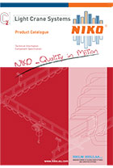](http://nikotrack.com/workstationcranes/files/2014/05/C2-Crane-Catalog.pdf)

NikoTrack Light Crane Systems

**Freestanding Bridge Cranes**

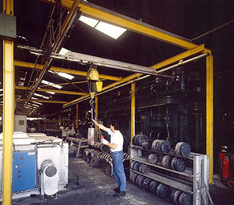NikoTrack crane enables the user an easy, fast and ergonomic movement of the material downshop and across a span. Manual bridge cranes operate faster than motorized systems, the latter is used where accessibility is restricted. NikoTrack has a tapered track that automatically guides the trolley to the center of the track, moving the heaviest loads only requires a fraction of force to begin movement and even less to maintain it. There is a 100/1 weight to force ratio, so to move a 1,000 lbs of material only requires 10 lbs of force to start moving it and only 8 lbs to continue moving. Also, with the NikoTracks inverted tapered track profile, there is a much less likelihood of dirt/dust accumulating inside of the track which will require less maintenance and ensure reliability.

NikoTrack has a full range of track, track joints, support brackets, I-beam connectors and end carriage trolleys. All designed for ease of design and installation. All fittings are zinc plate for maximum durability and protection for tough operating environments. **Tracks** are available in 6 meter length ( 19.70 feet), they are cold rolled with tapered sides designed to center the trolleys, prevent dust build up assuring smooth transfer of trolleys. The end carriage trolleys are fitted with horizontal guide rollers, connecting the moving cross bridge member to the down shop tracks.

**Festoon Cable System**

Nikotrack uses a C-track **festoon assembly** and **c-track festoon pendant system** for **overhead cranes**and industrial machinery. All festoon trolleys can be modified to fit either flat cable or round hose. Our nylon cable trolleys are extremely reliable and smooth running. Because of the self aligning tapered track, trolleys can never slide out of the center of the rail, ensuring a smooth and free operation.

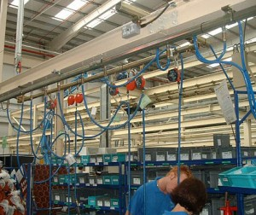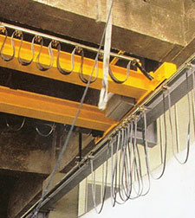

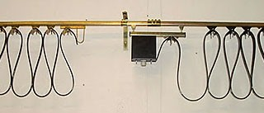

[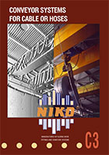](http://nikotrack.com/workstationcranes/files/2013/06/C3-Festoon-Catalog.pdf)

NikoTrack Conveyor Systems for Cable or Hoses

Top of Form

### Crane Quote Request

* Thank you for visiting our website. Please use the Form below to submit your Crane quote request and a Sales Engineer will contact you shortly.
* Your Name **\***
* Your Email Address: **\***
* Your Phone Number:
* Company

### Workstation / Gantry Crane

* Max Weight:
* Bridge Length:
* Runway Length:
* Festooning:

YesNo

* Height to Bottom of Track:
* Floor or Ceiling Mounted:

### Jib Crane

* Wall / Floor / Column Mounted
* Max Weight:
* Jib Arm Radius (choose one)

10121520

* Height to bottom of Track (Floor Mounted Only)

### Additional Details

* 

### Verification

* Please enter any two digitsExample: 12
* 

Bottom of Form

[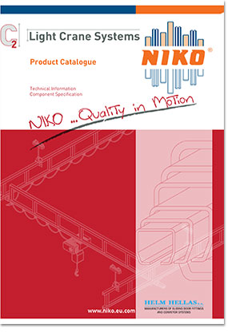](http://nikotrack.com/workstationcranes/files/2014/05/C2-Crane-Catalog.pdf)

C2 Light Crane Systems

[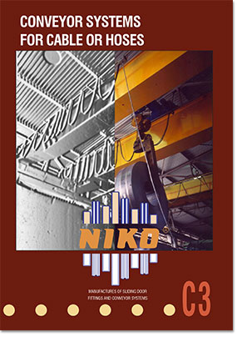](http://nikotrack.com/workstationcranes/files/2013/06/C3-Festoon-Catalog.pdf)

C3