HEADINGS
Q1 ideology of pakistan
- Introduction
- Derivation of word ideology(sceine or study of idea)
- Meaning of word(way of thinking of class culture and indicudal)
- Definition
- Characteristics:man power collective,max people,collective efforts,harmonized with feelings,beleifs,traditions
- Ideology of Pakistan
- Ideology of islam
- Islam and ideology of Pakistan
- Two nation theory
- Allama Iqbal and ideology
- Quiad and ideology
- Importance of ideology:politicalsocial,economical,religious
- Political:betterment of society,right of self determination,security of nation,saving the muslims of subcontinent
- Social : relief from British and hindus, formation of examplery society,muslim identity,Islamic culture and cicilization,human dignity
- Economical: better jobs ,industrlization, separate economy,freedom from econmogy
- Religious: symbol of power of islam,sepreading of islam, symbol of unity
- conclusion

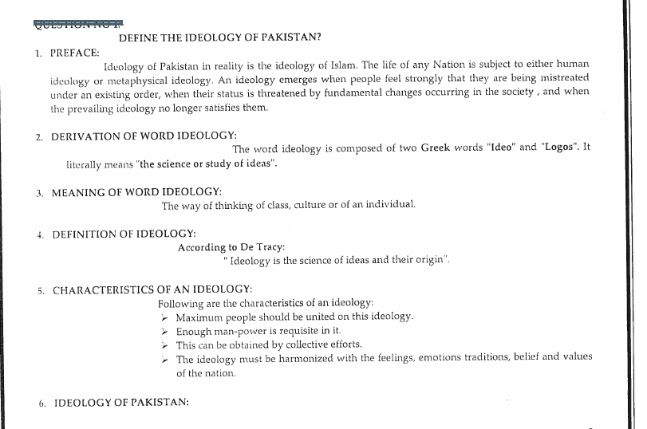

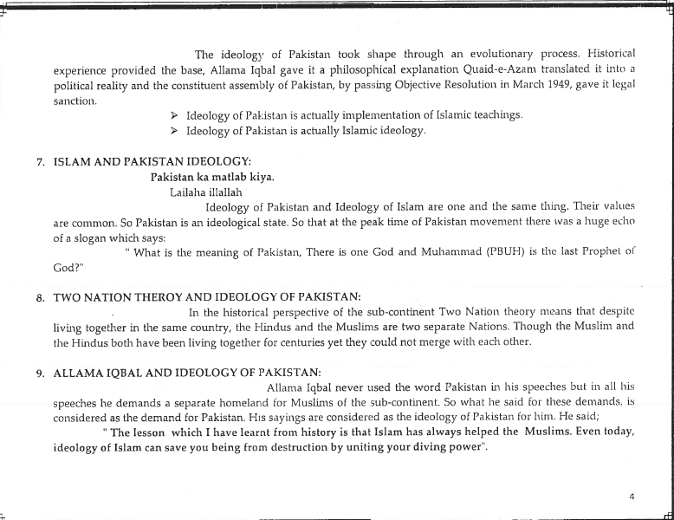

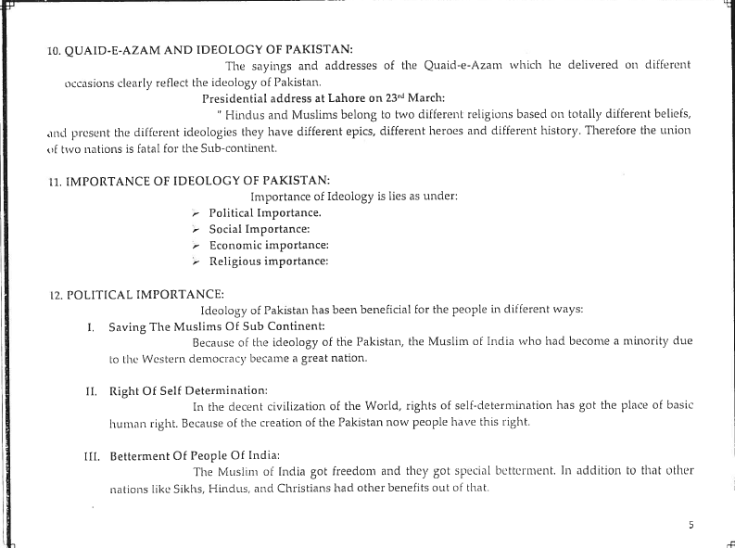

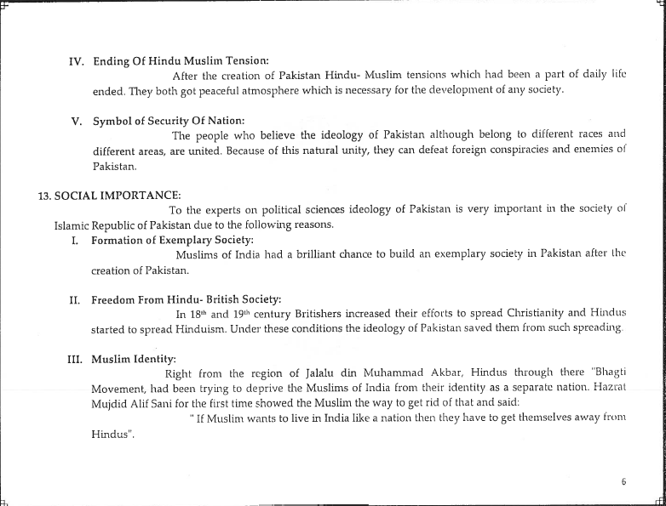

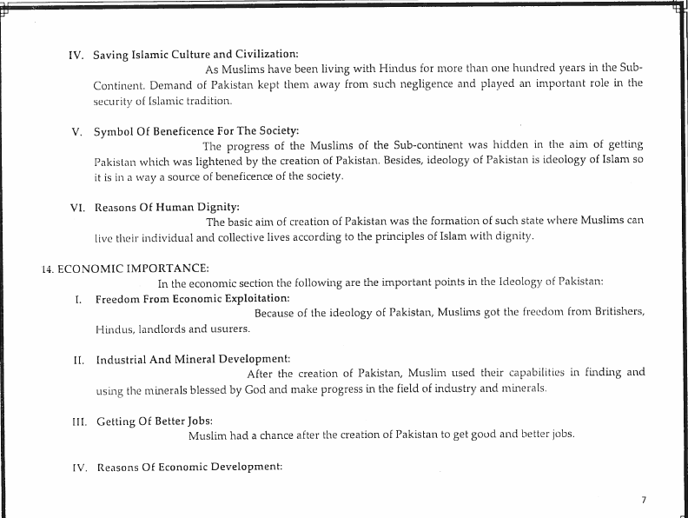

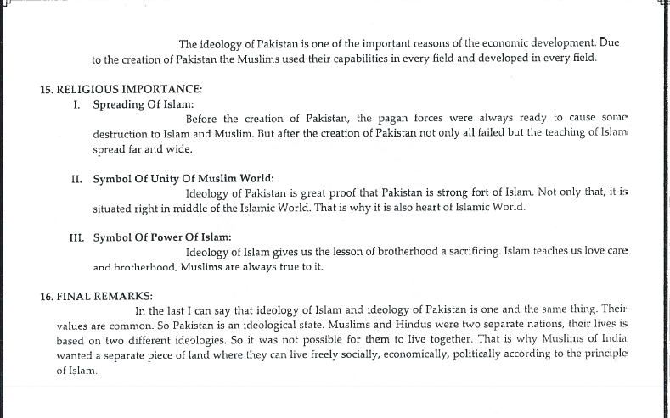

Q2:AIMS AND OBJECTIVES
HEADINGS
- introduction
- aims and objectives
- set up of free Islamic society
- free from communal riots
- social and political development
- protection of muslim language
- set up of Islamic state
- setting ab Islamic society
- protection of 2 nation theory
- dreams of muslim
- narrow mindness of hindus
- freedom from British
- attainment of peace in society
- Islamic culture and civilization
- Rid of hindu ram raj culture
- Fortress of islam
- Islamic unity
- Muslim unity
Q3:QUAID AND IDEOLOGY
- Introduction
- Derivation of word ideology(sceine or study of idea)
- Meaning of word(way of thinking of class culture and indicudal)
- Definition
- Characteristics
- Ideology and diff scholars( syed ali abbas(same meaning),dr aslam (molding) syed,allama Allaudin sidiquie(
- Quiad and ideology
- Foundation of muslim nation (first hindu muslim) 1944 march
- Pakistan and the holy quran(relation,rock,base,quran)
- Islam is a comp code of life (no need of any ism)
- Elimination of differences On 21 March, 1948 while addressing the people in Dhaka and said(punjabi ,sindhi cross all muslims tick)
- NEED OF DIVISION OF INDIA(not due to Hinduism and British but because of islam)
- NATIONAL IDENTITY OF THE MUSLIMS
- PAKISTAN, A PRACTICAL LABORATORY FOR ISLAMIC SYSTEM(not a piece of land)
- PROTECTION OF MUSLIM CULTURE(flourish,live freely)
- CRITICISM OF THE WESTERN ECONOMIC SYSTEM(unsolvable prbs,justice,equaltity and social justice)
- A GREAT SUPPORTER OF THE TWO NATION THEORY( by every right muslims are nation)
- Origin of Pakistan(Ahmedabad on 29th December 1940)
- Separate status of muslims
- Demand for separate homeland
- Islamic ideology
- Constitution of Pakistan
- National unity

Q4;initial problems of Pakistan
1:Political Problems
2. New Administration
3. Division of Assets
4. Integration of the Princely States
5. Communal Riots and Arrival of Refugees
6. Canal Water Dispute and Trade Issues
7. Economic Problems
8. Social Problems
Q5: aligadh movement
- Introduction
17 october1817…1839 joined east india company..1841 passed judiciary..1846 chief judge..march 27 1898
- Background
- Objectives (education English language..backup muslims inn politics…build confidence)
- Educational services of movement
- School in muradadbad 1859 persian school
- School in Ghazipur 1862
- Scientific society 1863 ..1876 move to Aligarh
- M.ao school in aligarg in 1875 ..1877 college and 1920 muslim univeristy ..viceroy
- Muhammadan educational conference 1886..all india muslim league in dhaka 1906
- Syllabi syllabus
- Conclusion
- Literary services(skip)
- Social and economic services of aligadh movement
- Lost glory
- Risala asbabe baghawate hind
- Loyak muhammadans of india
- Orphanges
- Govt jobs for muslims
- Political services
- Separate electorate
- Two nation theory 1867
- Special seats for muslims in local councils
- Quota services
- Urdu hindi
- Avoid politics
- Indian national congree
- Political reforms
- Conclusion
Q6:khilafat movement
- Introduction
- Leaders of khilafat comiitee
- Objectives
- Activities
- Delegations
- Medical aid
- Financial aid
- Processions
- Role of press(zamindar of zafar ali,alhala of abdul kamal,comrade of maulana ali juahar)
- Role of Gandhi
- Agreement of serves
- Non coperations movement
- Migrate to iran Afghanistan
- Civil disobedience
- Mutiny of moplah
- Cuahra chori tragedy
- End of movement
- Results and effects
- Reasons of failure
- Conclusion
Q7:nehru report
- Intro
- Background
- They challenged hindu leader
- Formation of comitte
- Members of comitte
- Features of report
- Reaction to report
- Report analyzis
- Conclusion
Q8:14 POINTS
- Federal structure
- Autonomy provinces
- Minority representation
- Separate electorrates
- Muslims representation in central legislature
- Territory change
- Muslims culture protection
- Religious freedom
- Sindhs separation
- Veto power
- Muslims in cabinets
- Constituitional amedmenst
- Reforms in nwfp
Q8:1973 CONSTITUIONA
- Sovereignty of allah
- Official relgion
- Countrys name
- Definition of muslim
- Muslim leader and prime miniter
- Protection of lismaic law
- Zakat and usher
- Arabic and printing of quran
- Compulsoary Islamic teachings and quran
- Islamic value
- Eleimintaion of riba
- Unity of Islamic world
- Protection of minorities
- End of rcial and provincial discrimintaions
- End of illiteracy
- Welfre state
- National language
- Free judiciary
- Protection of ideology
- Importance
- Suspension 1977 general zi aul haq and 3rd martial law imposed

Q9:Islamization
- Background
- Constitution of 1956,1962 and 1973
- Objective resolution 1940
- Steps
- Enforcement of hadood
- Teaching of islam
- Zakat and usher
- Elimination of interest
- Islamic teaching
- Arabic teaching
- Madaras formation
- Ehtra me Ramzan ordinance
- Islamic universiyy
- Namaz
- Respect for pbuh
- Hajj
- Objective resolution as permanent part
Q10 KASHMIR CONFLICT

