LAWYER INTERFACE – MODULES OVERVIEW:
1. Login & Authentication Module
- Function: Allows lawyers to securely log in and verify their identity.
- Why it's needed: Ensures that only verified lawyers access sensitive data like case files or client information.
- Tools: Use OAuth 2.0 (user-gated OAuth authentication as you mentioned) for secure and standard login.
- Support Email/Password login with Node.js backend + PostgreSQL for storing users and credentials.

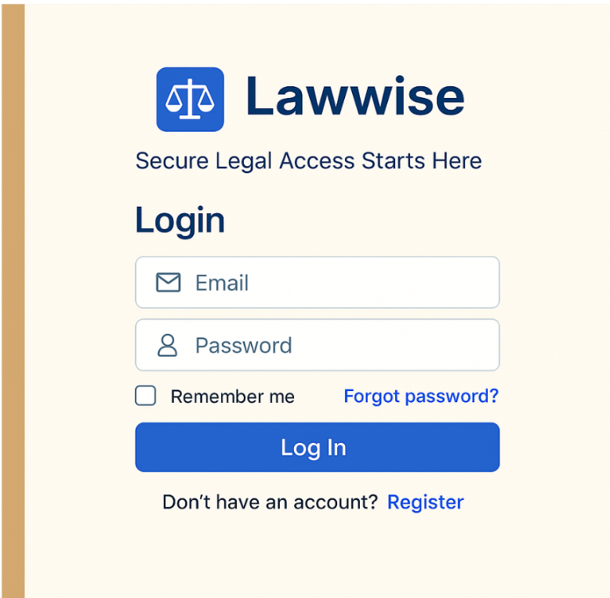

2. Dashboard Module Function:
- Displays a quick overview—upcoming hearings, messages, deadlines, and notifications.
- Why it's needed: Helps lawyers see all important updates in one place without digging around the app. after login our next screen will be dashboard
- Tools: for Framework Node.js with Express.js ,for Database MongoDB (for flexibility),for Real-time updates Socket.IO (Node.js),for Authentication JWT (JSON Web Tokens)
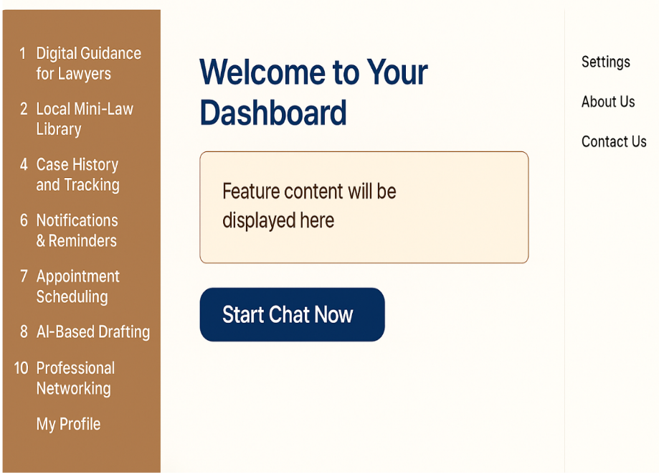

3. Case History & Tracking Module
- Function: Lawyers can view past and ongoing cases, including uploaded documents and notes.
- Why it's needed: Helps revisit previous cases for reference or legal strategy in new similar cases
- Tools : A backend system with a relational database like MySQL or PostgreSQL can be used to store structured case data
- The frontend should be built with frameworks like React or Angular for dynamic interaction, and tools such as PDF.js for document previewing. File upload components like Dropzone.js can facilitate easy document submission
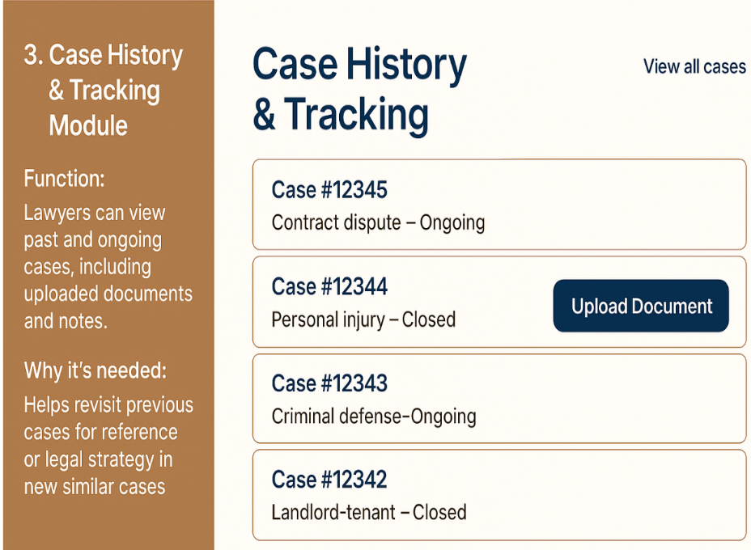

4. Lawyer Profile Management Module
- Function: Lawyers can build and update their profile with qualifications, experience, practice areas, and availability.
- Why it's needed: Builds trust for clients who want to see lawyer details before hiring; helps young lawyers stand out.
- Search & Filtering (Elasticsearch or PostgreSQL full-text search): To let users search for lawyers by name, specialization, city, etc
- Tool: Node.js with Express.js, Database PostgreSQL (recommended for structured profile data and advanced filtering), Search & Filtering Elasticsearch (for advanced, fast full-text search and filters), File Uploads (for certificates, profile pictures) Multer (Node.js) or Django File Upload + Media Storage


5. AI-Based Drafting Module:
- Function: Automatically generates legal documents like notices, contracts, and petitions based on inputs.
- Why it's needed: Saves time, reduces chances of human error, and provides ready-to-use documents faster.
- Tools: OpenAI GPT API (or similar LLM) for generating legally structured documents based on user input. Node.js + Express handles form inputs and API calls, with PostgreSQL optionally storing drafts and user history.
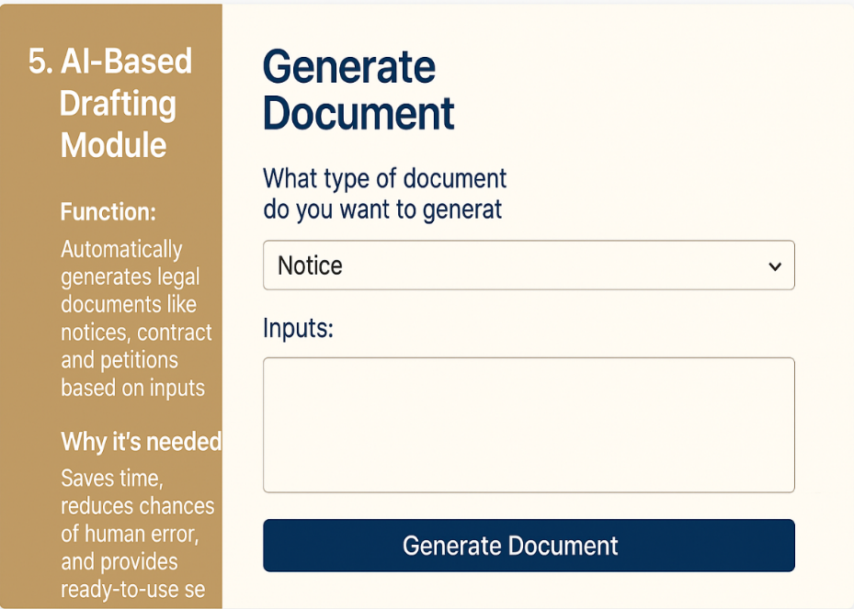
🧠 The AI/NLP model (e.g., GPT API)
This is the engine that understands user inputs and generates accurate, legally structured documents (like notices, contracts, or petitions).

6. Communication & Appointment Module
- Function: Allows lawyers to chat with clients, schedule meetings, and view upcoming appointments.
- Why it's needed: Makes client interaction smooth and professional without relying on WhatsApp or calls.
- Tools: Node.js + Express handles chat and scheduling APIs, with PostgreSQL storing messages and appointments. Socket.io enables real-time chat, and tools like FullCalendar (frontend) or node-cron manage appointments and reminders.

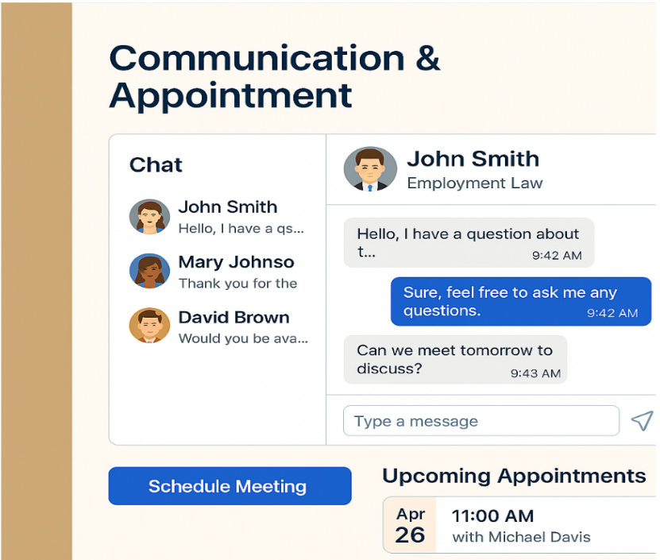

7. Mini-Law Library with AI Support Module :
- Function: Gives access to statutes, rules, and previous judgments, plus an AI that explains them simply.
- Why it's needed: Saves research time and helps lawyers, especially new ones, understand laws faster.
- Tools: Node.js + Express serves legal content from a PostgreSQL database, with full-text search via pg_trgm or Elasticsearch. OpenAI API (or similar LLM) powers the AI assistant to explain laws in simple terms.

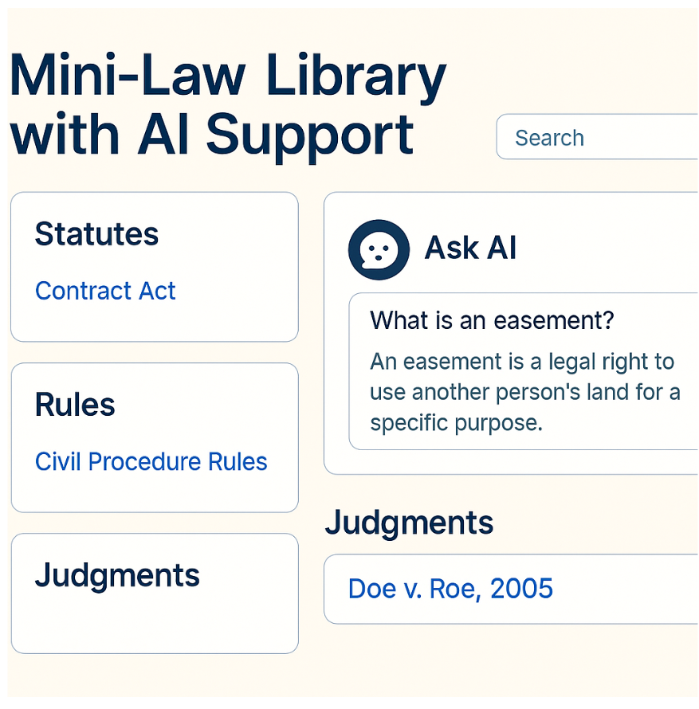
8. Video Tutorials Module:
- Function: Offers YouTube tutorials based on the lawyer’s need—e.g., "how to draft a petition", "how to e-file a case".
- Why it's needed: Especially useful for young or new lawyers; no need to search on YouTube manually.
- Tools: This module uses YouTube Data API with Node.js and Express to fetch and serve tutorials. PostgreSQL stores popular searches, while Axios handles API calls, EJS/React displays videos, and dotenv manages API keys securely.
- 

9. Notifications & Deadline Reminders Module
- Function: Sends alerts for upcoming hearings, meetings, or document submissions.
- Why it's needed: Prevents missing important dates and improves professionalism.
- Tools: This module uses Node.js with Express, node-cron, and Moment.js/Day.js for scheduling reminders. PostgreSQL stores events, while Nodemailer, FCM/OneSignal, and Socket.io handle email, push, and real-time notifications.
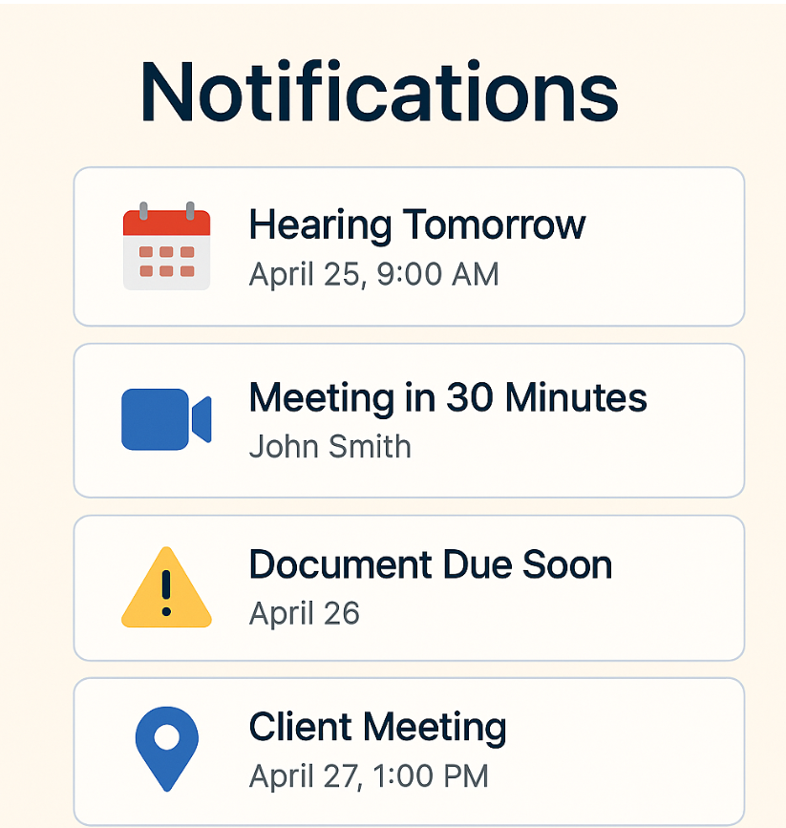

10. Professional Networking Module
- Function: Lets lawyers connect with peers, send messages, or collaborate.
- Why it's needed: Helps lawyers grow their network, get support, and share legal knowledge.
- Tools: This module uses Node.js with Express to build REST APIs, PostgreSQL with Sequelize for data management, and Socket.io for real-time messaging. JWT or OAuth 2.0 handles secure sessions, while React (optional) powers the interactive UI.
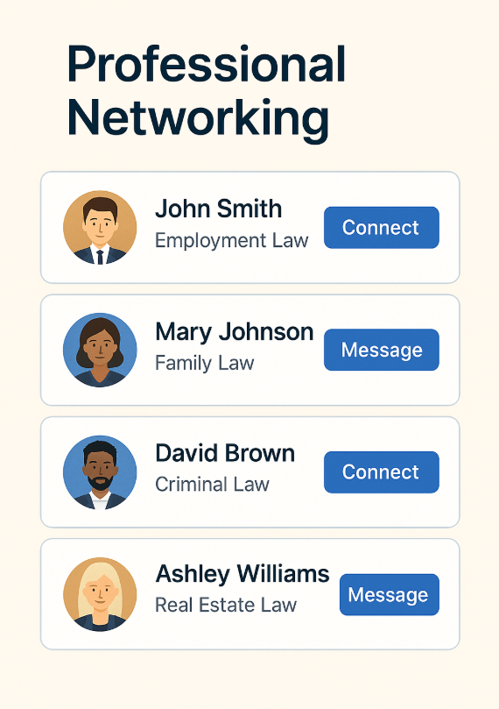

CLIENT INTERFACE – MODULES OVERVIEW:
1. Login And Authentication module:
- Function: Allows clients to securely log in and verify their identity.
- Why it's needed: Ensures that only verified clients access sensitive data like case files or client information.
- Tools: Use OAuth 2.0 (user-gated OAuth authentication as you mentioned) for secure and standard login.
- Support Email/Password login with Node.js backend + PostgreSQL for storing users and credentials.


2. E-Filing module:
- Function: Allows clients to file cases digitally by uploading legal documents and submitting case details through the app.
- Why it’s needed: Simplifies the case filing process, reduces paperwork, and speeds up legal proceedings.
- Tools: Node.js + Express for backend APIs, PostgreSQL to store case details and document metadata, Multer for handling file uploads, and AWS S3 (or similar) for secure document storage.
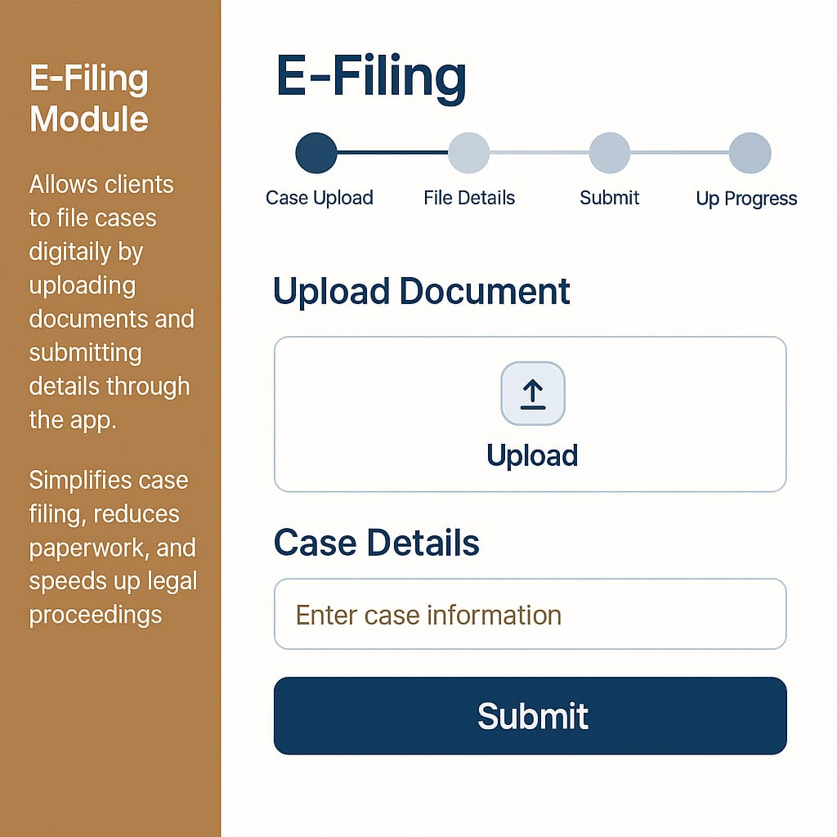
3. Lawyer filtering and selection:
- Module Function: Enables clients to browse, filter, and select lawyers based on categories, ratings, and reviews.
- Why it’s needed: Helps clients find the most suitable legal representation efficiently and confidently.
- Tools: Node.js + Express for API, PostgreSQL for storing lawyer profiles and reviews, Elasticsearch or PostgreSQL full-text search for filtering and search, React (or any frontend framework) for dynamic UI filtering.

4. Lawyer profiles and reviews:
- Module Function: Displays detailed lawyer profiles with qualifications, experience, client reviews, and ratings.
- Why it’s needed: Builds trust and transparency for clients before they hire a lawyer.
- Tools: PostgreSQL for profile and review data, Node.js + Express for serving profile data, and React/EJS for front-end display.

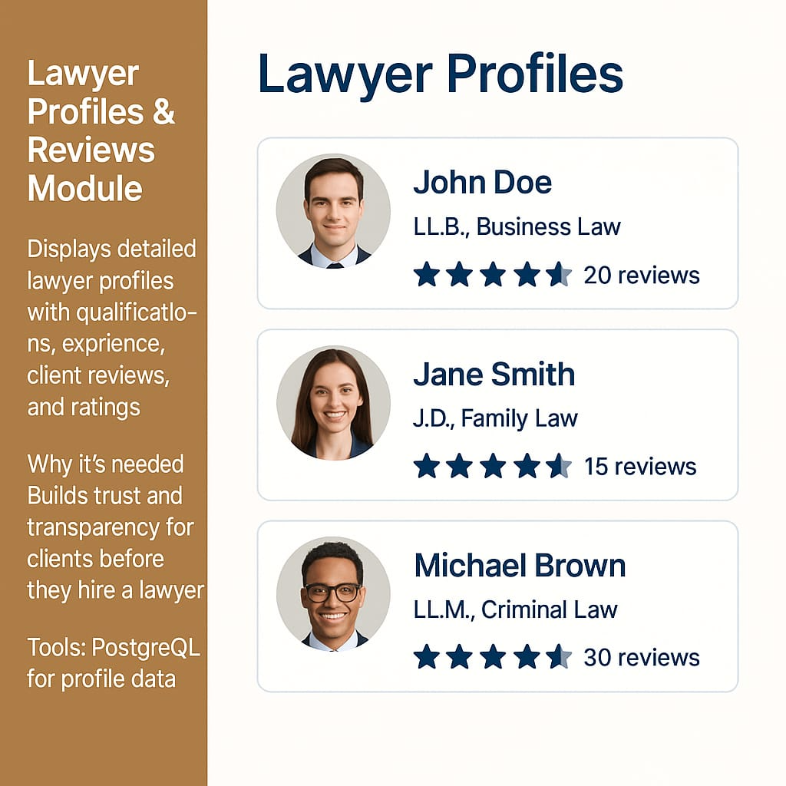
5. Notifications & Reminders:
- Module Function: Sends automated notifications and reminders about upcoming hearings, case updates, or deadlines to keep clients informed.
- Why it’s needed: Ensures clients never miss important dates, improving case management and client satisfaction.
- Tools: Node.js + Express for scheduling, node-cron for recurring jobs, PostgreSQL to track notifications, Nodemailer for email alerts, and Firebase Cloud Messaging (FCM) or OneSignal for push notifications.

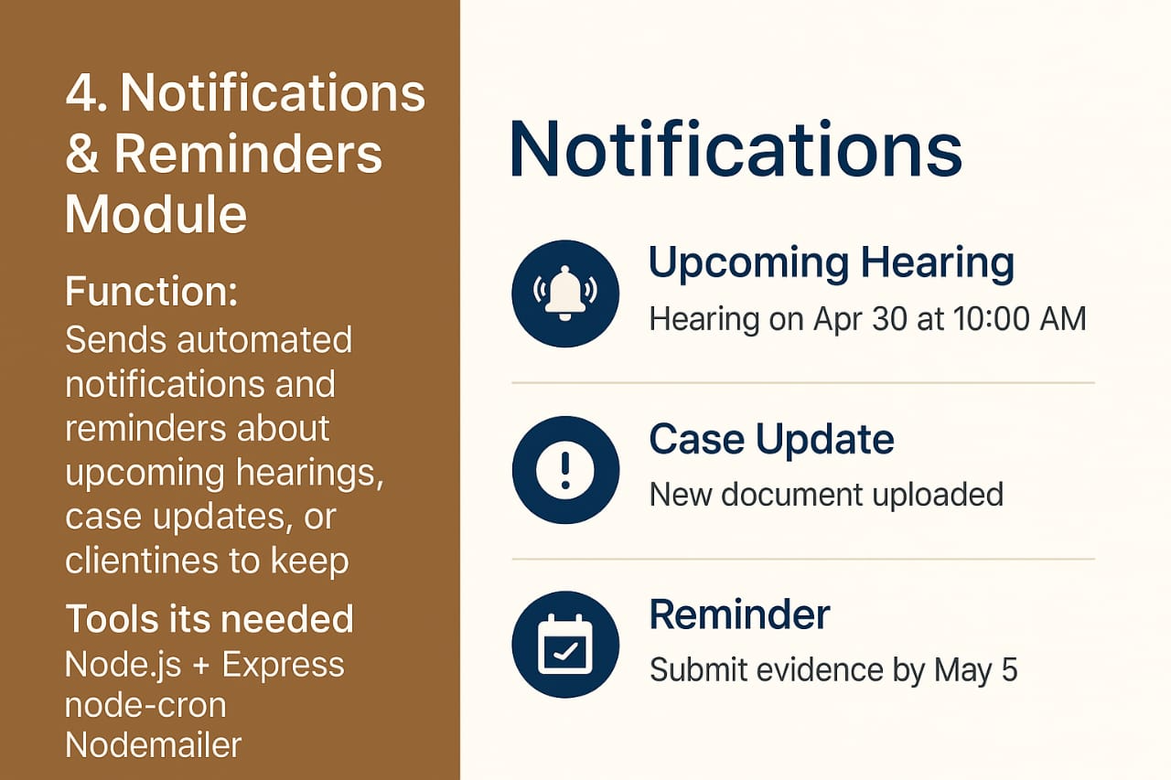

STUDENT INTERFACE – MODULES OVERVIEW:
1. Login And Authentication module:
- Function: Allows clients to securely log in and verify their identity.
- Why it's needed: Ensures that only verified clients access sensitive data like case files or client information.
- Tools: Use OAuth 2.0 (user-gated OAuth authentication as you mentioned) for secure and standard login.
- Support Email/Password login with Node.js backend + PostgreSQL for storing users and credentials.

2. Mini-Law Library Module:
- Function: Provides categorized notes, case summaries, and past papers organized by subject and year.
- Why it’s needed: Saves students time by offering centralized and organized academic content.
- Tools: Node.js + Express with PostgreSQL for content management; Multer for uploads; full-text search using PostgreSQL or Elasticsearch.

3. Smart Recommendations Module:
- Function: Suggests books, videos, and articles based on students’ areas of interest.
- Why it’s needed: Offers personalized learning resources tailored to each student’s legal focus.
- Tools: Node.js with PostgreSQL for preferences; YouTube Data API and curated lists for dynamic suggestions.

4. Auto-Generated Quiz & Test Module:
- Function: Creates quizzes based on selected subjects to help students self-assess.
- Why it’s needed: Encourages active recall and reinforces legal concepts.
- Tools: Node.js + PostgreSQL for quiz handling; optional OpenAI API for dynamic question generation.

5. Notes Sharing & Upload Module:
- Function: Enables students to upload and share notes with peers.
- Why it’s needed: Builds a collaborative learning environment among law students.
- Tools: Node.js + Express with Multer for uploads, PostgreSQL for metadata, and AWS S3 (or similar) for file storage.
