***Advanced* 3-D Scene Renderer**

* Marcus Koh

2018

Gungahlin College

ACT

A project submitted to

Young ICT Explorers

23/07/2018

Please answer to the best of your abilities all of the below questions**?** Yes.

1. ABSTRACT – *max 150 words*

Provide a short summary telling us about your project and what you hoped to achieve? My project is an interactive 3-D rendering program. I hope to achieve the following:

* Render a 3-D scene with basic shading
* Use bounding boxes and field of view calculation to speed up rendering
* Make a basic UI for the user to position and orient the camera, and add and remove models
* Make the UI user-friendly and intuitive

2. INTRODUCTION – *max 50 words*

What inspired the idea for your project?

3-D rendering has recently gotten my interest after watching several tutorials and showcases for 3-D rendered scenes and models.

3. PROBLEM STATEMENT – *max 50 words*

Explain the problem you are trying to solve with your project**?**

My project boils down the process to creating and rendering a scene into a simple, easy to use graphical application. It also allows the user to quickly save/load the scene.

* Design and Features – *max 75 words*  
  tell us about the design and some of the features of your project?

My project has a GUI for the user to be able to:

* + Render the scene, displaying it into a view window
  + Move and orient the camera
  + Select models by simply clicking on its bounding box
  + Move and orient the models
  + Save/load scenes and export render
  + Add and remove models

I have employed the following techniques in my project:

* + 3-D projection matrix transformations
  + Viewbox collision detection
  + Depth arrays (to solve visibility problem)
* Challenges Designing and Building this Project *– max 75 words*  
  what challenges did you have when designing and building your project?  
  Building a 3-D rendering engine from scratch is quite an undertaking. The mathematics of projection calculation and the visibility problem are just a few of the challenges. I also built the UI for this project from scratch.

4. CONCLUSION – *max 50 words*

Does your project do what you set out to achieve?

Yes. I have accomplished the following to a desired proficiency:

* Render a 3-D scene with basic shading
* Use bounding boxes and field of view calculation to speed up rendering
* Make a basic UI for the user to position and orient the camera, and add and remove models
* Make the UI user-friendly and intuitive

5. TECHNOLOGIES USED

List the programs and technologies used?

Programming Language: Python >= 3.6.x

Geometric and projection mathematics: numpy

GUI: tkinter

Image manipulation: PIL

APPENDIX A  
Insert images or screenshots or links to your project if published online (eg: Youtube video) in this section in support of your submission

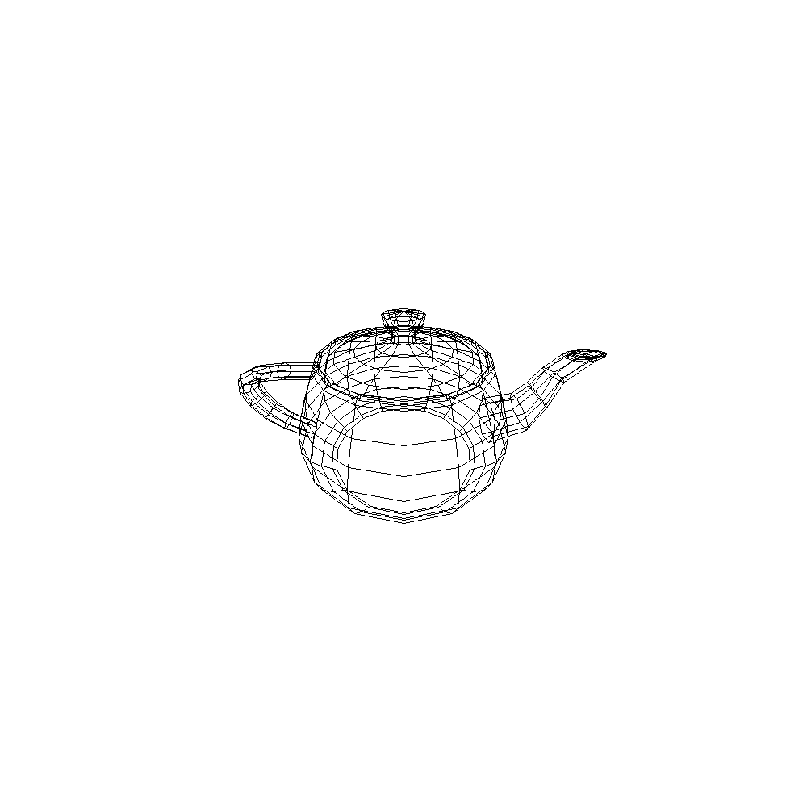

APPENDIX B

Insert samples of program code here (if applicable)

class Camera: # MUTABLE: CHANGE ORIENTATION, POSITION, ZOOM,

def __init__(self, pos=Point((0, 0, 0)), pan=0.0, tilt=0.0, roll=0.0, xspan=300, yspan=200, logzoom=1.8, maxdepth=100, scene=Scene()):

assert type(pos) is Point

assert type(pan) in (int, float)

assert type(tilt) in (int, float)

assert type(roll) in (int, float)

assert type(xspan) in (int, float)

assert type(yspan) in (int, float)

assert type(logzoom) in (int, float)

pan %= tau # rotates counterclockwise as pan increases

tilt = fix_range(tilt, (-pi, pi)) # tilt increase: camera tilts upwards and vise-versa

roll = fix_range(roll, (-pi, pi)) # roll increase: camera rotates counterclockwise and vise-versa

self._pos = pos

self._pan = pan

self._tilt = tilt

self._roll = roll

self._rotmatrix = np.matrix([[1, 0, 0],

[0, 1, 0],

[0, 0, 1]

])

self._update_rotmatrix()

self._xspan = xspan # == tan(angle from centre to right of view)

self._yspan = yspan # == tan(angle from centre to top of view)

self._logzoom = logzoom

self._zoom = 10**logzoom # scales xy of projected points

self._maxdepth = maxdepth

self._visible_models = []

self._scene = scene