1. **Task Description**Call radom quotes generator API and after that copy data current quote and create a new post
2. **Task Output Screenshot**

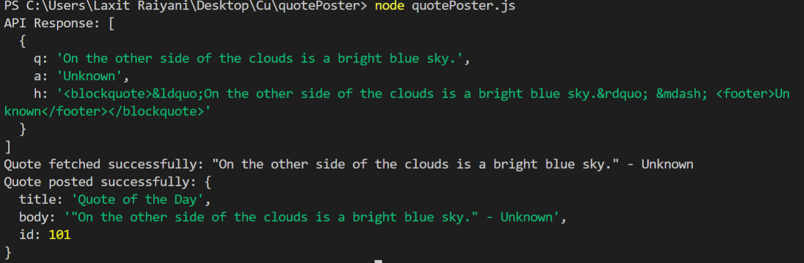

1. **Widget/Algorithm Used In Task**

**Axios**: Used for making HTTP requests. It's a promise-based HTTP client for the browser and Node.js.

**ZenQuotes API**: The external service that provides random quotes.

**JSONPlaceholder API**: A mock API for simulating the "post" action (useful for testing).