**Group Members:** Himang Patel(202212005)

Laxit Shah(202212042)

**Group ID:**17

**Course:** MSc(IT)

**Subject:**Database Management System

**1>show user table whose user_type is employee**

select * from users where user_type='employee';

**Output:**

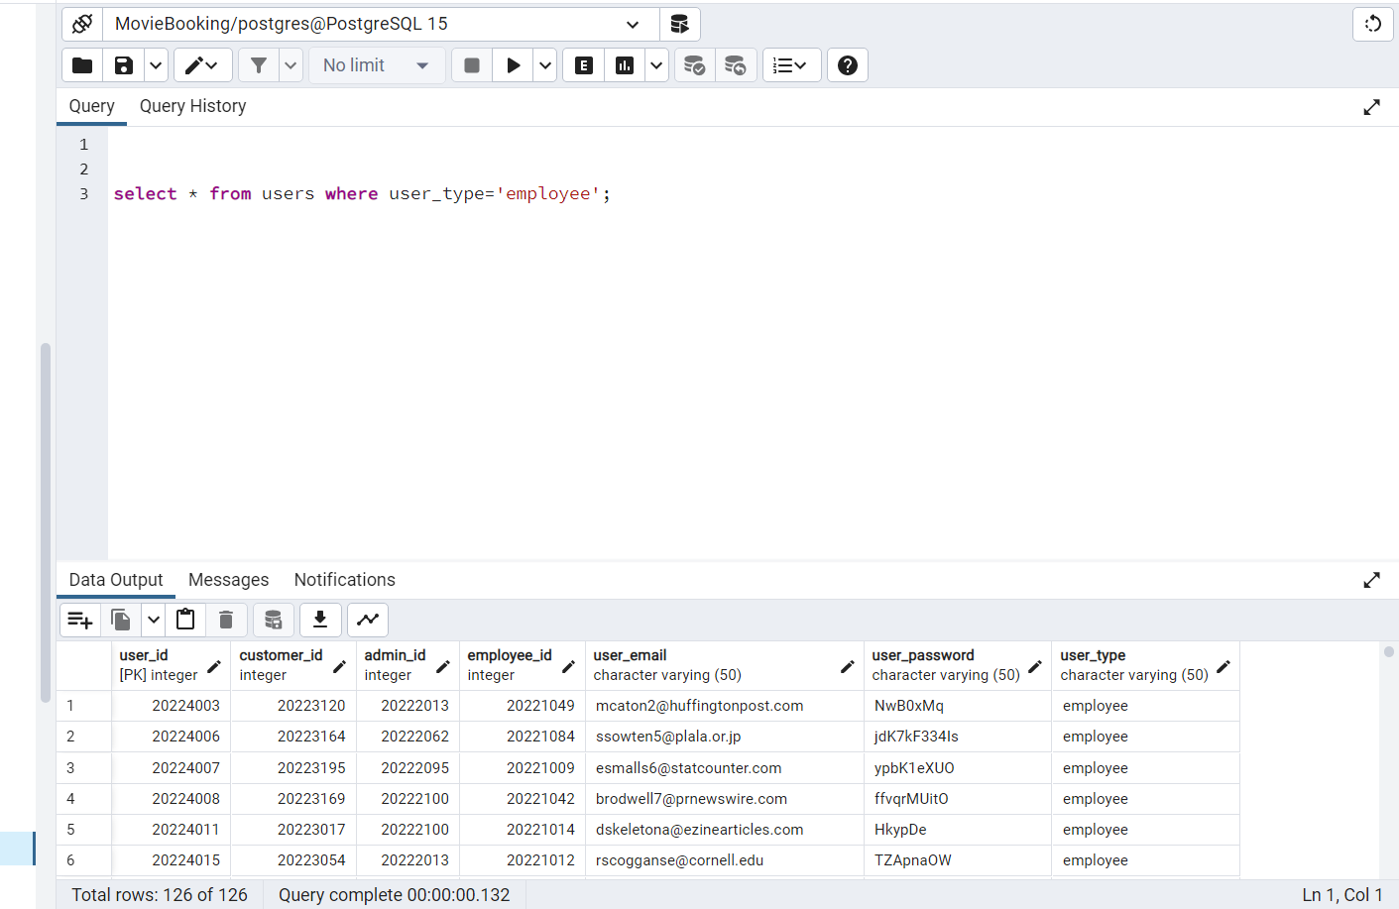

**2>Count all The booking Numbers.**

select count(*) from booking;

**Output:**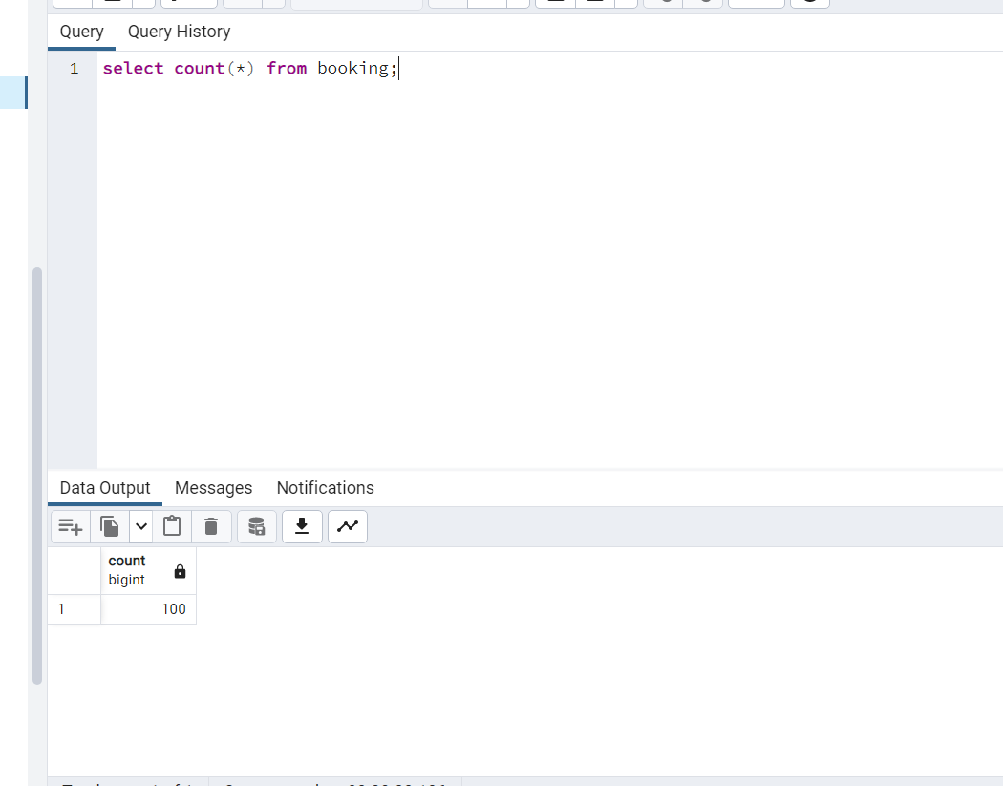

**3>Create view of 5 highest item amount and display it.**

create or replace view item_view as select * from menu order by item_amount limit 5

select * from item_view;

**Output:**

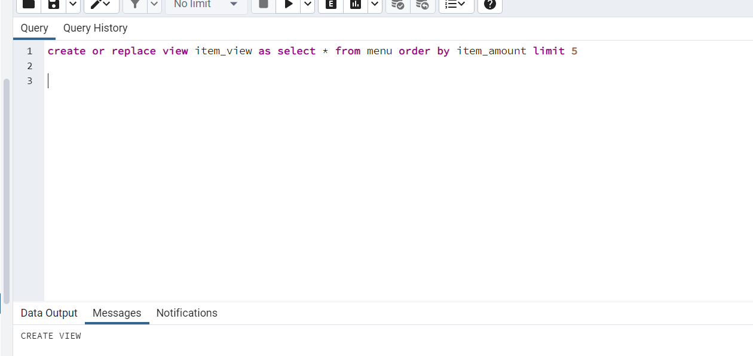

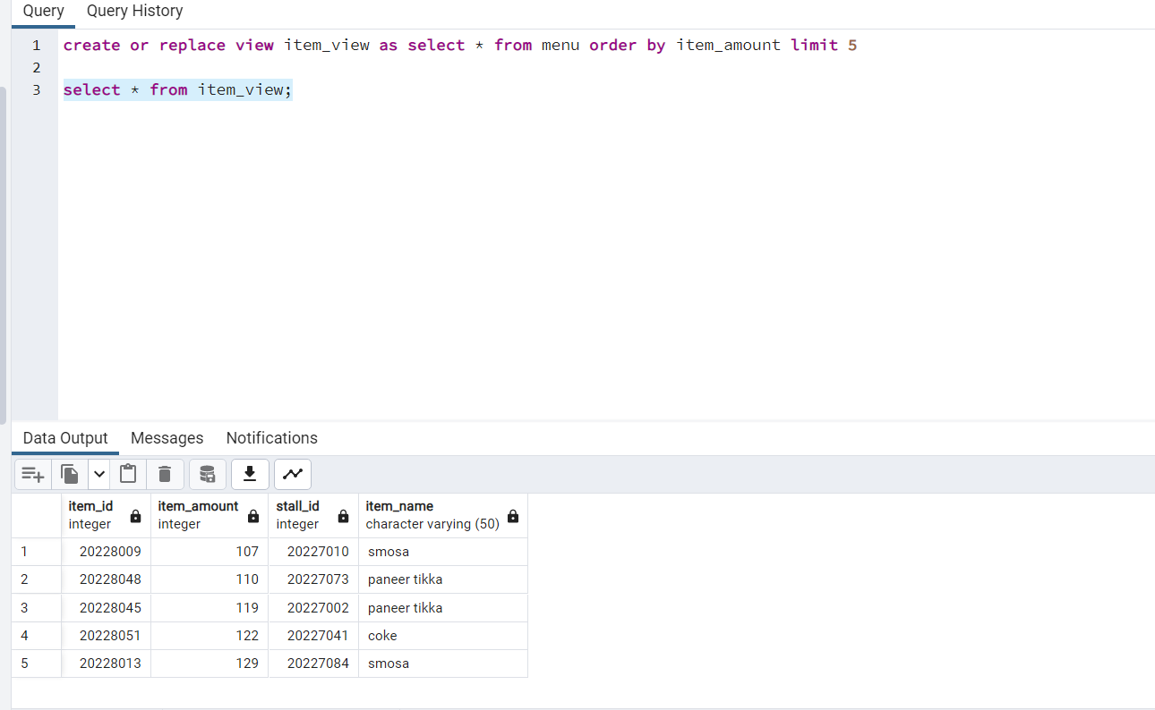

**4>Find ticket_price which is greater than average ticket_price**

**ans>**select amount as ticket_price from seats where amount> (select avg(amount) from seats);

**Output:**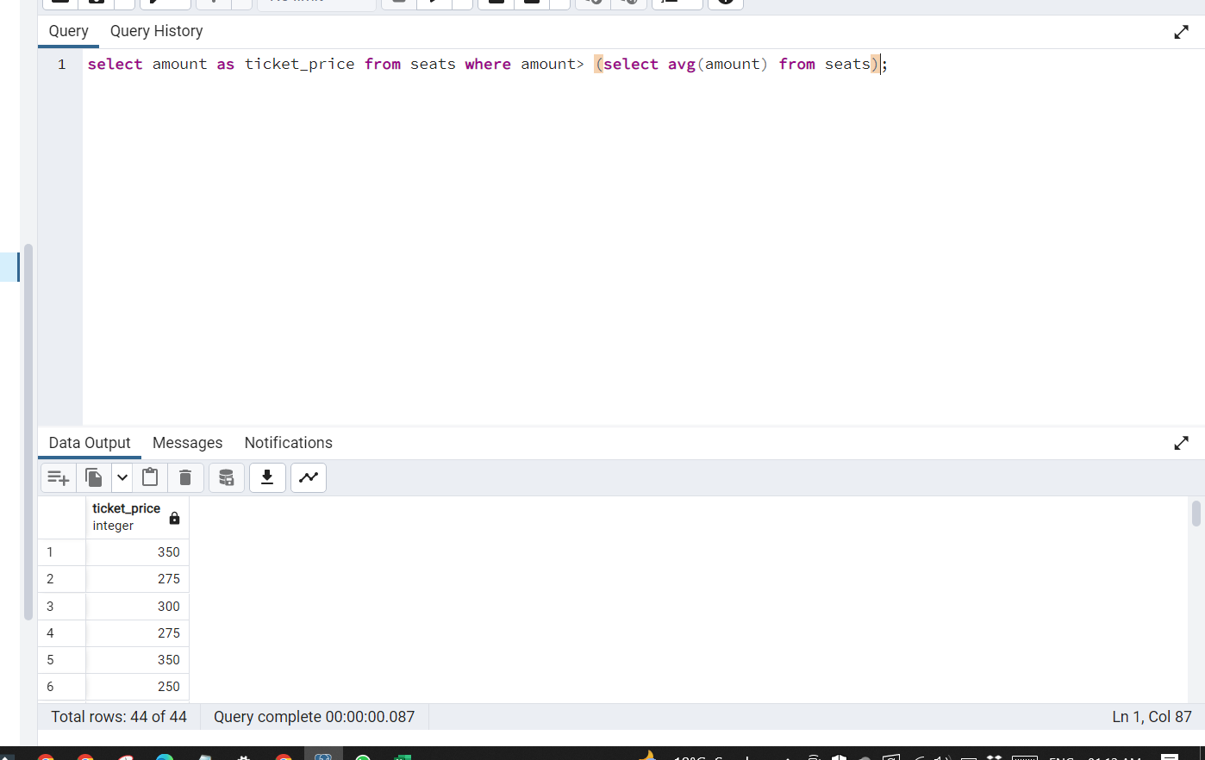

**5>Find count of different types of user_role**

**ans>**select user_type, count(*) from users group by user_type

**Output:**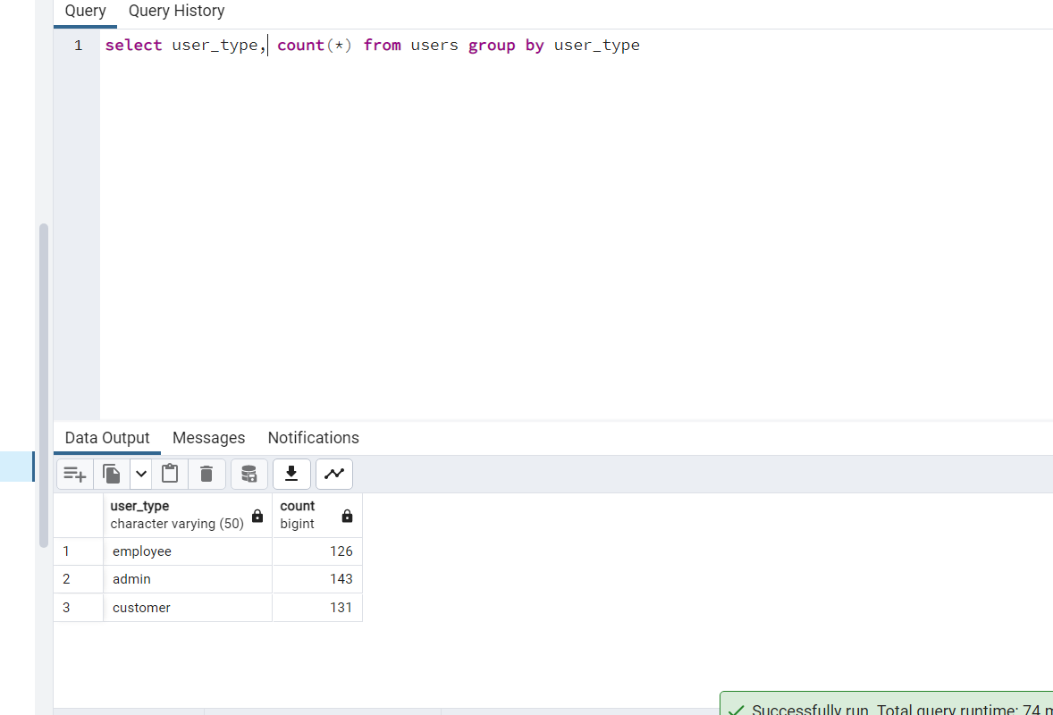

**6>Display show time and movie name**

select time ,movie_name from movie join shows on movie.movie_id=shows.movie_id

**Output:**

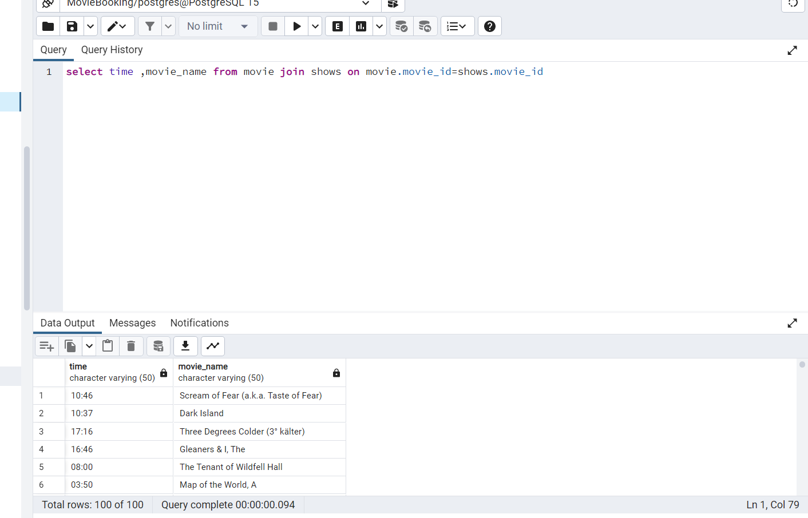

**7>Sort Employee Name**

select * from employee order by employee_name

**Output:**

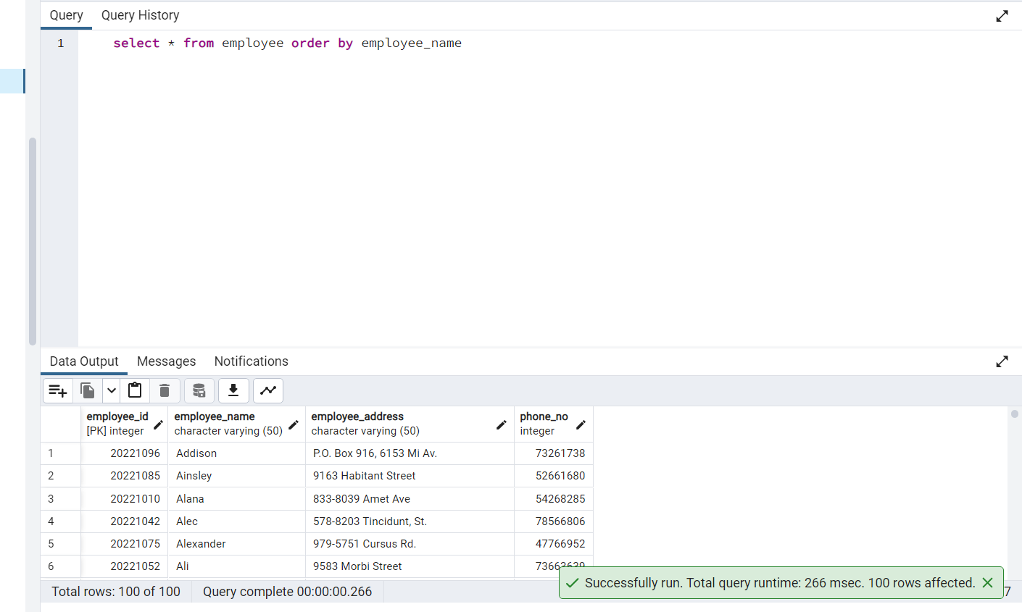

**8>Show Movie Name, Details and time and date .**

**ans>** select movie_name,movie_details,time ,date_ from movie join shows on movie.movie_id=shows.movie_id

**Output:**

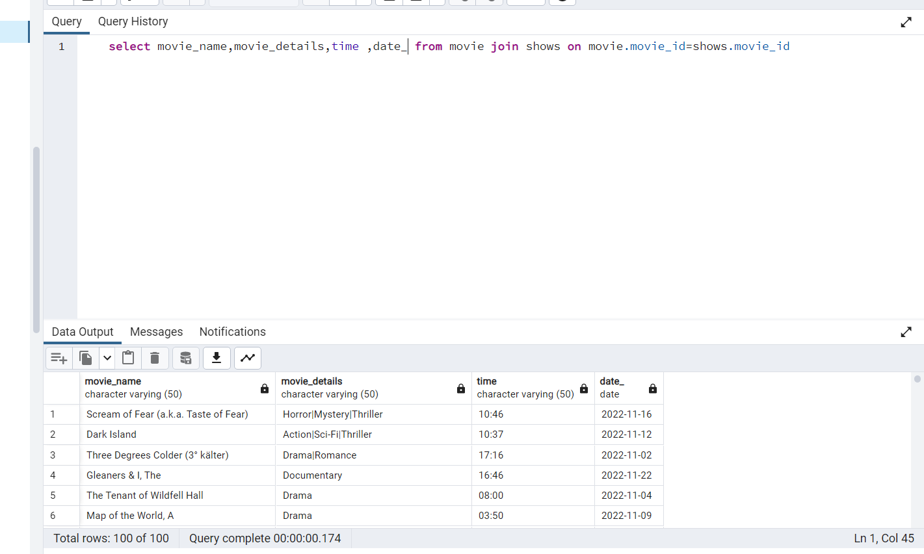

**9>Show Movie Name and amount**

**ans>**select movie.movie_name, seats.amount from movie join shows on movie.movie_id = shows.movie_id join seats on shows.hall_id = seats.hall_id

**Output:**

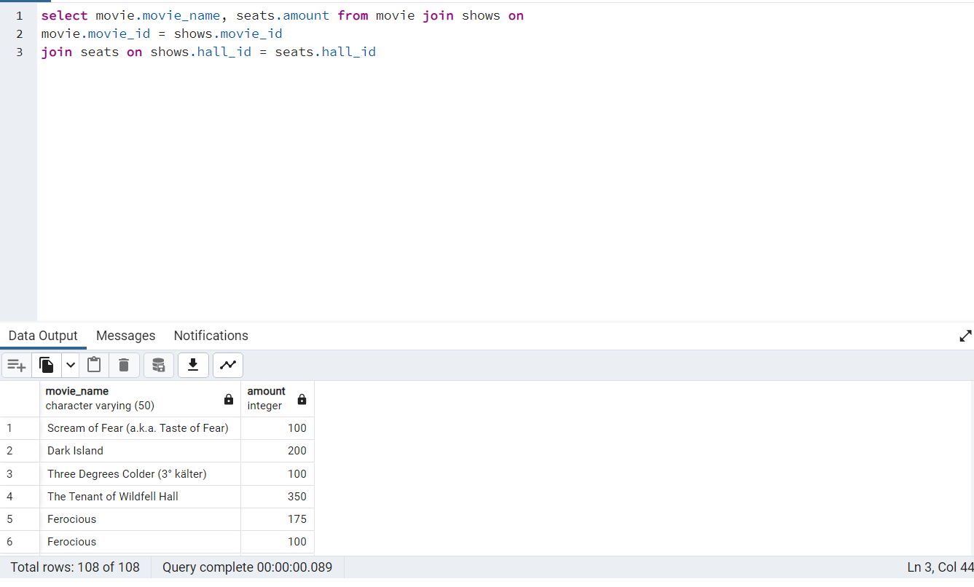

**10>select average item_amount**

**ans>**

select avg(item_amount) from menu

**Output:**

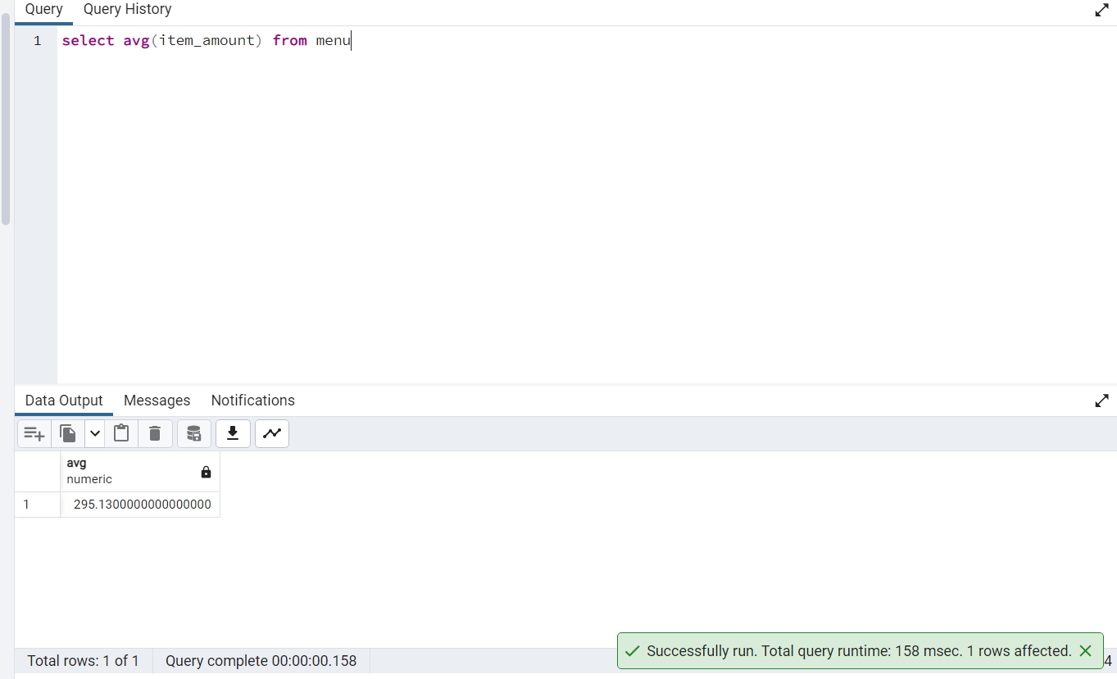

**11>Show Movie Name whose name start with 'A'**

select * from movie where movie_name like 'A%'

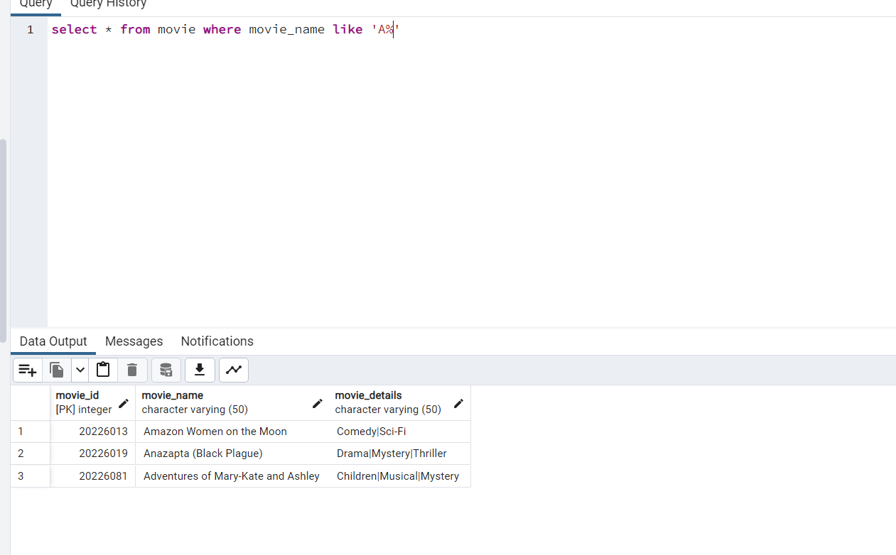

**12>Show Customer Name whose name start with 'B' and End With 'L'**

**ans>**select customer_name from customer where customer_name like 'B%' and customer_name like '%l'

**Output:**

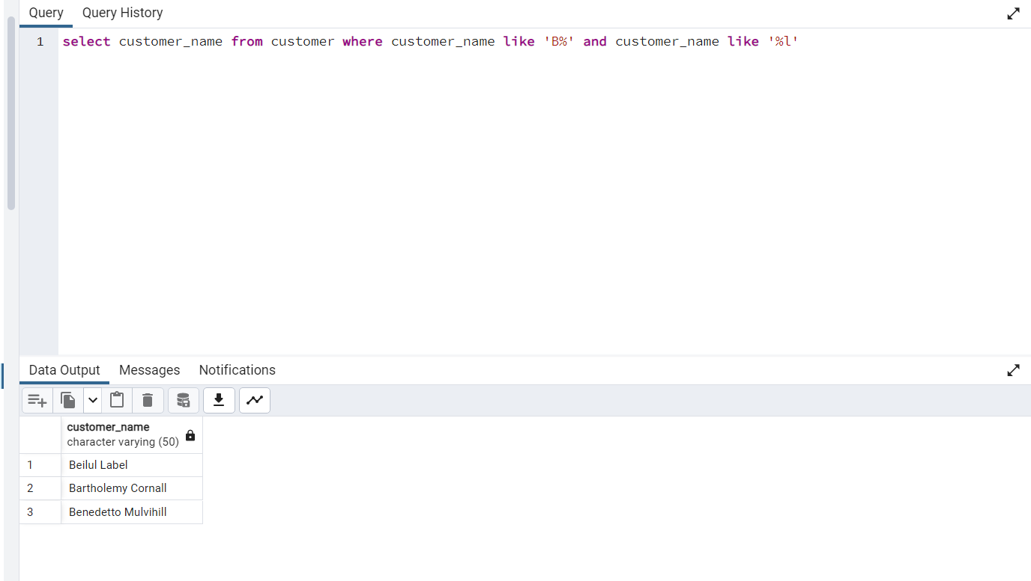

**13>Create a view for customer_details ,insert and display the view**

create or replace view view_customers as select * from customer

insert into view_customers values(20223401,'General Kenobi','221B Baker Streeets',99955533)

select * from view_customers

**Output:**

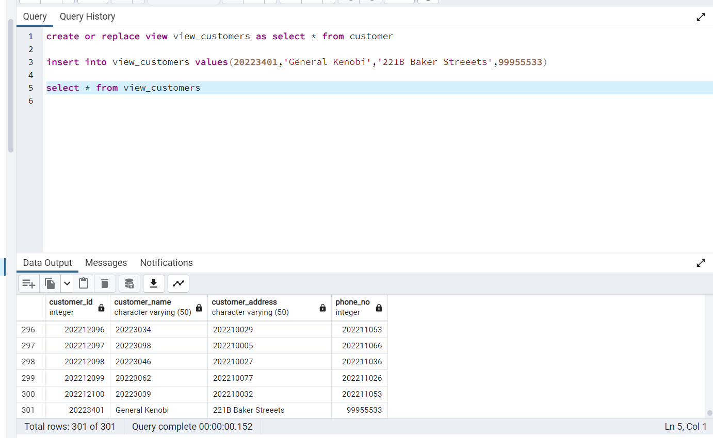

**14>Show the sum of total seat amount**

**ans>**select sum(amount) from seats

**Output:**

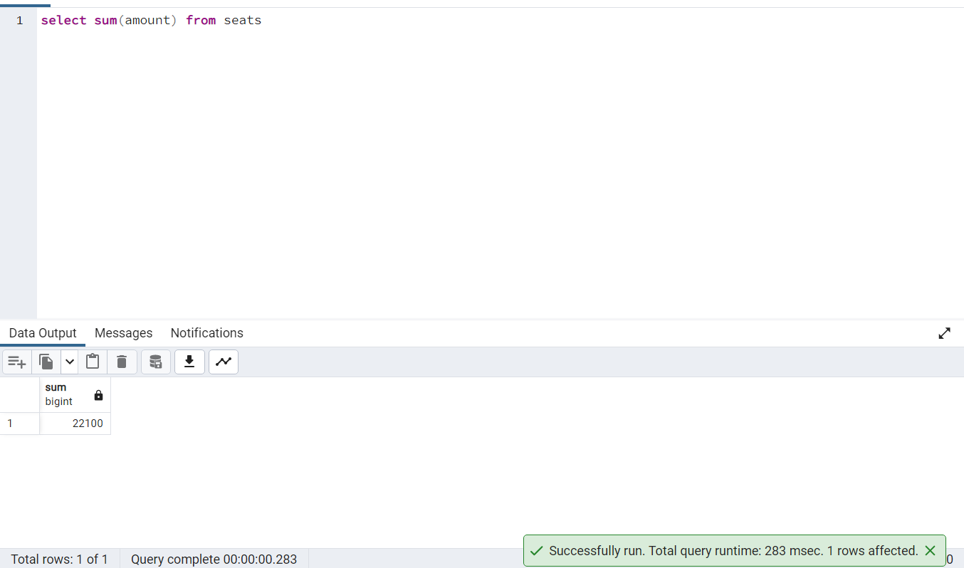

**15>Display Menu Name Descending wise.**

select menu_name from stalls order by menu_name desc

**Output:**

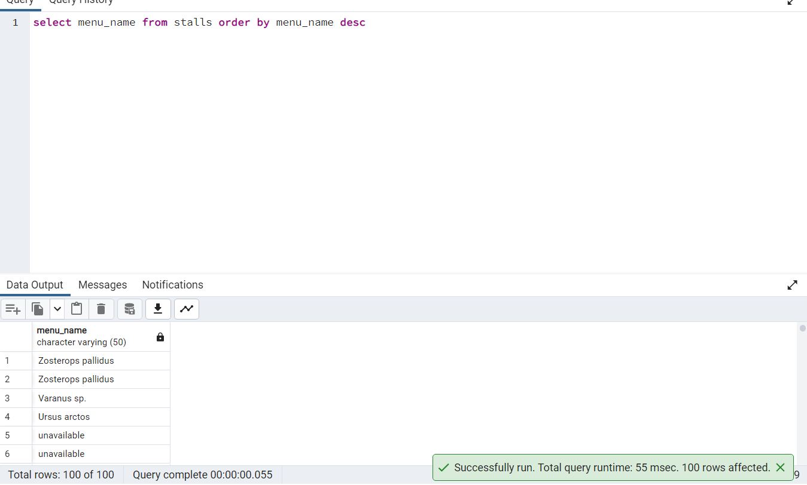

**16> Display record for the maximum total amount in seats**

select max(amount) from seats

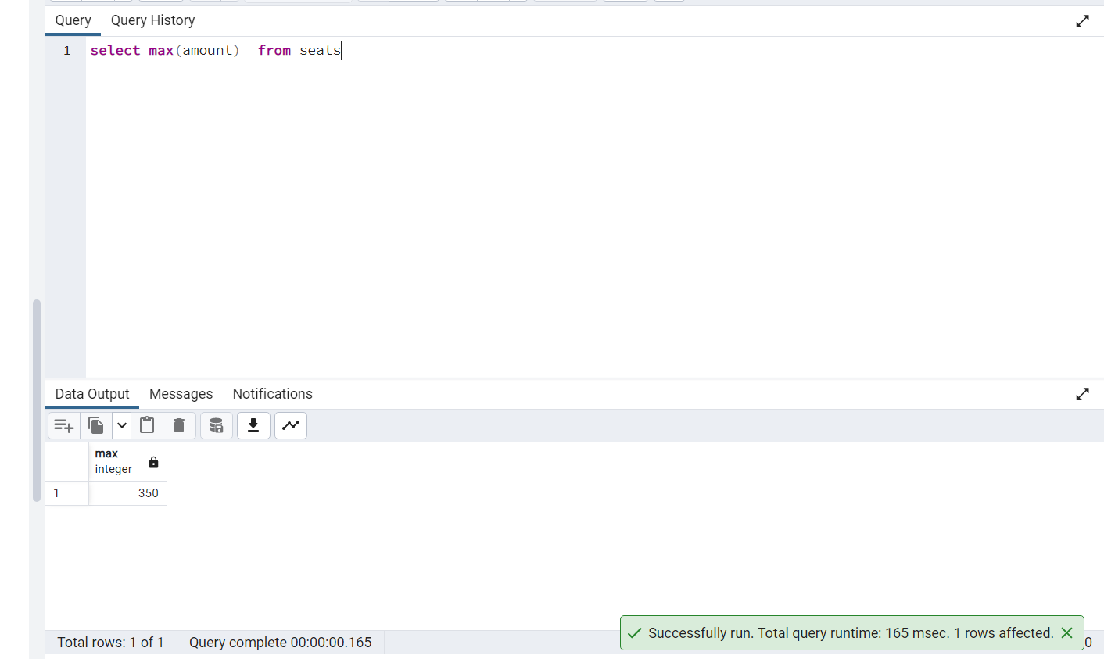

**17> show all the movies available at 08:00**

select * from shows where time='08:00'

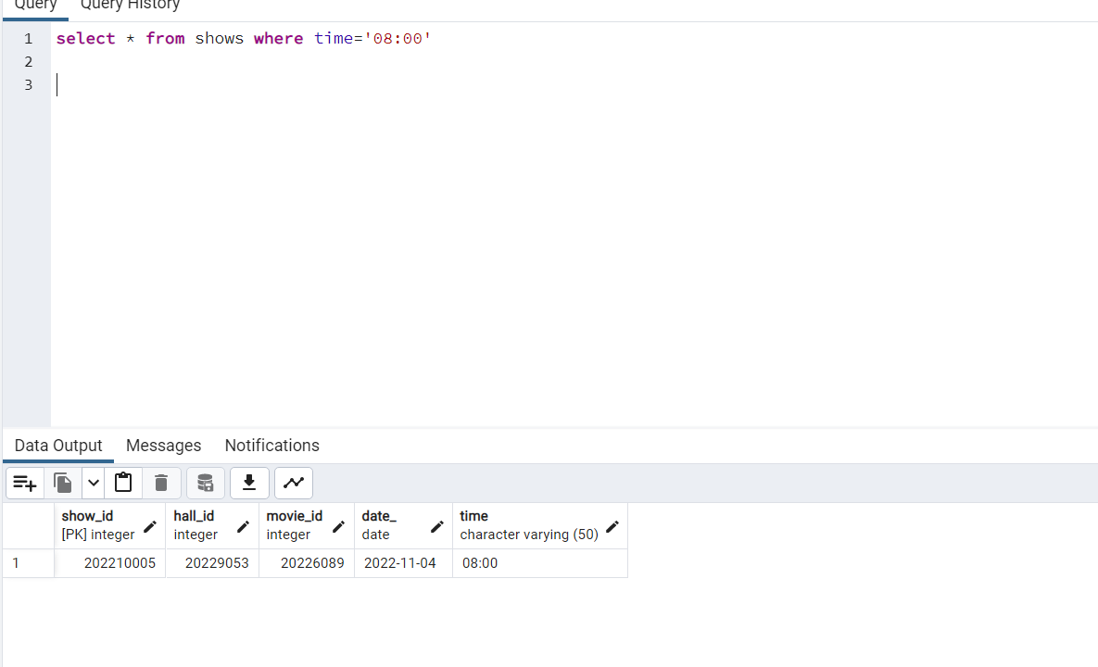

**18> Display employee details with sorted Email**

select * from employee order by employee_address

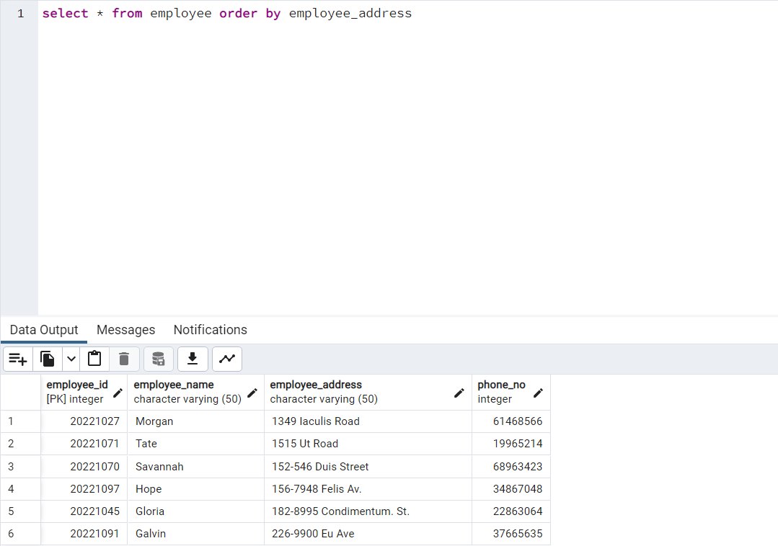

**19> show all the cinemas where menu price is less then Rs200**

**ans>**select * from menu where item_amount<200

**Output:**

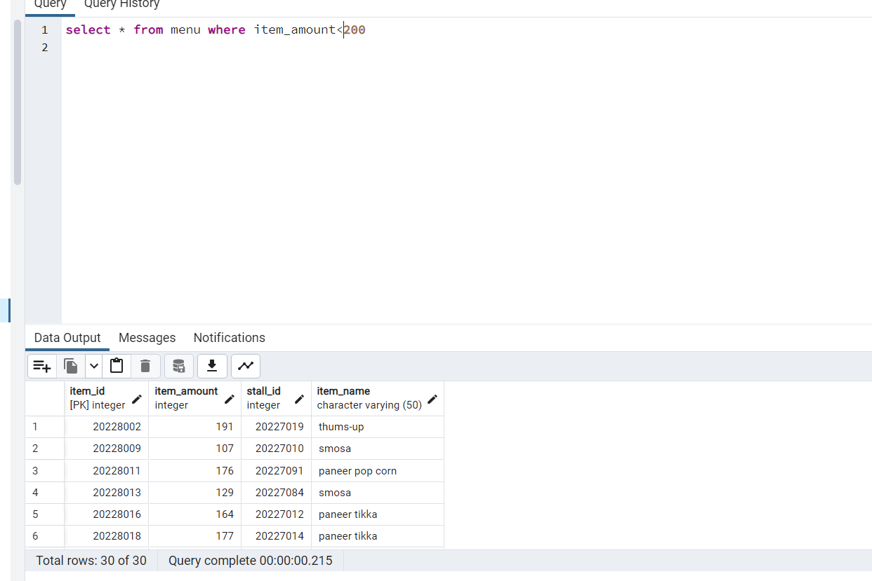

**20> show seats how's amount is less than Rs300 and greater than 100**

select * from seats where amount<300 and amount>100

**Output:**

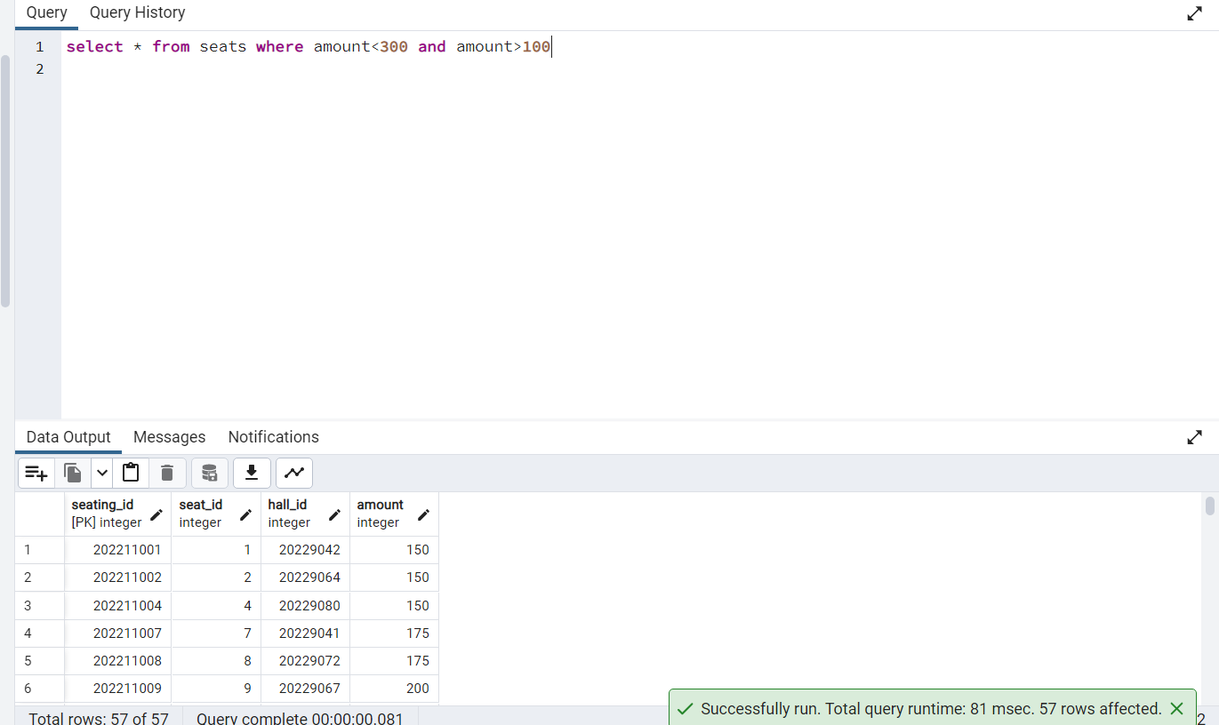

**21> create a view of seats details where seat_id is greater than 50 and amount less than 200**

**ans>**

create or replace view seat_details as select * from seats where seat_id>50 and amount<200

select * from seat_details

**Output:**

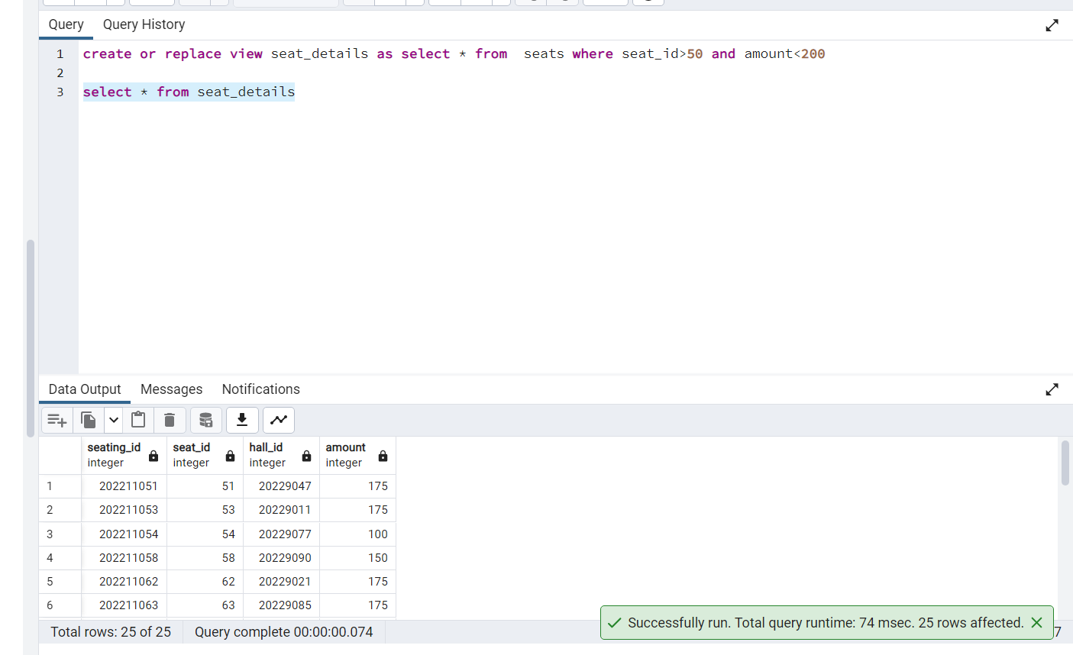

**22> list down the item details which has paneer in it**

**ans>**select * from menu where item_name like '%paneer%'

**Output:**

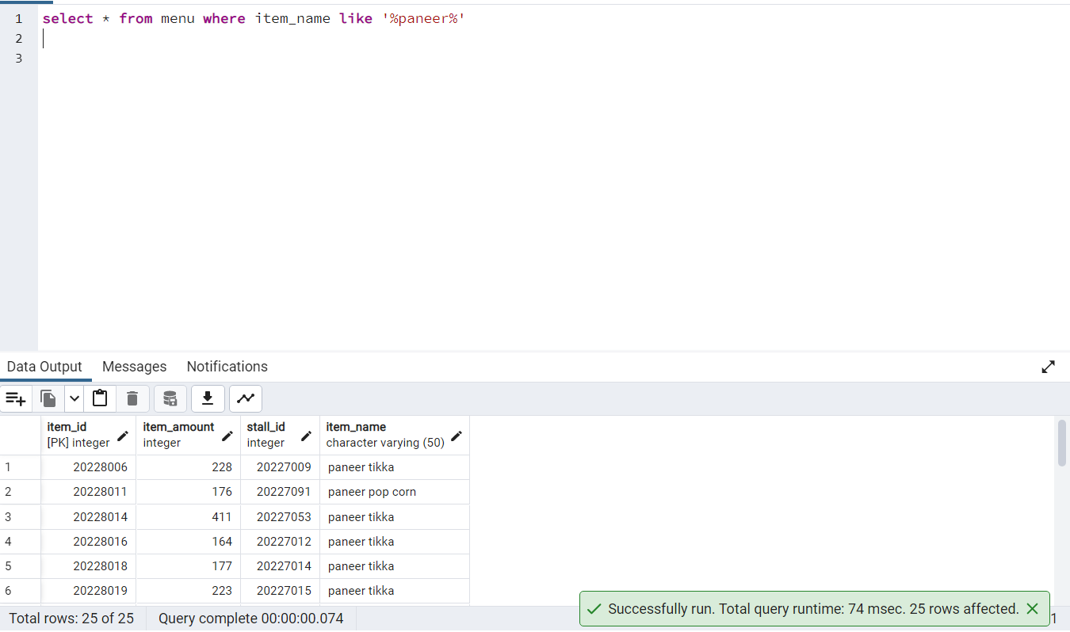

**23> Display the menu_name whose item_amount is less than average of item amount**

**ans>** select menu_name from stalls join menu on stalls.stall_id=menu.stall_id where item_amount<any(select item_amount from menu)

**Output:**

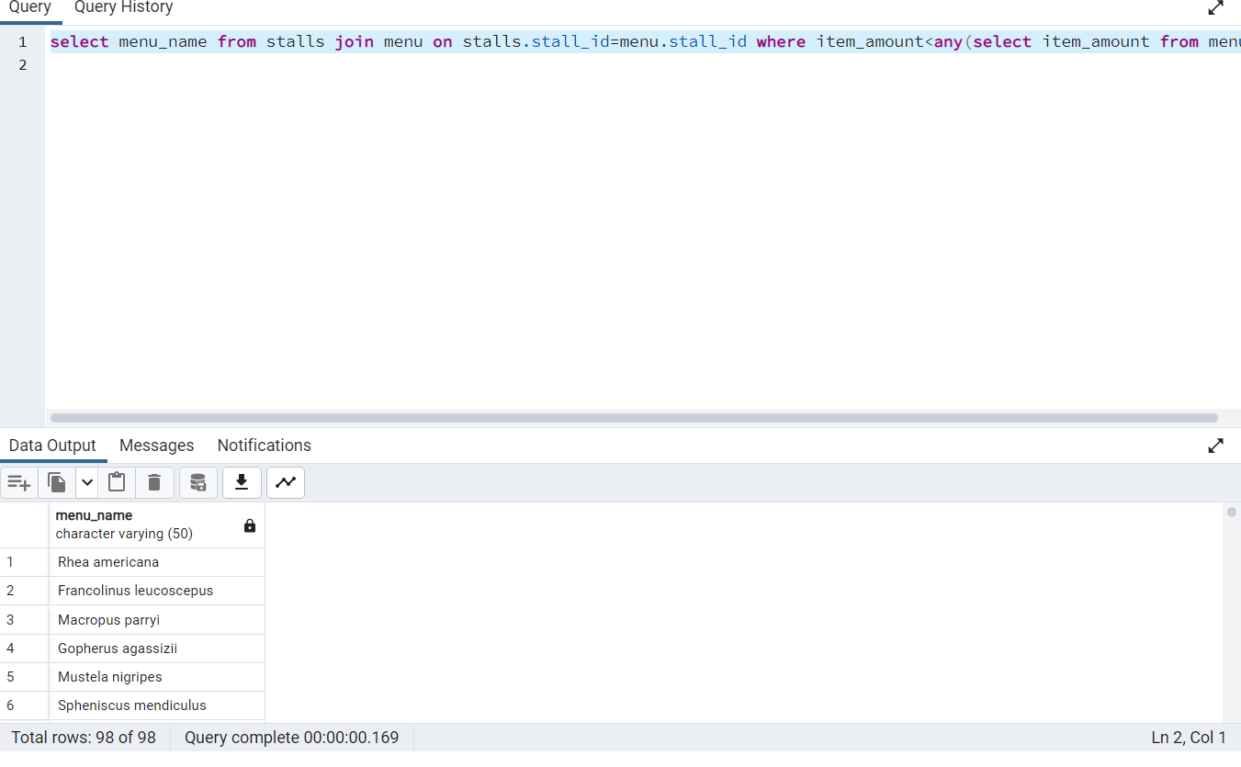

**24> Display all the Movie name and show time**

select movie.movie_name, shows.time from movie join shows

on movie.movie_id = shows.movie_id

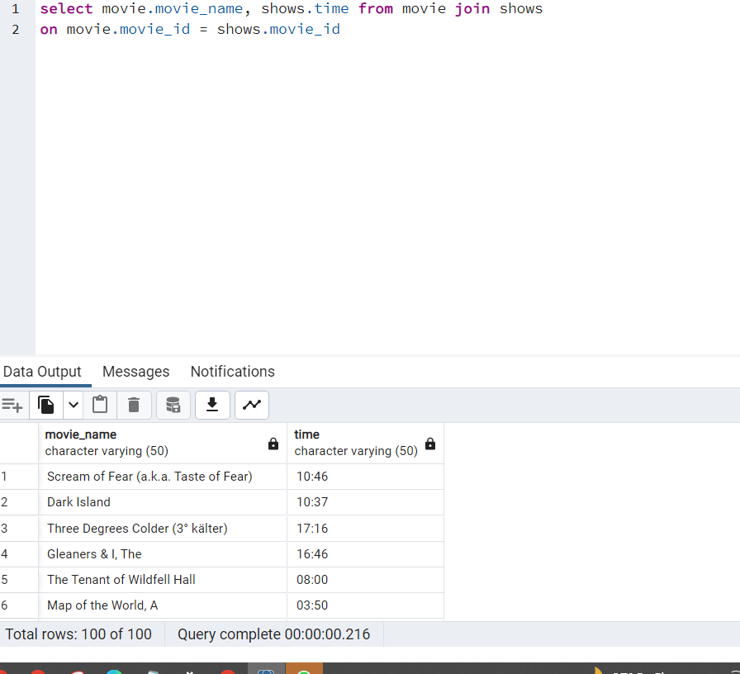

**25> display all the movies on 27th Nov 2022**

**ans>**

select movie_name from movie join shows on shows.movie_id=movie.movie_id where shows.date_='2022-11-24'

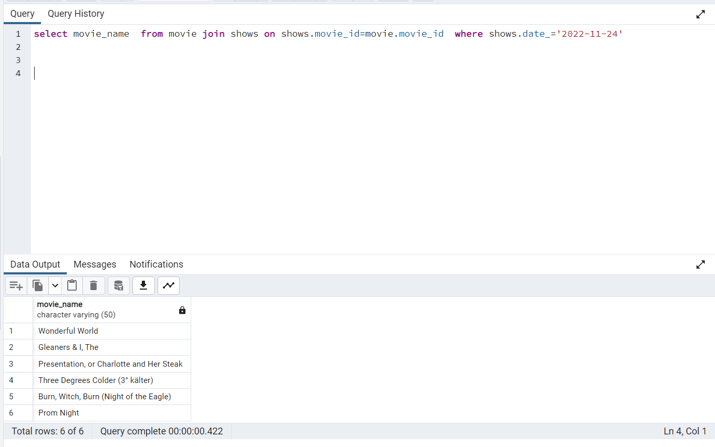

**26> Display the timing of movie name ‘Mad Money’**

select shows.time,movie.movie_name from shows join movie on

shows.movie_id = movie.movie_id

where

movie.movie_name = 'Mad Money';

**Output:**

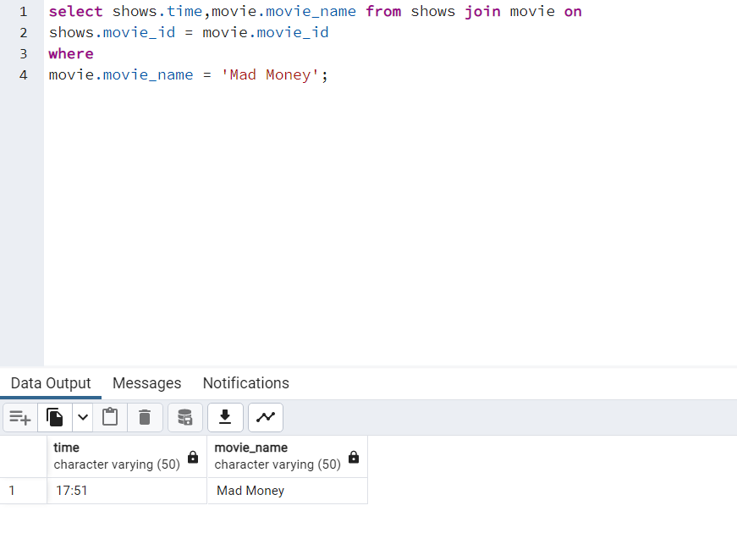

**27> Display employee name whose name starts with ‘C’ and ends with ‘r’ans>**select* from employee where employee_name like 'C%r';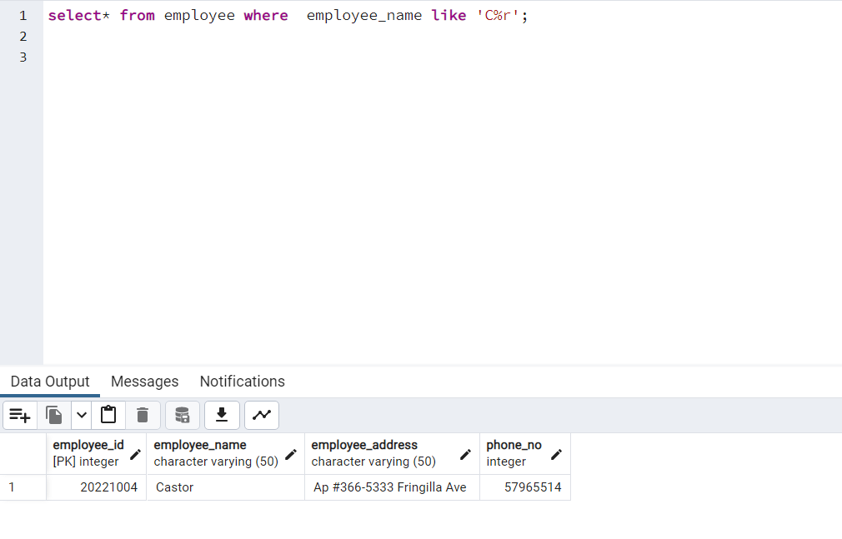

**28> show all the users who are customers**

select* from users where user_type = 'customer';

**Output:**

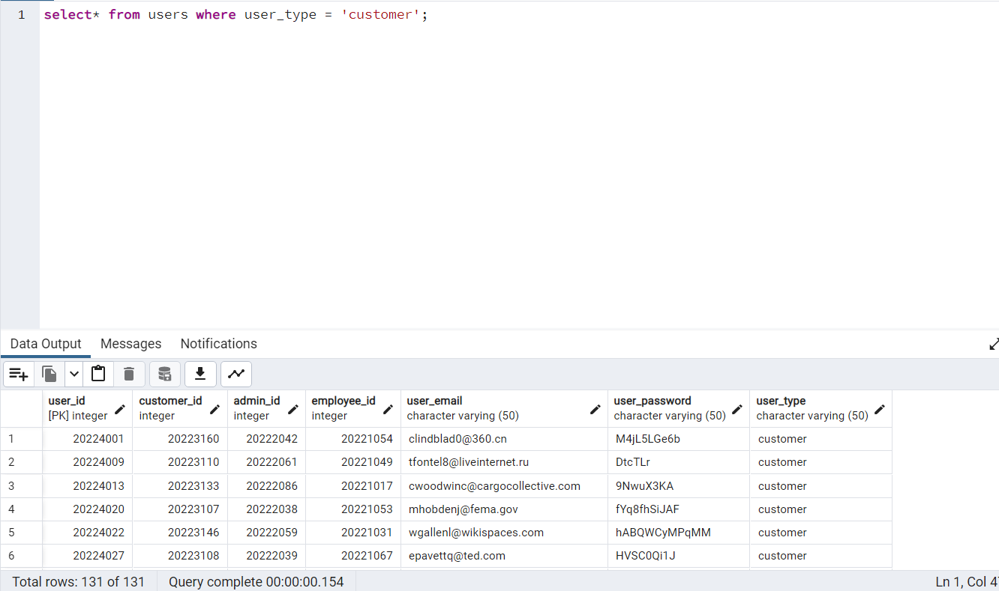

**29> show all the movie available on 27th Nov 2022**

select movie.movie_name, movie.movie_details from

movie join shows ON Movie.movie_id = shows.movie_id

where shows.date_ = '2022-11-28';

**Output:**

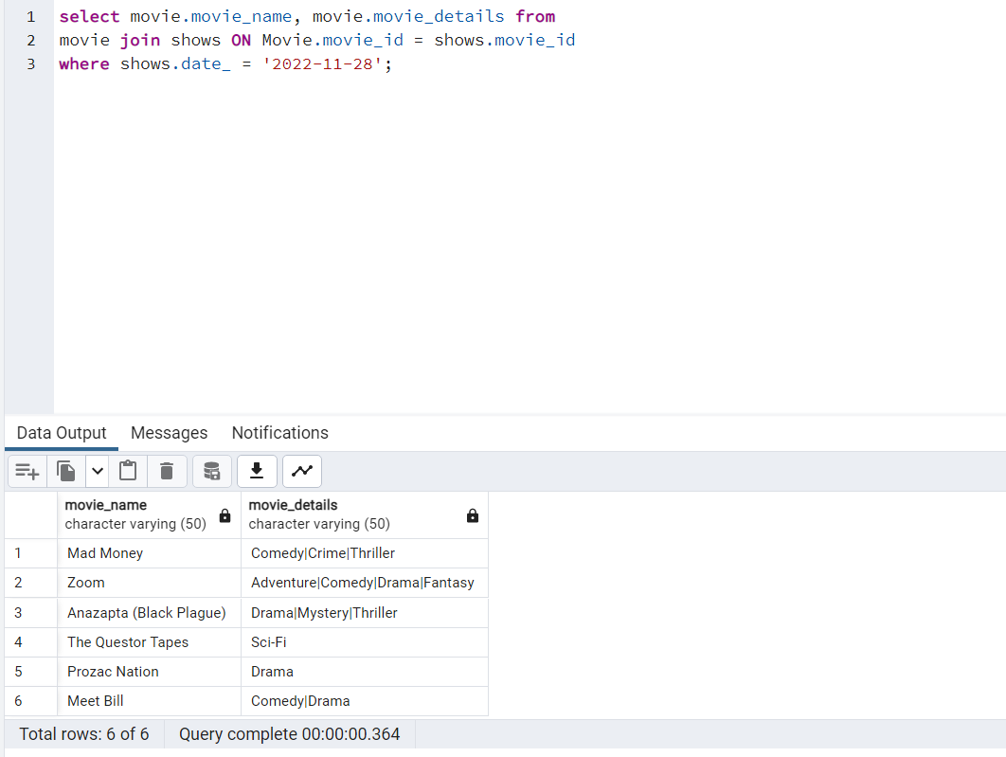

**30> show all the booking details**

Select * from bookings;

**Output:**

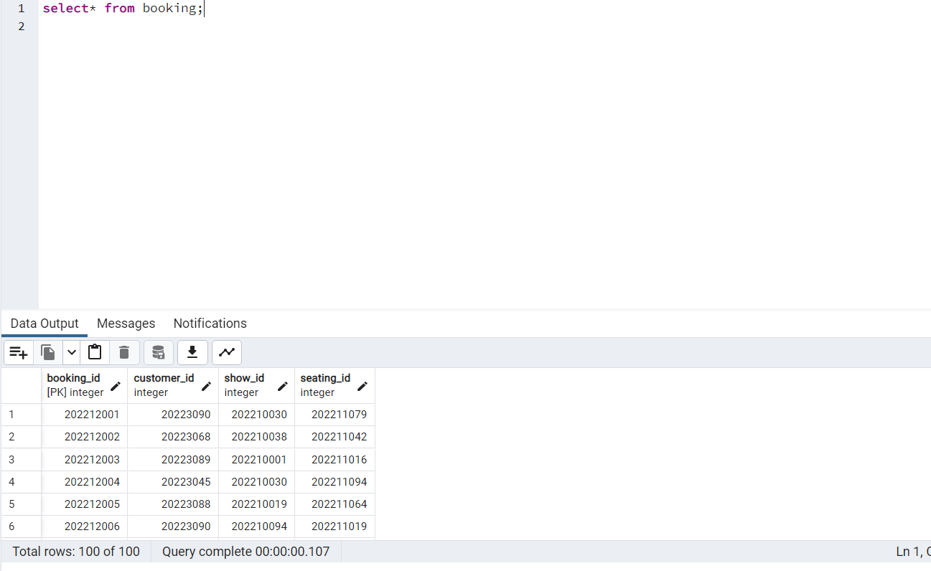

**31>show movie details whose name starts with vowels and ends with vowels**

select * from movie where left(movie_name,1) IN ('A','E','I','O','U') and right(movie_name,1)

IN ('a','e','i','o','u')

**Output:**

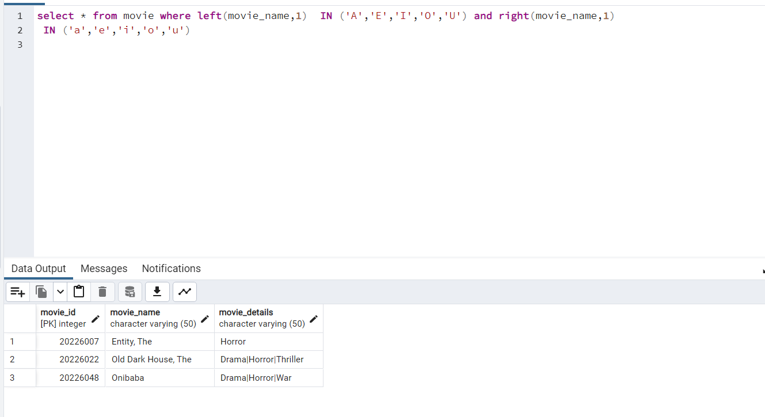

**32> Display halls detail where seats amount is more then average**

select halls.hall_id,seats.amount from halls JOIN seats ON

halls.hall_id=seats.hall_id

where seats.amount >(select avg(amount) from seats);

**Output:**

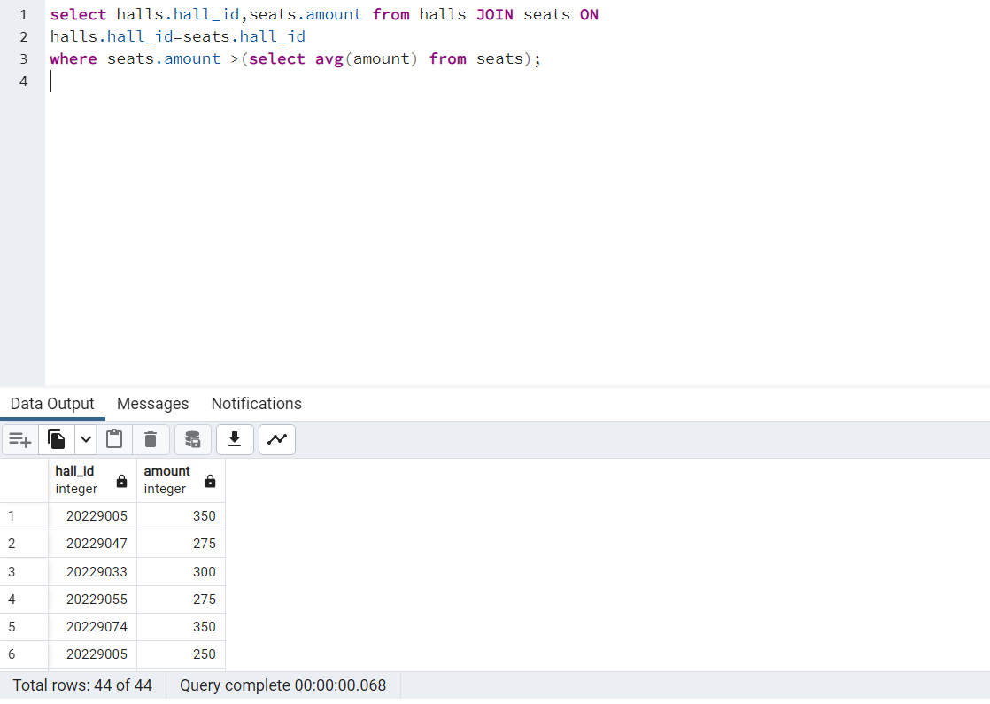

**33>Display menu name, item name where item_amount is more then the min item price**

select menu.item_name,stalls.menu_name from menu JOIN stalls ON

menu.stall_id=stalls.stall_id

where menu.item_amount > (select min(item_amount) from menu);

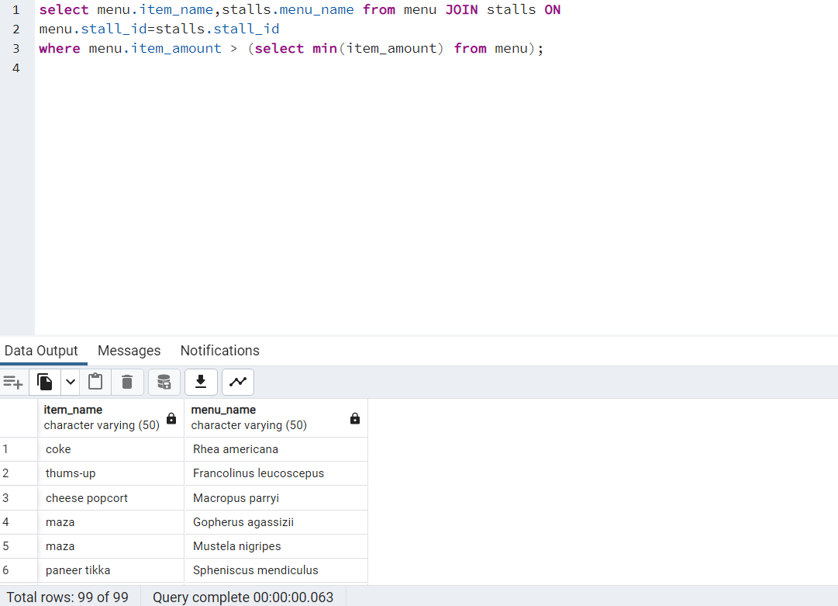

**34>Create a view on maximum price**

CREATE OR REPLACE VIEW max_price as SELECT MAX(amount) From seats;

select * from max_price

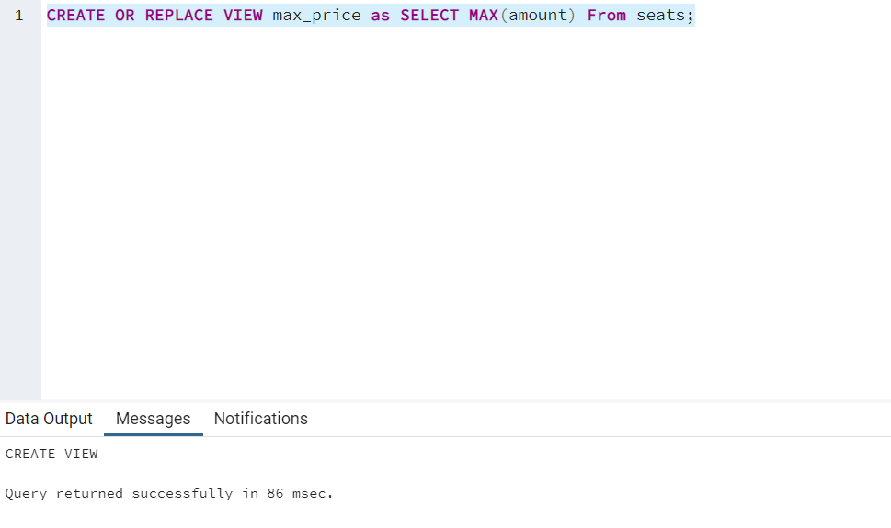

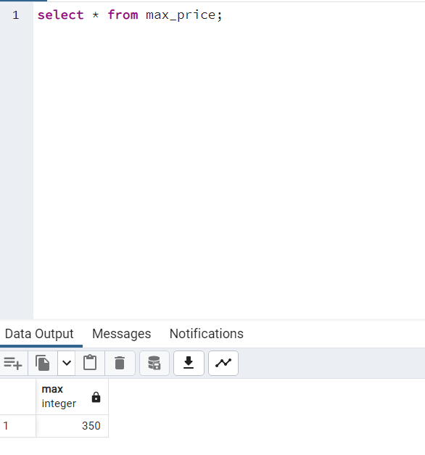

**35> Display all the shows time where seats amount is more than then the minimum price**

select shows.time from shows join halls ON

shows.hall_id = halls.hall_id where

halls.hall_id = any( select halls.hall_id from

halls join seats On halls.hall_id = seats.hall_id where

amount > (select min(amount) from seats));

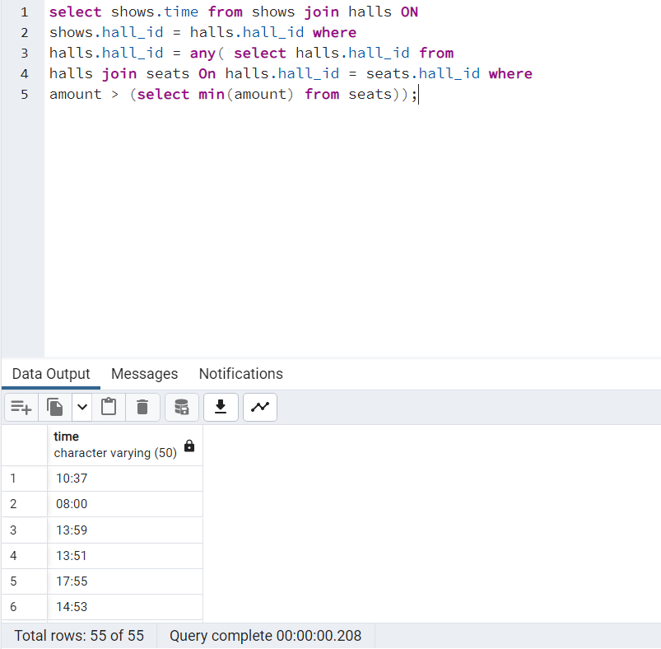

**36 > Display customer_id who have booked more then 3 times**

select customer_id from booking group by customer_id having count(*) >3;

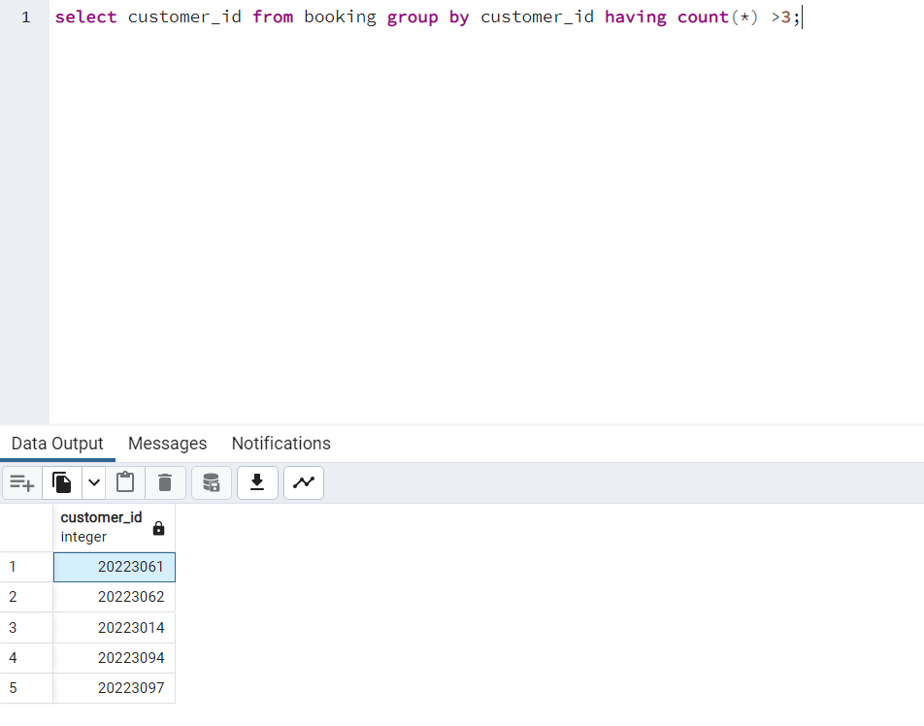

**37> Display stall details and menu item amount where item amount is more than Rs300 and less than Rs500**

select stalls.stall_id,menu.item_amount from stalls join menu on

stalls.stall_id = menu.stall_id

where menu.item_amount <500 and menu.item_amount > 300;

**Output:**

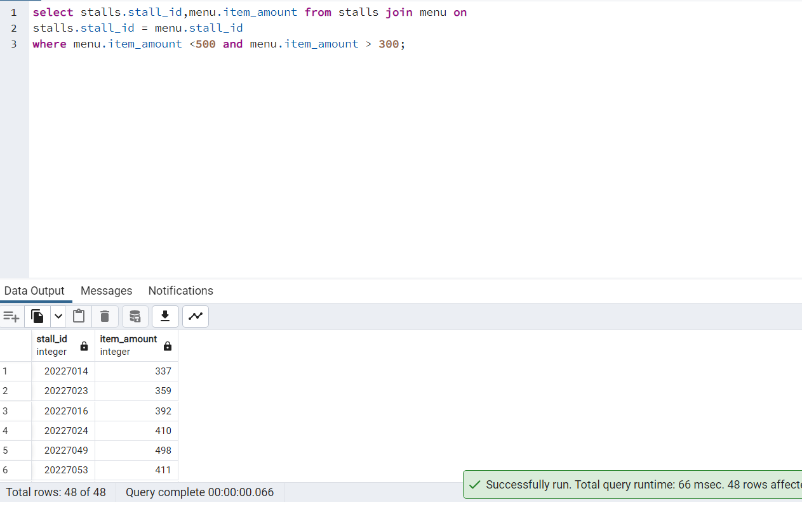

**38> DIsplay the booking_Id details of customer whose name starts with ‘I’.**

select customer.customer_name, booking.booking_id from customer join booking on

booking.customer_id = customer.customer_id where

customer.customer_name like 'I%';

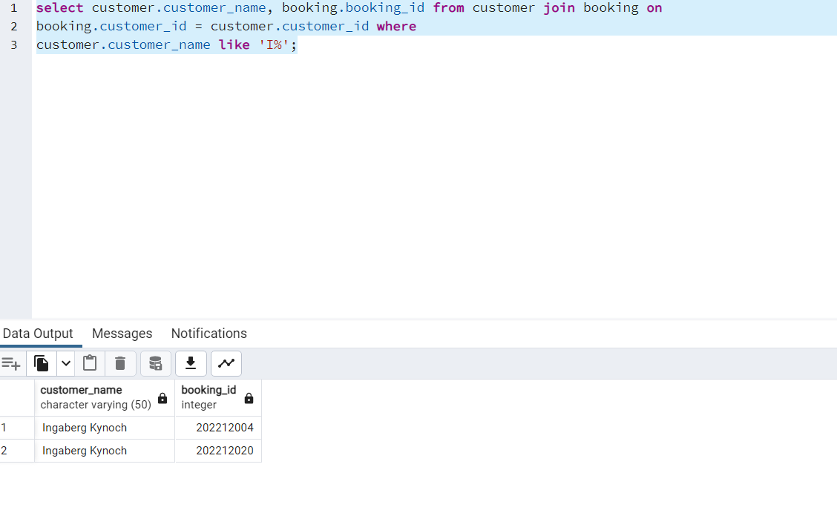

**39>Find the total sum of amount more then 300 of seat of individual halls**

select hall_id, sum(amount) from seats group by hall_id having sum(amount)>300;

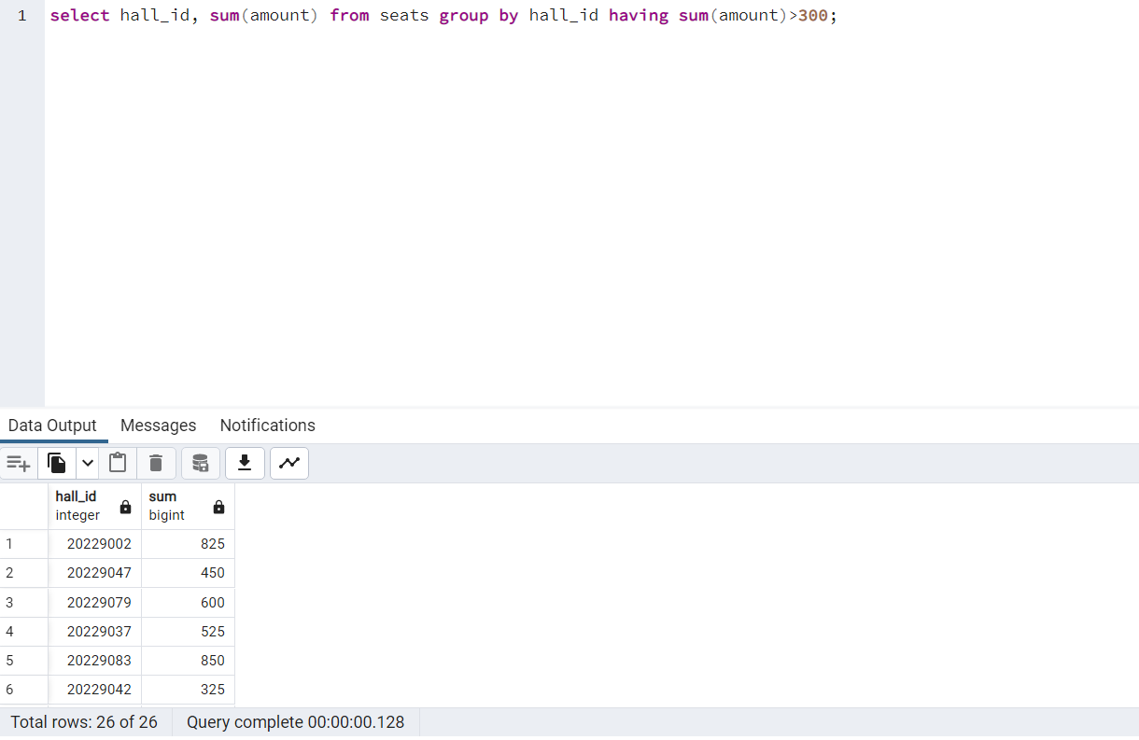

**‘**

**40>Display the sum of amount of seats on individual date**

select sh.date_, sum(s.amount) from shows sh join seats s

ON sh.hall_id = s.hall_id group by sh.date_;

**Output:**

