🏏 IPL 2026 Analysis Dashboard | Power BI

📌 Project Overview
The IPL 2026 Analysis Dashboard is an interactive Power BI project designed to analyze the complete IPL 2026 season using match-level and ball-by-ball data.
The dashboard transforms raw cricket data into meaningful insights through interactive visualizations, KPI cards, player analytics, and tournament statistics. It enables users to explore team performance, batting records, bowling achievements, and individual player profiles in a user-friendly interface.

🎯 Project Objectives
- Analyze overall IPL 2026 tournament performance.
- Compare batting and bowling statistics.
- Explore player-level performance.
- Identify tournament leaders and key milestones.
- Create an interactive dashboard suitable for business reporting and sports analytics.

📊 Dashboard Pages

🏠 1. Executive Dashboard
Provides a high-level overview of the tournament.
Includes:
- Total Matches
- Total Runs
- Total Wickets
- Total Sixes
- Total Fours
- Tournament Winner
- Team Performance
- Venue Analysis
- Match Summary
- Interactive Filters

🏏 2. Batting Lab
Dedicated to batting performance analysis.
Key Metrics
- Total Runs
- Strike Rate
- Batting Average
- Boundary Percentage
- Most Sixes
- Most Fours
- Highest Individual Score
Visuals
- Top Run Scorers
- Runs by Team
- Boundary Analysis
- Player Comparison
- Batting Performance Trends

🎯 3. Bowling Lab
Analyzes bowling performance throughout the tournament.
Key Metrics
- Total Wickets
- Economy Rate
- Bowling Average
- Strike Rate
- Dot Balls
- Maiden Overs
Visuals
- Top Wicket Takers
- Economy Comparison
- Bowling Performance by Team
- Wicket Distribution

👤 4. Player Profile
An interactive player analysis page.
Features
- Player Selection
- Player Image
- Team Information
- Batting Statistics
- Bowling Statistics
- Performance KPIs
- Interactive Charts

📈 5. Tournament Insights
Highlights the best performers of IPL 2026.
Includes
- Orange Cap Holder
- Purple Cap Holder
- Highest Strike Rate
- Best Economy
- Most Sixes
- Most Dot Balls
- Fastest Fifty
- Tournament Records
- Performance Highlights

📂 Dataset
The project uses IPL 2026 ball-by-ball and match-level datasets.
Main tables include:
- Deliveries
- Matches
- Players
- Teams
- Venues
- Calendar
- Player Images

🛠 Tools & Technologies
- Microsoft Power BI
- Power Query
- DAX
- Data Modeling
- Excel (Data Preparation)

✨ Key Features
- Interactive navigation
- Dynamic slicers
- KPI Cards
- Drill-through analysis
- Responsive dashboard design
- Player-level insights
- Team performance comparison
- Tournament summary
- Professional sports analytics layout

📚 Skills Demonstrated
- Data Cleaning
- Data Modelling
- DAX Calculations
- Power Query Transformations
- Data Visualisation
- Dashboard Design
- Business Intelligence
- Sports Analytics
- Storytelling with Data

📸 Dashboard Preview
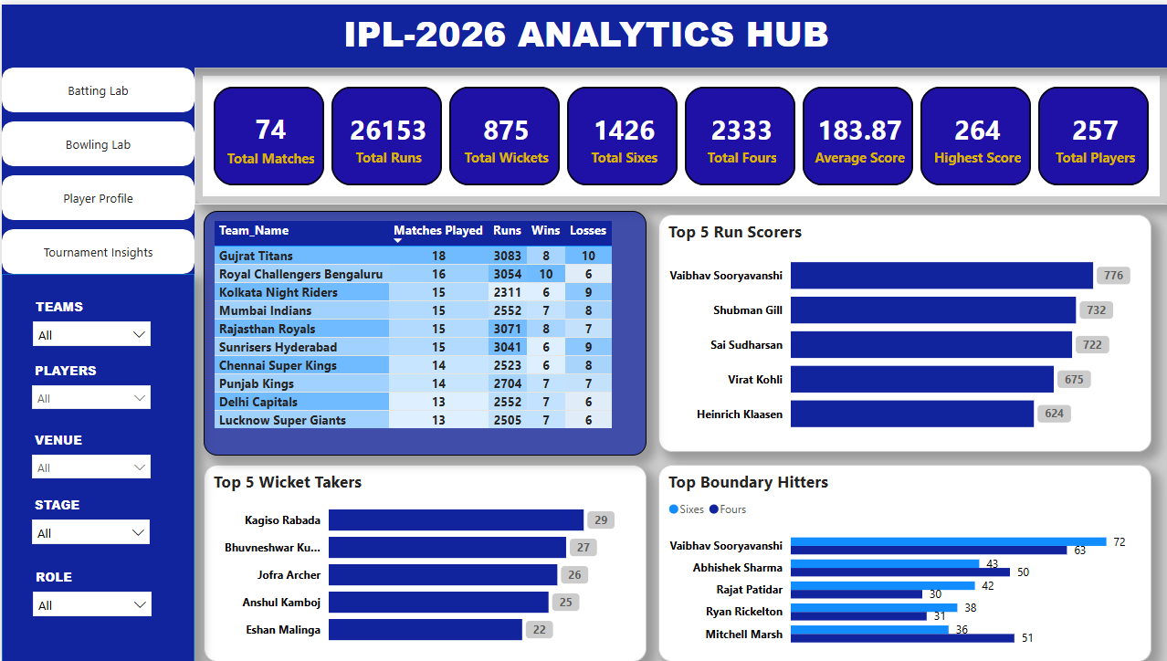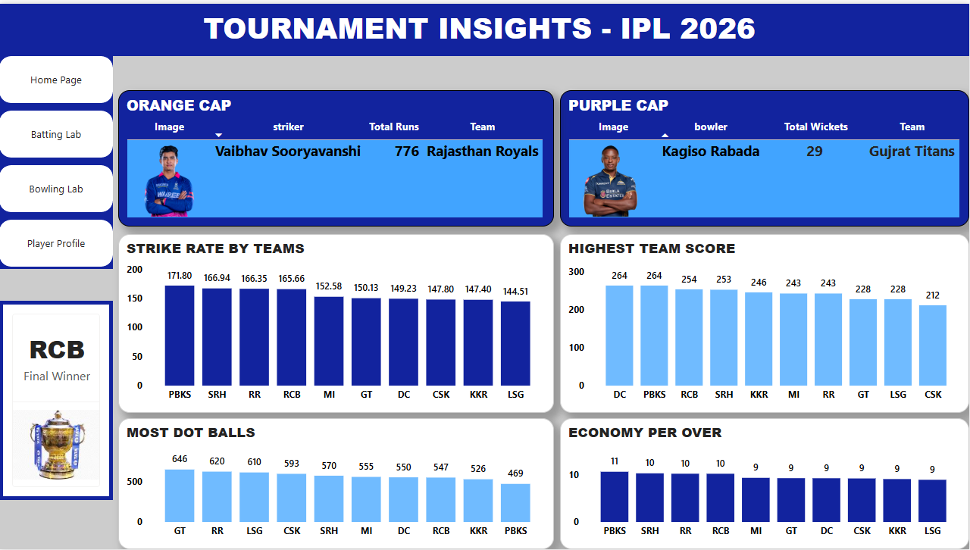

🚀 Future Enhancements
- Head-to-head team comparison
- Predictive match analysis
- Win probability visualization
- Advanced player rankings
- Historical IPL season comparison

👨‍💻 Author
Chippa Laxman
Aspiring Data Analyst passionate about transforming data into meaningful insights using Power BI, SQL, Excel, and Python.
If you found this project useful, feel free to ⭐ the repository.

