**Gold’s Gym Website Using HTML and CSS**

**Project**

*By*

**Ashish Singh (12214212) – (Roll no. – 31)**

**Adil Khan (12206746) – (Roll no. – 20)**

**Laxman (12214729) - (Roll no. – 32)**

**Section: K22JL**



**Student Declaration**

This is to declare that this report is written by us. No part of the report is copied from other sources. All information included from other sources have been duly acknowledged. We aver that if any part of the report is found to be copied. We shall take full responsibility for it.

**BACKGROUND AND OBJECTIVES OF PROJECT ASSIGNED:**

**BACKGROUND:**

We used our own creativity and ideas to build the web page. Here we used simple HTML code to provide structure to web page and we used CSS to provide the design to the web page.

We tried to create a “Gold’s Gym web page” with the knowledge that our faculty member has shared with us.

We used many elements such as <a> <div> and many more. We created a simple web page in which we used <a> to link different web pages. We also used image in background to fix the background. We used hover tag to highlight the link that we provided for different web page.

**OUTCOME:**

We have successfully created a web page for Gold’s Gym. It contains the blog page of our gym.

We also learned about many of the new tags and how they are used in a web page and what are their functions and features.

After gaining some knowledge and trying to implement it on our code we get different result. We learned many new elements and tags; we cleared our doubts on some respective topics and we successfully created a web page.

**OBJECTIVES:**

This little project has been done as a part of my course for the CSE at Lovely Professional University. Objective of the project is to build the html website and clear the concepts of HTML and CSS.

**IDEA:**

It has been the first experience of doing such a tiny project full of creative interest. We wanted to make our project an attractive website with creativity, we used different programming processes like HTML for creating a basic website, and to get a radiant look we used CSS part and for design stylishly the web. These programming processes are easy to approach and understand the coding.

**SCREENSHOTS :**

**Homepage –** 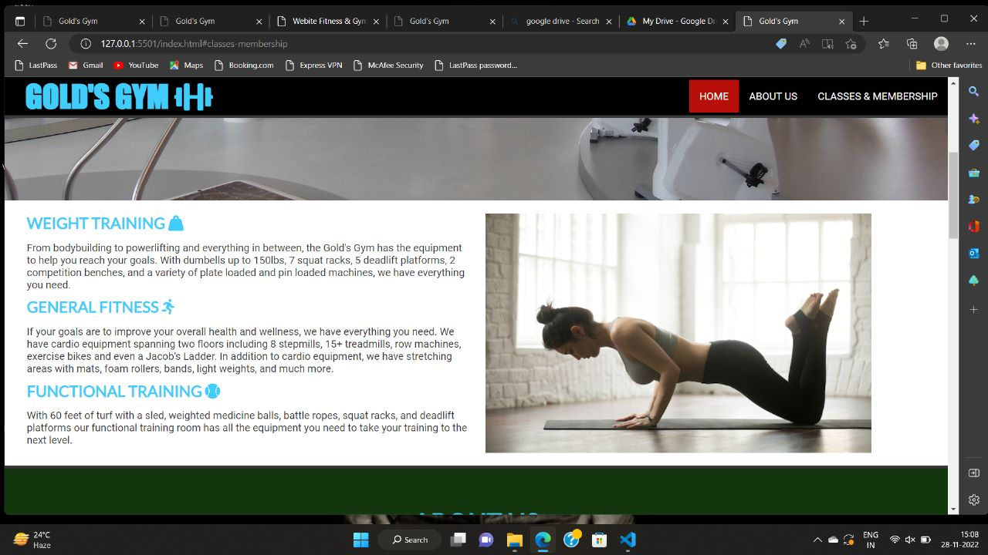

**About Us:**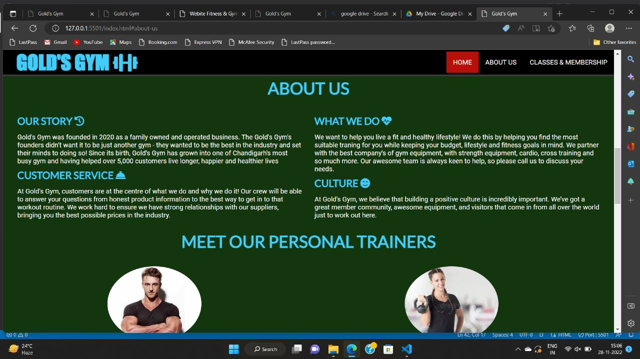

**Classes and Membership:**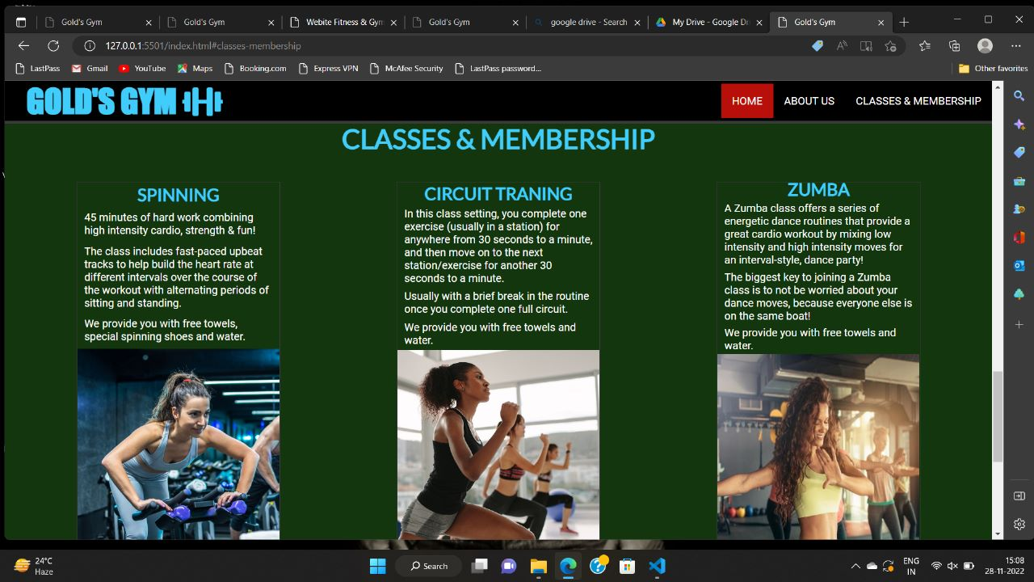

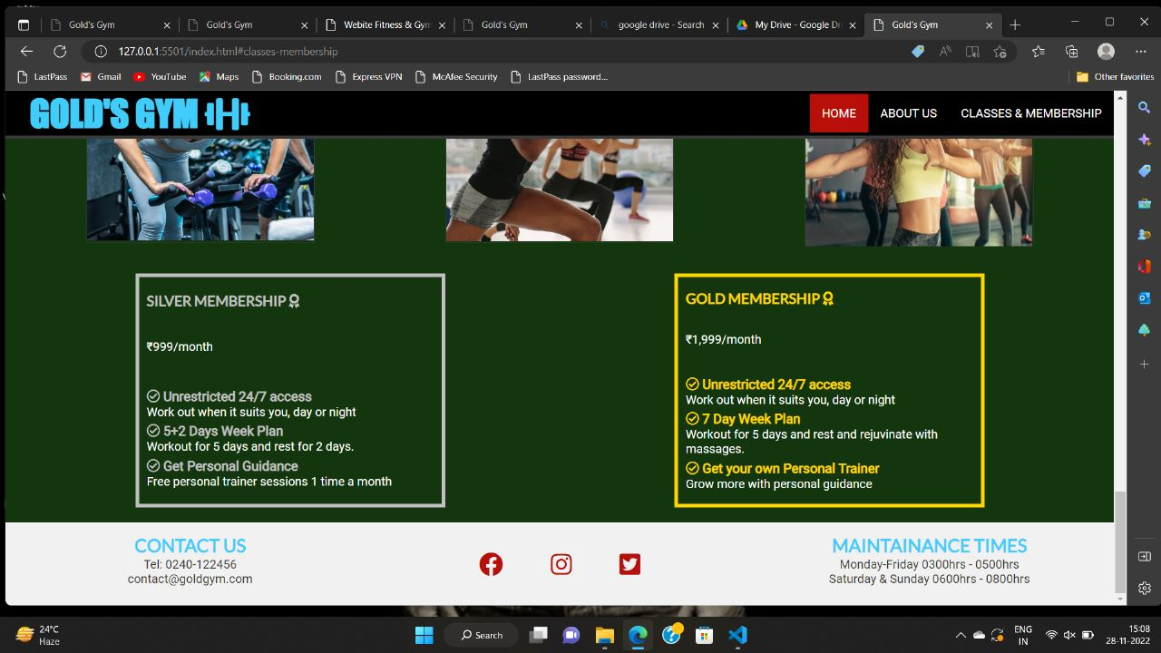

**Trainers:**



**Gallery:**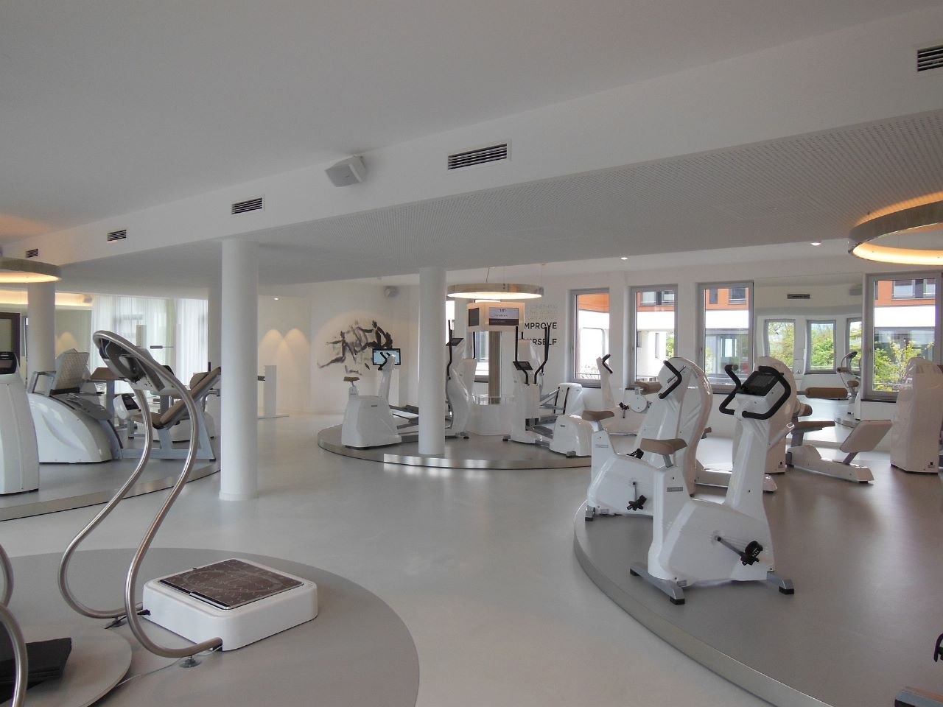

**TECHNOLOGIES AND FRAMEWEORK USED:**

**We use visual studio code for writing our code and chrome browser to run our program.**