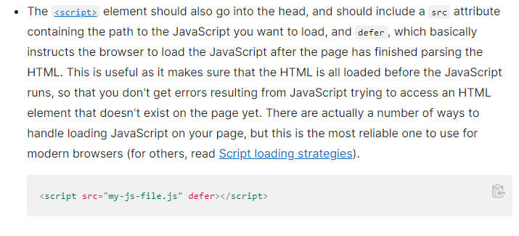

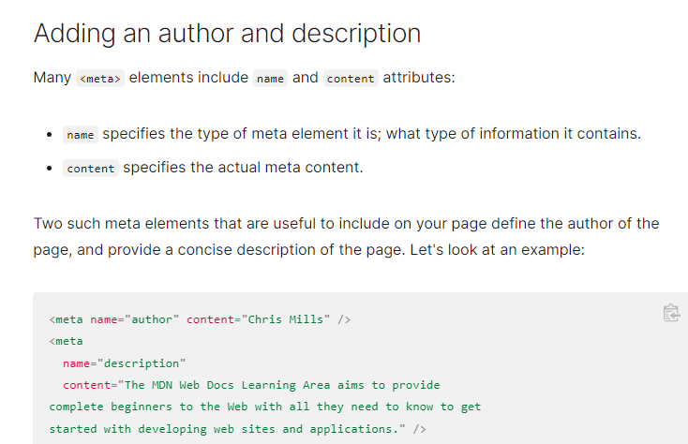

Specifying an author is beneficial in many ways: it is useful to be able to understand who wrote the page, if you have any questions about the content and you would like to contact them. Some content management systems have facilities to automatically extract page author information and make it available for such purposes.

Specifying a description that includes keywords relating to the content of your page is useful as it has the potential to make your page appear higher in relevant searches performed in search engines (such activities are termed [Search Engine Optimization](https://developer.mozilla.org/en-US/docs/Glossary/SEO), or [SEO](https://developer.mozilla.org/en-US/docs/Glossary/SEO).)