**SOFTWARE ERRORS/BUGS**

Hi Tanya,

Please find below mentioned errors with screenshot:

1) The drop down list for inspector is still not accessible… (As mentioned by you in your previous reply to our mail, the inspector field was to insert the number of table he was watching, but here the field to insert number of tables watching already exists. So we require a drop down list of staff for “Inspector field”

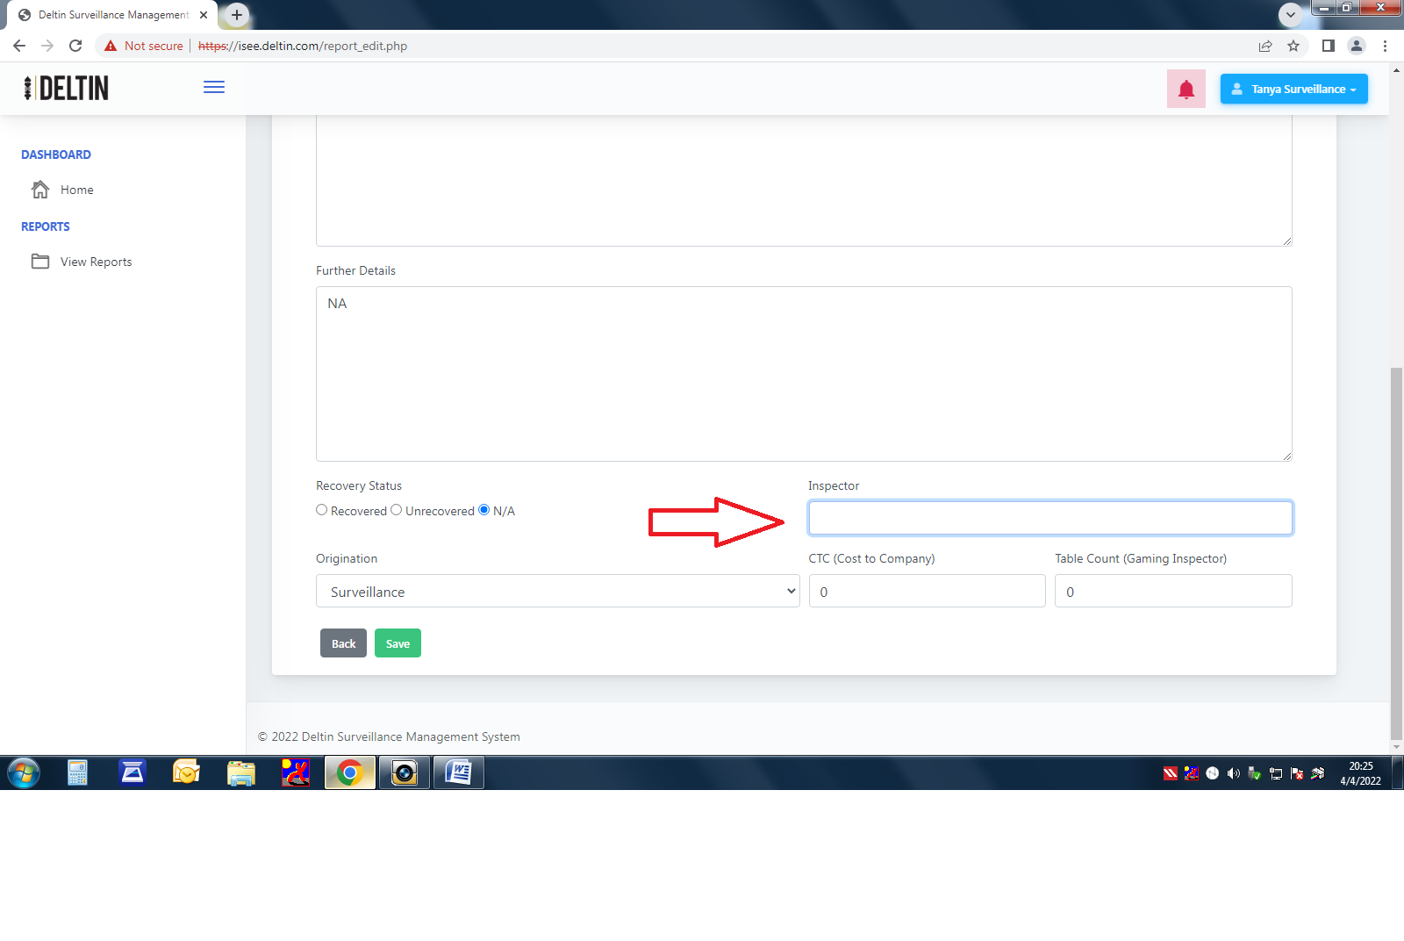

Inspector watching tables field already exist

2) The bug which was reported last time that once Surveillance user creates report the report can be viewed by other department, still persist. (find attached two images i.e. First one in which report is created by surveillance user and second image shows that the said report is viewable to deputy HOD gaming.)

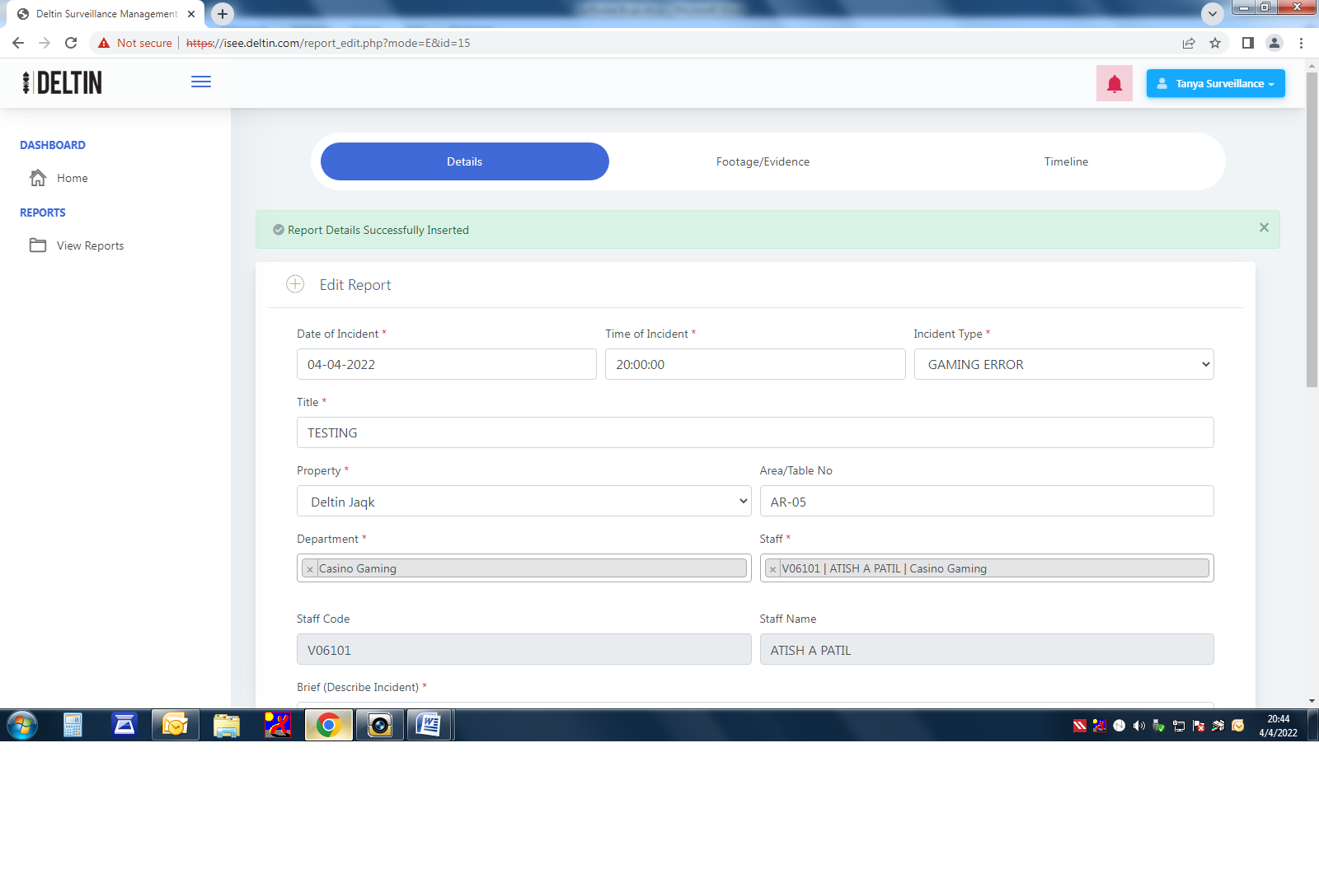

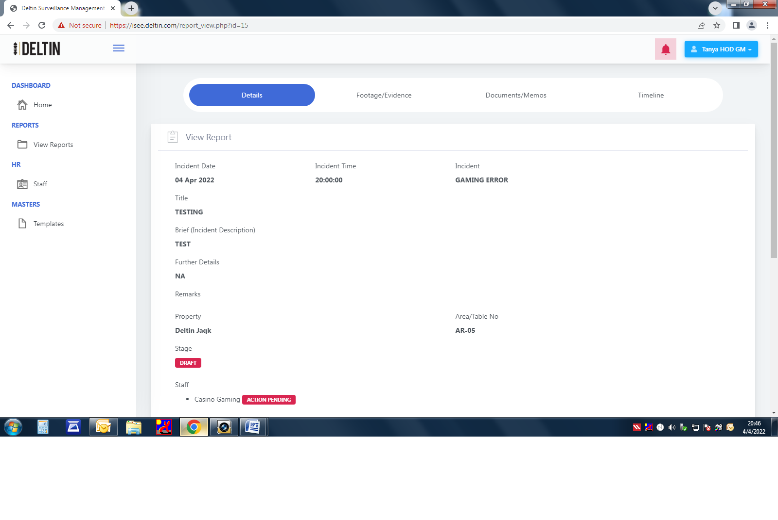

3) The approve field if clicked still shows blank screen (screenshot attached below)

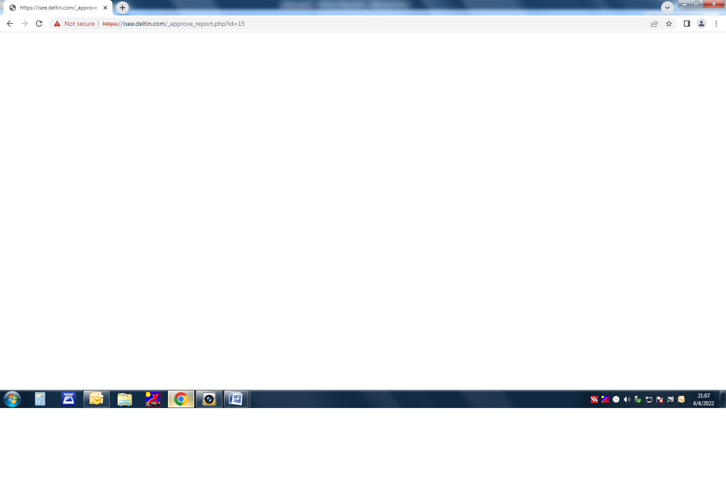

THE BLANK PAGE APPEARS

4) If any incorrect details are entered in report and the Deputy HOD gaming wants to resend the report back to surveillance manager than send back function is not working ….( screen shot not attached as the same can be shown during end-to-end testing)