Design & Implementation of a Lightweight Network Intrusion Detection System (NIDS)
Student: Laxman Raghoba Shet Narvenkar | Guide: <Name> | Institute: NFSU | Date: 15 Jan 2026

Abstract
This report presents a lightweight NIDS that captures packets and detects common attacks using heuristic, threshold-based rules.

1. Introduction
A NIDS monitors network traffic and alerts on suspicious behavior such as scans, spoofing and denial-of-service indicators.

2. System Architecture
The system includes packet capture, preprocessing, detection engine, and alert logging.
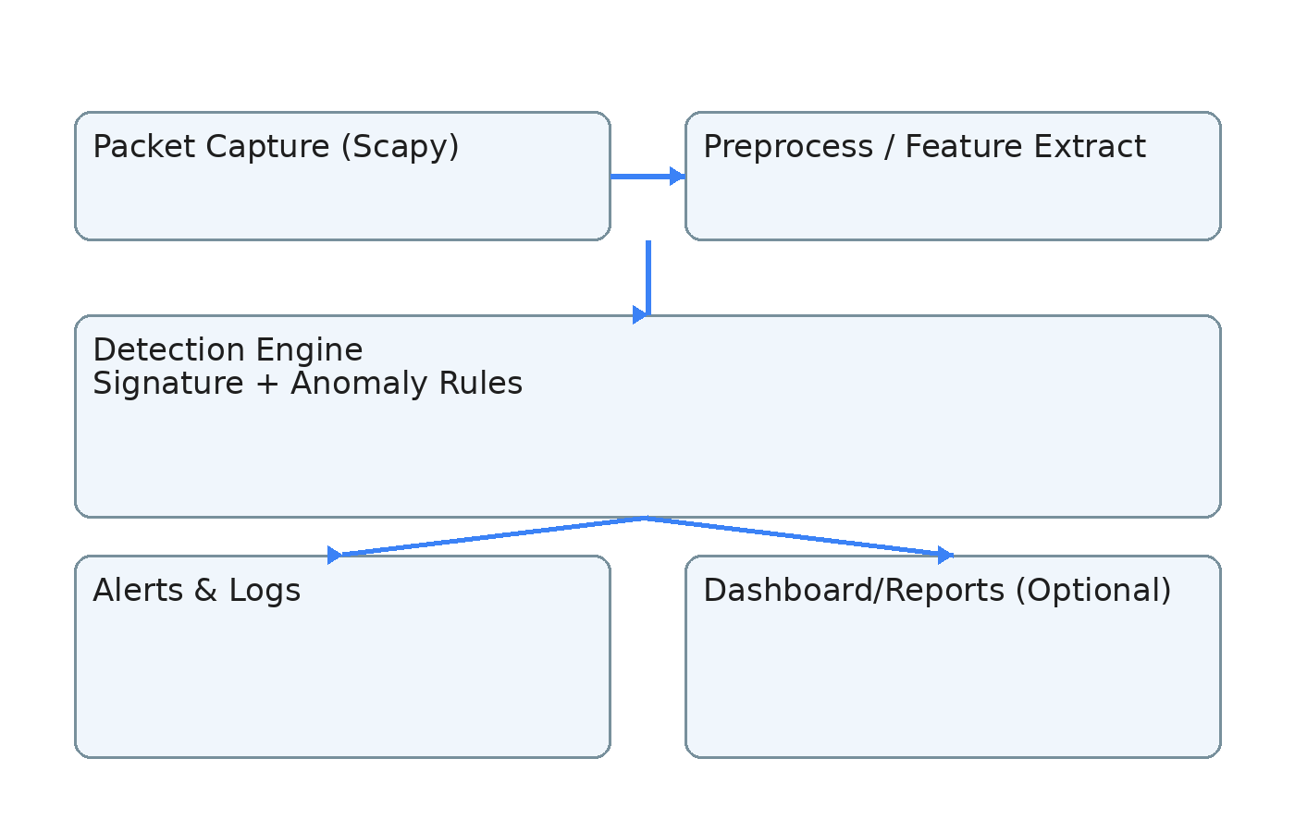

3. Detection Modules
Port Scan, SYN Flood, ARP Spoof, DNS Spoof, ICMP Sweep detectors are implemented as modular components.

4. Implementation
Implemented in Python using Scapy for packet capture and custom detectors for rule-based detection.

5. Experimental Setup
Lab uses Kali attacker and victim host in an isolated network. Attacks are simulated using standard tools.

6. Evaluation
Evaluate detection accuracy, false alerts, performance overhead, and alert latency. Add screenshots and logs here after testing.

7. Limitations & Future Work
Encrypted traffic limits payload inspection; heuristics may generate false positives. Future work includes ML and SIEM integration.

8. Conclusion
A functional educational NIDS prototype was built and can detect common network attacks in real time.

