Antimicrobial Activity of whole fruit body of Auricularia auricular on Clinical Pathogenic Bacteria and Fungi
Akpi Uchenna Kalu*, Ebeifenadi Uche Jonathan and Okobo Uchenna Jude
Department of Microbiology, University of Nigeria, Nsukka, Nigeria.
*Correspondence: E-mail: uck107@gmail.com, Mobile: +234 7069092500
ABSTRACT
The rampant multi-drug resistance among human pathogenic microorganisms has necessitated a continuous search for new and potent antimicrobial substances, especially among plants. Also, the importance of herbal plants as sources of alternative medicine is documented worldwide. In this study, antimicrobial activities of extracts of fruit bodies of Auricularia auricular against Staphylococcus aureus, Pseudomonas aeruginosa, Escherichia coli, Bacillus cereus, Candida albicans and Candida glabrata were investigated. Antimicrobial components from the mushrooms were extracted using ethanol, methanol and water and examined by agar well diffusion method. The Minimum Inhibitory Concentration (MIC), Minimum Bactericidal Concentration (MBC) and Minimum Fungicidal Concentration (MFC) were evaluated for each extract of the mushroom. The aqueous, methanol and ethanol extract of Auricularia auricular inhibited the growth of all the tested pathogenic organisms except P. aeruginosa. The phytochemical analysis revealed the presence of varying levels of bioactive compounds. Flavonoids, saponins, protein and carbohydrate were detected in all the extracts while glycosides, alkaloids and tannins were found in some. The results obtained from this study suggest that Auricularia auricular has broad-spectrum of activity against microbial isolates used.
Key words: Auricularia auricular, antimicrobial, phytochemicals, well diffusion method.

INTRODUCTION
Auricularia auricula-judae, known as Eru nti, the Jew'sear, wood ear, jelly ear or by a number of other common names, is a species of edible Auriculariales fungus found worldwide. The fruiting body is distinguished by its noticeably ear-like shape and brown colouration; it grows upon wood, especially elder. The fungus can be found throughout the year in temperate regions worldwide, where it grows upon both dead and living wood [1].
Auricularia auricula-judae has a soft, jelly-like texture. Though edible, it was not held in high culinary regard in the west for many years. It has been likened to "eating an Indian rubber with bones in it" [2] while in 19th century Britain, it was said that "it has never been regarded here as an edible fungus". It has a mild flavour, and is useful for mixed mushroom recipes, but is still considered bland in the west [3]. It can be dried and rehydrated, sometimes swelling to a very large size. Young specimens are best, but the species is not edible when raw, needing to be cooked thoroughly. The whole fruit body can be eaten, but should be thoroughly washed before cooking. Cooking can sometimes take a comparatively long time. The nutritional content of 100 g (3.5 oz) of dried fungus includes 370 kcal, 10.6 g of protein, 0.2 g of fat, 65 g of carbohydrate, 5.8 g ash, and 0.03% mg of carotene. Fresh mushrooms contain about 90% moisture [4]. Dried specimens may be ground up into a powder and used to absorb excess liquid in soups and stews, as it rehydrates into tiny fragments [5].
Mushrooms, also called puffballs are macroscopic fungi that can be found in various places such as wet environments, decayed plants and animal sites, termites nest, palm wastes, leaf litters, under shades, to mention but a few [6]. They are distinctive fruiting bodies which are either hypogeous or epigeous [7]. Mushrooms are differentiated into edible or poisonous, wild or domestic. In many countries of the world, Nigeria inclusive, edible mushrooms are good for food and are used in medicine to protect against free radicals and infections [8]. The use of mushrooms as food as well as medicine is gaining popularity in recent times [9]. Mushrooms have been found to contain all the essential amino acids [9, 10]. Edible mushrooms are attractive because of their flavor, taste and delicacy [11]. Many species of edible mushrooms exist in nature, less than 20 species are used as food and only 8-10 species are regularly cultivated in significant extent [12]. Mushrooms characteristically contain many different bioactive compounds such as polysaccharides, glycosides, sesquiterpenes etc with diverse biological activities such as anticancer, antibacterial, antifungal and antiviral agent [13]. Therefore, this study was aimed at evaluating the antimicrobial activity of Auricularia auricula mushroom extracts on bacterial and fungal isolates so as to offer informed recommendation on its use for the treatment of problem of antibiotic resistance.

MATERIALS AND METHODS
Collection and Identification of Materials
Auricularia auricula was collected from different sources of Umuahia North Local Government area, Abia state and identified by a botanist in the Department of botany, University of Nigeria, Nsukka.

Test Organisms Used
Pure cultures of Escherichia coli JCM 20135 and Bacillus cereus IFO 13804 were obtained from Department of Microbiology, University of Nigeria Nsukka while pure cultures of Staphylococcus aureus ATCC 25923, Candida albicans ATCC 10231, Pseudomonas aeruginosa ATCC 25783 and Candida glabrata ATCC 22018 were obtained from Spectramedics Laboratories No. 2 Adebayo close, Araromi Offiri Ikenne Road, Sagamu, Ogun State.

Standard Antimicrobials
Tetracycline (5 μg/ml), Amplicillin (5 μg/ml), Oxacillin (5 μg/ml) and Nystatin (20 μg/ml) oxoid discs were used as positive standards.

Sample Preparation and Extraction
Fresh Auricularia auricula mushrooms were thoroughly washed with distilled water, cut into pieces, air-dried at room temperature and pulverized using manual grinder. Fifty grams of each of the ground samples was soaked in 500 ml ethanol, cold water, and methanol for 24 hours with intermittent shaking. Each sample was filtered using Whatman №1 filter paper. The filtrate was dried with a rotary evaporator in order to obtain the extract which was scooped and poured into well-labeled sample bottles and stored at 4ºC [14, 15].

Inoculum Preparation
Inoculum was prepared by emulsifying overnight colonies from an agar medium. A 0.5 McFarland standard (equivalent to approximately 10⁸ cfu/ml) was used. Media plates were inoculated within 30 minutes of standardizing the inoculum to avoid changes in inoculums density.

Determination of Antimicrobial Activity of Mushroom Extracts
Antimicrobial activity of mushroom extracts was determined according to the National Committee of Clinical Laboratory Standards [16]. Agar disc diffusion method on SDA and Muller-Hinton agar were used for fungi and bacteria respectively. A micropipette was used to introduce 100 μL of the inoculum onto the agar plate, and spread with glass rod spreader under sterile conditions. The paper discs of 6 mm diameter soaked in 10 μL of different concentrations of the extracts (500, 250, 125, 62.5, 31.25, 15.63 and 7.81 mg/mL) was applied on the agar plate, paper discs of 6 mm with dilute dimethylsulfoxide were used as negative control and antibiotics discs of tetracycline (10 μg/mL) and ampicillin (10 μg/mL) were used for Gram negative bacteria isolates, oxacillin (5 μg/mL) was used for Gram positive bacteria isolates whereas antifungi disc of nystatin (20 μg/mL) oxoid disc was used as positive control. This procedure was carried out in triplicate for the entire test organisms and allowed to stand for 30 min on the bench after which they were incubated for 24 h at 37 ± 2ºC for bacteria and 72 at 28 ± 2ºC for yeast. After incubation, the inhibition zone diameters produced by the different concentrations of the crude extracts were measured (in millimeter) using transparent meter rule.

Determination of Minimum Inhibitory Concentrations (MICs) of the Mushroom Extracts
The MIC of the extracts was determined for the test organisms in triplicates at varying concentrations (250, 125, 62.5, 31.25, 15.62, 7.80 and 3.90 mg/ml). To obtain these concentrations, 1.0 ml of varying concentrations of the extracts with double strength (500, 250, 125, 62.5, 31.25, 15.62 and 7.80 mg/ml) were constituted in different test tubes. About 1.0 ml of
Mueller-Hinton broth (for bacteria) and Sabouraud dextrose broth (for fungi) was added and then a loopful of the test organism, previously diluted to 0.5 McFarland turbidity standard, was introduced. Controls of Mueller- Hinton broth and Sabouraud dextrose broth without the mushroom extract were set up. All the bacterial cultures were incubated at 37 ± 2ºC for 24 hours and yeast culture incubated at 28 ± 2ºC for 72 hours. After incubation each tube was examined for microbial growth. The lowest concentration of the extract that inhibited the growth of the test organisms as detected by lack of visual turbidity was designated the MIC [16].

Determination of Minimum Bactericidal Concentrations (MBCs) and Minimum Fungicidal Concentrations (MFCs) of the Mushroom Extracts
MBC was determined by selecting tubes that showed no bacterial growth during the MIC determination. A loopful from each of the tubes was sub-cultured on the Mueller Hinton Agar and incubated for 24 hours at 37 ± 2ºC. MFC was determined by selecting tubes that showed no fungal growth during MIC determination. A loopful from each of the test tubes was subcultured on Potato Dextrose agar. The plates were incubated for 72 hours at 28 ± 2ºC [16].

Statistical Analysis
Experimental values were given as means ± standard deviation (SD). Statistical significance of data were analyzed at P ≤ 0.05 (Independent-Samples T Test) using statistical package for social sciences (SPSS, Armonk, NY, USA) version 20.

RESULTS
Figure 1 presents the antimicrobial activity of Auricularia auricular of methanol extract on the test organisms. C. albicans and S. aureus were most susceptible to the extract, followed by C. glabrata and B. cereus while E. coli and P. aeruginosa were not inhibited even at the highest concentration of 500 mg/ml. However, inhibition of the antibacterial and antifungal control for the test organisms were significantly higher (p < 0.05) than that of the extract.
The antimicrobial activity of Auricularia auricular of ethanol extract of the test different test organisms showed varied susceptibility to the extract. E. coli, B. cereus, C. albicans and S. aureus were well inhibited. C. glabrata was only inhibited at concentrations of 500 mg/ml and 250 mg/ml. whereas P. aeruginosa was not inhibited even at the highest concentration of 500 mg/ml. However, inhibition of the antibacterial and antifungal control for the test organisms were significantly higher (p < 0.05) than that of the extract (Figure 2).
The antimicrobial activity of Auricularia auricular of aqueous extract on the different test organisms showed that C. albicans was most susceptible followed by B. cereus, C. glabrata and E.coli while P. aeruginosa was not even inhibited at the highest concentration of 500 mg/ml. However, inhibition of the antibacterial and antifungal control for the test organisms were significantly higher (p < 0.05) than that of the extract (Figure 3).
Table 1 shows the result of the average MIC and MBC of the ethanolic, methanolic and aqueous extracts of A.auricula on test organisms. The MIC of ethanolic extract of A. auricular varied between 31.25 and 62.5 mg/ml with MBC of 31.25 to 125 mg/ml. The MIC of methanolic extract of A.auricular varied between 31.25 and 125 mg/ml with MBC of 62.5 to 250 mg/ml while the MIC of aqueous extract of A. auricular varied between 125 and 250 mg/ml with MBC of 125 mg/ml for E. coli and B. cereus while S. aureus and P. aeruginosa showed no activity.
Table 2 shows the result of the average MIC and MFC of the ethanolic, methanolic and aqueous extracts of A.auricula on test organisms. The MIC of ethanolic extract of A. auricular showed 15.63 mg/ml with MFC of 31.25 mg/ml for C. albicans and no activity on C.glabrata, the MIC of methanolic extract of A.auricular showed 125 mg/ml for both C. albicans and C. glabrata with MFC of 250 mg/ml whereas the aqueous extract of A. auricular showed MIC of 7.81 and 250 mg/ml for C. albicans and C. glabrata with MFC of 15.63 and 250 mg/ml, respectively.
Table 3 shows the phytochemical analysis that revealed the presence of bioactive compounds which were present at varying levels. Saponins, protein and carbohydrate were detected in all the extracts while glycosides, alkaloids, tannins and flavonoids were found in some.

DISCUSSION
Natural products not only provide valuable components but also an important source of bioactive compounds that provide lead information for developing useful synthetic compounds. Mushrooms contain a large number of biologically active components that impart health benefits and protection against degenerative diseases [15, 34, 35]. They have been traditionally used world-wide for treatment of variety of chronic disease [34].
This study was designed to evaluate the antimicrobial activity of Auricularia auricular mushroom extracts on bacterial and fungal isolates. The study aimed to determine their minimum inhibitory concentration (MIC), minimum bactericidal concentration (MBC) and minimum fungicidal concentration (MFC) and the phytochemical properties of the mushroom so as to offer informed recommendation on its use for the treatment of problem of antibiotic resistance.
Mushrooms produce various antiviral, antifungal compounds to survive in the wild against competing or pathogenic agents [17, 18]. The variations in the antimicrobial activities of Auricularia auricular extracts may be due to the differences in their bioactive compositions or concentrations, methods of extraction and mechanism of action of active ingredients [41]. The results of the present study strengthened the outcomes of earlier works done by others which showed that mushrooms produced a great variety of antimicrobial agents. For instance, it is known that the extract from fruit bodies of several Lactarius sp. [19, 20]; Fomitopsis sp. [21]; Boletus sp. [22]; Ganoderma lucidum, Navesporus floccosa and Phellinus rimosus [23]; Pleurotus tuberregium [24]; Amanita caesarae, Armillaria mellea, Chroogomphus rutilus, Clavariadelphus truncates, Clitocybe geotropa, Ganoderma sp., Ganoderma carnosum, Hydnum repandum, Hygrophorus agathosmus, Lenzites betulina, Leucoagaricus pudicus, Paxillus involutus, Polyporus arcularius, Rhizopogon roseo, Sarcodon imbricatus, Suillus collitinus, Trametes versicolor, Tricholoma auratum, Tricholoma fracticum [25]; Lactarius deliciosus, Sarcodon imbricatus and Tricholoma portentosum [26]; Russula delica [27]; Pleurotus eryngii var. ferulae [28]; Infundibulicybe geotropa, Lactarius controversus, Lactarius delicious and Phellinus hartigii [29]; Lactarius indigo [30]; Trametes hirsuta [31]; Stereum ostrea [32]; Lycoperdum perlatum [33]; Polyporus alveolaris [34] and Pleurotus squarrosulus [15] contain a wide range of antimicrobial activity.

CONCLUSION
This research has further illuminated the medicinal value of Auricularia auricular. From the present study, it can be concluded that Auricularia auricular possesses good quantities of compounds which have potent antimicrobial activity. Therefore, they have lots of potentials for use in the production of novel drugs and medicines, considering the lingering threat of multi-drug resistance. Furthermore, clinical evaluation of Auricularia auricular through in vivo based research is highly recommended to achieve low cost, less side effect treatment and prevent recurrent infections.

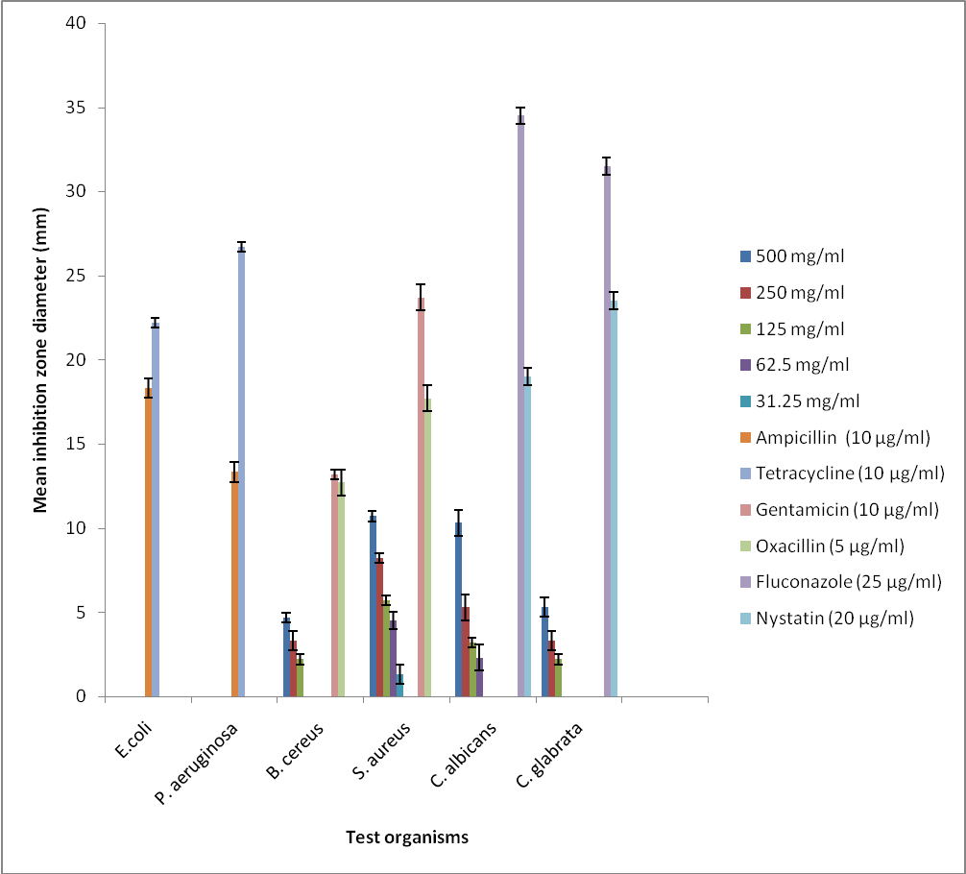
Fig 1: The effect of Auricularia auricula methanol extract on the different test organisms
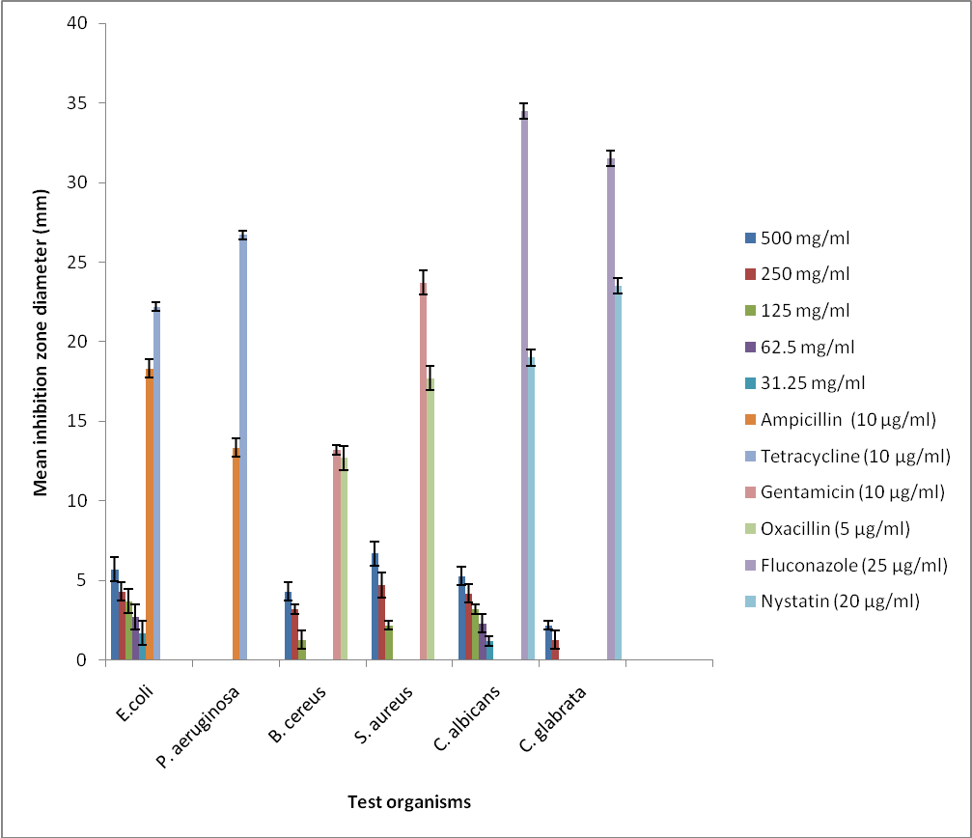

Fig 2: The effect of Auricularia auricula ethanol extract on the different test organisms
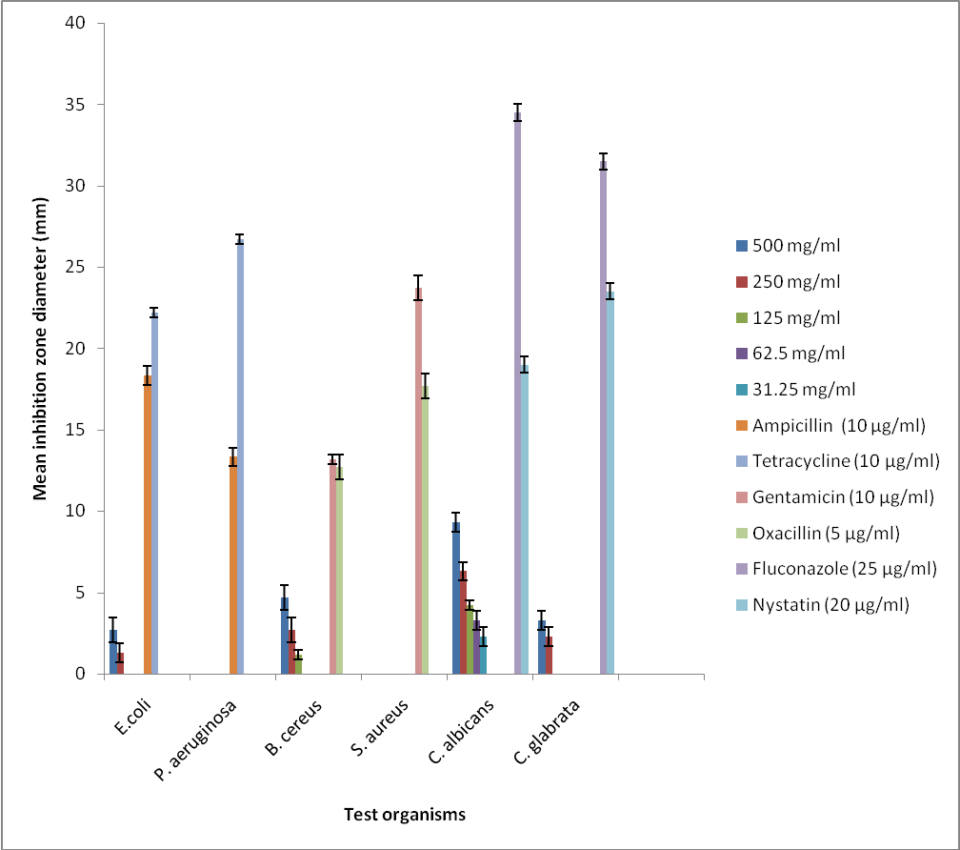

Fig 3: The effect of Auricularia auricula aqueous extract on the different test organisms

Table 1: The minimum inhibitory concentration (MIC) and Minimal Bactericidal Concentration (MBC) of the crude extract of Auricularia auricular.
Extract | Test organism | MIC (mg/ml) | MBC (mg/ml)
Ethanol
Ethanol | B. cereus | 62.5 | 62.5
Ethanol | S.aureus | 62.5 | 125
Ethanol | P. aeruginosa | ND | ND
 | E.coli | 31.25 | 31.25
Methanol
Methanol | B. cereus | 125 | 250
Methanol | S.aureus | 125 | 125
Methanol | P. aeruginosa | 62.5 | 62.5
 | E.coli | 31.25 | 62.5
Aqueous
Aqueous | B. cereus | 125 | 125
Aqueous | S.aureus | ND | ND
Aqueous | P. aeruginosa | ND | ND
 | E.coli | 125 | 250
ND = not determined

Table 2: The minimum inhibitory concentration (MIC) and Minimal fungicidal Concentration (MBC) of the crude extract of Auricularia auricular.
Extract | Test organism | MIC (mg/ml) | MFC (mg/ml)
Ethanol
Ethanol | C.albicans | 15.63 | 31.25
Ethanol | C.glabata | ND | ND
Methanol
Methanol | C.albicans | 125 | 250
Methanol | C.glabata | 125 | 250
Aqueous
Aqueous | C.albicans | 7.81 | 15.63
Aqueous | C.glabata | 250 | 250
ND = not determined

Table 3: PHYTOCHEMICAL ANALYSIS OF AURICULARIA AURICULAR IN DIFFERENT SOLVENT
Mushroom name Solvents Gly Tan Sap Fla Car Pro Alk
Auricularia auricular Ethanol - - +++ - + + ++
Methanol + ++ + + ++ +++ +
Aqueous ++ ++ + + + + -

- = not present, + = present in low concentration, ++ = moderate, +++ = present in high concentration, Gly = Glycoside, Tan = Tannins, Sap = Saponins, Fla = Flavonoids, Car = Carbohydrates, Pro = Proteins, Alk = Alkaloids.

REFERENCE
1. Kuo M."Auricularia auricula: The Jelly Ear". Www. MushroomExpert.com. 2002 Retrieved 20 December 2014.
2. Worrall JJ, Anagnost SE, Zabel RA. Comparison of wood decay among diverse lignicolous fungi. Mycologia. 1997; 89 (2): 199 – 219.
3. Conte AD, Læssøe T. The Edible Mushroom Book.Dorling Kindersley. 2008 Pp. 91-99.
4. Hobbs, C. Medicinal Mushrooms: An Exploration of Tradition, Healing & Culture. Culinary Arts Ltd. 1995 Pp. 73-80.
5. Tomblin, G. How to Identify Edible Mushrooms.Harper Collins UK. 2007; Pp. 146-149.
6. Oei P. Mushroom cultivation. Appropriate technology for mushroom growers. 3rd Edition. Backhuys Publishers Leiden, the Netherland. 2003 Pp. 171-177.
7. Chang ST, Miles PG. Mushrooms Cultivation, Nutritional Value, Medicinal Effect, and Environmental Impact. 2nd Edition. CRC Press, USA 2004.
8. Wood C, Pittler MH. Comparison of efficacy of ginger with various antimotion sickness drugs. British Journal of Anaesthesis 2000; 84 (3): 367 - 371.
9. Ayodele SM, Idoko ME. Antimicrobial activities of four wild edible mushrooms in Nigeria. International Journal of Science and Nature 2011; 2 (1): 55 – 58.
10. Breene W. Nutritional and medicinal value of specialty mushrooms. Journal of Food Protection1990; 53: 883 – 894.
11. Diyabalanage T, Mulabagal V, Mills G, DeWitt DL, Nair, MG. Health-beneficial qualities of the edible mushroom, Agrocybe aegerita. Food Chemistry 2008; 108: 97-102.
12. Balakumar R, Sivaprakasam E, Kavitha D, Sridhar S, Kumar, JS. Antibacterial and antifungal activity of fruit bodies of Phellinus mushroom extract. International Journal of Bioscience 2011; 1 (3): 72 – 77.
13. Wasser SP. Medicinal mushrooms as a source of antitumor and immunomodulating polysaccharides. Applied Microbiology and Biotechnology 2002; 60: 258 - 274.
14. Nwachukwu E, Uzoeto HO. Antimicrobial activity of some local mushrooms on pathogenic isolates. Journal of Medicinal Plant Research 2010; 4 (23): 2460 - 2465.
15. Akpi UK, Odoh CK. Antimicrobial Activity of Pleurotus squarrosulus on Clinical Pathogenic Bacteria and Fungi. Journal of Advances in Microbiology 2017; 4(3): 1-9.
16. National Committee of Clinical Laboratory Standards. Performance Standards Antimicrobial Disc Susceptibility Tests.Approved standard 5th edition. 1998. NCCLS document M2-AS, Villanova, PA, USA.
17. Sorimachi K, Ikehara Y, Maezato G. Inhibition of Agaricus blazei murill fractions of cytopathic effect induced by western in vitro. Biosc. Biotechnol. biochem, 2001; 65 (7): 1645-1647.
18. Jang WJ, Hyung SW. Production of natural c9, t11 conjugated linoleic acid (c9, cLA) by submerged liquid culture of mushrooms. Gyeongsang National University, South Korea, Jinju 2004 Pp. 660 - 701.
19. Bergendorf O, Sterner O. These squiterpenes of Lactarius delicious and Lactarius deterrimus. Phytochemistry 1988; 27: 97 - 100.
20. Anke H, Bergendorff O, Sterner O. Assays of the biological activities of guaiane sesquiterpenoids isolated from the fruit bodiesof edible Lactarius species. Food and Chemical Toxicology 1989; 27: 393 - 397.
21. Keller AC, Maillard MP, Hostettmann K. Antimicrobial steroids from the fungus Fomitopsis pinicola. Phytochemistry 1996. 41: 1041 - 1046.
22. Lee SJ, Yeo WH, Yun BS, Yoo ID. Isolation and sequence analysis of newpeptaibol, Boletusin, from Boletus spp. Journal of Peptide Science 1999; 5: 374 - 378.
23. Sheena N, Ajith TA, Thomas M, Janardhanan KK. Antibacterial activity of three macrofungi, Ganoderma lucidum, Navesporus floccosa and Phellinus rimosus occurring in South India. Pharmaceutical Biology 2003; 41: 564 - 567.
24. Ezeronye OU, Daba ASO, Onumajuru IAIC. Antibacterial effect of crude polysaccharide extracts from sclerotium and fruitbody (Sporophore) of Pleurotus tuberregium (Fried) singer on some clinical isolates. International Journal of Molecular Medicine and Advance Sciences 2005; 1 (3): 202 - 205.
25. Yamac, M. and Bilgili, F. (2006). Antimicrobial activities of fruit bodies and/or mycelia cultures of some mushroom isolates. Pharmaceutical Biology. 44: 660 - 667.
26. Barros L, Calhelha RC, Vaz JA, Ferreira ICFR, Baptista P, Estevinho LM. Antimicrobial activity and bioactive compounds of Portuguese wild edible mushroom methanolic extracts. European Food Research and Technology 2006; 225: 151 - 156.
27. Turkoglu A, Duru EM, Mercan N. Antioxidant and antimicrobial activity of Russula delica Fr: An edible wild mushroom. Eurasian Journal of Analytical Chemistry 2007; 2: 54 - 67.
28. Akyuz M, Kirbag S. Antimicrobial activity of Pleurotus eryngii var. ferulae grown on various agro-wastes. EurAsian Journal of Biosciences 2009; 3: 58 - 63.
29. Altuner EM, Akata I. Antimicrobial activity of some macrofungi extracts.Sakarya University Fen Bilimleri Dergisi Cilt. 2010; 14: 45 - 49.
30. Ochoa-Zarzosa A, Vazquez-Garciduenas SM, Robinson-Fuentes VA, Vazquez-Marrufo G. Antimicrobial and cytotoxicactivity from basidiocarp extracts of the edible mushroom Lactarius indigo (Schw.) Fr. (Russulaceae). African Journal of Pharmacy and Pharmacology 2011; 5: 281-288.
31. Sivaprakasam E, Kavitha D, Balakumar R, Sridhar S, Suresh K. (). Antimicrobial activity of whole fruiting bodies of Trametes hirsute (Wulf. Fr.) Pil. Against some common pathogenic bacteria and fungus. International Journal of Pharmaceutical Science drug Research. 2011; 3 (3): 219-221.
32. Praveen K, Usha KY, Naveen M, Rajasekhar BR. Antibacterial activity of a mushroom-Stereum ostrea. Journal of Biology Agriculture and Healthcare 2012; 2: 1 - 5.
33. Akpi UK, Odoh CK, Ideh EE, Adobu US. Antimicrobial Activity of Lycoperdum perlatum whole fruit body on common pathogenic bacteria and Fungi. African Journal of Clinical Experimental Microbiology 2017; 18 (2):79-85.
34. Akpi UK, Nwankwo EO, Odoh CK. In Vitro Antimicrobial Activity of Polyporus Alveolaris on Clinical Pathogens. Journal of Current Biomedical Research 2017; 1(1):47-54

