Pre and Post Forming Evaluation of Similar and Dissimilar Material Fabricated by Friction Stir Welding.

AB Abdullah
School of Mechanical Engineering, Universiti Sains Malaysia, Malaysia

Abstract

Recently, the use of friction stir welding (FSW) has been successfully demonstrated for producing tailor welded blanks (TWBs) for the transportation industry. This speech will focus on experimental investigation on pre and post forming evaluation of TWB produced by FSW. The blank samples were fabricated by combining various grades of alloy, similar as well as dissimilar. The welding was performed for optimum welding speed, feed rate and tilt angle using a flat pin tool on a conventional milling machine modified for FSW process. The effects of different combination of alloys, bending direction and bending location to formbility and geometrical defect such as springback were observed. Furthermore, process parameters including stroke and rolling direction were also considered. It was found that the welded blank that combined similar alloy will result in higher springback as compared to dissimilar alloys. Furthermore, it was found that the effect of rolling directions, bending direction and bending location were also significant to the springback response.
.

Biography

Ahmad Baharuddin Abdullah, Senior Lecturer.

Ahmad Baharuddin Abdullah is a Associate Professor at the School of Mechanical Engineering, Universiti Sains Malaysia (USM). He earned his undergraduate degree in year 1999 and Master in year 2002 in Mechanical Engineering from Universiti Sains Malaysia. He pursues his study in metal forming research obtained his PhD in year 2013 from Universiti Putra Malaysia, Malaysia. His research interest is on sheet metal forming, tool and die and metal additive manufacturing. He already published more than 100 articles and actively involved as reviewer for several journals including International Journal of Advanced Manufacturing and many more. He is a graduate member of Board of Engineers Malaysia (BEM) since 2003 and obtained his Professional Engineer (PE) status in year 2018.

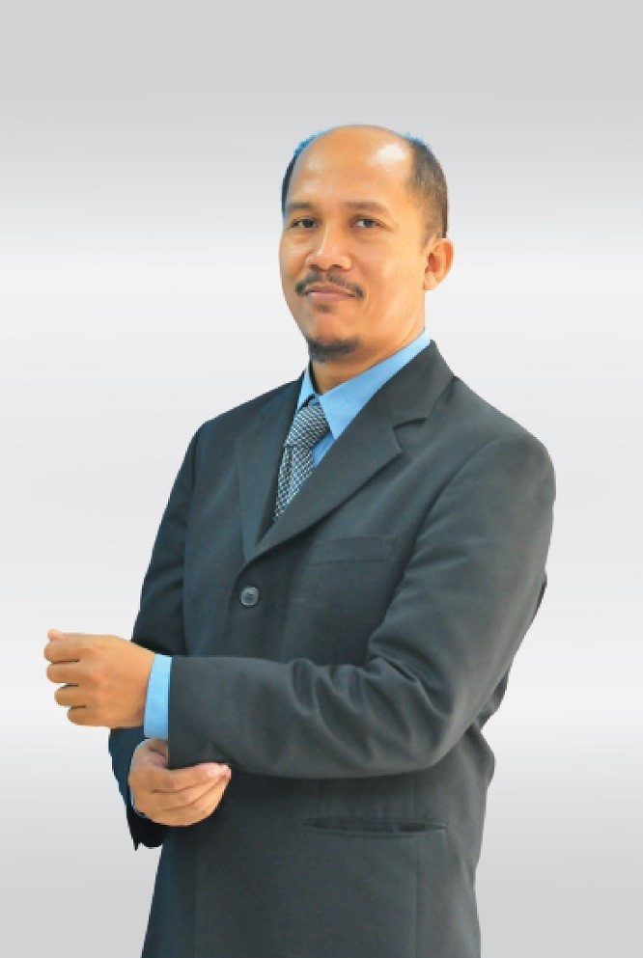

Details of presenting author to be mentioned in the certificate:
Name: Ahmad Baharuddin Abdullah
Affiliation: School of Mechanical Engineering, Universiti Sains Malaysia.
Country: MALAYSIA

Other Details:
Presentation Category: (Oral/Poster Presentation)
Session Name: Manufacturing Processes
Email: mebaha@usm.my
Alternative email: metalforminglabusm@gmail.com
Contact Number: 604-5996381
Twitter/Facebook/LinkedIn: Ir. Ahmad Baharuddin Abdullah

