Key Information Systems Management Tasks – Where to Focus

Dr. Seppo Sirkemaa
University of Turku, Finland

Abstract - Keynote presentation

Information technology management challenges managers to create a robust platform for other systems in the organization. However, it is not only about reliability of technology, systems should also be secure, flexible and adapt to future business needs. Clearly, there are several perspectives to information technology infrastructure management. Understanding development and maintenance activities which take the human element in technology into consideration is the key to successful information technology infrastructure management.

Biography of presenting author
Seppo J. Sirkemaa
Seppo J. Sirkemaa has a Ph.D. in information systems management from Turku School of Economics at University of Turku, in Finland. Dr. Sirkemaa has held several academic positions ranging from researcher to research professor and worked as vice director of Pori Unit in Turku School of Economics at University of Turku, Finland. Dr. Sirkemaa is also an IT consultant and has published over 100 academic publications.

Details of presenting author to be mentioned in the certificate:
Dr. Seppo Sirkemaa
University of Turku
Finland

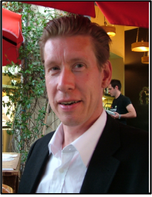

seppo.sirkemaa@utu.fi

Recent Photograph!

