**DISTRIBUTION OF DUST PARTICLES IN NEAR-PLANETARY SPACES**

Abduljalol G. Safarov

Tajik National University, 734025, Tajikistan, Dushanbe, 17 Rudaki av.

**Abstract:**

Studies of active processes in cometary nuclei, in particular the ejection of dust particles of comet tails, carried out earlier suggest the existence of a significant number of meteoroid swarms that do not cross the Earth's orbit. We have identified about 100 comets that had an anomalous tail, and at the same time most of them recorded the destruction of the core, consisting of large meteoroid particles. Some of them belong to short-period comets of the Jupiter family. Meteoroid swarms of some of these comets with orbital perihelion distance q < 1 AU or q ≈ 1 AU known (for example, the meteoroid swarm associated with the comet 2P). Other comets have q > 1 AU. and very active kernels. For example, comets 4P, 6P, 7P, 10P, 11D, 17P, 19P, 29P, 33P, 37P, 39P, 51P, 53P, 57P, 67P, 69P, 73P, 79P, 81P, 88P, 97P, 101P, 108P, 128P, 205P, P/2004 V5, D/1884 O1, D/1993 F2 recorded nuclear destruction, dust jets or anomalous tail. After the ejection of large dust from the core, a swarm of large particles remains along the comet's orbit. Information on meteoroid swarms of cometary origin that do not cross the Earth's orbit seems to be important in the study of meteoroid matter in the solar system and ensuring the safety of space missions.

**Biography of presenting authors**

Safarov Abduljalol Gafurovich graduated from Tajik State National University (TSNU) in Dushanbe in 2004. Having graduated with a degree in Astronomer, he began working in the Astronomy Department of TSNU in 2004. He was a graduate student in the Department of Physics of Comets and Asteroids of the Institute of Astrophysics of the Republic of Tajikistan in 2006-2009. After graduating from graduate school from 2010 to this day, he has been working at the Department of Astronomy of the Tajik National University (TNU). Since 2019 he is the head of the Department of Astronomy of TNU. Candidate of physical and mathematical sciences, specialty in 01.03.04 planetary research.

**Details of presenting author to be mentioned in the certificate:**

Name: Abduljalol

Affiliation:

Country: Tajikistan

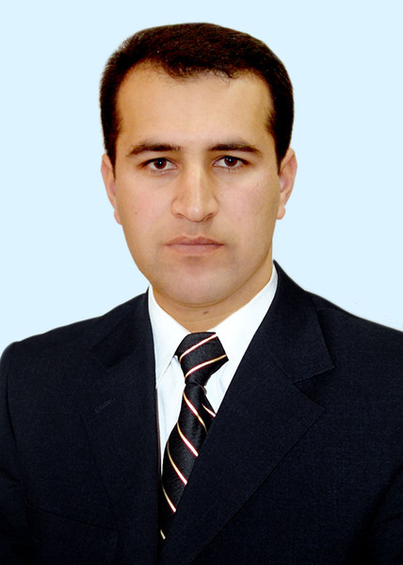**Other Details:**

Presentation Category: (Poster Presentation)

Session Name: Astronomy and Astrophysics

Email: aj_safarov@mail.ru

Alternative email: safarzoda81@gmail.com

Contact Number: +992919620046

<https://www.facebook.com/abduljalol.safarov>