Stereolithographic Additive Manufacturing of Fine Ceramic Components

Soshu Kirihara

Joining and Welding Research Institute, Osaka University, Japan

In stereolithographic additive manufacturing (STL-AM), 2-D cross sections were created through photo polymerization by UV laser drawing on spread resin paste including nanoparticles, and 3-D models were sterically printed by layer lamination. The lithography system has been developed to obtain bulky ceramic components with functional geometries. An automatic collimeter was newly equipped with the laser scanner to adjust the beam diameter. Fine or coarse beams could realize high resolution or wide area drawings, respectively. As the row material of the 3-D printing, nanometer sized metal and ceramic particles were dispersed into acrylic liquid resins at about 60 % in volume fraction. These materials were mixed and deformed to obtain thixotropic slurry. The resin paste was spread on a glass substrate with 50 μm in layer thickness by a mechanically moved knife edge. An ultraviolet laser beam of 355 nm in wavelength was adjusted to 50 μm in variable diameter and scanned on the spread resin surface. Irradiation power was automatically changed for an adequate solidification depth for layer bonding. The composite precursors including nanoparticles were dewaxed and sintered in the air atmosphere. In recent investigations, ultraviolet laser lithographic additive manufacturing (UVL-AM) was newly developed as a direct forming process of fine metal or ceramic components. As an additive manufacturing technique, 2-D cross sections were created through dewaxing and sintering by UV laser drawing, and 3-D components were sterically printed by layer laminations with interlayer joining. Through computer-aided smart manufacturing, design, and evaluation (Smart MADE), practical material components were fabricated to modulate energy and material transfers in potential fields between human societies and natural environments as active contributions to Sustainable Development Goals (SDGs).

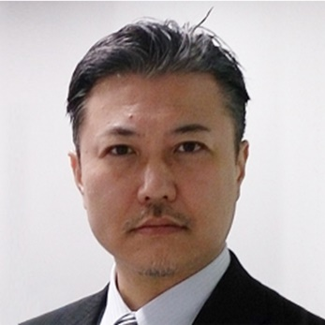

Full Name: Soshu Kirihara

Email: kirihara@jwri.osaka-u.ac.jp

Soshu Kirihara is a doctor of engineering and a professor of Joining and Welding Research Institute (JWRI), Osaka University, Japan. In his main investigation “Materials Tectonics as Sustainable Geoengineering” for environmental modifications and resource circulations, multi-dimensional structures were successfully fabricated to modulate energy and materials flows effectively. Ceramic and metal components were fabricated directly by smart additive manufacturing, design and evaluation (Smart MADE) using high power ultraviolet laser lithography. Original stereolithography systems were developed, and new start-up company “SK-Fine” was established through academic-industrial collaboration.

