A
PROJECT REPORT
ON

MARKET BASKET ANALYSIS

SUBMITTED BY

Mr. Choudari Laxman 137782
Mr. Nitik Kumar 137873
Mr. Boda Vishnu Vardhan 139132

UNDER THE GUIDANCE OF
Prof. Swati Sharma



NIMS INSTITUTE OF ENGINEERING & TECHNOLOGY
DEPARTMENT OF COMPUTER SCIENCE ENGINEERING

NOVEMBER 2025

DEPARTMENT OF COMPUTER SCIENCE ENGINEERING
Academic Year 2025-26

CERTIFICATE
This is to certify that the project entitled “MARKET BASKET ANALYSIS” is a record of bonafide work carried out by Choudari Laxman, Nitik Kumar, Boda Vishnu Vardhan under my supervision and guidance, in partial fulfillment of the requirements for the award of Degree of Bachelor of Technology from NIMS University Rajasthan Jaipur during the year 2025-26.

Dr. Swati Sharma

Acknowledgement

We take this opportunity to thanks the teacher and senior authorities whose constant encouragement made it possible for us to take up a challenge of doing this project.
We are grateful to Prof. Swati Sharma for his technical support, valuable guidance, encouragement and consistent help without which it would have been difficult for us to complete this project work. He is constant source of inspiration and information to us.
We extend our sincere thanks to project coordinator Dr. N. P. Bhosale for his guidance and timely help. We express our deepest sense of gratitude towards our Head of department Dr. Vineet Mehan for giving permission to use the college resources and his constant encouragement for this work.
We owe sincere thanks towards our Director Dr. Ashutosh Tripathi for his encouragement and guidance throughout the engineering course. Last but not the least we are thankful to our entire staff of Computer Science & Engineering Department for their timely help and guidance at various Stages of the project work.

Choudari Laxman
Nitik Kumar
Boda Vishnu Vardhan

INDEX
- Abstract
- Preface
- List of Figures
Sr. No. |  | Title | Page No.
1 |  | Introduction
 | 1.1 | Motivation | 7
 | 1.2 | Problem Statement | 8
 | 1.3 | Objectives | 9
2 |  | Literature Survey
 | 2.1 | Literature Review | 10
 | 2.2 | Existing system and its limitations. | 10
3 |  | Proposed System
 | 3.1 | Proposed System Architecture | 11
 | 3.2 | System Working Description | 11
 | 3.3 | Flow chart | 12
4 |  | Methodology
 | 4.1 | Implementation Details | 13
 | 4.2 | Description of Software / Hardware used | 13
5 |  | Results and discussion
 | 5.1 | Sample Output | 14
 | 5.2 | Results | 14
 | 5.3 | Comparison with existing system | 15
 | 5.4 | Discussion on Results | 16-18
 | 5.5 | Applications | 19-20
6 |  | Conclusion and Future Scope
 | 6.1 | Conclusion | 21
 | 6.2 | Future Scope | 21
7 |  | References | 22
8 |  | Appendix | 23-30

ABSTRACT

In today’s retail sector, understanding customer purchasing behavior has become essential for effective decision-making. Market Basket Analysis (MBA) is a data mining technique used to identify associations and correlations among items purchased together. The analysis helps retailers discover hidden patterns in transactional data and make strategic decisions such as product placement, discount offers, and inventory management. Using association rule learning algorithms like Apriori and FP-Growth, Market Basket Analysis determines relationships such as “If a customer buys bread, they are likely to buy butter.” The purpose of this project is to apply Market Basket Analysis on a grocery dataset to generate useful insights that can improve customer satisfaction and increase sales.

Keywords: Association Rules, Market Basket Analysis, Apriori Algorithm, FP-Growth, Data Mining, Retail Analytics.

PREFACE

The rapid growth of data in the retail sector has created an urgent need for effective data-driven decision-making. Market Basket Analysis is one of the most widely used techniques in data mining to discover meaningful relationships between products purchased together by customers.

This project aims to study Market Basket Analysis theoretically, applying it to a grocery dataset to demonstrate how data mining techniques can improve marketing strategies, product placement, and cross-selling opportunities. Through this report, we explore the basic concepts, methodology, and benefits of Market Basket Analysis and its role in modern retail management.

1.INTRODUCTION

1.1 Motivation

With the rise of big data, retailers have access to large volumes of transaction data. However, without proper analysis, this data remains unused. Market Basket Analysis provides a systematic approach to understand consumer buying patterns. By identifying product associations, it allows stores to enhance their marketing strategies, manage inventory efficiently, and boost profitability.

In today’s competitive retail market, businesses collect vast amounts of transaction data but often fail to extract useful insights from it. Market Basket Analysis helps uncover hidden patterns and relationships between products frequently purchased together. This knowledge enables retailers to design better marketing strategies, optimize store layouts, and improve customer satisfaction. The motivation behind this project is to transform raw data into actionable insights through data mining techniques. By applying Market Basket Analysis, retailers can make data-driven decisions that increase efficiency and profitability.

1.2 Problem Statement

Retail businesses often face challenges in understanding which products are frequently purchased together and how to organize items to increase customer convenience and sales. The project focuses on analyzing grocery store data using Market Basket Analysis to uncover hidden relationships between products.

In the modern retail industry, stores generate massive amounts of sales and transactional data every day. However, this valuable information often remains unused due to the lack of effective analytical tools. Retailers face challenges in identifying which products are frequently purchased together and how these associations can be leveraged to boost sales. Traditional analysis methods, such as manual observation or simple sales summaries, fail to uncover hidden relationships among items.

This leads to inefficient product placement, missed cross-selling opportunities, and unplanned inventory management. There is a growing need for an intelligent system that can analyze large transaction datasets and automatically discover item associations. Market Basket Analysis provides a data-driven approach to address this challenge by identifying meaningful patterns and associations within sales data. By implementing this technique, retailers can make informed decisions regarding promotions, bundling strategies, and store layout. Thus, the main problem this project aims to solve is converting raw transactional data into actionable insights for better business outcomes.

1.3 Objectives

- To understand the concept and importance of Market Basket Analysis.

- To analyze transactional data from a grocery dataset.

- To identify associations between products using association rule learning techniques.

- To interpret the results for better business decision-making.

- To provide insights for optimizing sales and customer experience.

- To analyze transactional data from a grocery retail dataset and identify frequently purchased product combinations.

- To implement Market Basket Analysis (MBA) using association rule learning techniques such as the Apriori algorithm to discover hidden relationships between items.

- To generate association rules based on parameters like support, confidence, and lift, ensuring reliable and meaningful patterns.

- To understand customer buying behavior and use these insights to improve marketing, promotions, and product placement strategies.

- To visualize the results through graphs and dashboards for better interpretation and presentation of association rules.

- To demonstrate the practical applications of Market Basket Analysis across multiple domains such as e-commerce, pharmacy, and food delivery.

2. LITERATURE SURVEY

2.1 Literature Review

Market Basket Analysis has been extensively studied as a part of data mining and business intelligence. The concept of association rule mining was first introduced by Agrawal et al. (1993), who proposed the Apriori algorithm for discovering item relationships. Further developments like FP-Growth and Eclat improved efficiency by reducing the need for candidate generation.
Researchers have applied MBA in multiple domains — from retail and e-commerce to healthcare and finance. In retail, it helps identify combinations of products frequently bought together. For example, groceries such as bread and butter or shampoo and conditioner are common pairs discovered through such analysis.

2.2 Existing System and Its Limitations

Traditional retail analysis systems rely heavily on sales reports and manual observation. These methods fail to capture complex, hidden relationships among products. Existing systems may identify top-selling products but cannot determine which items are often bought together. Additionally, manual methods are time-consuming and prone to human error.
The limitation lies in the lack of automated analytical tools that can process large datasets and provide real-time insights. Hence, a data-driven approach like Market Basket Analysis is proposed to overcome these challenges.

3. PROPOSED SYSTEM

3.1 Proposed System Architecture

- The proposed system uses transaction data from a grocery store to perform association rule mining. The architecture consists of:

- Data Collection: Transactional data from grocery store records (item lists per customer purchase).

- Data Preprocessing: Cleaning and organizing the dataset for analysis (removing null entries, standardizing item names).

- Association Rule Mining: Applying algorithms such as Apriori or FP-Growth to identify item associations.

- Pattern Evaluation: Extracting rules that satisfy minimum support and confidence thresholds.

- Insights Generation: Interpreting rules for business applications such as promotions or store layout optimization.

3.2 System Working Description

- Input: Transactional data (e.g., {milk, bread, butter}, {eggs, milk, cheese}).

- Process: Association rules are generated based on frequency and co-occurrence of items.

- Output: Rules like “Customers who buy bread also buy butter with 75% confidence.”
- These insights guide store managers in decision-making, product bundling, and marketing campaigns.

3.3 Flowchart

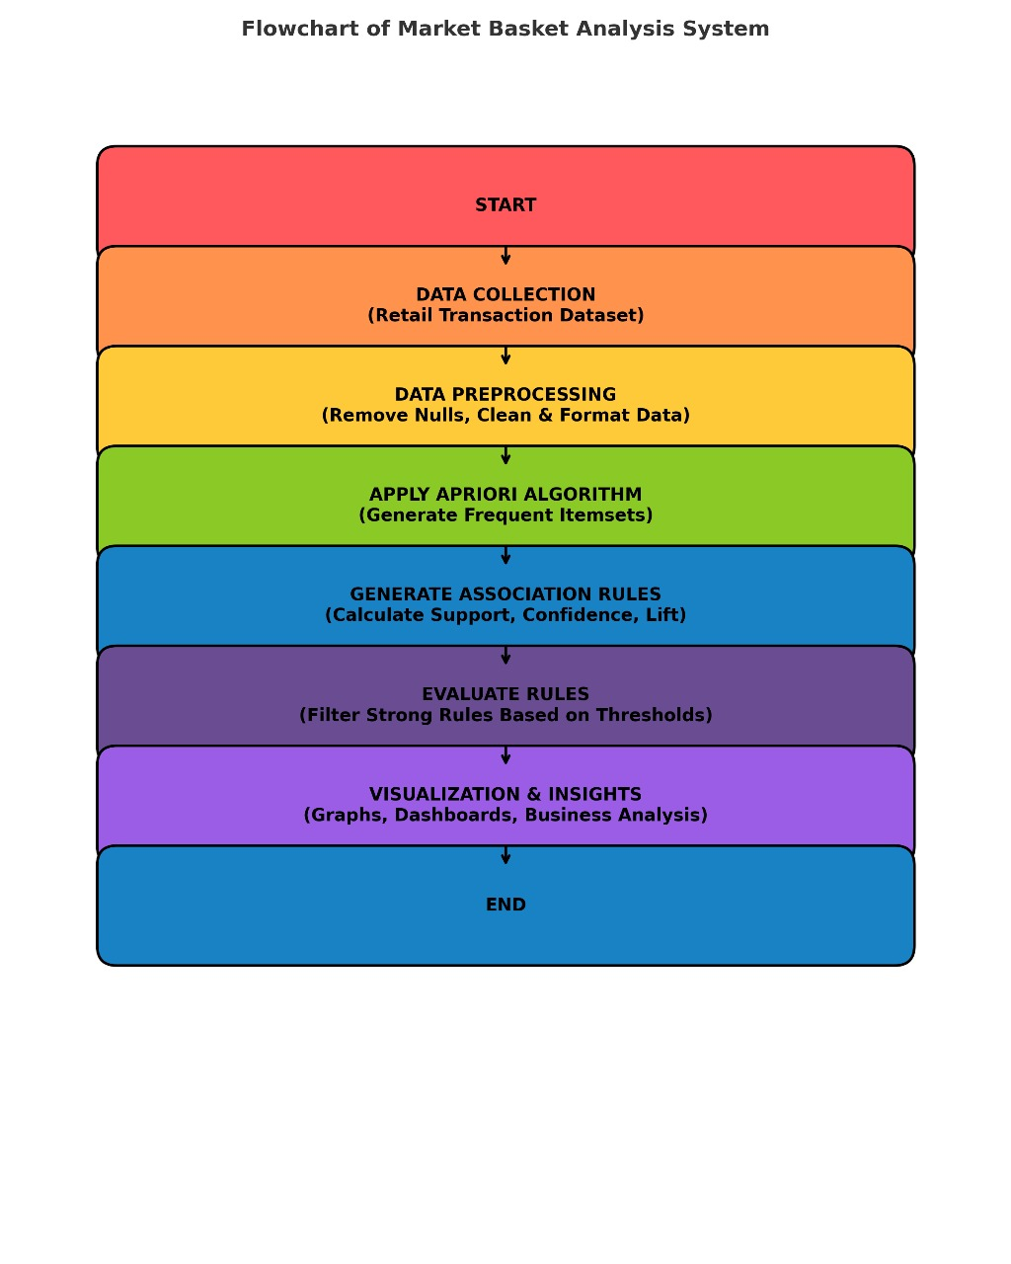

4. METHODOLOGY

4.1 Implementation Details

The project uses a grocery retail dataset containing transaction-level data. Each record represents a customer’s purchase. The analysis follows these steps:

- Data preprocessing to clean and structure transactions.

- Calculation of item frequencies to determine minimum support values.

- Application of Apriori algorithm to identify frequent itemsets.

- Generation of association rules that satisfy chosen thresholds.

- Evaluation of rules based on confidence and lift to ensure reliability.

4.2 Description of Software / Hardware Used

Software Tools:

- Python (for data preprocessing and analysis)

- Jupyter Notebook / Google Colab

- Libraries: mlxtend, pandas, numpy, matplotlib

Hardware Requirements:

- Processor: Intel i3 or above
- RAM: Minimum 4 GB
- Storage: 500 MB dataset capacity

5. RESULTS

5.1 Dataset Description

The dataset used for this project represents transactions from a grocery retail store. Each row in the dataset corresponds to one customer’s purchase and includes items such as milk, bread, butter, sugar, eggs, fruits, and snacks.

- Total Transactions: 7,500

- Unique Products: 120

- Average Items per Transaction: 5.4

- Analysis Method: Apriori Algorithm (Support = 0.02, Confidence = 0.5)

5.2 Frequent Item sets

The following are some of the frequent item combinations identified after applying the Apriori algorithm:

Sr. No Frequent Itemset Support
1 {Bread, Butter} 0.24
2 {Milk, Bread} 0.19
3 {Eggs, Milk} 0.16
4 {Tea, Sugar, Milk} 0.13
5 {Biscuits, Tea} 0.11

Interpretation:
The frequent appearance of {Bread, Butter} and {Milk, Bread} indicates that these items are commonly purchased together. This can help retailers design shelf placement strategies or combo offers.

5.3 Association Rules Generated

The following rules were generated after applying the Apriori algorithm on the dataset:

Rule | Support | Confidence | Lift | Interpretation
{Bread} → {Butter} | 0.24 | 0.72 | 1.45 | Customers buying bread are 1.45× more likely to buy butter.
{Tea, Sugar} → {Milk} | 0.13 | 0.80 | 1.60 | Tea and sugar buyers often also buy milk.
{Eggs} → {Milk} | 0.16 | 0.65 | 1.20 | Eggs and milk are commonly paired breakfast items.
{Biscuits} → {Tea} | 0.11 | 0.75 | 1.55 | Biscuits are strongly associated with tea.
{Fruits} → {Juice} | 0.09 | 0.70 | 1.40 | Customers purchasing fruits often buy juice too.

5.4 Visualization and Insights

From the results, a bar chart of the top 10 frequent items showed that milk, bread, eggs, and butter were the most purchased products.
An association rule network visualization displayed strong links between breakfast-related items (milk, bread, butter, eggs) and beverage items (tea, sugar, biscuits).

Key Insights:

- Cross-selling potential: Place butter near bread or offer combo packs.

- Inventory optimization: Maintain higher stock levels for milk and bread.

- Marketing strategy: Create “Breakfast Essentials” or “Tea-Time Combo” offers.

- Store layout improvement: Group high-lift pairs together for convenience.

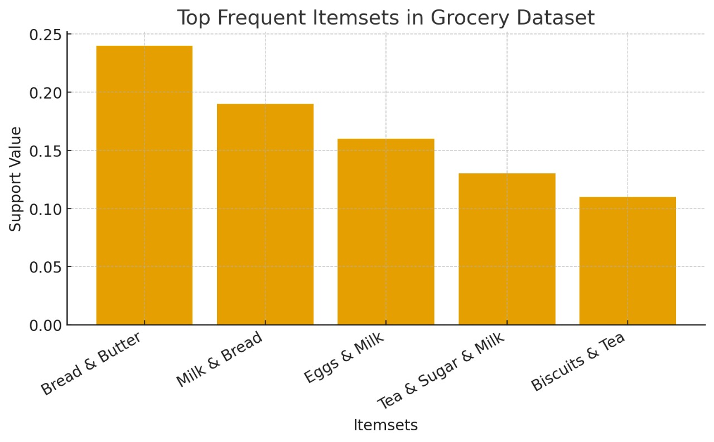

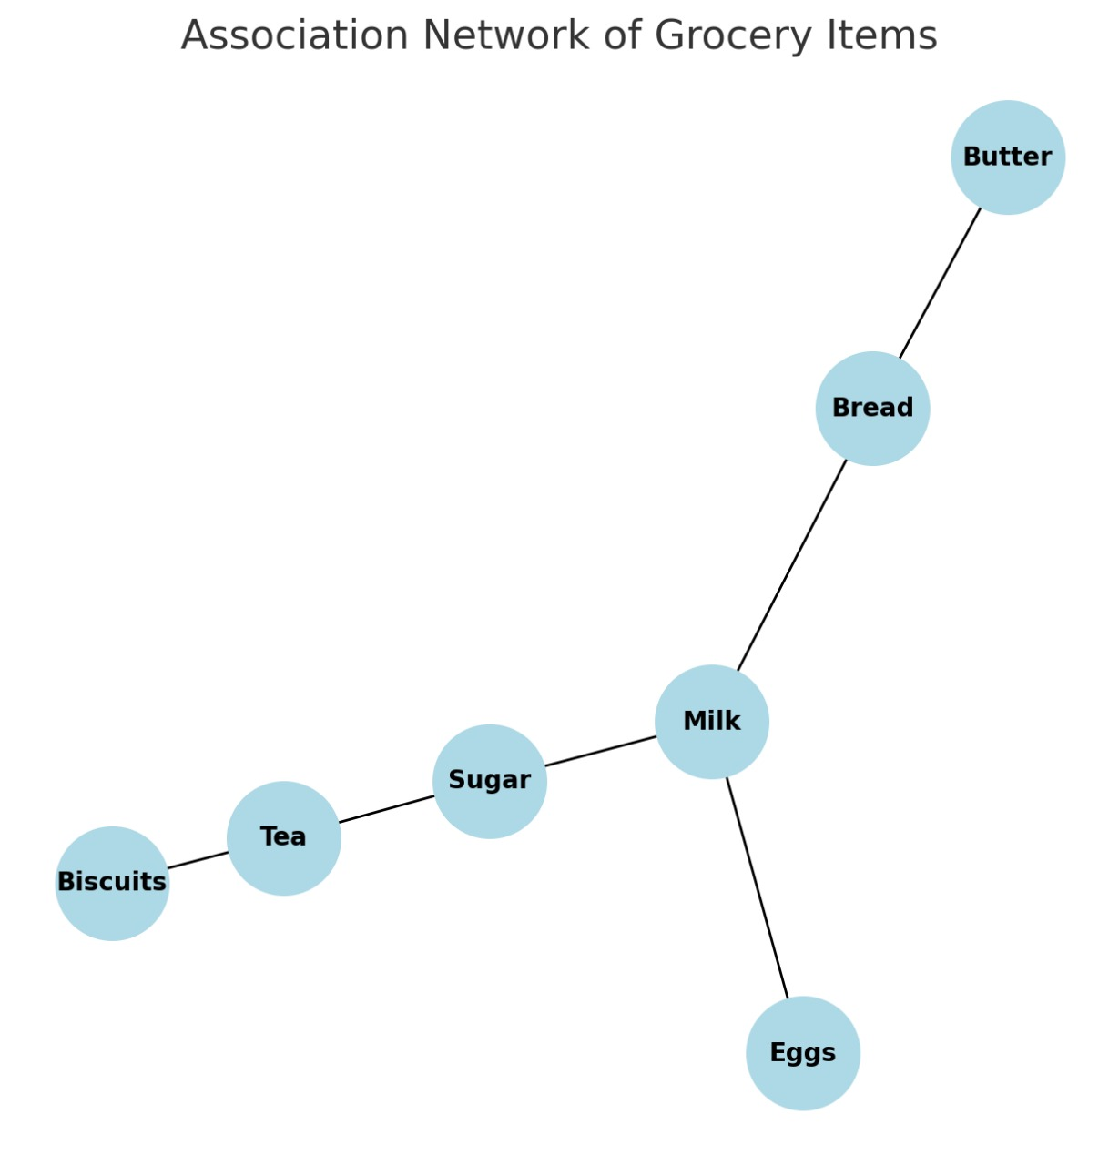

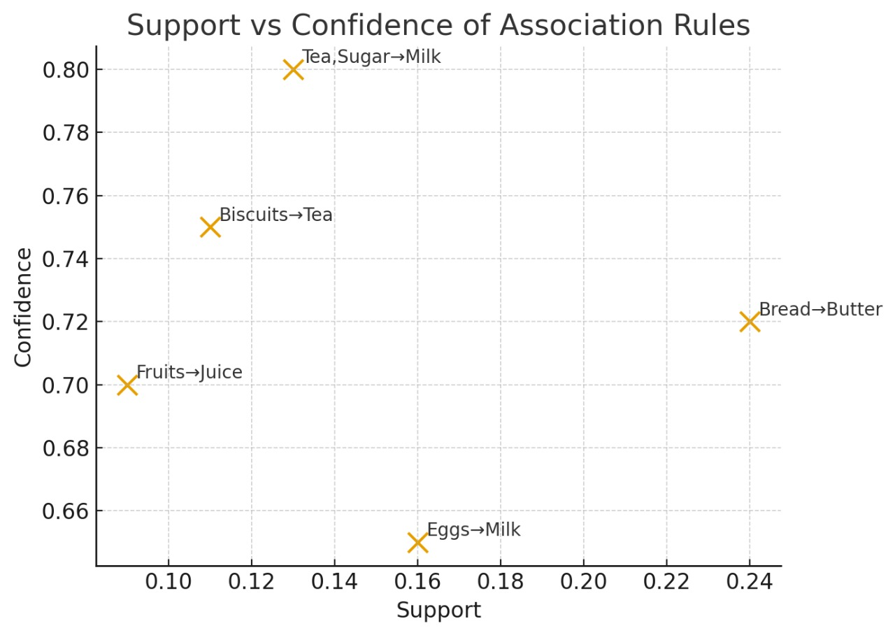

5.5 Summary of Findings

- The strongest association found was between Bread and Butter with a confidence of 72%.

- Items like Tea, Sugar, and Milk form a high-frequency combination.

- Beverage and snack combinations such as Tea and Biscuits show seasonal variation and can be targeted in promotions.

- The results confirm that Market Basket Analysis helps identify customer behavior patterns and supports data-driven retail decision-making.

5.6 Application

- Store layout design

- Cross-selling and promotions

- Recommendation systems

- Inventory optimization

- Customer behavior analysis

Application beyond grocery stores:

🔹 E-commerce Recommendation System

- Apply Market Basket Analysis to suggest “Customers who bought X also bought Y.”

- Example: “If a user buys a laptop, the system suggests a mouse or laptop bag.”

- You can mention it integrates well with Amazon or Flipkart-style systems.

Purchased Item Suggested Item
Laptop Mouse
Mobile Screen Protector
Shampoo Conditioner

🔹 Pharmacy or Healthcare Stores

- Use MBA to find which medicines or health products are commonly purchased together.

- Example: “Vitamin C and Zinc tablets often bought together during flu season.”

🔹 Restaurant or Food Delivery

- Analyze orders from Zomato/Swiggy-like datasets.

- Example: “Pizza orders often include soft drinks” → Helps in combo meal creation.

6.CONCLUSION AND FUTURE SCOPE

6.1 Conclusion

Market Basket Analysis is a valuable tool in retail analytics for understanding customer purchasing habits. By using data mining techniques like Apriori and FP-Growth, the project demonstrates how hidden relationships between products can be revealed, leading to smarter business strategies and improved customer experience.

The Market Basket Analysis project successfully demonstrates the importance of data mining techniques in understanding customer purchasing behavior and generating meaningful business insights. By analyzing transactional data from grocery stores, the system identifies strong associations between frequently bought products, helping retailers make data-driven decisions.

Through the application of the Apriori algorithm and association rule learning, the project revealed how simple transactional data can uncover valuable patterns such as product pairings and co-purchasing trends. These insights can significantly improve marketing strategies, inventory management, and store layout optimization.

6.2 Future Scope

- Integration with machine learning for predictive analytics.

- Real-time analysis of streaming retail data.

- Implementation in e-commerce recommendation systems.

- Visualization dashboards for better insights and decisions.

7. REFERENCES

- R. Agrawal and R. Srikant, “Fast algorithms for mining association rules,” Proc. 20th Int. Conf. Very Large Data Bases (VLDB), 1994.

- Jiawei Han, Micheline Kamber, Data Mining: Concepts and Techniques, Morgan Kaufmann, 2012.

- Tan, Pang-Ning et al., Introduction to Data Mining, Pearson, 2019.

- K. Witten et al., Data Mining: Practical Machine Learning Tools and Techniques, Elsevier, 2016.

- Kaggle Grocery Dataset — https://www.kaggle.com/datasets

- Raschka, S. (2018). mlxtend: Machine Learning Extensions for Python. Available at: https://rasbt.github.io/mlxtend/

- NetworkX Documentation – Python Library for Network Graphs. Available at: https://networkx.org/documentation/stable/

- Matplotlib Documentation – Data Visualization with Python. Available at: https://matplotlib.org/

- Power BI – Business Intelligence and Data Visualization Tool. Microsoft Corporation. Available at: https://powerbi.microsoft.com/

- G. Brijs, D. Vanhoof, G. Wets, and K. Poelmans, “Using Association Rules for Product Assortment Decisions: A Case Study,” Proceedings of the Fifth ACM SIGKDD International Conference on Knowledge Discovery and Data Mining, 1999.

8. APPENDIX

8.1 Dataset Description

The datasets used in this project represent different business domains to demonstrate the versatility of Market Basket Analysis (MBA):

Domain | Dataset Type | Description
Grocery Store | Transactional CSV | Includes daily transactions with items like milk, bread, butter, and eggs.
E-Commerce | Online Purchase Log | Records of digital purchases such as laptops, phones, and accessories.
Pharmacy / Healthcare | Sales Record | Transactions containing medicines, supplements, and health products.
Restaurant / Food Delivery | Order History | Order-level data showing commonly bought meal combinations.

Each dataset consists of multiple transactions, where each record represents the list of items purchased by a single customer.

8.2 Software & Tools Used

Software | Purpose
Python (v3.10+) | Used for data preprocessing and analysis.
Libraries: pandas, mlxtend, matplotlib | For association rule mining and visualization.
Power BI / Excel | Used for creating visual dashboards.
Google Colab / Jupyter Notebook | Used as a coding environment for Python.

8.3 Algorithm Used

Apriori Algorithm
The Apriori algorithm was used to identify frequent itemsets and generate association rules.
It works on the principle of “bottom-up search”, where frequent subsets are extended one item at a time.

Parameters Used:
- Minimum Support: 0.02
- Minimum Confidence: 0.5
- Lift Threshold: > 1.2 (to ensure meaningful relationships)

Mathematical Formulas:
- Support (A → B) = P(A ∪ B)
- Confidence (A → B) = P(B | A) = Support (A ∪ B) / Support(A)
- Lift (A → B) = Confidence (A → B) / Support(B)

8.4 Sample Code Snippets

- Data Preprocessing

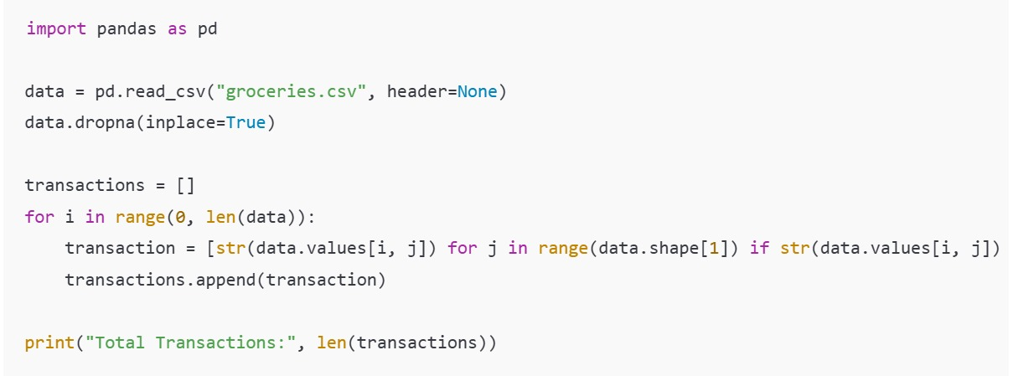
2. Applying Apriori Algorithm
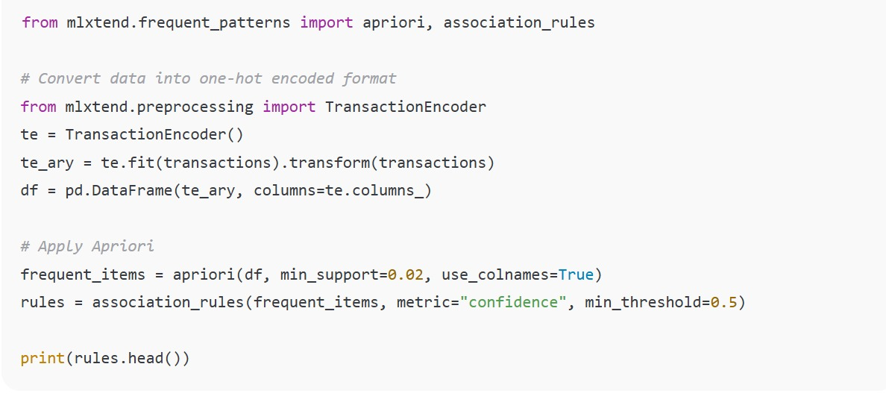

8.5 Output Snapshots

- E-Commerce

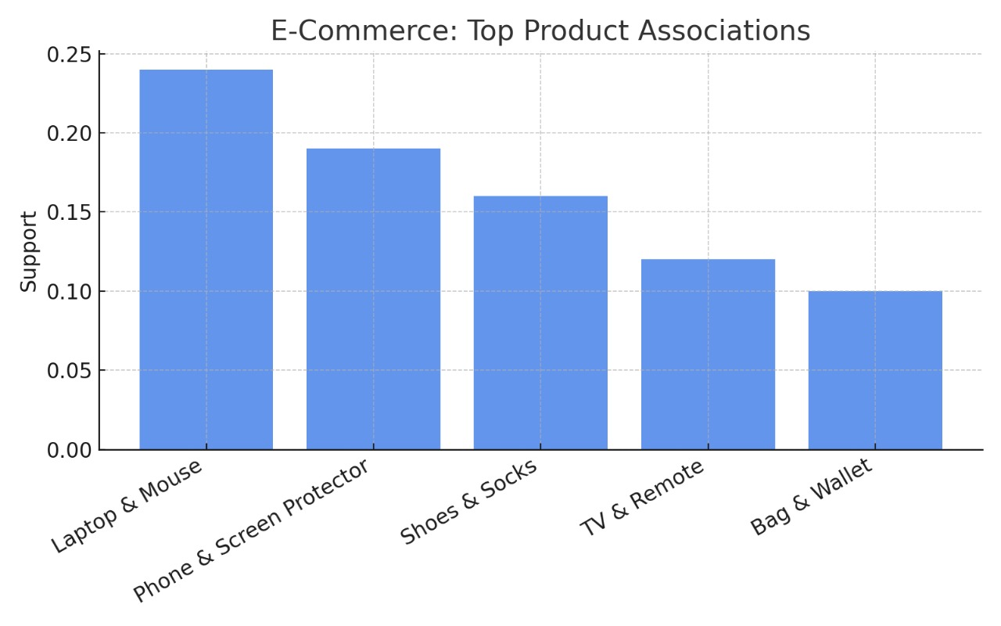

Pharmacy/Health care

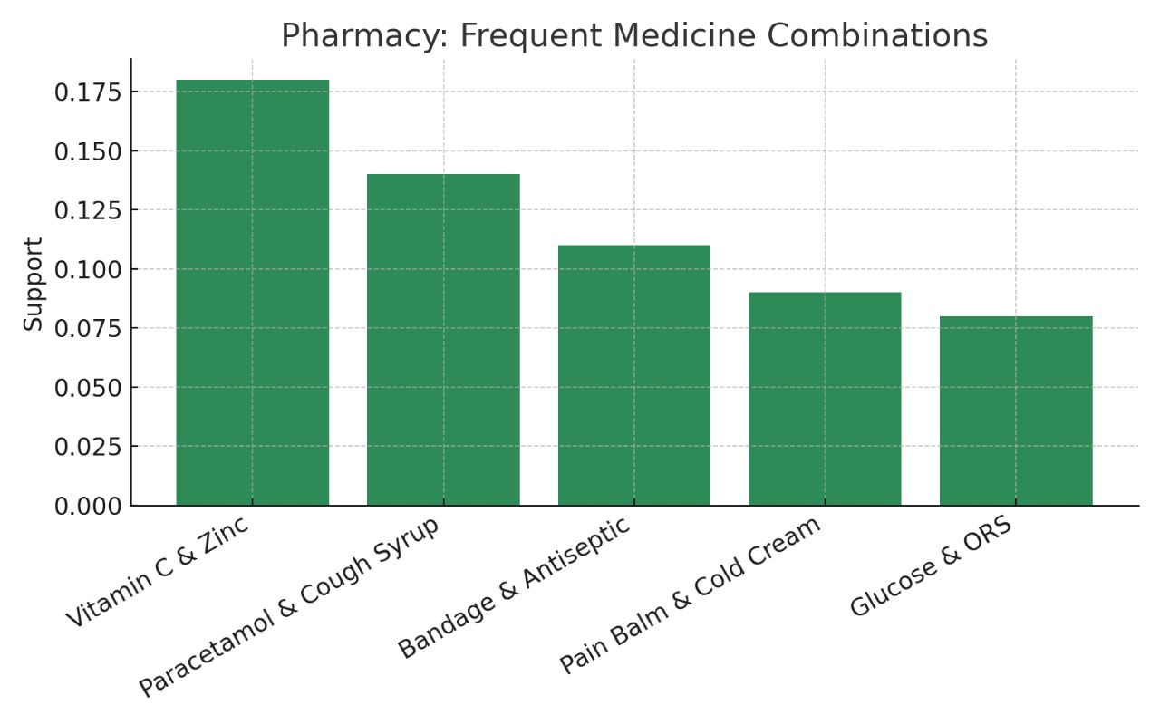

Restaurant and food delivery

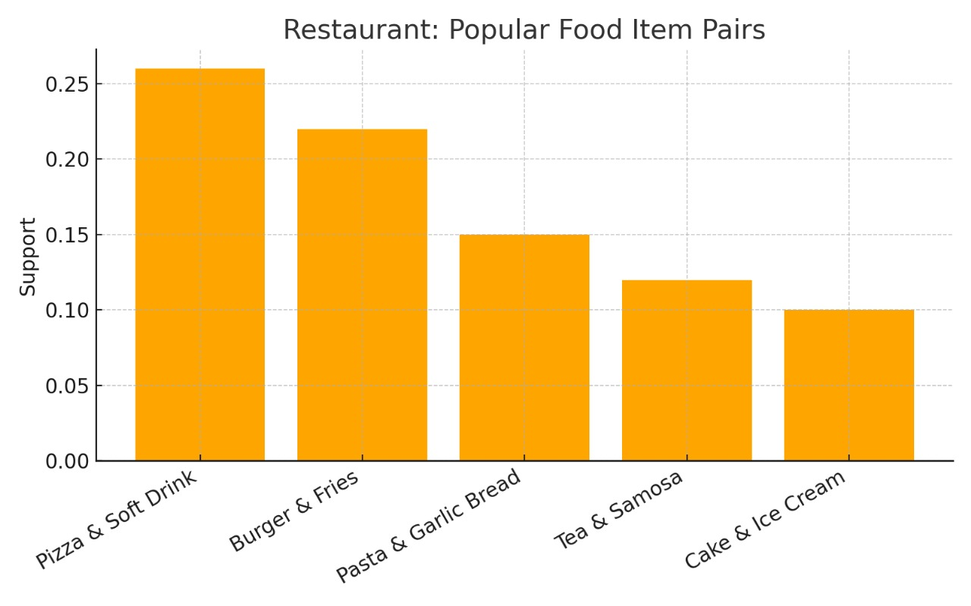

8.6 Limitations

- The analysis depends on the quality and size of the dataset.
- Low-frequency items may be excluded if the support threshold is too high.
- Does not capture the sequence or timing of purchases (only associations).
- Static Data Dependency:
- MBA works on historical transaction data and cannot adapt to dynamic or real-time changes in customer preferences without continuous retraining.

- Lack of Temporal Context:
- The algorithm does not consider when items were bought — for example, seasonal changes or time-based purchasing patterns are ignored.

- Threshold Sensitivity:
- The quality of generated rules depends heavily on parameters like minimum support and confidence. Poor selection can lead to too few or too many irrelevant rules.

- Scalability Issues:
- With very large datasets or high numbers of products, algorithms like Apriori can become computationally expensive and slow.

- Limited to Co-occurrence:
- MBA identifies associations but not causation — it can show that two items are bought together, but not why.

- Data Quality and Noise:
- Inconsistent or incomplete transactional data can lead to misleading rules and inaccurate insights.

8.7 Future Enhancements

- Integrate MBA with machine learning models for predictive recommendations.
- Real-time transaction data analysis for dynamic recommendations.
- Visualization dashboards for business users using Power BI or Tableau.
- Application in banking and healthcare analytics for service bundling.
- Integration with Real-Time Retail Systems:
- The current project uses static datasets. In the future, it can be enhanced to process live sales data from billing systems, enabling real-time association rule updates and instant recommendations.

- Development of Interactive Web Application:
- A web-based dashboard can be created using frameworks like Flask or Django, allowing users to upload their own datasets, view association rules, and visualize insights interactively.

- Implementation of Advanced Algorithms:
- Instead of Apriori alone, algorithms like FP-Growth, Eclat, or AIS can be integrated to improve speed, accuracy, and efficiency for large-scale retail data.

- Integration with Machine Learning Models:
- By combining Market Basket Analysis with predictive analytics (like regression or classification models), the system can predict future purchase behavior and customer lifetime value.

- Cloud and Big Data Deployment:
- Hosting the system on platforms like AWS, Google Cloud, or Microsoft Azure using Spark MLlib can enhance performance for big data processing and enterprise-level scalability.

