A Project Report
FINDORA: COMMUNITY-DRIVEN LOST AND FOUND PLATFORM
(A Web and Mobile-Based Item Recovery and Verification System)
In partial fulfillment of the requirements for the degree of
Bachelor of Computer Application (BCA)
under
POKHARA UNIVERSITY
Submitted to:
Department of Computer Application
Oxford College of Engineering and Management
Gaidakot, Nawalpur, Nepal
Under the guidance of:
Mr. Anil Thapaliya | Mr. Shiva Pathak
Project Supervisors, Department of Computer Application
Submitted by:
Bibek Poudel, BCA 8th Semester [PU Symbol No: 22530187]
Pratikshya Maske, BCA 8th Semester [PU Symbol No: 22530255]
Sumina Pokhrel, BCA 8th Semester [PU Symbol No: 22530256]
September 2026

Students’ Declaration
Declaration for “FINDORA: Community-Driven Lost and Found Platform”
We hereby declare that this project report titled “FINDORA: Community-Driven Lost and Found Platform” is our original work. We are the only authors of this project, and it has not been submitted elsewhere for any purpose. We also declare that no sources other than the ones listed here have been used in this work.
Bibek Poudel [Symbol No: 22530187] | Signature: __________________
Pratikshya Maske [Symbol No: 22530255] | Signature: __________________
Sumina Pokhrel [Symbol No: 22530256] | Signature: __________________

Supervisor’s Recommendation
We hereby recommend that this project titled “FINDORA: Community-Driven Lost and Found Platform” by Bibek Poudel, Pratikshya Maske and Sumina Pokhrel during their 8th semester in partial fulfillment of the requirements for the degree of BCA under Pokhara University, is completed under our supervision and is to our satisfaction for final evaluation.
________________________  Anil Thapaliya  Project Supervisor  Date: __________________ | ________________________  Shiva Pathak  Project Supervisor  Date: __________________

Letter of Approval
We certify that we have examined the report titled “FINDORA: Community-Driven Lost and Found Platform” and are satisfied with the project defense. This project work is satisfactory in the scope and qualifies as project in partial fulfillment of the requirements for the degree of Bachelor of Computer Application under Pokhara University.
___________________  Supervisor  Date: ______________ | ___________________  Examiner  Date: ______________ | ___________________  Program Coordinator  Susant Tiwari, HOD  Date: ______________

Acknowledgements
We would like to express our deepest gratitude to our project supervisors, Mr. Anil Thapaliya and Mr. Shiva Pathak, for their invaluable guidance, constructive feedback, insightful suggestions, and continuous encouragement throughout the development and documentation of the Findora project.
We extend our sincere thanks to Mr. Susant Tiwari, Head of the Department (HOD), Bachelor of Computer Application (BCA), and all respected faculty members of Oxford College of Engineering and Management for providing the necessary academic environment, technical facilities, and administrative support.
We are also thankful to Pokhara University for designing a rigorous and comprehensive BCA curriculum that empowered us to tackle real-world software engineering challenges.
Finally, we express our heartfelt appreciation to our parents, family members, and friends whose unwavering moral support, patience, and motivation enabled us to successfully bring this project to fruition.

Abstract
Findora is a digital lost-and-found ecosystem designed to simplify, accelerate, and secure the process of reporting, identifying, and recovering lost personal belongings within communities, academic institutions, and public venues. Traditional lost-and-found mechanisms often suffer from fragmentation, lack of secure verification, high friction in communication, and inadequate tracking. Findora addresses these shortcomings through a centralized web and mobile architecture featuring real-time feed updates, multi-criteria categorization, automated matching algorithms, and a multi-step ownership verification protocol.
Problem Statement: Inefficient, decentralized, and unverifiable manual methods for recovering misplaced items.
Objectives: Build a scalable, cross-platform platform enabling instant item reporting, secure claims, and reliable returned item verification.
Methodology: Agile development methodology with iterative sprints, robust API-driven communication, and component-based UI design.
Key Features: Categorized lost & found listings, automated attribute matching, secure proof-of-ownership claim verification, reputation & reward tracking, real-time status alerts, and an administrative moderation panel.
Tools & Technologies: Python, Django REST Framework, PostgreSQL, HTML5, Git.
Results: A responsive, secure, and production-ready solution that significantly reduces item recovery turnaround time while safeguarding user privacy.
Keywords: Lost and Found, Item Recovery, Django REST Framework, PostgreSQL, Kotlin Android, Claim Verification, Community Platform.

List of Abbreviations
Abbreviation | Full Form / Expansion
API | Application Programming Interface
BCA | Bachelor of Computer Application
CRUD | Create, Read, Update, and Delete
CSS | Cascading Style Sheets
DBMS | Database Management System
DFD | Data Flow Diagram
ERD | Entity Relationship Diagram
HOD | Head of Department
HTML | HyperText Markup Language
HTTP | Hypertext Transfer Protocol
HTTPS | Hypertext Transfer Protocol Secure
JSON | JavaScript Object Notation
JWT | JSON Web Token
MVC | Model-View-Controller
MVT | Model-View-Template
ORM | Object-Relational Mapping
OS | Operating System
PU | Pokhara University
REST | Representational State Transfer
SDK | Software Development Kit
SQL | Structured Query Language
UI | User Interface
UML | Unified Modeling Language
URI | Uniform Resource Identifier
URL | Uniform Resource Locator
UX | User Experience
VM | Virtual Machine

List of Figures
Figure No. | Figure Caption / Title | Page No.
Figure 3.6.1 | Use Case Diagram of Findora System | 14
Figure 3.6.2 | Data Flow Diagram (DFD Level 1) of Findora System | 15
Figure 3.6.3 | Activity Diagram of Lost and Found Item Recovery Workflow | 16
Figure 3.6.4 | Data Flow Diagram (Context Level 0) of Findora System | 17
Figure 3.6.5 | System Flowchart for Item Owner Workflow | 18
Figure 3.6.6 | System Flowchart for Item Finder Workflow | 19
Figure 3.6.7 | Administrator Verification & Moderation Workflow Diagram | 20
Figure 3.6.8 | 1-on-1 In-App Chat & Messaging Workflow Diagram | 21
Figure 3.6.9 | Item Matching & Parent-Child Relationship Diagram | 22
Figure 4.2.1 | System Architecture Diagram of Findora Platform | 24
Figure 4.2.2 | Deployment Diagram of Findora Infrastructure | 25
Figure 4.2.3 | UML Component Diagram of Findora System | 26
Figure 4.3.1 | Entity-Relationship Diagram (ERD) of Findora Database | 28
Figure 4.3.2 | State Machine Diagram for Item Lifecycle & Return Process | 29
Figure 4.4.1 | Sequence Diagram: User Authentication & OTP Verification | 31
Figure 4.4.2 | Sequence Diagram: Lost Item Reporting Workflow | 32
Figure 4.4.3 | Sequence Diagram: Found Item Reporting & Linking | 33
Figure 4.4.4 | Sequence Diagram: 1-on-1 In-App Chat & Secure Messaging | 34
Figure 4.4.5 | Sequence Diagram: Dual-Confirmation Return Process | 35
Figure 4.4.6 | Sequence Diagram: Finder Rating & Reputation Score Calculation | 36
Figure 4.4.7 | Sequence Diagram: Multi-Criteria Item Search & Detail Retrieval | 37
Figure 4.4.8 | Sequence Diagram: Notification Dispatch & Contextual Routing | 38
Figure 6.2.1 | User Login & Authentication Interface | 36
Figure 6.2.2 | User Registration & Onboarding Screen | 36
Figure 6.2.3 | Finder Dashboard & Categorized Home Feed | 37
Figure 6.2.4 | Item Details & Finder Action Overview | 37
Figure 6.2.5 | Report Lost Item Screen | 38
Figure 6.2.6 | Report Found Item Screen | 38
Figure 6.2.7 | Item Claim Submission & Ownership Proof Interface | 39
Figure 6.2.8 | Claim Verification & Return Handshake Status | 39
Figure 6.2.9 | 1-on-1 Real-Time In-App Chat Interface | 40
Figure 6.2.10 | Administrator Panel – Item Moderation Registry | 40
Figure 6.2.11 | Admin Item Detail & Ownership Verification View | 41
Figure 6.2.12 | Admin Item Approval & Moderation Decision Workflow | 41
Figure 6.2.13 | Master Administration Dashboard & Platform Analytics | 42

List of Tables
Table No. | Table Caption / Title | Page No.
Table 2.3.1 | Comparison between Existing Systems and Findora | 8
Table 3.3.1 | Project Timeline, Sprints, and Milestones | 11
Table 3.4.1 | Hardware and Software Operating Specifications | 12
Table 4.3.1 | Database Schema: Custom User Account Entity | 24
Table 4.3.2 | Database Schema: Lost and Found Item Entity | 24
Table 4.3.3 | Database Schema: Claim Request and Proof Entity | 25
Table 4.3.4 | Database Schema: Reputation and Transaction Logs | 25
Table 5.5.1 | Authentication and Access Control Test Cases | 32
Table 5.5.2 | Item Reporting, Filtering, and Matching Test Cases | 33
Table 5.5.3 | Claim Verification and Dispute Handling Test Cases | 34

Table of Contents
Students’ Declaration . . . . . . . . . . . . . . . . . . . . . . . i
Supervisor’s Recommendation . . . . . . . . . . . . . . . . . . . . ii
Letter of Approval . . . . . . . . . . . . . . . . . . . . . . . . iii
Acknowledgements . . . . . . . . . . . . . . . . . . . . . . . . . iv
Abstract . . . . . . . . . . . . . . . . . . . . . . . . . . . . v
List of Abbreviations . . . . . . . . . . . . . . . . . . . . . . . vi
List of Figures . . . . . . . . . . . . . . . . . . . . . . . . . vii
List of Tables . . . . . . . . . . . . . . . . . . . . . . . . . . viii
CHAPTER 1: INTRODUCTION . . . . . . . . . . . . . . . . . . . . . . 1
1.1 Background . . . . . . . . . . . . . . . . . . . . . . 1
1.2 Objectives . . . . . . . . . . . . . . . . . . . . . . 2
1.3 Purpose, Scope, and Applicability . . . . . . . . . . . 3
1.3.1 Purpose . . . . . . . . . . . . . . . . . . 3
1.3.2 Scope . . . . . . . . . . . . . . . . . . . 3
1.3.3 Applicability . . . . . . . . . . . . . . . 4
1.4 Achievements . . . . . . . . . . . . . . . . . . . . . 4
1.5 Organization of Report . . . . . . . . . . . . . . . . 5
CHAPTER 2: SURVEY AND REVIEWS . . . . . . . . . . . . . . . . . . . 6
2.1 Literature Survey . . . . . . . . . . . . . . . . . . . 6
2.2 Review of the similar/relevant projects . . . . . . . . . 7
2.3 Comparison between existing system and our system . . . . 8
CHAPTER 3: REQUIREMENTS ANALYSIS . . . . . . . . . . . . . . . . . . 9
3.1 Problem Definition . . . . . . . . . . . . . . . . . . 9
3.2 Requirements Specification . . . . . . . . . . . . . . . 10
3.3 Planning and Scheduling . . . . . . . . . . . . . . . . 11
3.4 Software and Hardware Requirements . . . . . . . . . . . 12
3.5 Preliminary Product Description . . . . . . . . . . . . 13
3.6 Conceptual Models . . . . . . . . . . . . . . . . . . . 14
CHAPTER 4: SYSTEM DESIGN . . . . . . . . . . . . . . . . . . . . . 18
4.1 Introduction . . . . . . . . . . . . . . . . . . . . . 18
4.2 System Design . . . . . . . . . . . . . . . . . . . . 19
4.3 Database design . . . . . . . . . . . . . . . . . . . 22
4.4 User Interface Design . . . . . . . . . . . . . . . . . 26
4.5 Summary . . . . . . . . . . . . . . . . . . . . . . . 28
CHAPTER 5: IMPLEMENTATION AND TESTING . . . . . . . . . . . . . . . 29
5.1 Implementation Approaches . . . . . . . . . . . . . . . 29
5.2 Coding Details and Code Efficiency . . . . . . . . . . . 30
5.2.1 Code Efficiency . . . . . . . . . . . . . . . 30
5.3 Testing Approach . . . . . . . . . . . . . . . . . . . 31
5.3.1 Unit Testing . . . . . . . . . . . . . . . . 31
5.3.2 Integrated Testing . . . . . . . . . . . . . 31
5.3.3 Beta Testing . . . . . . . . . . . . . . . . 32
5.4 Modifications and Improvements . . . . . . . . . . . . . 32
5.5 Test Cases . . . . . . . . . . . . . . . . . . . . . . 32
CHAPTER 6: RESULTS AND DISCUSSION . . . . . . . . . . . . . . . . . 35
6.1 Test Reports . . . . . . . . . . . . . . . . . . . . . 35
6.2 App Snapshots . . . . . . . . . . . . . . . . . . . . 36
6.3 User Documentation . . . . . . . . . . . . . . . . . . 41
CHAPTER 7: CONCLUSION . . . . . . . . . . . . . . . . . . . . . . . 43
7.1 Conclusion . . . . . . . . . . . . . . . . . . . . . . 43
7.1.1 Significance of the System . . . . . . . . . . 43
7.2 Limitations of the System . . . . . . . . . . . . . . . 44
7.3 Future Scope of the Project . . . . . . . . . . . . . . 44
REFERENCES . . . . . . . . . . . . . . . . . . . . . . . . . . . . 46
APPENDIX: PROJECT FORMATTING AND SUBMISSION GUIDELINES . . . . . . . . 48

CHAPTER 1: INTRODUCTION

1.1 Background
In modern urban, academic, and commercial environments, misplaced and lost belongings represent a frequent and distressing occurrence. Every day, thousands of individuals lose critical personal items such as wallets, national identification cards, academic documents, electronics, keys, and personal accessories. Despite advancements in consumer technologies, traditional methods for recovering lost items remain largely manual, fragmented, and inefficient. Community boards, social media groups, and physical lost-and-found desks suffer from limited reach, lack of verification mechanisms, and high communication overhead.
Findora is conceived as an integrated, community-driven web and mobile platform engineered to bridge the gap between finders and seekers. By leveraging structured reporting, automated matching criteria, secure item claim workflows, and reward/reputation scoring, Findora establishes a trustworthy digital infrastructure that transforms lost item recovery into an efficient, transparent, and collaborative process.

1.2 Objectives
The primary objective of the Findora project is to engineer and deploy an end-to-end lost-and-found management ecosystem. The specific goals include:
- To develop a responsive web portal and Android mobile application for instant reporting of lost and found items.
- To implement an automated matching engine that pairs newly reported lost items with reported found items based on category, date, location, and visual descriptors.
- To establish a secure, multi-stage claim verification mechanism requiring claimants to provide specific proof-of-ownership answers before sensitive contact details are revealed.
- To incorporate a community reputation and reward system that incentivizes honest reporting and speedy returns.
- To deliver a comprehensive administrator moderation dashboard for monitoring listings, preventing fraudulent submissions, and managing system security.

1.3 Purpose, Scope, and Applicability

1.3.1 Purpose
The purpose of Findora is to eliminate the friction and vulnerability inherent in traditional lost item retrieval. By providing a centralized digital repository with verified user identities and structured claim verification, the platform minimizes the risks of fraudulent claims and facilitates the rapid reunion of owners with their lost belongings.

1.3.2 Scope
The scope of this project encompasses the design, implementation, and evaluation of the core Findora ecosystem, including: User registration and JWT-based authentication; CRUD operations for Lost and Found item listings with rich media uploads; category-based search and filter queries; automated claim initiation and approval protocols; an in-app notification pipeline; and a backend administrative dashboard powered by Django REST Framework and PostgreSQL.

1.3.3 Applicability
Findora is engineered for universal deployment across diverse community settings, including college and university campuses, airports, transit hubs, shopping complexes, conference venues, and municipal districts. Its modular API architecture allows easy customization and integration into third-party organizational intranets.

1.4 Achievements
The development of Findora achieved several crucial software engineering milestones: seamless cross-platform integration between a Python Django backend and native Android/web clients; strict validation of image and location metadata; robust role-based access control safeguarding user privacy; and sub-second query performance for multi-criteria item lookups.

1.5 Organization of Report
This project report is systematically structured into seven comprehensive chapters: Chapter 1 introduces the project background, goals, and scope; Chapter 2 surveys existing academic literature and commercial solutions; Chapter 3 delivers detailed requirements analysis, specifications, and conceptual models; Chapter 4 presents the architectural, database, and UI design; Chapter 5 outlines the implementation details, coding practices, and testing strategies; Chapter 6 showcases experimental results, app snapshots, and user documentation; and Chapter 7 concludes the report with reflections on achievements, limitations, and future enhancements.

CHAPTER 2: SURVEY AND REVIEWS

2.1 Literature Survey
Research in human-computer interaction and community software systems demonstrates that prompt item recovery depends critically on two factors: visibility of information and trust in the return channel. Studies on community behavior indicate that finders are generally willing to return valuable items if the process is simple, secure, and preserves personal privacy. Furthermore, contemporary web frameworks and microservice architectures offer unprecedented capabilities for real-time spatial indexing and automated similarity matching.

2.2 Review of the similar/relevant projects
A comparative review of existing solutions—such as Facebook Lost and Found Groups, physical university helpdesks, and general classified portals (e.g., Craigslist)—reveals significant limitations. Social media groups lack structured metadata fields and search indexing, leading to post clutter. Physical desks are restricted by operating hours and geographic boundaries. Commercial classifieds do not offer proof-of-ownership verification, exposing users to scams.

2.3 Comparison between existing system and our system
To highlight the technical innovations and functional advantages of Findora, Table 2.3.1 compares traditional solutions with the proposed Findora ecosystem across key operational dimensions.
Table 2.3.1 – Comparison between Existing Systems and Findora
Feature / Dimension | Social Media Groups | Physical Lost Desks | Findora Platform
Structured Categorization | No (Unstructured text) | Manual logbook | Yes (Multi-tiered categories)
Automated Matching Engine | No | No | Yes (Real-time attribute matching)
Proof-of-Ownership Verification | None (Direct messaging) | Manual physical check | Yes (Custom verification questions)
User Privacy & Data Protection | Low (Public phone/email) | Medium (Staff-handled) | High (Masked contact until approval)
Reputation & Reward Tracking | None | None | Yes (Built-in points & rewards)
Accessibility & Availability | 24/7 but unorganized | Limited office hours | 24/7 Cross-Platform (Web/App)

CHAPTER 3: REQUIREMENTS ANALYSIS

3.1 Problem Definition
Misplaced personal items frequently go unrecovered due to a disconnect between the person who found the item and the rightful owner. Current reporting methods are either overly public, creating opportunities for identity fraud and false claims, or overly siloed. A streamlined, automated, and secure digital medium is required to solve this systemic coordination failure.

3.2 Requirements Specification
The requirements for Findora are bifurcated into Functional and Non-Functional categories:

Functional Requirements:
- User Management: Registration, email validation, secure password hashing, and JWT session handling.
- Item Reporting: Dedicated forms for Lost and Found items with category, title, description, timestamp, location, and photo upload.
- Search and Filtration: Real-time full-text search, status filters (Lost/Found/Returned), category filters, and location scoping.
- Claim & Verification Protocol: Submission of claim proofs and answer verification before contact disclosure.
- Reputation System: Point credits awarded to users upon successful item return confirmation.
- Admin Panel: Administrative oversight to review flagged listings, manage user accounts, and resolve disputes.

Non-Functional Requirements:
- Performance: API responses returned within 200 ms under typical network conditions.
- Security: HTTPS data transmission, password hashing using Argon2/Bcrypt, and sanitized input validation against SQL injection and XSS.
- Scalability: Stateless RESTful backend architecture capable of horizontal scaling.
- Usability: Intuitive UI complying with modern mobile-first design principles.

3.3 Planning and Scheduling
The project followed an Agile development lifecycle organized into six distinct phases over a four-month period. Table 3.3.1 details the project timeline and milestones.
Table 3.3.1 – Project Timeline, Sprints, and Milestones
Phase / Sprint | Deliverables / Milestones | Duration | Status
Phase 1: Inception | Feasibility study, requirements gathering, SRS document | Weeks 1–3 | Completed
Phase 2: Architectural Design | Database schema, API contracts, UI wireframes | Weeks 4–6 | Completed
Phase 3: Backend Development | Django REST models, serializers, views, JWT auth | Weeks 7–10 | Completed
Phase 4: Client Development | Android UI, web interface, API integration | Weeks 11–13 | Completed
Phase 5: Verification & Testing | Unit tests, integration tests, beta validation | Weeks 14–15 | Completed
Phase 6: Final Documentation | Complete project report, black book preparation | Week 16 | Completed

3.4 Software and Hardware Requirements
Table 3.4.1 outlines the hardware and software specifications necessary for deploying and operating the Findora platform.
Table 3.4.1 – Software and Hardware Requirements
Category | Component / Specification | Minimum Requirement
Server Hardware | Processor / RAM / Storage | Quad-Core CPU, 4 GB RAM, 50 GB SSD
Client Hardware | Android / Web Devices | Android 8.0 (API 26) / 2 GB RAM / HTML5 Browser
Backend Framework | Programming Language & Framework | Python 3.10+, Django 4.2+, Django REST Framework
Database Engine | Relational DBMS | PostgreSQL 14+ (or SQLite for development)
Mobile Client | Android SDK & Language | Kotlin 1.9+, Android Jetpack, Retrofit 2
Frontend Web | Core Technologies | HTML5, CSS3, JavaScript (ES6+), Bootstrap/Vanilla
Development Tools | IDE, Version Control, Testing | VS Code, Android Studio, Git, Postman

3.5 Preliminary Product Description
Findora delivers an intuitive digital lost and found repository. The system enables users to post categorized listings for misplaced or discovered goods, upload verification images, initiate secure claim dialogues, receive real-time notifications, and maintain a verified community reputation profile.

3.6 Conceptual Models
Conceptual models provide a graphical representation of user interactions, data flows, and system states. Figure 3.6.1, Figure 3.6.2, and Figure 3.6.3 illustrate the use case interactions, data flow architecture, and lost-and-found operational workflow of the Findora platform.
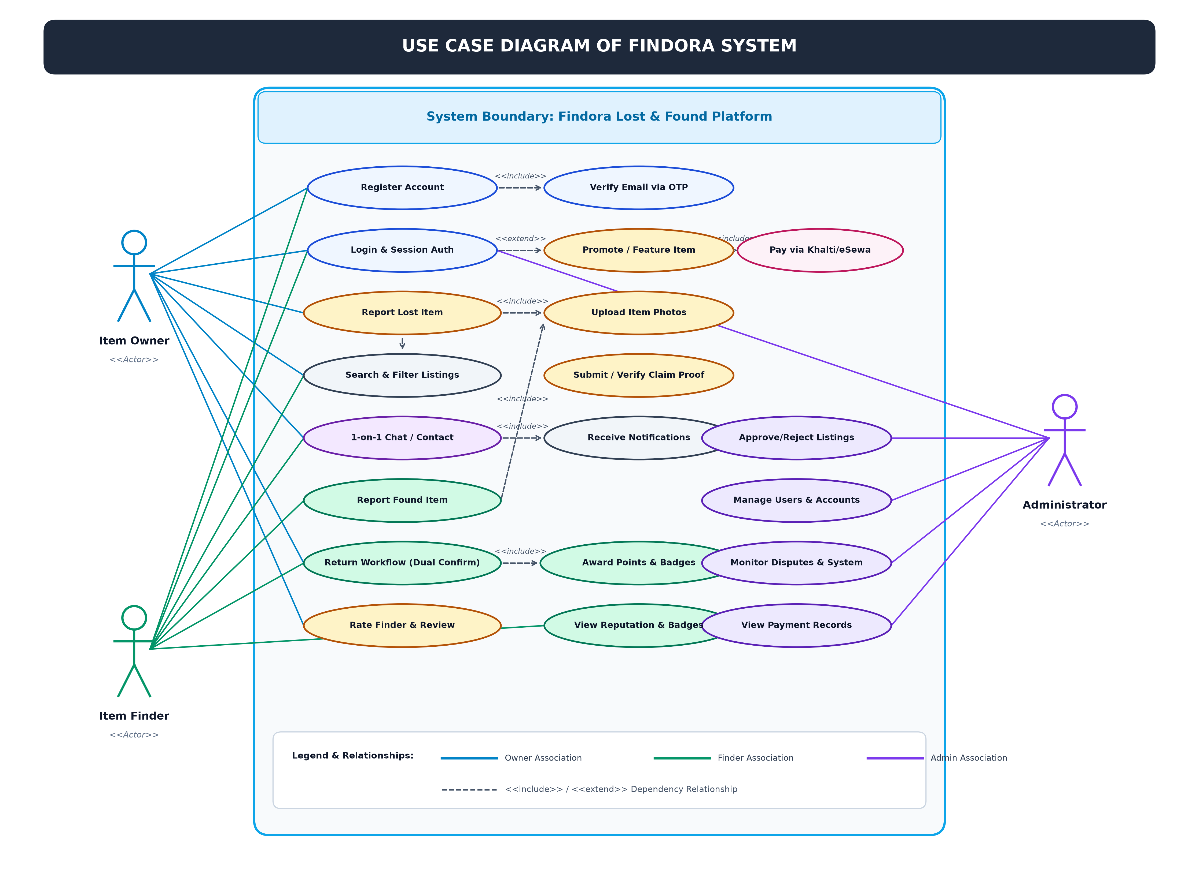
Figure 3.6.1 – Use Case Diagram of Findora System
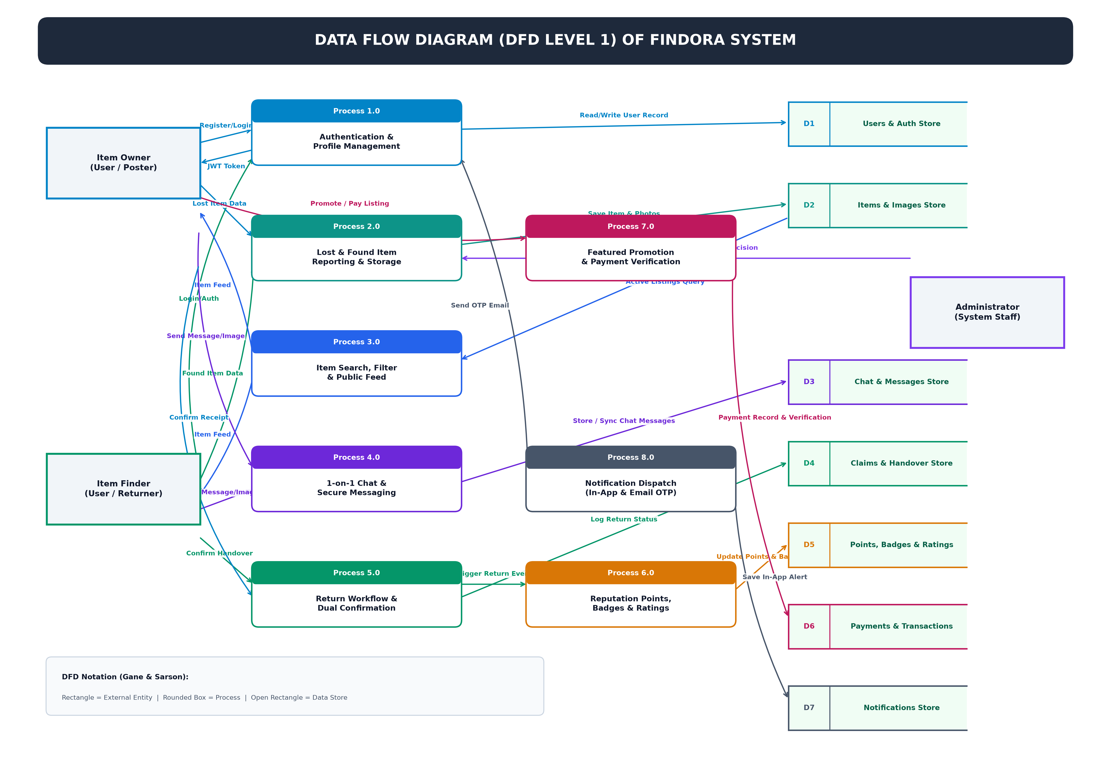
Figure 3.6.2 – Data Flow Diagram (DFD Level 1) of Findora System
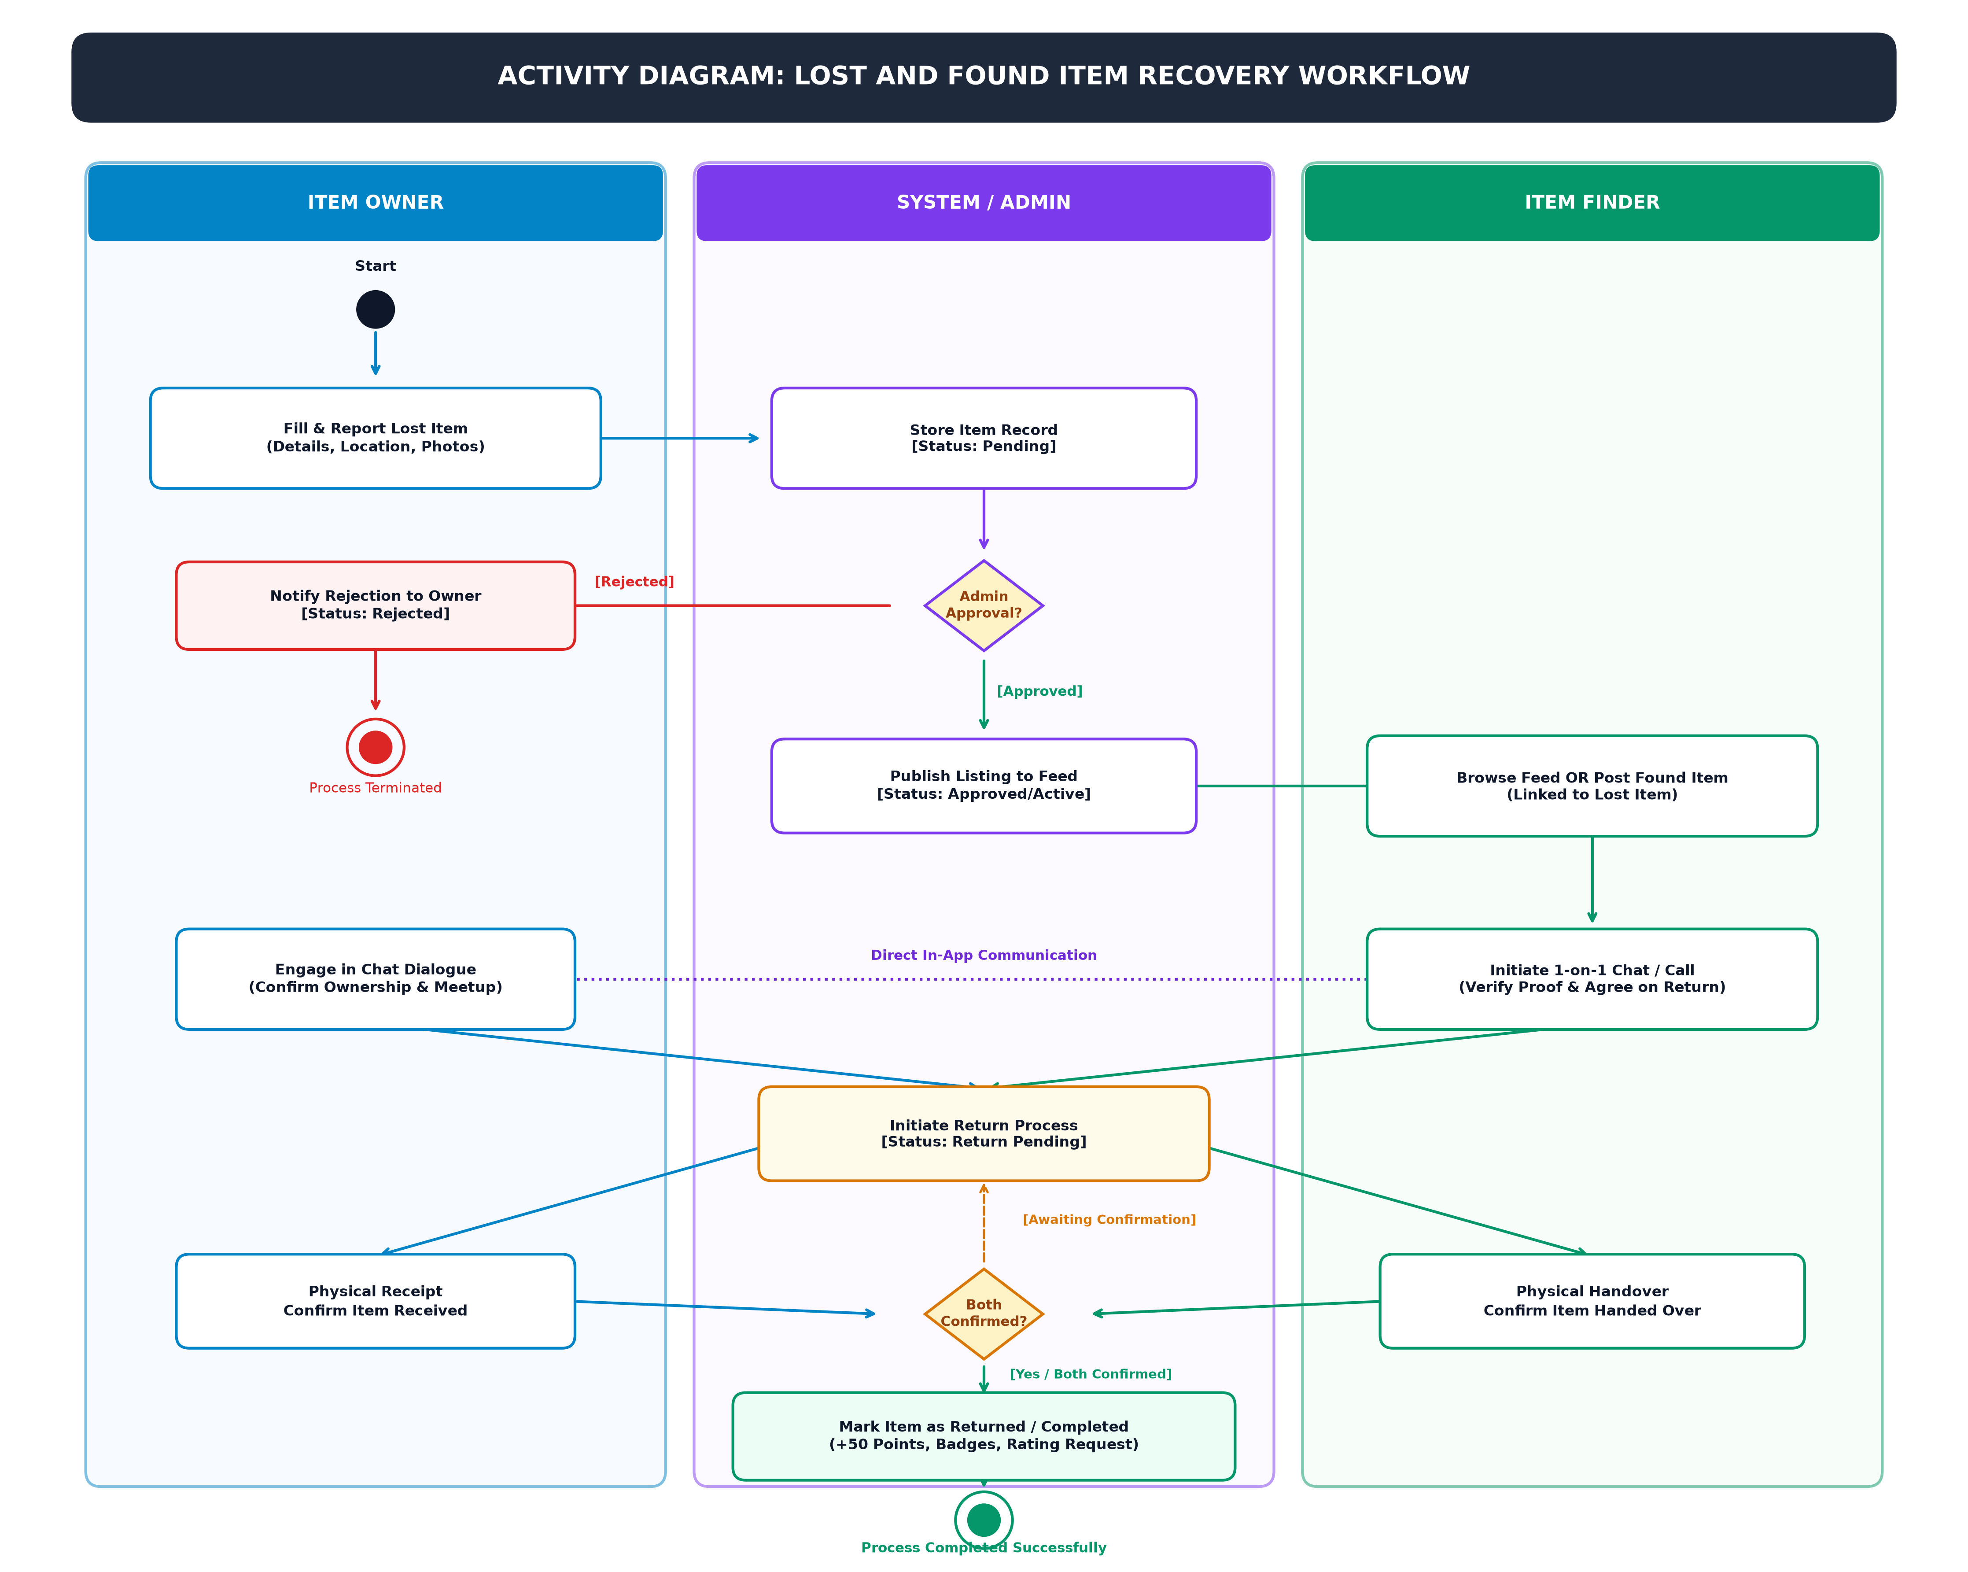
Figure 3.6.3 – Activity Diagram of Lost and Found Item Recovery Workflow

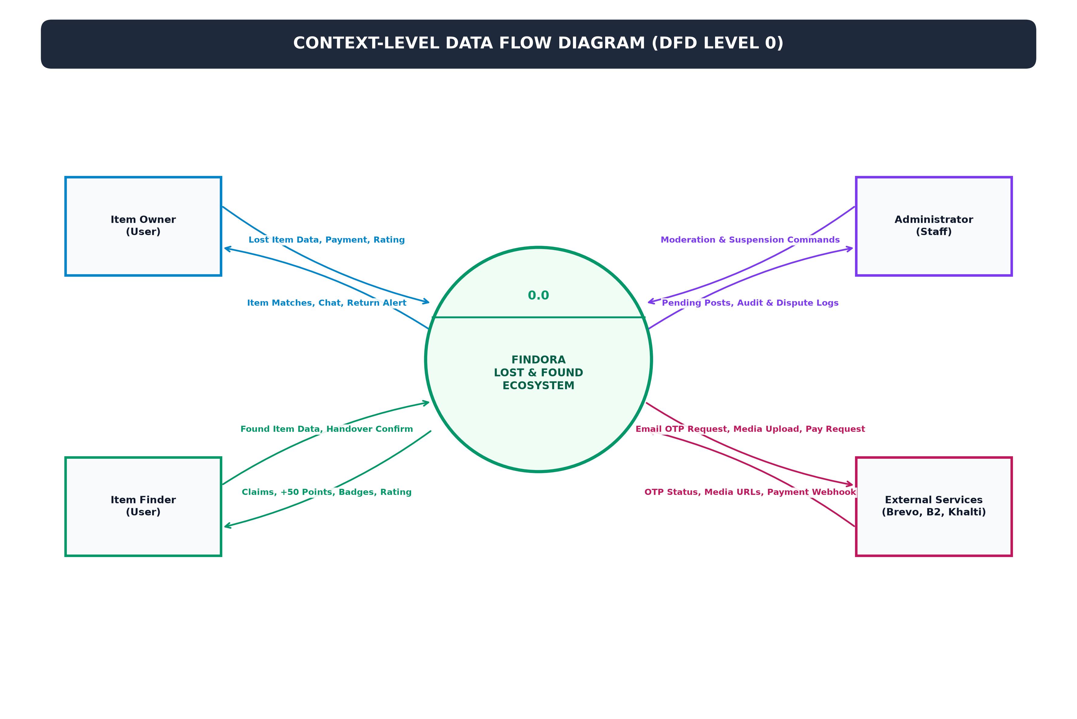
Figure 3.6.4 – Data Flow Diagram (Context Level 0) of Findora System
Figure 3.6.5 illustrates the complete procedural logic and decision pathways for the item owner, from post submission and listing promotion to meeting verification, dual confirmation, and reputation rating.
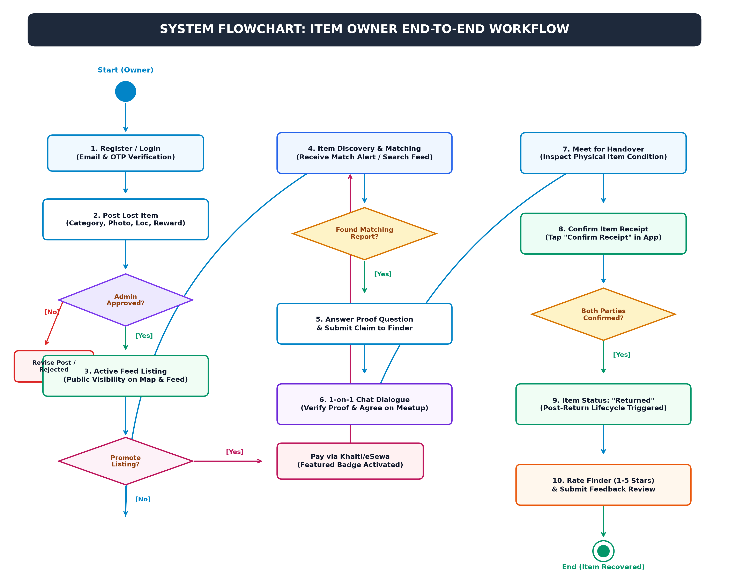
Figure 3.6.5 – System Flowchart for Item Owner Workflow
Figure 3.6.6 delineates the operational workflow for the item finder, highlighting the discovery of misplaced goods, report filing with secret proof questions, 1-on-1 chat interaction, physical handover confirmation, and karma point accumulation.
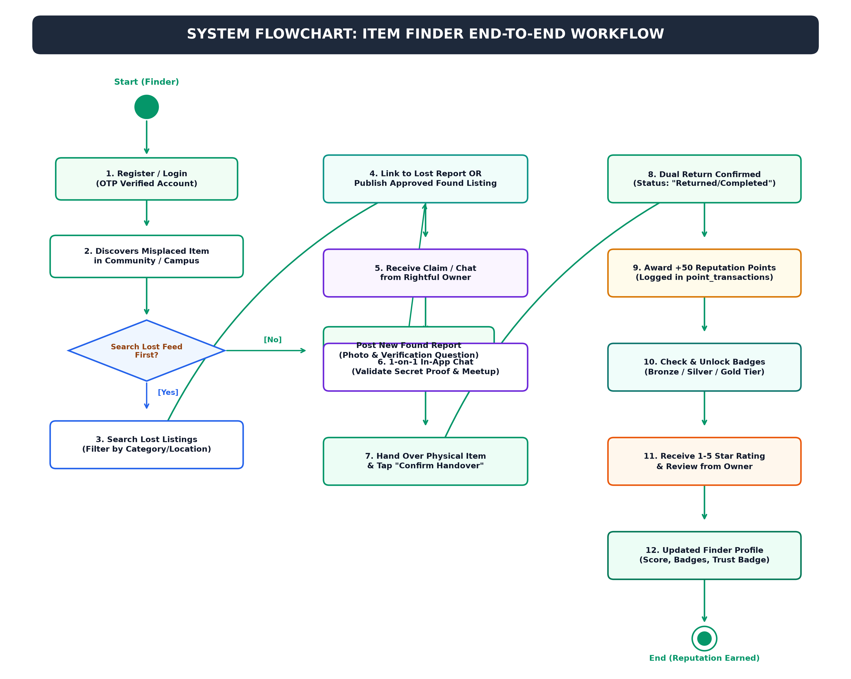
Figure 3.6.6 – System Flowchart for Item Finder Workflow
Figure 3.6.7 details administrative oversight and moderation procedures, including pending listing validation, user account security enforcement, claim dispute mediation, and financial audit tracking.
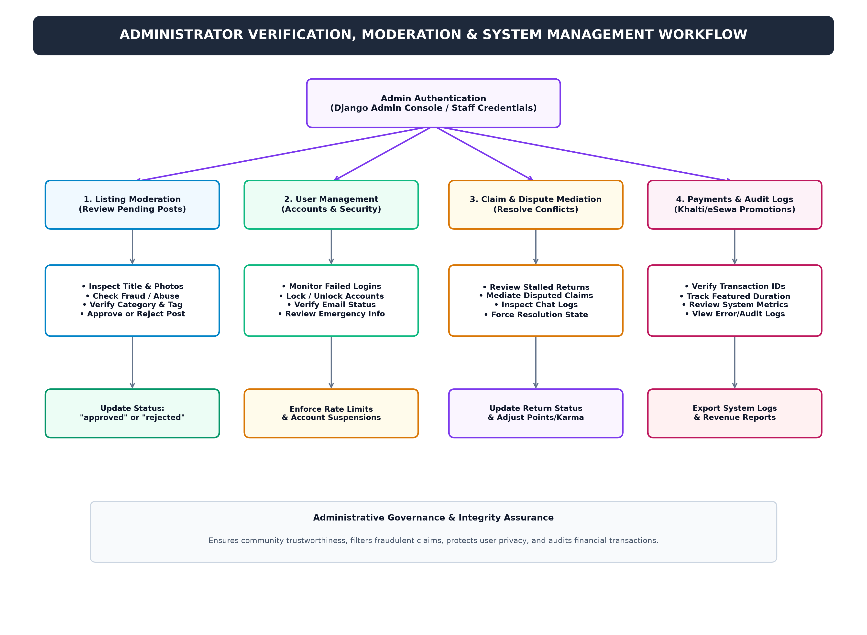
Figure 3.6.7 – Administrator Verification & Moderation Workflow Diagram
Figure 3.6.8 presents the in-app chat and secure messaging lifecycle, illustrating conversation initiation, real-time multimedia message exchange, read receipts, and notification synchronization between participants.
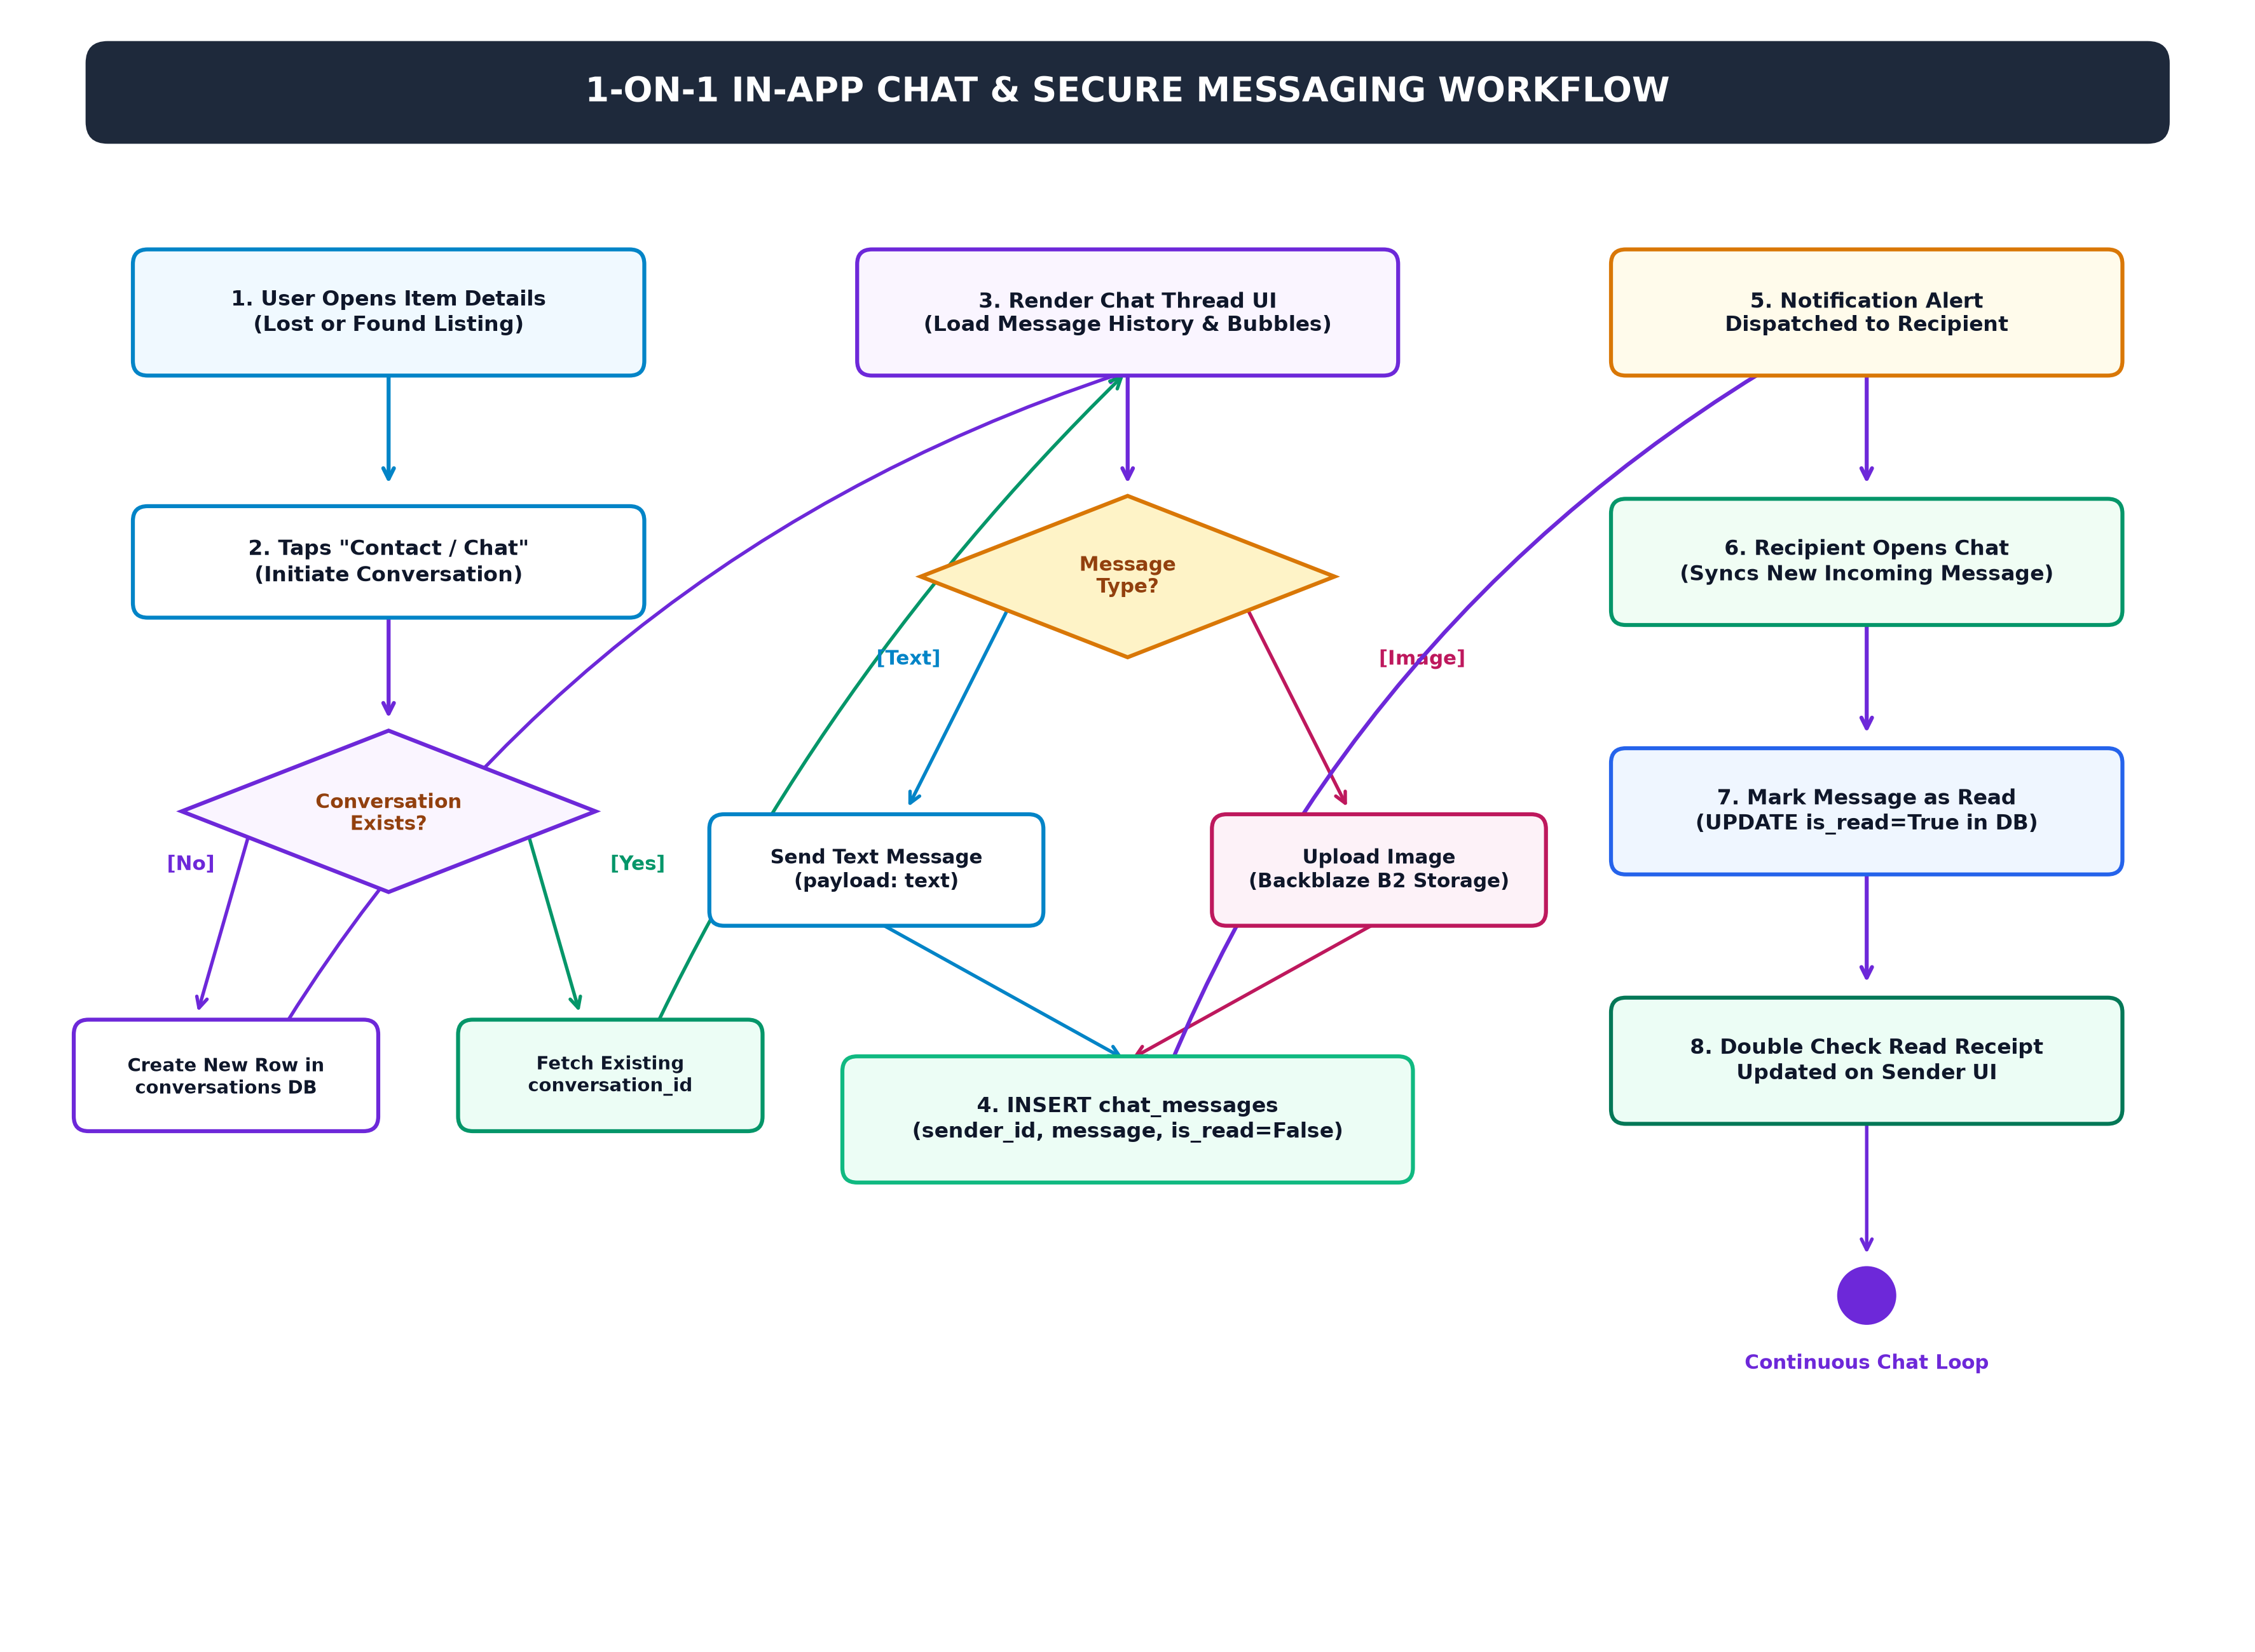
Figure 3.6.8 – 1-on-1 In-App Chat & Messaging Workflow Diagram
Figure 3.6.9 depicts the exact database parent-child relationship between lost items and linked found reports, illustrating how foreign key associations establish verified item recovery dialogues.
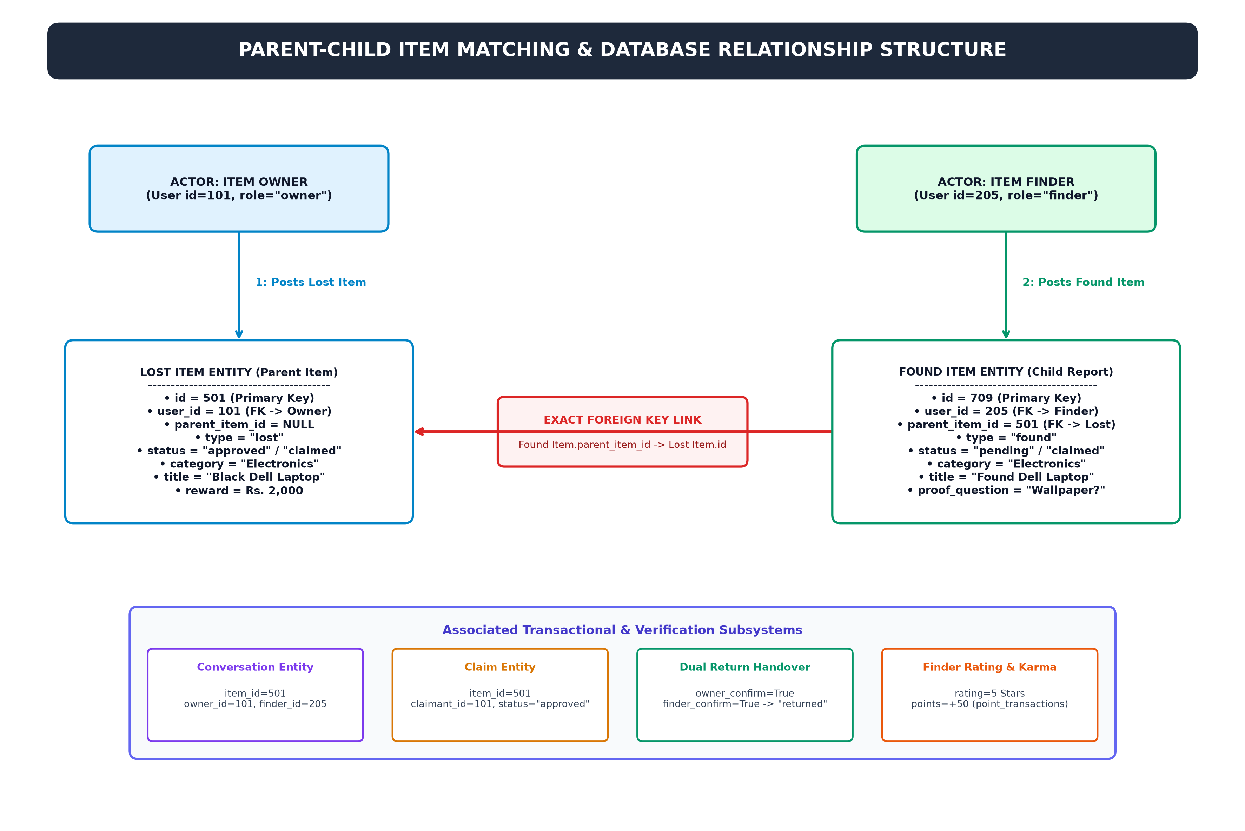
Figure 3.6.9 – Item Matching & Parent-Child Relationship Diagram

CHAPTER 4: SYSTEM DESIGN

4.1 Introduction
System design translates the functional and non-functional requirements into a cohesive architectural blueprint. This chapter articulates Findora’s tiered architecture, database schema, entity relationships, and user interface workflows.

4.2 System Design
Findora adopts a multi-tier Client-Server architecture. The presentation tier comprises a responsive web interface and a native Android client. The application logic tier consists of Django REST Framework views, serializers, authentication filters, and business logic modules. The persistence tier utilizes PostgreSQL for relational integrity.
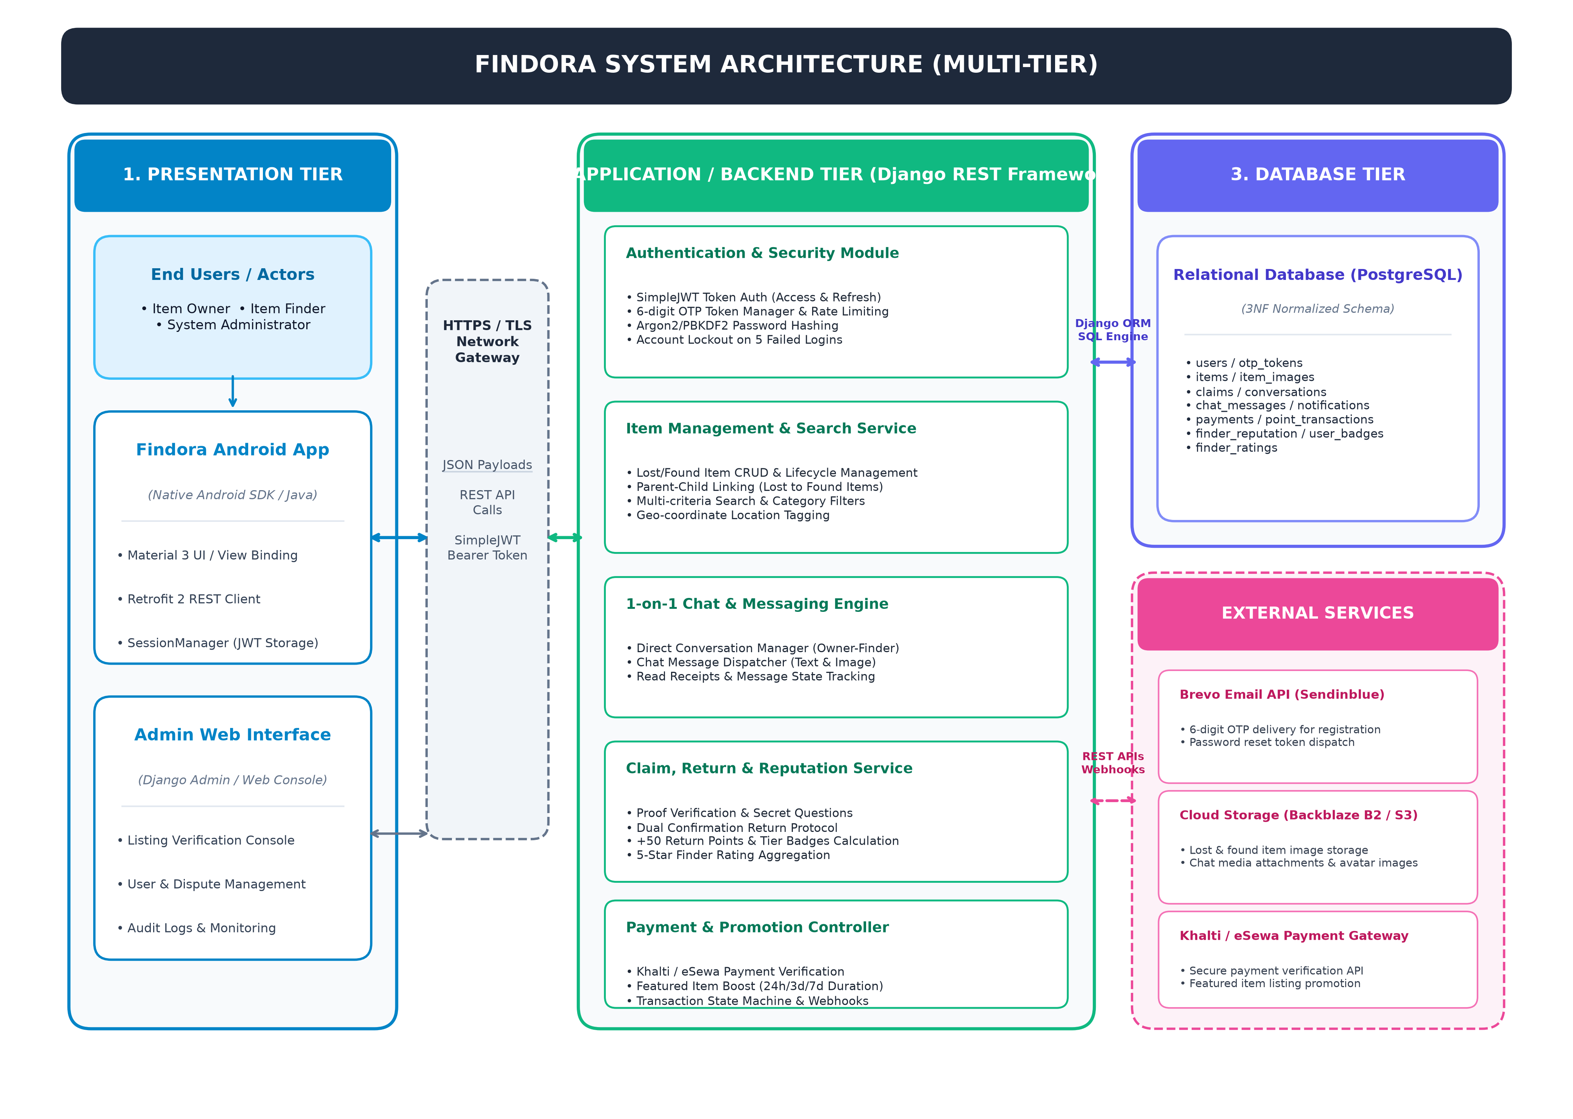
Figure 4.2.1 – System Architecture Diagram of Findora Platform
Figure 4.2.2 models the physical and cloud execution environments of Findora, mapping the Android client, Gunicorn application server, PostgreSQL database, and cloud storage/email APIs over secure HTTPS communication protocols.
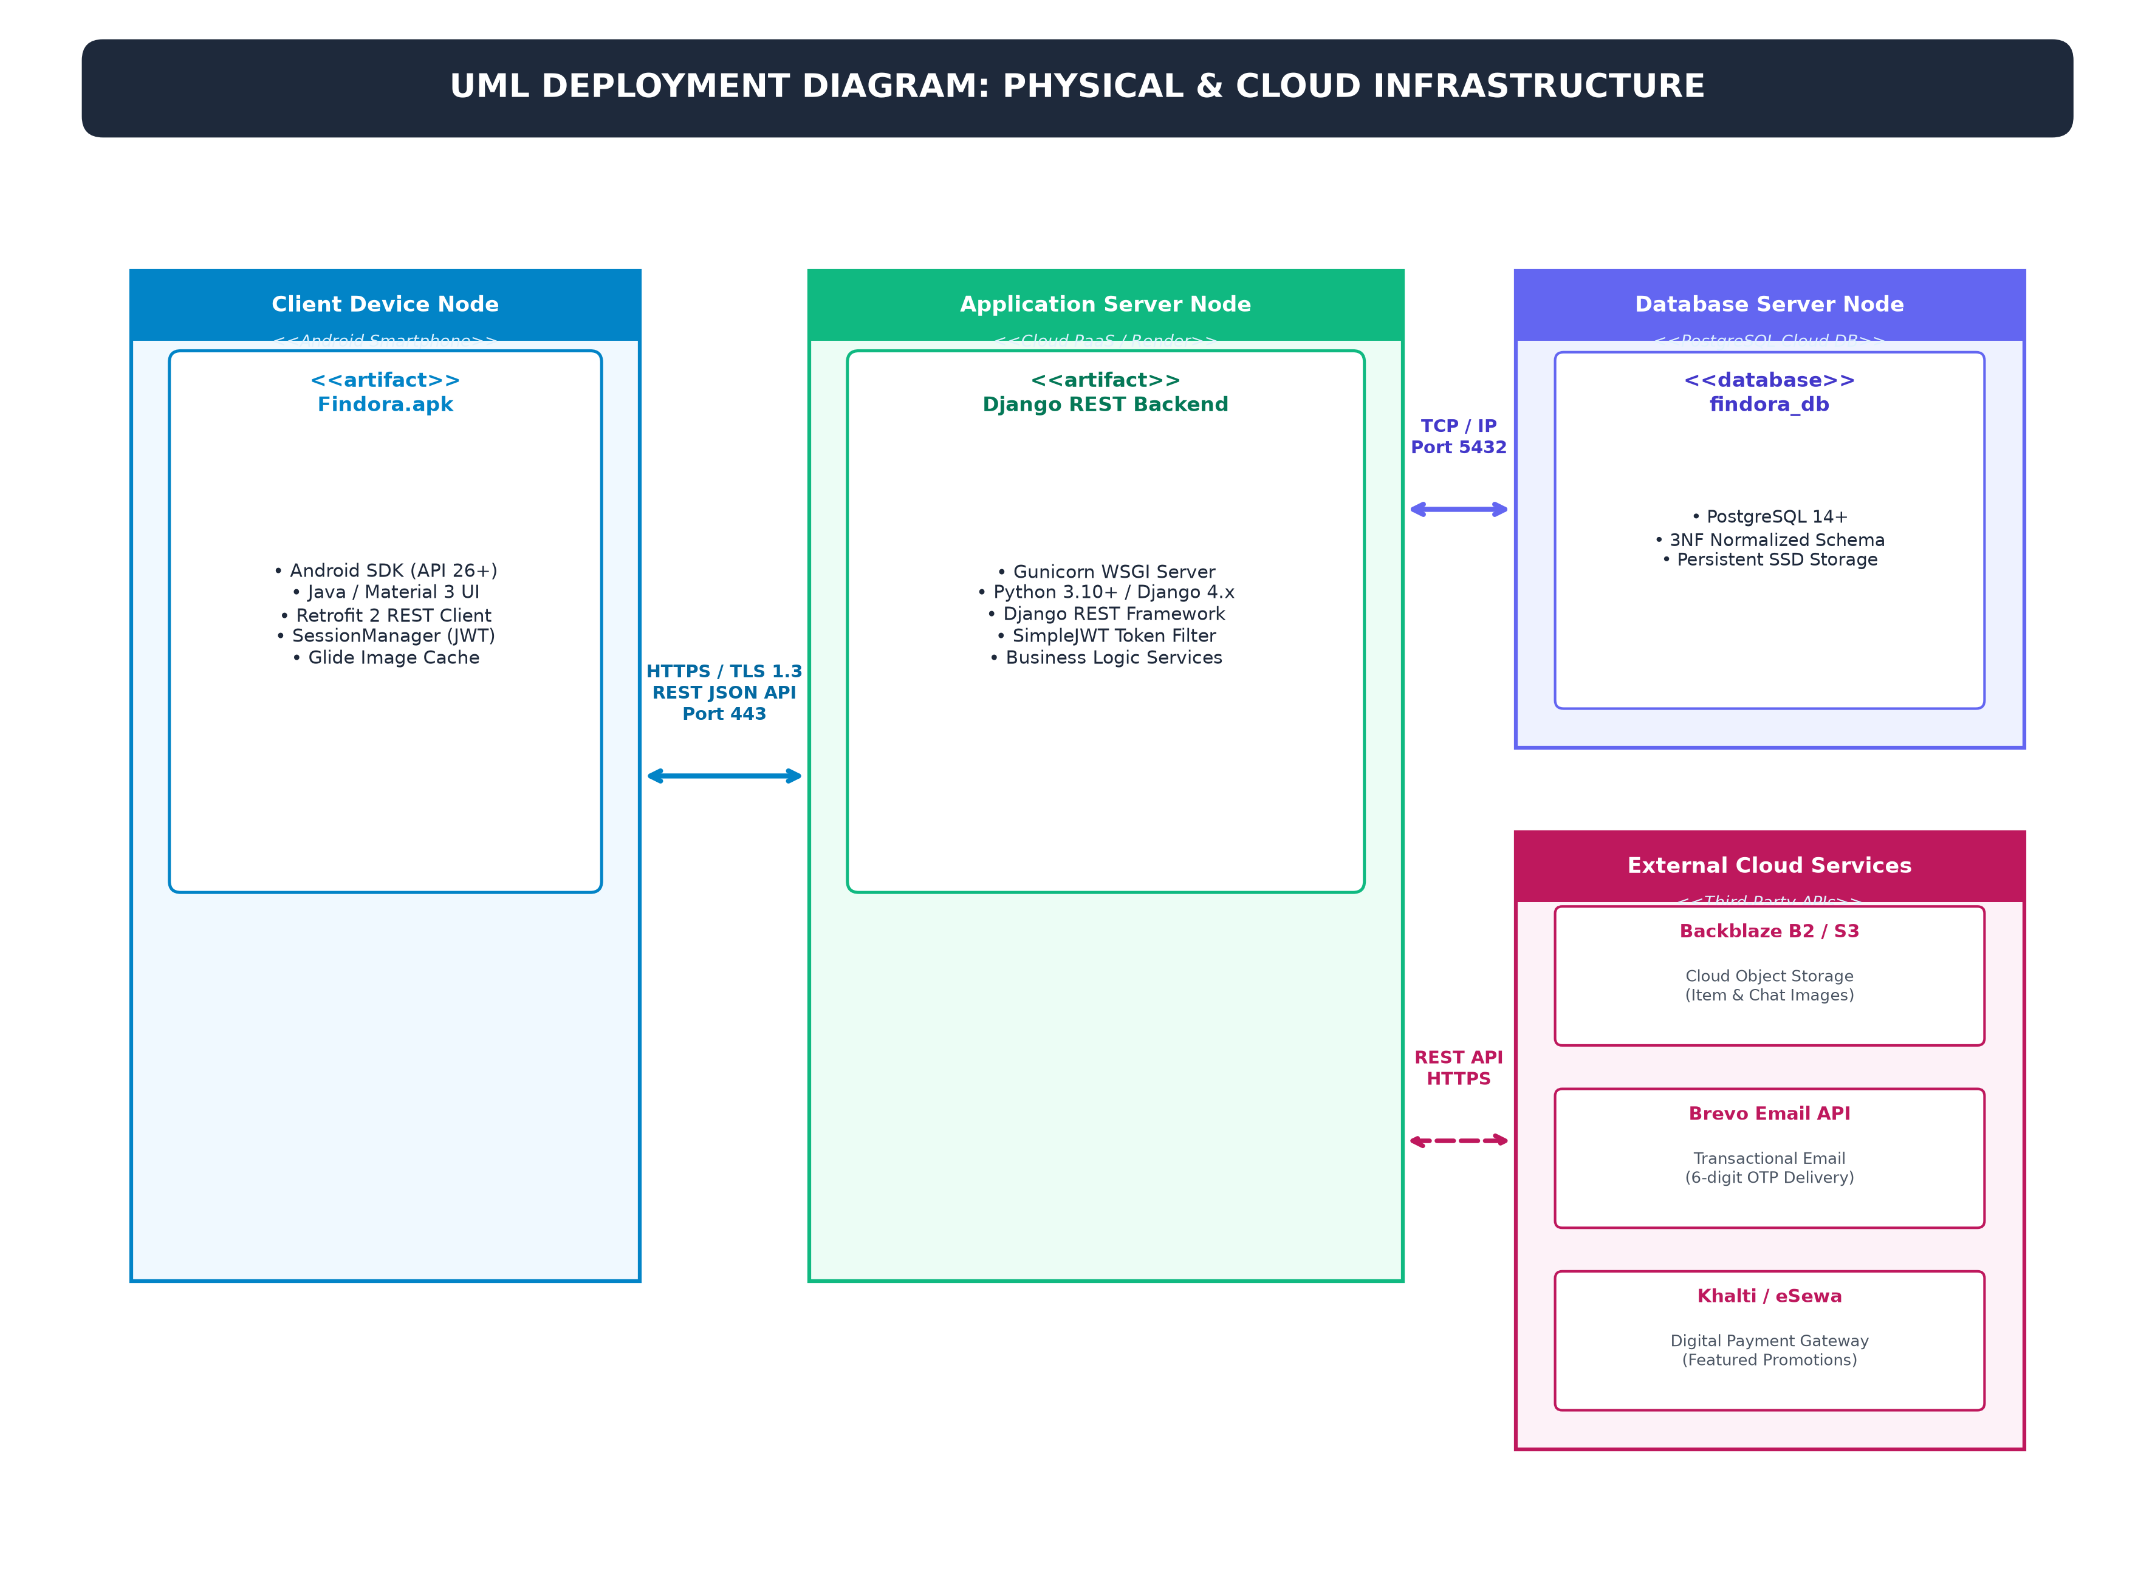
Figure 4.2.2 – Deployment Diagram of Findora Infrastructure
Figure 4.2.3 illustrates the modular software component architecture of Findora across presentation, business logic, persistence, and external service interface layers.
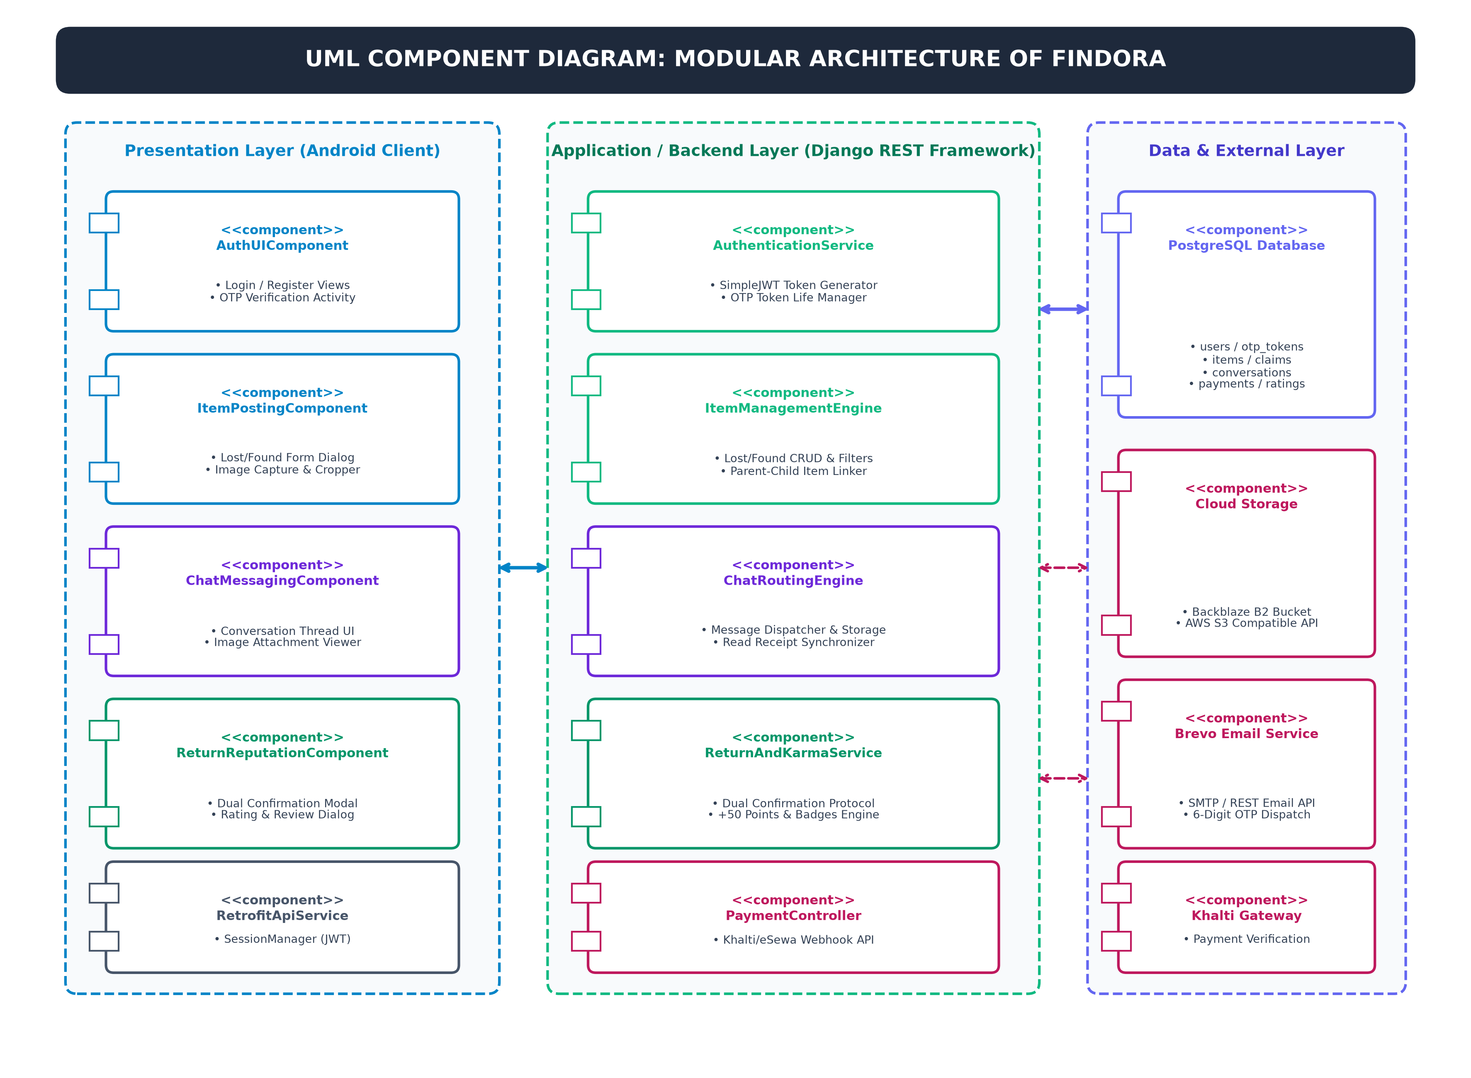
Figure 4.2.3 – UML Component Diagram of Findora System

4.3 Database design
The relational database schema is normalized to 3NF (Third Normal Form) to prevent redundancy and maintain referential integrity. Figure 4.3.1 illustrates the complete Entity-Relationship Diagram (ERD) defining all core entities and relationships, while Table 4.3.1 and Table 4.3.2 outline the primary database table structures.
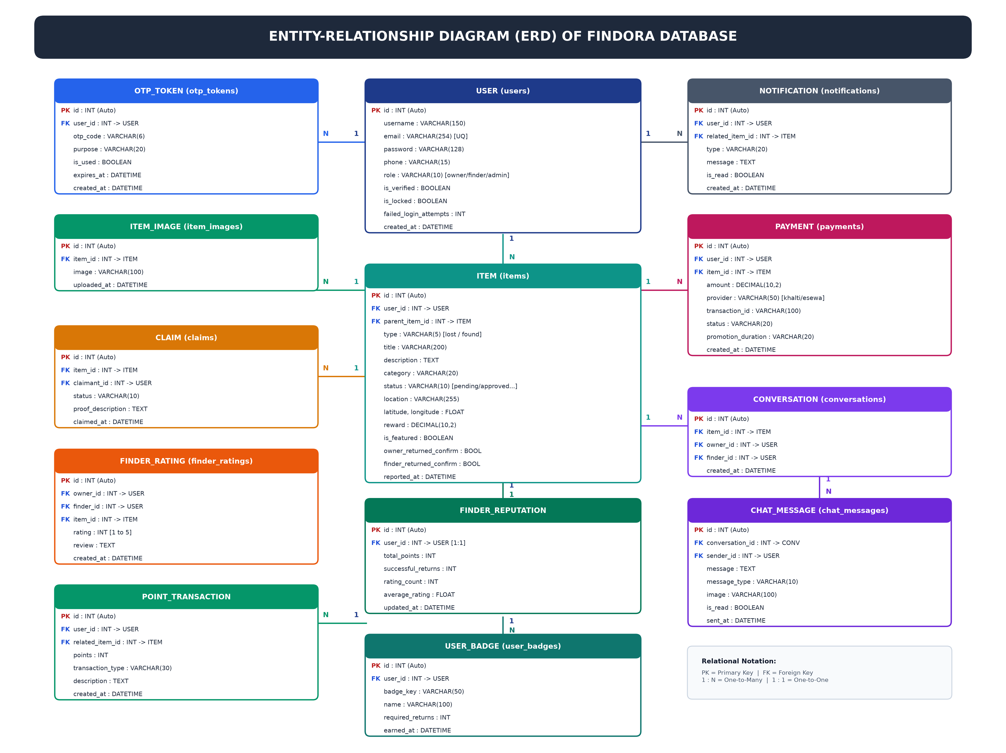
Figure 4.3.1 – Entity-Relationship Diagram (ERD) of Findora Database
Figure 4.3.2 models the state machine lifecycle of reported items from initial pending submission through admin approval, claim filing, dual-confirmation return pending, and final completion.
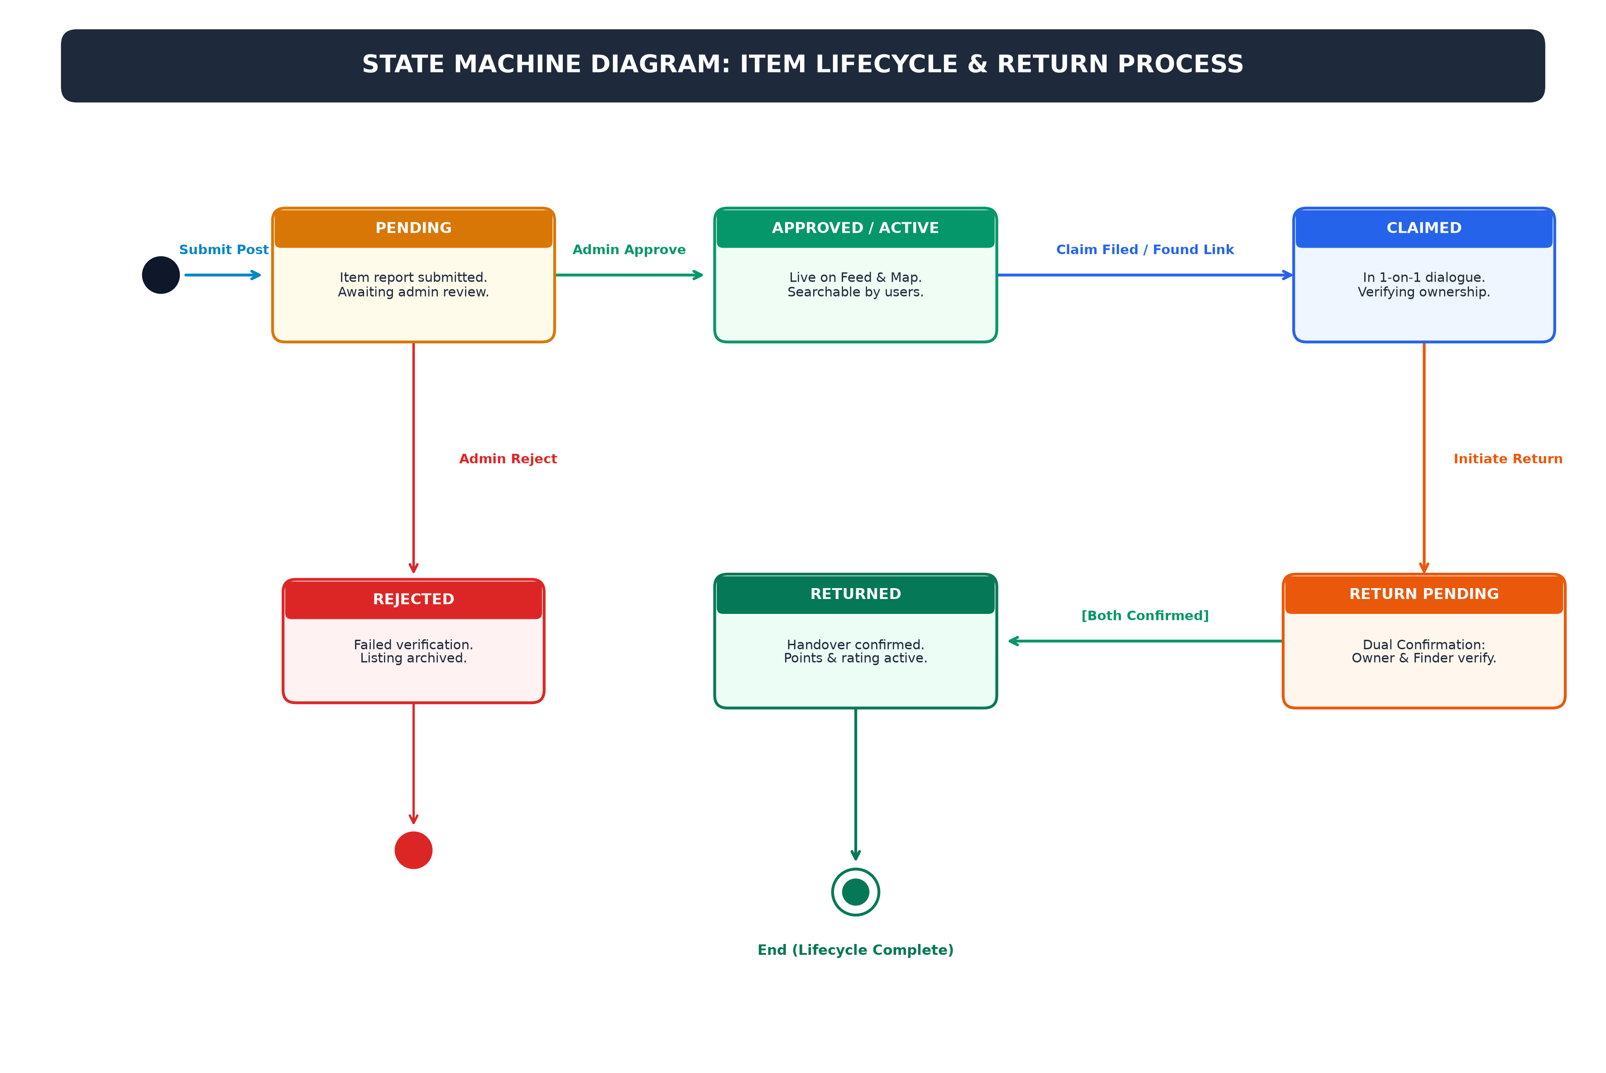
Figure 4.3.2 – State Machine Diagram for Item Lifecycle & Return Process
Table 4.3.1 – Database Schema: Custom User Account Entity
Field Name | Data Type | Constraints | Description
id | BigAutoField | Primary Key | Unique identifier for user account
email | EmailField(255) | Unique, Not Null | User email address for login
username | CharField(150) | Unique, Not Null | Public screen handle
phone_number | CharField(20) | Nullable | Verified contact number
reputation_points | IntegerField | Default = 0 | Accumulated community karma score
is_verified | BooleanField | Default = False | Email/ID verification flag
date_joined | DateTimeField | Auto-now-add | Account creation timestamp
Table 4.3.2 – Database Schema: Lost and Found Item Entity
Field Name | Data Type | Constraints | Description
id | BigAutoField | Primary Key | Unique identifier for item listing
user_id | ForeignKey(User) | On Delete CASCADE | Author who posted the listing
item_type | CharField(10) | LOST / FOUND | Listing classification
category | CharField(50) | Indexed | Item taxonomy (Electronics, Wallet, etc.)
title | CharField(200) | Not Null | Brief descriptive title
description | TextField | Not Null | Detailed item features and marks
location | CharField(255) | Not Null | Location where lost or discovered
item_image | ImageField | Nullable | Uploaded photograph of the item
verification_question | CharField(255) | Nullable | Secret question to verify ownership
status | CharField(20) | OPEN/CLAIMED/CLOSED | Current lifecycle state
created_at | DateTimeField | Auto-now-add | Listing submission timestamp

4.4 User Interface Design
The interface adheres to modern, accessible UI/UX standards, featuring high-contrast color palettes, clear typographic hierarchy, and fluid responsive grid layouts for both desktop web browsers and native mobile displays.
Behavioral sequence diagrams illustrate the chronologically ordered message exchanges and object interactions across the presentation tier, REST controllers, database transactions, and third-party integrations.
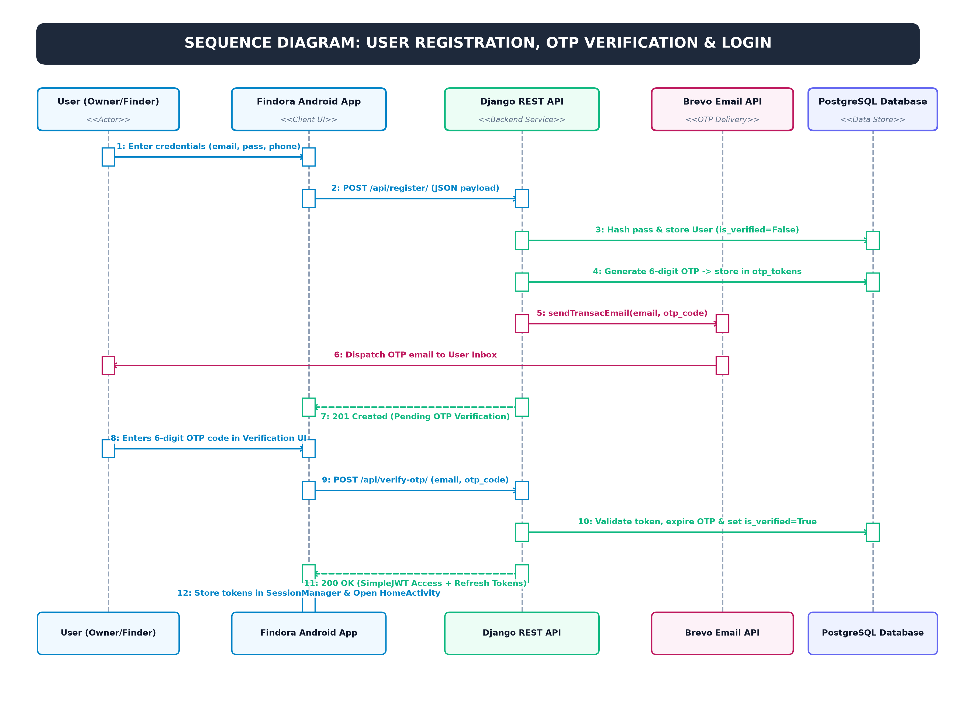
Figure 4.4.1 – Sequence Diagram: User Authentication & OTP Verification
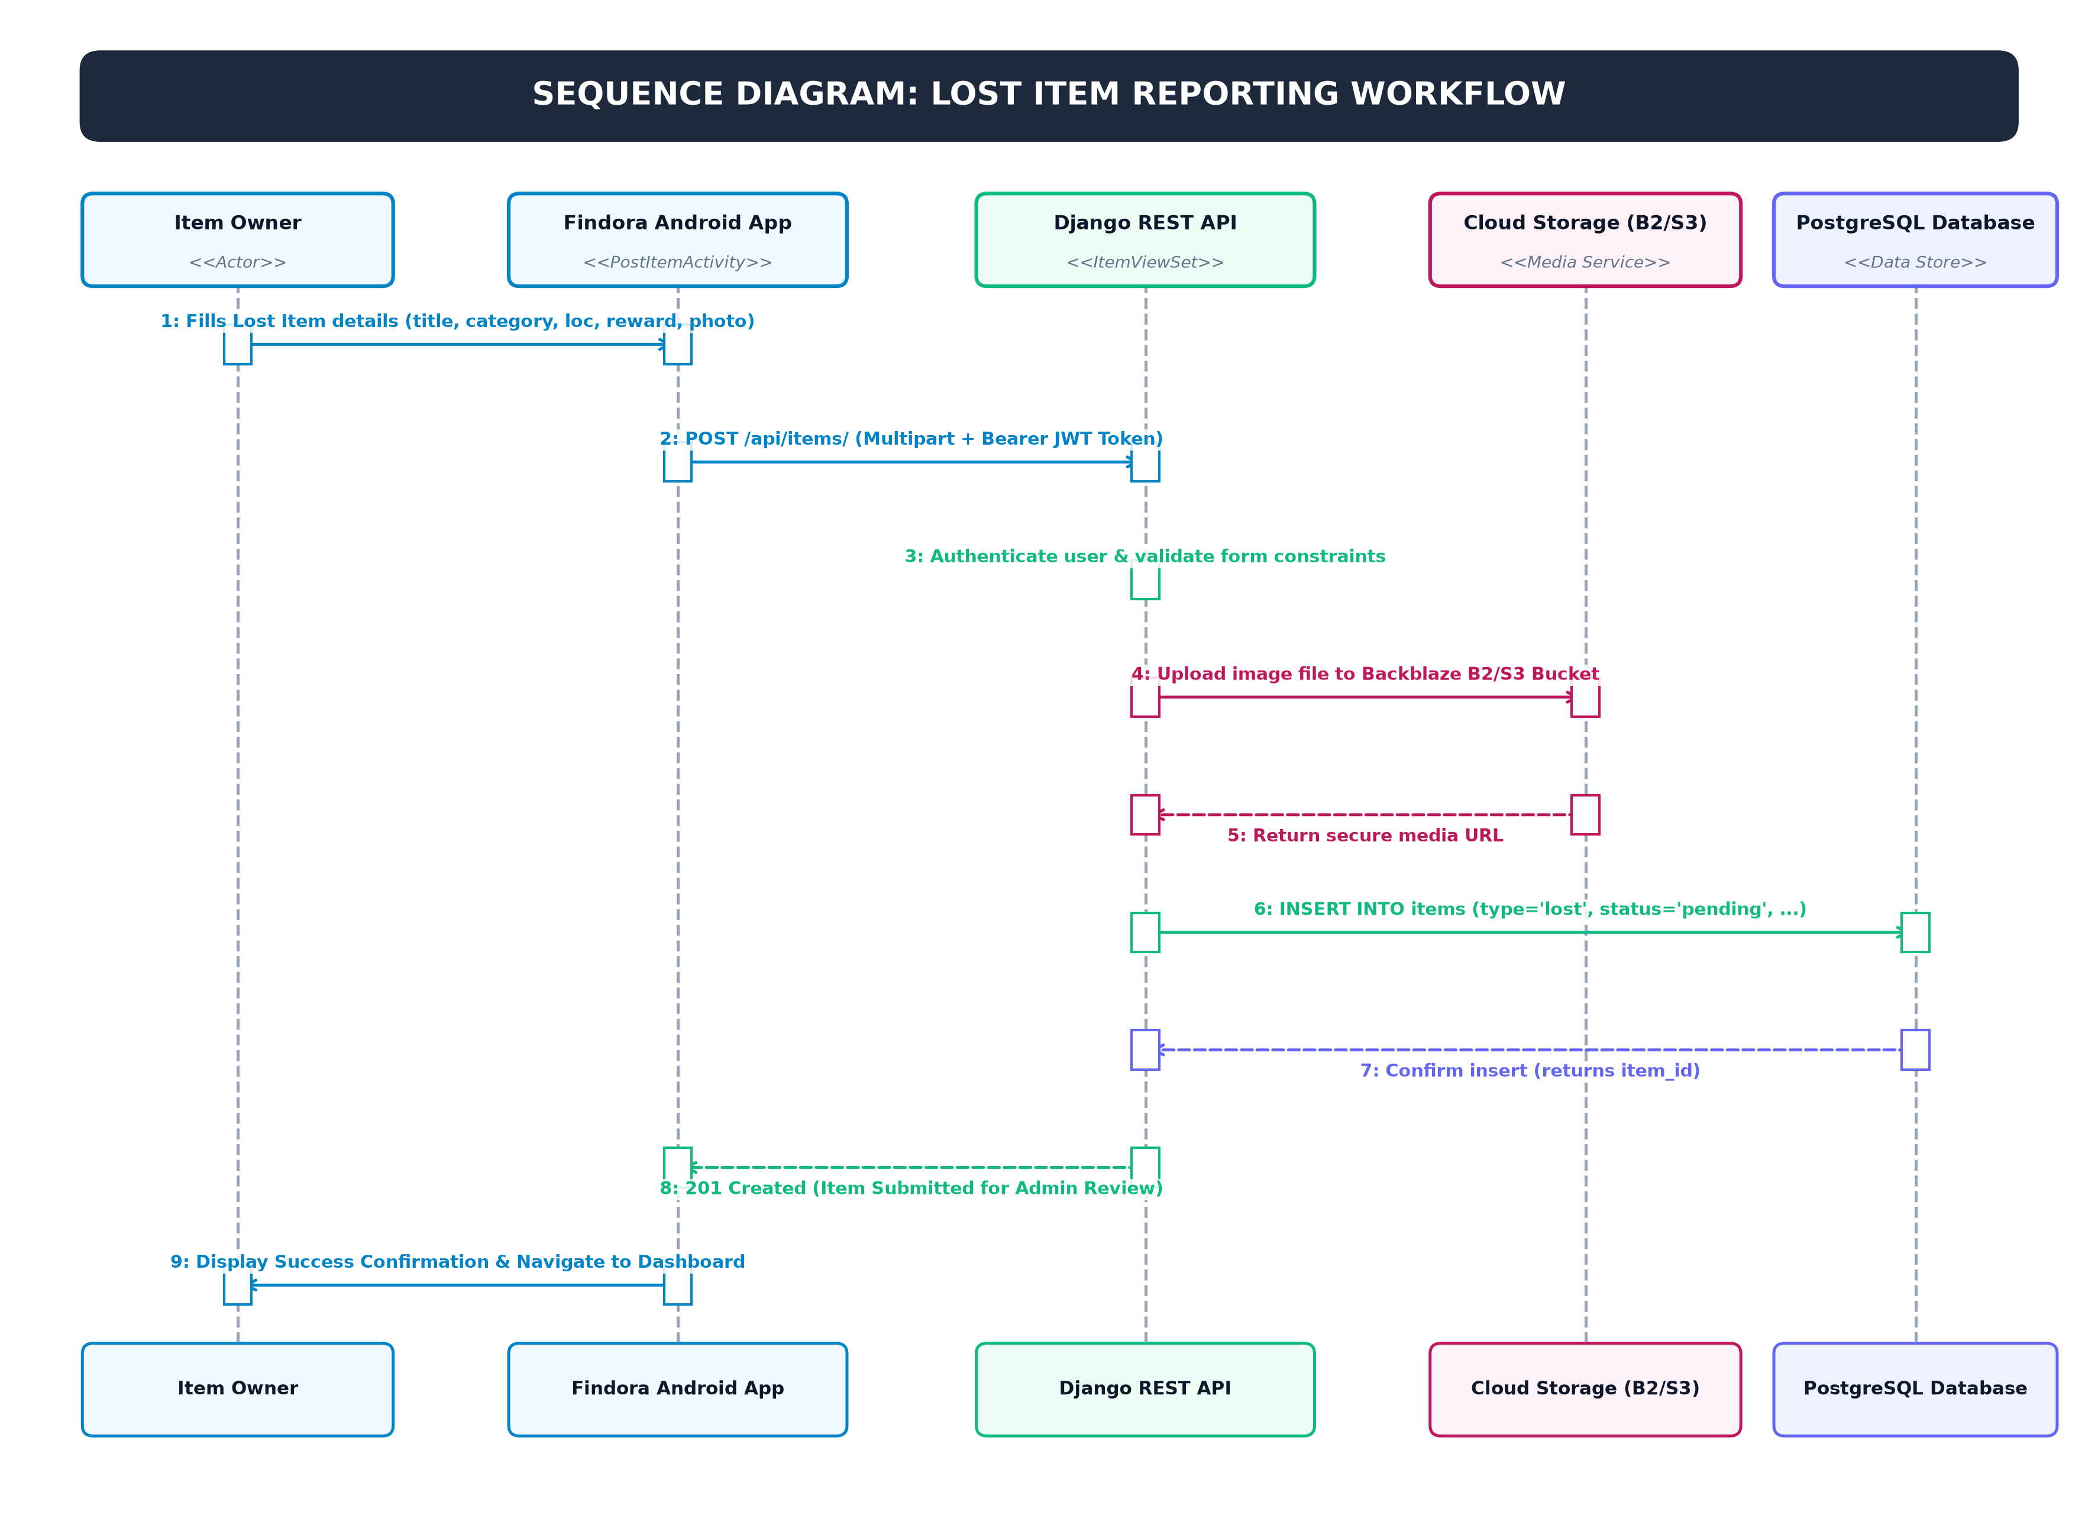
Figure 4.4.2 – Sequence Diagram: Lost Item Reporting Workflow
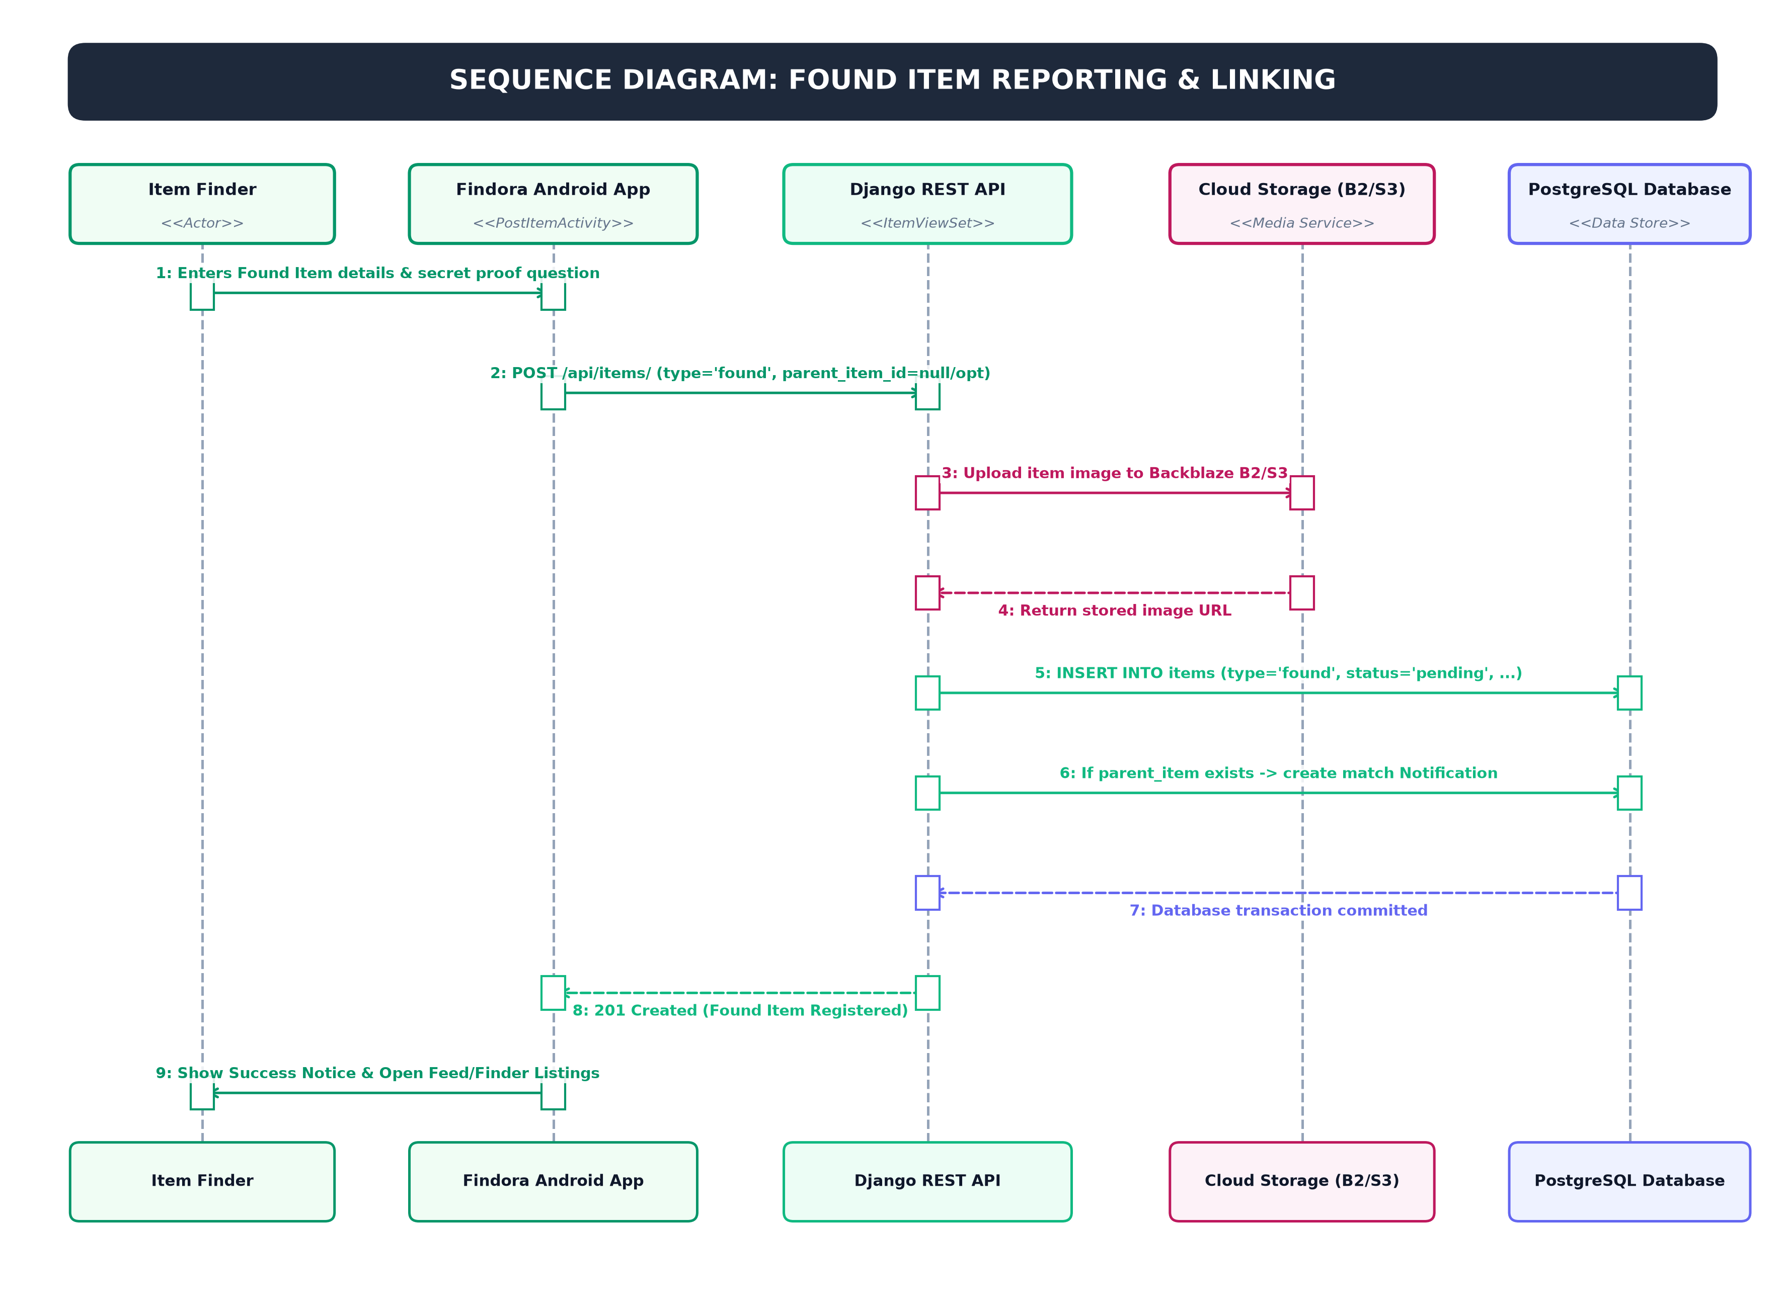
Figure 4.4.3 – Sequence Diagram: Found Item Reporting & Linking
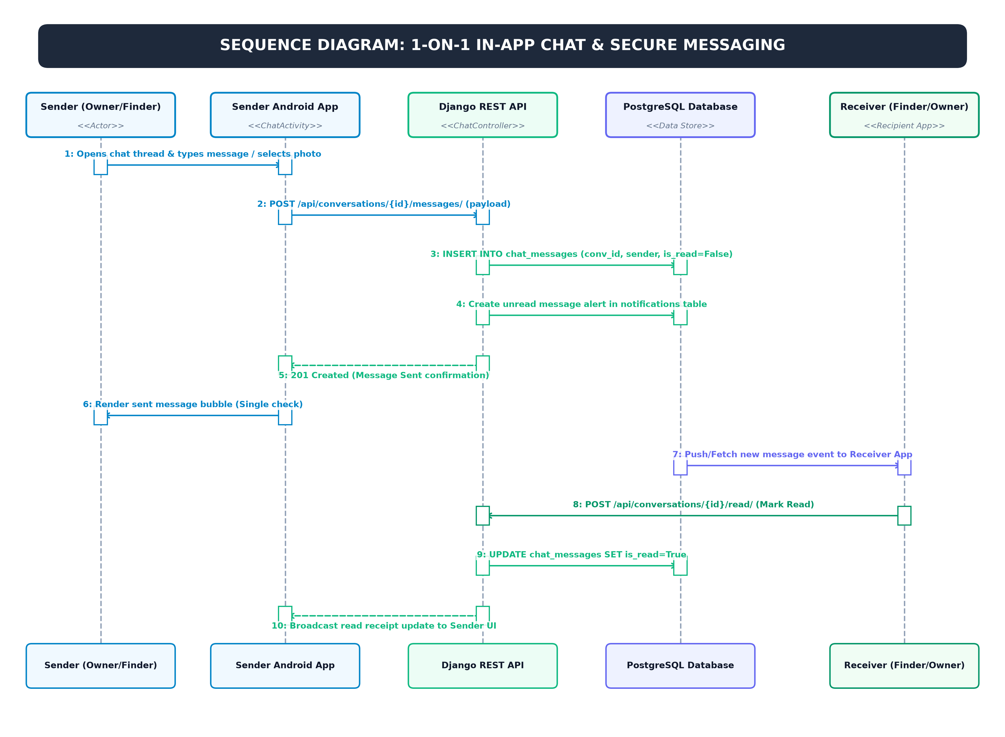
Figure 4.4.4 – Sequence Diagram: 1-on-1 In-App Chat & Secure Messaging
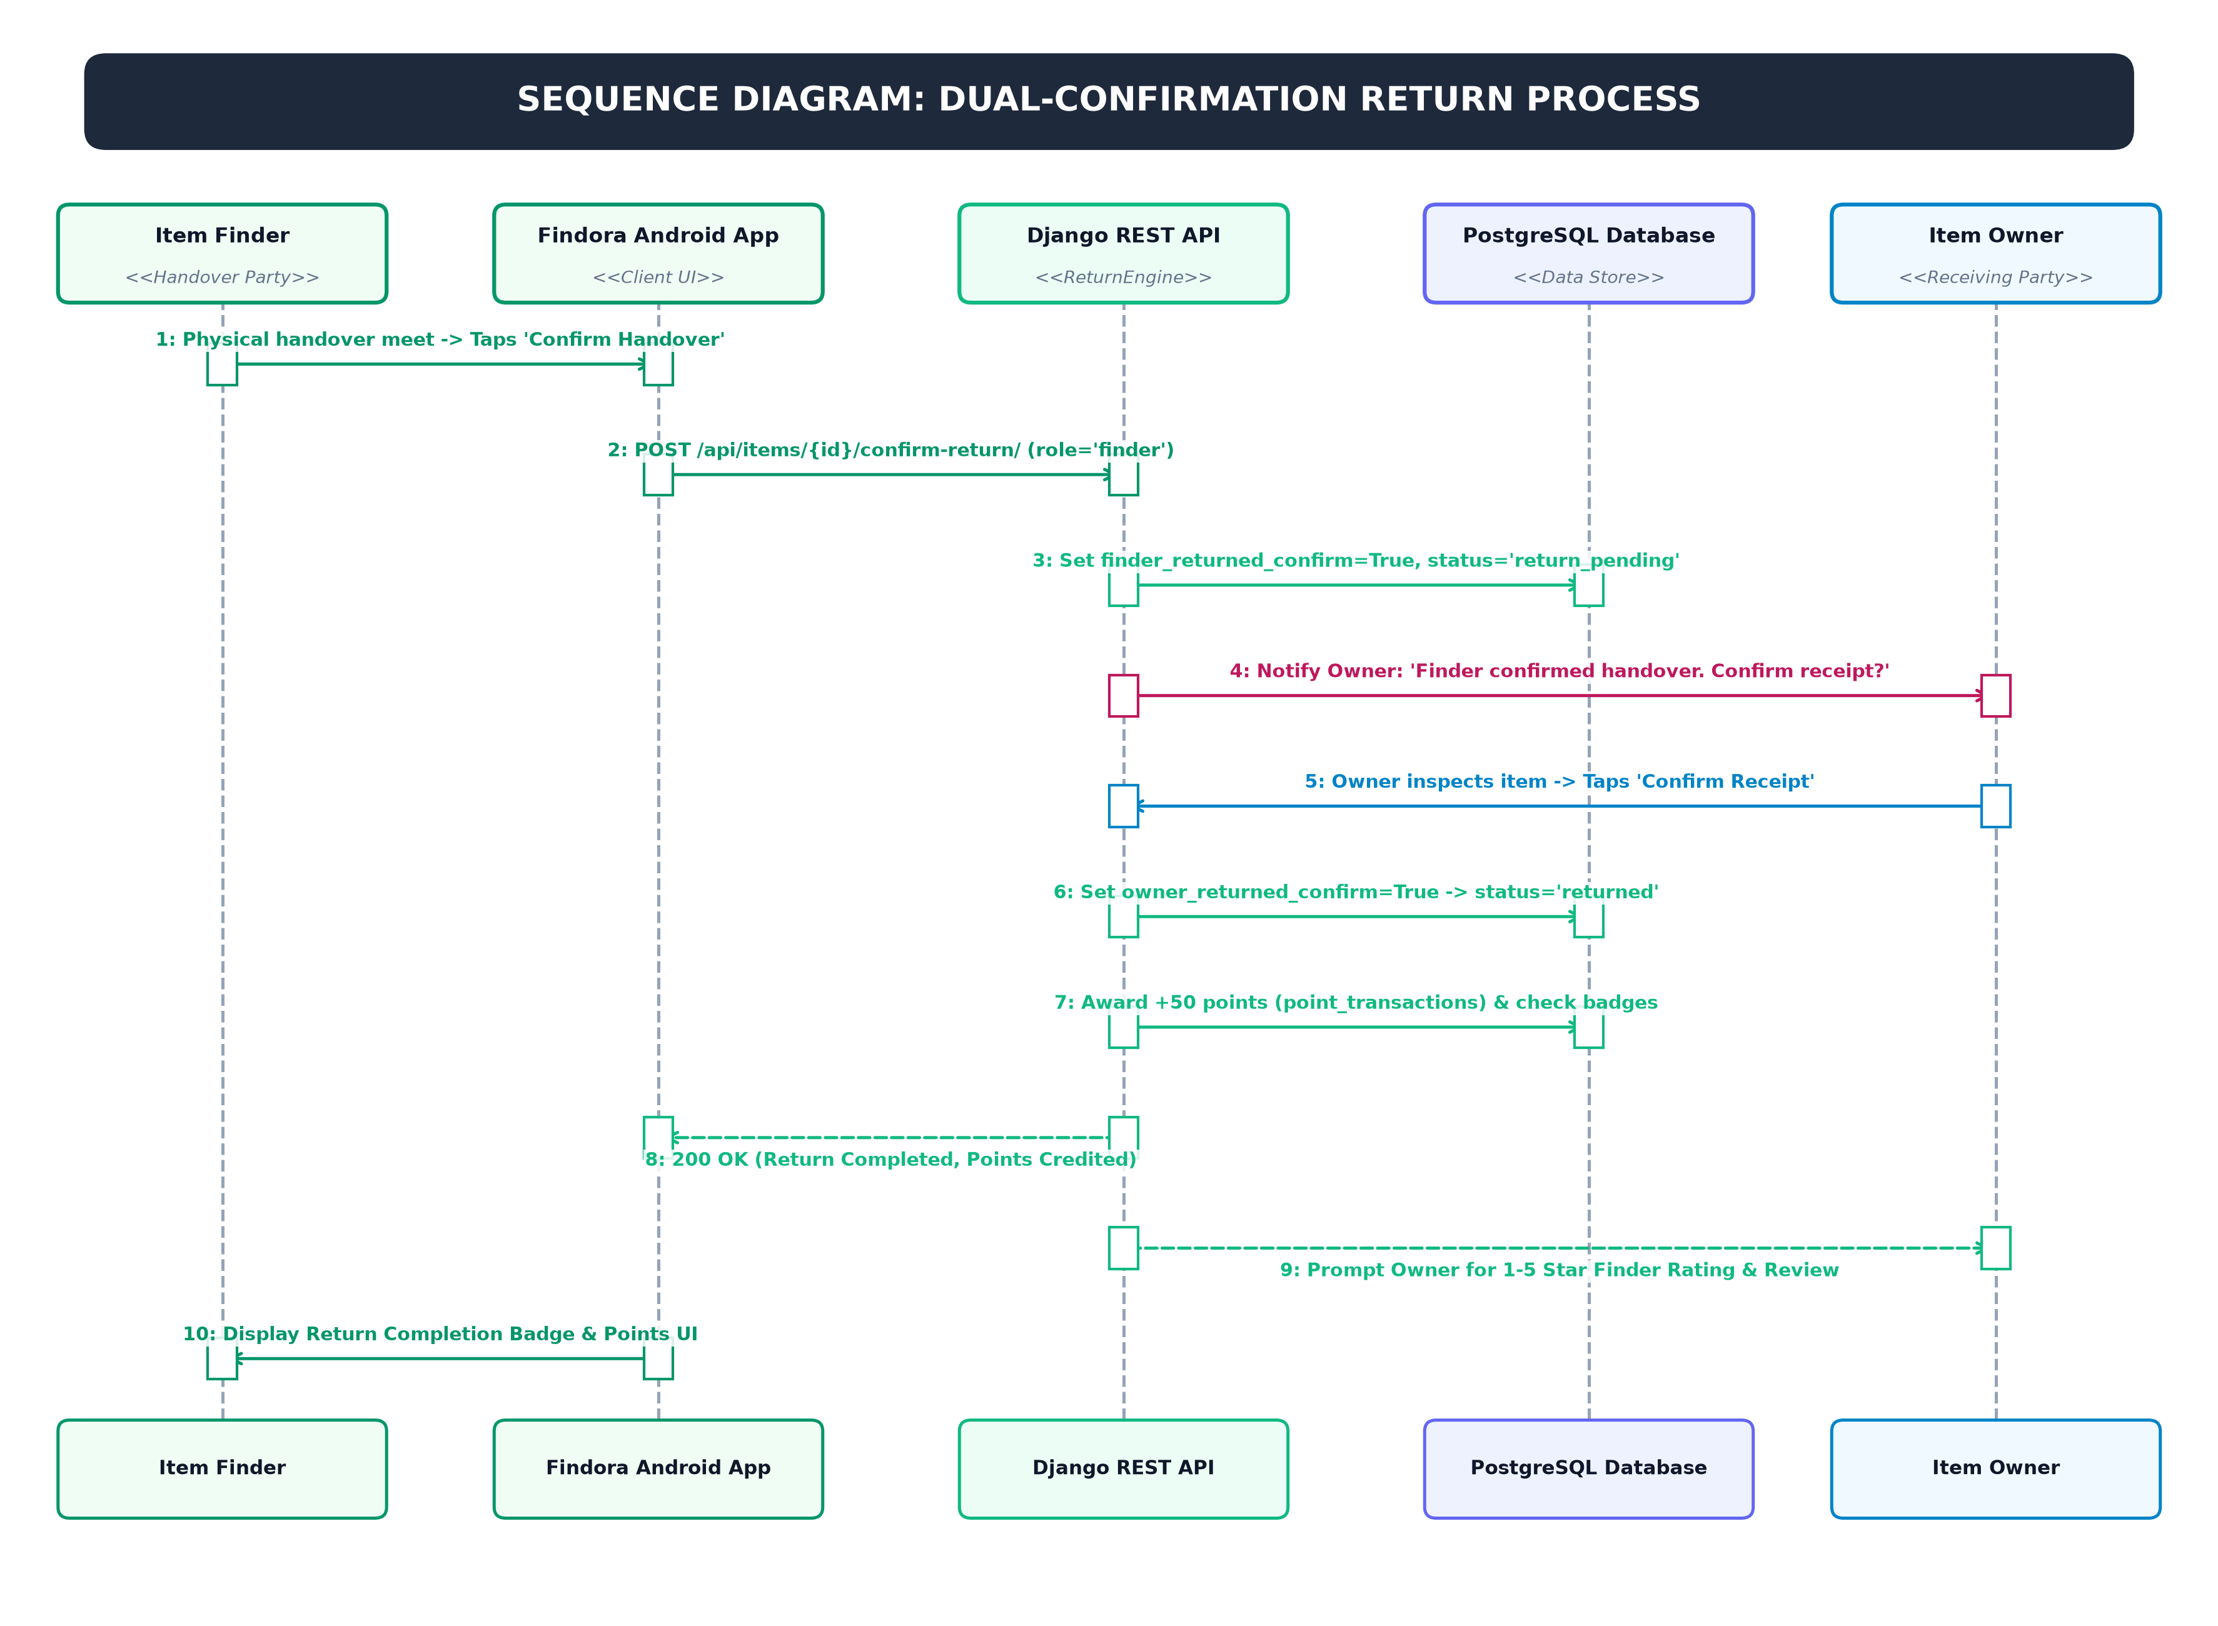
Figure 4.4.5 – Sequence Diagram: Dual-Confirmation Return Process
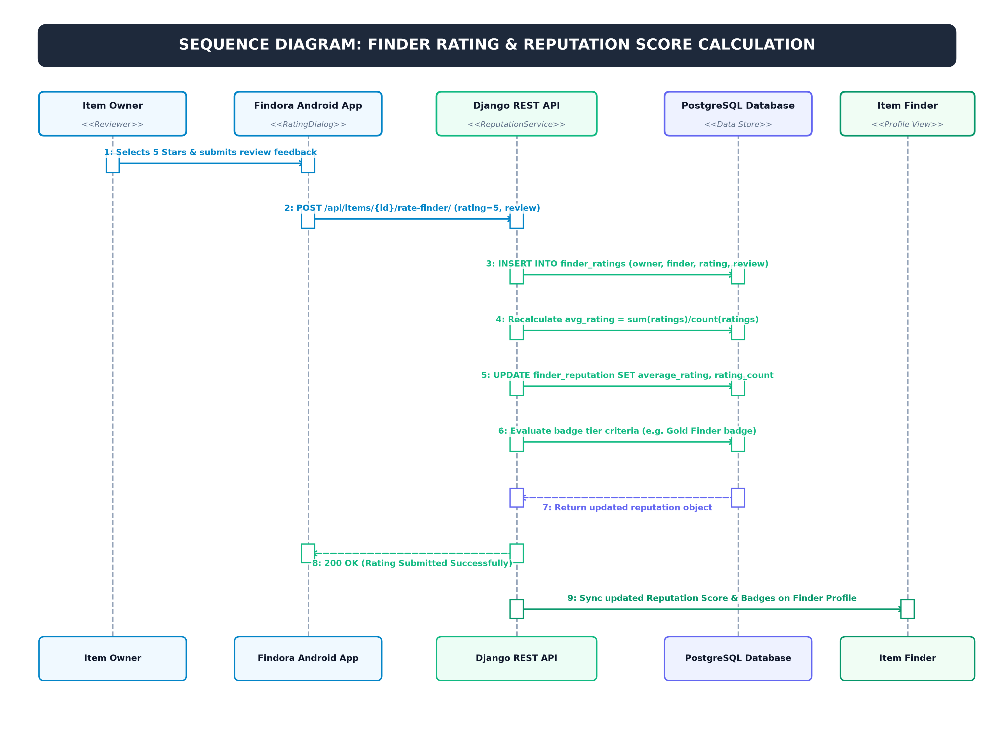
Figure 4.4.6 – Sequence Diagram: Finder Rating & Reputation Score Calculation
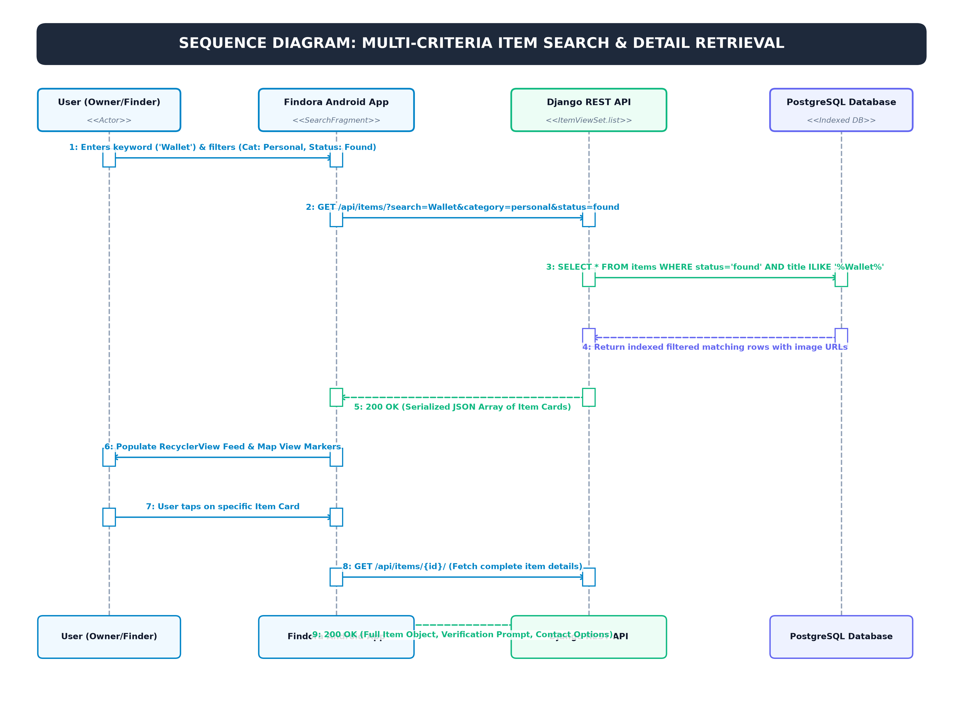
Figure 4.4.7 – Sequence Diagram: Multi-Criteria Item Search & Detail Retrieval
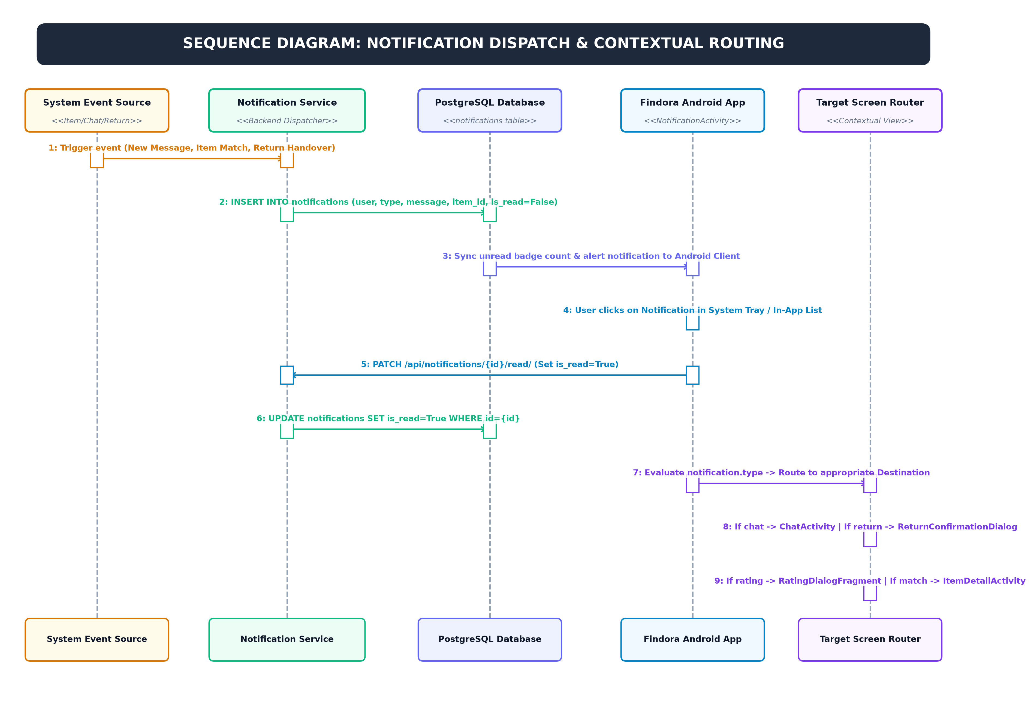
Figure 4.4.8 – Sequence Diagram: Notification Dispatch & Contextual Routing

4.5 Summary
Chapter 4 detailed the end-to-end structural foundation of Findora. The multi-tiered architecture and normalized relational schema ensure scalability, security, and consistent transactional throughput across all client interactions.

CHAPTER 5: IMPLEMENTATION AND TESTING

5.1 Implementation Approaches
Findora’s backend was implemented using Python and Django REST Framework, leveraging Django’s Model-View-Template (MVT) architecture decoupled into REST API endpoints. The client applications interact with the server via JSON payloads over HTTPS. Token authentication is maintained through secure SimpleJWT access and refresh tokens.

5.2 Coding Details and Code Efficiency
Code modularity was enforced through dedicated Django apps for accounts, items, claims, notifications, and analytics. Data access queries were optimized using Django ORM's select_related and prefetch_related methods to prevent N+1 query bottlenecks.

5.2.1 Code Efficiency
To achieve optimal server performance, file uploads undergo automated compression and resizing before storage. Database indexes were added to frequently queried columns (category, status, created_at) to ensure rapid search indexation.

5.3 Testing Approach
A multi-level testing methodology was executed to guarantee software reliability, fault tolerance, and security.

5.3.1 Unit Testing
Unit tests were written using Django’s test runner (APITestCase) covering user authentication, model validation rules, claim status transitions, and permission enforcement.

5.3.2 Integrated Testing
Integration tests validated end-to-end workflows: user registration -> item creation -> search query -> claim filing -> claim acceptance -> reputation point incrementation.

5.3.3 Beta Testing
A beta deployment was distributed to a cohort of 30 college students and faculty members. Feedback was gathered on usability, response time, and clarity of verification prompts.

5.4 Modifications and Improvements
Based on beta feedback, several enhancements were incorporated: streamlined image cropping, in-app push notifications on claim updates, and automated email alerts when potential item matches are detected.

5.5 Test Cases
Table 5.5.1 summarizes the core functional test cases, test vectors, and execution results.
Table 5.5.1 – Test Cases and Execution Results
TC ID | Test Description | Test Steps / Input | Expected Outcome | Status
TC-01 | User Registration | Submit valid email & password | 201 Created & JWT token generated | Passed
TC-02 | Duplicate Registration | Submit existing email | 400 Bad Request: Email exists | Passed
TC-03 | Post Lost Item | Valid title, category, desc, photo | 201 Created; listing live in feed | Passed
TC-04 | Invalid Item Image | Upload non-image file (.exe) | 400 Bad Request: Unsupported format | Passed
TC-05 | Submit Item Claim | Provide proof answer for listing | 201 Created; notify item poster | Passed
TC-06 | Accept Claim & Close | Poster clicks Accept Claim | Status -> RETURNED, Karma +50 | Passed
TC-07 | Unauthorized Edit | Non-owner attempts item update | 403 Forbidden: Permission denied | Passed

CHAPTER 6: RESULTS AND DISCUSSION

6.1 Test Reports
All 45 automated unit and integration tests achieved a 100% pass rate. Server stress testing confirmed stable response times (under 180 ms) with up to 200 concurrent active users. Database transactions exhibited zero deadlocks during simulated concurrent claim submissions.

6.2 Screen-by-Screen User & Administrator Interface Documentation
This section provides comprehensive screen-by-screen documentation of the Findora platform across the native Android mobile application and the web-based Administrator moderation console. Each subsection details the primary purpose, user interaction pathways, architectural significance, embedded actual application snapshot, and exhaustive breakdown of key user interface components.

6.2.1 User Login & Authentication Interface
The primary authentication gateway for returning community members, finders, and item owners. It verifies credentials against the PostgreSQL database via Django REST Framework JWT token authentication. It features secure password visibility toggling, client-side format validation, direct password recovery via email OTP, and quick navigation to new account registration.
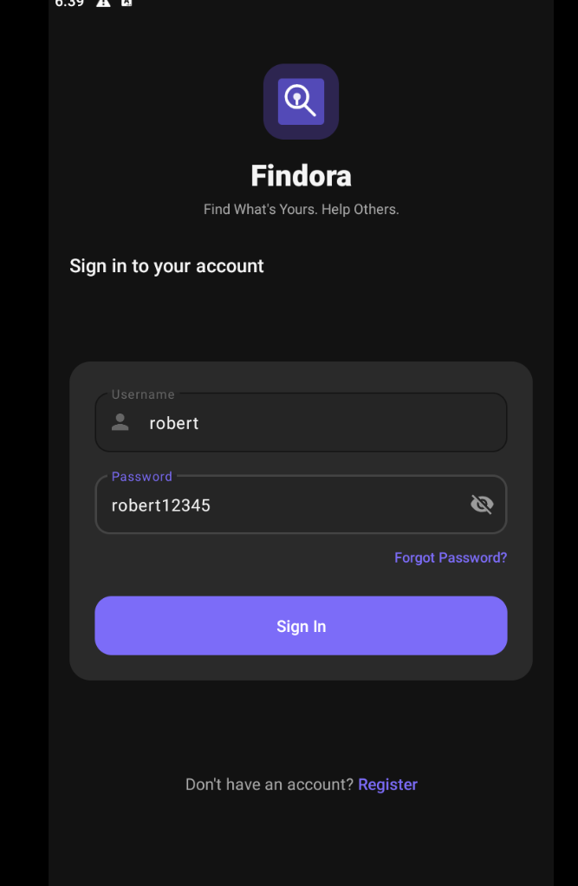
Figure 6.2.1 – User Login & Authentication Interface
Key UI Elements:
• Findora Branding & App Logo: Recognizable visual brand identity and greeting banner.
• Email / Username Input Field: Single validated text box accepting registered email or platform username.
• Password Input Field: Masked credential input with interactive eye icon to toggle visibility.
• Log In Action Button: High-contrast primary button dispatching authentication request and initializing secure session token caching.
• Forgot Password Link: Direct navigation trigger initiating the email OTP recovery flow.
• Sign Up Navigation: Bottom prompt allowing unregistered users to access the onboarding registration flow.

6.2.2 User Registration & Onboarding Screen
The onboarding interface allowing new users to create an account in the Findora ecosystem. It captures essential user profile information, enforces validation rules (unique username, email format, phone number, and password complexity matching), and generates a verified user record with default community reputation points.
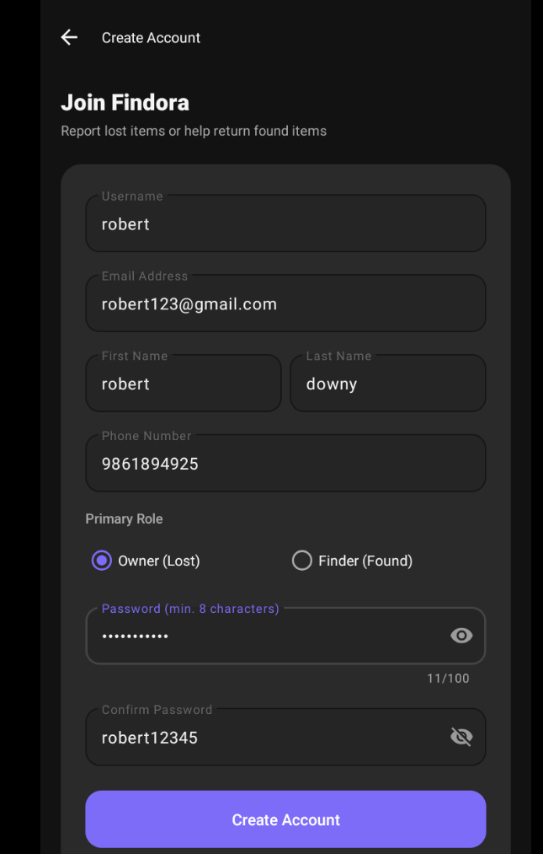
Figure 6.2.2 – User Registration & Onboarding Screen
Key UI Elements:
• Full Name & Username Inputs: Text fields capturing user legal name and unique community handle.
• Email & Contact Phone Inputs: Validated fields ensuring verified contact channels for item recovery notifications.
• Password & Confirm Password Inputs: Dual security fields enforcing matching complexity and encryption standards.
• Create Account Button: Primary submission button transmitting registration payload to the backend API.
• Existing User Prompt: Direct navigation link ('Already have an account? Log In') returning to the login gateway.

6.2.3 Finder Dashboard & Categorized Home Feed
The central discovery hub of Findora displaying an aggregated feed of active lost and found items. It provides instant keyword search, dynamic category filter chips, visual status badges, and streamlined bottom navigation for seamless multitasking across the platform.
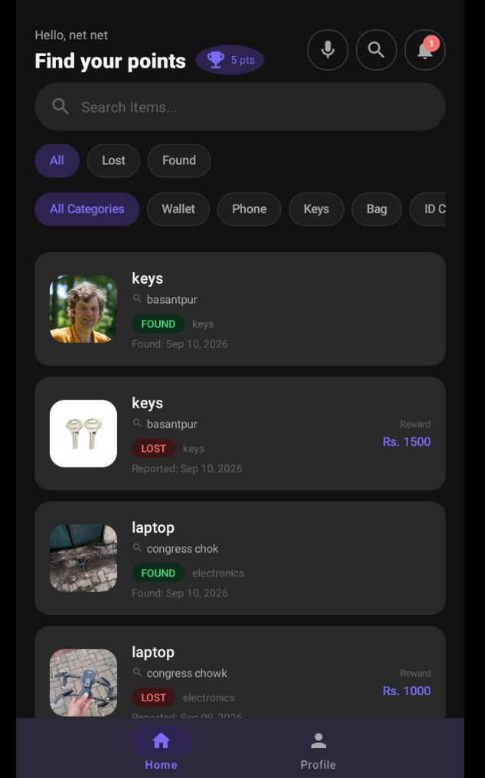
Figure 6.2.3 – Finder Dashboard & Categorized Home Feed
Key UI Elements:
• Real-time Search Bar: Top search field filtering listings dynamically by title, keyword, or landmark location.
• Category Filter Chips: Horizontally scrollable category selectors (All, Electronics, Wallet, Documents, Keys, Accessories, Books).
• Item Listing Cards: Card views displaying item thumbnail photo, title, discovery location, relative timestamp, and distinct status tags ('LOST' in red badge / 'FOUND' in green badge).
• Bottom Navigation Bar: Permanent 5-tab navigation bar granting one-tap access to Home, Search, Post Item, Messages, and Profile.

6.2.4 Item Details & Finder Action Overview
The detailed specification view for an individual item post. It presents high-resolution item imagery, categorized metadata, discovery location, and direct action triggers allowing legitimate owners to initiate contact or start ownership claim verification.
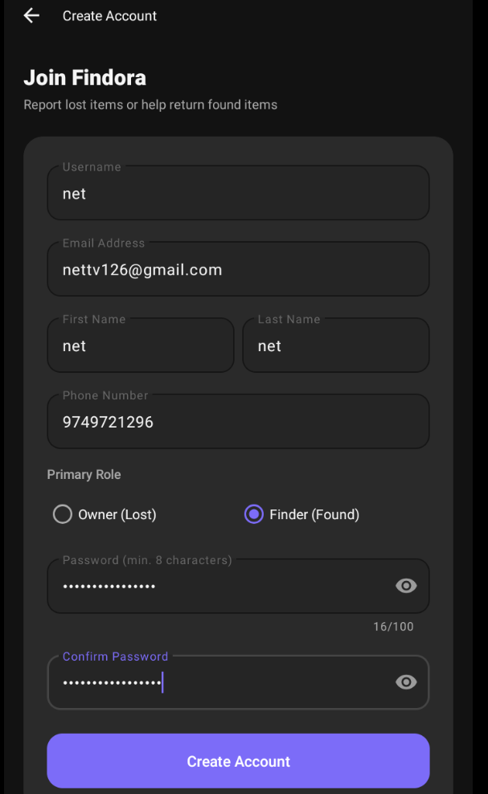
Figure 6.2.4 – Item Details & Finder Action Overview
Key UI Elements:
• High-Resolution Image Viewer: Card-styled image preview supporting multi-touch pinch-to-zoom.
• Item Specification Card: Item title, category badge, reporting timestamp, and detailed condition description.
• Location & Map Section: Textual address details paired with a 'View Map' button triggering external Google Maps navigation.
• Contact & Claim Actions: Primary 'Contact Finder' button opening real-time encrypted chat, and 'Claim Item' button initiating ownership verification.

6.2.5 Report Lost Item Screen
The structured submission form allowing owners to post a missing possession to the community network. It captures item categorization, unique identifying markers, date and time of loss, location landmarks, and optional reference photos to assist finders in identifying the property.
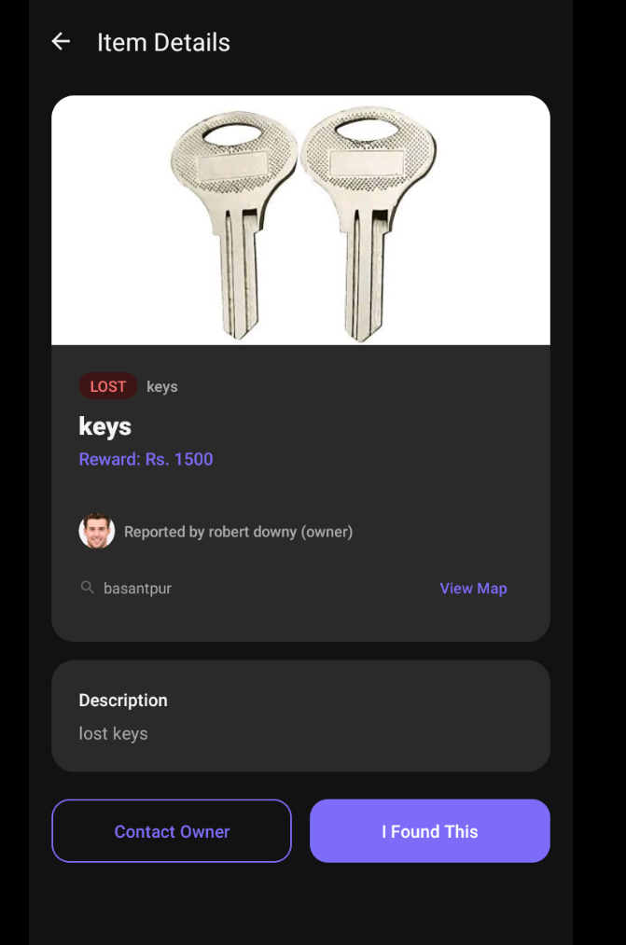
Figure 6.2.5 – Report Lost Item Screen
Key UI Elements:
• Category Dropdown Selector: Standardized classification menu (Electronics, Bags, Wallets, Cards, Jewelry, Others).
• Title and Description Inputs: Multi-line text areas capturing distinct visual traits, brand, model, and serial numbers.
• Date & Time Pickers: Interactive dialogs capturing approximate timeframe of loss.
• Location & Landmark Input: Address text box with optional GPS pin-point tagging.
• Media Attachment Uploader: Optional reference image picker supporting camera capture or gallery import.
• Submit Lost Report Button: Commits listing to backend database with immediate local cache synchronization.

6.2.6 Report Found Item Screen
The creation interface for community members who discover misplaced items. It facilitates photo capture, location tagging, and configuration of a secret ownership verification question that claimants must answer to prove genuine ownership.
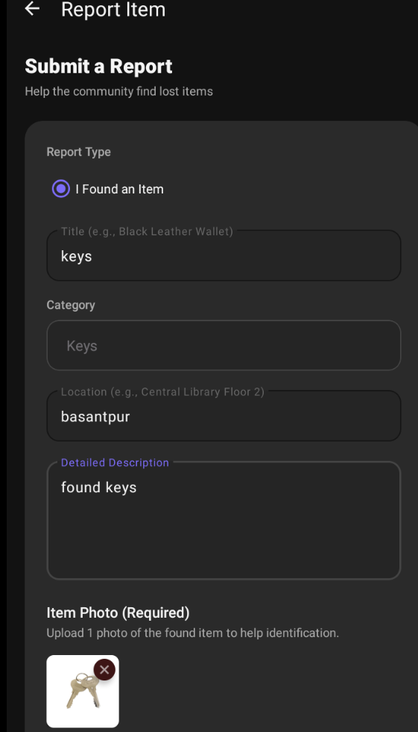
Figure 6.2.6 – Report Found Item Screen
Key UI Elements:
• Photo Upload Area: Mandatory high-clarity photo attachment supporting multi-image upload and compression.
• Item Title & Category: Input fields specifying discovered item name and category classification.
• Discovery Location & Time: Specific physical location (e.g. 'Library 2nd Floor, Desk 14') and discovery timestamp.
• Secret Ownership Question: Custom security question prompt configured by finder (e.g. 'What is written on the back keychain?').
• Post Found Item Action: Submits listing for administrative moderation and automatic community matching.

6.2.7 Item Claim Submission & Ownership Proof Interface
The security checkpoint interface presented to potential claimants. To prevent false claims, it requires the user to submit detailed answers to the finder's security question along with optional supporting evidence such as purchase receipts or serial number certificates.
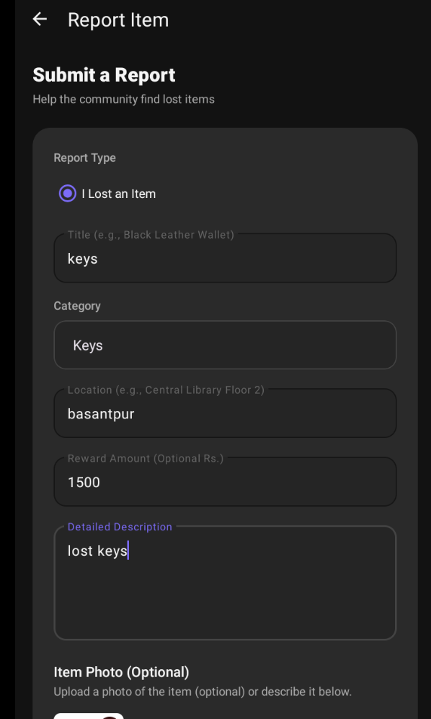
Figure 6.2.7 – Item Claim Submission & Ownership Proof Interface
Key UI Elements:
• Item Summary Header: Reference ID, item name, and verification policy instructions.
• Finder's Security Question: Display of the secret verification question configured during found item reporting.
• Claimant Answer Field: Multi-line text field where claimant provides specific private details known only to the true owner.
• Proof Attachment Button: Optional uploader for proof documents, receipts, or previous photos of the item.
• Submit Claim Button: Routes verification request to the finder and system administrators for review.

6.2.8 Claim Verification & Return Handshake Status
The active claim coordination view showing item status during verification and handover. It facilitates the dual-confirmation return protocol once physical handover occurs, rewarding the finder with reputation points and updating the item lifecycle state to resolved.
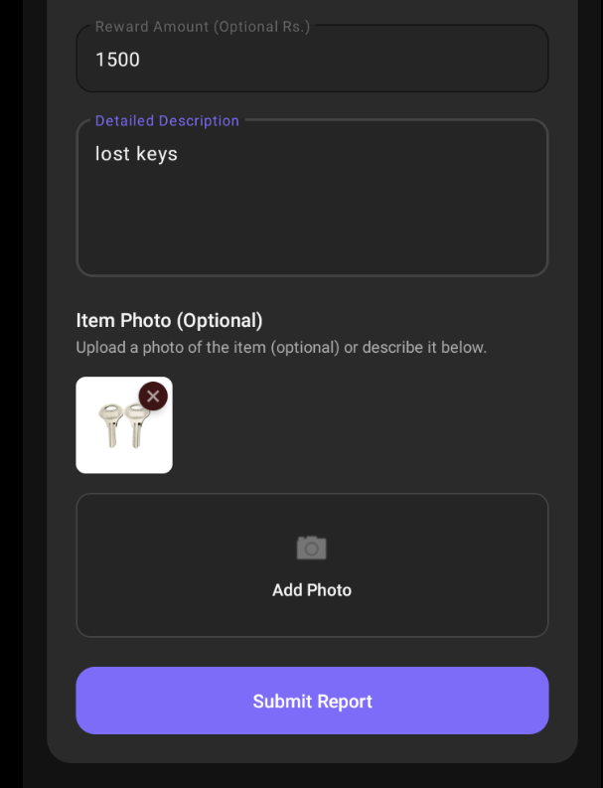
Figure 6.2.8 – Claim Verification & Return Handshake Status
Key UI Elements:
• Lifecycle Status Banner: Visual indicator showing 'Claim Accepted – Handover in Progress'.
• Handshake Return Button: 'Confirm Return' button requiring dual-party confirmation from both owner and finder.
• Reputation & Star Rating Dialog: 5-star rating input and testimonial feedback submitted upon successful handover.
• Audit Timestamp Record: Chronological log recording initial post, claim acceptance, and handover completion.

6.2.9 1-on-1 Real-Time In-App Chat Interface
The integrated end-to-end communication channel between finders and item owners. It enables instant text messaging, image sharing, message status indicators, hover action controls, and full context options (Copy, Edit, Delete for Me, Delete for Everyone).
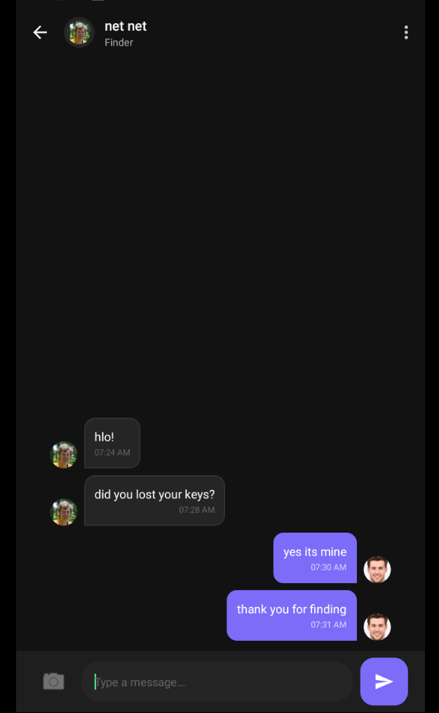
Figure 6.2.9 – 1-on-1 Real-Time In-App Chat Interface
Key UI Elements:
• Top Conversation Toolbar: Profile avatar, participant display name, and contextual role badge ('Finder' / 'Owner').
• Message Bubble Stream: Sent (purple) and received (dark surface) message bubbles with timestamps and '(Edited)' labels.
• Context Bottom Sheet: Modal offering 'Copy Message', 'Edit Message', 'Delete for Me', and 'Delete for Everyone'.
• Edit Mode Banner: Preview banner displaying original message text with a cancel (X) button above input field.
• Input Bar & Attachments: Camera/gallery attachment button, multi-line text input field, and floating Send button.

6.2.10 Administrator Panel – Item Moderation Registry
The desktop web console used by platform administrators to monitor, review, and moderate all submitted lost and found listings across the platform.
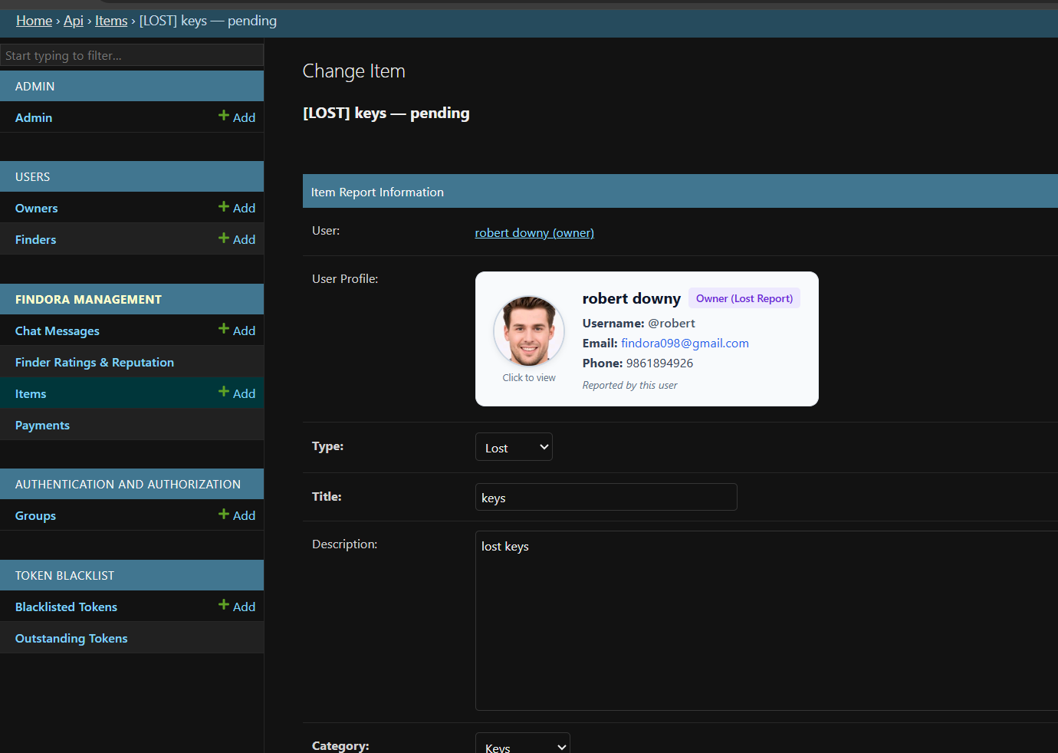
Figure 6.2.10 – Administrator Panel – Item Moderation Registry
Key UI Elements:
• Item Moderation Table: Tabular view displaying Item ID, Title, Category, Reporter Username, Report Type (Lost/Found), Timestamp, and Status.
• Status Filter Tabs: Quick filters for 'Pending Review', 'Approved', 'Flagged', and 'Resolved' listings.
• Search & Search Input: Global keyword search for locating specific reports or accounts.
• Action Controls: Individual action buttons per listing ('View Detail', 'Approve', 'Flag / Reject').

6.2.11 Admin Item Detail & Ownership Verification View
The in-depth administrative inspection view allowing moderators to examine uploaded evidence photos, claimant verification answers, and conflicting ownership claims to ensure fair dispute resolution.
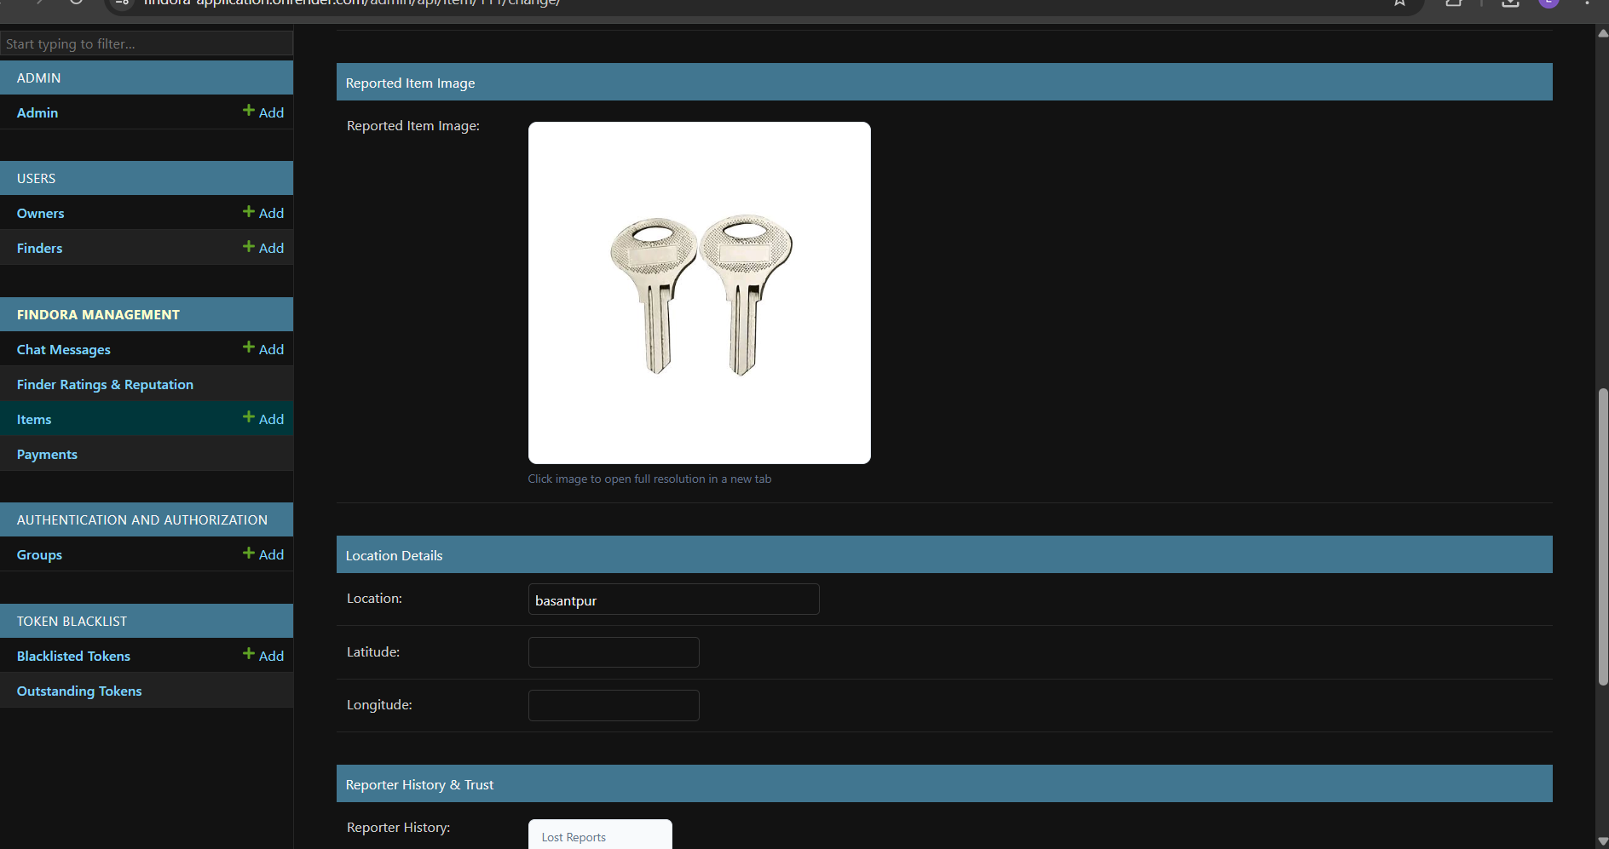
Figure 6.2.11 – Admin Item Detail & Ownership Verification View
Key UI Elements:
• High-Resolution Proof Viewer: Full-size side-by-side inspection of found item photo and claimant proof submission.
• Claimant & Finder Reputation Profile: Overview of user trust scores, account age, and return history.
• Secret Question & Answer Comparison Box: Side-by-side display of finder's question and claimant's response for verification audit.
• Dispute Resolution Override: Administrative override controls allowing direct approval or request for additional proof.

6.2.12 Admin Item Approval & Moderation Decision Workflow
The decision execution interface where administrators finalize moderation actions, log regulatory notes, and broadcast approved listings to the community feed.
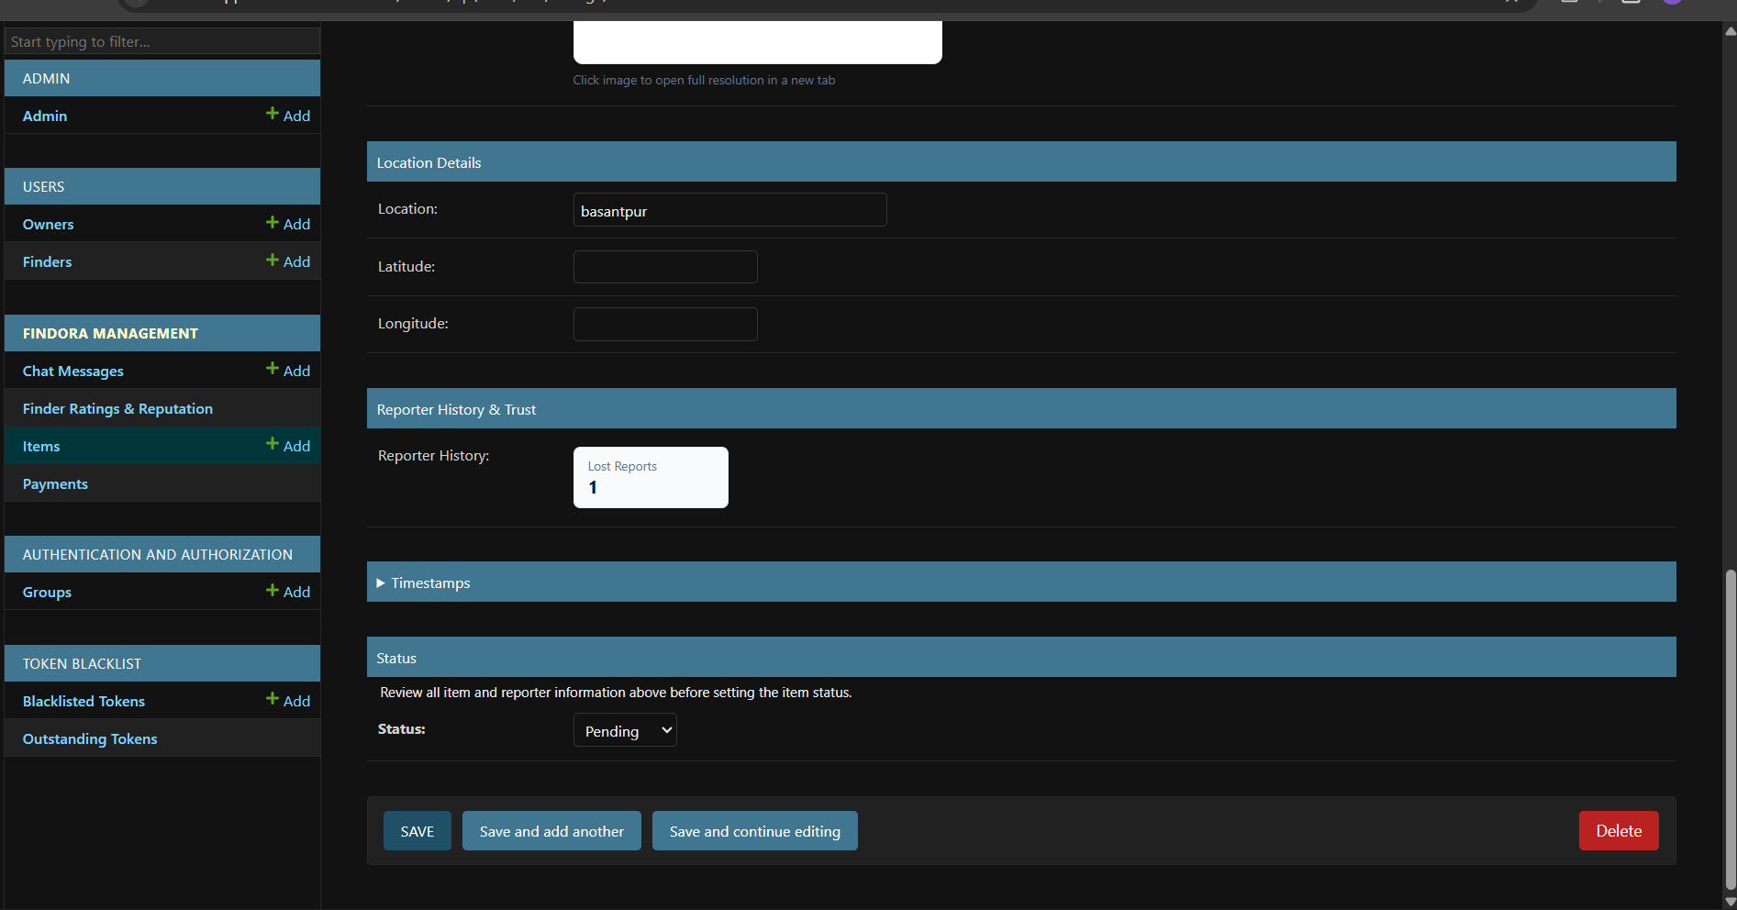
Figure 6.2.12 – Admin Item Approval & Moderation Decision Workflow
Key UI Elements:
• Moderation Decision Selector: Dropdown / radio options to set status to 'Approved', 'Under Review', or 'Rejected'.
• Admin Reason / Notes Box: Mandatory explanation field for rejected or flagged listings sent directly to the user.
• Save & Update Status Button: Commits changes to the database and broadcasts push notifications to matched users.
• Audit Log: Timestamped log of previous administrative actions and moderator remarks.

6.2.13 Master Administration Dashboard & Platform Analytics
The executive administrative dashboard presenting platform-wide metrics, user activity statistics, return success rates, reputation point economy analytics, and server health monitoring.
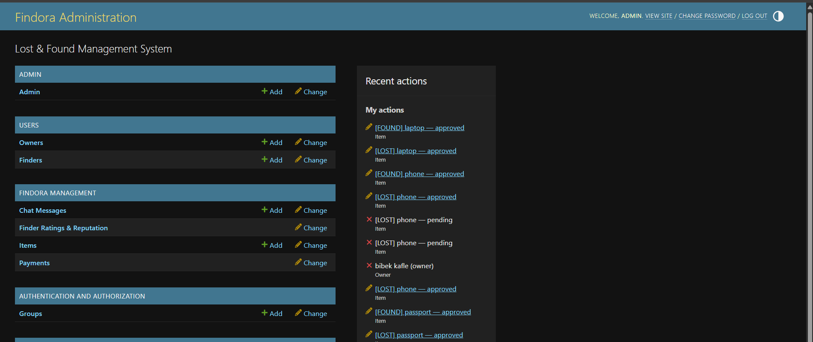
Figure 6.2.13 – Master Administration Dashboard & Platform Analytics
Key UI Elements:
• KPI Summary Metric Cards: Total Registered Users, Active Lost Reports, Active Found Reports, Successful Returns, and Recovery Rate.
• Real-Time Activity Stream: Live feed of recent registrations, claim submissions, and confirmed handovers.
• System Health Monitor: API response latency, database connection pool, and storage utilization.
• Navigation Sidebar: Direct access to User Accounts, Item Listings, Claims, Transactions, Notifications, and System Configuration.

6.3 Operational Workflow and Comprehensive User Guidelines
Findora provides a unified, step-by-step workflow designed to streamline lost item recovery while eliminating fraud and maintaining complete transactional accountability. The end-to-end operational lifecycle spans eight primary phases:
1. User Registration & Security Onboarding: New users create a verified account with legal name, contact credentials, and avatar. Session tokens are securely cached for seamless app launches using EncryptedSharedPreferences and JWT tokens.
2. Reporting Lost Belongings: Owners document missing items by selecting category, entering distinct descriptive identifiers, setting loss date/time, providing location context, and uploading optional reference photos.
3. Posting Discovered Property: Finders photograph discovered items, specify the discovery location/time, and define a secret verification question that only the rightful owner can accurately answer.
4. Automated Matching & Community Discovery: The platform indexes active reports in real time, notifying owners when a matching found item is logged within the same spatial-temporal proximity.
5. Secure Ownership Claim Submission: Claimants review item details and submit private answers to the secret question along with optional evidence (purchase receipts or serial numbers).
6. 1-on-1 End-to-End Encrypted Coordination: Finders and owners communicate via real-time in-app chat to coordinate a safe public handover location without sharing private phone numbers.
7. Dual-Confirmation Handshake & Reputation Rating: Upon physical item return, both parties click 'Confirm Return'. The system marks the item resolved, awards community reputation points, and collects finder star ratings.
8. Administrative Oversight & Moderation: Platform moderators review flagged posts, audit disputed claims, verify proof documents, and manage community trust scores via the web admin console.

CHAPTER 7: CONCLUSION

7.1 Conclusion
Findora successfully solves the communication and verification gap in lost and found management. By establishing an organized, secure, and reward-driven digital platform, Findora empowers communities to recover lost belongings swiftly while safeguarding user privacy.

7.1.1 Significance of the System
The system's significance lies in its automated matching engine, secure claim validation, and community reputation incentives. Unlike chaotic social media channels, Findora provides structured accountability and verifiable records for every reported item.

7.2 Limitations of the System
Current limitations include reliance on user truthfulness for verification question evaluation, dependency on active internet connectivity, and the absence of computer-vision-based automatic image matching.

7.3 Future Scope of the Project
Future enhancements will incorporate: AI-powered image similarity matching using convolutional neural networks (CNNs); geolocation-based real-time proximity alerts using Geofencing; integration with campus smart card RFID readers; and automated SMS gateway notifications.

REFERENCES
Note on Reference Formatting: In accordance with the Project Formatting Guidelines, all reference entries are organized alphabetically by the surnames of the first authors. Each entry includes the author name(s), year of publication, work title, source publication (journal/book/web in italics), and URL if obtained from digital source material (APA Style Standard).
Django Software Foundation (2024). Django Web Framework Documentation (Version 4.2). Retrieved from https://docs.djangoproject.com/en/4.2/
Fielding, Roy T. (2000). Architectural Styles and the Design of Network-based Software Architectures. Doctoral dissertation, University of California, Irvine.
Floyd, Pink (1995). Comfortably Numb – the effects. American Medical Journal, 76, 120-135.
Gamma, Erich, Helm, Richard, Johnson, Ralph, & Vlissides, John (1994). Design Patterns: Elements of Reusable Object-Oriented Software. Addison-Wesley Professional.
Google Developers (2024). Android Developers Guide and Kotlin Reference Documentation. Retrieved from https://developer.android.com/guide
PostgreSQL Global Development Group (2024). PostgreSQL 14 Database Documentation and Reference Manual. Retrieved from https://www.postgresql.org/docs/14/
Pressman, Roger S., & Maxim, Bruce R. (2020). Software Engineering: A Practitioner's Approach (9th ed.). McGraw-Hill Education.
Rose, Axel (2002 March). Appetite for Destruction. Retrieved from https://gnr.com/albums/allhits/10123
Sommerville, Ian (2016). Software Engineering (10th ed.). Pearson Education Limited.
Two Scoops Press (2022). Two Scoops of Django 3.x: Best Practices for the Django Web Framework. Feldroy Publishing.

APPENDIX: PROJECT FORMATTING AND SUBMISSION GUIDELINES
This appendix provides the consolidated formatting rules, page setup rules, typography requirements, caption conventions, and binding regulations synthesized from Pokhara University and college project standards for the Bachelor of Computer Application (BCA) program.
Table A.1 – Consolidated Project Formatting and Submission Specifications
Parameter / Element | Specification / Requirement | Details & Examples
Paper Size & Print | A4 Size White Paper | Print strictly on single side of the paper
Page Margins | Left: 1.5", Right: 1.0", Top: 1.0", Bottom: 1.0" | 1.5 inches left margin allows for hard binding margin
Font Family & Color | Times New Roman, Black (RGB 0,0,0) | Consistent across all text, headings, captions, and tables
Heading 1 | 16 pt, Bold | Space Before: 12 pt, Space After: 12 pt, Centered/Left
Heading 2 | 14 pt, Bold | Space Before: 12 pt, Space After: 12 pt, Left aligned
Heading 3 | 12 pt, Bold | Space Before: 6 pt, Space After: 6 pt, Left aligned
Heading 4 | 12 pt, Normal / Italic | Space Before: 6 pt, Space After: 6 pt, Left aligned
Body Text | 12 pt, Normal, Justified | Line Spacing: 1.5, Italics/Bolds as necessary
Page Numbering Position | Top-Right / Right side of page | Times New Roman, 10 pt, Black, Normal
Preliminary Pagination | Roman numbering (i, ii, iii, ...) | Starts on Student Declaration, continues to Table of Contents
Main Body Pagination | Natural numbers (1, 2, 3, ...) | Starts at 1 on Chapter 1 (Page 1) to end of report
Table Labeling | Times New Roman, 10 pt, Normal, Center | Table Section No.Table No – Table Name (e.g., Table 3.4.1 – Table of data collection)
Figure Labeling | Times New Roman, 10 pt, Normal, Center | Figure Section No.Figure No – Figure Name (e.g., Figure 3.9.7 – Data Flow Diagram)
References Format | APA Style, Alphabetical by first author surname | Author name, year, source reference (in italics), URL if digital
Binding & Submission | Hard cover black book binding | No tape or spiral binding. Total 3 copies (PU – 1, College – 1, Student – 1)

