

Assignment-1

CSY1018



name: Laxman mAlla

UN ID: 16443353

# 

# **Contents**

INTRODUCTION

GitHub Activity

Sketches for desktop and Mobile

* Homepage
* About page
* CV page
* Contact page

Design

Wireframes

Wireframes for Desktop

* Wireframe for home page
* Wireframe for my about page
* Wireframe for my about page
* Wireframe for my contact page

Wireframes for Mobile

* Wireframe for home page
* Wireframe for my about page
* Wireframe for my about page
* Wireframe for my contact page

Logo (My Design)

Prototype

* My header
* My footer
* Desktop final Design
  + - 1. Homepage
      2. About page
      3. CV page
      4. Contact page
* Mobile final Design

1. Homepage
2. About page
3. CV page
4. Contact page

Conclusion

References

INTRODUCTION

In order to start a big project we should setup our mind and manage the time. So that to make ­­­­­ this website at first I made the simple sketches for Desktop and I liked my website to view in mobile so that, I draw simple sketches for mobile also. Then slowly I made the wireframes for that sketches in both Desktop as well as mobile view. Then I made my final design which contains four different pages: homepage, bio page, CVpage, contact page. I also made my own logo through online.

GitHub Activity

After the completion of each pages of html and css I put them in my Github account by adding, commiting and then pushing it to my Github account. My Github account is <https://github.com/Laxmanmalla/CSY1018-assignment1.git> and <https://laxmanmalla.github.io/CSY1018-assignment1/>

Sketches for Desktop:

Homepage

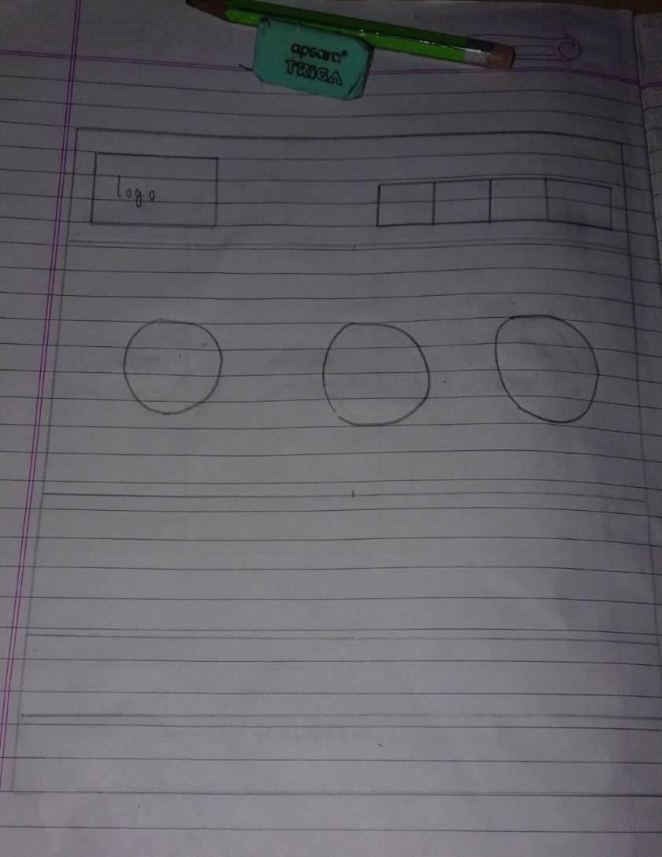

I want to make my homepage simple but attractive to others so I am going to divide whole page into 3 parts i.e. header, section and footer in every pages.­­­­­­­­ In header I will keep my own creation logo which will be using by animation so that it moves from left to right. I have kept the navigation bar on the header which color will change to gray when it is hover. In section part I will be separating it into three different div which will be containing three small icon pic and I will also use the background images so that, I will be writing some of my information briefly over that background images. At the footer I will be separating it into three different div where first div will contain one important Quotes, second div will contain the icons of social media and lastly third div will contain the email address of mine. There will also be a link in each and every webpages and some other important words.

About page

In this page I will be keeping the same header and footer as in home page. The only changes I will made is in section part. I will keep the other background images to this pages and put the large image of mine on the left side of the webpage. On the right hand side I will be given the description on about me, my hobbies and my interest.

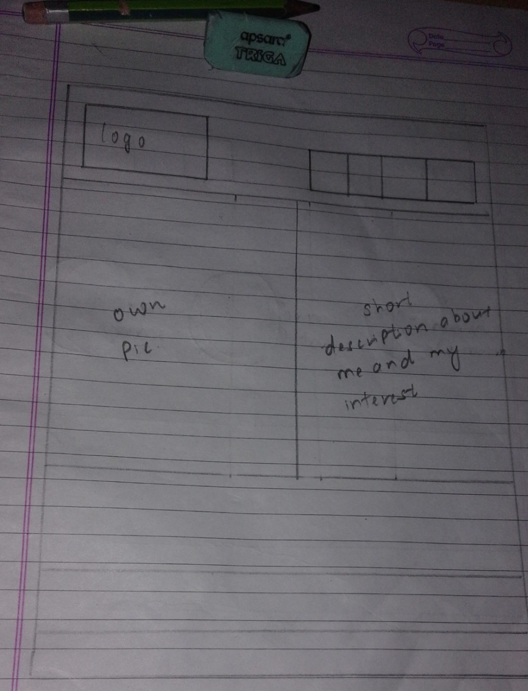

CV page

In CV page I simply will be changing the background color and made two different div as in bio page and I will keep a large size image to the left hand side of my web pages and give the information about my curriculum vitae. There will also be the link to my schools and colleges web sites so that anybody can get the information about my school and college. This will also include some description about my skills and experiences.

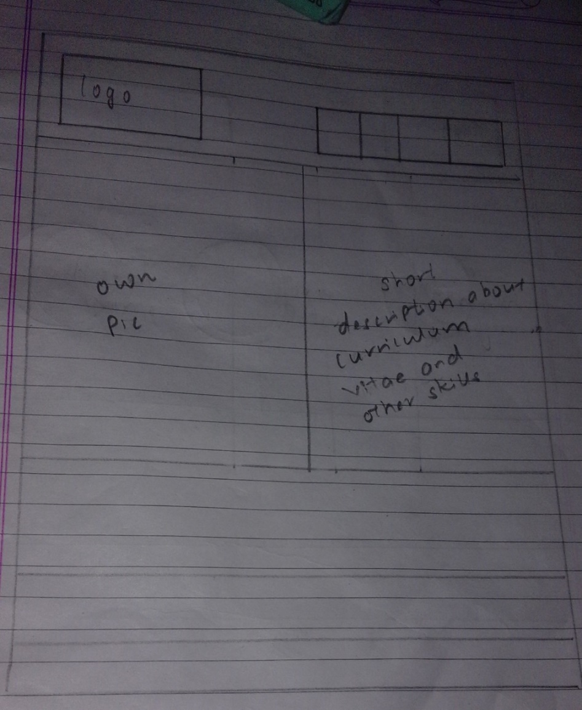

Contact page

This page also include same content in the header and footer as in other pages. But, The main thing that will be in this page is that it will be divided into three equal div class where first div will contain the Form name, second div will contain the Form data and lastly, the third div contain the contact information.

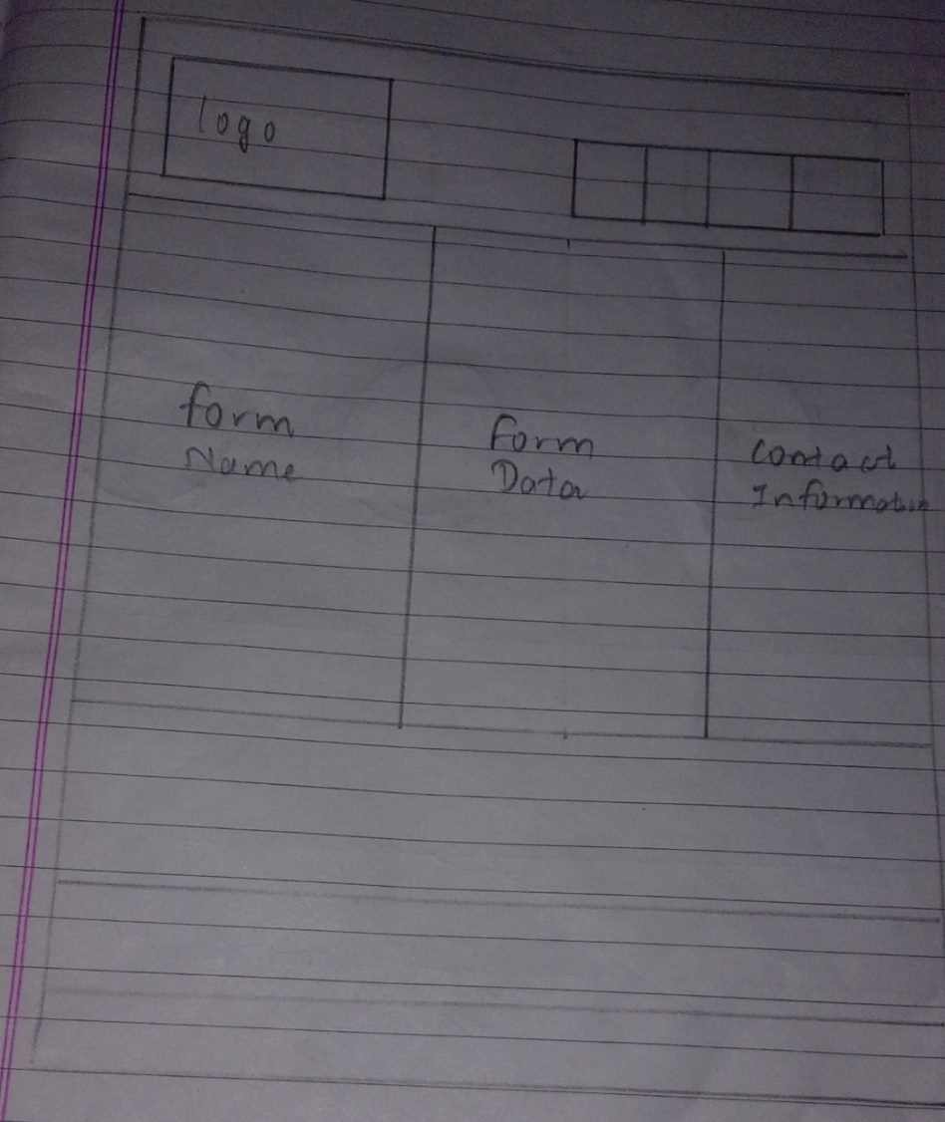

Sketches for Mobile:

Homepage

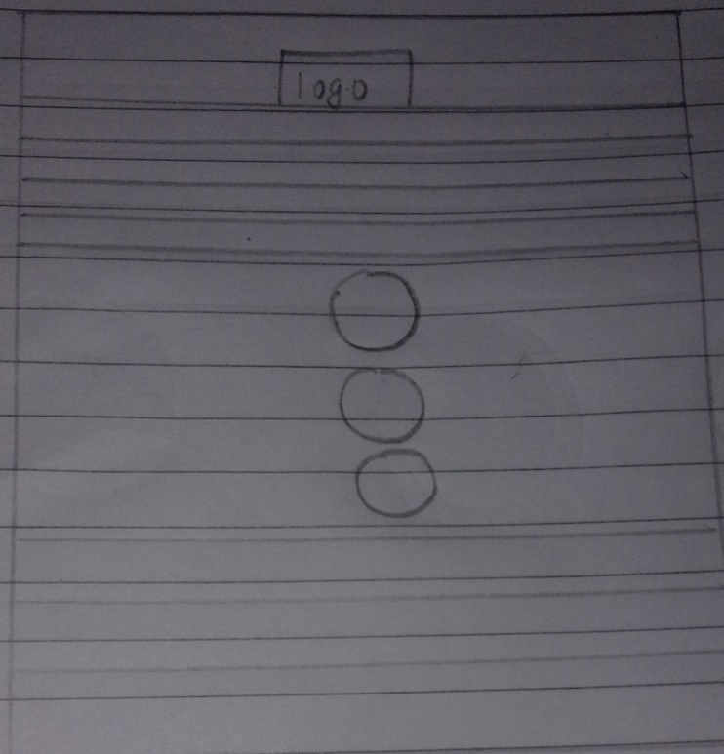

About page

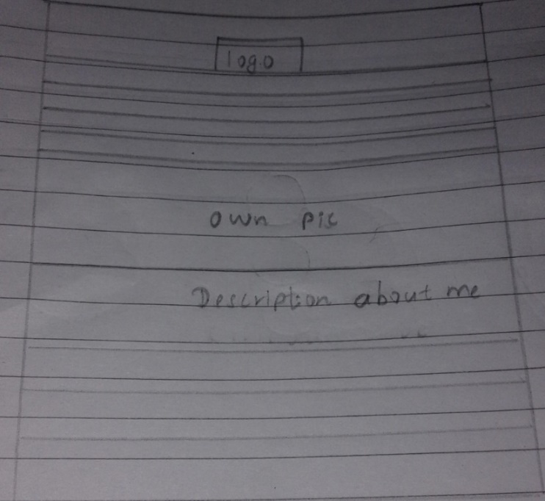

CV page

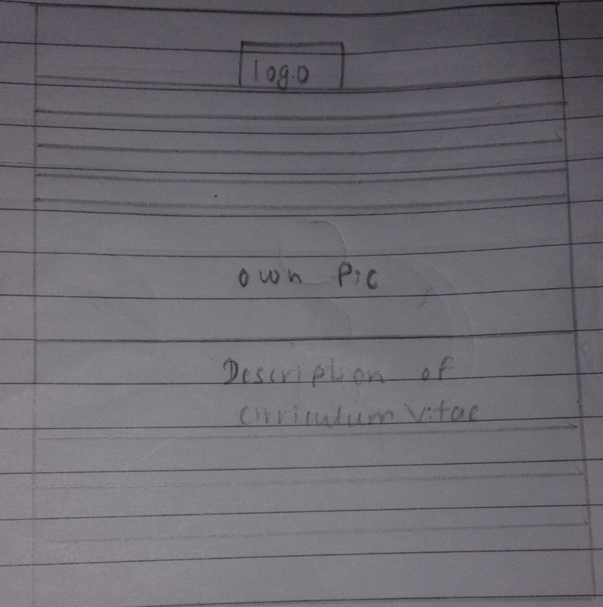

Contact page

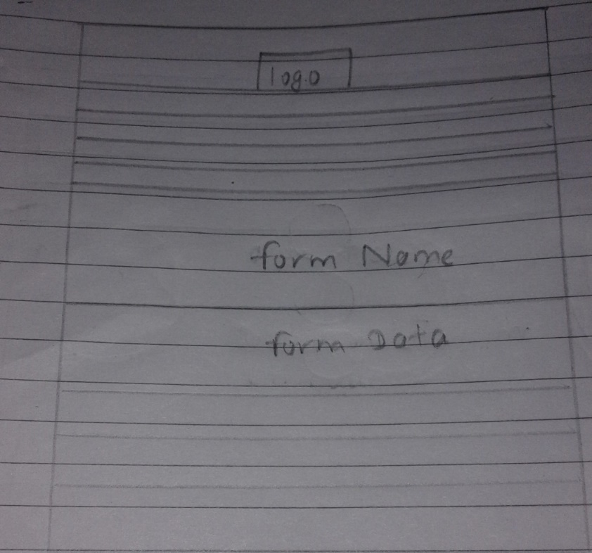

DESIGNS

Wireframes for Desktop:

Wireframe for my Homepage

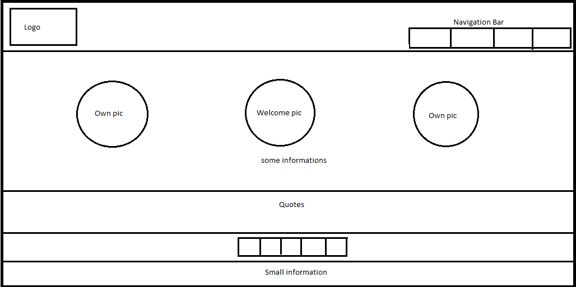

I divided whole page into 3 parts i.e. header, section and footer in every pages.­­­­­­­­ In header I kept my own creation logo which will be using by animation so that it moves from left to right. I have kept the navigation bar on the header which color will change to gray when it is hover. In section part I separated it into three different div which will be containing three small icon pic and I will use the background images so that, I will be writing some of my information briefly over that background images. At the footer I separated it into three different div where first div contain one important Quotes, second div contain the icons of social media and lastly third div contain the email address of mine. There is be a link in each and every webpages and some other important words.

Wireframe for my about page

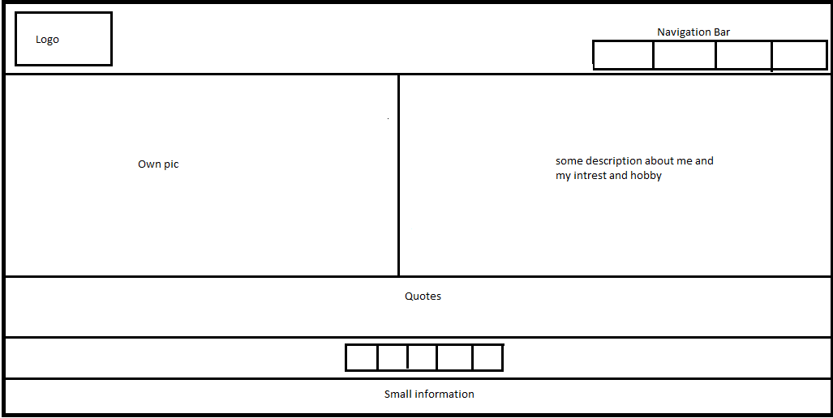

In this page I kept the same header and footer as in home page. The only changes I made is in section part. I will keep the other background images to this pages and put the large image of mine on the left side of the webpage. On the right hand side I will be given the description on about me, my hobbies and my interest.

Wireframe for my CV page

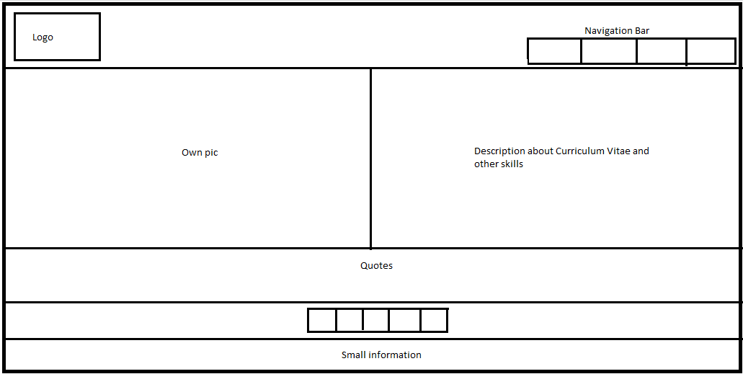

In CV page separated the page into two div class as in bio page and I simply make the changes on background color and kept a large size image to the left hand side of my web pages and give the information about my curriculum vitae. There will also be the link to my schools and colleges web sites so that anybody can get the information about my school and college. This will also include some description about my skills and experiences.

Wireframe for my contact page

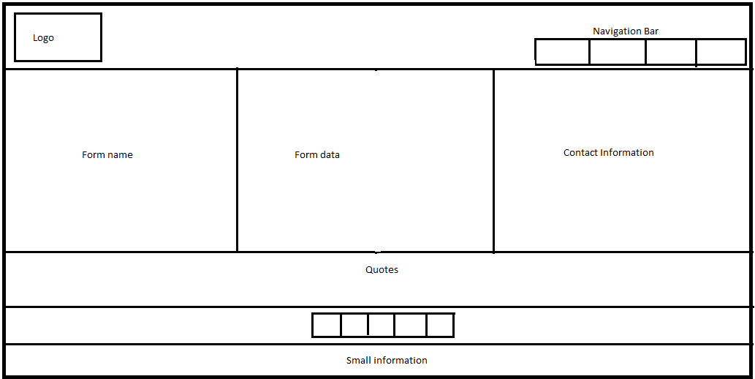

This page also include same content in the header and footer as in other pages. But, The main thing that will be in this page is that I divided into three equal div class where first div will contain the Form name, second div will contain the Form data and lastly, the third div contain the contact information.

Wireframes for Mobile:

Wireframe for my Homepage

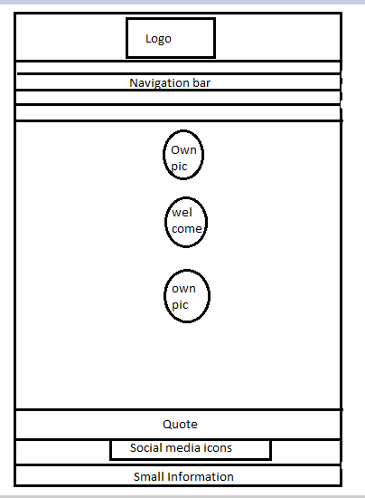

Wireframe for my about page

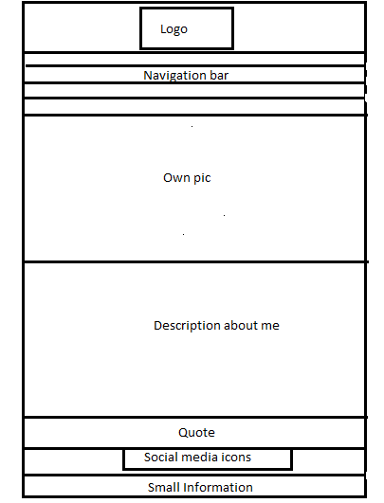

Wireframe for my CV page

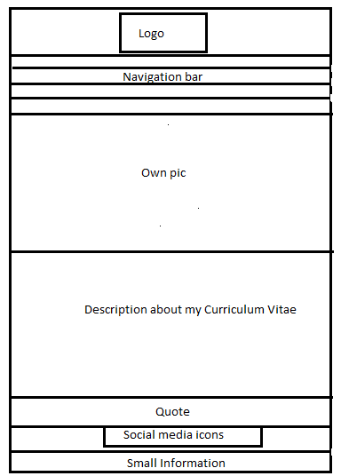

Wireframe for my contact page

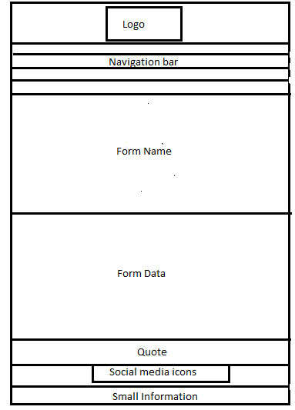

Logo (My design)

In order to make my own logo I tried to make it from different sources like paint, Photoshop and other many sources but I felt some how easy and faster way by making the logo through free logo design tools so I went to the websites <https://www.designimo.com> where I made my own logo by myself.

This is the logo which I used for my personal webpages and is animated on the header in each pages. Here this logo contain my initial letter of my name. I made this picture as a logo because I am the nature lover and I wanted to research and visit many natural places and things. In the logo there is a man who is clicking the picture of the nature and I am assuming that man as me.

PROTOTYPE

My header

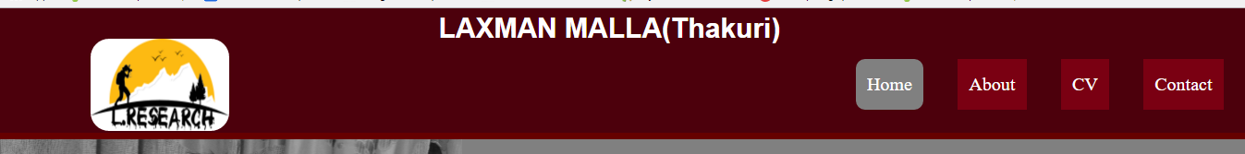

Header is separated into three div class where it contain Logo, h1 (name) and navigation bar. Header which contain navigation bar is link with many pages. Logo which is my own creation is used by animation so that it moves from left to right. This navigation bar color get changes to gray when it is hover. Logo is kept in left side of the header and Name is using the h1 tag and it is kept in center.

My footer

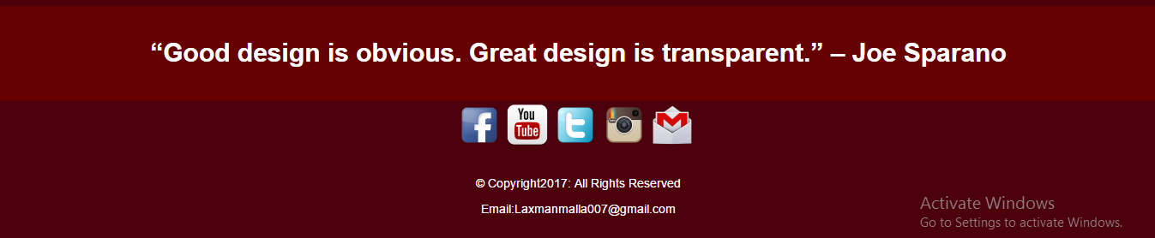

Footer part is divided into three div class where first div include one quote written by “Joe Sparano”, second div include the social icons through which anybody can check out my profile and last div contain my E-mail address.

Desktop final Design

Home page

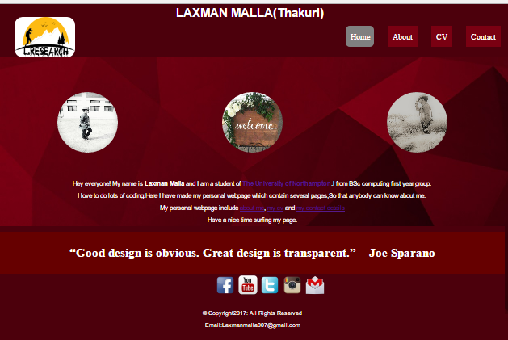

About page

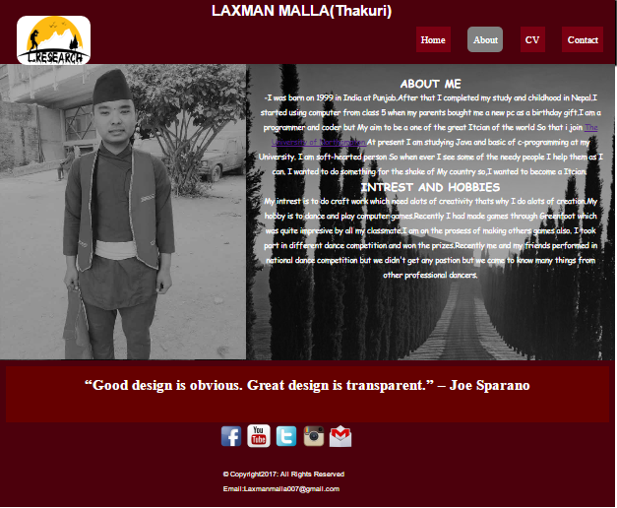

CV page

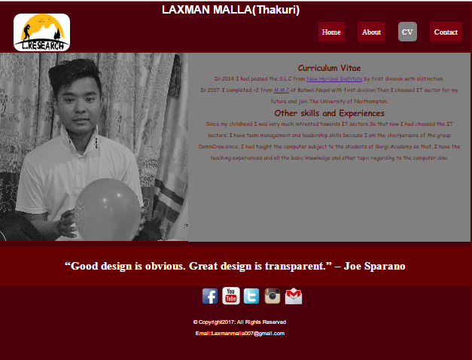

Contact page

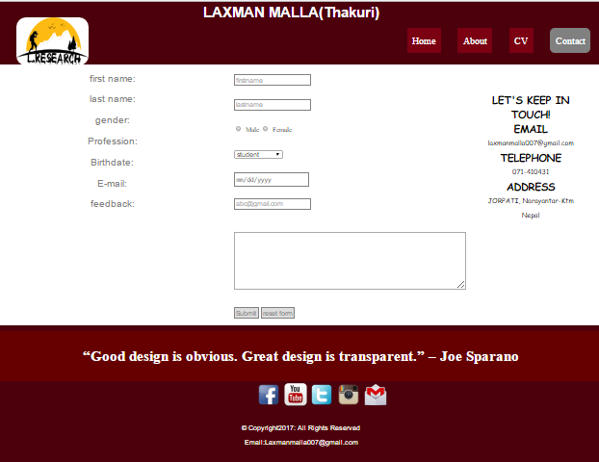

Mobile final Design

Header

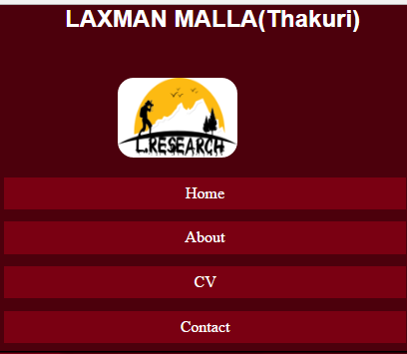

Footer

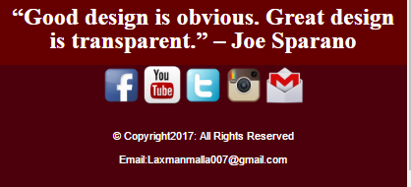

Homepage

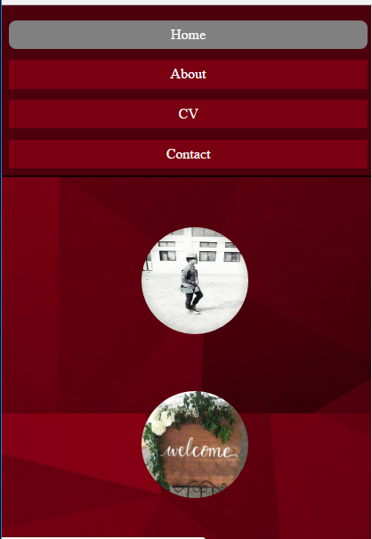

About page

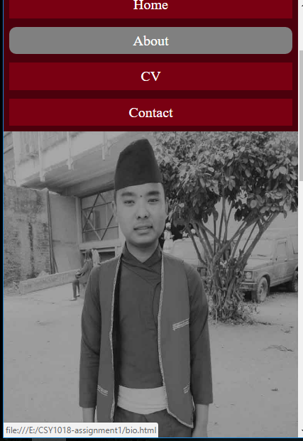

CV page

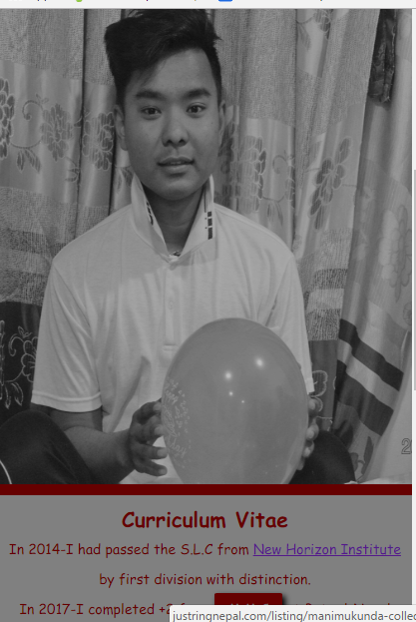

Contact page

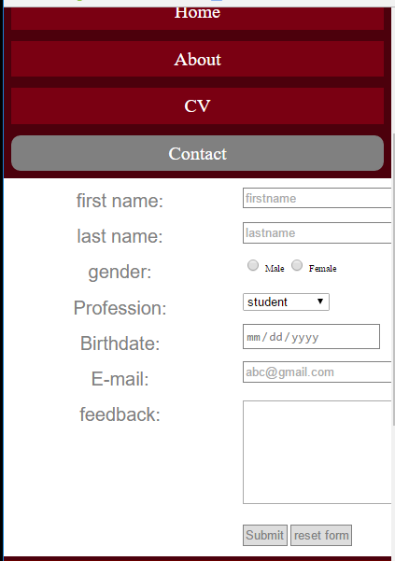

Conclusions

Finally, I made my website by the help of HTMl and CSS file. At first I draw sketch for both mobile and desktop design and then I made the final design for both view. From HTML and CSS I learn more knowledge to make different websites and used CSS in order to make websites more attractive to others. We may also add many other things in my website like videos, image slider which I had not included it.

References

* Standford,J.(2015).*Joel.sh*.Nile[online]Available at:

http://joel.sh[Accessed march 30, 2017]

* Burns,M.(2016).*MELISSABURNS*[online]Availablefrom: <http://www.melissaburns.me[Accessed> 10 march 2017]
* Anon, Free Logo Design Tool & Online Logo Maker.Designimo,Available at:

<http://www.designimo.com/> [Accessed march 30, 2017]