# **Contents**

Sketches

* Homepage
* About page
* CV page
* Contact page

Design

Wireframes

* Wireframes for my webpage
* Wireframe for home page
* Wireframe for my about page
* Wireframe for my contact page
* Logo (My Design)

Prototype

* My header
* My footer
* Homepage
* About page
* CV page
* Contact page

Sketches:

Homepage

I want to make my homepage simple but attractive to others so I divided whole page into 3 parts i.e. header, section and 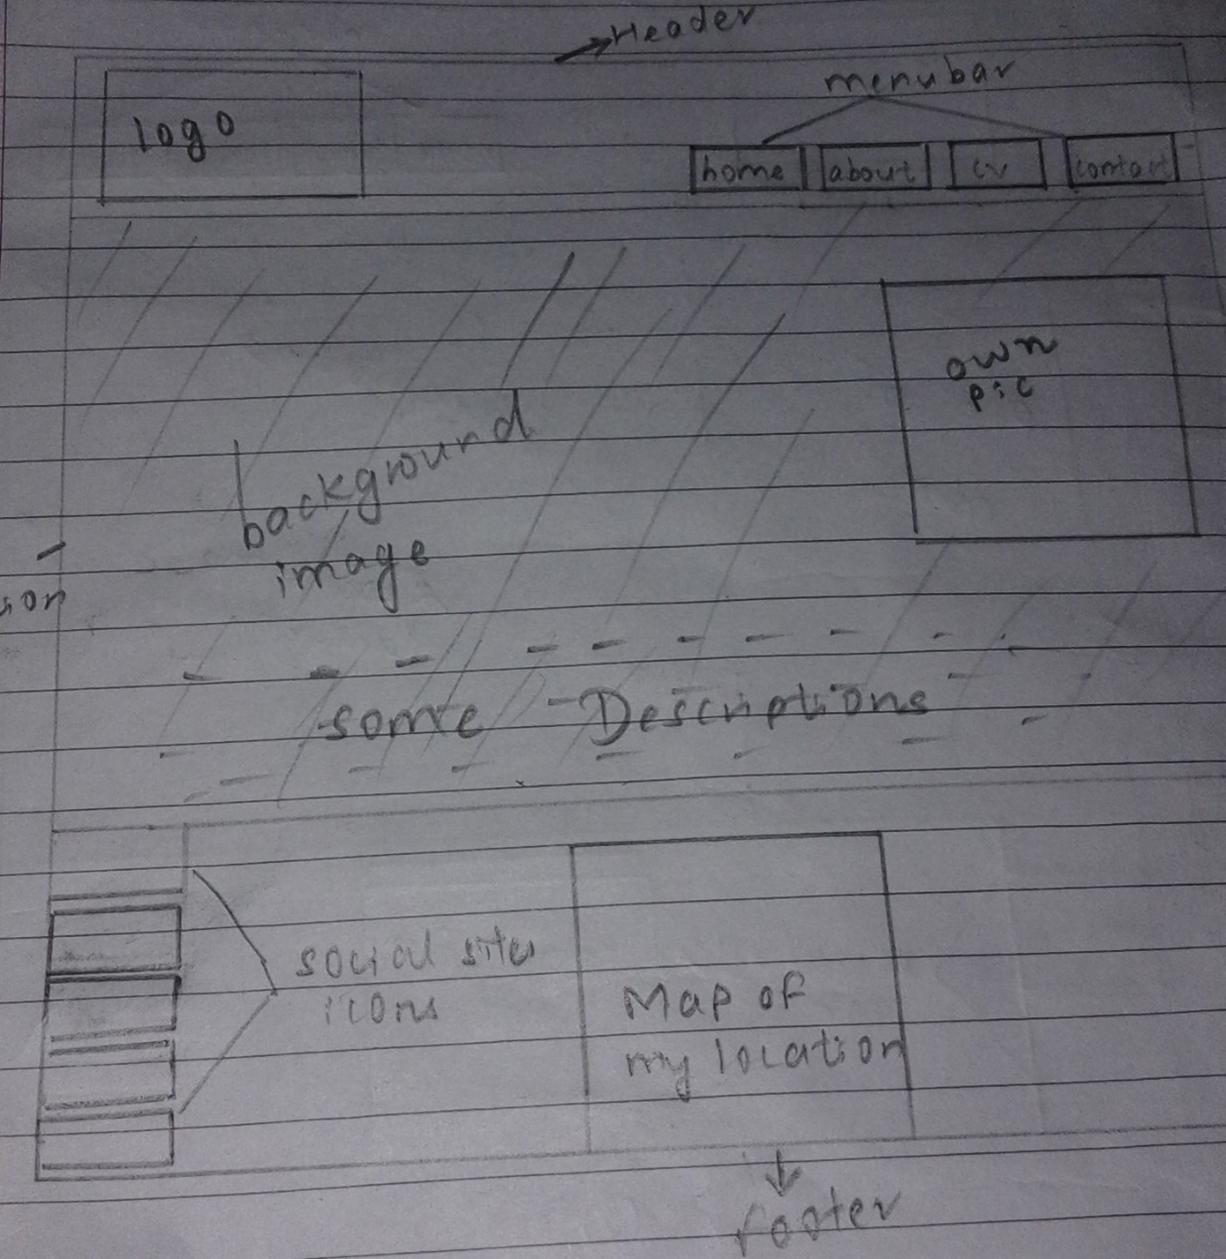footer in every pages. In header I had kept my own creation logo which is used by animation so that it moves from left to right. I have kept the navigation bar on the header which color changes to gray when it is hover. In section part I kept the background images and my small own picture over it at the right so that, I can give some of the description about me briefly. At the footer I put the icons of social sites so that people can easily access to the social sites directly through my websites and I kept my Google location map so that people can know about mine location. There will also be a link in each and every webpages and some other important words.

About page

In this page I have put the same header and footer as in home page. The only changes I have made is in section part. I have kept the other background images to this pages and put the large image of mine on the left side of the webpage. On the right hand side I have given the description on about me, my hobbies and my interest.

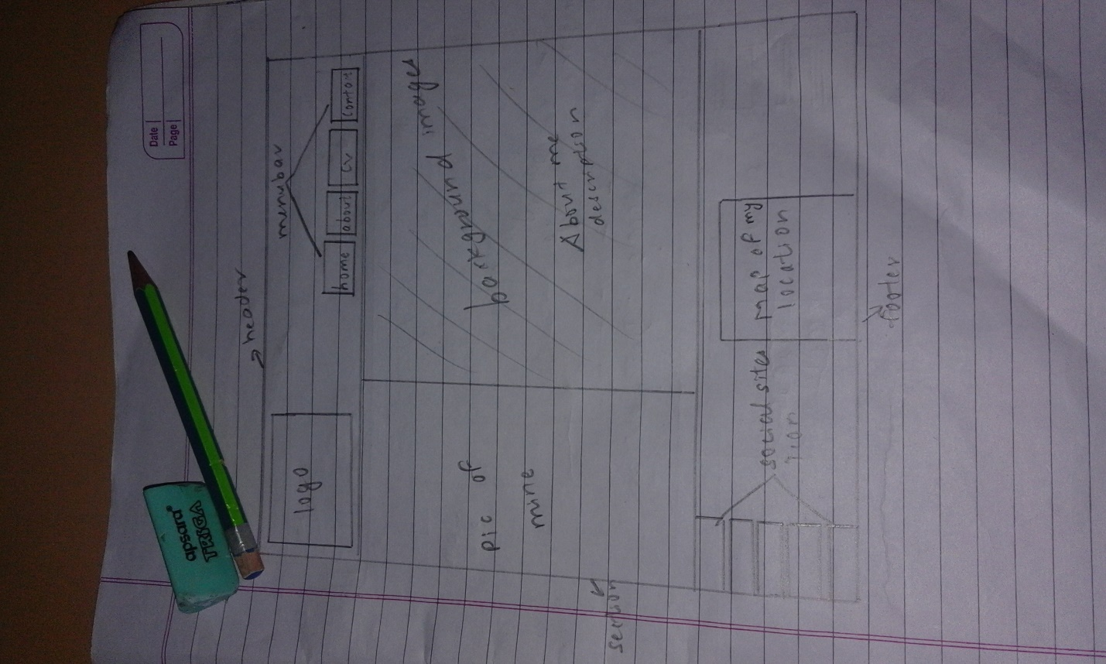

CV page

In CV page I simply changes the background color and made two different div and put a large size image to the left hand side of my web pages and give the information about my curriculum vitae. There is also the link to my schools and colleges web sites so that anybody can get the information about my school and college. This also include some description about my skills and experiences.

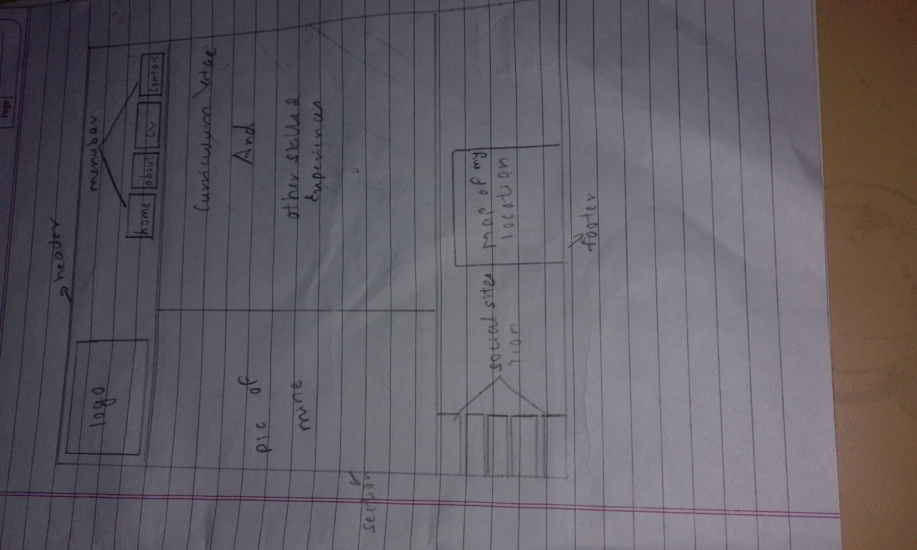

Contact page

This page also include same content in the header and footer as in other pages. But, it include the forms where anyone can fill it and send some feedback to me. I added some of my address to this section on the right hand side.

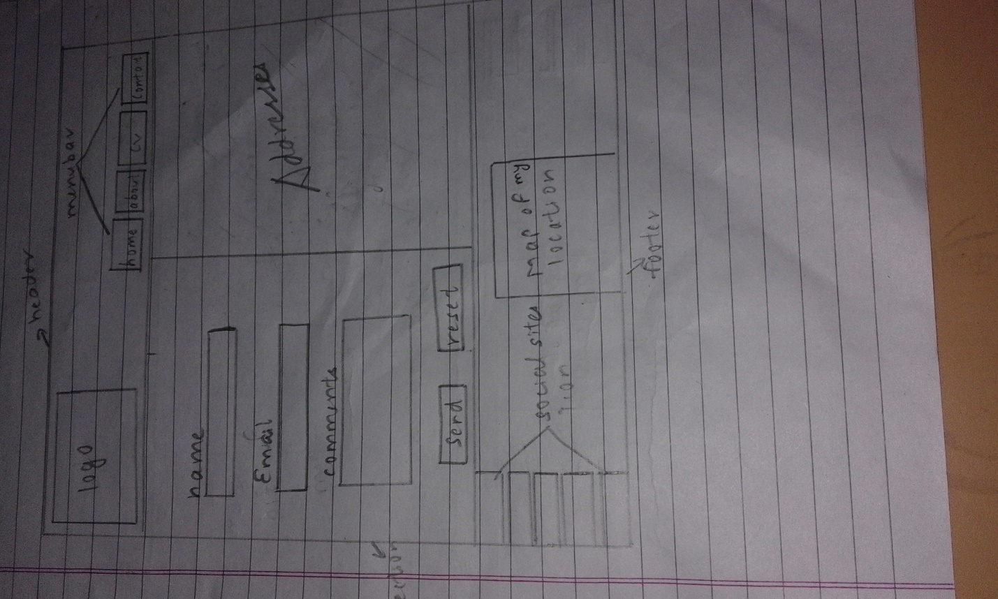

DESIGNS

Wireframes for my webpage

Wireframe for my Homepage

Header

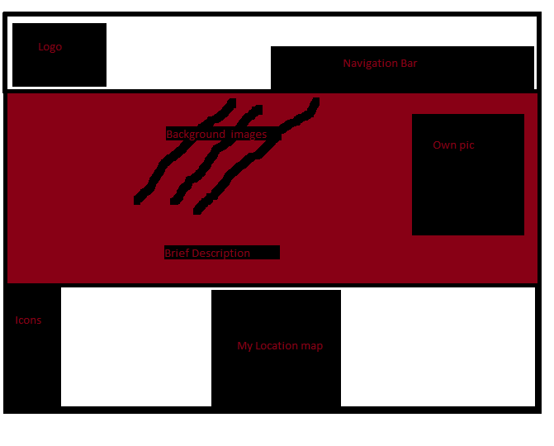

Section Footer

Social sites icons

I divided whole page into 3 parts i.e. header, section and footer in every pages. In header I had kept my own creation logo which is used by animation so that it moves from left to right infinitely. I have kept the navigation bar on the header. In section part I kept the background images and my small own picture over it at the right so that, I can give some of the description about me briefly. At the footer I put the icons of social sites so that people can easily access to the social sites directly through my websites and I kept my Google location map so that people can know about mine location. There will also be a link in each and every webpages and some other important words.

Wireframe for my about page

Header

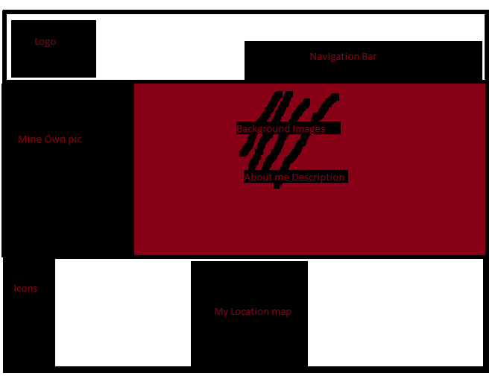

Icons of social sites

Section Footer

I have kept the same header and footer as in home page. The only changes I have made is in section part. I kept the other background images to this pages and put the large image of mine on the left side of the webpage. On the right hand side I have given the description on about me, my hobbies and my interest.

Wireframe for my CV page

Header

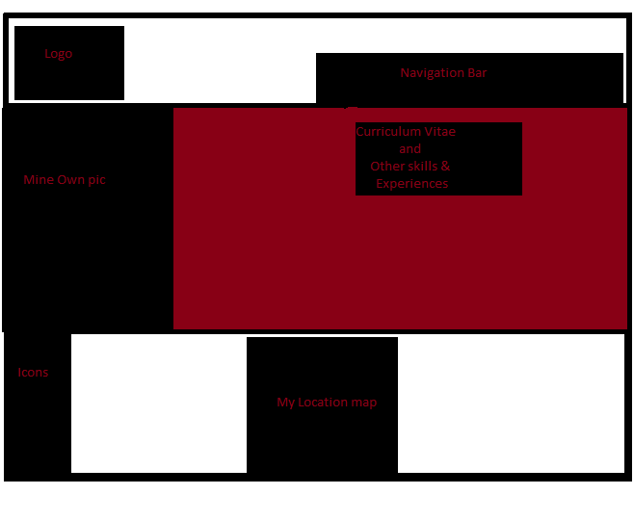

Icons of social sites Section Footer

Here I made two different div and put a large size image to the left hand side of my web pages and give the information about my curriculum vitae. There is also the link to my schools and colleges web sites. This also include some description about my skills and experiences.

Wireframe for my contact page

Section

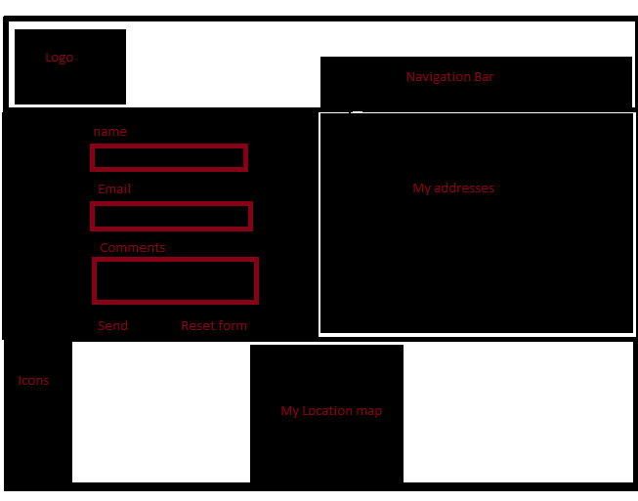

Forms

Icons of social sites Section Footer

Here is also same content in the header and footer as in other pages. But, it include the forms where anyone can fill it and send some feedback to me. I added some of my address to this section on the right hand side.

Logo (My design)

In order to make my own logo I tried to make it from different sources like paint, Photoshop and other many sources but I felt some how easy and faster way by making the logo through free logo design tools so I went to the websites <https://www.designimo.com> where I made my own logo by myself.

This is the logo which I used for my personal webpages and is animated on the header in each pages. Here this logo contain my initial letter of my name. I made this picture as a logo because I am the nature lover and I wanted to research and visit many natural places and things. In the logo there is a man who is clicking the picture of the nature and I am assuming that man as me.

PROTOTYPE

My header



Header part navigation bar which is link with many pages. This navigation bar color get changes to gray when it is hover. Logo is kept in left side of the header and Name is using the h1 tag and it is kept in center by padding. The background color is given as black. The Logo is using the animation so it moves infinitely from left to right.

My footer

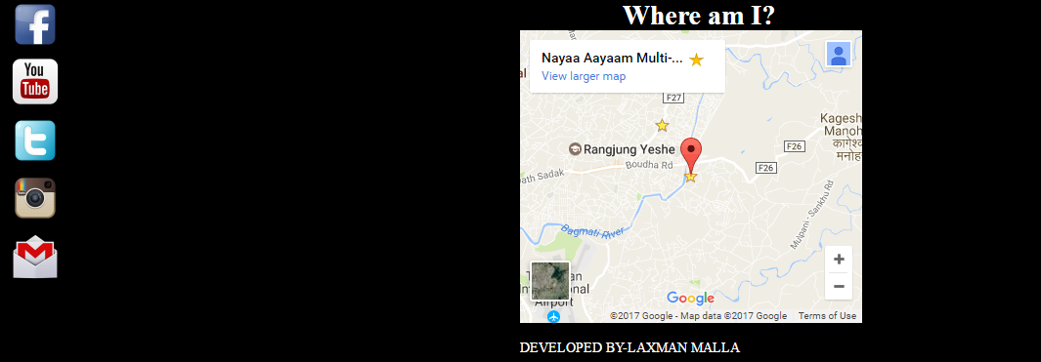

Footer part contain two div one contains social websites icons and another is the Google map which give the present location of mine. I have given the <h1> tag to the header of footer. People can easily open the social sites through my website.

*Google map appears and social sites get opened in the presence of Internet only.

Home page

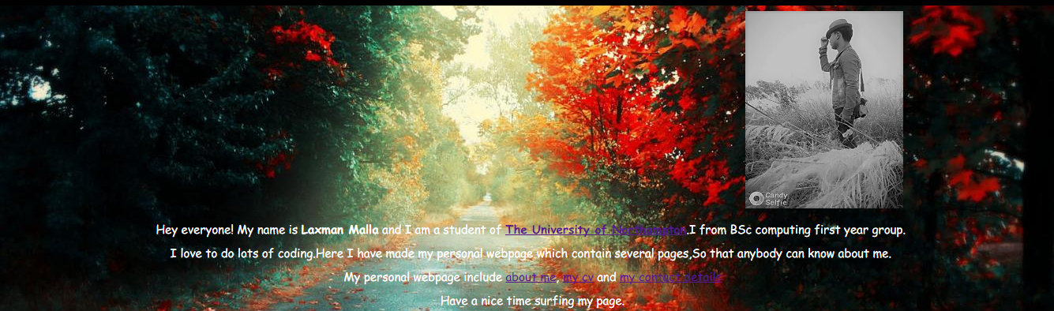

About page

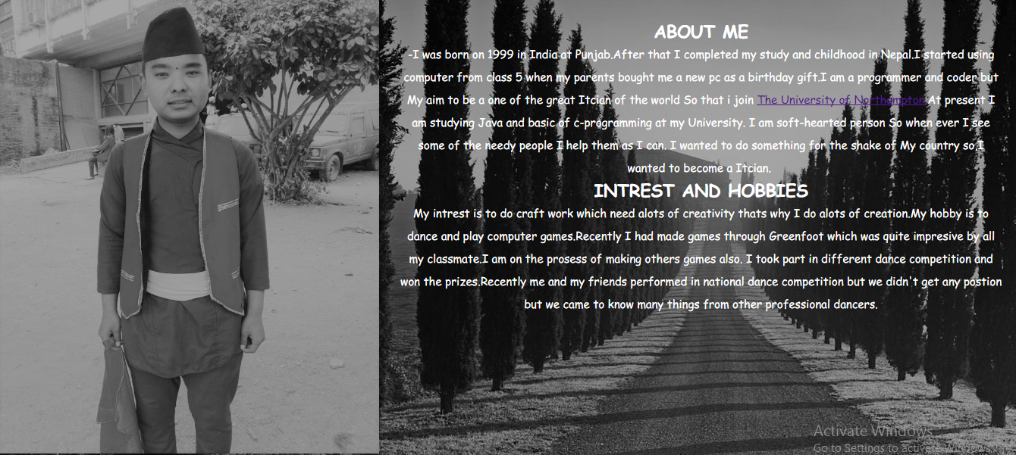

CV page



Contact page

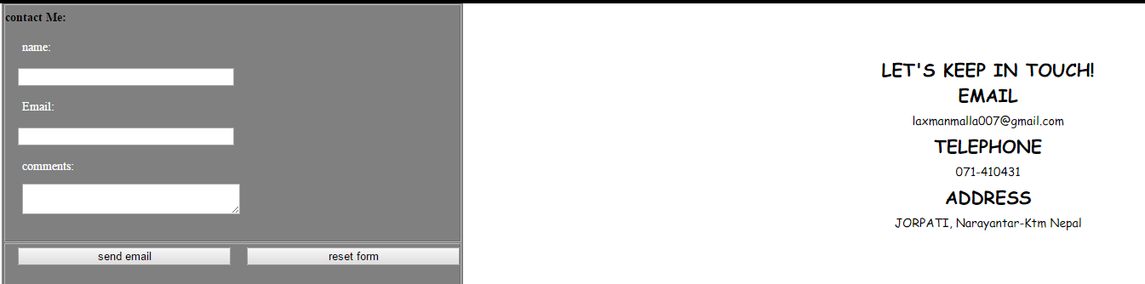

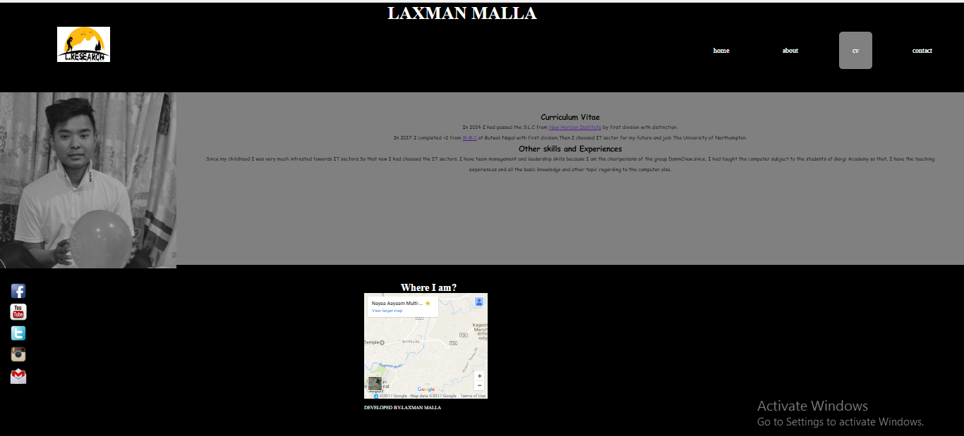

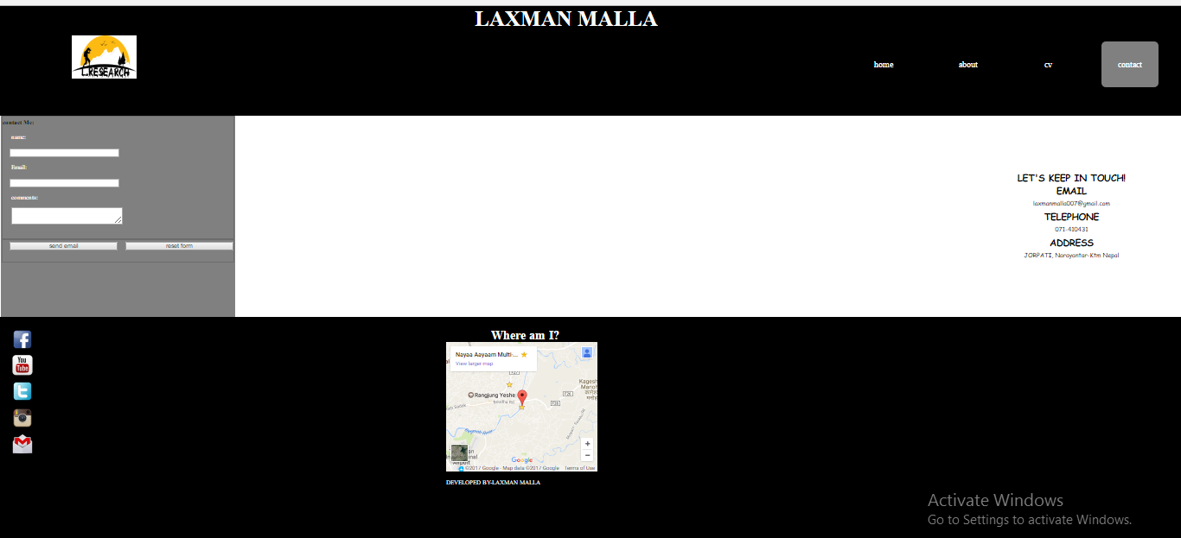

References

I had no any idea to make my webpage and totally unknown about how my websites looks like Before I started creating my personal webpages I looked other peoples portfolios and got some ideas so that I could style and can make mine webpage. The website which I looked and inspired me a lot to make my own webpages are:

### Standford,J.(2015).*Joel.sh*.Nile[online]Available from:http://joel.sh[Accessed 10 march 2017]

* Burns,M.(2016). *MELISSA BURNS*[online]Available from: <http://www.melissaburns.me[Accessed> 10 march 2017]