WEEK4-ASSIGNMENT
Azure Cloud Fundamentals and Data Pipeline Implementation using Azure Data Factory

Task 1: Resource Group Creation
Aim
To create a Resource Group for managing Azure resources.
Output
Resource Group Created Successfully

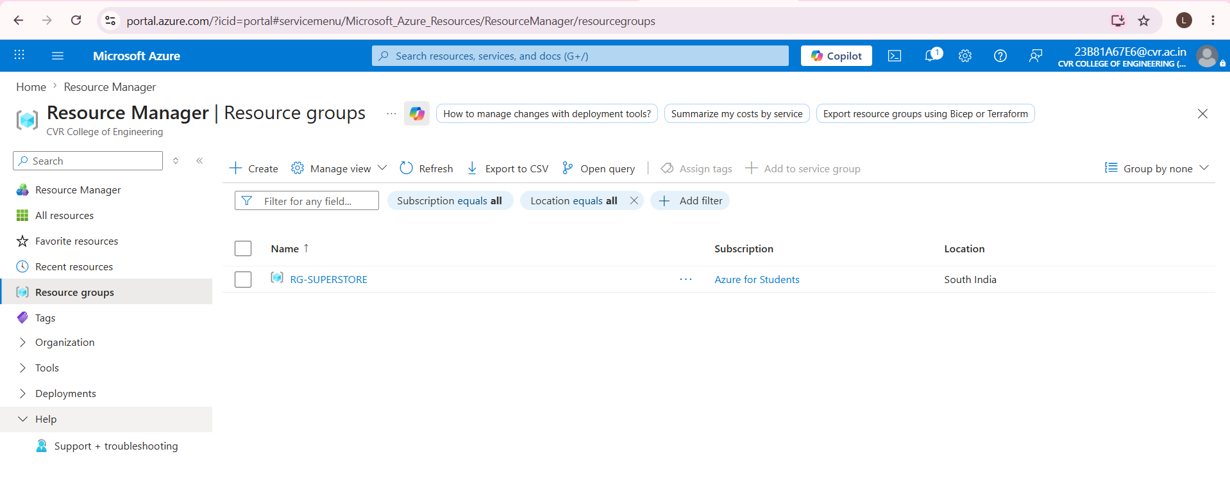

Task 2: Storage Account Setup
Aim
To create an Azure Storage Account, Blob Container, and upload a CSV file.
Output
Storage Account

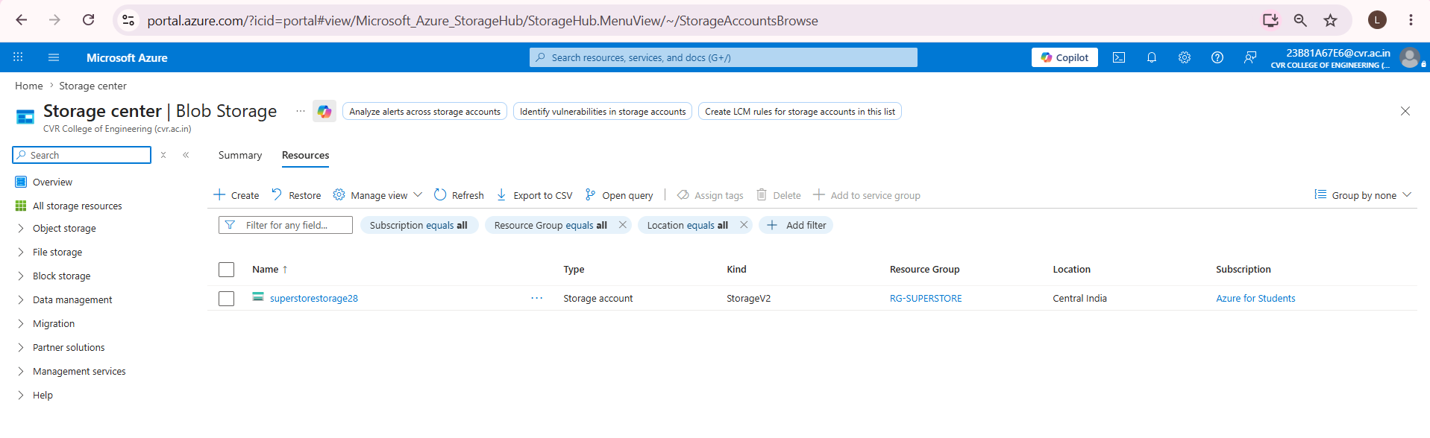
Blob Containers
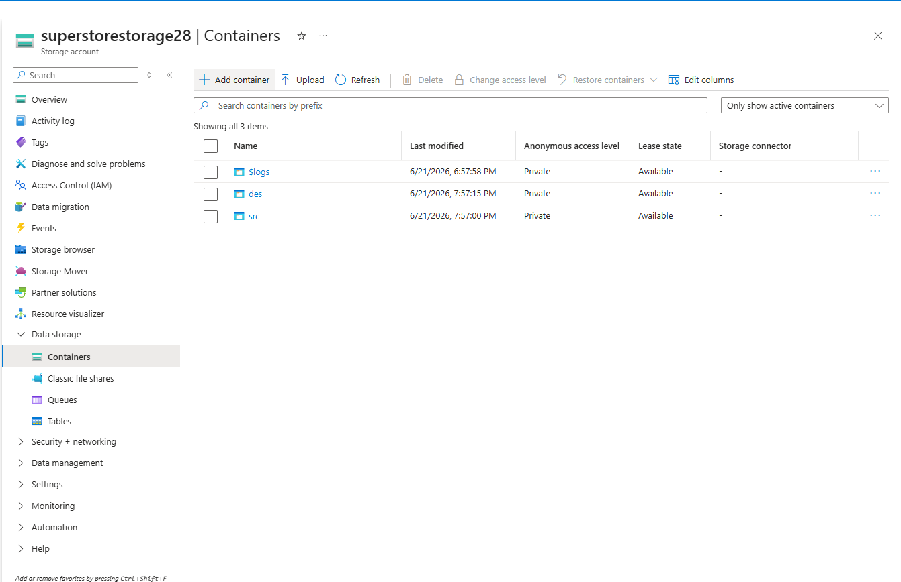

Uploaded CSV File

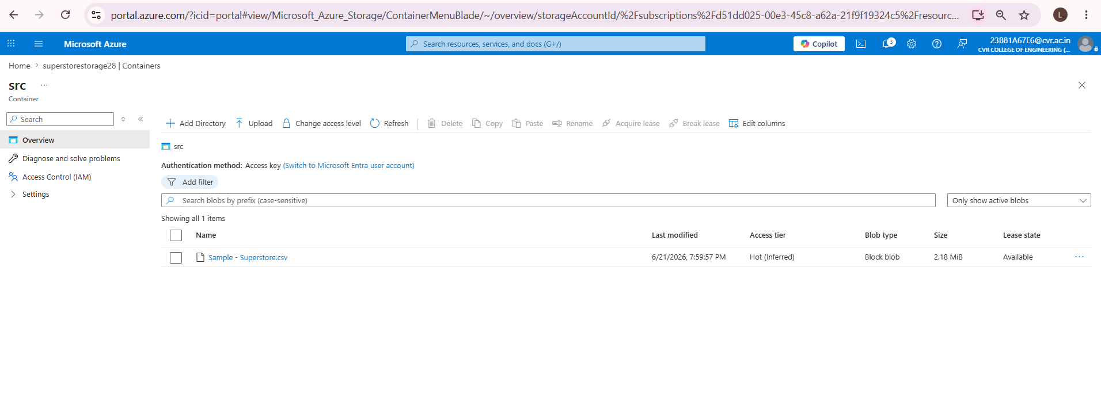
Task 3: Azure Data Factory Basics
Aim
To create Azure Data Factory and configure Linked Services, Datasets, and Metadata activity.

3.1 Azure Data Factory Creation
Output
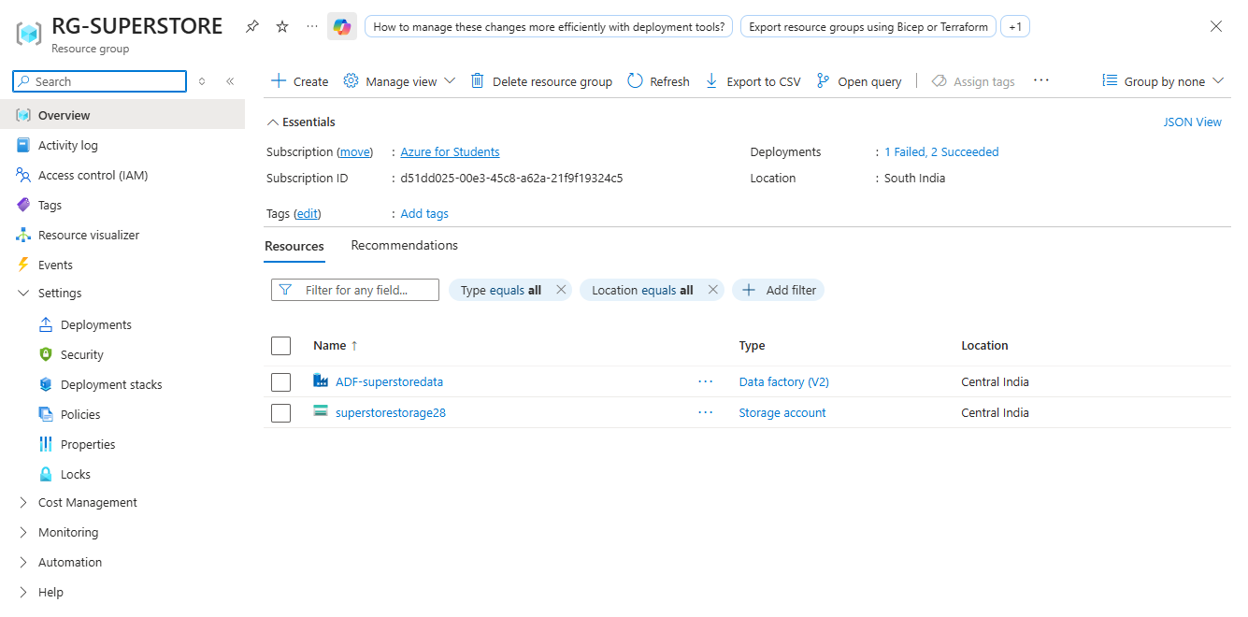
ADF-Studio
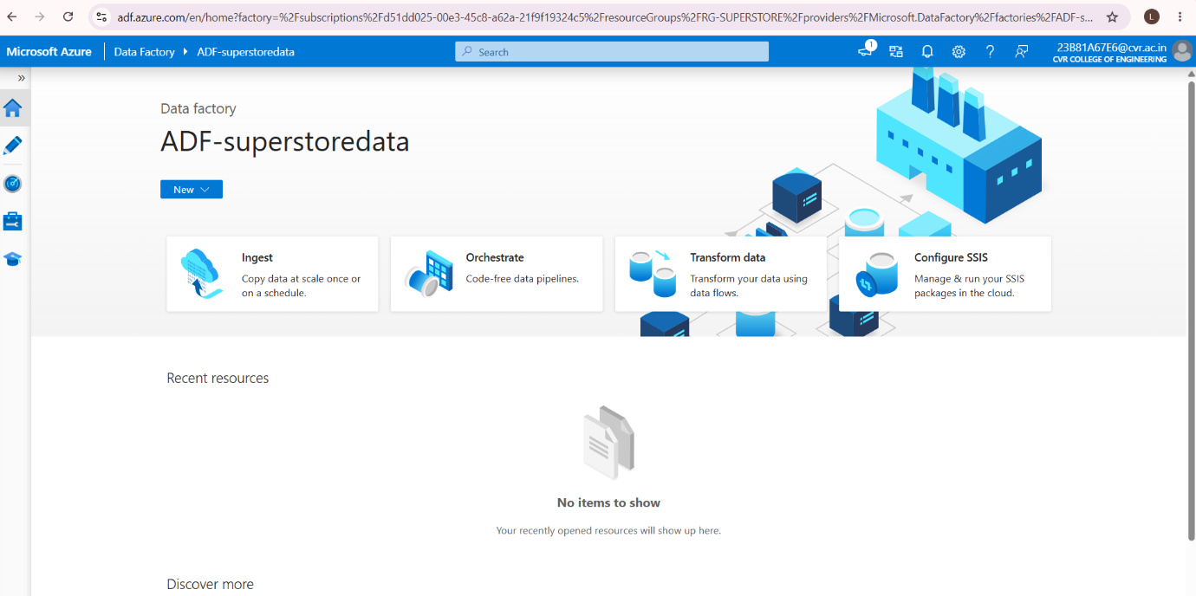

3.2 Linked Service Creation
Output
Linked Service Created Successfully

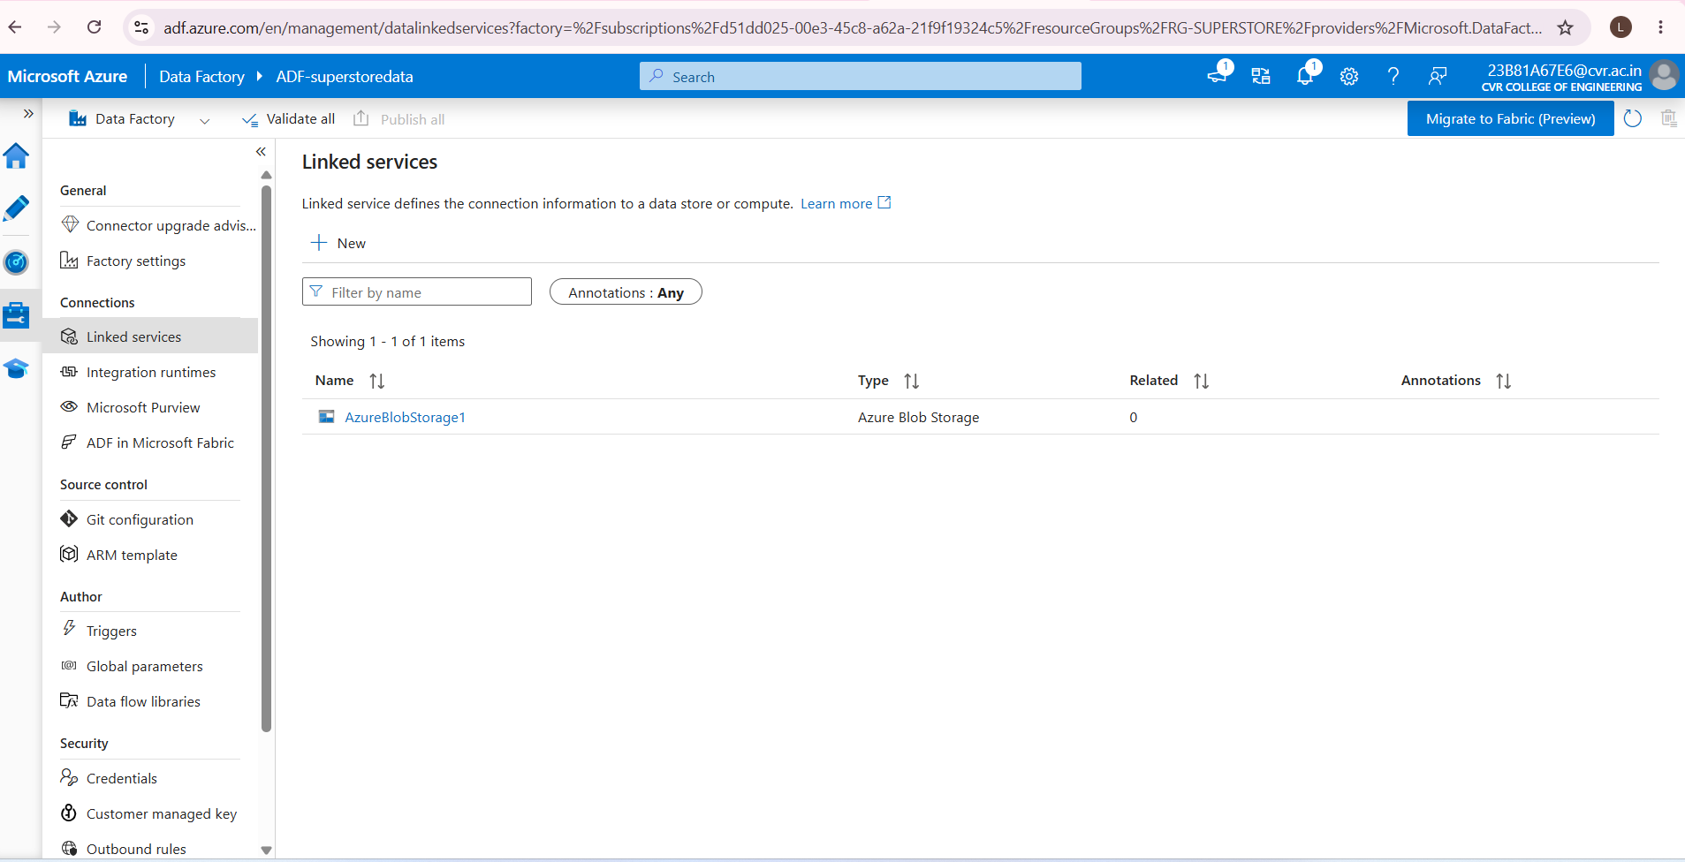
3.3 Dataset Creation
Source Dataset
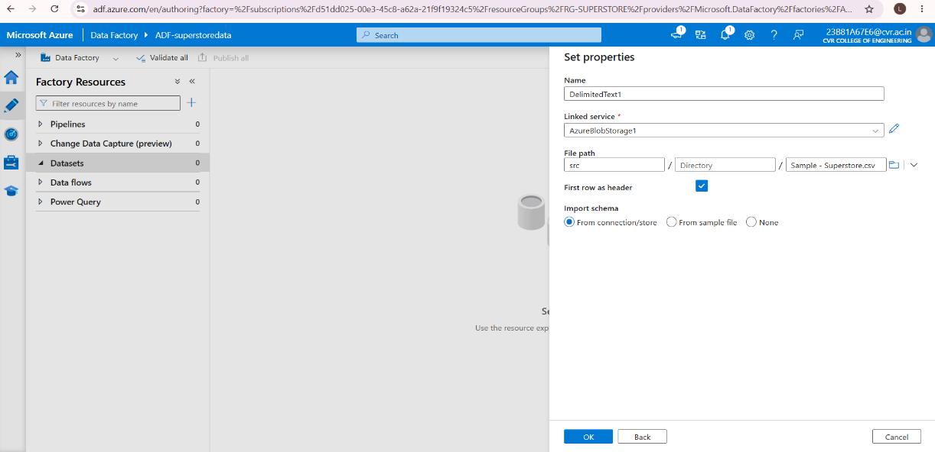
Destination Dataset
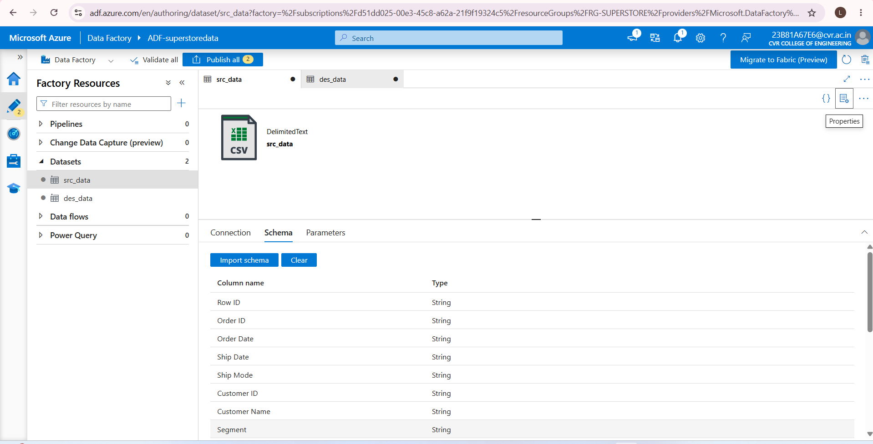
3.4 Get Metadata Activity
Output
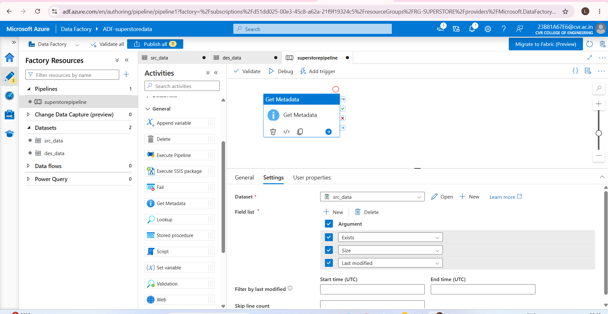

Task 4: Pipeline Development
Aim
To create a pipeline for copying data from source to destination.
Output
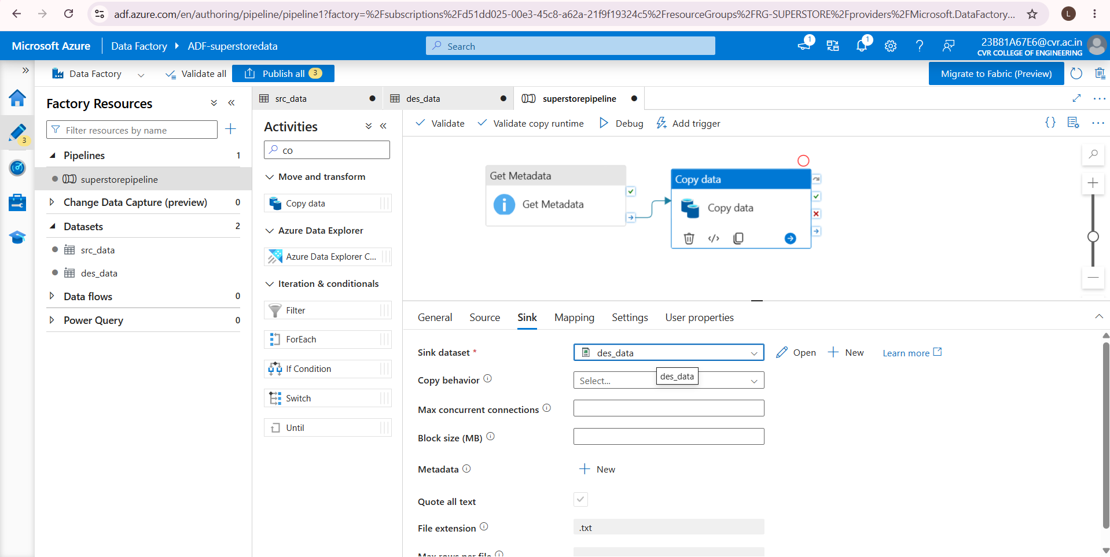
Task 5: Pipeline Execution
Aim
To execute the pipeline and verify successful completion.
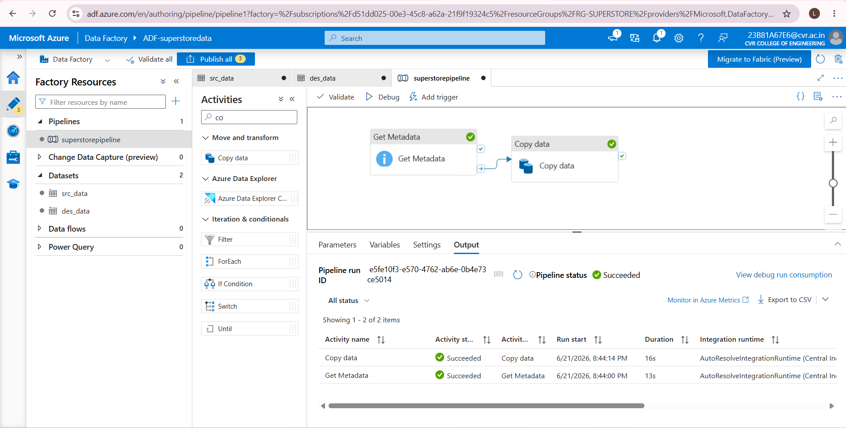

Verification of Output:
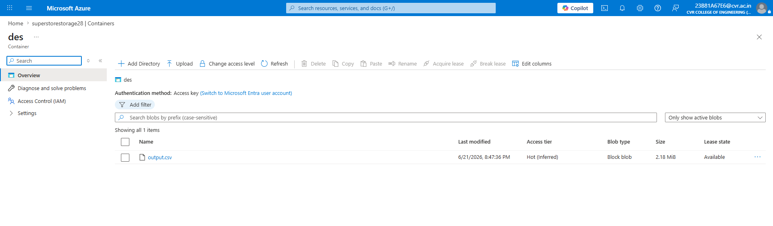
Task 6: IAM Role Assignment
Aim
To assign Azure roles for secure access.
Roles Assigned
Reader Role
Storage Blob Data Contributor role
Output
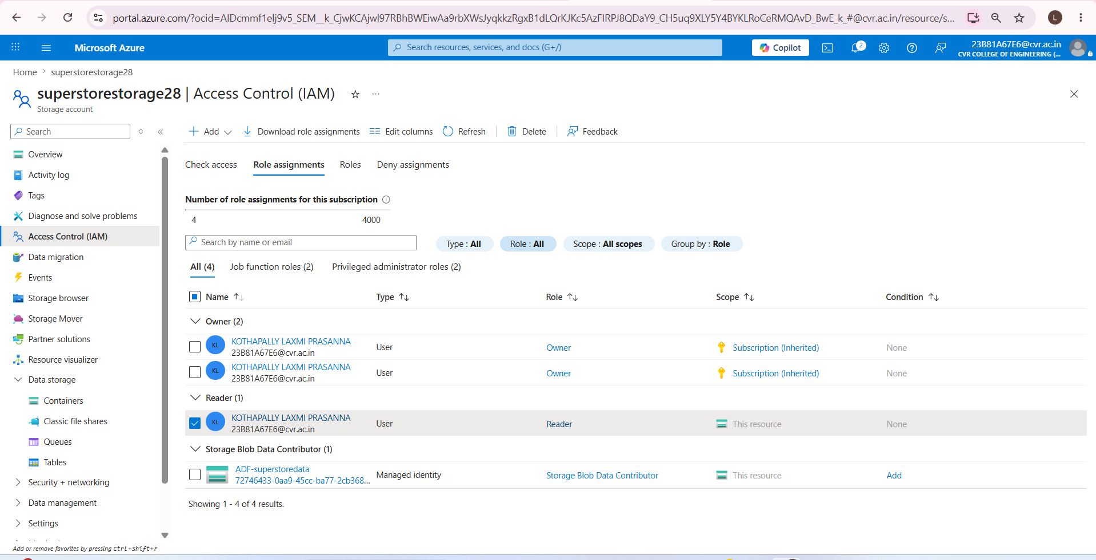

Contributor Role: Contributor role assignment was explored as part of IAM management.

