DecodeLabs Industrial Training Kit
Artificial Intelligence — Project 3
AI Recommendation Logic: Tech Stack Recommender

1. Project Overview
This project implements a content-based recommendation engine that maps a user's raw skills and career interests to the most relevant job role. Rather than relying on collaborative filtering (which needs large historical user-interaction datasets), this engine uses pure item-attribute matching — comparing a user's skill profile directly against the skill profile of each job role.
Goal: Take user input (skills/interests), match it against a dataset of job roles using similarity logic, and display the Top-3 most relevant career recommendations.

2. System Architecture (Input → Process → Output)
INPUT | PROCESS | OUTPUT
User State: at least 3 raw skills captured as text (e.g. Python, Cloud Computing, Automation) | Similarity Logic: TF-IDF vectorization + Cosine Similarity comparing the user profile against every job role | Top-N List: the 3 highest-scoring job roles, ranked by similarity score

3. Why Content-Based Filtering
Recommendation systems generally fall into two categories: Collaborative Filtering (driven by community behaviour — “users who picked this also picked that”) and Content-Based Filtering (driven purely by item attributes, independent of other users). This project uses Content-Based Filtering exclusively, which lets the engine work immediately without needing massive historical interaction data, and makes it naturally resistant to the Item Cold-Start problem.

4. Feature Engineering: TF-IDF Weighting
Machines cannot understand qualitative skill names like “Python” or “Cloud Computing” directly — they need numbers. Every skill is mapped into a shared numerical vocabulary space using TF-IDF (Term Frequency – Inverse Document Frequency):
- Term Frequency (TF): how often a skill term appears within one job role's profile, relative to that profile's total terms.
- Inverse Document Frequency (IDF): penalizes skills that appear across many job roles (generic terms) and rewards skills that are distinctive to fewer roles.
Formula used:
TF(t,d) = count(t in d) / total terms in d
IDF(t) = log(Total Job Roles / Job Roles containing t) + 1
Weight = TF(t,d) × IDF(t)

5. Similarity Scoring: Cosine Similarity
Once both the user profile and every job role are represented as TF-IDF vectors, the engine measures how closely they align using Cosine Similarity rather than Euclidean Distance. Cosine Similarity measures the angle between two vectors, making it independent of profile length/magnitude — ideal for skill lists of different sizes.
cos(θ) = (A · B) / (||A|| × ||B||)
Score 1 -> Vectors perfectly aligned (strong match)
Score 0 -> Vectors share no common skills
Score -1 -> Not possible here, since TF-IDF values are non-negative

6. The 4-Step Ranking Pipeline
- Step 1 — Ingestion: Capture at least 3 raw user skills as input.
- Step 2 — Scoring: Convert the user profile and every job role into TF-IDF vectors and compute Cosine Similarity for each role.
- Step 3 — Sorting: Rank every job role in descending order of similarity score.
- Step 4 — Filtering: Truncate the ranked list and return only the Top-3 highest-scoring job roles.

7. Dataset: raw_skills.csv
A custom dataset of 15 job roles, each tagged with its representative skills/tools, was built for this project (excerpt below):
Job Role | Skills
Data Scientist | Python, SQL, Machine Learning, Statistics, Pandas, NumPy, Visualization
DevOps Engineer | AWS, Docker, Kubernetes, CI/CD, Linux, Automation, Cloud Computing, Git
Cloud Architect | AWS, Azure, Cloud Computing, Networking, Security, Automation, Docker, Kubernetes
Full Stack Developer | JavaScript, Python, SQL, React, Node, APIs, Git, Web Design
AI Research Engineer | Python, Machine Learning, Deep Learning, Algorithms, Data Structures, Statistics, Research

(Full 15-role dataset is included in the attached raw_skills.csv file.)

8. Implementation: tech_stack_recommender.py
Key class powering the recommendation engine:
class TechStackRecommender:
def __init__(self, csv_path):
self.roles, self.documents = load_dataset(csv_path)
self.vocab = build_vocabulary(self.documents)
self.idf_scores = compute_idf(self.documents, self.vocab)
self.role_vectors = [
build_tfidf_vector(doc, self.vocab, self.idf_scores)
for doc in self.documents
]
def recommend(self, user_skills, top_n=3):
if len(user_skills) < 3:
raise ValueError("Please provide at least 3 skills.")
user_tokens = tokenize(" ".join(user_skills))
user_vector = build_tfidf_vector(user_tokens, self.vocab, self.idf_scores)
scores = []
for role, role_vector in zip(self.roles, self.role_vectors):
score = cosine_similarity(user_vector, role_vector)
scores.append((role, round(score, 4)))
scores.sort(key=lambda x: x[1], reverse=True) # Step 3: Sorting
return scores[:top_n] # Step 4: Filtering
Cosine similarity is implemented from first principles (no external ML library required):
def cosine_similarity(vec_a, vec_b):
dot_product = sum(a * b for a, b in zip(vec_a, vec_b))
mag_a = math.sqrt(sum(a * a for a in vec_a))
mag_b = math.sqrt(sum(b * b for b in vec_b))
if mag_a == 0 or mag_b == 0:
return 0.0
return dot_product / (mag_a * mag_b)

9. Sample Run — Output
Four test queries were run against the engine to validate it across different career domains:
User Skills: ['Python', 'Cloud Computing', 'Automation']
1. DevOps Engineer -> Similarity Score: 0.5514
2. Cloud Architect -> Similarity Score: 0.5363
3. QA Automation Engineer -> Similarity Score: 0.2021
User Skills: ['JavaScript', 'React', 'Web Design']
1. Full Stack Developer -> Similarity Score: 0.7331
2. Frontend Developer -> Similarity Score: 0.6161
3. Data Scientist -> Similarity Score: 0.0
User Skills: ['SQL', 'Excel', 'Statistics']
1. Business Intelligence Developer -> Similarity Score: 0.5779
2. Data Analyst -> Similarity Score: 0.5643
3. Data Scientist -> Similarity Score: 0.2527
User Skills: ['Python', 'Machine Learning', 'Deep Learning']
1. AI Research Engineer -> Similarity Score: 0.7233
2. Machine Learning Engineer -> Similarity Score: 0.6911
3. Data Scientist -> Similarity Score: 0.4052

10. Visualization
Bar chart of the Top-3 similarity scores for the query ["Python", "Cloud Computing", "Automation"]:
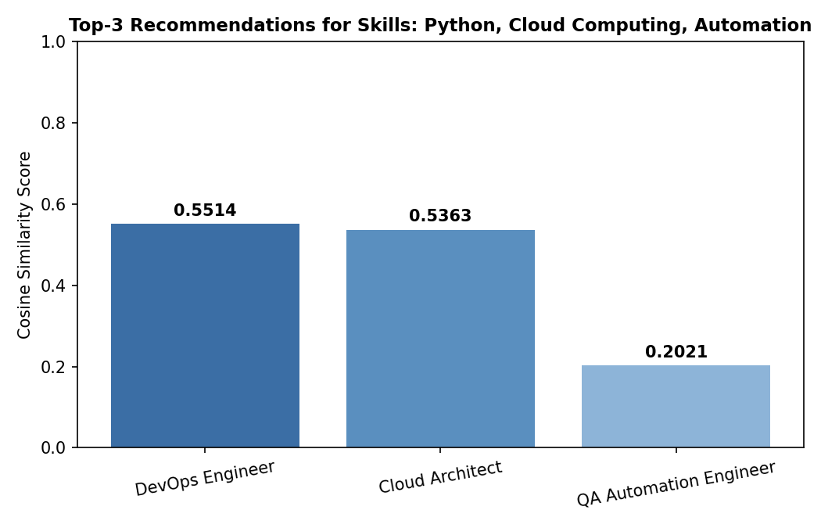

11. Handling the Cold-Start Problem
Content-Based Filtering is naturally resistant to the Item Cold-Start problem, since a brand-new job role can be recommended immediately once it has skill tags — no historical interaction data is needed. For a brand-new user with zero input skills (User Cold Start), this engine raises a validation error requiring at least 3 skills; a production system would instead fall back to an onboarding survey, trending/popular roles, or metadata inference (e.g., based on the user's educational background).

12. Key Learnings
- Content-based filtering can deliver accurate, personalized results without needing large historical datasets.
- TF-IDF weighting is essential — without it, generic skills (e.g. “Python”, appearing in many roles) would dominate the match score as much as distinctive skills.
- Cosine Similarity outperforms Euclidean Distance here because it is invariant to profile length — a role with a longer skill list isn't unfairly penalized.
- Item feature vocabulary and user input vocabulary must match exactly, or the similarity math silently fails (returns 0).

13. Conclusion
This project bridges the gap between raw user skill data and relevant career guidance through pure algorithmic logic — without relying on neural networks or collaborative filtering. The same Input → Process → Output architecture, TF-IDF feature extraction, and Cosine Similarity scoring used here are the same fundamental principles that power production recommendation engines such as Netflix and Amazon, scaled down to a transparent, explainable, from-scratch implementation.

Submission Files
- tech_stack_recommender.py — main recommendation engine
- raw_skills.csv — job role dataset (15 roles)
- similarity_chart.png — output visualization
- Project_3_AI_Recommendation_Logic_Report.pdf — this report

