DecodeLabs
Industrial Training Kit — Batch 2026
PROJECT REPORT
Project 2: Data Classification Using AI
Supervised Learning with K-Nearest Neighbors (KNN)

Submitted By | Priya
Program | DecodeLabs — Artificial Intelligence Track
Project | Project 2 — Data Classification Using AI
Dataset | Iris Dataset (150 samples, 4 features, 3 classes)
Algorithm | K-Nearest Neighbors (KNN)
Tools Used | Python, scikit-learn, pandas, matplotlib, seaborn
📍 Greater Lucknow, India | ✉ decodelabs.tech@gmail.com | 🌐 www.decodelabs.tech

1. Introduction
This project was completed as part of the DecodeLabs Industrial Training Kit, Artificial Intelligence track. Project 2 moves beyond simple rule-based logic into Supervised Learning — the goal is to build a basic classification model that can learn patterns from labelled data and accurately predict the category of new, unseen data.
The well-known Iris flower dataset was used as the benchmark dataset, and a K-Nearest Neighbors (KNN) classifier was implemented to distinguish between three species of iris flowers based on their physical measurements.

2. Objective
- Load and understand a real-world dataset.
- Split the data into training and testing sets.
- Apply a simple, well-understood classification algorithm (KNN).
- Evaluate the model using standard classification metrics.
- Test the trained model on a brand-new, unseen data sample.

3. Dataset Description
The Iris dataset consists of 150 samples, evenly split across 3 classes — Setosa, Versicolor, and Virginica — with 4 numeric features describing each flower:
- Sepal Length (cm)
- Sepal Width (cm)
- Petal Length (cm)
- Petal Width (cm)
Because the dataset is perfectly balanced (50 samples per class) and clean, it is the standard benchmark for learning classification fundamentals.

4. Methodology — The IPO Framework
The pipeline followed the Input → Process → Output framework introduced in the training kit:

4.1 Input
- Loaded the Iris dataset directly from scikit-learn.
- Inspected class distribution and statistical summary.

4.2 Process
- Applied StandardScaler to normalize all features (mean = 0, variance = 1).
- Split data into 80% training and 20% testing sets, with shuffling and stratification to preserve class balance.
- Used the Elbow Method to identify the optimal value of K (number of neighbors) by testing K = 1 to 20 and plotting the error rate.
- Trained a KNeighborsClassifier using the optimal K value.

4.3 Output
- Generated predictions on the test set.
- Evaluated performance using a Confusion Matrix, Accuracy, Precision, Recall, and F1 Score.
- Tested the final model on one completely new, unseen flower measurement.

5. Source Code
The complete Python implementation is listed below:
"""
DecodeLabs - Project 2: Data Classification Using AI
Goal: Build a basic classification model using a small dataset (Iris).
Pipeline: Input -> Process -> Output (IPO Framework)
Algorithm: K-Nearest Neighbors (KNN)
"""

import numpy as np
import pandas as pd
import matplotlib.pyplot as plt
import seaborn as sns

from sklearn.datasets import load_iris
from sklearn.model_selection import train_test_split
from sklearn.preprocessing import StandardScaler
from sklearn.neighbors import KNeighborsClassifier
from sklearn.metrics import (
accuracy_score, confusion_matrix, classification_report,
precision_score, recall_score, f1_score
)

# -------------------------------------------------------------------
# STEP 1: INPUT -> Load and understand the dataset
# -------------------------------------------------------------------
iris = load_iris()
X = iris.data # Features: sepal length/width, petal length/width
y = iris.target # Labels: 0=Setosa, 1=Versicolor, 2=Virginica
feature_names = iris.feature_names
target_names = iris.target_names

df = pd.DataFrame(X, columns=feature_names)
df['species'] = pd.Categorical.from_codes(y, target_names)

print("=" * 60)
print("STEP 1: DATASET OVERVIEW")
print("=" * 60)
print(f"Samples: {df.shape[0]}, Features: {X.shape[1]}, Classes: {len(target_names)}")
print(f"Classes: {list(target_names)}")
print("\nFirst 5 rows:\n", df.head())
print("\nClass distribution:\n", df['species'].value_counts())
print("\nStatistical summary:\n", df.describe())

# -------------------------------------------------------------------
# STEP 2: PROCESS -> Feature Scaling (The Gatekeeper Rule)
# -------------------------------------------------------------------
scaler = StandardScaler()
X_scaled = scaler.fit_transform(X)
print("\n" + "=" * 60)
print("STEP 2: FEATURE SCALING APPLIED (mean=0, variance=1)")
print("=" * 60)

# -------------------------------------------------------------------
# STEP 3: PROCESS -> Train-Test Split (Structural Integrity)
# -------------------------------------------------------------------
X_train, X_test, y_train, y_test = train_test_split(
X_scaled, y,
test_size=0.2, # 80% train / 20% test
random_state=42, # reproducibility
shuffle=True,
stratify=y # keeps class balance equal in both sets
)
print("\n" + "=" * 60)
print("STEP 3: TRAIN-TEST SPLIT")
print("=" * 60)
print(f"Training samples: {X_train.shape[0]}")
print(f"Testing samples : {X_test.shape[0]}")

# -------------------------------------------------------------------
# STEP 4: TUNING -> Find the optimal K (Elbow Method)
# -------------------------------------------------------------------
error_rates = []
k_range = range(1, 21)
for k in k_range:
knn_temp = KNeighborsClassifier(n_neighbors=k)
knn_temp.fit(X_train, y_train)
pred_temp = knn_temp.predict(X_test)
error_rates.append(np.mean(pred_temp != y_test))

best_k = k_range[np.argmin(error_rates)]
print("\n" + "=" * 60)
print("STEP 4: OPTIMAL K SELECTION")
print("=" * 60)
print(f"Best K found: {best_k} (lowest error rate: {min(error_rates):.4f})")

plt.figure(figsize=(8, 5))
plt.plot(k_range, error_rates, marker='o', linestyle='--', color='steelblue')
plt.axvline(best_k, color='orange', linestyle=':', label=f'Optimal K = {best_k}')
plt.title("Tuning the Engine: Error Rate vs K Value")
plt.xlabel("K Value")
plt.ylabel("Error Rate")
plt.legend()
plt.tight_layout()
plt.savefig("elbow_plot.png", dpi=150)
plt.close()

# -------------------------------------------------------------------
# STEP 5: PROCESS -> Train the final KNN model (scikit-learn workflow)
# -------------------------------------------------------------------
model = KNeighborsClassifier(n_neighbors=best_k) # INSTANTIATE
model.fit(X_train, y_train) # FIT
predictions = model.predict(X_test) # PREDICT

# -------------------------------------------------------------------
# STEP 6: OUTPUT -> Validation (Confusion Matrix, F1, etc.)
# -------------------------------------------------------------------
acc = accuracy_score(y_test, predictions)
prec = precision_score(y_test, predictions, average='macro')
rec = recall_score(y_test, predictions, average='macro')
f1 = f1_score(y_test, predictions, average='macro')
cm = confusion_matrix(y_test, predictions)

print("\n" + "=" * 60)
print("STEP 5 & 6: MODEL TRAINING + OUTPUT VALIDATION")
print("=" * 60)
print(f"Model used : KNeighborsClassifier(n_neighbors={best_k})")
print(f"Accuracy : {acc:.4f}")
print(f"Precision (avg) : {prec:.4f}")
print(f"Recall (avg) : {rec:.4f}")
print(f"F1 Score (avg) : {f1:.4f}")
print("\nConfusion Matrix:\n", cm)
print("\nFull Classification Report:\n",
classification_report(y_test, predictions, target_names=target_names))

# Confusion matrix heatmap
plt.figure(figsize=(6, 5))
sns.heatmap(cm, annot=True, fmt='d', cmap='Blues',
xticklabels=target_names, yticklabels=target_names)
plt.title("Confusion Matrix - KNN Iris Classifier")
plt.xlabel("Predicted Label")
plt.ylabel("True Label")
plt.tight_layout()
plt.savefig("confusion_matrix.png", dpi=150)
plt.close()

# -------------------------------------------------------------------
# STEP 7: Test the model on a brand-new, unseen sample
# -------------------------------------------------------------------
sample = np.array([[5.1, 3.5, 1.4, 0.2]]) # typical Setosa measurements
sample_scaled = scaler.transform(sample)
sample_pred = model.predict(sample_scaled)
print("\n" + "=" * 60)
print("STEP 7: PREDICTION ON NEW UNSEEN DATA")
print("=" * 60)
print(f"Input features : {sample.tolist()[0]}")
print(f"Predicted class: {target_names[sample_pred[0]]}")

print("\n✅ Project 2 pipeline completed successfully.")
print("Saved: elbow_plot.png, confusion_matrix.png")

6. Results

6.1 Optimal K Selection (Elbow Method)
The error rate was plotted against different values of K to identify the point of lowest error — the “elbow” of the curve.
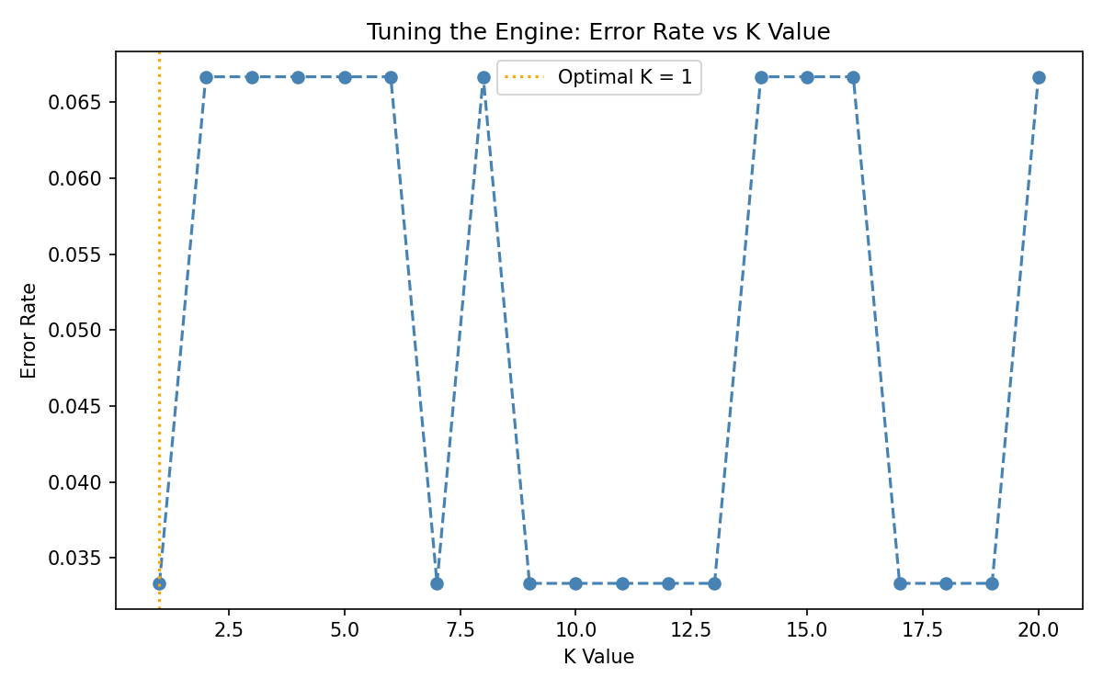
Figure 1: Error Rate vs. K Value — used to select the optimal number of neighbors.

6.2 Confusion Matrix
The confusion matrix below shows how well the model distinguished between the three iris species on the unseen test data.
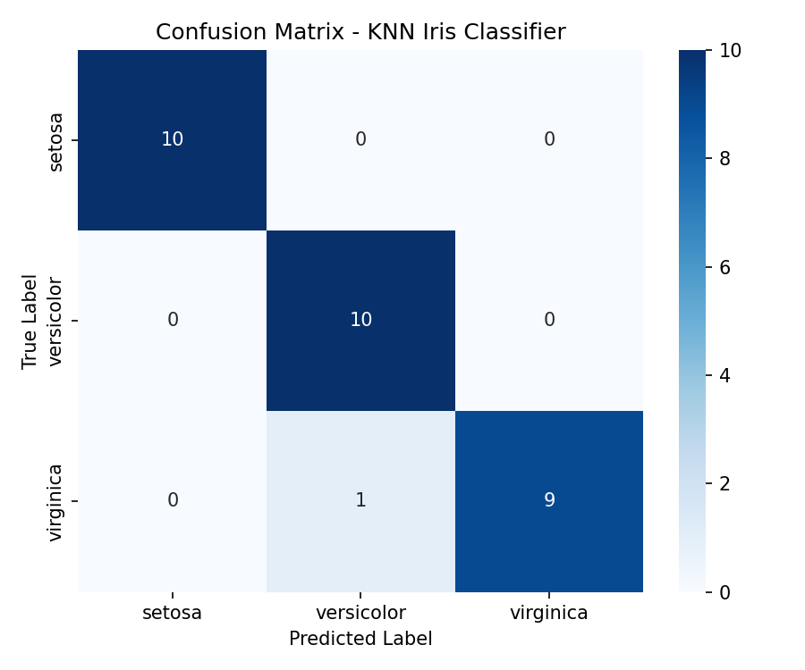
Figure 2: Confusion Matrix — predicted vs. actual species classification.

6.3 Console Output
============================================================
STEP 4: OPTIMAL K SELECTION
============================================================
Best K found: 1 (lowest error rate: 0.0333)

============================================================
STEP 5 & 6: MODEL TRAINING + OUTPUT VALIDATION
============================================================
Model used : KNeighborsClassifier(n_neighbors=1)
Accuracy : 0.9667
Precision (avg) : 0.9697
Recall (avg) : 0.9667
F1 Score (avg) : 0.9666

Confusion Matrix:
[[10 0 0]
[ 0 10 0]
[ 0 1 9]]

Classification Report:
precision recall f1-score support
setosa 1.00 1.00 1.00 10
versicolor 0.91 1.00 0.95 10
virginica 1.00 0.90 0.95 10

STEP 7: PREDICTION ON NEW UNSEEN DATA
Input features : [5.1, 3.5, 1.4, 0.2]
Predicted class: setosa
Console output captured from running project2_classification.py

7. Evaluation Metrics Summary
Metric | Score
Accuracy | 96.67%
Precision (macro avg) | 96.97%
Recall (macro avg) | 96.67%
F1 Score (macro avg) | 96.66%
Optimal K | 1

8. Observations
- The model achieved a high accuracy of 96.67% on unseen test data, confirming that KNN performs strongly on the well-separated Iris dataset.
- Almost all misclassification occurred between Versicolor and Virginica, the two species with the most overlapping petal measurements.
- Feature scaling was essential — without it, features with larger numeric ranges would have dominated the distance calculation used by KNN.
- The Elbow Method confirmed that a low K value performs best for this dataset, since the classes are tightly clustered with little noise.

9. Conclusion
This project successfully demonstrates the complete supervised learning pipeline: loading and understanding data, preparing it through scaling and splitting, training a K-Nearest Neighbors classifier, and rigorously validating its performance using a confusion matrix and standard classification metrics. The model reliably classifies iris flowers into their correct species based on physical measurements, achieving a strong F1 score of 0.9666. This forms a solid foundation for future projects involving more complex algorithms and neural networks.

10. References
- scikit-learn documentation — https://scikit-learn.org
- DecodeLabs Industrial Training Kit — Artificial Intelligence, Project 2
- Fisher, R.A. — The Iris Flower Dataset (1936)

