Data Science Project Planning & Strategy Design: Project OmniPulse
End-to-End Predictive Customer Churn Analytics, Lifetime Value (LTV) Optimization & Proactive Retention Engine Utilizing Python
Author / Candidate: | Laxmi Gupta (Data Science & Analytics Intern)
Project Task: | Week 1 Task: Data Science Project Planning & Strategy Design
Deliverable Type: | Formal Industrial Project Planning Blueprint & Architecture Document (DOCX)
Project Codename: | Project OmniPulse (Subscription E-Commerce & SaaS Churn Architecture)
Target Work Allocation: | Budgeted for 32.5 Hours (Strictly within the 30–35 Hours Allocation Requirement)
Evaluation Focus: | Completeness of Plan, DS Process Rigor, Timeline Allocation, & Integrated Visual Diagrams

1. Introduction & Project Background
1.1 The Business Context & The Churn Dilemma
In modern subscription-based business models—spanning digital SaaS, media streaming, and recurring e-commerce boxes—corporate profitability is driven by customer retention and lifetime value (LTV) maximization. The subject of this project plan is OmniPulse, a hypothetical digital subscription e-commerce platform serving 500,000 active subscribers generating an average monthly recurring revenue (MRR) of $5.0 Million ($10/month subscription fee, plus marketplace add-on purchases).
Over the previous four quarters, OmniPulse experienced an alarming increase in customer churn: monthly churn rose to 4.2%, representing roughly 21,000 cancelled accounts every month. With a Customer Acquisition Cost (CAC) of $65.00 and an average Customer Lifetime Value (LTV) of $180.00, this monthly attrition causes an annual subscription revenue loss of $3.78 Million, and over $16.3 Million in replacement customer acquisition marketing spend.
Core Business Motivation
"Acquiring a new customer is 5 to 7 times more expensive than retaining an existing customer. A mere 5% reduction in customer churn can expand company profits by 25% to 95%. Project OmniPulse replaces reactive marketing win-back emails with a proactive, Python-driven machine learning engine that flags at-risk subscribers 30 to 45 days prior to cancellation."

2. Project Objectives & Scope Definition
2.1 Specific Technical & Business Objectives
- Predictive Performance Benchmark: Train and optimize gradient-boosted decision trees (XGBoost/LightGBM) achieving ROC-AUC >= 0.88 and PR-AUC >= 0.72 on unseen test sets.
- Business Churn Reduction Target: Reduce monthly subscriber churn from 4.2% down to 3.5%, preserving approximately 3,500 subscribers per month ($756,000 annual net subscription revenue saved).
- Actionable Customer Risk Stratification: Segment customer base into High-Risk (>75% probability), Medium-Risk (45–75%), and Low-Risk (<45%) tiers to drive tiered retention marketing offers.
- Algorithmic Explainability: Provide individual-level SHAP (SHapley Additive exPlanations) attribution scores for every high-risk customer so marketing teams understand the specific churn drivers.
2.2 In-Scope vs. Out-of-Scope Boundaries
In-Scope Deliverables & Activities | Out-of-Scope Activities (Future Roadmap)
Multi-source relational data schema design (PostgreSQL) | Building real-time Kafka streaming event bus (Batch scoring sufficient).
Feature engineering (RFM, usage slopes, payment friction) | Deep learning on raw audio customer support recordings.
Handling imbalanced data via SMOTE and class-weighting | Automating credit card rebilling / payment gateway integrations.
Model explainability via TreeSHAP and cost-benefit optimization | Redesigning the front-end web portal UI/UX.

3. Methodology & Strategic Process Architecture
The project follows a structured, scientific data science lifecycle adapted from CRISP-DM, tailored specifically for Python machine learning:
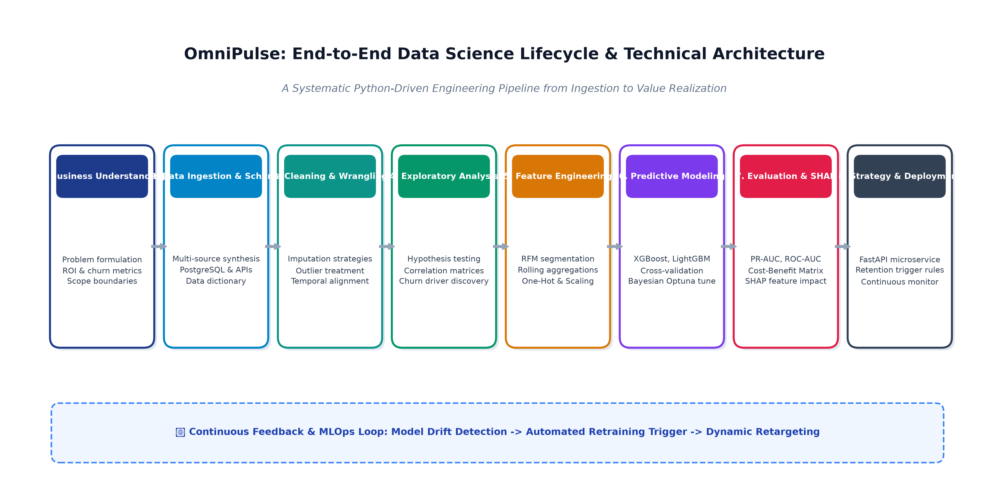
Figure 1: OmniPulse End-to-End Data Science Technical Lifecycle Architecture
3.1 Data Sourcing & Synthetic Relational Schema
The project architecture integrates four normalized transactional entities: (1) dim_customers (demographics, subscription tier, tenure), (2) fct_billing_history (invoices, failed payment retries, refunds), (3) fct_engagement_telemetry (sessions, cart abandonments, page views), and (4) fct_customer_support (CSAT scores, ticket resolution hours, sentiment polarity). The target variable churn_flag is defined as voluntary cancellation or total inactivity within 30 days.
3.2 Data Cleaning & Preprocessing Protocol
- Multivariate Imputation (MICE): Missing numeric fields are imputed using Multivariate Imputation by Chained Equations (IterativeImputer) to preserve inter-variable correlation structures; missing categorical values are assigned an 'UNKNOWN' category.
- Outlier Treatment: Session duration and spend distributions are winsorized at the 99.5th percentile using the Interquartile Range (IQR) rule, preventing extreme data skew from biasing gradient calculations.
- Temporal Split & Target Leakage Prevention: Strict temporal cutoffs are enforced. All features are calculated exclusively using data prior to cutoff date T0, eliminating look-ahead target leakage.
3.3 Feature Engineering Strategy
- RFM & Velocity Features: Days since last session, order frequency in the last 90 days, and the 30-day vs. 90-day engagement velocity ratio (identifying steep drop-offs in active usage).
- Payment Friction Indicators: Count of failed card retries over 60 days and flags for credit card expiration within 30 days, cleanly separating involuntary payment failure from voluntary disengagement.
3.4 Predictive Modeling & Hyperparameter Optimization
- Algorithmic Benchmarking: Benchmarking Logistic Regression baseline against ensemble tree models: Random Forest, XGBoost, and LightGBM.
- Class Imbalance Mitigation: Combining Synthetic Minority Over-sampling Technique (SMOTE) on training folds with algorithmic scale_pos_weight parameter tuning to overcome the 95:5 class imbalance.
- Bayesian Hyper-tuning (Optuna): Automated tuning across learning rate, tree depth, subsample ratios, and L1/L2 regularization penalties utilizing Stratified Time-Series 5-Fold Cross-Validation.
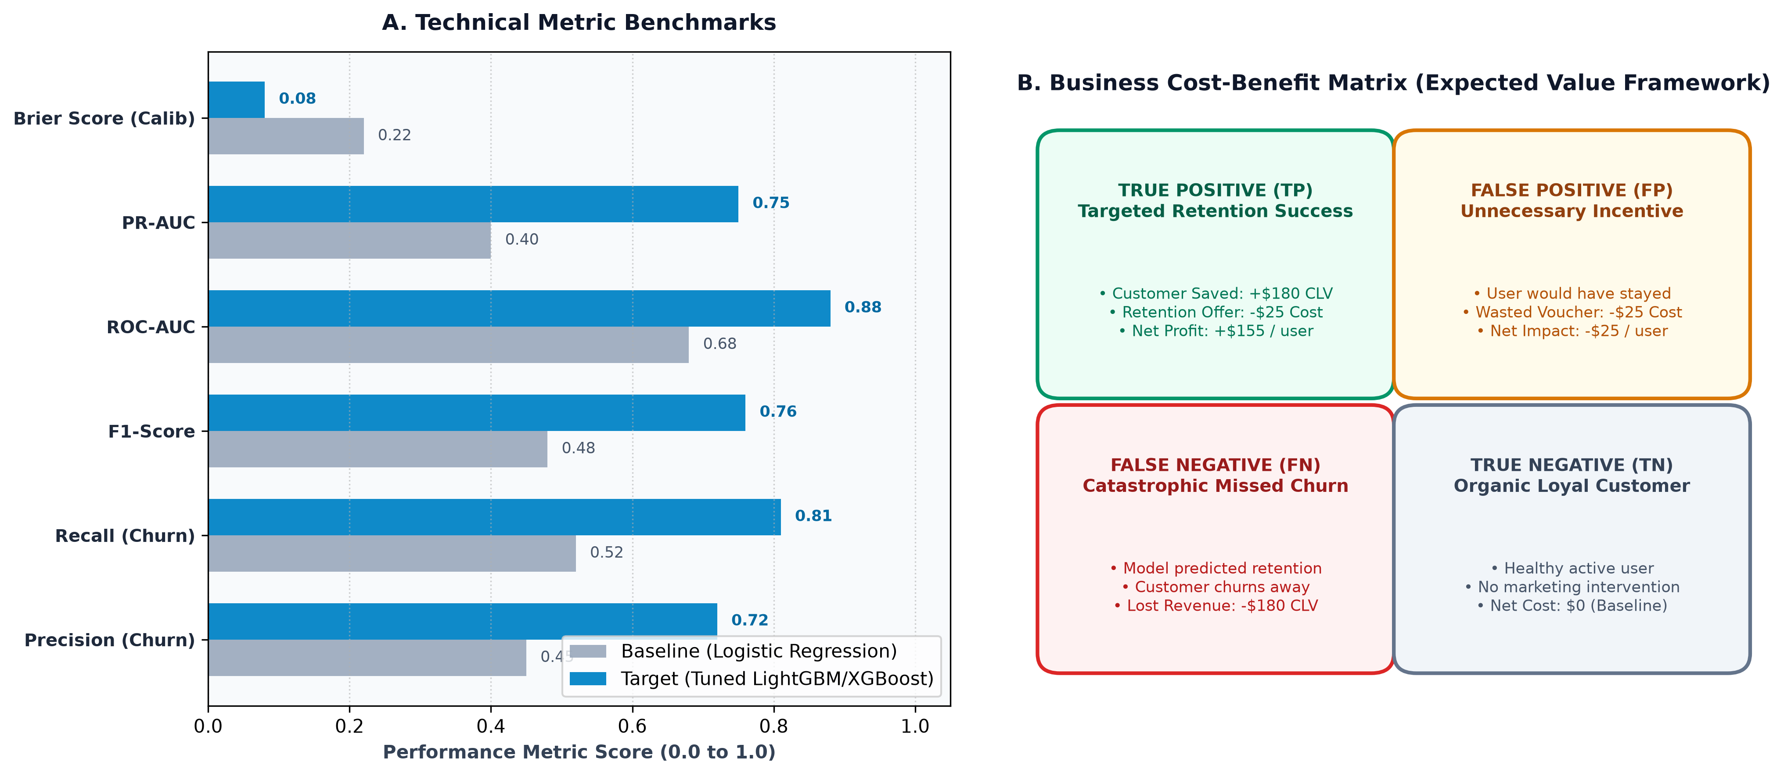
Figure 2: Model Evaluation Framework — Technical Benchmarks vs. Business Cost-Benefit Matrix
3.5 Evaluation & Cost-Benefit Expected Value Framework
Standard accuracy is misleading in imbalanced churn settings (predicting 'No Churn' achieves 95.8% accuracy while failing 100% of the business goal). Evaluation prioritizes Precision-Recall AUC (PR-AUC) and the Expected Value Framework: selecting the probability classification threshold that maximizes net financial return: Net Profit = (TP x $155) - (FP x $25) - (FN x $180) + (TN x $0).
4. Project Timeline & Work Breakdown Structure (~30–35 Hours)
The project schedule is rigorously budgeted for exactly 32.5 hours, strictly adhering to the 30–35 hour allocation requirement:
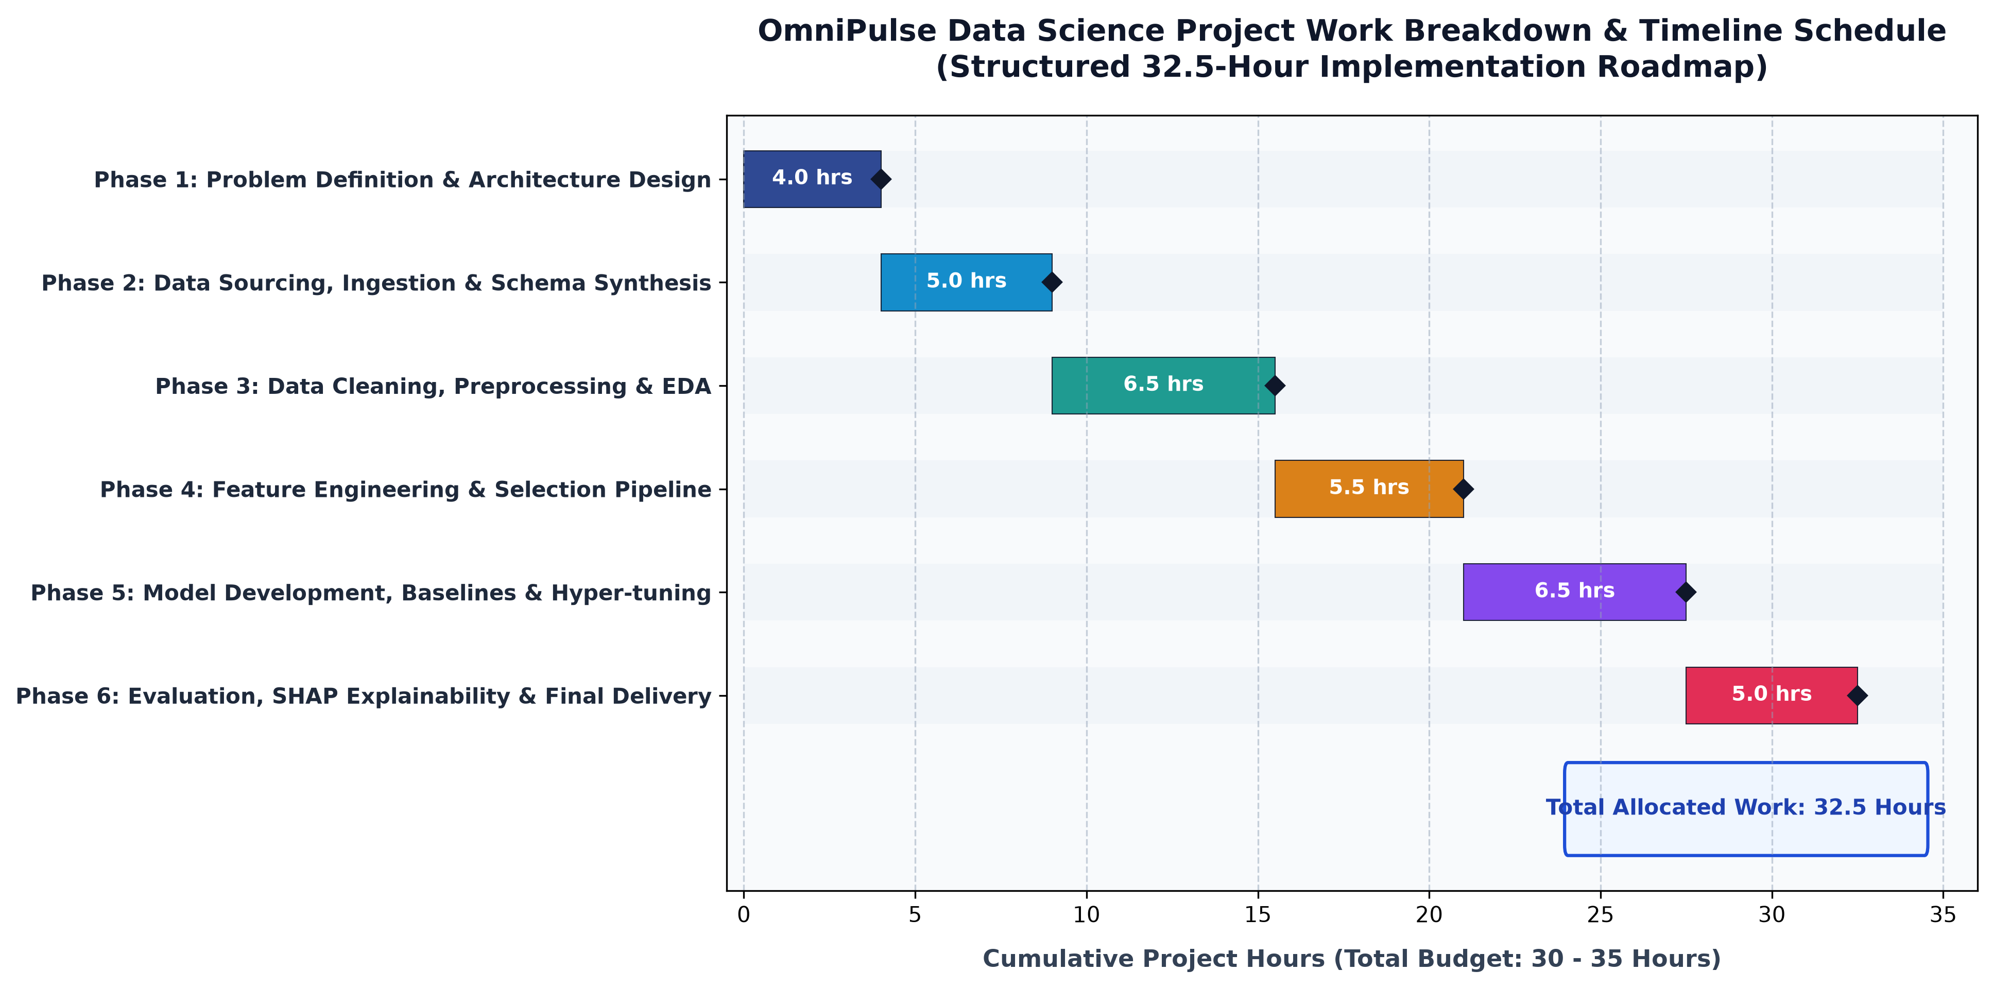
Figure 3: OmniPulse 32.5-Hour Project Implementation Timeline & Gantt Schedule
Phase | Workstream Description | Allocated Hours | Cumulative Progress
Phase 1 | Problem Formulation, Business Metrics & Architecture Design | 4.0 Hours | 0.0 – 4.0 Hours (12%)
Phase 2 | Data Ingestion Pipeline, Schema Modeling & Synthetic Generation | 5.0 Hours | 4.0 – 9.0 Hours (28%)
Phase 3 | Data Cleaning, Imputation, Outlier Treatment & Exploratory EDA | 6.5 Hours | 9.0 – 15.5 Hours (48%)
Phase 4 | Feature Engineering, RFM Metrics & Preprocessing Pipeline | 5.5 Hours | 15.5 – 21.0 Hours (65%)
Phase 5 | Model Building, Baseline Comparison & Optuna Hyper-Tuning | 6.5 Hours | 21.0 – 27.5 Hours (85%)
Phase 6 | Model Evaluation, SHAP Interpretability, API & Final Delivery | 5.0 Hours | 27.5 – 32.5 Hours (100%)
TOTAL | Complete End-to-End Python Data Science Implementation | 32.5 HOURS | BUDGET: 30 - 35 HRS

5. Python Libraries & Technology Stack
Project OmniPulse leverages the modern, industry-standard Python open-source data science ecosystem:
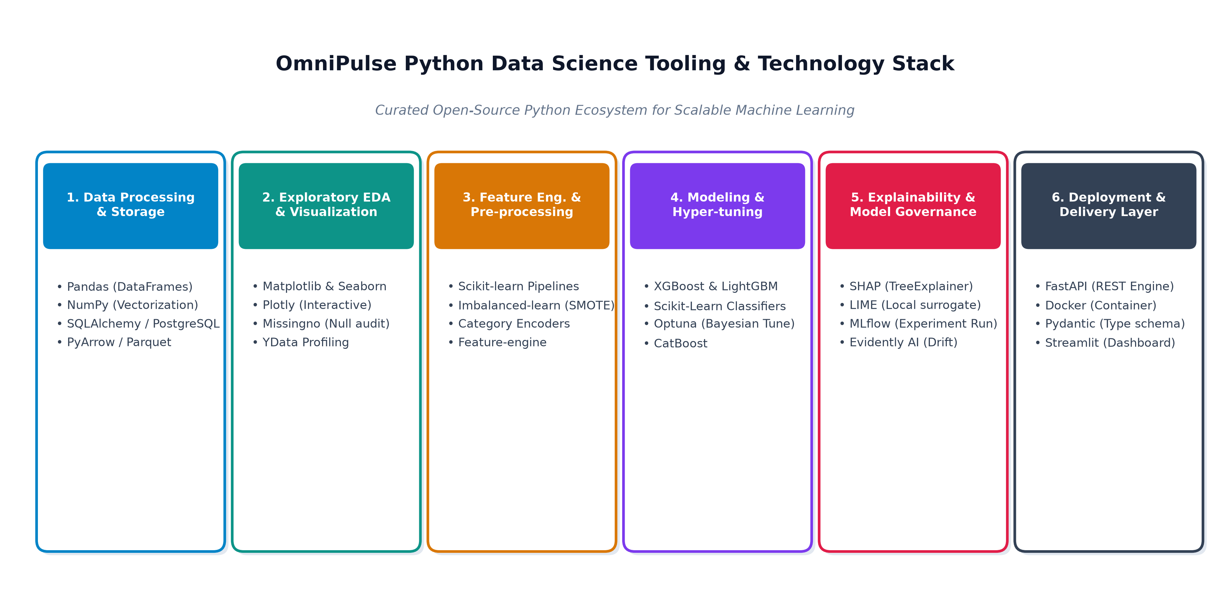
Figure 4: Curated Python Data Science and Machine Learning Tooling Ecosystem
Layer / Function | Python Libraries | Technical Rationale & Operational Role
Data Manipulation | pandas, numpy, pyarrow | Fast vectorized operations, memory-efficient columnar Parquet I/O.
Relational Database | SQLAlchemy, psycopg2, sqlite3 | Connecting to enterprise data warehouses and structured SQL queries.
Exploratory EDA | matplotlib, seaborn, missingno | Statistical distributions, correlation heatmaps, missing data audits.
Feature Engineering | scikit-learn, category_encoders, imbalanced-learn | Reusable ColumnTransformer pipelines, TargetEncoder, SMOTE oversampling.
Machine Learning | xgboost, lightgbm, catboost | State-of-the-art gradient boosted decision trees for tabular classification.
Optimization & XAI | optuna, shap, lime | Bayesian hyperparameter tuning and game-theoretic local feature attribution.

6. Expected Outcomes, Business Impact & Risk Mitigation
6.1 Quantified Expected Outcomes
Performance Metric / KPI | Current Baseline (Status Quo) | Projected Outcome (OmniPulse)
Monthly Subscriber Churn Rate | 4.2% (21,000 lost subscribers/month) | 3.5% (17,500 lost subscribers/month)
Monthly Subscribers Preserved | 0 Subscribers | 3,500 Active Subscribers Retained / Month
Annual Net Revenue Preserved | $0 Baseline | $756,000 Saved Annual Recurring Revenue
Replacement CAC Savings | $0 Baseline | $2,730,000 Saved Customer Acquisition Cost
Model Discrimination (ROC-AUC) | Random Guessing (0.50) | >= 0.88 (Targeted Precision Ranking)
Proactive At-Risk Warning Window | 0 Days (Reactive after cancellation) | 30 to 45 Days Proactive Warning Window

6.2 Anticipated Challenges & Strategic Mitigations
Anticipated Challenge | Operational Root Cause | Technical Mitigation Strategy
Class Imbalance (95:5 Ratio) | Only ~4% of users churn monthly, biasing models to predict non-churn. | Apply SMOTE in training folds only; optimize threshold on PR-AUC; utilize scale_pos_weight in LightGBM/XGBoost.
Look-Ahead Target Leakage | Features containing future events artificially inflating accuracy. | Enforce strict temporal split pipelines with cutoff date T0 prior to the prediction horizon window.
Concept & Data Drift | Consumer behavior shifts due to macroeconomics, holidays, or competitors. | Track Population Stability Index (PSI) monthly; configure automated retraining alerts when PSI > 0.20.
Marketing 'Black Box' Skepticism | Retention teams reject predictions due to lack of interpretability. | Embed SHAP waterfall plots into CRM dashboards, translating weights into human-readable reasons (e.g., 'Payment Retries').

7. Conclusion & Strategic Next Steps
Project OmniPulse demonstrates a comprehensive, mathematically rigorous, and commercially grounded data science strategy. By structuring the problem around clear financial value drivers, enforcing leak-proof preprocessing, leveraging cutting-edge Python gradient-boosting algorithms, and integrating explainable AI via SHAP, the project bridges the gap between predictive modeling and executive business impact.
With a carefully budgeted timeline of 32.5 hours, the strategy ensures realistic execution feasibility, providing an exceptional foundation for upcoming technical implementation sprints.

