**Tasklist-1**

**Practice What You Learnt (Level 1)**

**PART-1**

1. **Import the Business data file into Microsoft PowerBI.**

* Launch the Power BI Desktop application on your computer.
* On the Home tab, click on "Get Data."
* Choose the data source that matches your Business data file. example, if your file is an Excel file, select "Excel."
* Browse to the location of your Business data file and select it.

1. **Load only the “Account” sheet from the workbook after transforming the data.**

* After selecting your file, Power BI will show a preview of the data.
* In the Navigator window, select only the "Account" sheet by checking its checkbox. Then click "Transform Data."
* This will open the Power query Editor. Here, you can perform various transformations on the "Account" sheet data.
* Once you have transformed the data as needed, click "Close & Apply" in the Power Query Editor. This will load the transformed "Account" sheet data into Power BI.
* Now you can use the transformed "Account" sheet data to create visualizations in Power BI.

**3. Represent the data as per the given criteria:**

**(3.a) Represent the data, which includes the total count of account numbers against the country, in a tabular format.**

* Go to the "Report" view in Power BI Desktop.
* Click on the "Table" visualization in the Visualizations pane.
* In the Fields pane, drag the "Country" field to the "Values" area of the Table visualization.
* Next, drag the "Account Number" field to the "Values" area as well.
* By default, Power BI might sum or show individual account numbers. To show the count:
* Click on the drop-down arrow next to the "Account Number" field in the Values area of the Visualizations pane.
* Select "Count" from the list of available aggregations.
* You can adjust the layout, font size, and other formatting options using the Format pane to make the table more readable.

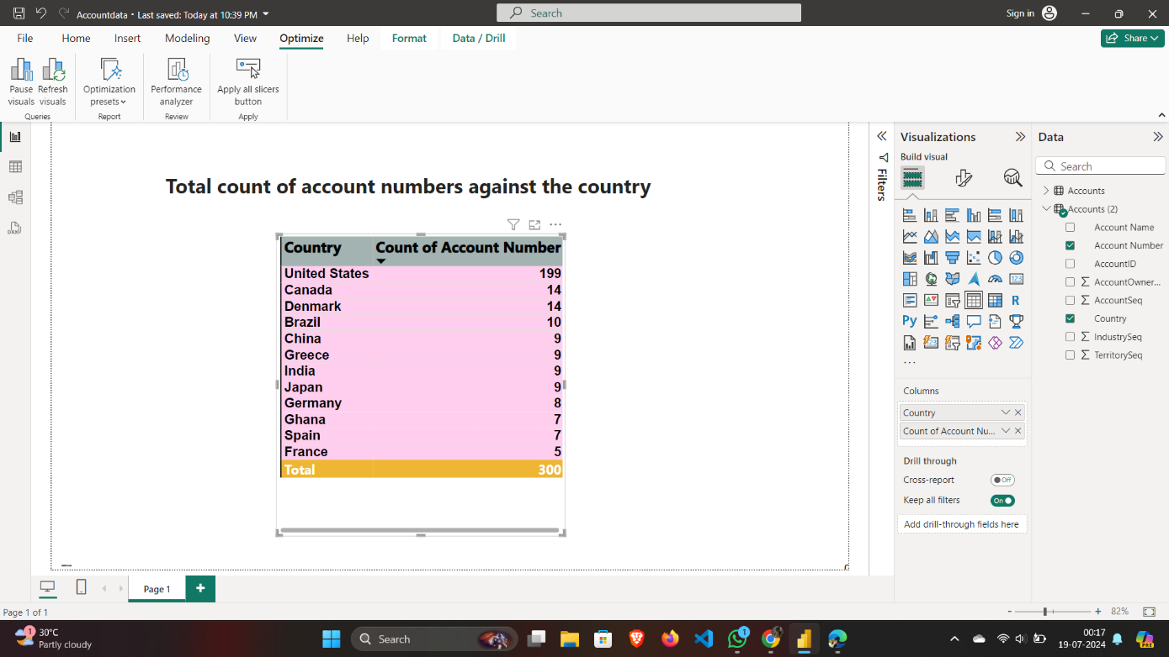

**(3.b) Insert another table and represent the data on the country-wise Account holder's name.**

* Go to the "Report" view in Power BI Desktop.
* Click on the "Table" visualization in the Visualizations pane to create a new table.
* In the Fields pane, drag the "Country" field to the "Values" area of the Table visualization.
* Next, drag the "Account Holder's Name" field to the "Values" area of the Table visualization.
* You can adjust the layout, font size, and other formatting options using the Format pane to make the table more readable.

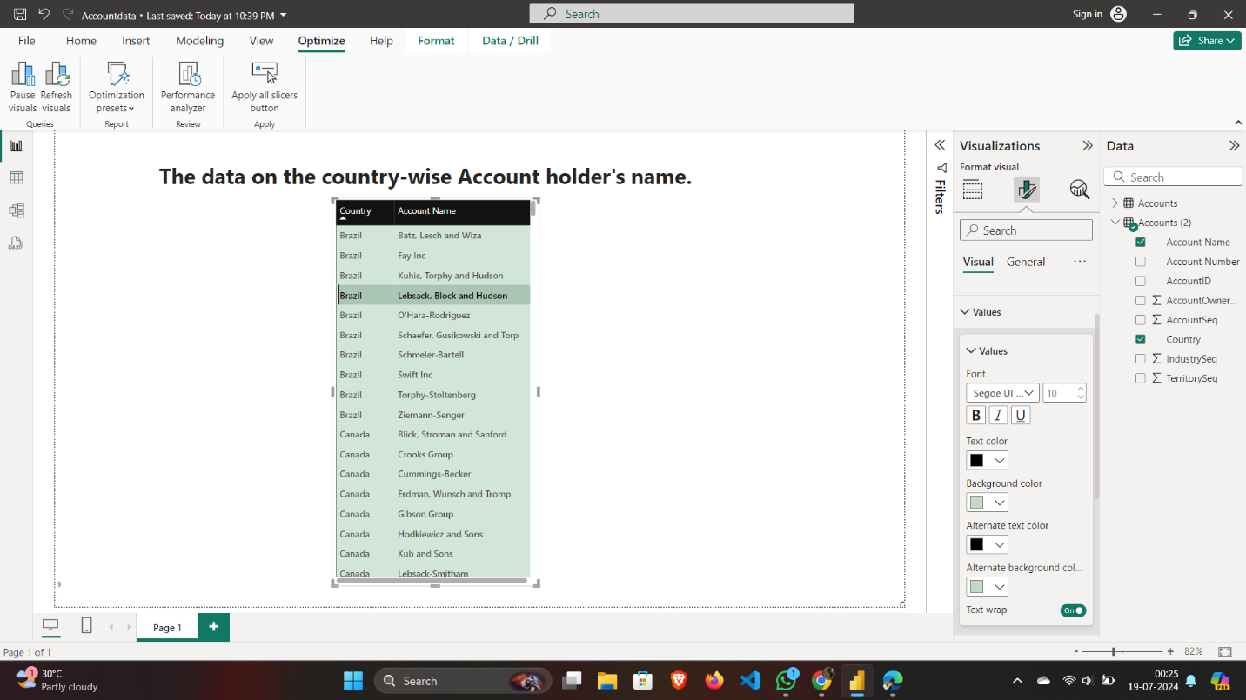

**(3.c) Insert a slicer from the visualization section and add a country-wise filter**

* Go to the "Report" view in Power BI Desktop.
* Click on the "Slicer" visualization in the Visualizations pane. This will create a blank slicer on your report canvas.
* In the Fields pane, find and drag the "Country" field to the "Field" area of the slicer visualization.
* Position and Resize the Slicer
* You can customize the appearance and functionality of the slicer using the Format pane.

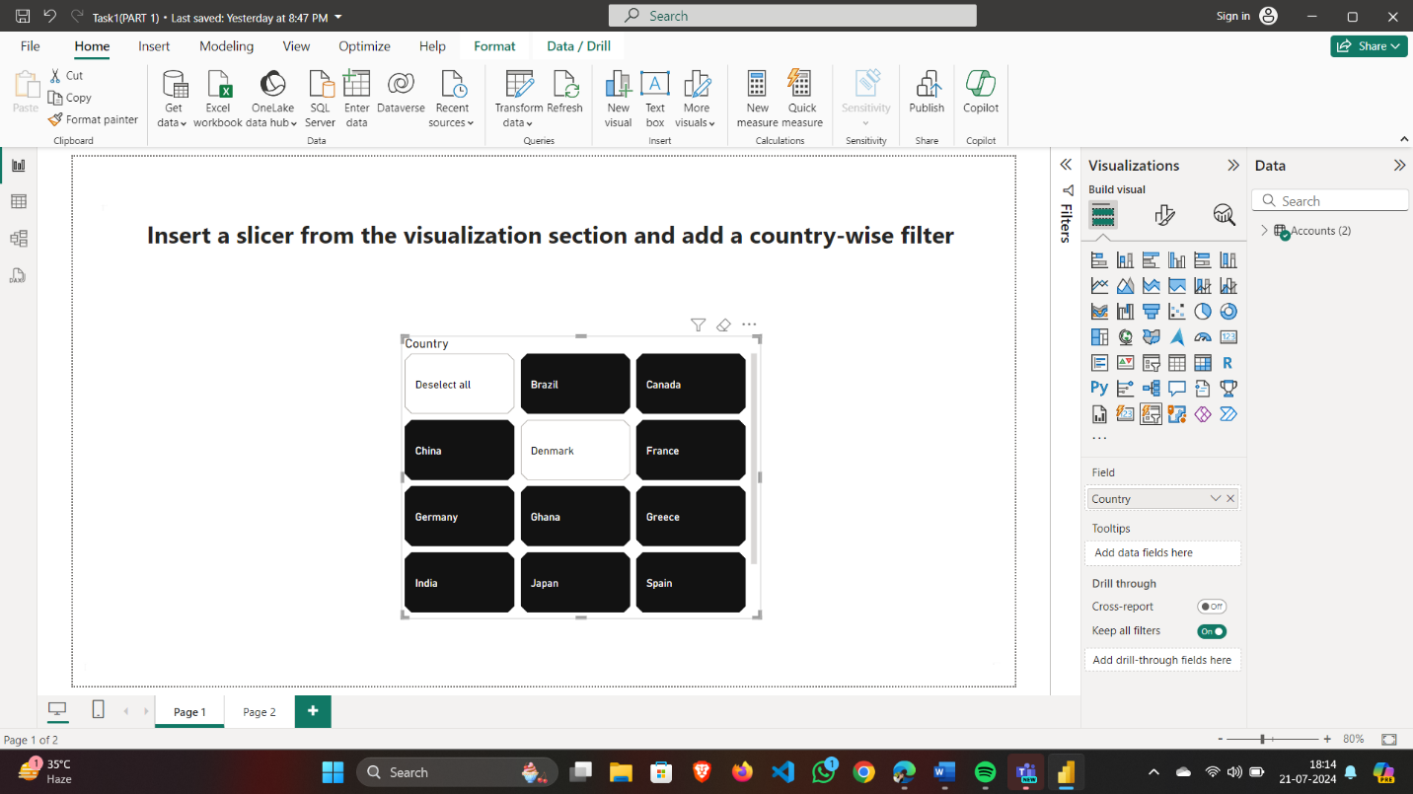

**(3.d) Represent the data of India, Brazil, Greece, and France together.**

* Go to the "Report" view in Power BI Desktop.
* Click on the "Table" visualization in the Visualizations pane.
* In the Fields pane, drag all the field of “Account” field to the "Values" area of the Table visualization.
* Use the Filters pane to include only the data for India, Brazil, Greece, and France.

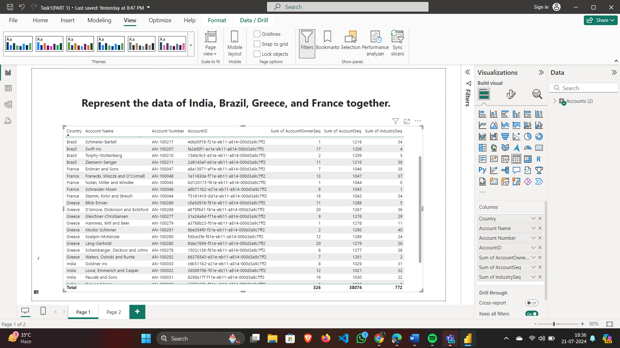

**Final Dashboard will look like:**

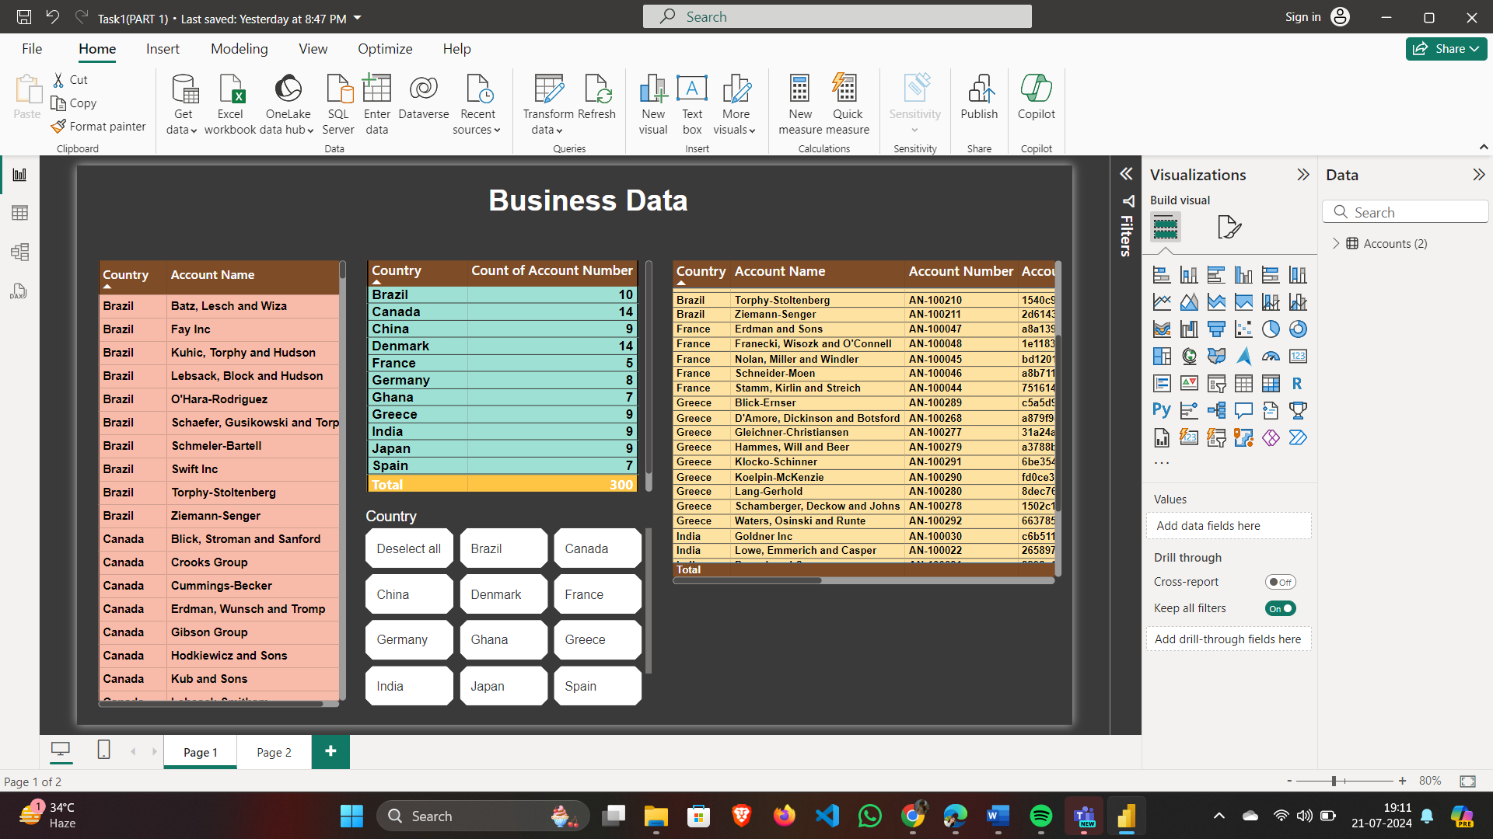

**PART-2**

**1. Add a page into PowerBI and import the worksheets named Accounts, Industry & Opportunities from the same Business data file.**

* At the bottom of the Power BI Desktop, click the "+" icon to add a new page.
* Click on the "Home" tab.
* Click on "Get Data."
* Select "Excel".
* Locate and select your Business data file.
* In the Navigator window, check the boxes next to "Accounts," "Industry," and "Opportunities."
* You can either click "Load" to load the data directly or click "Transform Data" if you need to make modifications in Power Query Editor before loading.
* If you click "Transform Data," you can apply any necessary transformations or cleaning steps, then click "Close & Load" to load the data into Power BI.

**2. Represent the data as per the given criteria:**

**(2.a) Country-wise industry and average profitability margin (in Percentage %)**

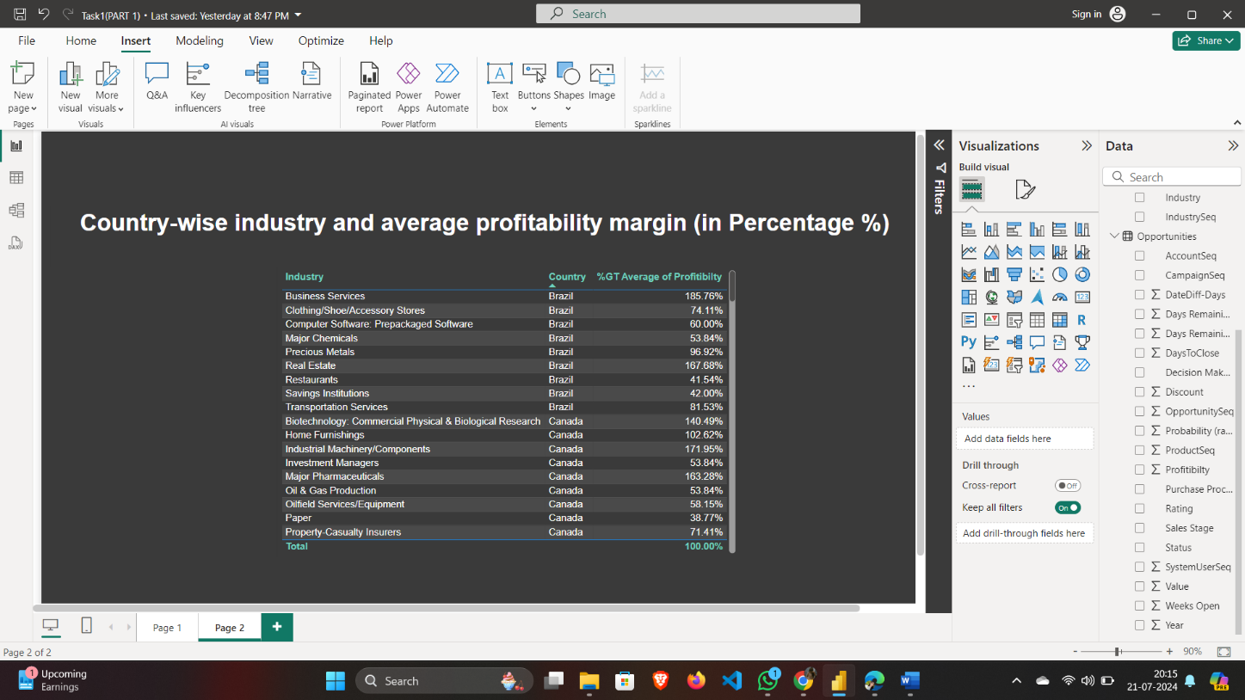

**(2.b) Add a separate filter so that country-wise industry and profitability margins can be shown based on the selective countries (There is no bar on country selection)**

* In the "Visualizations" pane, select the "Slicer" visual.
* Drag the 'Country' field from the "Fields" pane into the slicer.
* Resize and place the slicer on the page as desired.
* You can customize the slicer to allow multi-selection by clicking on the slicer, then going to the "Format" pane and enabling "Multi-select with CTRL."

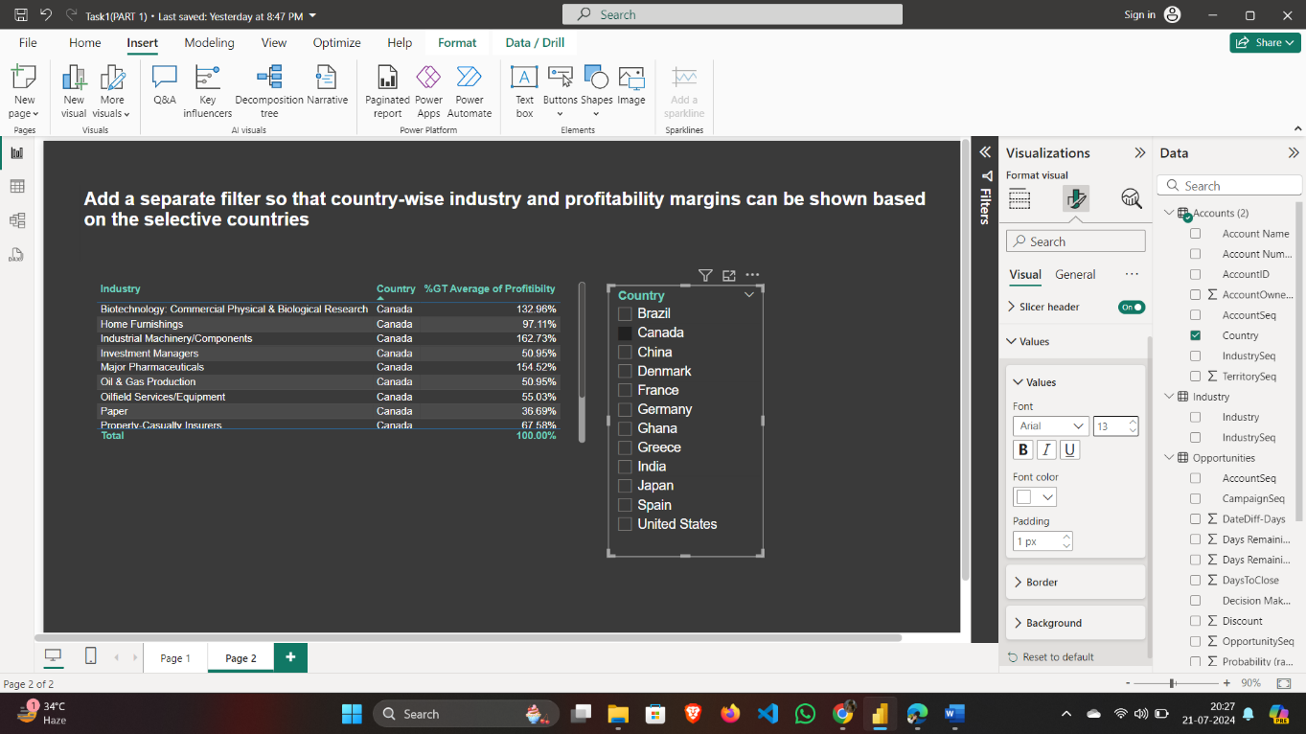

1. **Represent the following data using a pie chart:**

(3.a) **Industry-wise profitability percentage**

* In the "Visualizations" pane, select the "Pie chart" visual.
* From the "Fields" pane, drag 'Industry' to the "Legend" area.
* Drag 'Profitability Margin' to the "Values" area.
* Ensure 'Profitability Margin' is set to average by clicking on the dropdown arrow next to it in the "Values" area and selecting "Average".
* Select the 'Profitability Margin' field in the "Fields" pane.
* Go to the "Modeling" tab and set the data type to "Percentage" and specify the number of decimal places if needed.

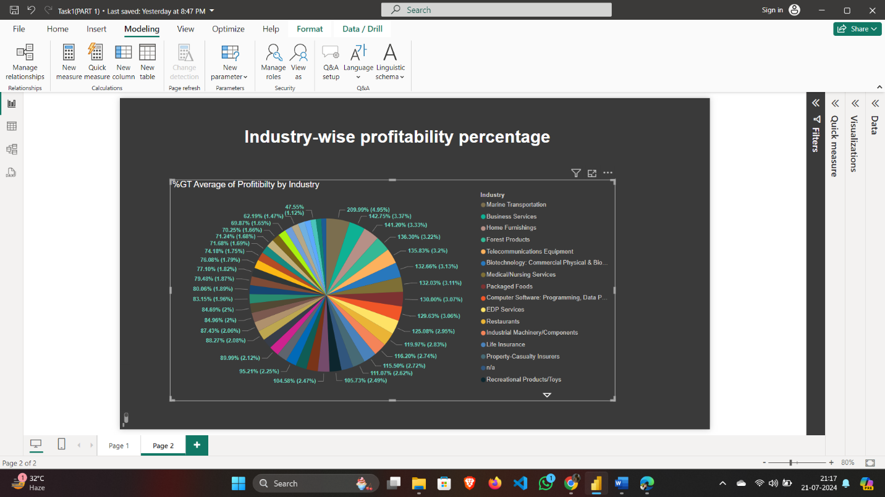

**(3.b) The data should be visualized in single or multiple country-wise**

* Add a slicer visual and drag the 'Country' field into it.
* Enable multi-selection in the slicer settings

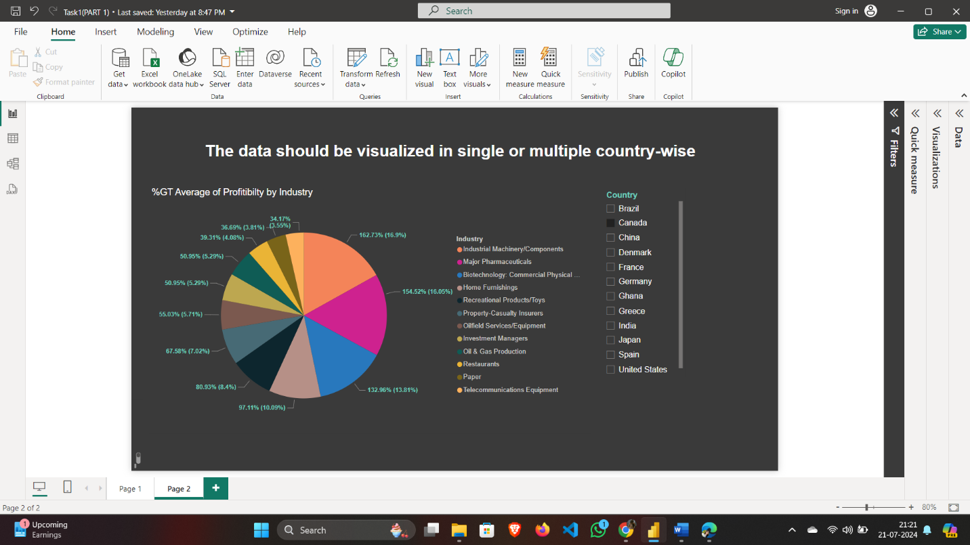

1. **Present the data that shows industry-wise profitability trends by taking the Line & stacked column chart from the visualization section.**

* In the "Visualizations" pane, select the "Line and Stacked Column Chart" visual.
* Place the 'Industry' field in the Shared axis area.
* Place the 'Profitability Margin' field in the Column values area.
* If applicable, place a time field (e.g., Year, Month) in the Column series area to show trends over time.
* Optionally, place another metric (e.g., ‘Profitability Margin’) in the Line values area for comparison.

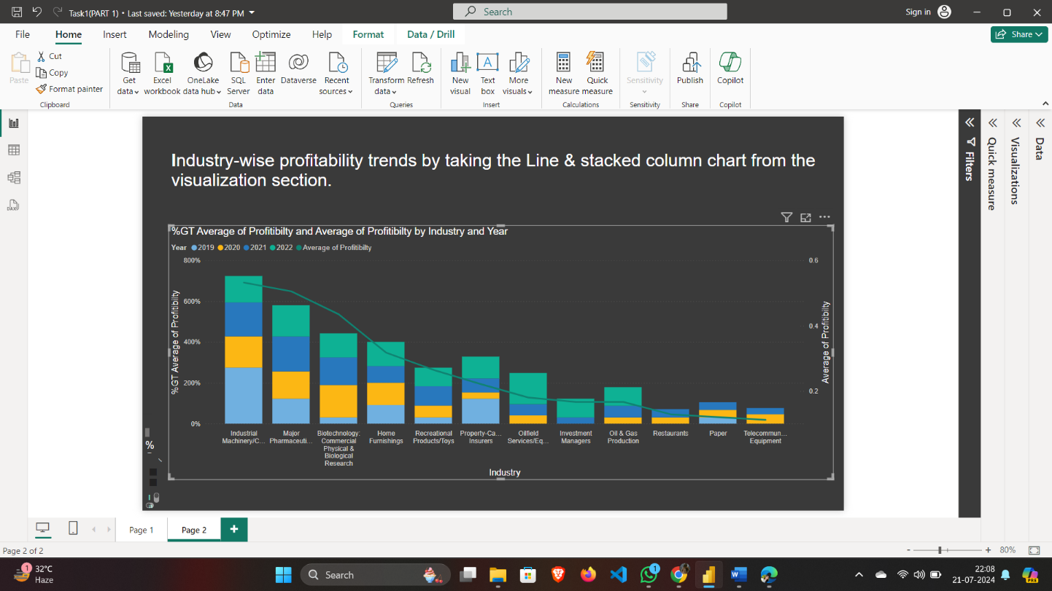

**5.Present the data to show country-wise industry market values and industrywise presence by taking the map chart.**

* In the "Visualizations" pane, select the "Map" visual.
* From the "Fields" pane, drag the 'Country' field to the "Location" area.
* Drag the 'Industry' field to the "Legend" area to differentiate industries by color.
* Drag the 'Market Value' field to the "Size" area to represent the market values with different bubble sizes.

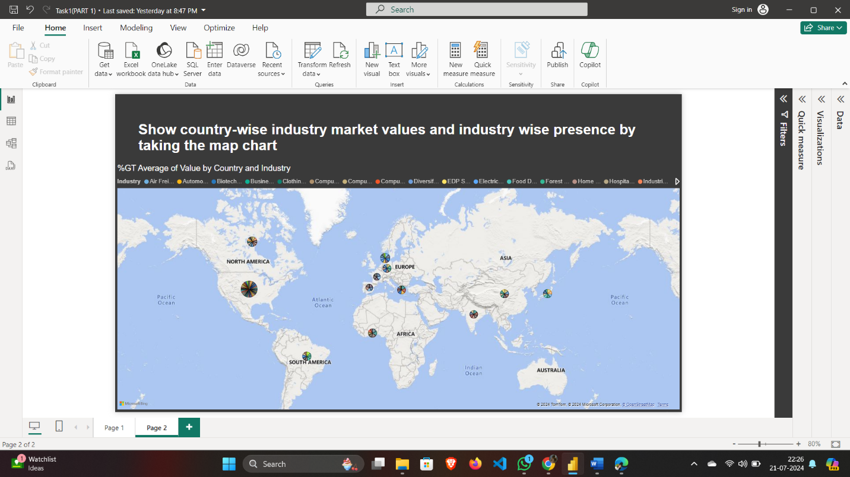

**Final Dashboard will look like:**

