DNS Log Analysis using Splunk
By Laxmi Dahale

📌Project Overview
This project focuses on analyzing DNS (Domain Name System) logs using Splunk Enterprise to monitor network activity, detect suspicious domain requests, and identify potential security threats. DNS logs were ingested, parsed, and visualized in Splunk to gain insights into domain resolution patterns and uncover indicators of malicious behavior such as command-and-control (C2) communications, DNS tunneling, and access to suspicious domains.
The project involved collecting DNS query logs, creating custom searches and dashboards, and generating alerts for unusual DNS activities. By leveraging Splunk's search and reporting capabilities, the analysis helped improve network visibility, strengthen threat detection, and support proactive security monitoring.

🎯Project Objective
By completing this project, you will learn how to:
- Ingest JSON-formatted DNS logs into Splunk
- Extract useful DNS metadata (queries, IPs, record types)
- Write SPL queries for DNS traffic analysis
- Detect suspicious or abnormal DNS activity
- Build a foundation for DNS-based threat detection

🛠️Technologies Used
- Splunk Enterprise
- Zeek DNS Logs (JSON format)
- Search Processing Language (SPL)
📂 Dataset Information
The dataset consists of Zeek-style DNS logs in JSON format that capture DNS query and response activities across a network. These logs provide detailed information about domain resolution requests and can be used to identify normal network behavior as well as potential security threats.
Key fields included in the dataset:
- ts – Timestamp of the DNS event
- uid – Unique identifier for the DNS transaction
- id.orig_h – Source IP address initiating the DNS query
- id.orig_p – Source port of the client
- id.resp_h – DNS server IP address
- id.resp_p – DNS server port (typically 53)
- qclass_name – DNS query class
- qtype_name – DNS query type (A, AAAA, MX, TXT, etc.)
- rcode_name – DNS response code indicating success or failure
- answers – DNS response records returned
- TTLs – Time-to-Live values for DNS responses

⚙️Lab Setup and Pre Requisites
Upload DNS logs into Splunk.
Step 1 : Upload DNS logs.
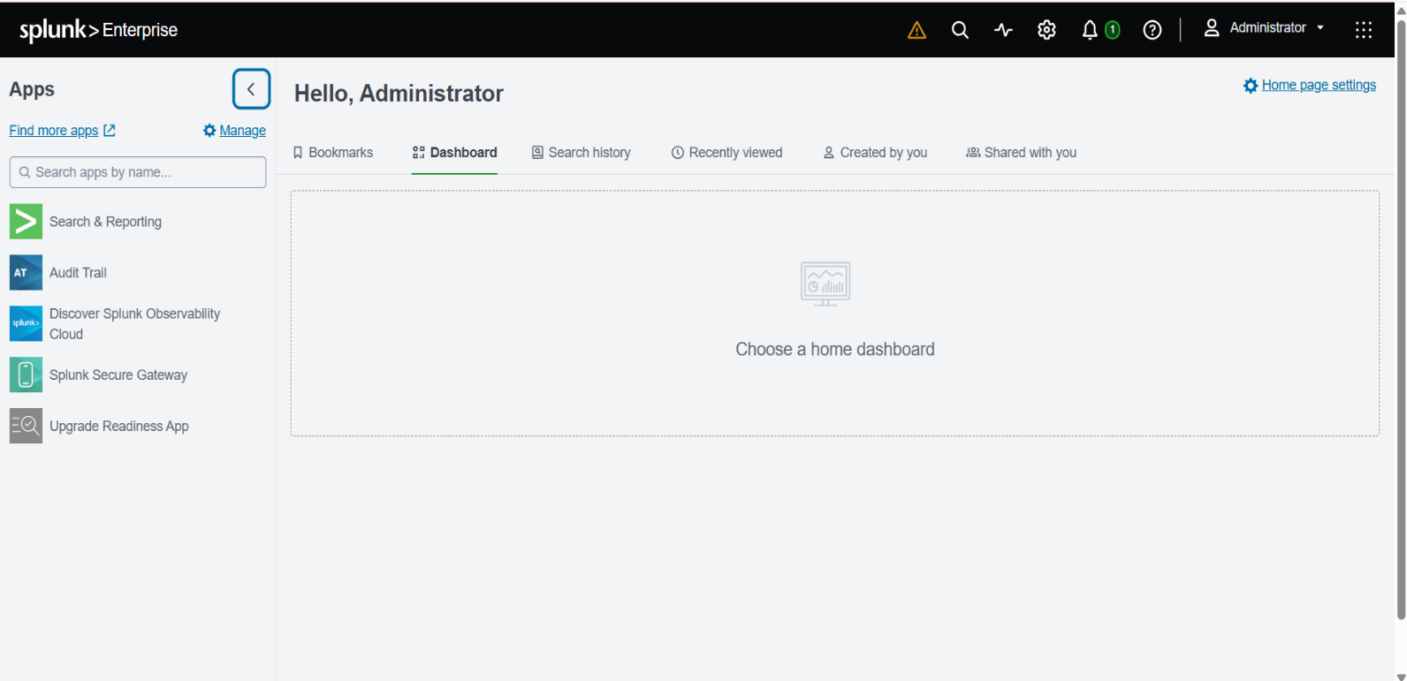
1.Open Splunk Web.

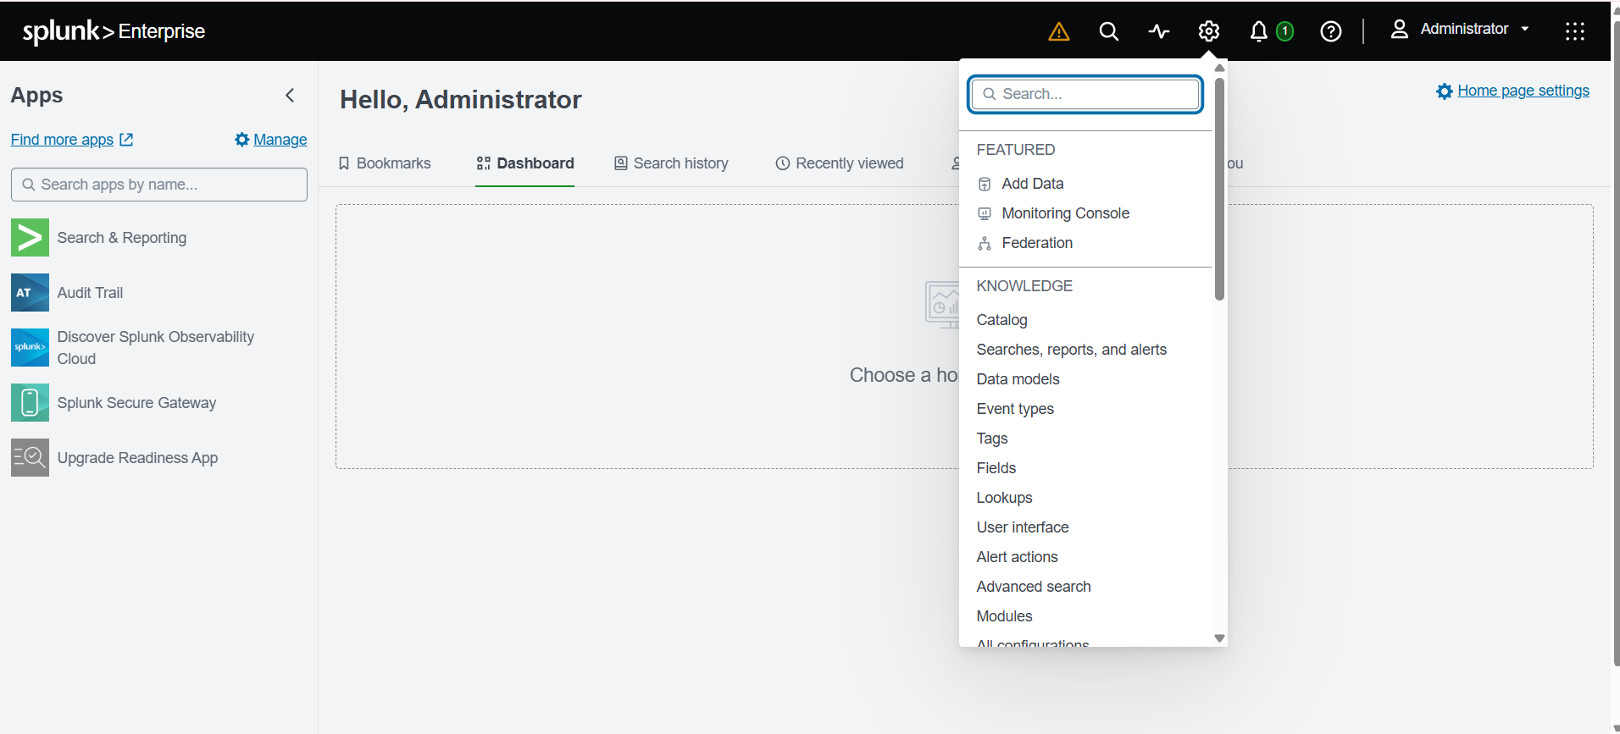
2.Navigate to : Settings → Add Data → Upload.

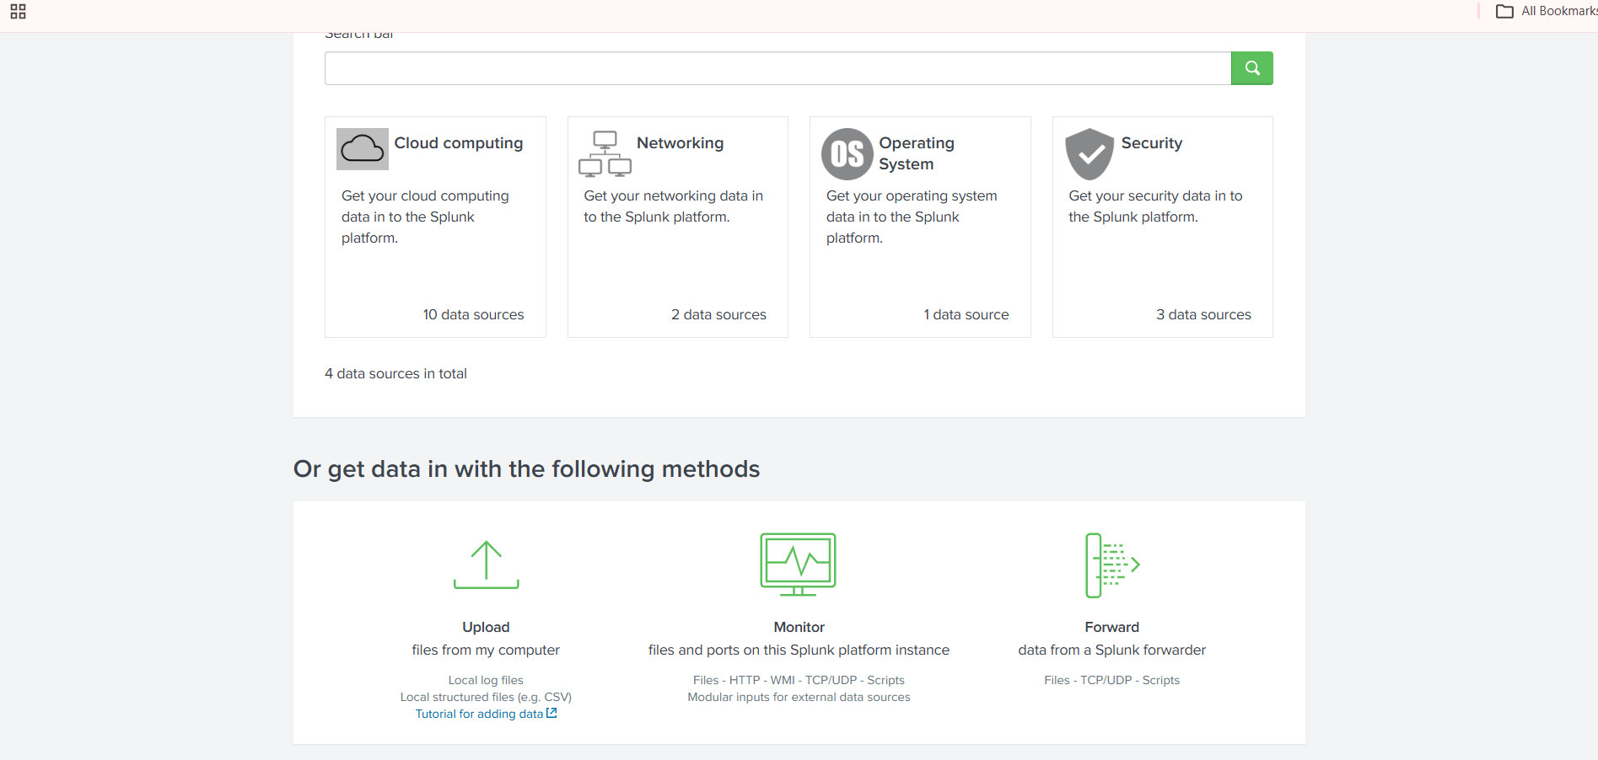

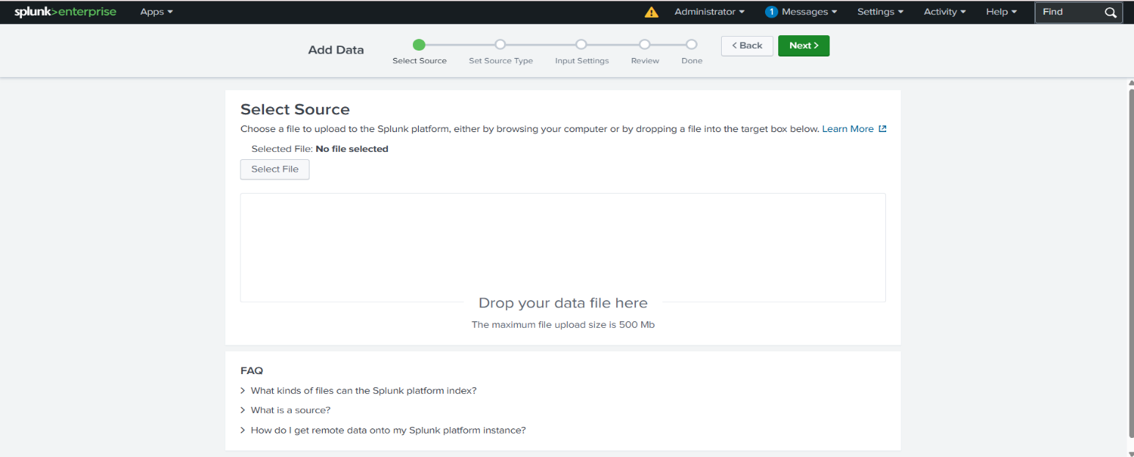

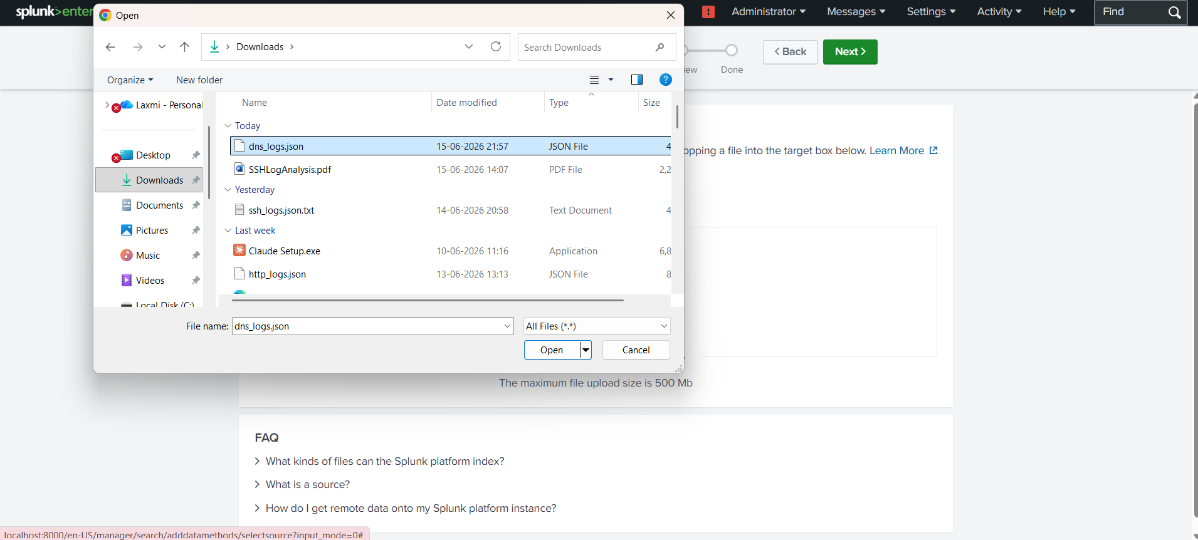
3.Select the File : dns_logs.json

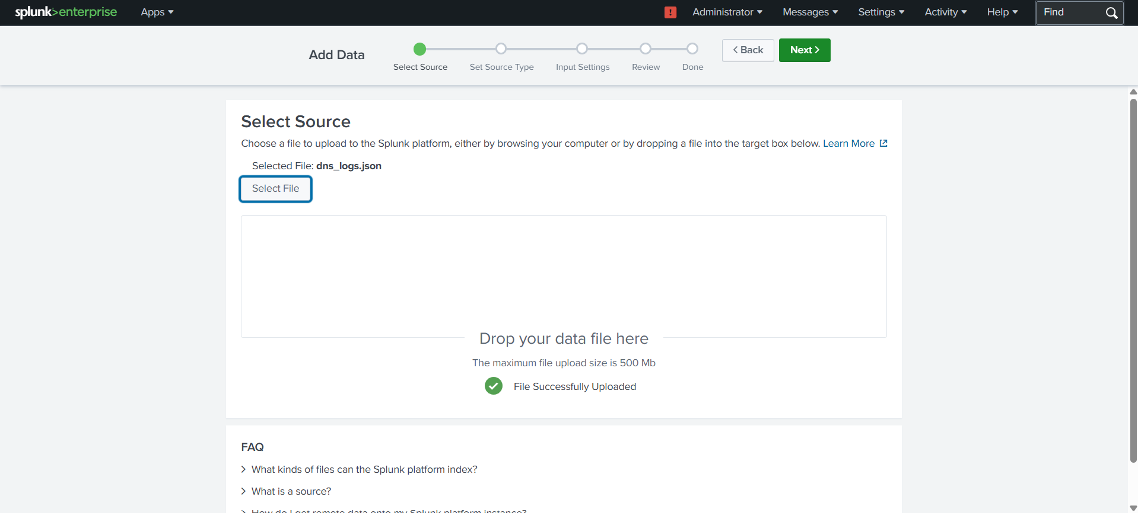

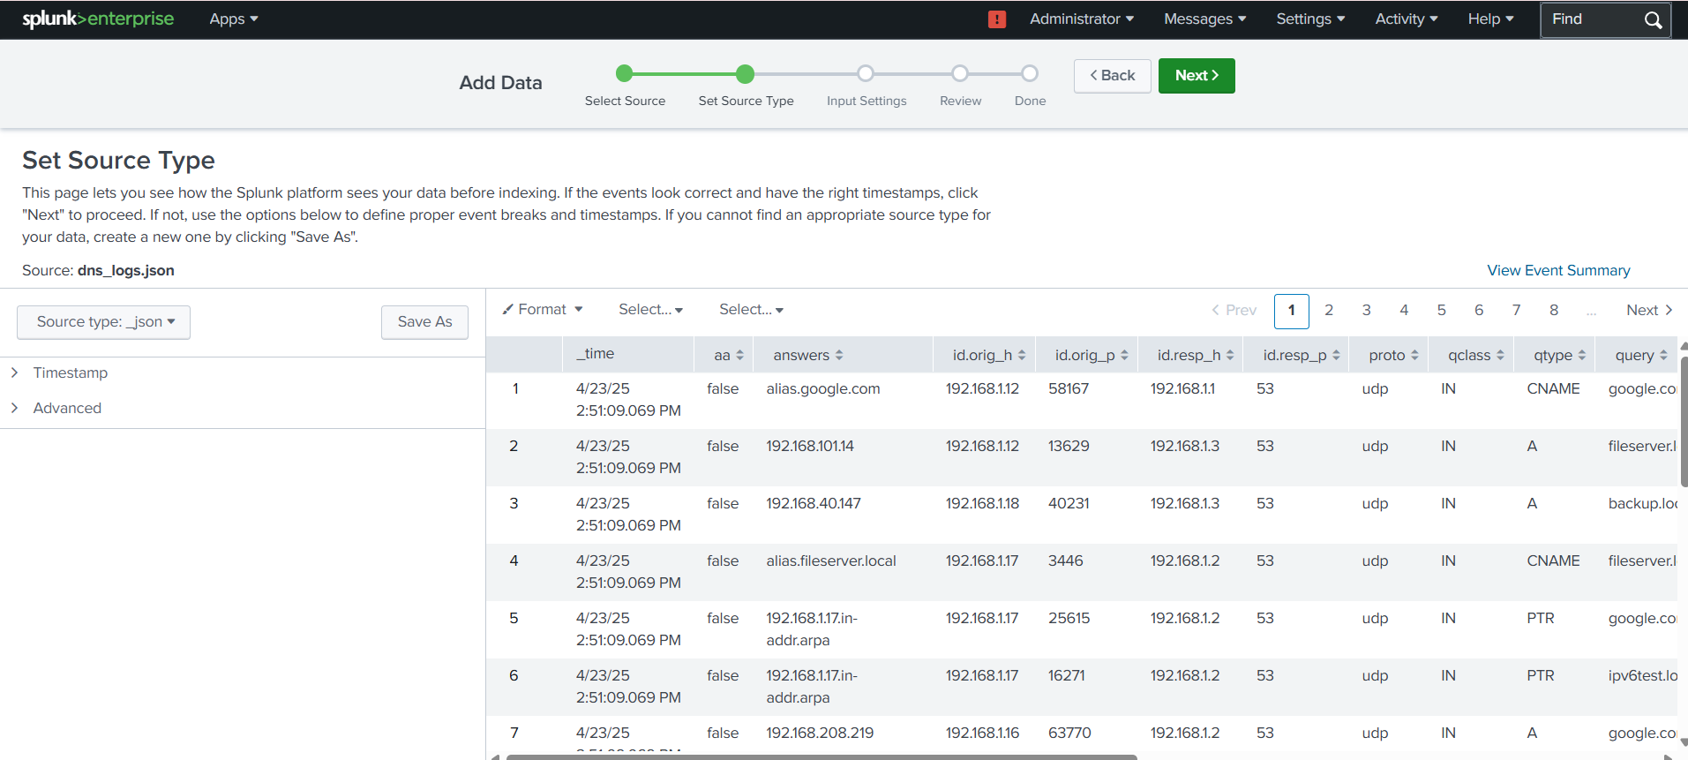

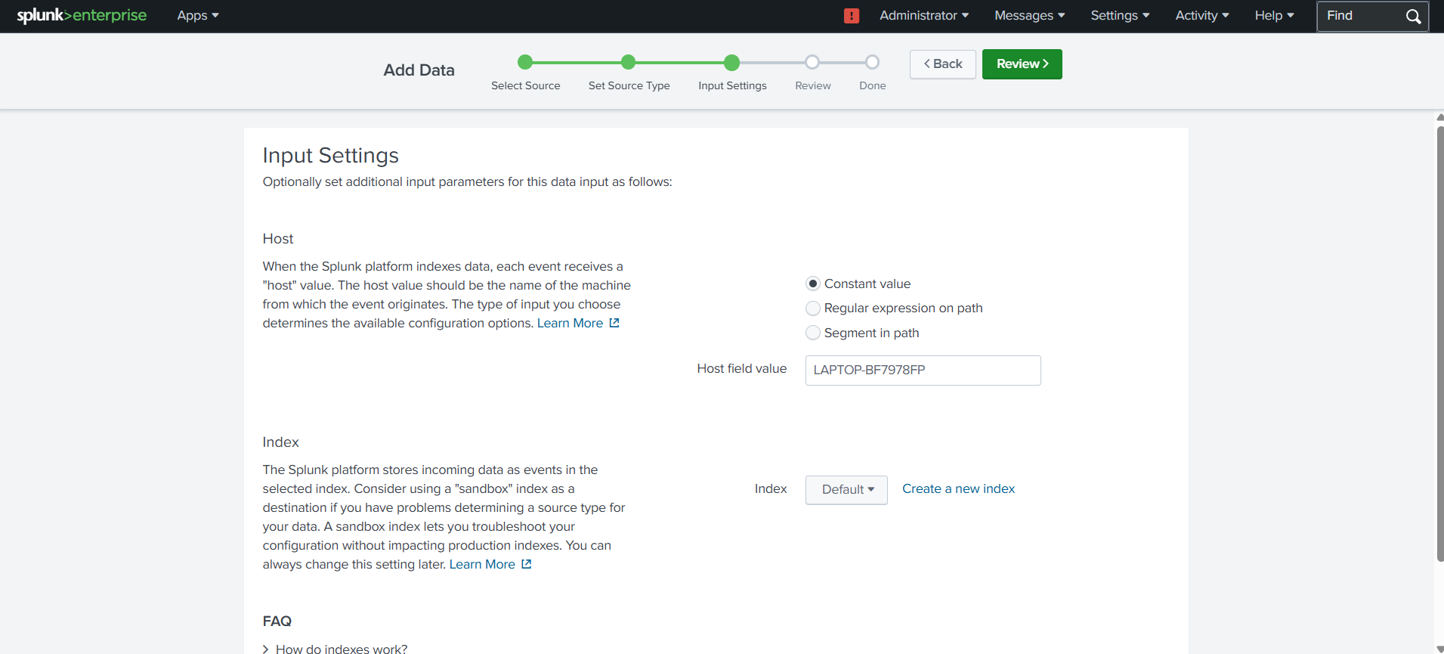

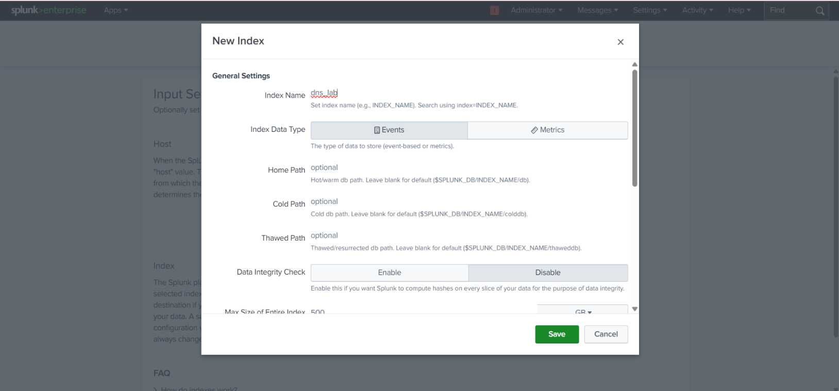

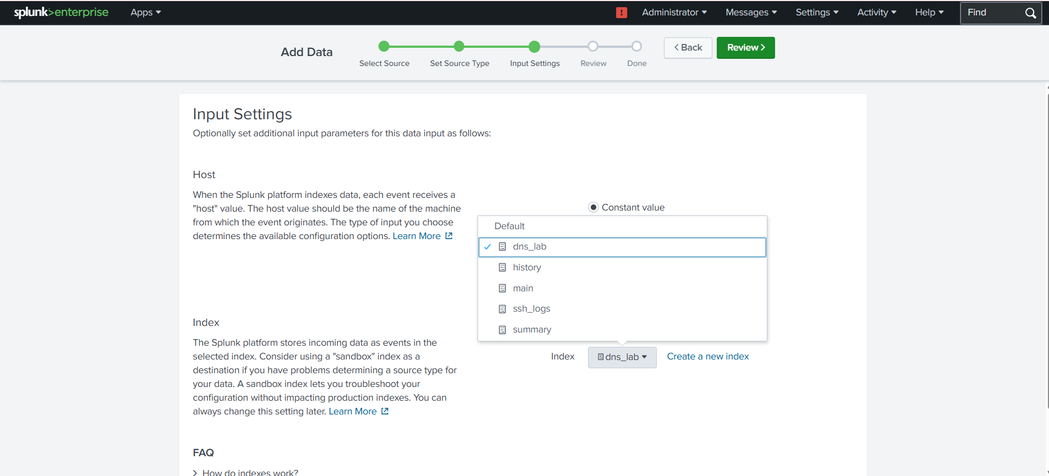

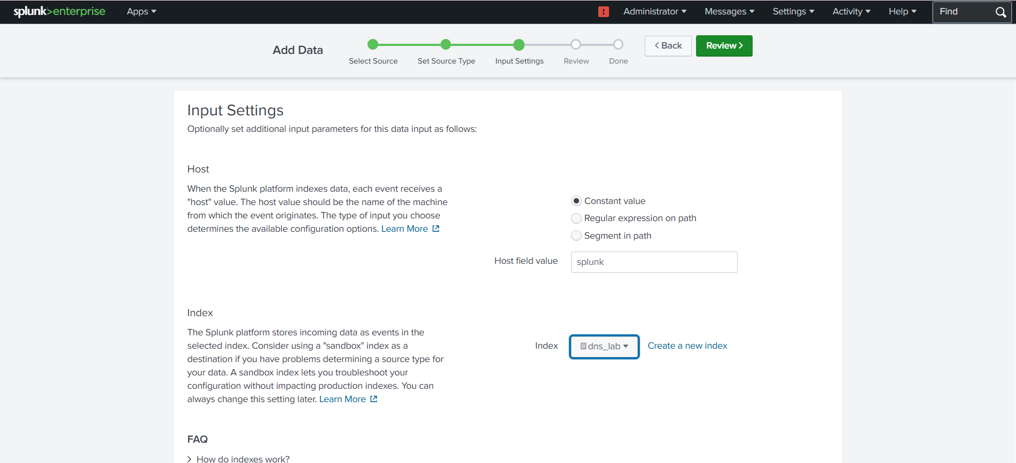

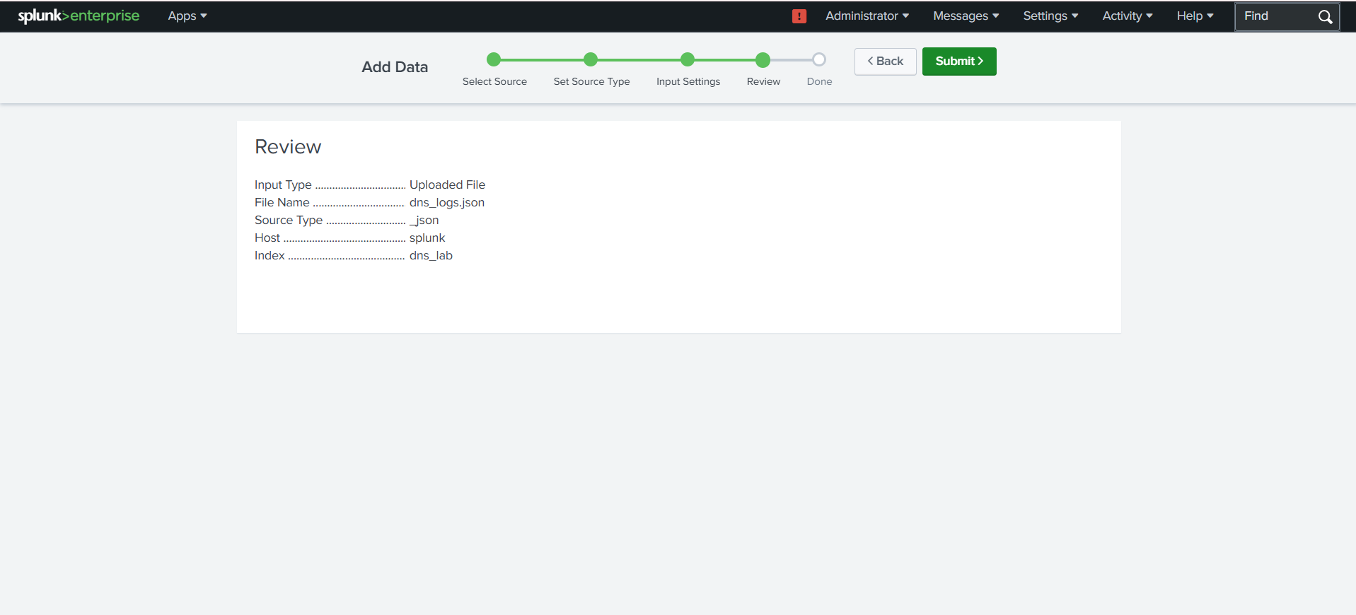

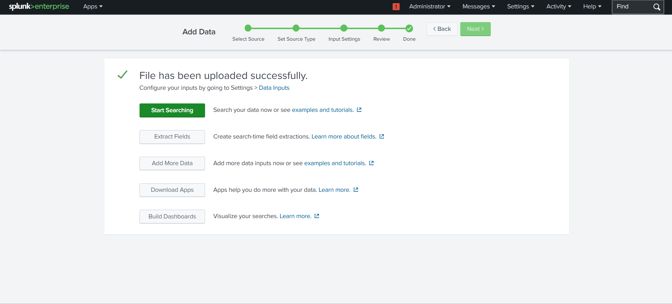

Step 2: Verify Data Ingestion
Run the following SPL query:
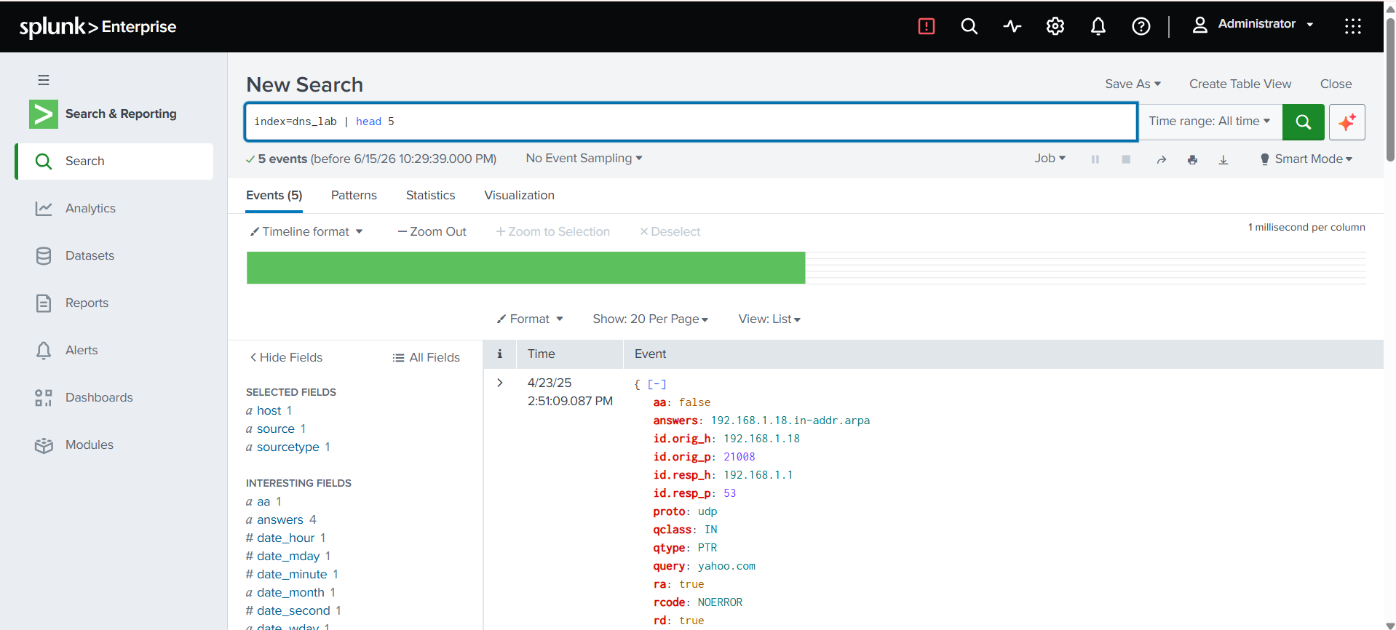
index=dns_lab | head 5

🔍 Lab Tasks & SPL Queries

- Task 1: Most Frequently Queried Domain Names
Identify the domains queried most often.
index=dns_lab
| stats count by query
| sort -count

Use Case: Detect suspicious domains, beaconing behavior, or malware C2 traffic.
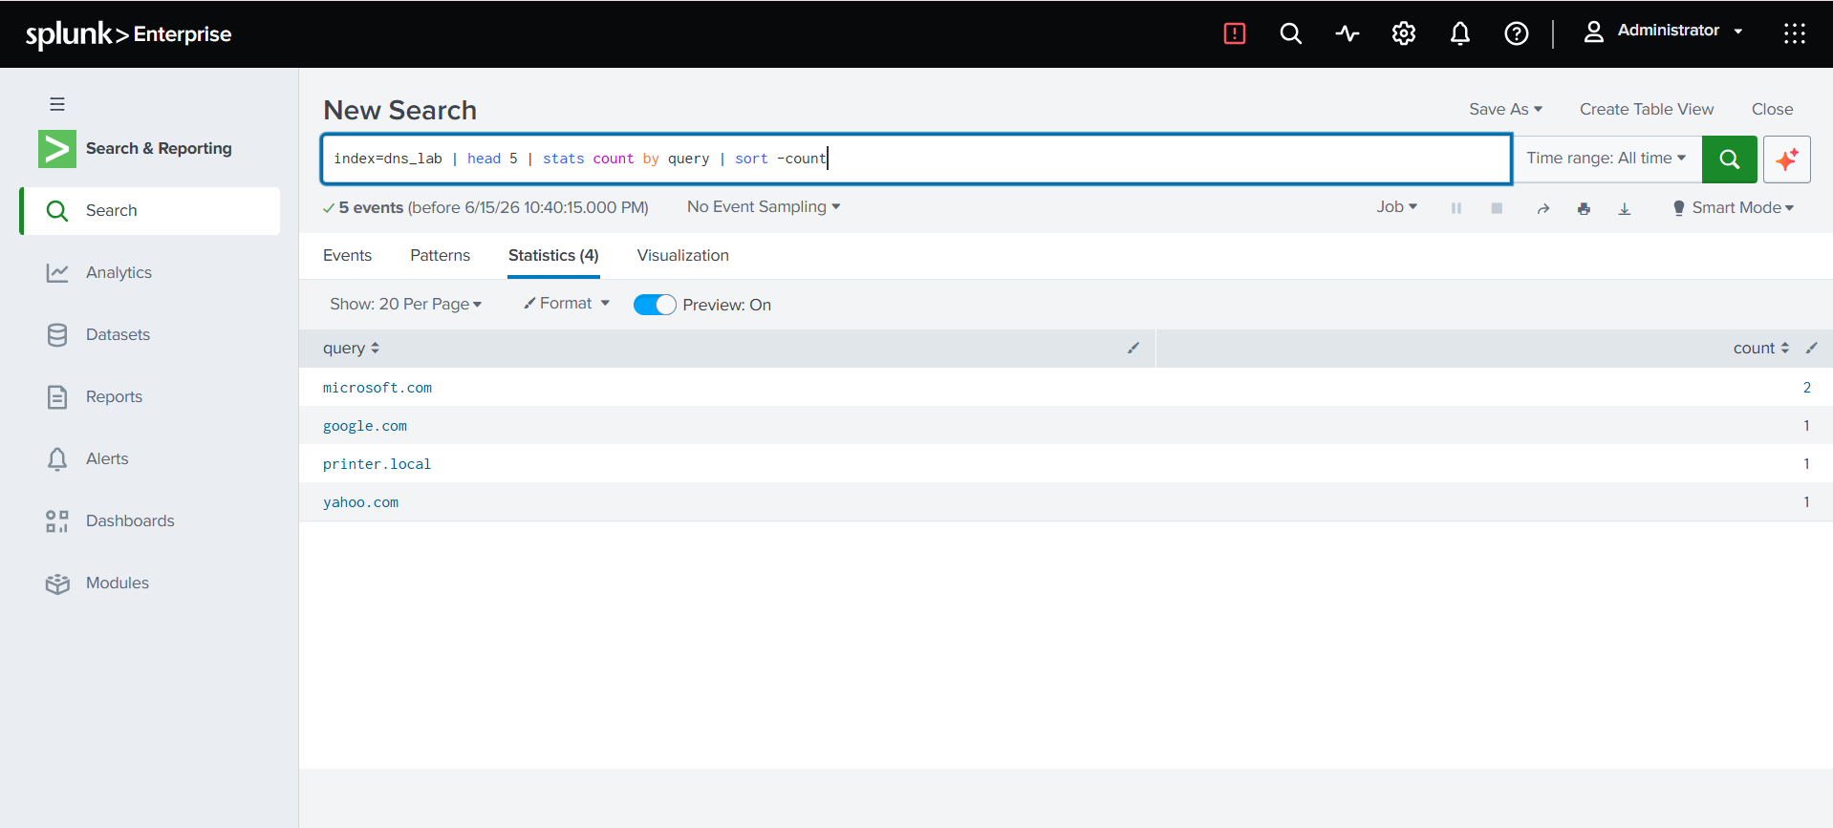

- Task 2 : Most Active Client Ips.
Find which internal hosts generate the highest DNS traffic.
index=dns_lab
| stats count by "id.orig_h"
| sort -count

Use Case: Identify compromised systems or misconfigured devices.
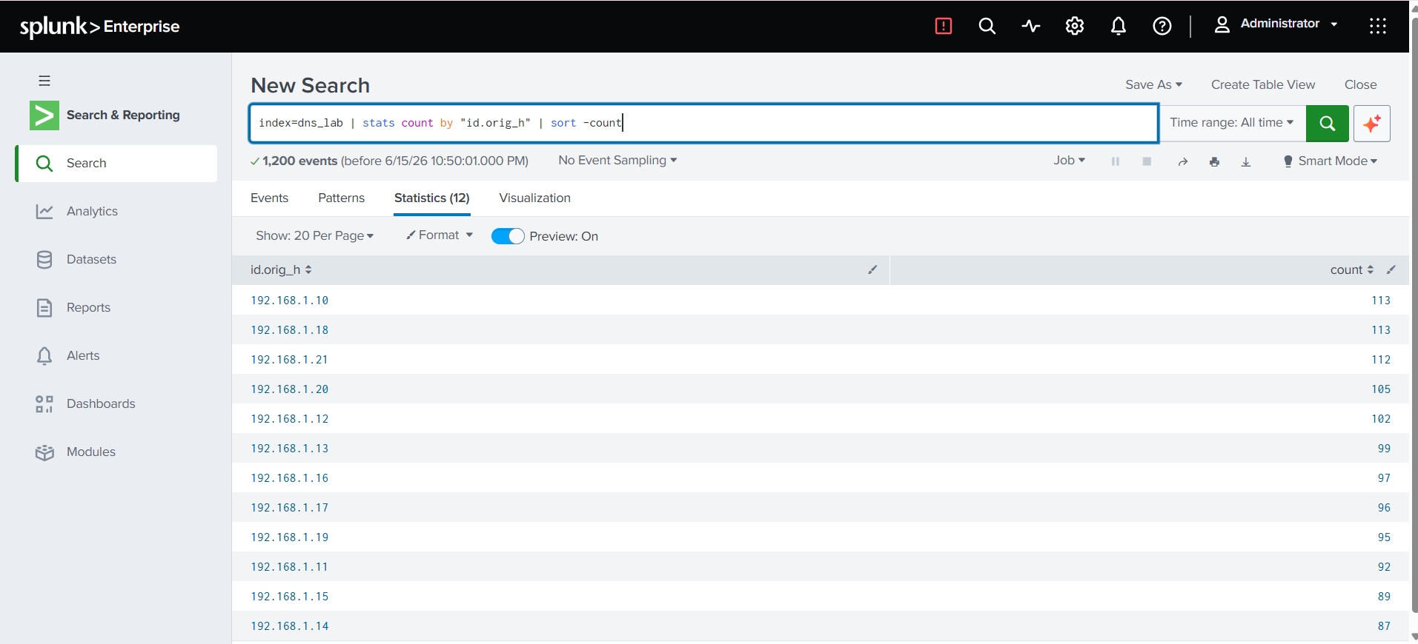

- Task 3: DNS Query Type Breakdown
Analyze DNS record types used in the environment.
index=dns_lab
| stats count by qtype

Use Cases :
PTR → Reverse Lookups
Excessive AAAA → IPv6 Behaviour
CNAME → Redirects the alias Usage
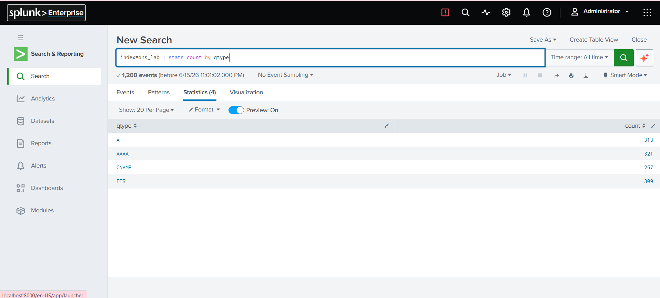

📈 Key Findings
- Identified top queried domains (e.g., Google, Microsoft, Yahoo)
- Discovered high-volume DNS-generating client IPs
- Observed distribution of A, AAAA, CNAME, and PTR records
- Analyzed response time (RTT) and failed DNS resolutions
- Established a baseline for DNS behavior

🚨 Security Insights
This analysis can help detect:
- DNS tunneling
- Malware beaconing via repeated DNS queries
- Excessive reverse DNS lookups
- High-latency or failed DNS responses
- Rare or suspicious domain queries

📊 Dashboards & Alerts (Enhancements)
Future improvements may include:
- Splunk dashboards for DNS activity visualization
- Alerts for:
  - High DNS query volume
  - NXDOMAIN spikes
  - Rare or newly observed domains

✅ Conclusion
By completing this project, you have:
- Successfully ingested and parsed DNS logs in Splunk
- Built SPL queries for DNS traffic analysis
- Gained hands-on experience in SIEM-based security analysisLearned how to ingest and parse DNS logs into Splunk for analysis.
- Identified the most frequently queried domains and the top clients generating DNS traffic.
- Gained experience in analyzing different DNS record types (A, AAAA, CNAME, PTR).
- Detected anomalies such as failed resolutions, suspicious queries, and high-latency lookups.
This project is well-suited for SOC Analyst, Cybersecurity, and SIEM roles.

🚀 Future Enhancements
- GeoIP enrichment for DNS responses
- DNS tunneling detection using entropy analysis
- Correlation with HTTP or proxy logs
- Automated alerting and reporting

