HTTP Log Analysis using Splunk Project
By Laxmi Dahale
Hands-on cybersecurity lab focused on analyzing HTTP traffic using Splunk and Zeek-style JSON logs to detect errors, anomalies, and suspicious web activity.

Objective
In this lab, you will:
- Ingest and analyze HTTP logs using Splunk
- Detect client-side (4xx) and server-side (5xx) HTTP errors
- Identify suspicious User-Agents and URIs
- Detect large file transfers that may indicate data exfiltration
- Gain practical experience with SPL (Search Processing Language)

Tech Stack & Tools
- SIEM Tool: Splunk Enterprise
- Log Source: Zeek-style HTTP logs (JSON format)
- Index: http_lab (custom index)
- Sourcetype: json or zeek:http

Lab Setup
✅ Prerequisites
- Splunk installed and accessible via Splunk Web
- HTTP logs in JSON format (http_logs.json)

Data Ingestion Steps
- Open Splunk Web
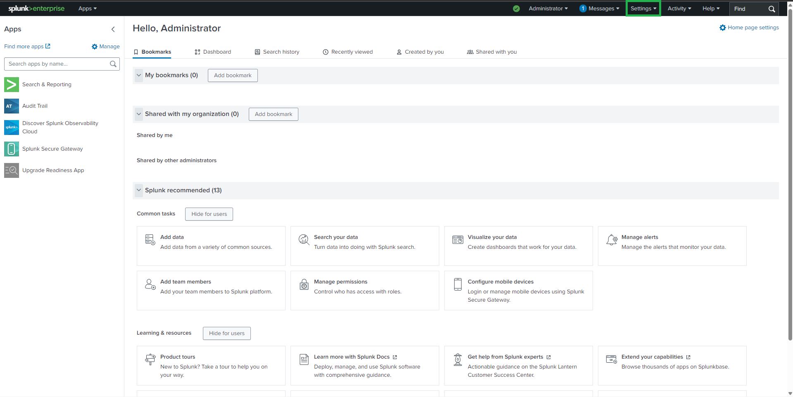
- Navigate to Settings → Add Data
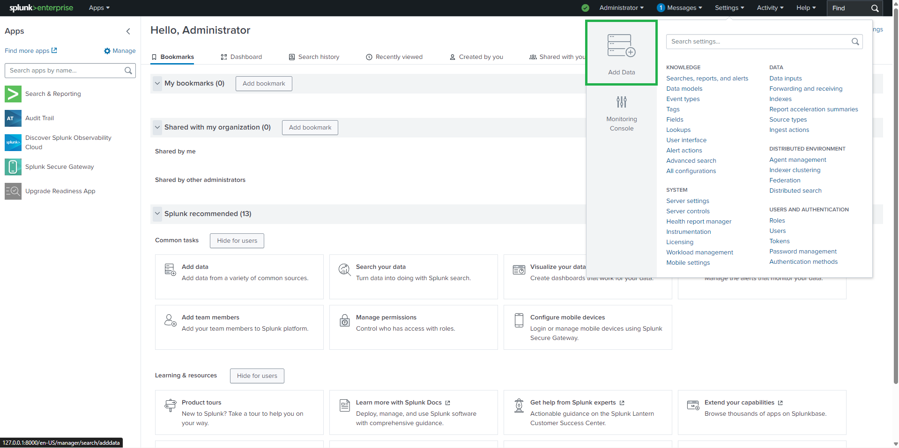

- Select Upload
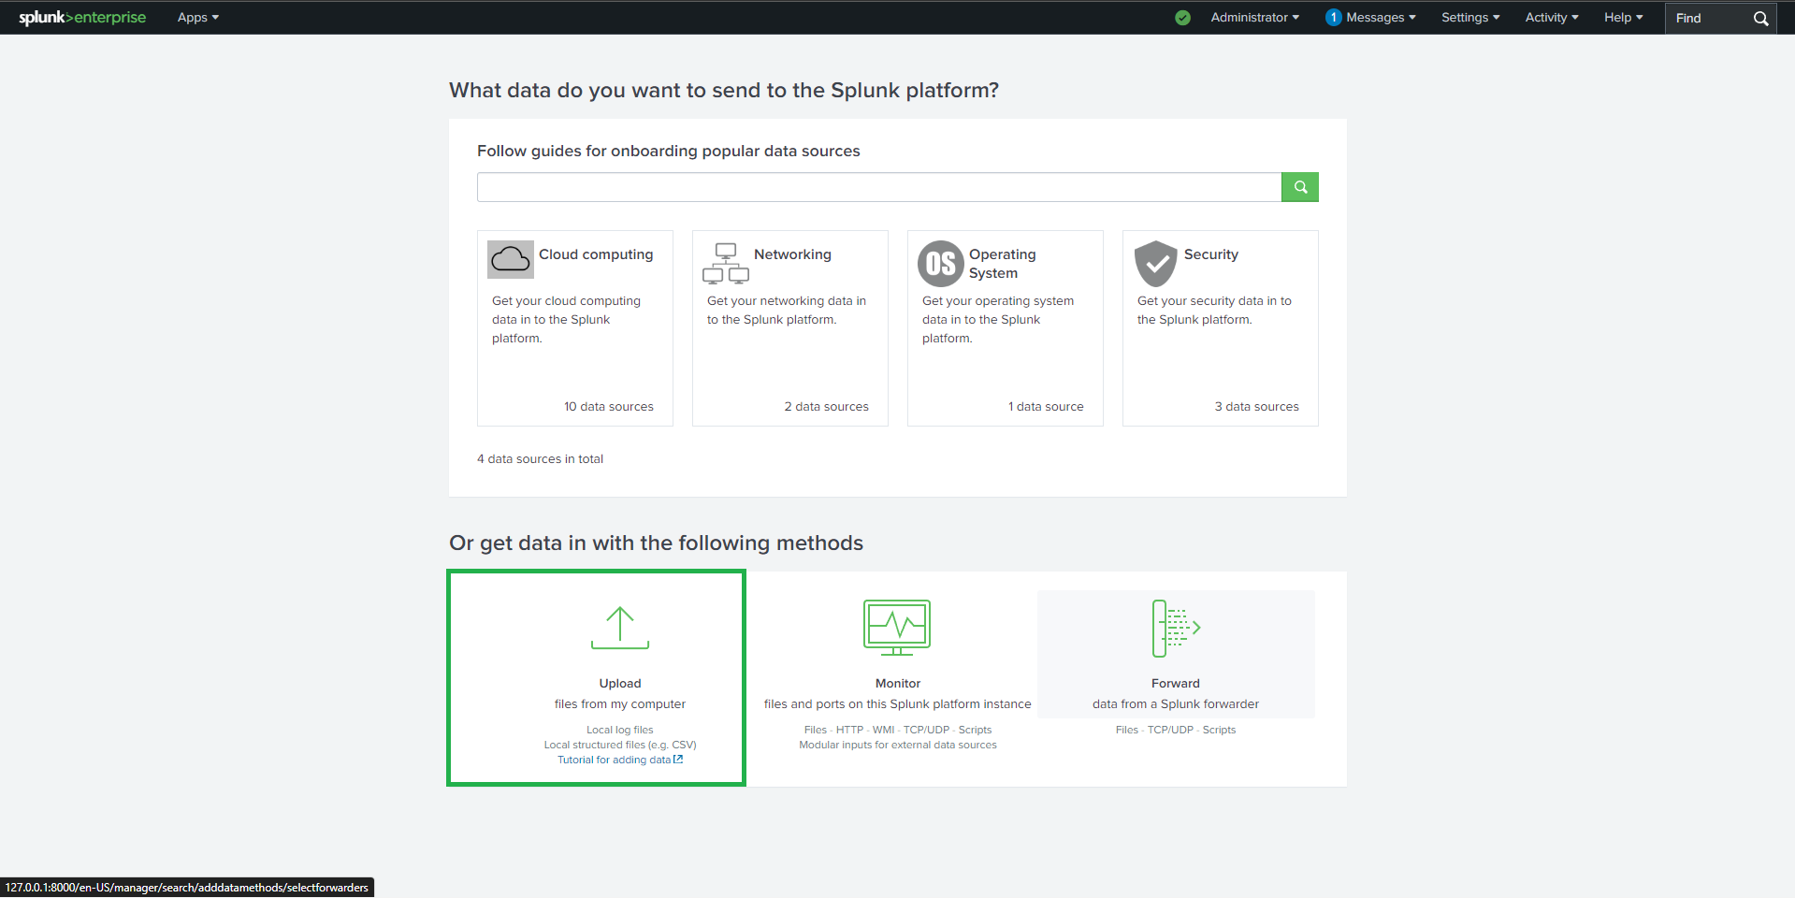
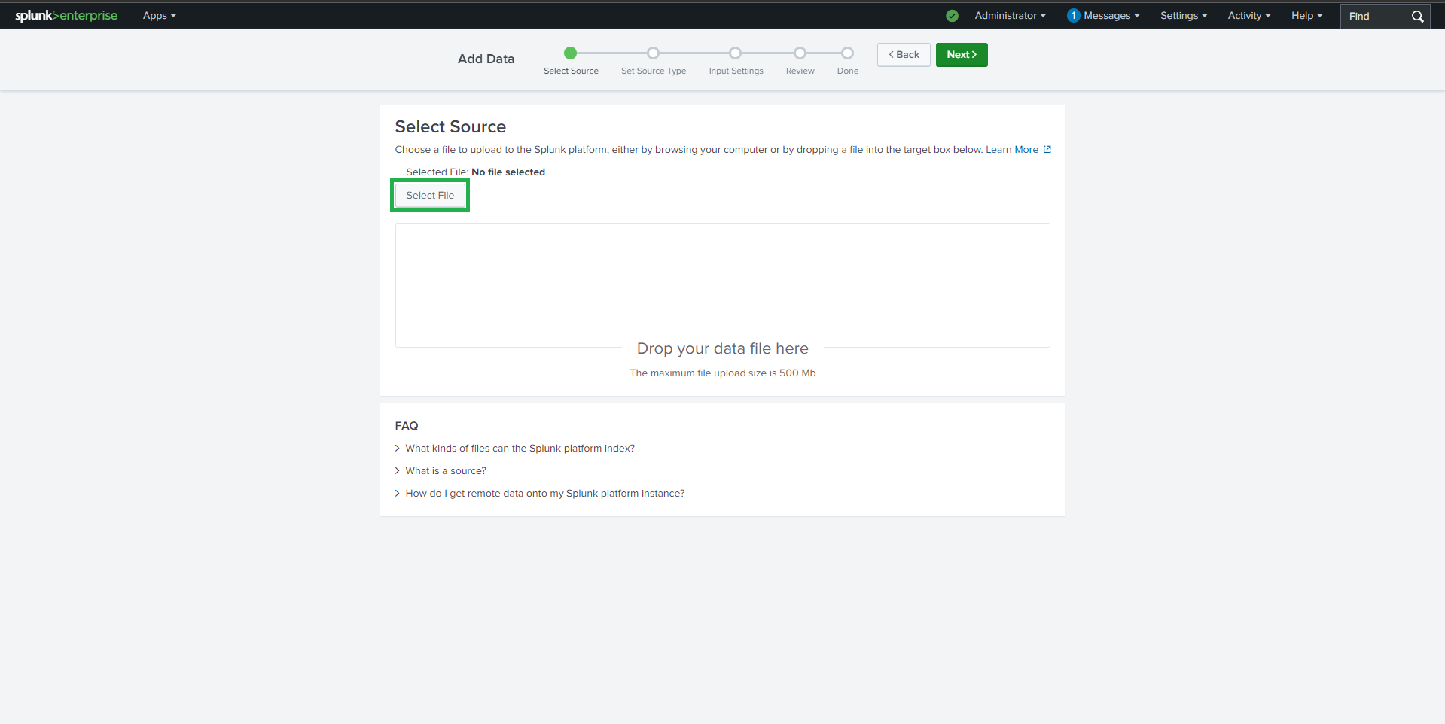

- Upload http_logs.json
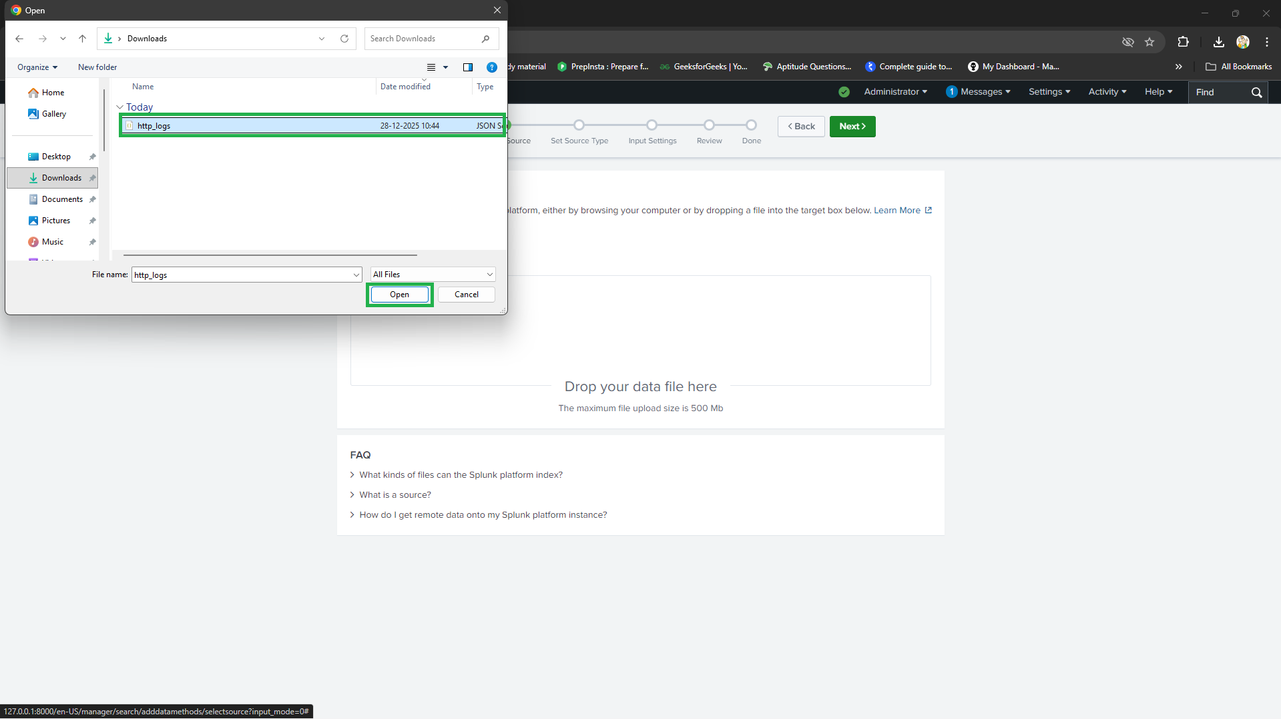
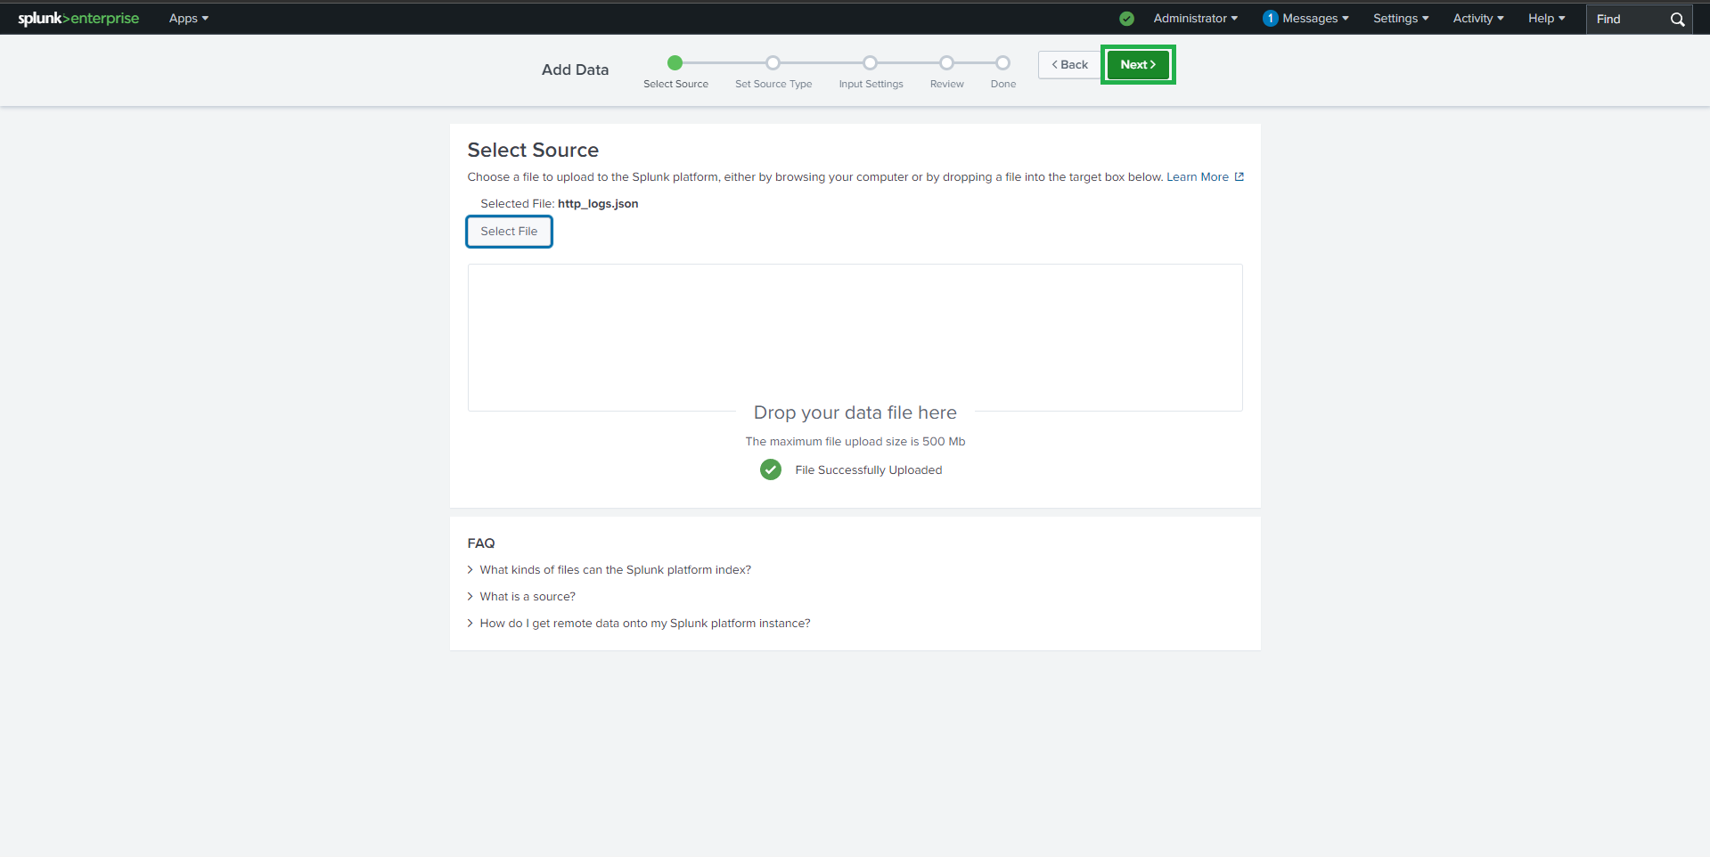

- Configure:
  - Source type: json or create zeek:http
  - Index: http_lab (recommended)
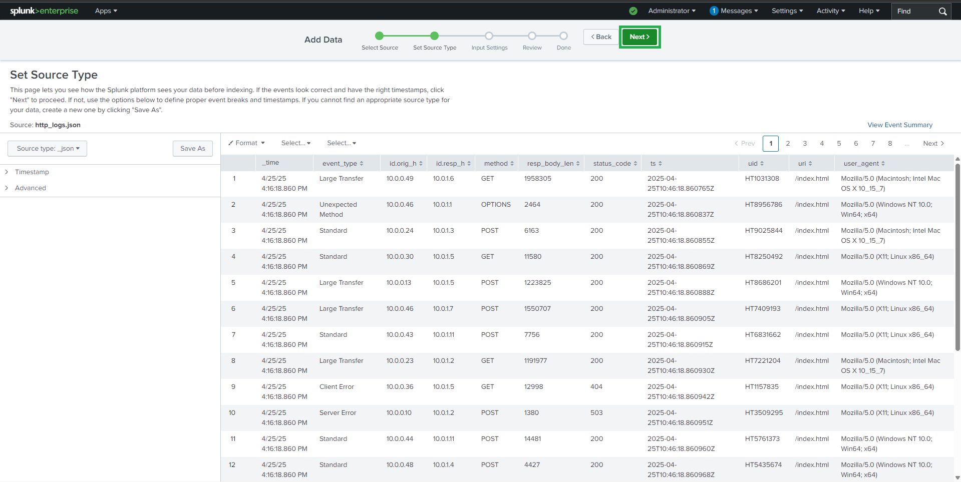
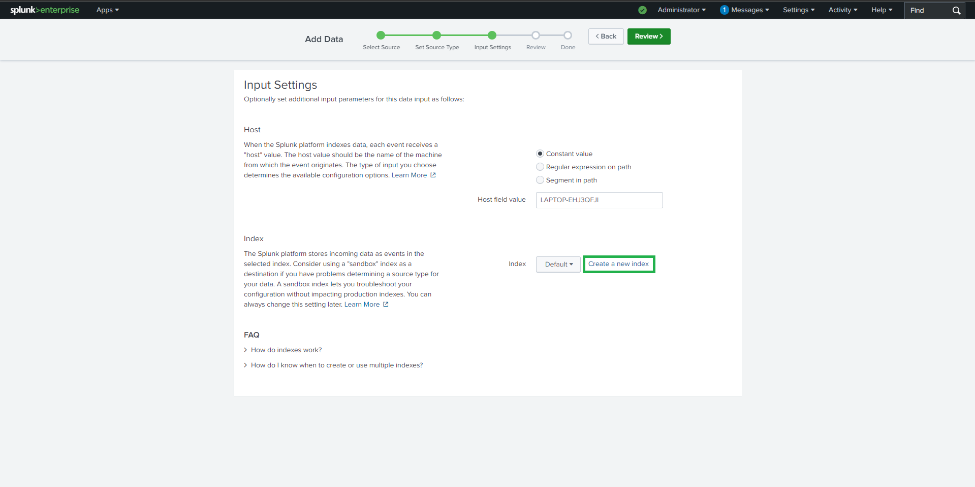

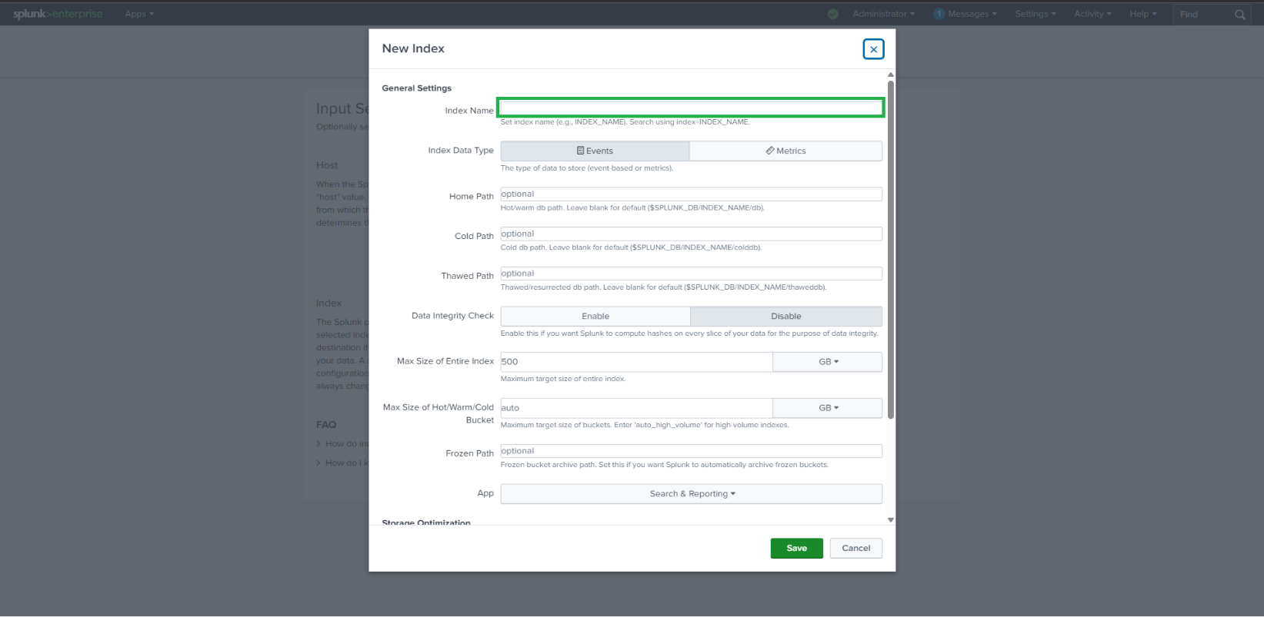
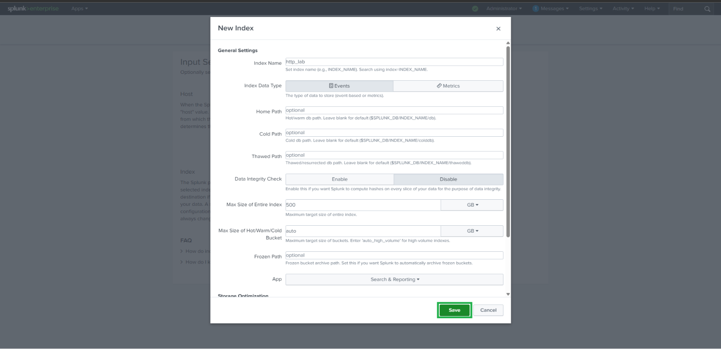

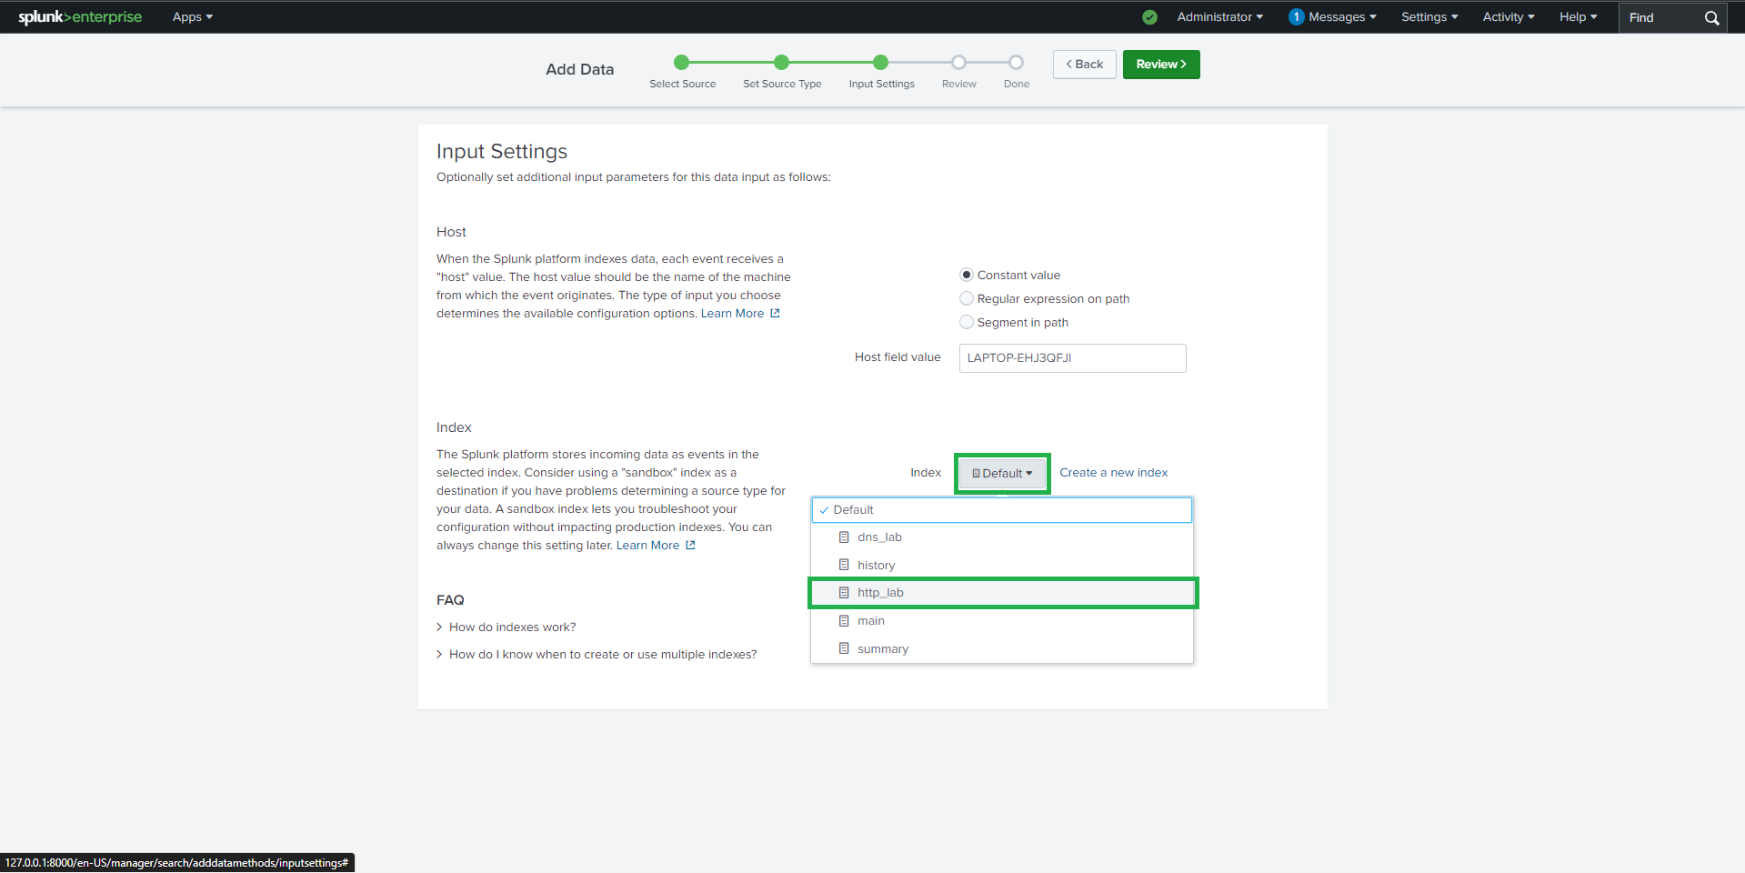
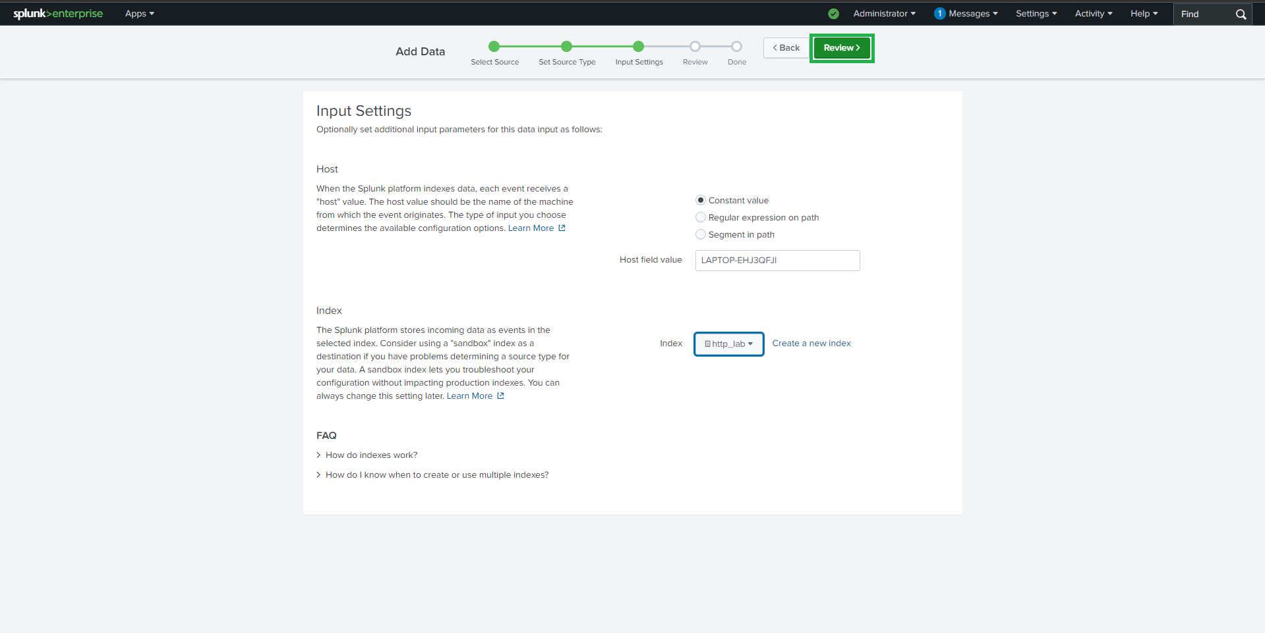

- Finish upload and verify indexing
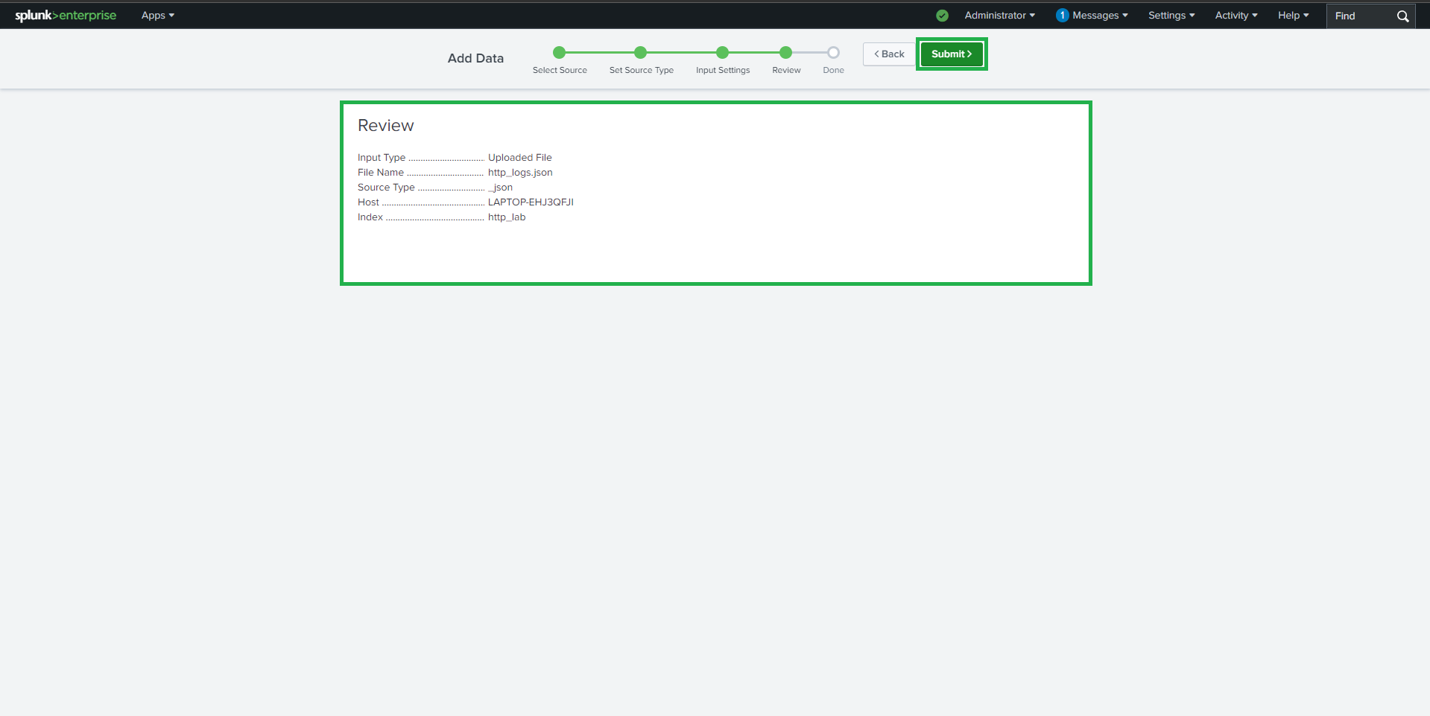
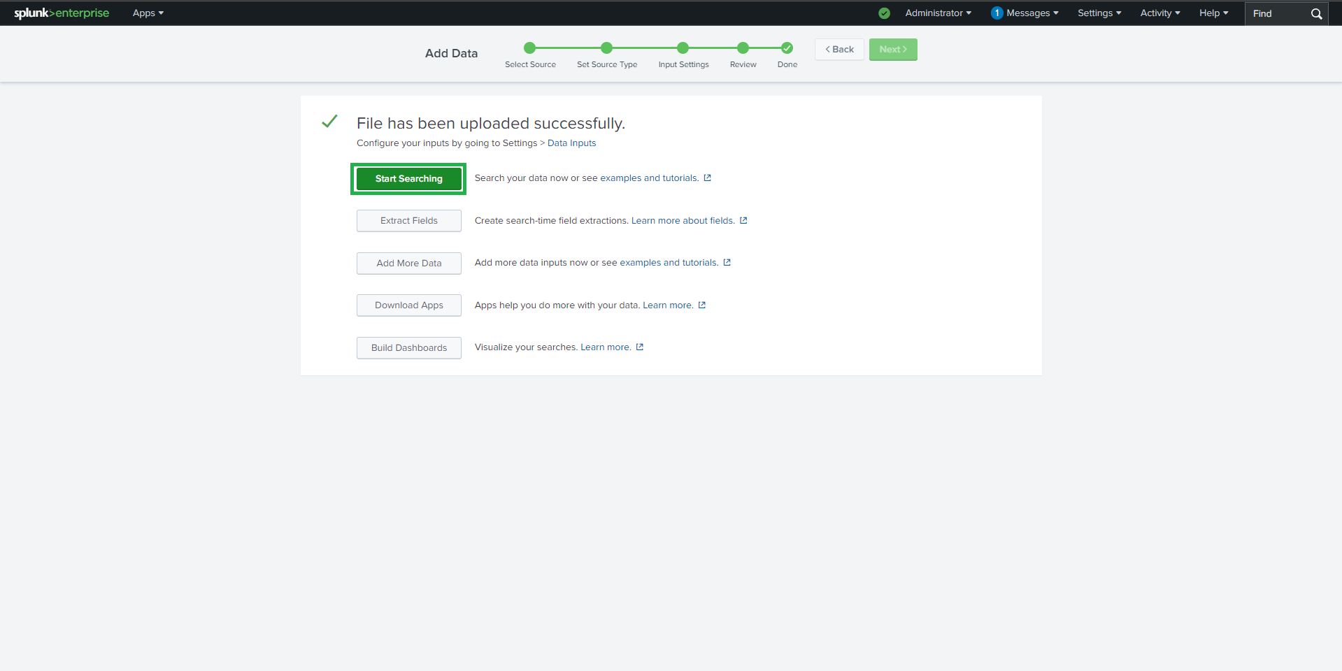

Lab Tasks & SPL Queries
- Task 1: Top 10 Endpoints Generating Web Traffic
index=http_lab
| stats count by "id.orig_h"
| sort -count
| head 10
Identifies the most active source IPs generating HTTP requests.
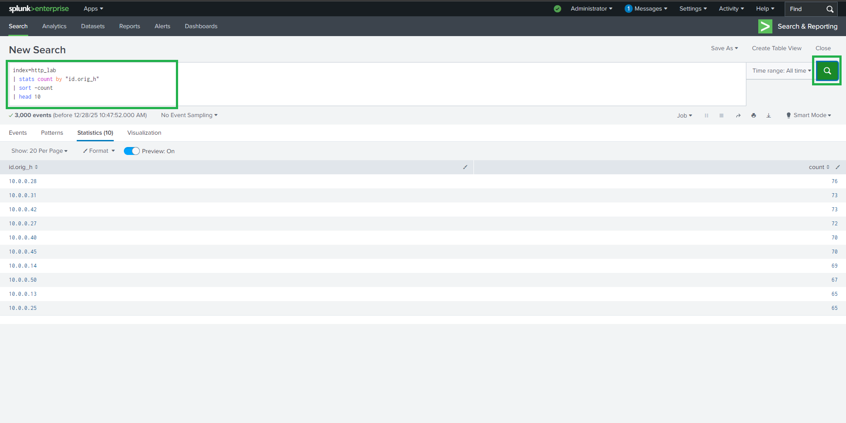

- Task 2: Count Server Errors (HTTP 5xx)
index=http_lab status_code>=500 status_code<600
| stats count as server_errors
Helps detect backend failures or application crashes.
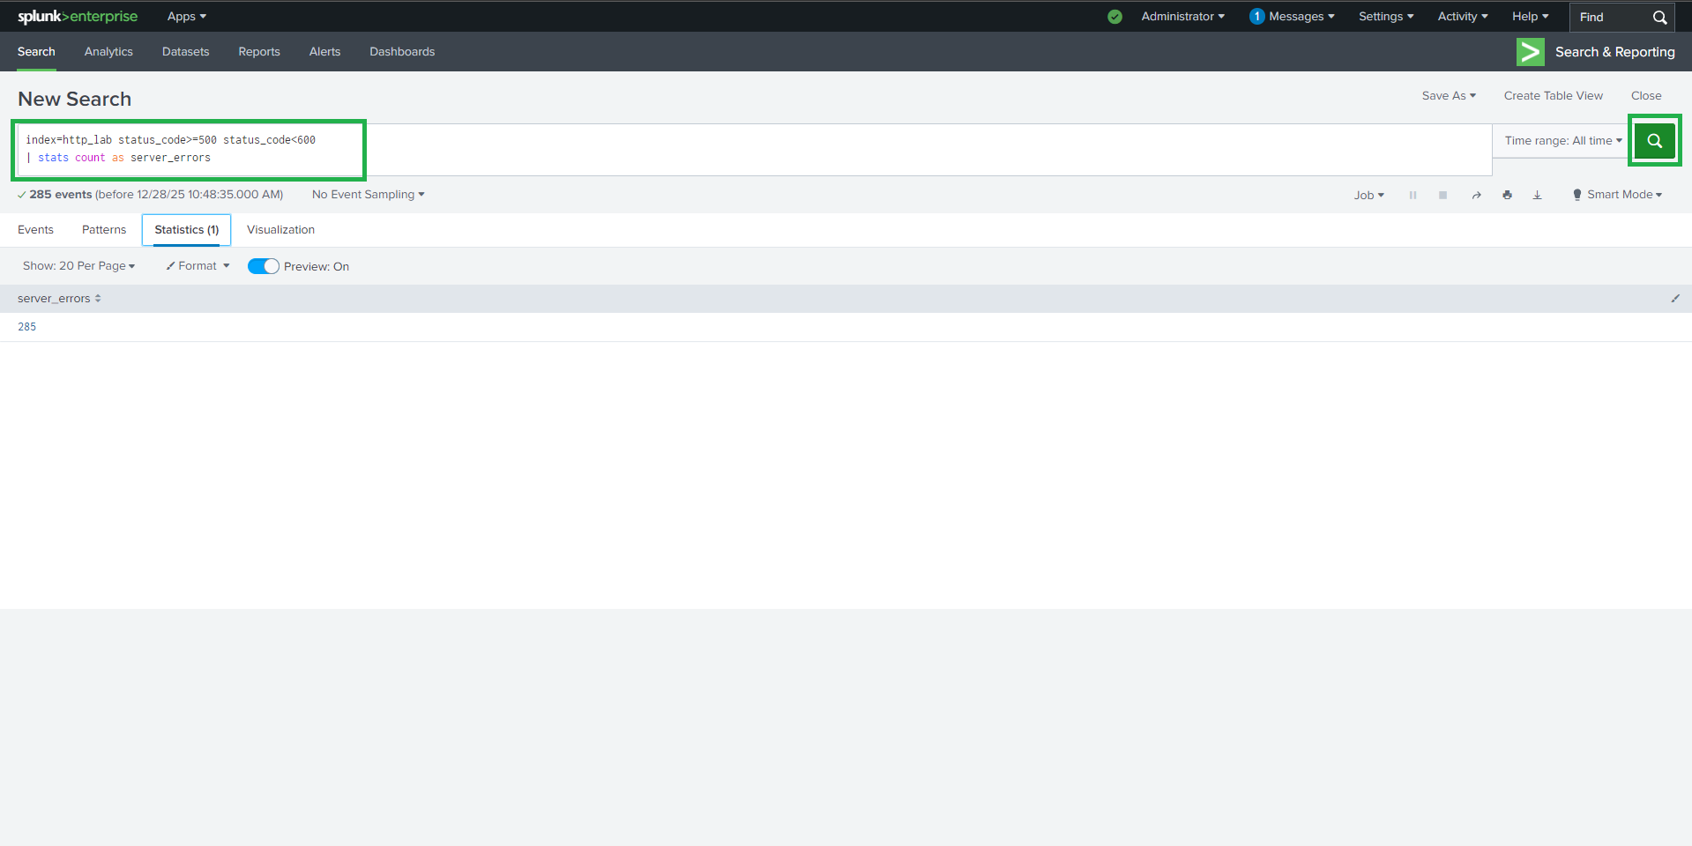

- Task 3: Detect Suspicious / Scripted User-Agents
index=http_lab
user_agent IN ("sqlmap/1.5.1", "curl/7.68.0", "python-requests/2.25.1", "botnet-checker/1.0")
| stats count by user_agent
Identifies automated tools commonly used in attacks or scanning.
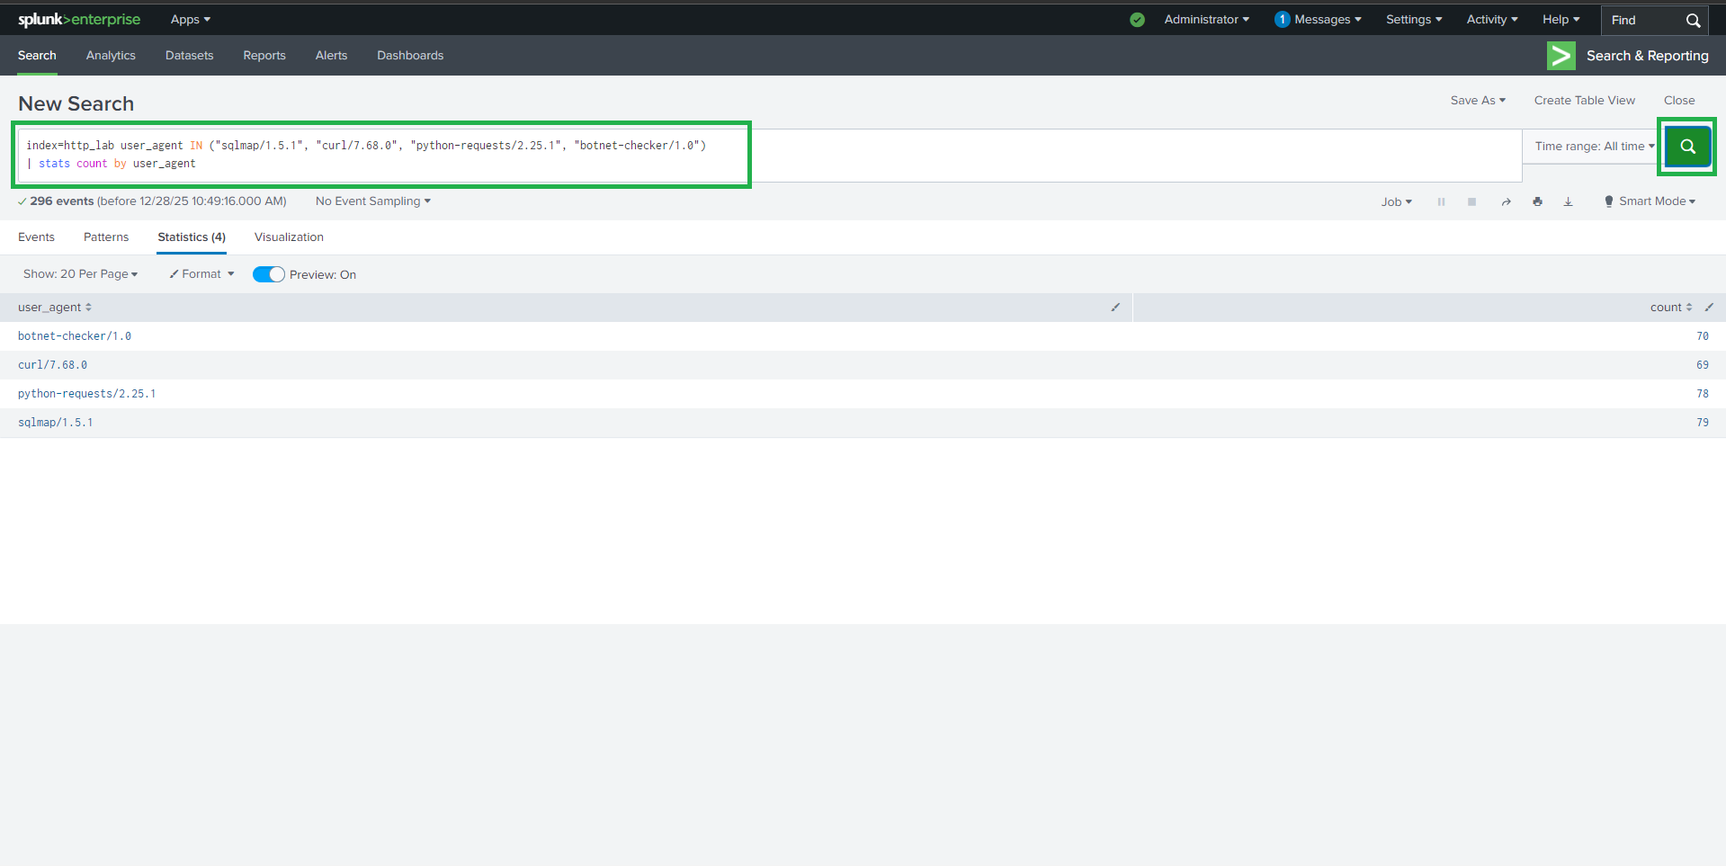

- Task 4: Find Large File Transfers (> 500 KB)
index=http_lab resp_body_len>500000
| table ts "id.orig_h" "id.resp_h" uri resp_body_len
| sort -resp_body_len
Useful for spotting potential data leaks or suspicious downloads.
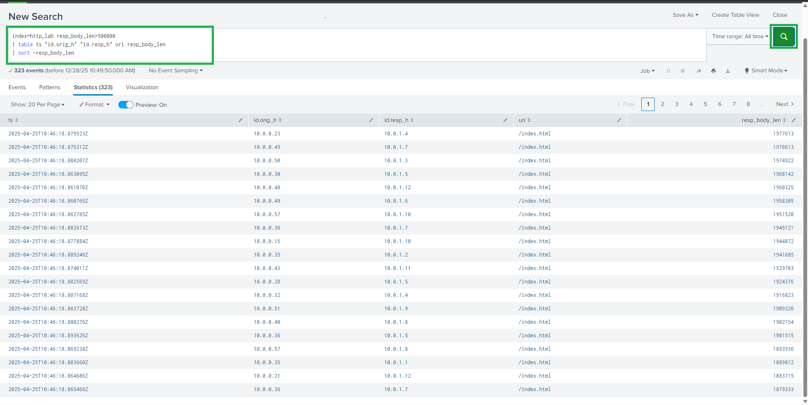

- Task 5: Detect Suspicious URI Access Attempts
index=http_lab
uri IN ("/admin","/shell.php","/etc/passwd")
| stats count by uri, "id.orig_h"
Highlights attempts to access admin panels, shells, or sensitive files.
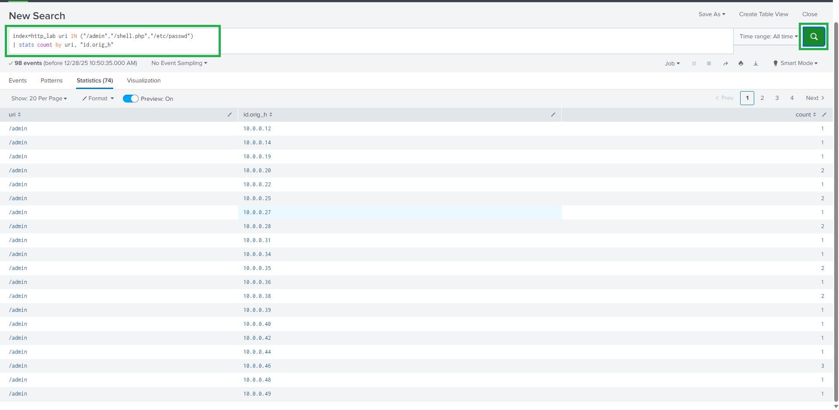

Security Insights Gained
Through this lab, you can:
- Detect malicious web reconnaissance
- Identify brute-force or scanning tools
- Monitor abnormal HTTP behavior
- Recognize potential data exfiltration
- Build detection logic for SOC use cases

Possible Enhancements
- Create Splunk alerts for:
  - Repeated 5xx errors
  - Large file transfers
  - Suspicious User-Agents
- Build dashboards for:
  - HTTP status trends
  - Top URIs and IPs
- Integrate with IDS / threat intelligence feeds

Learning Outcome
By completing this project, you have:
- Gained hands-on experience with Splunk SPL
- Learned real-world HTTP log analysis
- Practiced threat detection techniques
- Strengthened SIEM & SOC analyst skills

Conclusion
This lab demonstrates how SIEM tools like Splunk can be effectively used to analyze web traffic, detect attacks, and improve organizational security posture using log data.
A must-have project for Cybersecurity, SOC Analyst, and Blue Team portfolios.

