SSH Log Analysis using Splunk
By Laxmi Dahale

📌Project Overview
This project focuses on analyzing SSH authentication logs using Splunk Enterprise to identify suspicious login activities, detect potential brute-force attacks, and monitor unauthorized access attempts on Linux systems.
The objective is to collect, index, and analyze SSH logs in Splunk, creating dashboards and alerts that help security analysts quickly identify security incidents and improve system monitoring.

🎯Project Objective
The goal of this project is to analyze SSH authentication logs to detect:
- Successful logins (who connected, from where)
- Failed login attempts (possible brute-force or password spraying)
- Multiple failed authentication attempts (indicators of brute-force)
- Connections without authentication (potential scanning or incomplete sessions)
By completing this project, you’ll learn how to use Splunk to ingest SSH logs, run queries, create dashboards, and generate alerts.

🛠️Technologies Used
- Splunk Enterprise
- Universal Forwarder
- Linux (RHEL/Ubuntu/CentOS)
- SSH Service
- SPL (Search Processing Language)

📂Dashboard Components
- Failed Login Attempts
- Successful Logins
- Top Source IPs
- Top Target Users
- SSH Activity Timeline
- Brute Force Detection Panel

⚙️Lab Setup and Pre Requisites
Upload ssh_log.json into Splunk.
1.Open Splunk Web.
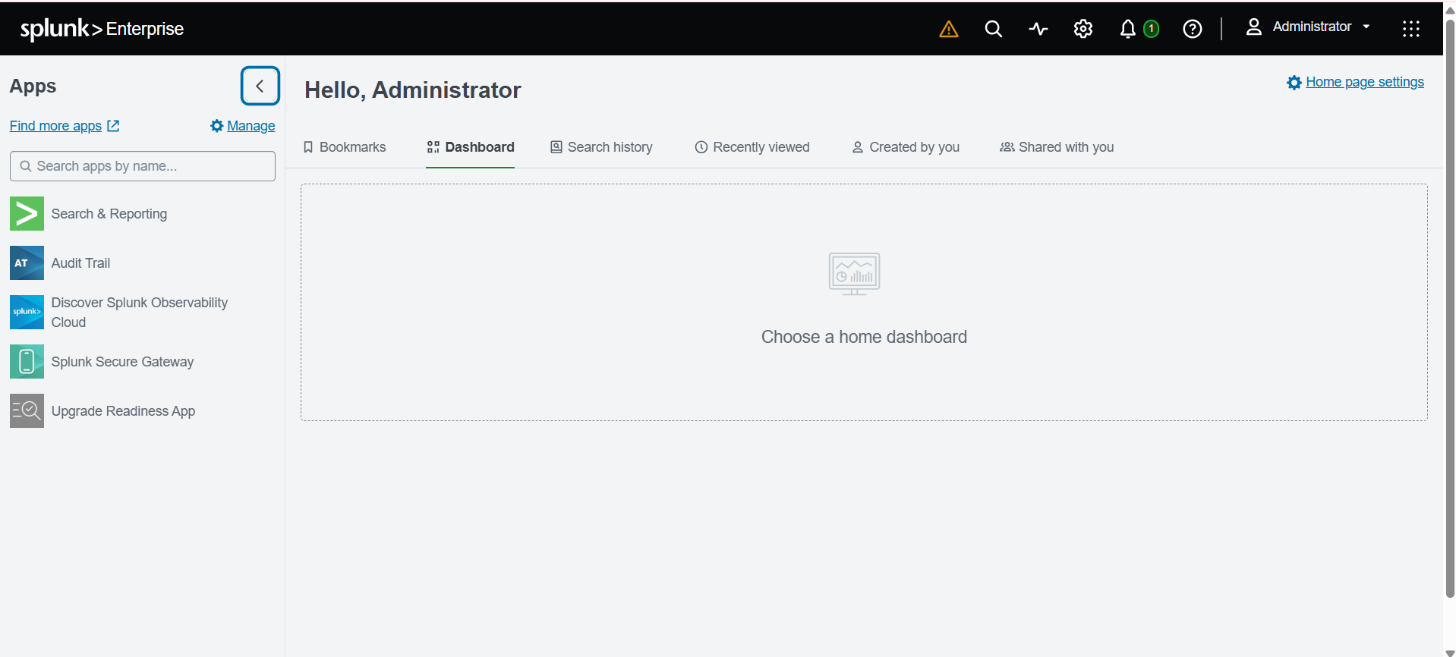

2.Navigate to : Settings → Add Data → Upload.
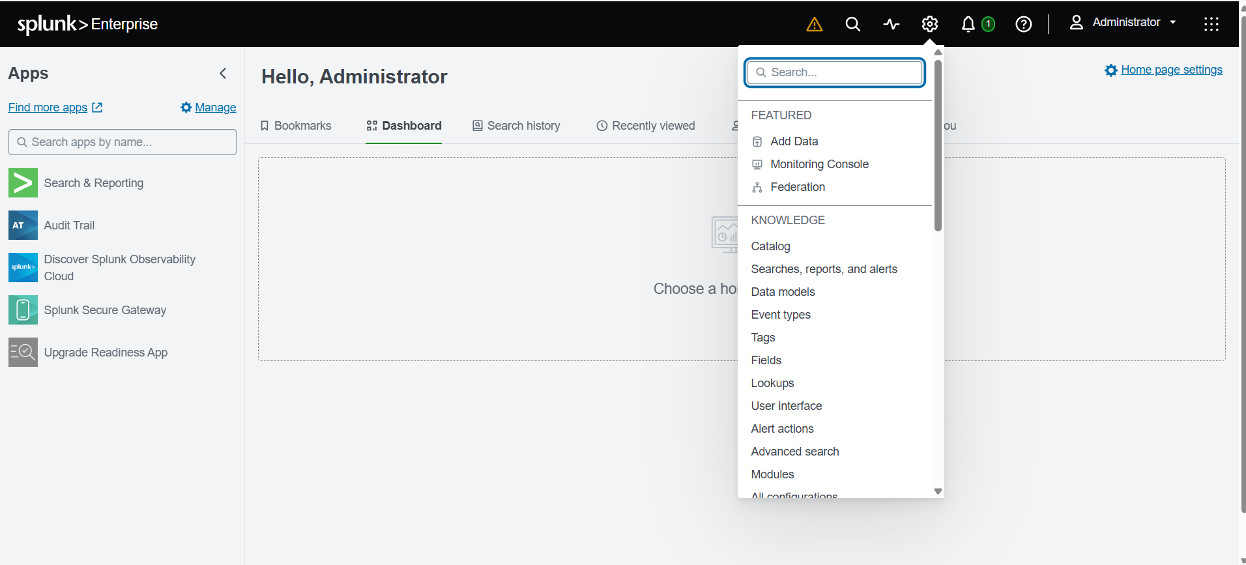
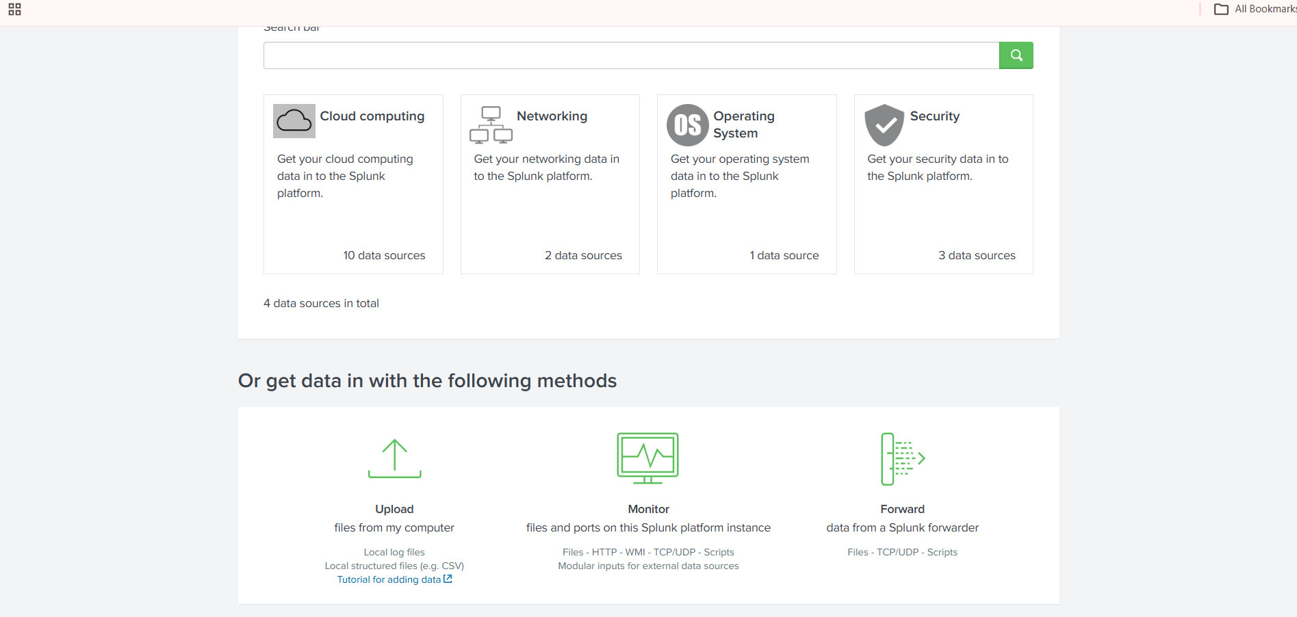

3.Select the File.
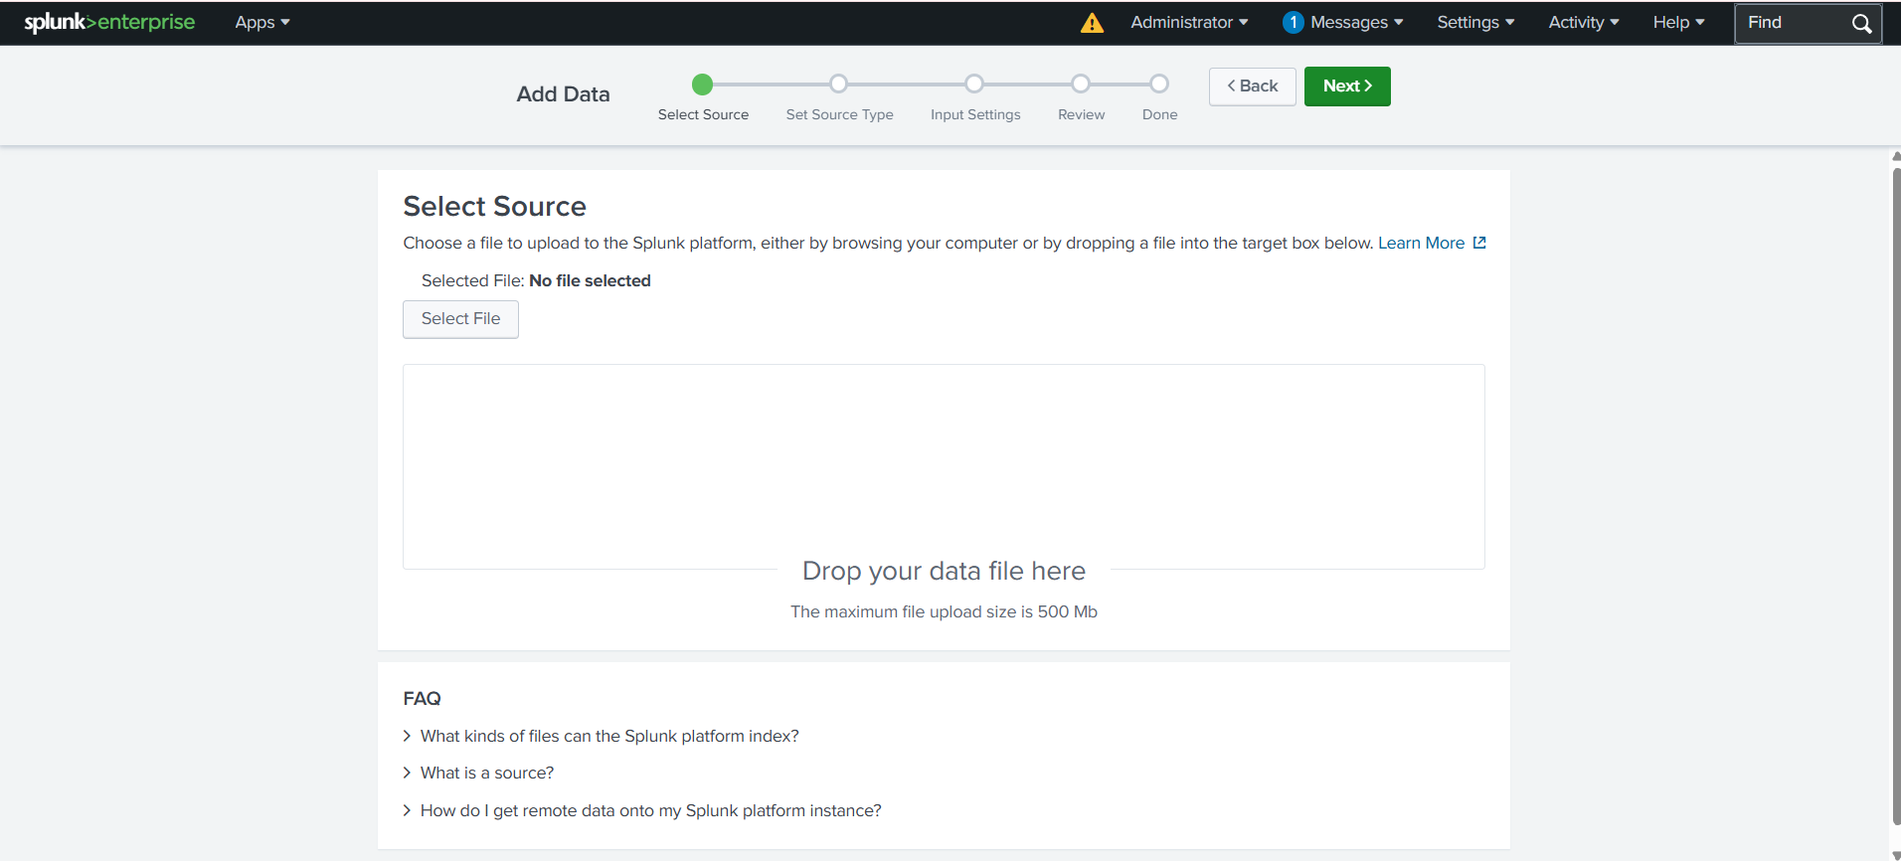

🔍 Lab Tasks & SPL Queries

- Task 1 : Ingest and Parse Logs.
1.Upload the ssh_log.json into Splunk.
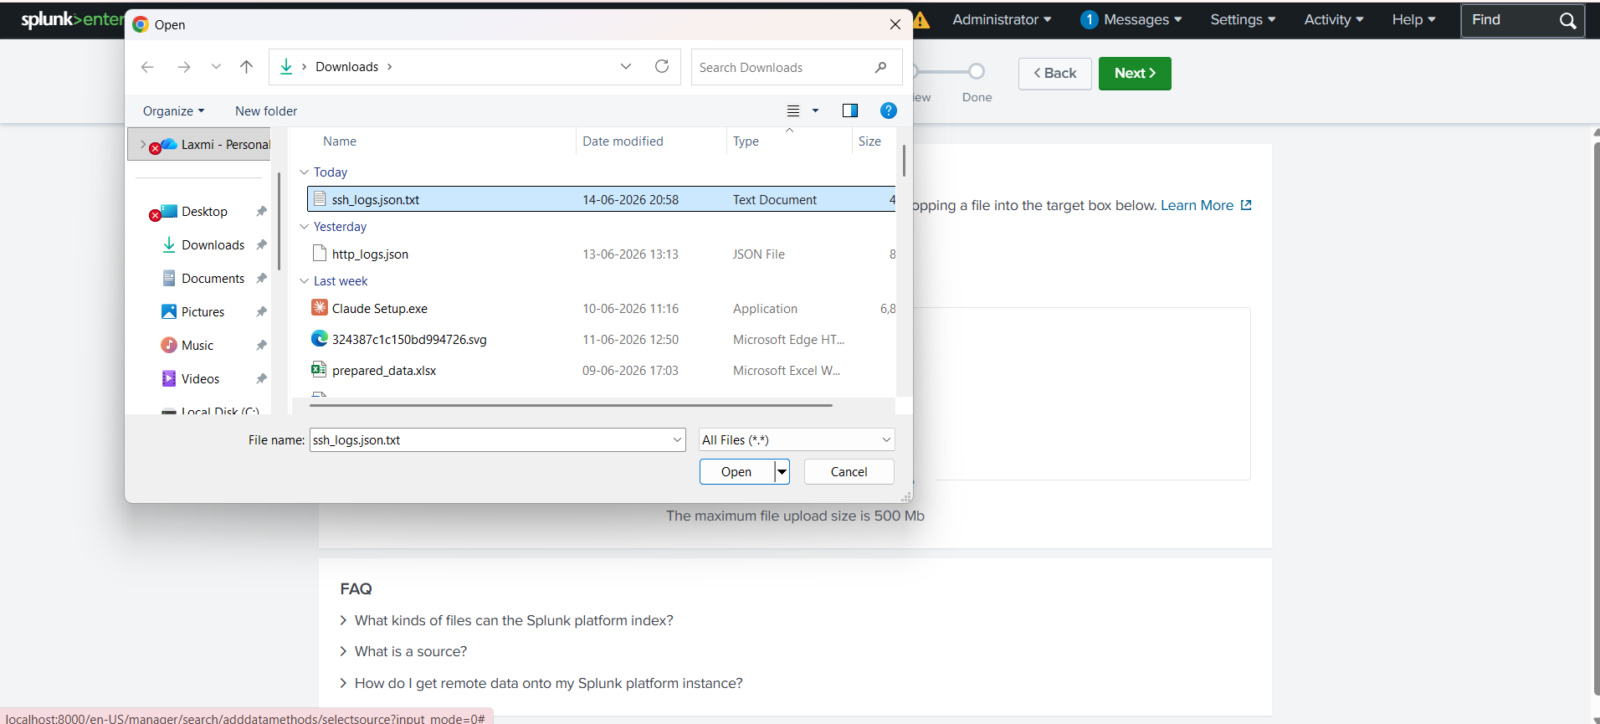
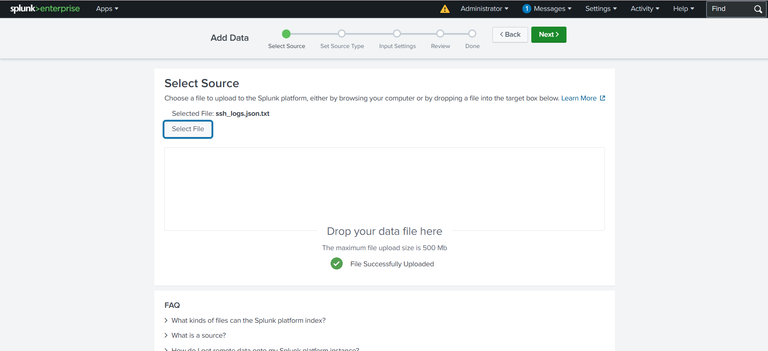
Configure : Source Type as json (or default)
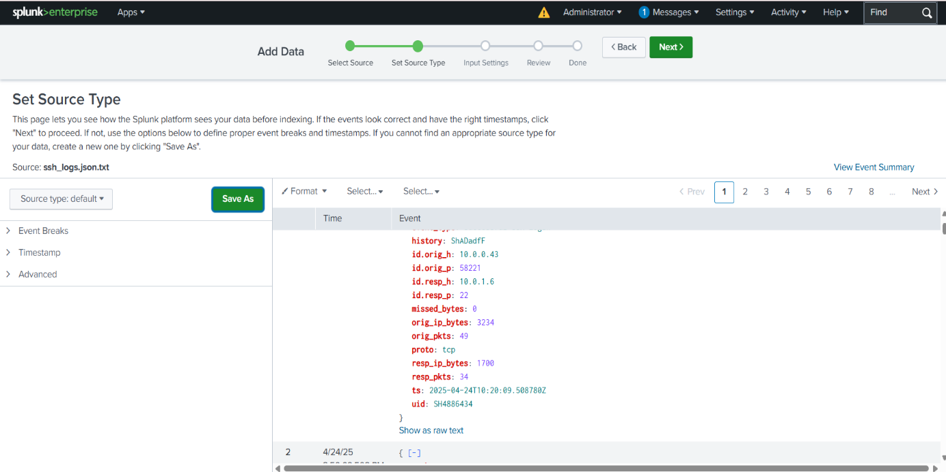
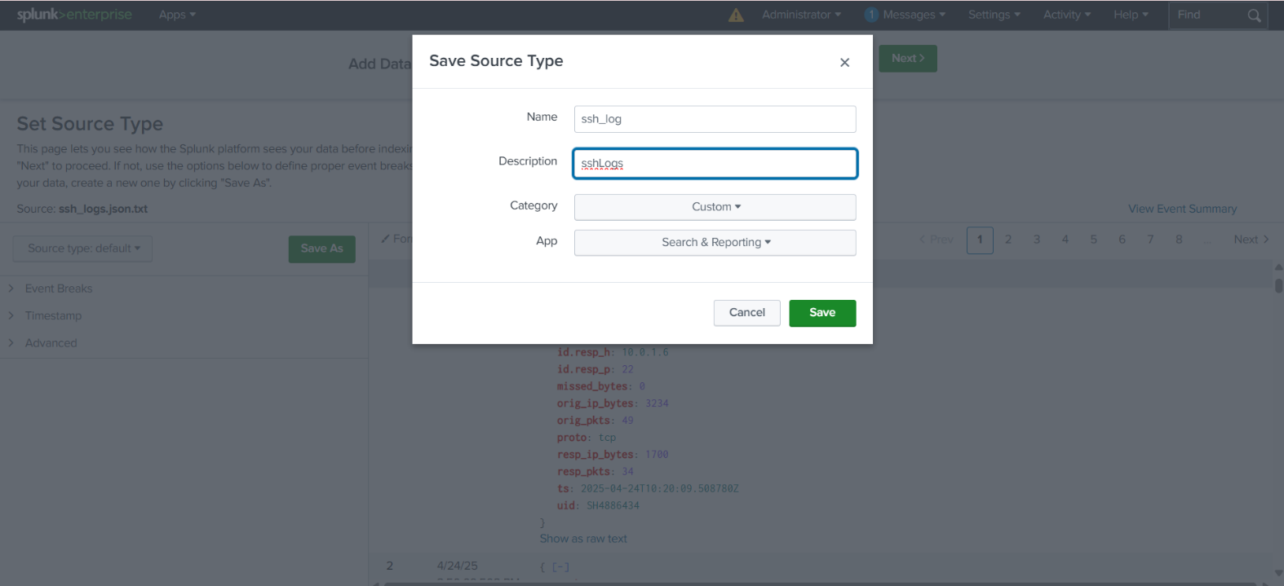

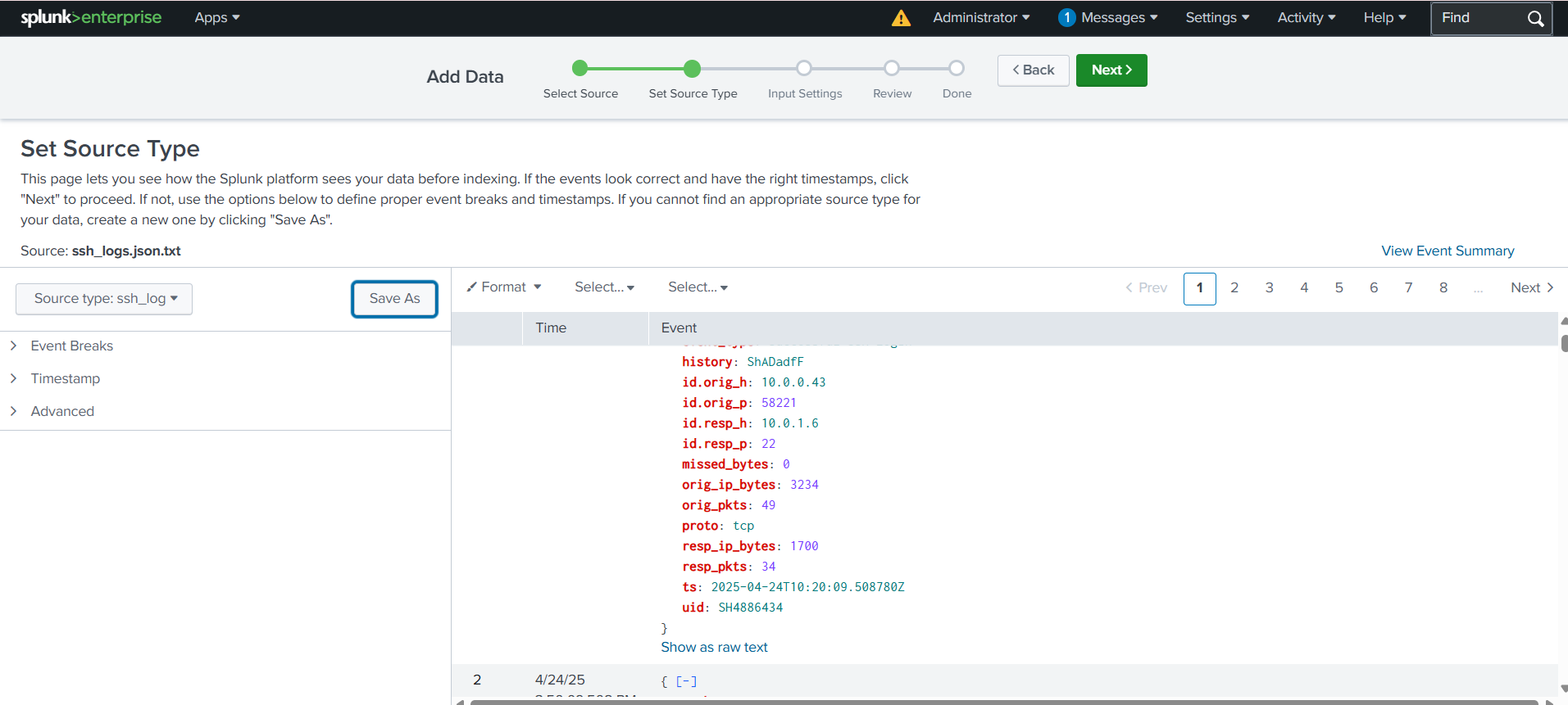

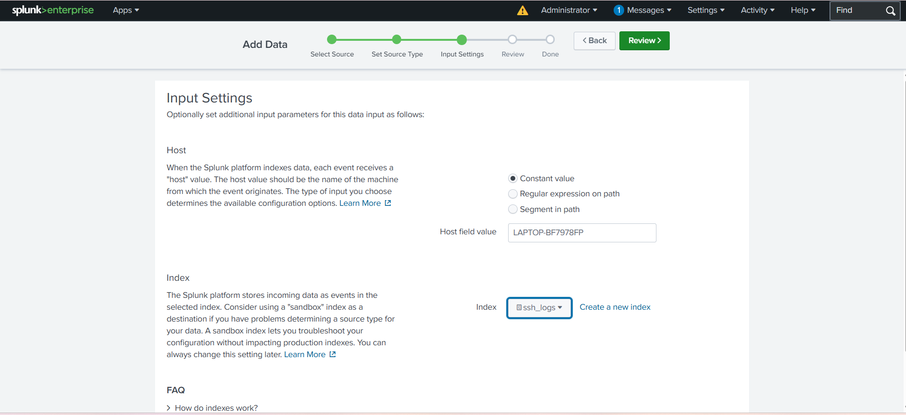
Create a new index (ssh_logs) and click Review.

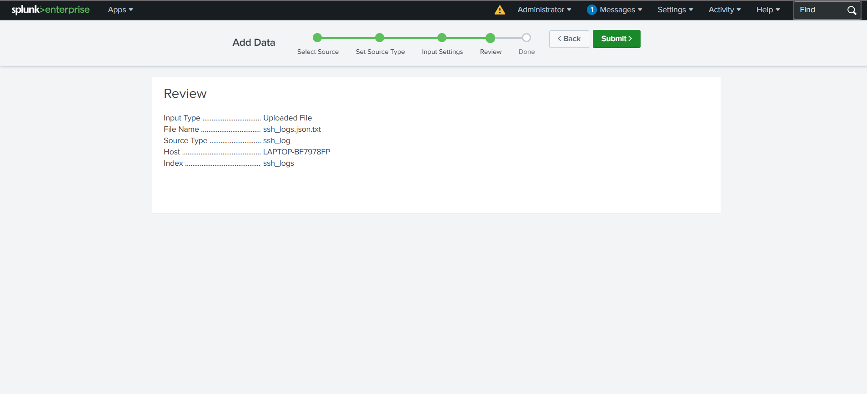

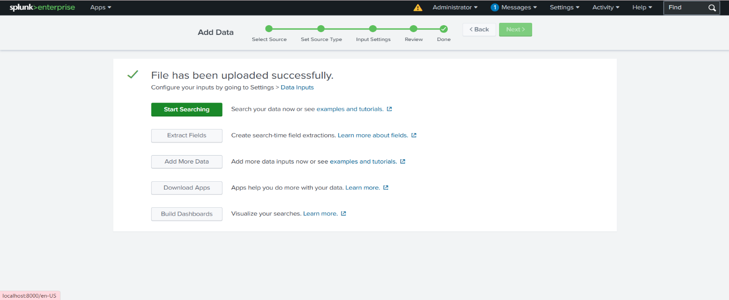

2. Run a Validation search:
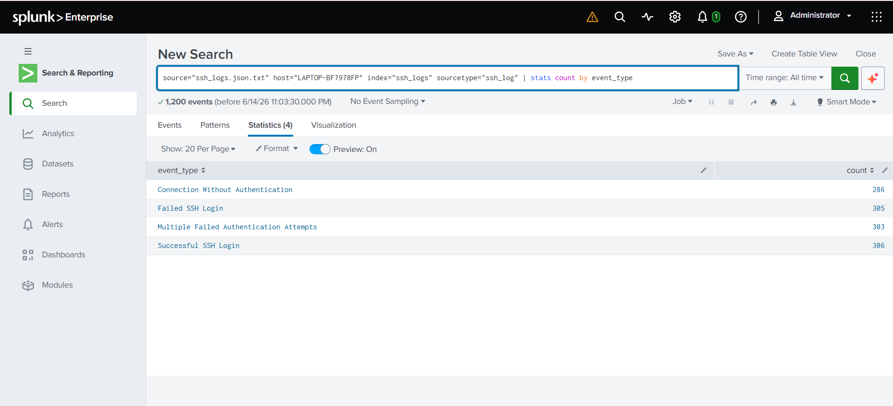
index=ssh_log | stats count by event_type

- Task 2 : Analyze Failed Login Attempts
Identify all failed login attempts:
index=ssh_logs event_type="Failed SSH Login"
| stats count by id.orig_h
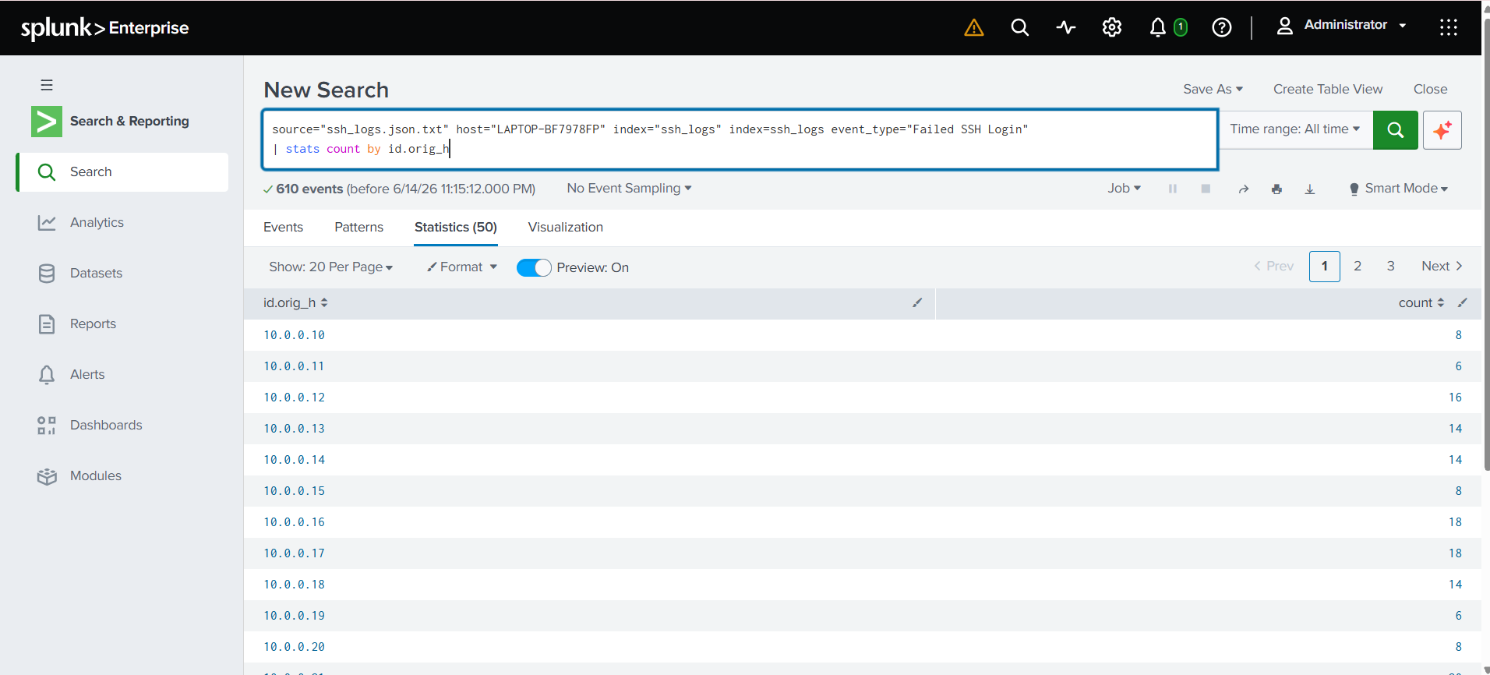

Create a bar chart visualization for failed login attempts per source IP.
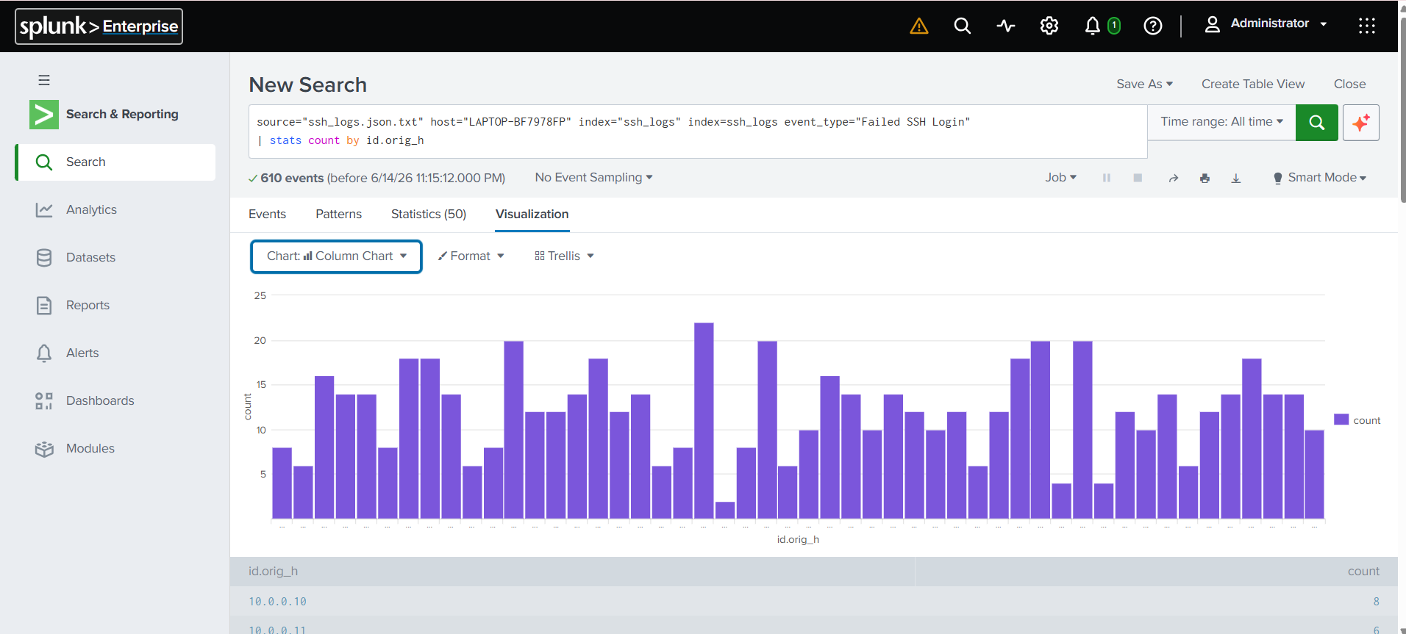
(For Bar Chart Visualization Click on Visualization and Select the Chart Option. )

- Task 3 : Detect Multiple Failed Authentication Attempts
(Brute Force).
Search for multiple failed attempts in logs:
index=ssh_logs event_type="Multiple Failed Authentication Attempts"
| stats count by id.orig_h, id.resp_h
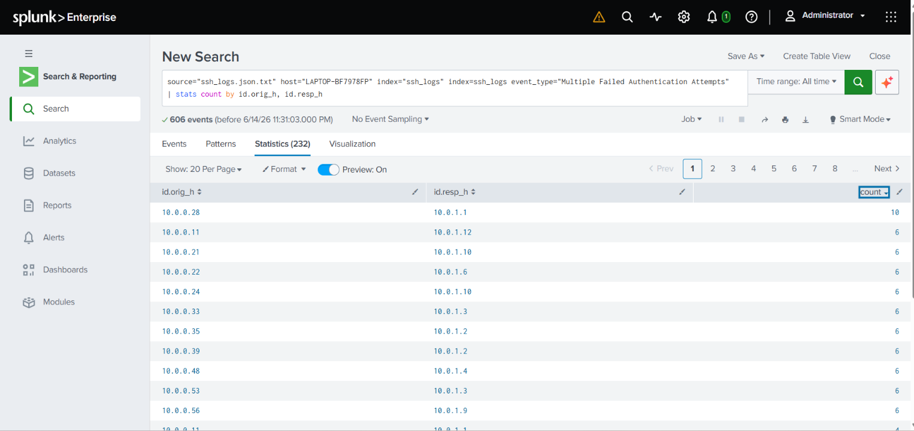

Configure a Splunk alert:
Trigger when any IP attempts more than 5 logins within 10 minutes.
Navigate to : Save As → Alert.
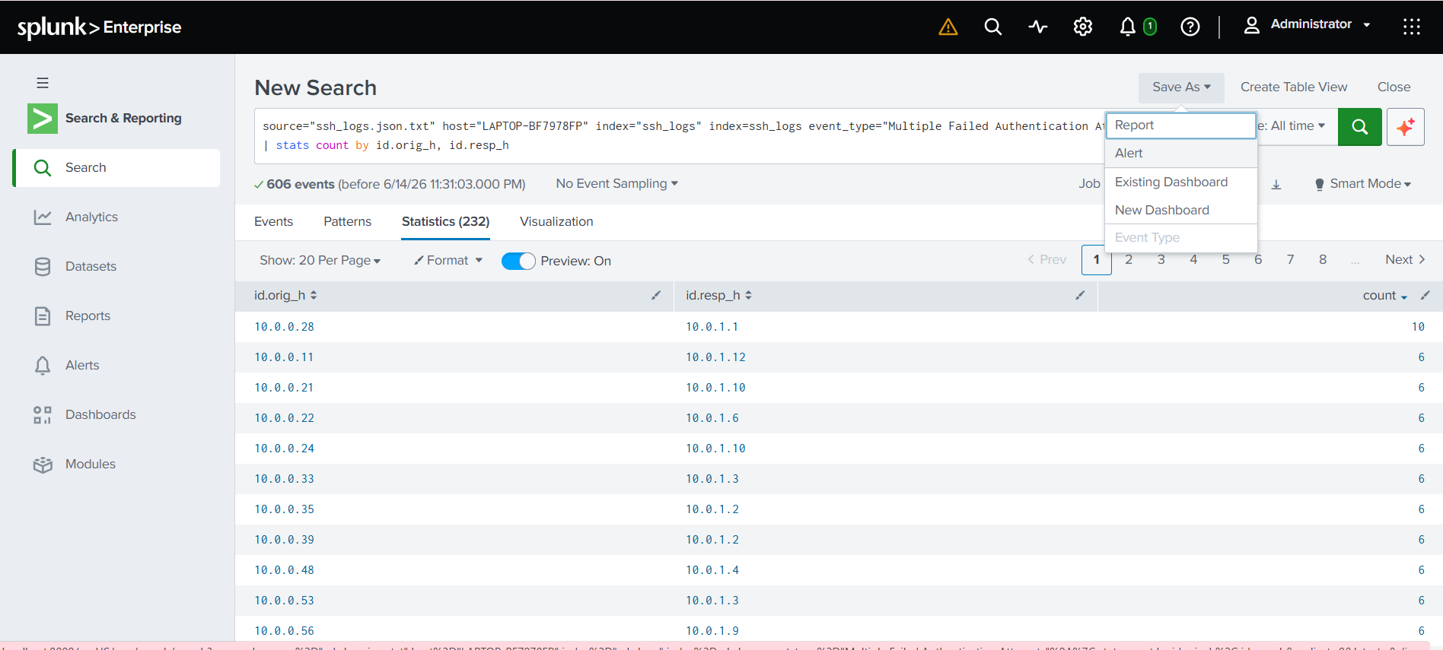

Name the Alert as Brute Force → Select Alert Type as Real-time → Add Action as Add to Trigger Alerts → Save.
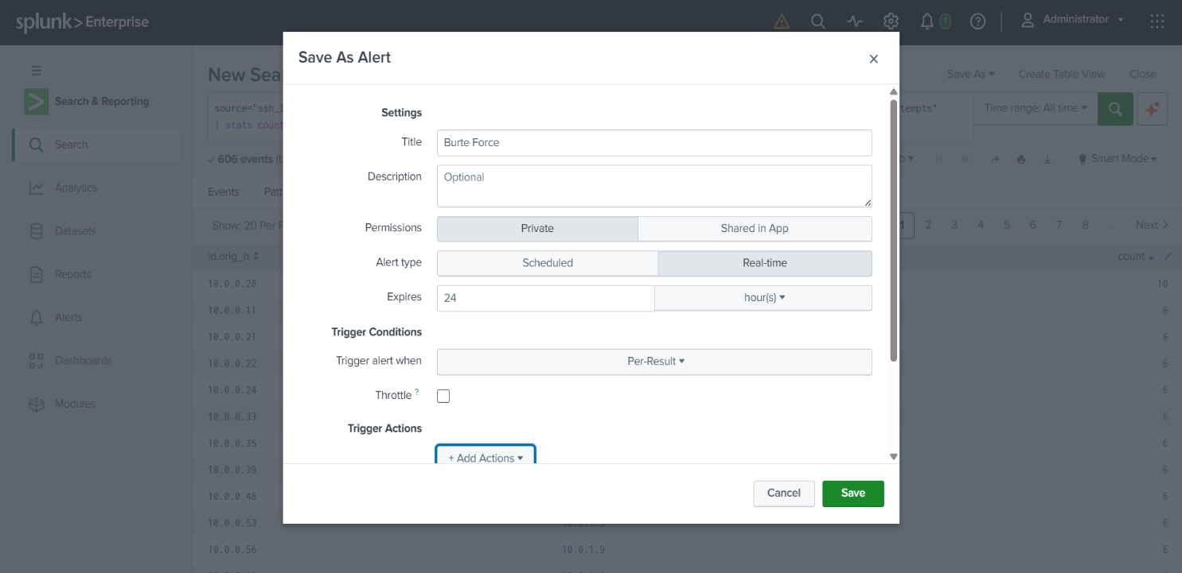

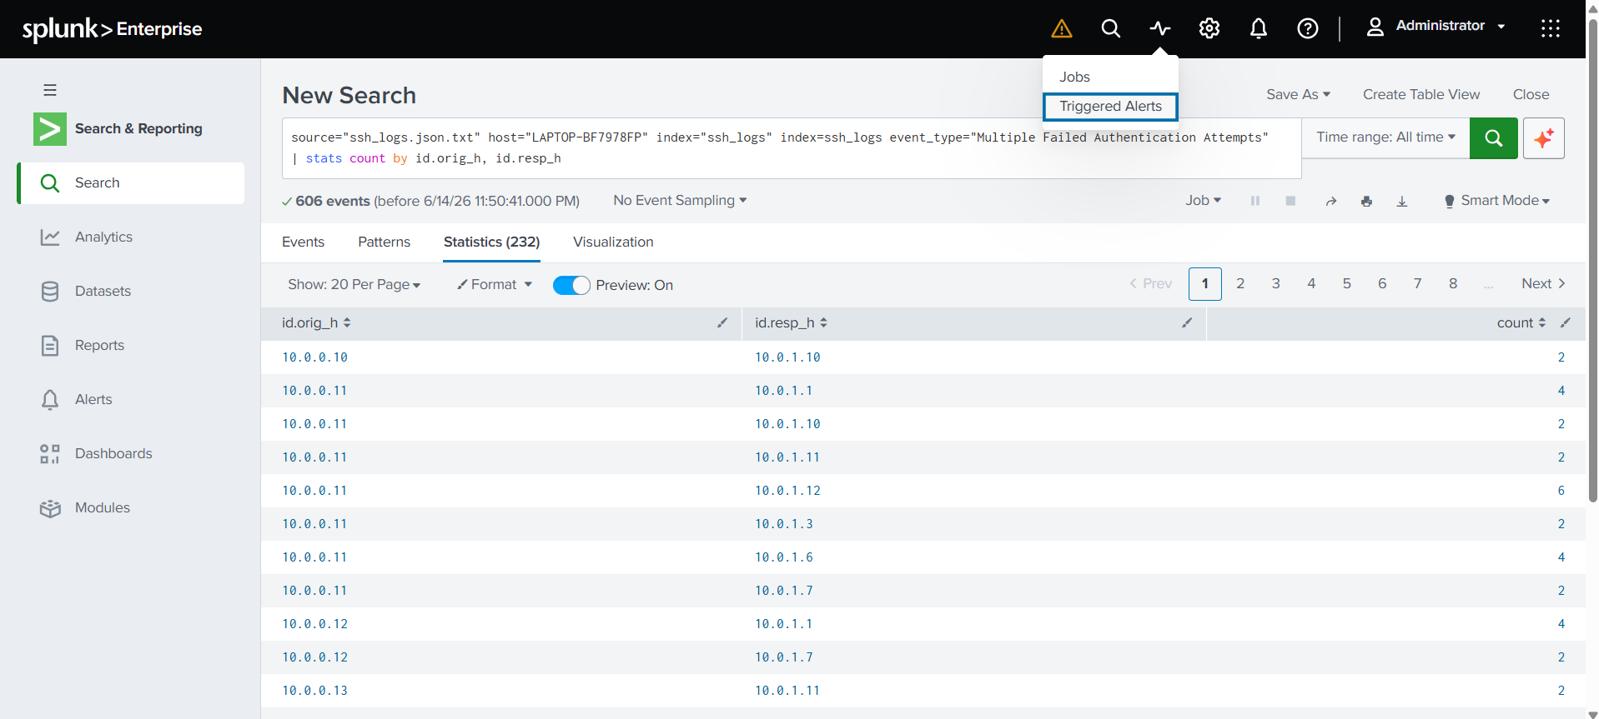
Whenever such Attempt will happen we’ll get Notification under the Activity.

- Task 4: Track Successful Logins
Search for successful logins:
index=ssh_logs event_type="Successful SSH Login"
| stats count by id.orig_h, id.resp_h
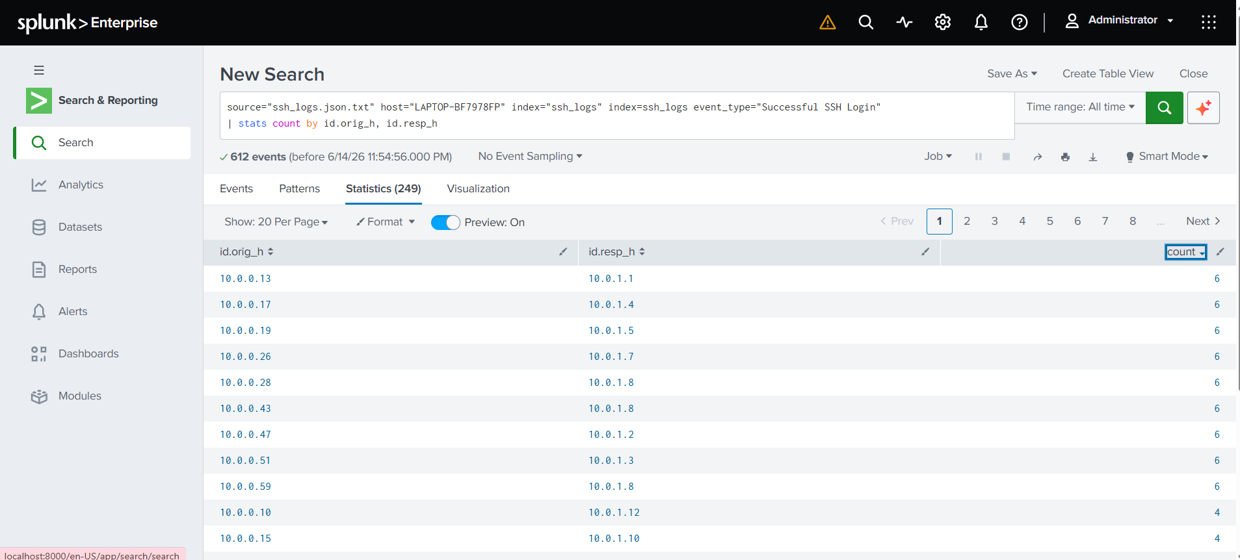

Create a dashboard panel showing top source IPs for successful logins.
(Click on Save As → New Dashboard)
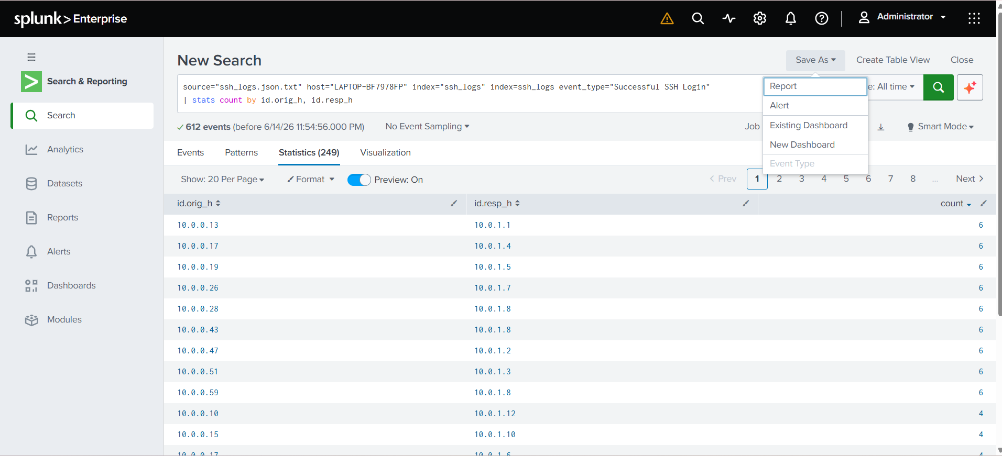

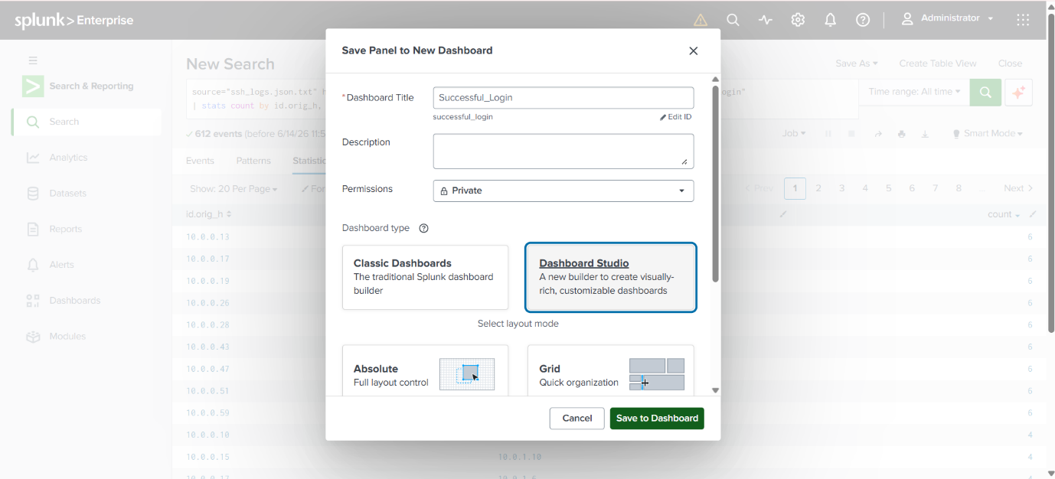
Dashboard Title as Successful_Login → Dashboard Type as Dashboard Studio and Save.

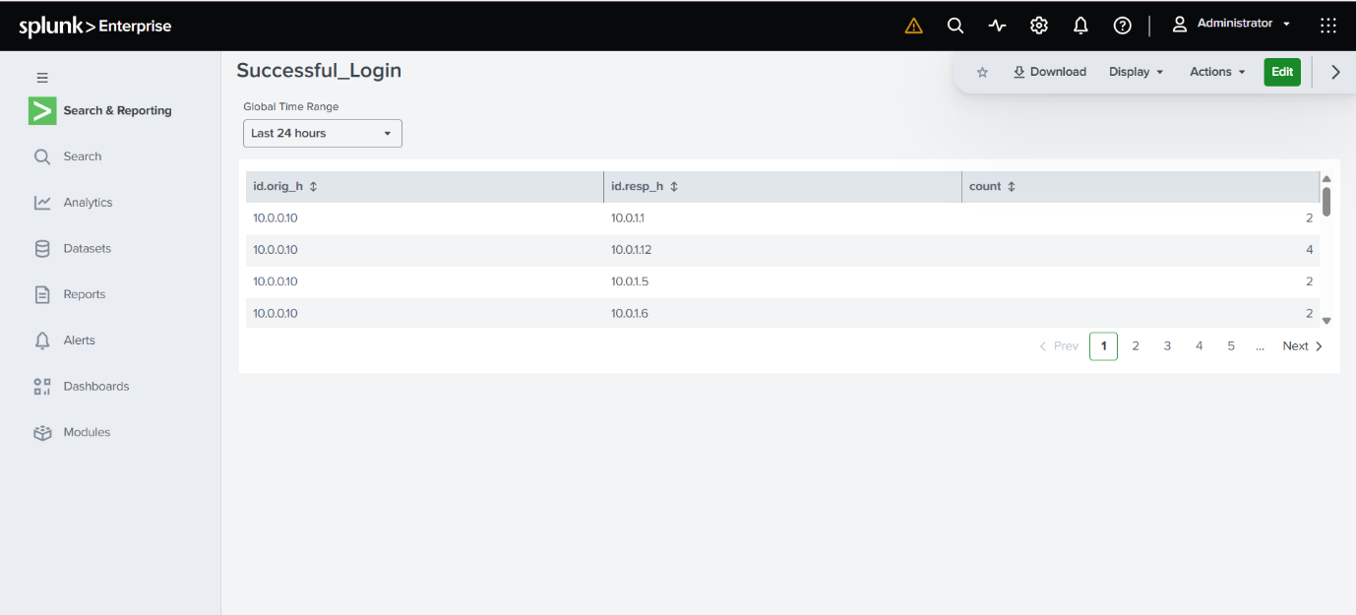
Dashboard created Successfully!

Task 5: Spot Suspicious Connections Without Authentication
Search for unauthenticated SSH connections:
index=ssh_logs event_type="Connection Without Authentication"
| stats count by id.orig_h
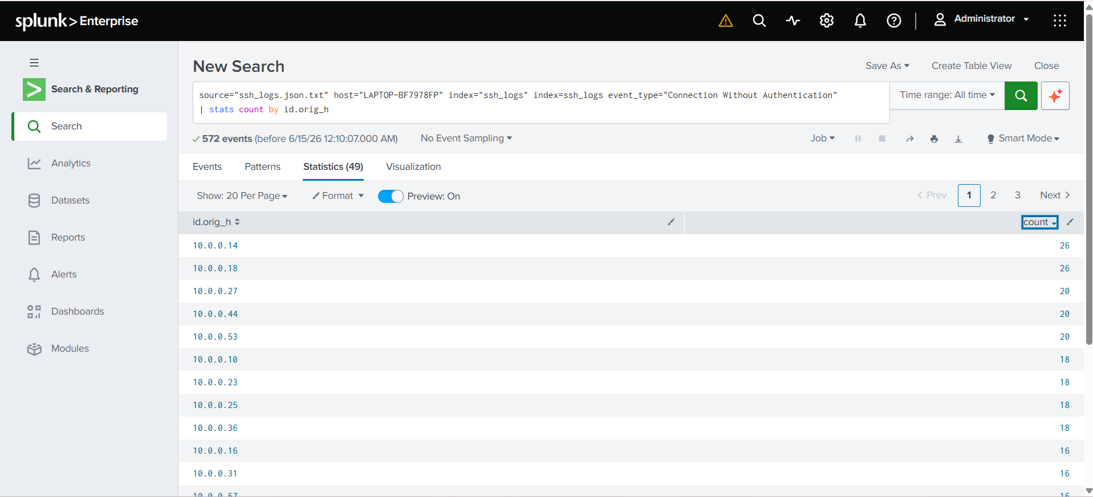

Create a timechart visualization to monitor such events over time:
index=ssh_logs event_type="Connection Without Authentication"
| timechart count by id.orig_h
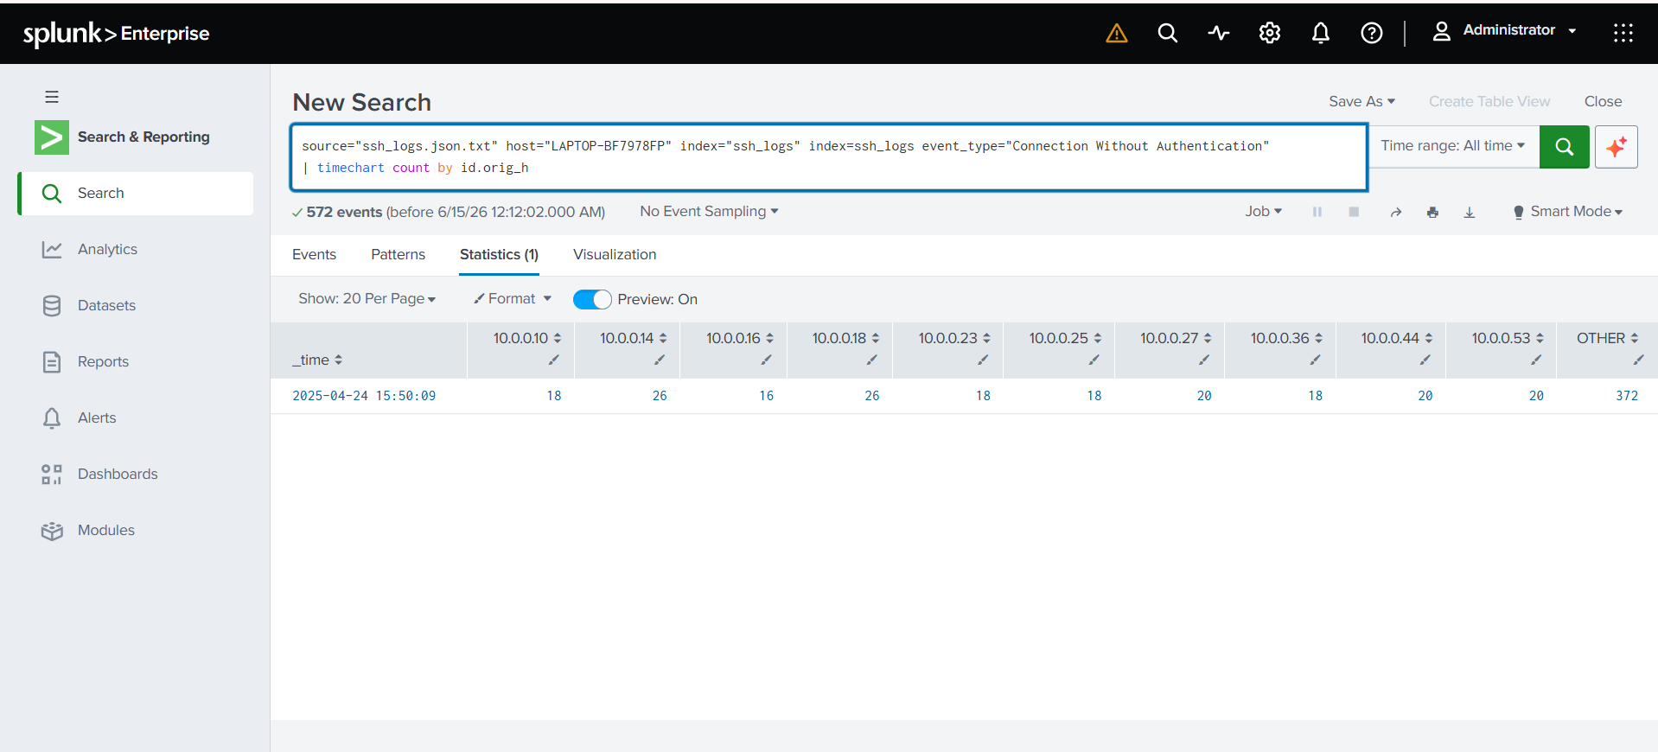

🎯Key Findings
- Detected multiple failed SSH login attempts indicating potential brute-force attacks.
- Identified suspicious source IP addresses responsible for repeated authentication failures.
- Observed successful logins following multiple failed attempts, suggesting possible credential compromise.
- Found unauthorized login attempts using invalid usernames.
- Noticed frequent targeting of privileged accounts such as root and admin users.
- Analyzed login trends to identify unusual access times and user behavior.
- Created real-time dashboards and alerts for rapid threat detection.
- Improved visibility into SSH authentication activities and security incidents.

🛡️Conclusion
By the end of this project, you will have:
- Built dashboards to monitor SSH activity.
- Identified brute-force login attempts and suspicious access attempts.
- Configured Splunk alerts for high-risk behavior.
- Learned how to parse, search, visualize, and alert on SSH logs in Splunk.
This project provides practical SOC Analyst–level log analysis skills and strengthens your cybersecurity portfolio.

🚀Future Enhancements
- Integrate threat intelligence feeds to detect known malicious IPs.
- Correlate SSH logs with firewall and IDS/IPS logs.
- Add geolocation tracking for login attempts.
- Develop advanced security dashboards.
- Integrate with SOAR platforms for automated incident response.
- Enhance monitoring with MFA-related security events.

