**Exercise 1: Control Structures**

**Scenario 1: Apply 1% interest rate discount for customers above 60**

BEGIN

FOR cust IN (SELECT c.CustomerID, l.LoanID, l.InterestRate, c.DOB

FROM Customers c JOIN Loans l ON c.CustomerID = l.CustomerID) LOOP

IF MONTHS_BETWEEN(SYSDATE, cust.DOB)/12 > 60 THEN

UPDATE Loans

SET InterestRate = InterestRate - 1

WHERE LoanID = cust.LoanID;

END IF;

END LOOP;

END;

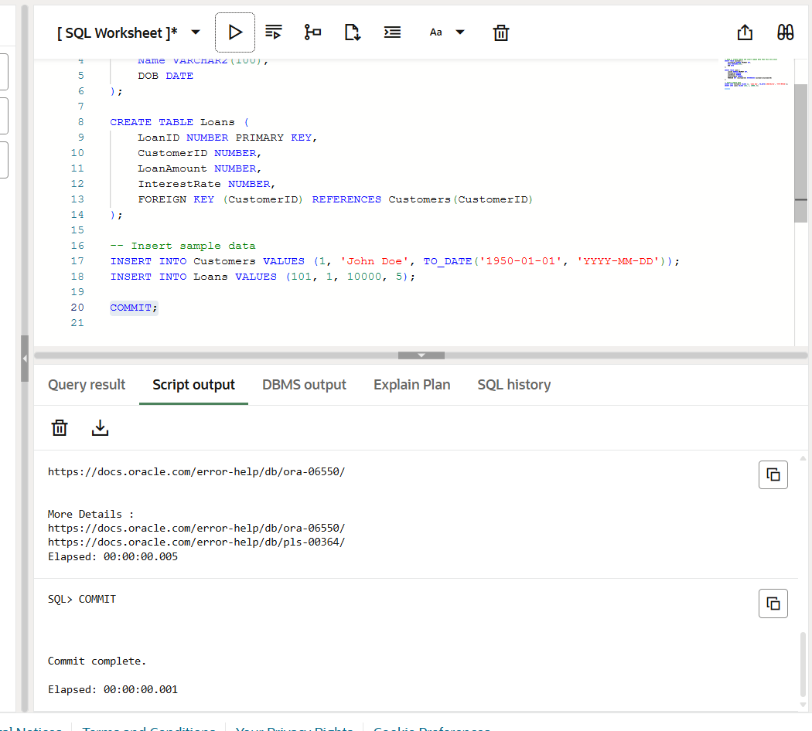

**Scenario 2: Set IsVIP = TRUE for customers with balance > 10,000**

**Add Column (if not already exists):**

BEGIN

FOR cust IN (SELECT CustomerID, Balance FROM Customers) LOOP

IF cust.Balance > 10000 THEN

UPDATE Customers

SET IsVIP = 'Y'

WHERE CustomerID = cust.CustomerID;

END IF;

END LOOP;

END;

**Scenario 3: Send reminders for loans due within 30 days**

BEGIN

FOR l IN (SELECT l.LoanID, c.Name, l.EndDate

FROM Loans l JOIN Customers c ON l.CustomerID = c.CustomerID

WHERE l.EndDate <= SYSDATE + 30) LOOP

DBMS_OUTPUT.PUT_LINE('Reminder: Loan ' || l.LoanID || ' for ' || l.Name || ' is due on ' || TO_CHAR(l.EndDate, 'DD-MON-YYYY'));

END LOOP;

END;

**Exercise 2: Error Handling**

**Scenario 1: Safe Transfer of Funds**

BEGIN

SELECT Balance INTO v_from_balance FROM Accounts WHERE AccountID = p_from FOR UPDATE;

IF v_from_balance < p_amount THEN

RAISE_APPLICATION_ERROR(-20001, 'Insufficient funds');

END IF;

UPDATE Accounts SET Balance = Balance - p_amount WHERE AccountID = p_from;

UPDATE Accounts SET Balance = Balance + p_amount WHERE AccountID = p_to;

COMMIT;

EXCEPTION

WHEN OTHERS THEN

ROLLBACK;

DBMS_OUTPUT.PUT_LINE('Error during transfer: ' || SQLERRM);

END;

**Scenario 2: Update Salary with Error Handling**

CREATE OR REPLACE PROCEDURE UpdateSalary(p_empid NUMBER, p_percent NUMBER) AS

BEGIN

UPDATE Employees

SET Salary = Salary + Salary * p_percent / 100

WHERE EmployeeID = p_empid;

IF SQL%ROWCOUNT = 0 THEN

RAISE_APPLICATION_ERROR(-20002, 'Employee not found');

END IF;

COMMIT;

EXCEPTION

WHEN OTHERS THEN

ROLLBACK;

DBMS_OUTPUT.PUT_LINE('Error updating salary: ' || SQLERRM);

END;

**Scenario 3: Add New Customer with Duplicate Check**

CREATE OR REPLACE PROCEDURE AddNewCustomer(p_id NUMBER, p_name VARCHAR2, p_dob DATE, p_balance NUMBER) AS

BEGIN

INSERT INTO Customers (CustomerID, Name, DOB, Balance, LastModified)

VALUES (p_id, p_name, p_dob, p_balance, SYSDATE);

COMMIT;

EXCEPTION

WHEN DUP_VAL_ON_INDEX THEN

DBMS_OUTPUT.PUT_LINE('Customer with ID ' || p_id || ' already exists.');

WHEN OTHERS THEN

DBMS_OUTPUT.PUT_LINE('Error adding customer: ' || SQLERRM);

END;

**Exercise 3: Stored Procedures**

**Scenario 1: Process Monthly Interest (1%)**

CREATE OR REPLACE PROCEDURE ProcessMonthlyInterest IS

BEGIN

UPDATE Accounts

SET Balance = Balance + Balance * 0.01

WHERE AccountType = 'Savings';

COMMIT;

END;

**Scenario 2: Update Bonus Based on Department**

CREATE OR REPLACE PROCEDURE UpdateEmployeeBonus(p_dept VARCHAR2, p_bonus_percent NUMBER) AS

BEGIN

UPDATE Employees

SET Salary = Salary + Salary * p_bonus_percent / 100

WHERE Department = p_dept;

COMMIT;

END;

**Scenario 3: Transfer Funds Between Customer Accounts**

CREATE OR REPLACE PROCEDURE TransferFunds(p_from NUMBER, p_to NUMBER, p_amount NUMBER) AS

v_balance Accounts.Balance%TYPE;

BEGIN

SELECT Balance INTO v_balance FROM Accounts WHERE AccountID = p_from FOR UPDATE;

IF v_balance < p_amount THEN

RAISE_APPLICATION_ERROR(-20003, 'Insufficient balance in source account');

END IF;

UPDATE Accounts SET Balance = Balance - p_amount WHERE AccountID = p_from;

UPDATE Accounts SET Balance = Balance + p_amount WHERE AccountID = p_to;

COMMIT;

EXCEPTION

WHEN OTHERS THEN

ROLLBACK;

DBMS_OUTPUT.PUT_LINE('Transfer failed: ' || SQLERRM);

END;

**Exercise 4: Functions**

**Scenario 1: Calculate Customer Age**

CREATE OR REPLACE FUNCTION CalculateAge(p_dob DATE) RETURN NUMBER IS

BEGIN

RETURN TRUNC(MONTHS_BETWEEN(SYSDATE, p_dob)/12);

END;

**Scenario 2: Calculate Monthly Loan Installment**

sql

CopyEdit

CREATE OR REPLACE FUNCTION CalculateMonthlyInstallment(p_amount NUMBER, p_rate NUMBER, p_years NUMBER) RETURN NUMBER IS

v_monthly_rate NUMBER := p_rate / (12 * 100);

v_months NUMBER := p_years * 12;

BEGIN

RETURN (p_amount * v_monthly_rate) / (1 - POWER(1 + v_monthly_rate, -v_months));

END;

**Scenario 3: Check Sufficient Balance**

sql

CopyEdit

CREATE OR REPLACE FUNCTION HasSufficientBalance(p_accid NUMBER, p_amount NUMBER) RETURN BOOLEAN IS

v_balance NUMBER;

BEGIN

SELECT Balance INTO v_balance FROM Accounts WHERE AccountID = p_accid;

RETURN v_balance >= p_amount;

EXCEPTION

WHEN NO_DATA_FOUND THEN

RETURN FALSE;

END;

**Exercise 5: Triggers**

**Scenario 1: Update LastModified**

CREATE OR REPLACE TRIGGER UpdateCustomerLastModified

BEFORE UPDATE ON Customers

FOR EACH ROW

BEGIN

:NEW.LastModified := SYSDATE;

END;

**Scenario 2: Log Transactions**

CREATE TABLE AuditLog (

LogID NUMBER GENERATED ALWAYS AS IDENTITY,

AccountID NUMBER,

Amount NUMBER,

TransactionType VARCHAR2(10),

LogDate DATE

);

CREATE OR REPLACE TRIGGER LogTransaction

AFTER INSERT ON Transactions

FOR EACH ROW

BEGIN

INSERT INTO AuditLog (AccountID, Amount, TransactionType, LogDate)

VALUES (:NEW.AccountID, :NEW.Amount, :NEW.TransactionType, SYSDATE);

END;

**Scenario 3: Enforce Deposit/Withdrawal Rules**

sql

CopyEdit

CREATE OR REPLACE TRIGGER CheckTransactionRules

BEFORE INSERT ON Transactions

FOR EACH ROW

DECLARE

v_balance NUMBER;

BEGIN

SELECT Balance INTO v_balance FROM Accounts WHERE AccountID = :NEW.AccountID;

IF :NEW.TransactionType = 'Withdrawal' AND :NEW.Amount > v_balance THEN

RAISE_APPLICATION_ERROR(-20004, 'Withdrawal exceeds account balance');

ELSIF :NEW.TransactionType = 'Deposit' AND :NEW.Amount <= 0 THEN

RAISE_APPLICATION_ERROR(-20005, 'Deposit amount must be positive');

END IF;

END;

**Exercise 6: Cursors**

**Scenario 1: Generate Monthly Statements**

sql

CopyEdit

DECLARE

CURSOR cur_statements IS

SELECT a.CustomerID, t.AccountID, t.TransactionDate, t.Amount, t.TransactionType

FROM Transactions t

JOIN Accounts a ON t.AccountID = a.AccountID

WHERE TO_CHAR(t.TransactionDate, 'MMYYYY') = TO_CHAR(SYSDATE, 'MMYYYY');

BEGIN

FOR rec IN cur_statements LOOP

DBMS_OUTPUT.PUT_LINE('Customer ' || rec.CustomerID || ', Account ' || rec.AccountID ||

': ' || rec.TransactionType || ' of ' || rec.Amount || ' on ' || rec.TransactionDate);

END LOOP;

END;

**Scenario 2: Apply Annual Fee**

sql

CopyEdit

DECLARE

CURSOR cur_accounts IS SELECT AccountID, Balance FROM Accounts;

BEGIN

FOR acc IN cur_accounts LOOP

UPDATE Accounts

SET Balance = Balance - 100 -- annual fee

WHERE AccountID = acc.AccountID;

END LOOP;

COMMIT;

END;

**Scenario 3: Update Loan Interest Rates**

sql

CopyEdit

DECLARE

CURSOR cur_loans IS SELECT LoanID, InterestRate FROM Loans;

BEGIN

FOR l IN cur_loans LOOP

UPDATE Loans

SET InterestRate = InterestRate + 0.5 -- e.g., policy increase

WHERE LoanID = l.LoanID;

END LOOP;

COMMIT;

END;

**Exercise 7: Packages**

**Scenario 1: CustomerManagement Package**

CREATE OR REPLACE PACKAGE CustomerManagement AS

PROCEDURE AddCustomer(p_id NUMBER, p_name VARCHAR2, p_dob DATE, p_balance NUMBER);

PROCEDURE UpdateCustomer(p_id NUMBER, p_name VARCHAR2);

FUNCTION GetBalance(p_id NUMBER) RETURN NUMBER;

END;

/

CREATE OR REPLACE PACKAGE BODY CustomerManagement AS

PROCEDURE AddCustomer(p_id NUMBER, p_name VARCHAR2, p_dob DATE, p_balance NUMBER) IS

BEGIN

INSERT INTO Customers VALUES (p_id, p_name, p_dob, p_balance, SYSDATE);

END;

PROCEDURE UpdateCustomer(p_id NUMBER, p_name VARCHAR2) IS

BEGIN

UPDATE Customers SET Name = p_name WHERE CustomerID = p_id;

END;

FUNCTION GetBalance(p_id NUMBER) RETURN NUMBER IS

v_balance NUMBER;

BEGIN

SELECT Balance INTO v_balance FROM Customers WHERE CustomerID = p_id;

RETURN v_balance;

END;

END;

**Scenario 2: EmployeeManagement Package**

CREATE OR REPLACE PACKAGE EmployeeManagement AS

PROCEDURE HireEmployee(p_id NUMBER, p_name VARCHAR2, p_pos VARCHAR2, p_sal NUMBER, p_dept VARCHAR2, p_hire DATE);

PROCEDURE UpdateEmployee(p_id NUMBER, p_name VARCHAR2);

FUNCTION GetAnnualSalary(p_id NUMBER) RETURN NUMBER;

END;

/

CREATE OR REPLACE PACKAGE BODY EmployeeManagement AS

PROCEDURE HireEmployee(p_id NUMBER, p_name VARCHAR2, p_pos VARCHAR2, p_sal NUMBER, p_dept VARCHAR2, p_hire DATE) IS

BEGIN

INSERT INTO Employees VALUES (p_id, p_name, p_pos, p_sal, p_dept, p_hire);

END;

PROCEDURE UpdateEmployee(p_id NUMBER, p_name VARCHAR2) IS

BEGIN

UPDATE Employees SET Name = p_name WHERE EmployeeID = p_id;

END;

FUNCTION GetAnnualSalary(p_id NUMBER) RETURN NUMBER IS

v_salary NUMBER;

BEGIN

SELECT Salary INTO v_salary FROM Employees WHERE EmployeeID = p_id;

RETURN v_salary * 12;

END;

END;

**Scenario 3: AccountOperations Package**

sql

CopyEdit

CREATE OR REPLACE PACKAGE AccountOperations AS

PROCEDURE OpenAccount(p_accid NUMBER, p_custid NUMBER, p_type VARCHAR2, p_balance NUMBER);

PROCEDURE CloseAccount(p_accid NUMBER);

FUNCTION GetTotalBalance(p_custid NUMBER) RETURN NUMBER;

END;

/

CREATE OR REPLACE PACKAGE BODY AccountOperations AS

PROCEDURE OpenAccount(p_accid NUMBER, p_custid NUMBER, p_type VARCHAR2, p_balance NUMBER) IS

BEGIN

INSERT INTO Accounts VALUES (p_accid, p_custid, p_type, p_balance, SYSDATE);

END;

PROCEDURE CloseAccount(p_accid NUMBER) IS

BEGIN

DELETE FROM Accounts WHERE AccountID = p_accid;

END;

FUNCTION GetTotalBalance(p_custid NUMBER) RETURN NUMBER IS

v_total NUMBER;

BEGIN

SELECT SUM(Balance) INTO v_total FROM Accounts WHERE CustomerID = p_custid;

RETURN v_total;

END;

END;