
Tech Assurance Group Review Template
DSM-NIS Booking Automation

Revision History:
No. | Version | Date of Publishing | Author | Reviewer | Approver
1 | V1.0 | 10th September 2026 | EA Team | Vikas Baweja, Gopal Chaubey, Sagar Gulati, Rajesh Lad, Manoj Gupta, Biswajit Baruah, Kallol Sarkar

Tech Assurance Group Reviews (To be proportionately filled)
This is the single TAG submission template. All projects start with the Impact Assessment form. Based on the assessment outcome, the system classifies the request into NR (No Review), LR (Light Review), or FR (Full Review). Only the sections marked applicable for the assigned category must be completed.

1. Basic Details (applicable to all categories)
Project Name | DSM-NIS Booking Automation (AGEL142)
Business Unit | Adani Green Energy Limited (AGEL)
Sub-BU / Location | Renewables – Finance / Commercial Operations
Functional Owner | Harshit Shah (Business User)
BU IT Owner | Kiran KR
Application/Project Type | AI / Automation (Digital project)
Business Analyst (BA) | Priyanka Pandey
Developer | Rohit Kumar (AI Engineer)
Project Timeline | Initiated: 09-Feb-2026 | Phase 1 completed: 11-Apr-2026 | Phase 2 started: 17-Jun-2026 (in progress). Development complete; deployment pending.
High-level Objective | Automate the weekly DSM (Deviation Settlement Mechanism) / NIS (Non-Invoice Settlement) booking process end-to-end: read DSM emails, extract SPV charge tables, book positive amounts on the NIS Fiori portal and negative amounts in SAP, track HOD/FC approvals, merge evidence PDFs, update the SharePoint tracker, and send stage-wise completion notifications.

2. Standardization & Reuse Assessment (NR / LR / FR)
Mandatory section enforcing the group standardization mandate.
Capability | Email-triggered RPA + AI booking automation across NIS portal and SAP GUI
Similar solution existing in the Group. (provide reference to an existing solution or prior TAG/ARB ID) | No
Overlap Estimate (Significant / Moderate / No overlap) | No overlap
Seeking Exception? (Yes/No) | No
Exit / Convergence Strategy (in case of exception) | Not applicable
Delta scope that needs to be reviewed (In case of reuse) | Not applicable

3. Business Requirements (NR / LR / FR)
Approved high-level business requirements for the DSM-NIS Booking Automation.
# | High Level Business Requirements | Must Have / Nice to Have
1 | Monitor the dedicated Outlook mailbox and detect DSM-NIS-BOOKING emails from the last 2 days. | Must-Have
2 | Extract metadata and SPV charge tables from the email HTML body and download invoice attachments. | Must-Have
3 | Classify each SPV amount: positive -> NIS booking, negative -> SAP checklist, zero -> skip. | Must-Have
4 | Look up vendor master data (vendor/company code, cost center, plant, bank key) from SharePoint. | Must-Have
5 | Automate NIS Fiori portal booking for positive amounts (login, PDF upload, expense items, submit). | Must-Have
6 | Automate SAP ZDCC debit/credit checklist creation for negative amounts and capture checklist number. | Must-Have
7 | Run booking on a schedule (3x daily) with crash-resume and idempotent re-processing. | Must-Have
8 | Group same-cost-center rows into one NIS booking; support 1/2/3/5-row table scenarios. | Must-Have
9 | Extract invoice numbers from vendor PDFs using AI (Azure OpenAI), with auto-generation fallback. | Must-Have
10 | Track HOD and FC approvals via inbound emails and progress the workflow automatically. | Must-Have
11 | Merge all evidence documents (email, invoice, NIS & SAP checklists) into one PDF per booking. | Must-Have
12 | Trigger the Debit/Credit finance email flow for 5-row tables and process finance reply PDFs. | Must-Have
13 | Update the SharePoint output tracker (DSM-NIS-OUTPUT.xlsx) per SPV with all booking references. | Must-Have
14 | Send stage-wise and final completion notification emails to the configured recipients. | Must-Have
15 | Run NIS bookings in parallel (up to 3 concurrent) to reduce processing time. | Nice-to-Have
16 | Send an LLM-generated failure-explanation email when a booking cannot be completed. | Nice-to-Have
Process flow diagram (email trigger -> classification -> NIS/SAP booking -> approvals -> merge -> completion) is embedded in Section 5 below.

4. Vendor Details (NR / LR / FR)
4.a No Review – Not applicable.
4.b Light Review – Not applicable.
4.c Vendor details:
Development Model | In-house build (Adani AI Engineering)
External Product Vendor | None – no third-party product licence procured
Underlying Platform Vendors | Microsoft Azure (PostgreSQL, OpenAI, AD/Graph, Windows VM), SAP (SAP GUI), SharePoint / Microsoft 365
Rationale | Solution is a custom automation over existing licensed Adani platforms (Microsoft 365, Azure, SAP, NIS). No new vendor onboarding required.

5. Solution Overview & Architecture Snapshot (LR / FR)
Deployment Model (SaaS / Adani Cloud / On Prem) | Adani Cloud (Azure) + On-Prem/VM. NIS service runs on a host with Playwright; SAP service runs on a Windows VM with SAP GUI. Shared Azure PostgreSQL for state.
Core functional components/modules | Email ingestion & classification (Graph API), HTML table parser, vendor master lookup, NIS booking engine (Playwright), SAP automation engine (win32com COM), AI invoice extractor, HOD/FC approval tracking, PDF merge, Debit/Credit finance flow, SharePoint tracker, notification service.
User Type (Internal/External) | Internal
Who will be the users? | AGEL Finance / Commercial team (business user Harshit Shah), sender of DSM-NIS-BOOKING emails; HOD & FC approvers; Finance team (Debit/Credit notes).
Internet Facing (Yes/No) | No (runs within the Adani network / tenant; portals accessed as an authenticated internal user)
Logical Architecture – DSM-NIS Booking Automation:
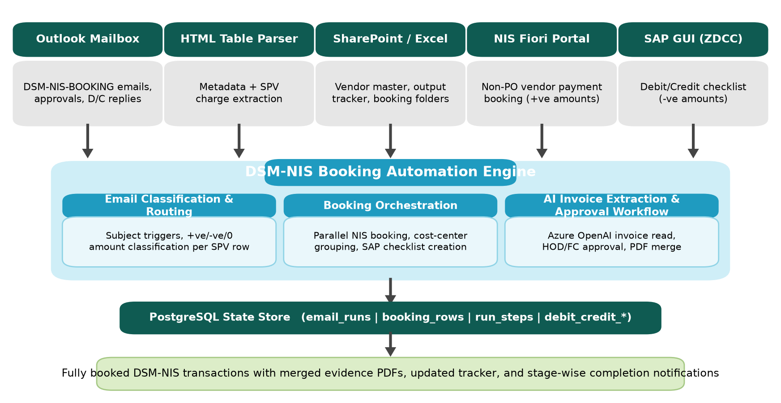
Layered Technical Architecture:
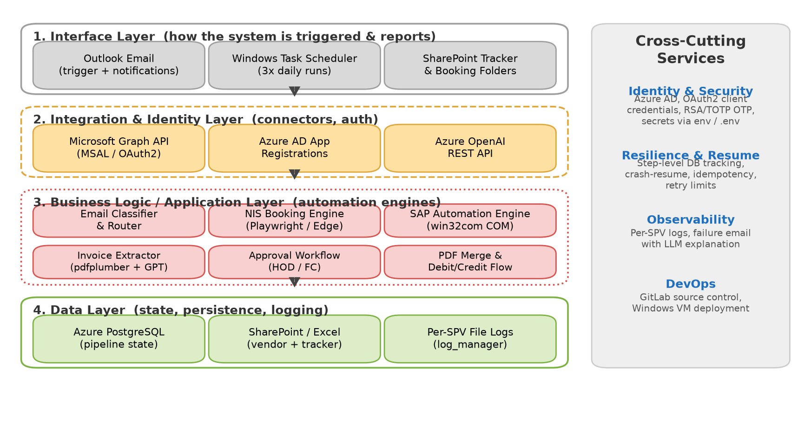

6. Technology Stack (LR / FR)
List of key technologies used. Deviations from group standards are marked explicitly (Standard vs Exception).
Layer / Component | Technology / Product | Version | Standard / Exception | Underlying Compute (where deployed?)
Automation Runtime | Python 3.10+ | 3.11 | Standard | Windows VM / host process
Browser Automation | Playwright (Microsoft Edge / Chromium) | 1.44+ | Standard | Windows VM / host
SAP Automation | win32com COM + pywinauto (SAP GUI Scripting) | pywin32 306+ | Standard | Windows VM (SAP GUI)
Database | Azure PostgreSQL (managed) / SQLite (local dev) | psycopg2 2.9+ | Standard | Azure – India region
Email & SharePoint | Microsoft Graph API via MSAL + requests | msal 1.28+ | Standard | Microsoft 365 tenant
AI / LLM | Azure OpenAI (GPT) – invoice extraction & failure explanation | GPT-4 class | Standard | Azure OpenAI
PDF Processing | pdfplumber (extract), pypdf (merge), reportlab (email->PDF) | — | Standard | Host process
Job Scheduler | Windows Task Scheduler (3x daily) | — | Standard | Windows VM
Version Control / CI-CD | GitLab | — | Standard | GitLab

7. Integration Interface Register (LR / FR)
From System | To System | Purpose | Integration Method | Middleware / Orchestration | Authentication Method | Data being exchanged | Mode & Frequency
Outlook Mailbox (M365) | DSM-NIS Automation | Read DSM emails, approvals, D/C replies; send notifications | Microsoft Graph REST API | Point-to-Point | Azure AD OAuth2 (client credentials, MSAL) | Email body HTML tables, PDF attachments, notification emails | Scheduled (3x daily) / On-Demand
SharePoint / OneDrive (M365) | DSM-NIS Automation | Vendor master, output tracker, booking folder storage | Microsoft Graph REST API | Point-to-Point | Azure AD OAuth2 (client credentials) | Vendor master Excel, tracker Excel, booking PDFs (invoice/checklist/merged) | On-Demand / per booking
Azure OpenAI | DSM-NIS Automation | Invoice number extraction from PDFs; failure explanations | REST API | Point-to-Point | API Key | Extracted PDF text (prompt), invoice number / explanation (response) | On-Demand
NIS Fiori Launchpad | DSM-NIS Automation | Non-PO vendor payment booking of positive amounts | Browser automation (Playwright/Edge) | UI Automation | User login + password + RSA/TOTP OTP | Booking form fields, invoice PDF upload, NIS checklist number | Per booking (parallel up to 3)
SAP ERP (SAP GUI, ZDCC) | DSM-NIS Automation | Debit/Credit checklist creation for negative amounts | SAP GUI Scripting (win32com COM) | UI Automation | SAP GUI session (user credentials) | Debit/credit form fields, SAP checklist number, checklist PDF | Per booking / on Windows VM
Azure PostgreSQL | DSM-NIS Automation | Shared pipeline state & resume tracking | psycopg2 (TCP, SSL) | Point-to-Point | DB username/password (SSL enforced) | email_runs, booking_rows, run_steps, debit_credit_* records | Real-time / per step

8. Non-Functional Requirements (NFRs) (LR / FR)
Measurable targets (initial assumptions where actuals are pending deployment validation).
Deployment Location | Azure Cloud – India region (state DB) + Windows VM for portal/SAP automation
Availability Target (%) | Batch automation – runs 3x daily. Azure PostgreSQL SLA 99.99%; target ~99% successful scheduled-run completion.
RTO requirement | 24 Hours (re-run picks up incomplete work from DB state)
RPO requirement | Near-zero for pipeline state (every step persisted before/after execution)
HA Strategy | Stateless services + durable state in Azure PostgreSQL. Any host can resume from the shared DB; SAP work is polled independently by the SAP service.
DR Strategy | Recovery via Azure-managed PostgreSQL backups and redeployment of the VM/host. Idempotent, resume-aware pipeline avoids duplicate bookings on recovery.
Backup Strategy | Azure PostgreSQL managed automated backups; SharePoint/OneDrive versioning for tracker and booking documents.
Sizing & Scalability | Configurable parallel NIS booking (NIS_PARALLEL_COUNT, default 3). Throughput scales with worker count and VM capacity.
Performance Requirements | Single scan of last 2 days processed within one scheduled run; per-row NIS booking within a few minutes including login + OTP.
Concurrent Users / Transactions | System (unattended) actor; up to 3 concurrent NIS booking sessions. No interactive concurrent end users.

9. Key Risk & Deviation Summary (LR / FR)
Area | Risk / Exposure | Mitigation / Control
Credential & Access Management | Automation depends on service-account credentials, RSA/OTP for NIS, SAP GUI login, and Graph API secrets. Delays in obtaining cost-center access, ID creation, RSA bypass, email credentials and CEO approval extended the timeline and remain an operational dependency. | Store secrets outside source control (env / .env / secret store), rotate regularly, use dedicated service accounts, and document access dependencies for renewals.
Portal / GUI UI Changes | NIS Fiori portal or SAP ZDCC screen changes can break UI-based automation (Playwright selectors / SAP scripting). | Resilient selectors, retry limits (NIS_MAX_ROW_RETRIES), failure alerts, and a maintenance runbook to update flows when screens change.
Email Parsing Accuracy | Malformed HTML tables, missing columns, or unexpected date formats in the source email may cause extraction errors or wrong classification. | Strict validation step, date normalization, mandatory-field checks, and an LLM-generated failure email describing the missing/mismatched value.
AI Invoice Extraction Reliability | LLM may return an incorrect or empty invoice number from vendor PDFs. | Deterministic fallbacks (auto-generated invoice numbers for special SPVs/vendors), per-row pre-extraction for 3-row/INOX bills, and human-visible tracker for review.
Duplicate / Double Booking | Re-runs or concurrent workers could book the same transaction twice. | Message-id dedup, step-level DB state, DB locks on tracker writes, cost-center grouping, and idempotent approval handling.
Security & Data Handling | Financial data, vendor details, and portal credentials are processed; unauthorized access or leakage would be sensitive. | Internal-only execution, OAuth2 client-credential access scoped to required resources, SSL to PostgreSQL, and least-privilege service accounts.
Deployment Dependency | Development is complete but deployment is pending; production readiness (scheduling, monitoring, VM hardening) still to be finalized. | Complete deployment checklist: Task Scheduler setup, monitoring/alerting, credential provisioning, and a production smoke test before go-live.

10. Cost & Commercial View (TCO) (FR mandatory, LR optional)
High-level TCO for transparency. Detailed procurement artifacts are not required in this template. (3-year TCO to be shared.)
Cost Component | Nature of expense (One time/Recurring) | Value | Notes
Software License / Subscription | Recurring | Nil (net-new) | Built on existing Adani M365, Azure and SAP licences; no new product licence.
Infra & Services Cost | Recurring | To be confirmed | Azure PostgreSQL, Azure OpenAI usage, Windows VM compute.
AI / LLM Usage | Recurring | To be confirmed | Azure OpenAI token consumption for invoice extraction & failure explanations.
Annual Maintenance Cost | Recurring | To be confirmed | In-house support for UI-flow updates, monitoring and enhancements.
Development (one-time) | One time | Internal effort | In-house AI Engineering (Phase 1 + Phase 2).

11. Full Review – Deep Dive (FR only)
Required only for Full Review items:
- Detailed architecture diagrams: see Section 5 (logical + layered). Two-service design (NIS Booking + SAP Automation) communicating only through a shared PostgreSQL state store.
- Capacity and scalability analysis: parallel NIS booking is configurable (default 3 concurrent sessions); throughput scales with VM capacity and worker count; SAP work polled independently.
- Threat model (lite): internal-only execution; OAuth2 client-credential scopes; SSL to DB; secrets kept out of source control; least-privilege service accounts; RSA/TOTP for NIS login.
- Operational readiness: step-level DB tracking with crash-resume, idempotent operations, retry limits, per-SPV file logs, failure notification emails, and SAP recovery markers.
- Alternatives considered: manual booking (baseline, error-prone/slow) vs. UI automation over existing portals (chosen, no API available for NIS/SAP booking screens).
- Exception rationale + convergence plan: no group-standard deviation; UI automation is used only where no supported API exists for the target screens.

12. Tech Assurance Group Decision (NR / LR / FR)
Decision (Approved / Rejected / Approved with Condition)
Key Recommendations
Architecture Decision

