**ASSIGNMENT-2**

**1. Showcase one Many-Many relation.**

Output:

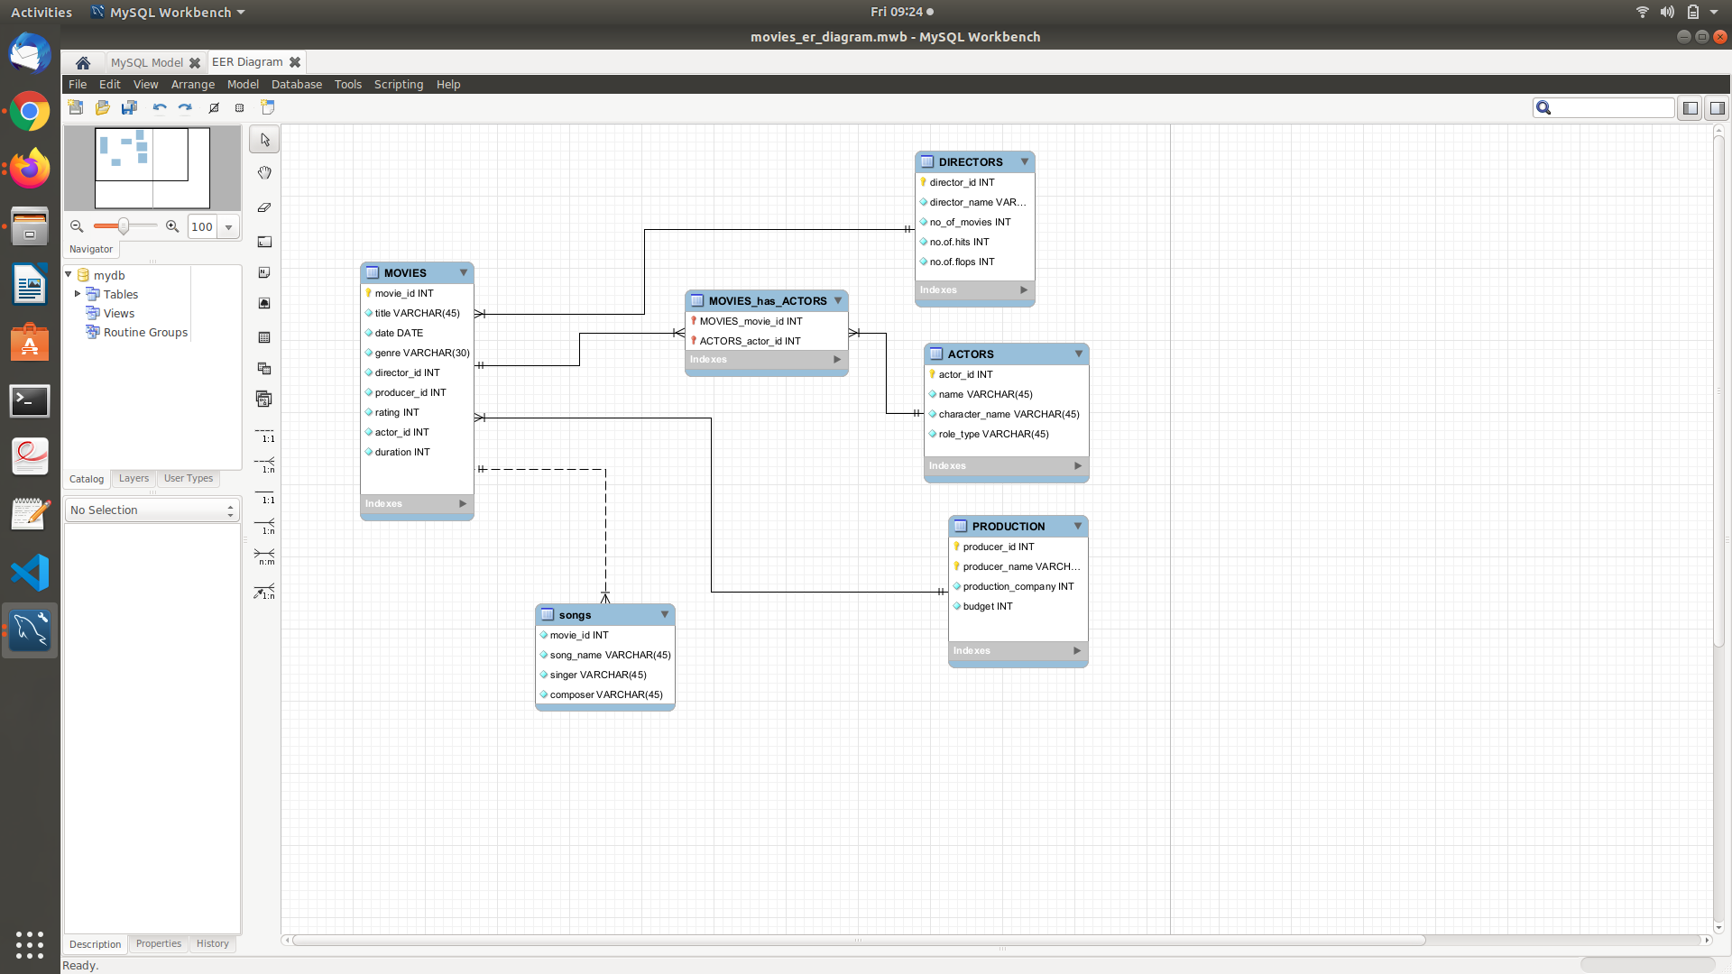

**2. Represent Composite key and Weak Entity in your Database**

Weak entity : “songs” in the above er diagram

Composite key : In directors entity (no.of hits,no. of flops) is composite key.

**3. Show Violation of Primary Key, Unique Not Null and default key constraints through insertion.**

SQL Query :

create database m1;

use m1;

create table m2(movie_id int primary key, movie_name varchar(45) unique, budget int not null,lead_role_gender varchar(45) default "male");

insert into m2(movie_id, movie_name, budget) values(123, "Valimai", 50000);

insert into m2(movie_id, movie_name, budget) values(123, "polladavan", 30000);

insert into m2(movie_id, movie_name, budget) values(123, "Valimai", 50000);

insert into m2(movie_id, movie_name, budget) values(124, "Valimai", 60000);

insert into m2(movie_id, movie_name) values(125, "commander");

insert into m2(movie_id, movie_name, budget, lead_role_gender) values(131, "wonder_woman",80000,"female");

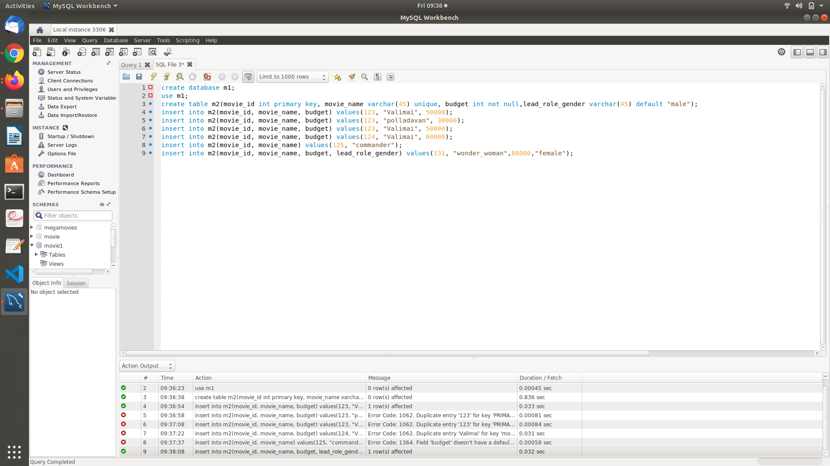

**4. One Derived attribute should be added to the Database design**

**5. Insert tuples into the table and see how foreign key constraint works if you try to insert into the dependent table first.**

SQL Query :

create database d4;

create table movie4(movie_id int primary key, movie_name varchar(45) unique, budget int not null,

lead_role_gender varchar(45) default "male");

create table songs1(movie_id int, song_name varchar(45), singer varchar(45), composer varchar(45),

foreign key(movie_id) references movie4(movie_id));

insert into songs1 values(123, "Dil_bechara", "Mariam", "ar_rahman");

