**ASSIGNMENT-3**

**1. Show how to Create and Drop Database**

SQL query : create database megamovies;

Output :

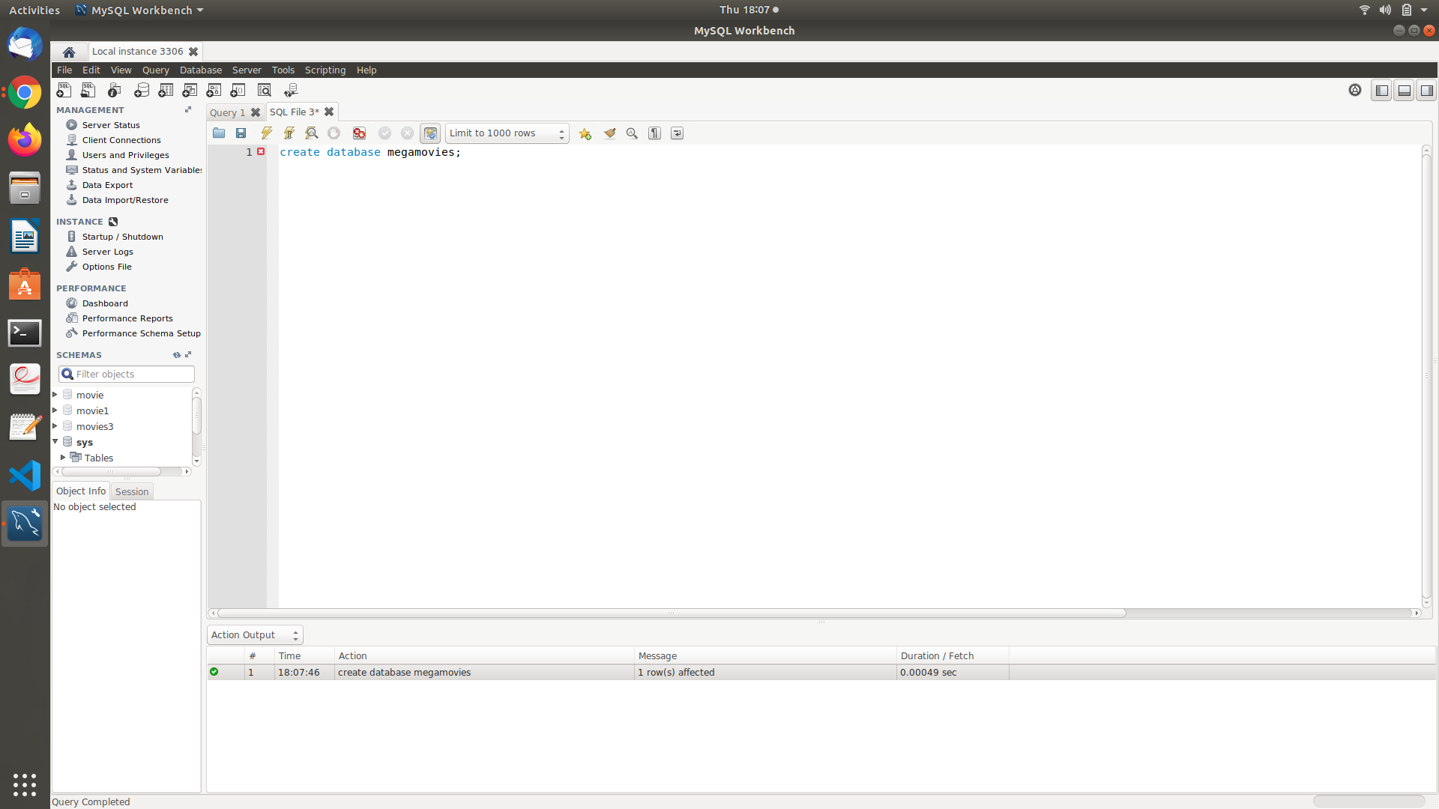

Drop database:

SQL query : drop database megamovies;

Output :

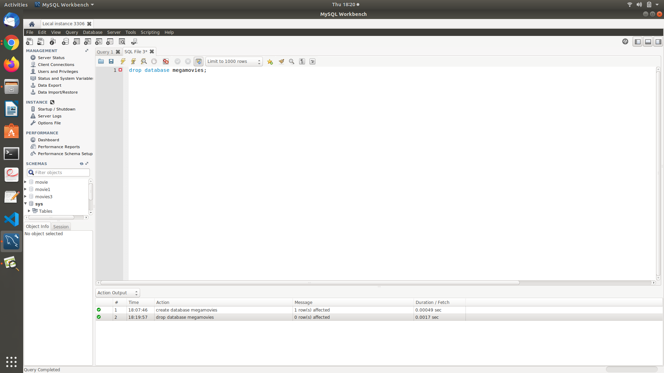

**2. Show all the Databases are in the system**

SQL Query : show databases;

Output :

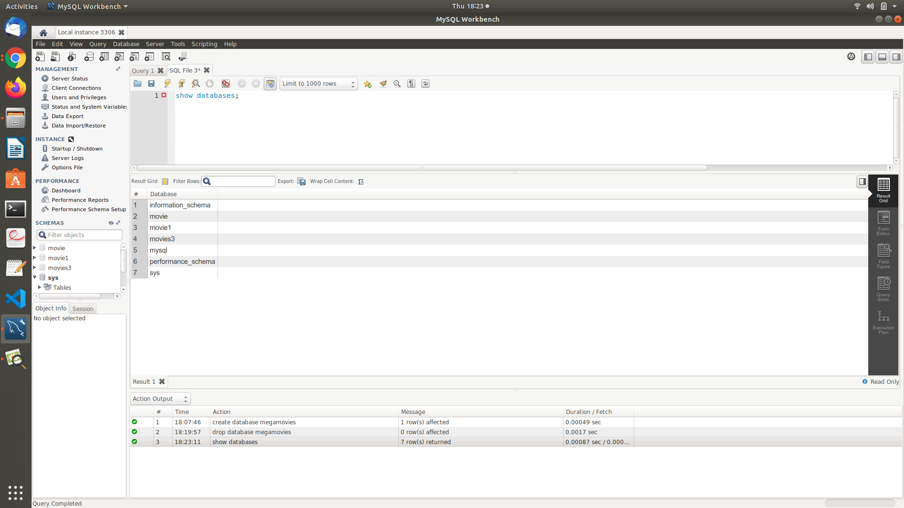

3. Create Table for your Database

SQL Query : use megamovies;

create table movies(

movie_id int primary key,

title varchar(30),

genre varchar(30),

date1 date,

director varchar(45),

rating int

)

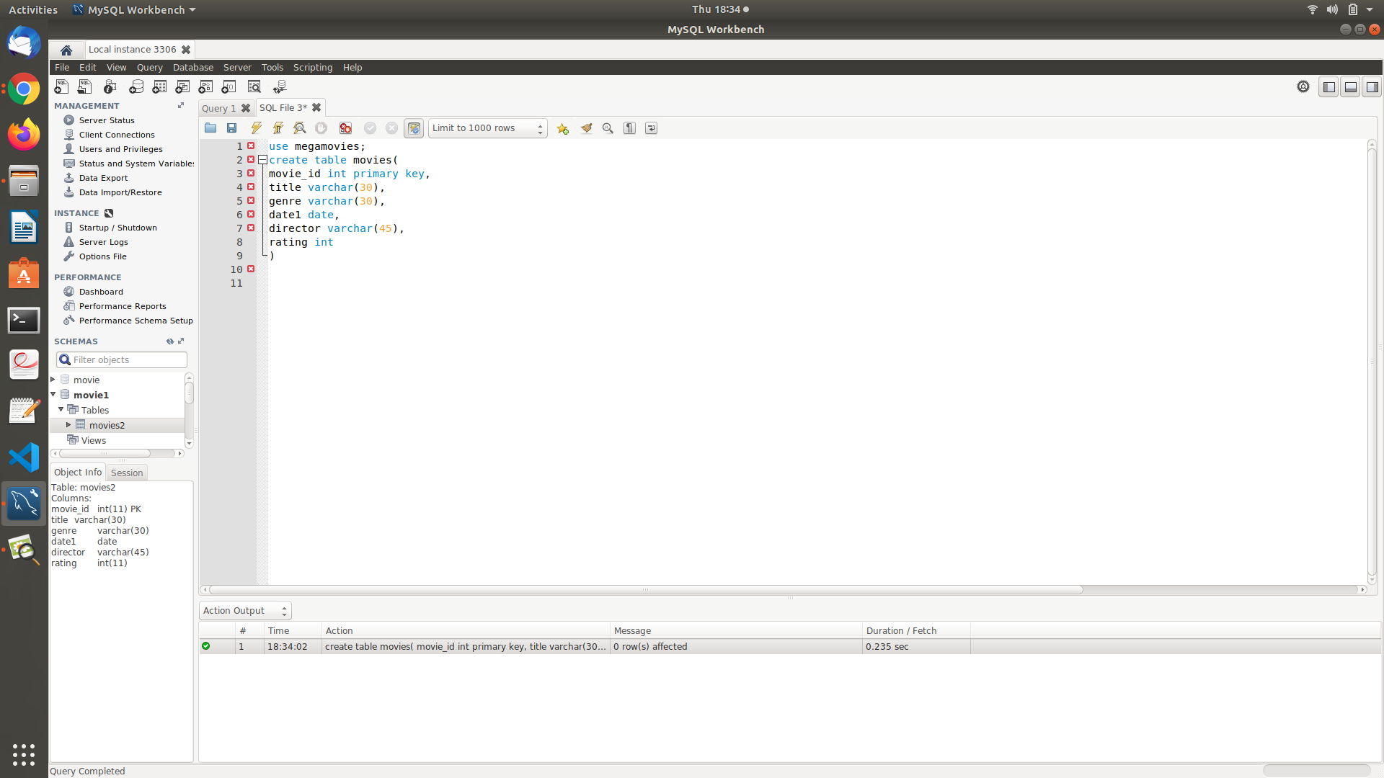

4. Show how select can be used for Creating table

SQL Query : create table movieinfo1 as select movie_id,title,director,rating from movies;

Output:

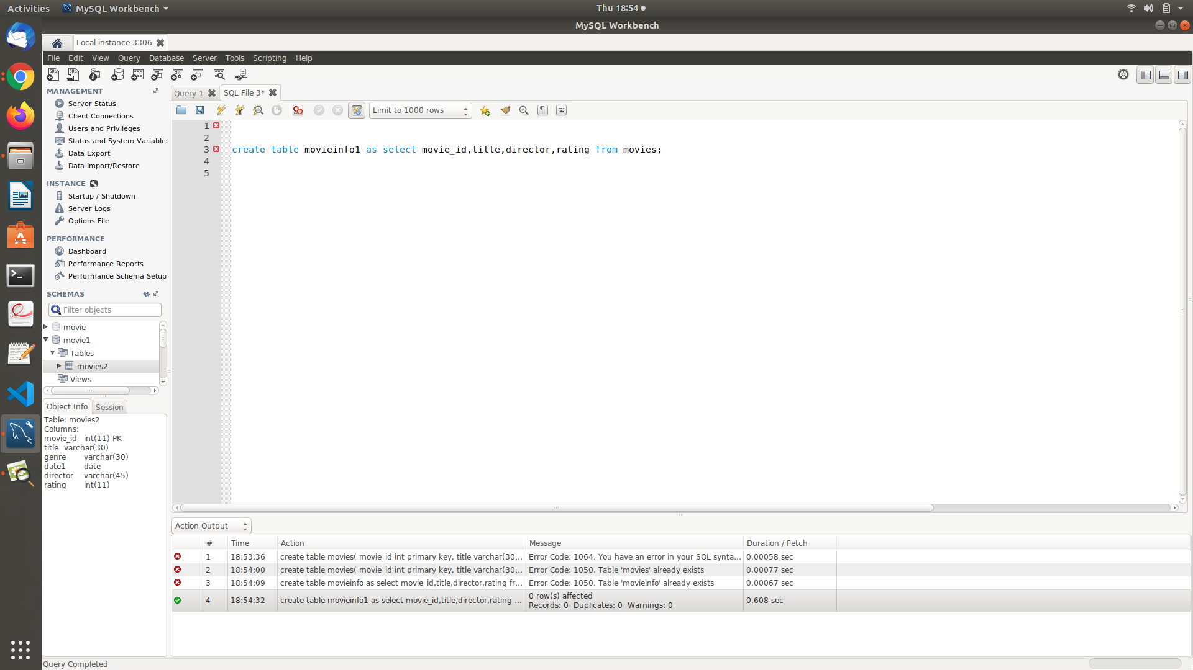

5. Drop table

SQL Query : drop table movieinfo1;

Output:

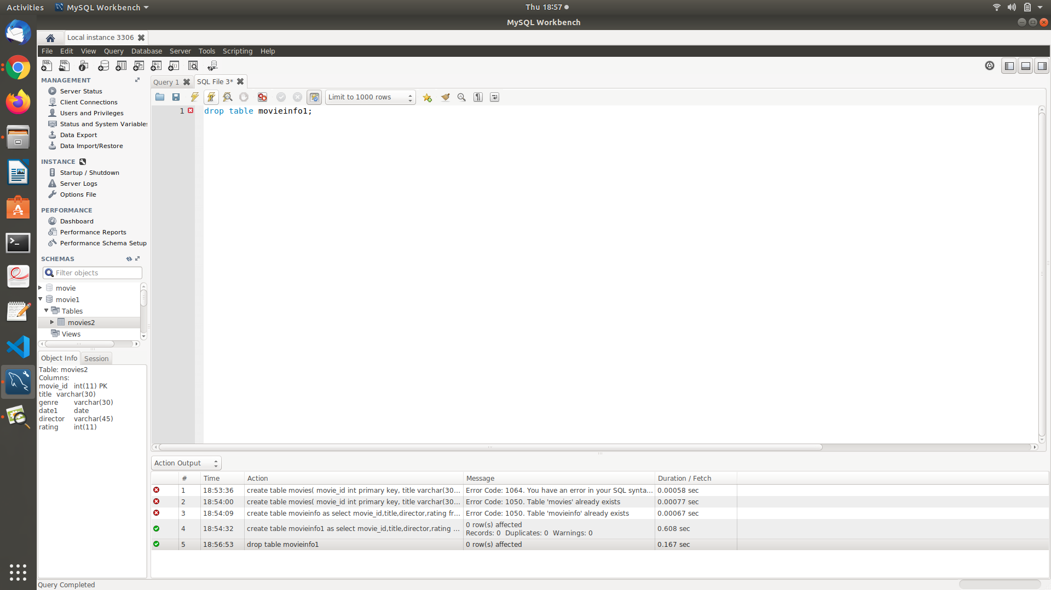

6. Show how to check the schema of the tables

SQL Query : desc movies;

Output:

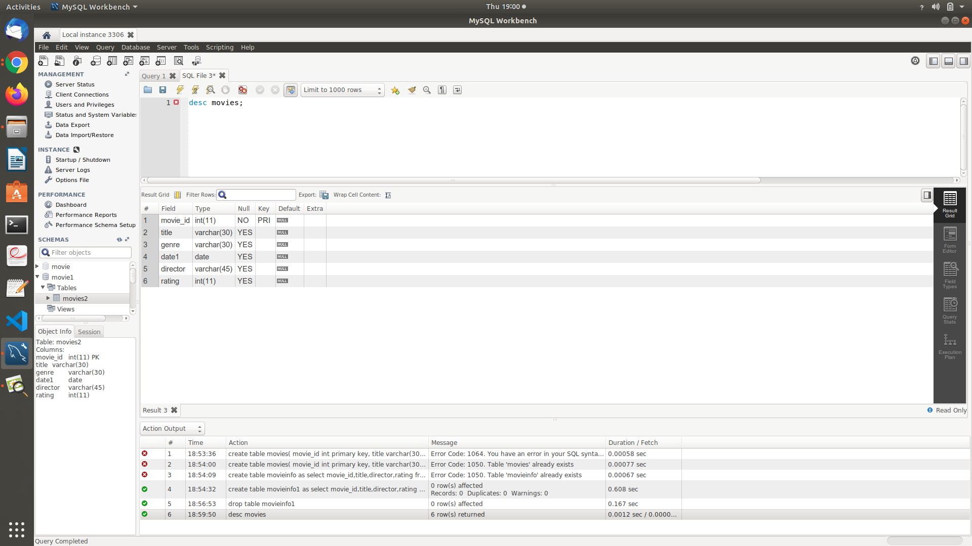

7. Show all the tables from the database

SQL Query : show tables;

Output:

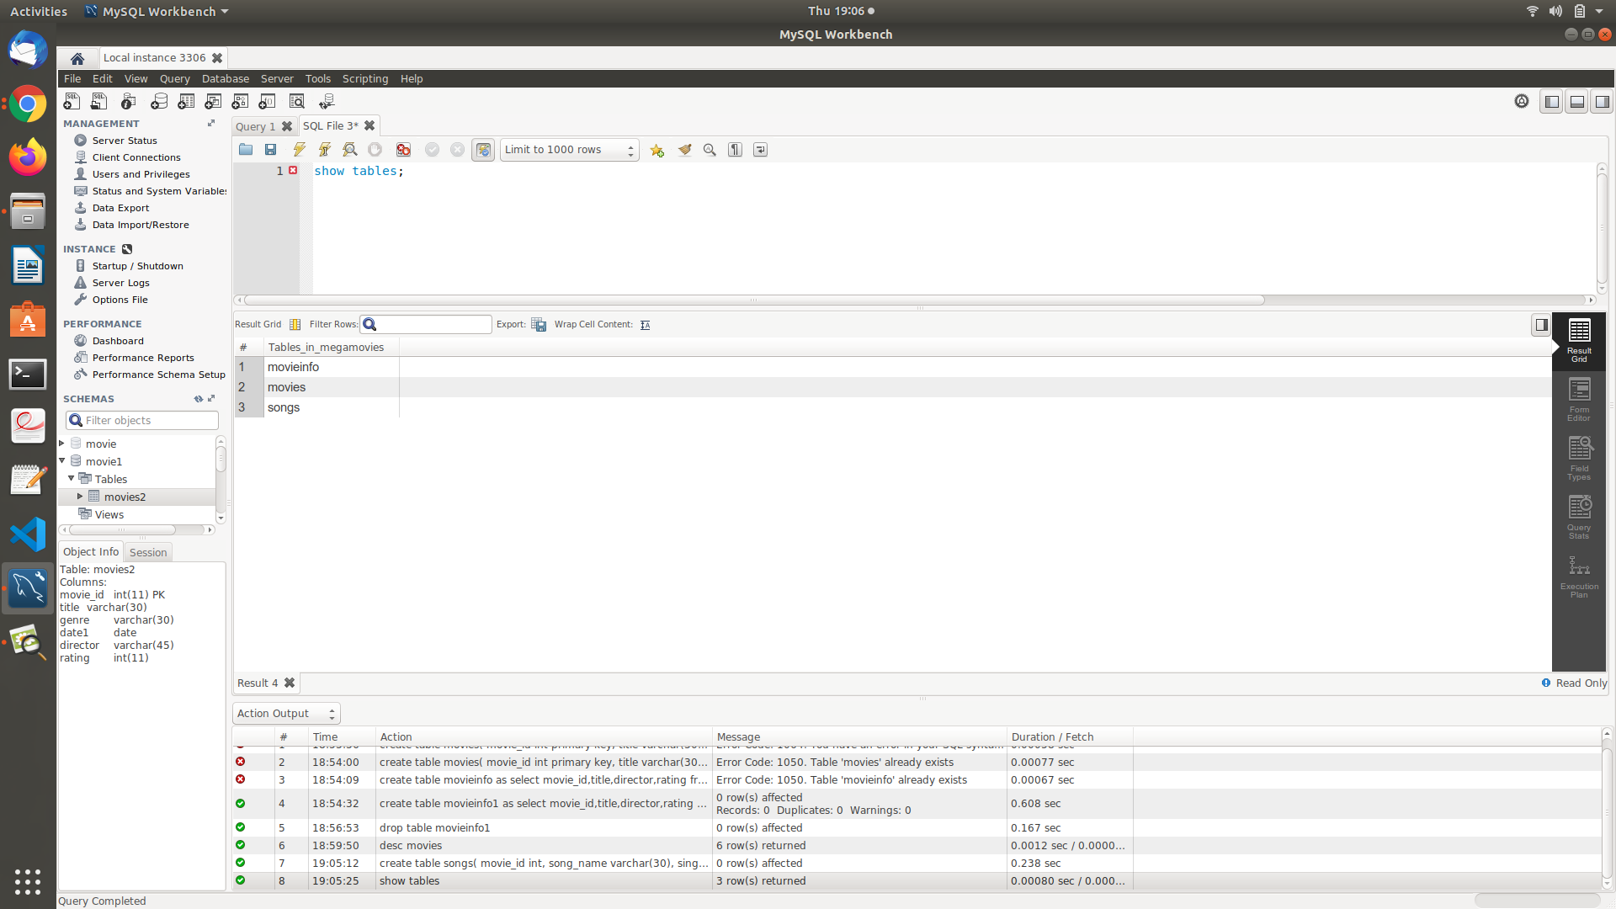

8. Insert 5 to 10 rows in each of the tables of your Database

SQL Query : insert into movies values(1,'pushpa','action','2021-07-21','sukumar',8);

insert into movies values(2,'acharya','drama','2021-05-10','koratasiva',9);

insert into movies values(3,'RRR','action/drama','2022-04-01','Rajamouli',9.5);

insert into movies values(4,'master','romance','2021-01-05','lokesh kanagaraj',8);

insert into movies values(5,'Tenet','action','2020-09-01','christopher nolan',7.5);

insert into movies values(6,'Trance','methodological','2020-07-12','nivin pauly',8);

insert into songs values(1,'vaathi coming','anirudh','anirudh');

insert into songs values(2,'hello','haricharan','anup rubens');

insert into songs values(3,'holy','justin beiber','justin beiber');

insert into songs values(4,'memories','vineeth','sudhu');

insert into songs values(1,'shape of you','ed sheran','ed sheran');

Output:

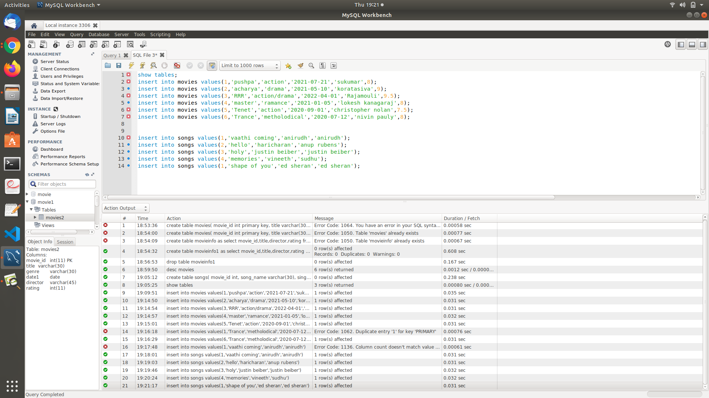

9. Show usage of Simple Select Statement

SQL Query : select * from movies;

Output:

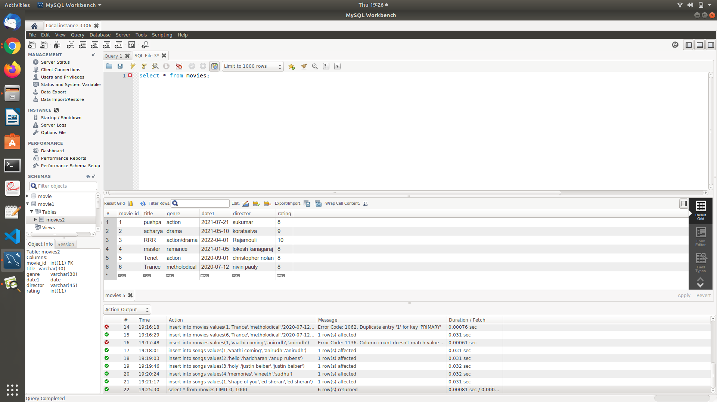

10. Select Statement using Relational and Logical operators.

SQL Query : select * from movies where rating>=8 and genre='action';

Output:

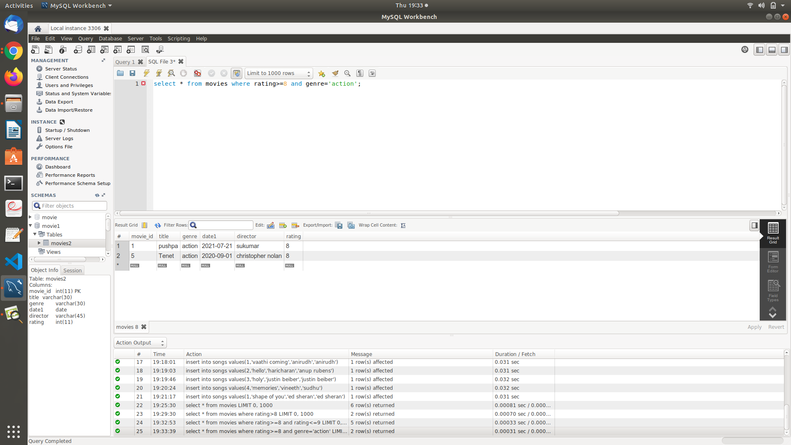

11. One simple Subquery using select

SQL Query : select * from movies where title IN(select title from movies where title='RRR');

Output:

