**ASSIGNMENT-3**

**1. Show how to Create and Drop Database**

**SQL query** : create database megamovies;

**Output** :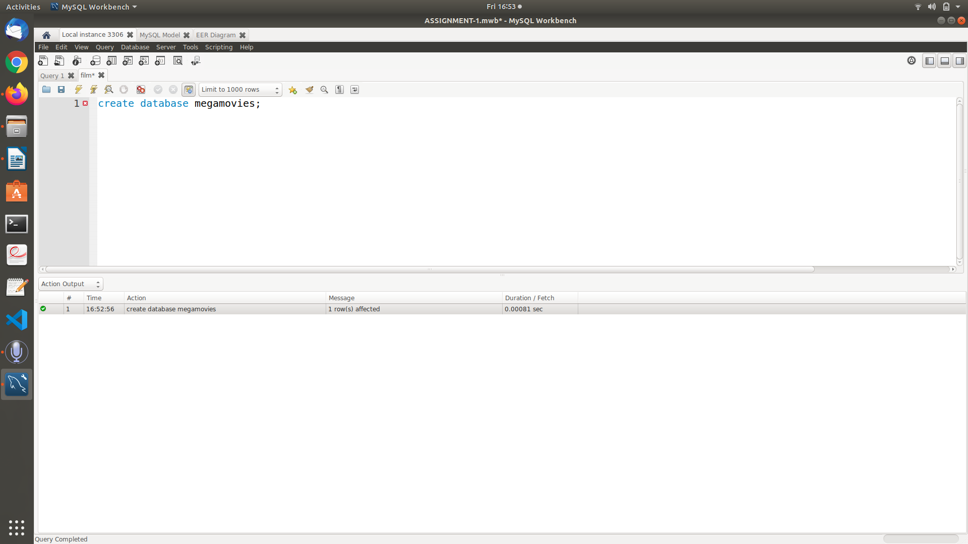

Drop database:

**SQL query** : drop database megamovies;

**Output** :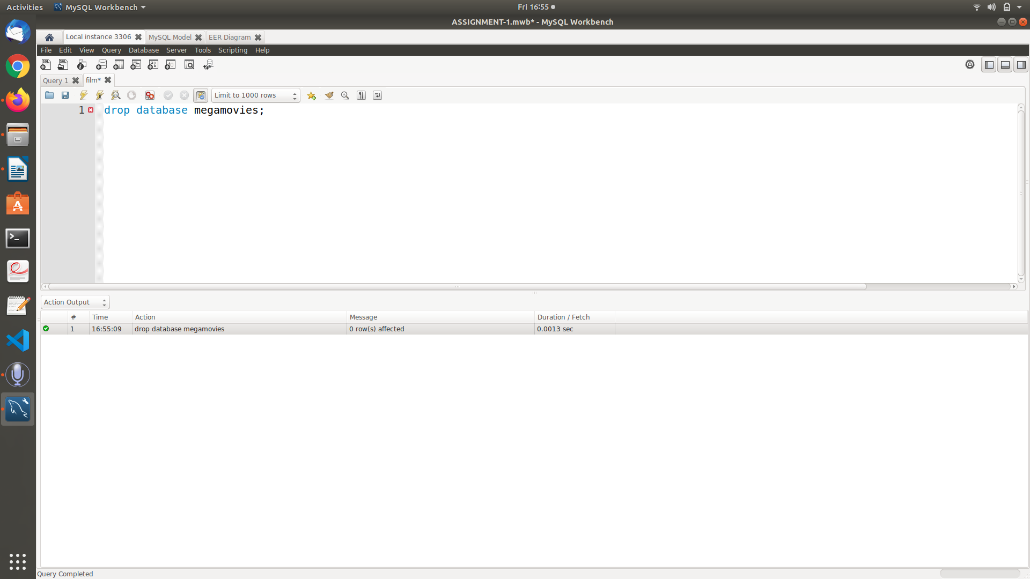

**2. Show all the Databases are in the system**

**SQL Query** : show databases;

**Output** : 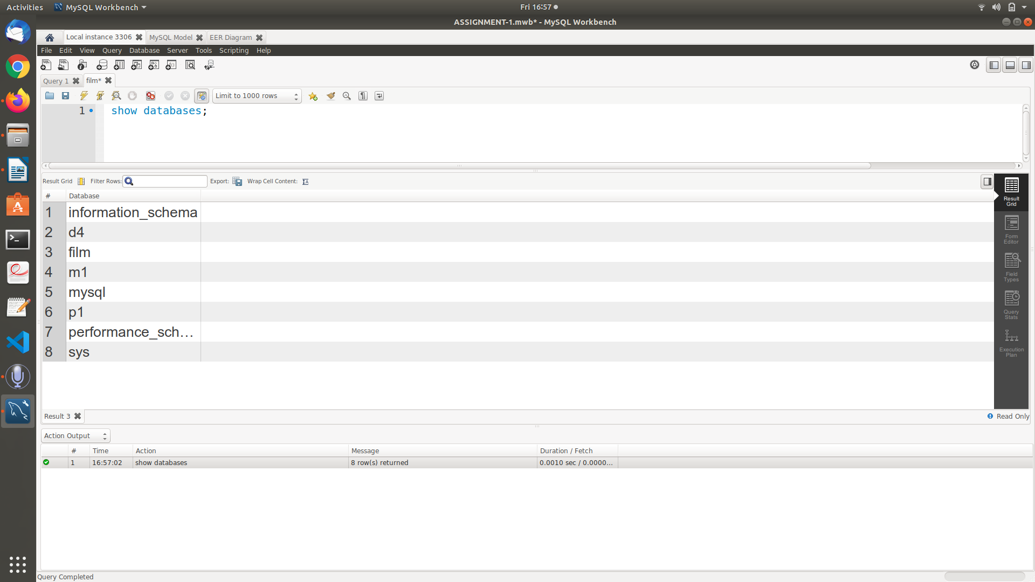

**3. Create Table for your Database**

**SQL Query** : use megamovies;

create table movies(

movie_id int primary key,

title varchar(30),

genre varchar(30),

date1 date,

director varchar(45),

rating int

)

**Output**: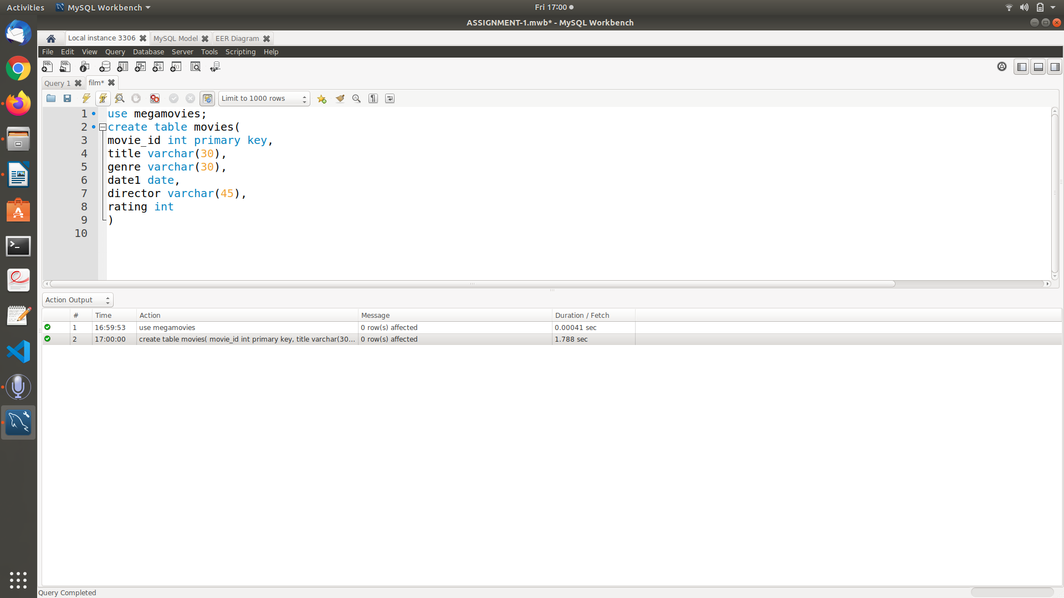

**4. Show how select can be used for Creating table**

**SQL Query** : create table movieinfo1 as select movie_id,title,director,rating from movies;

**Output** :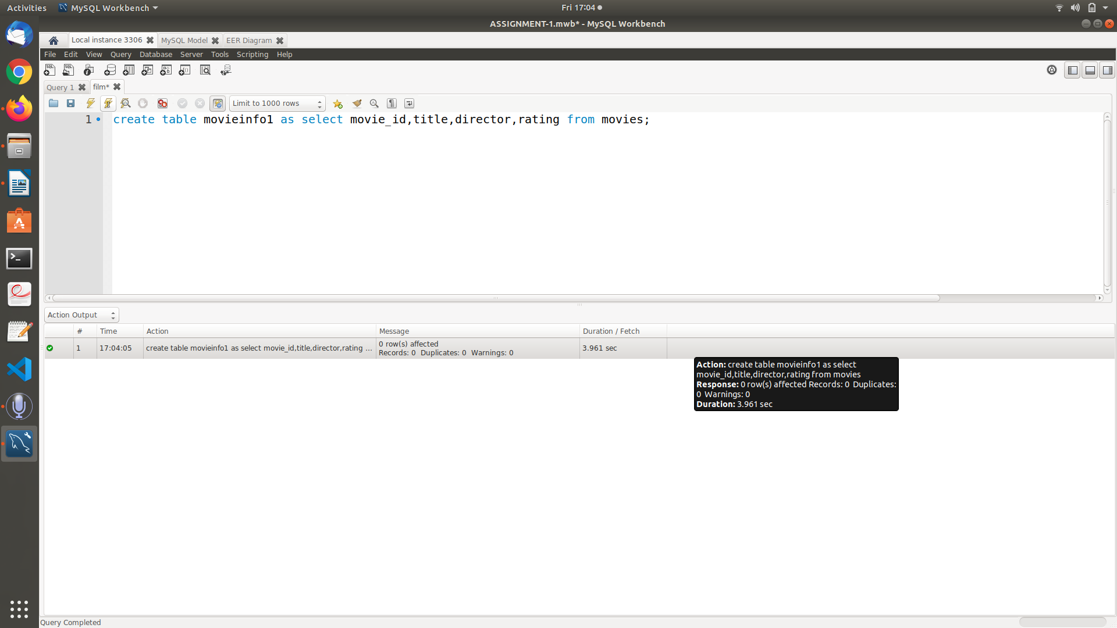

**5. Drop table**

**SQL Query** : drop table movieinfo1;

**Output** :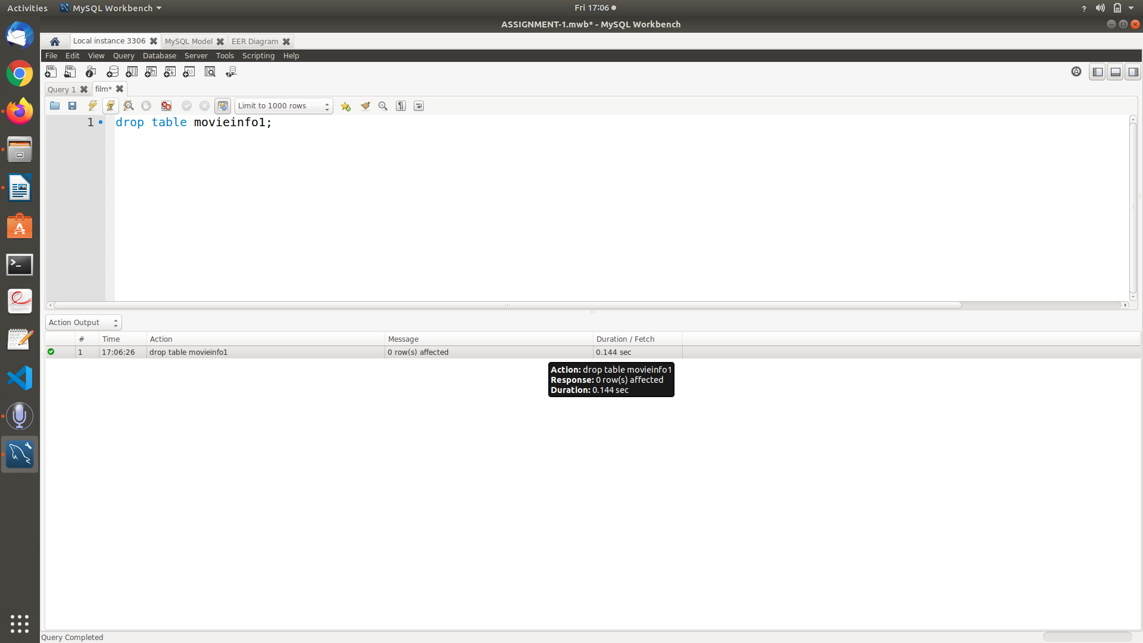

**6. Show how to check the schema of the tables**

**SQL Query** : desc movies;

**Output** :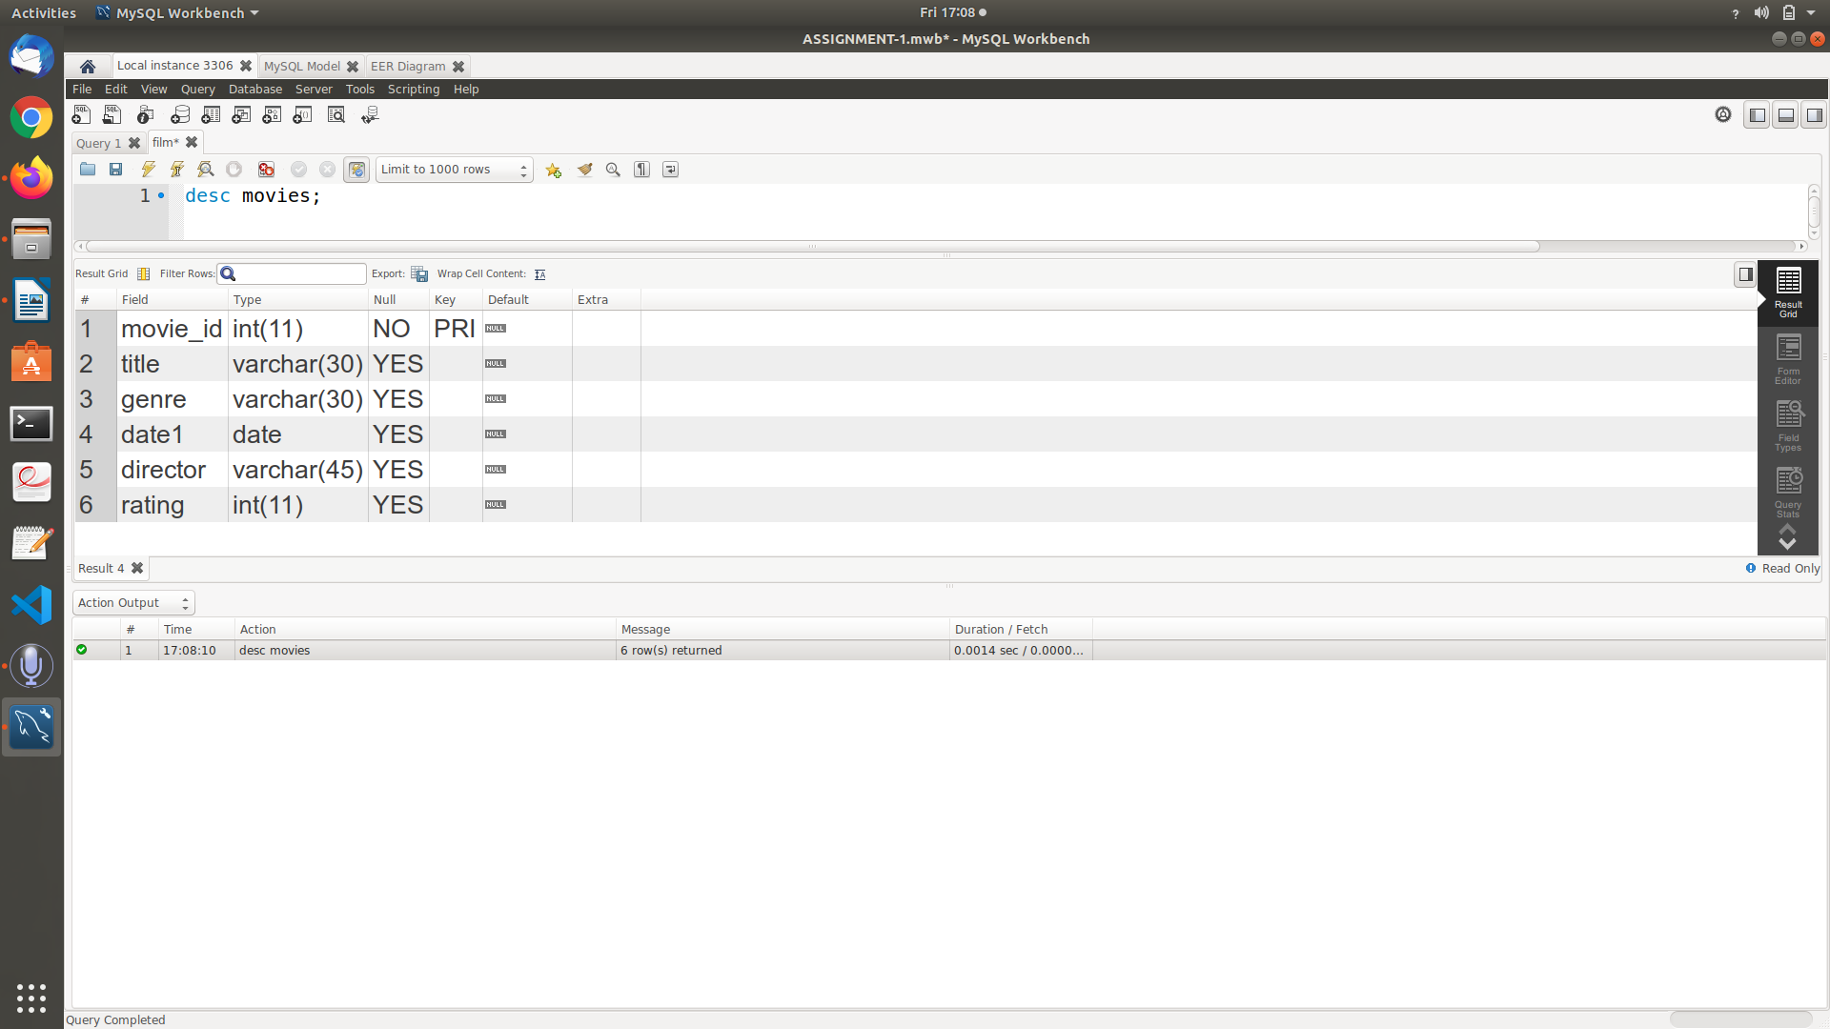

**7. Show all the tables from the database**

**SQL Query** : show tables;

**Output** :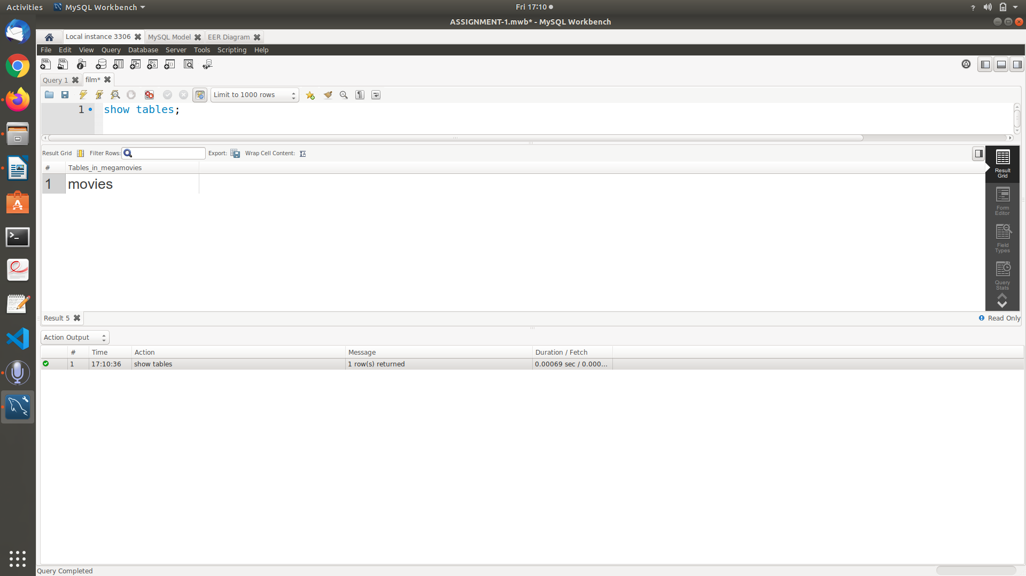

**8. Insert 5 to 10 rows in each of the tables of your Database**

**SQL Query** : insert into movies values(1,'pushpa','action','2021-07-21','sukumar',8);

insert into movies values(2,'acharya','drama','2021-05-10','koratasiva',9);

insert into movies values(3,'RRR','action/drama','2022-04-01','Rajamouli',9.5);

insert into movies values(4,'master','romance','2021-01-05','lokesh kanagaraj',8);

insert into movies values(5,'Tenet','action','2020-09-01','christopher nolan',7.5);

insert into movies values(6,'Trance','methodological','2020-07-12','nivin pauly',8);

**Output:**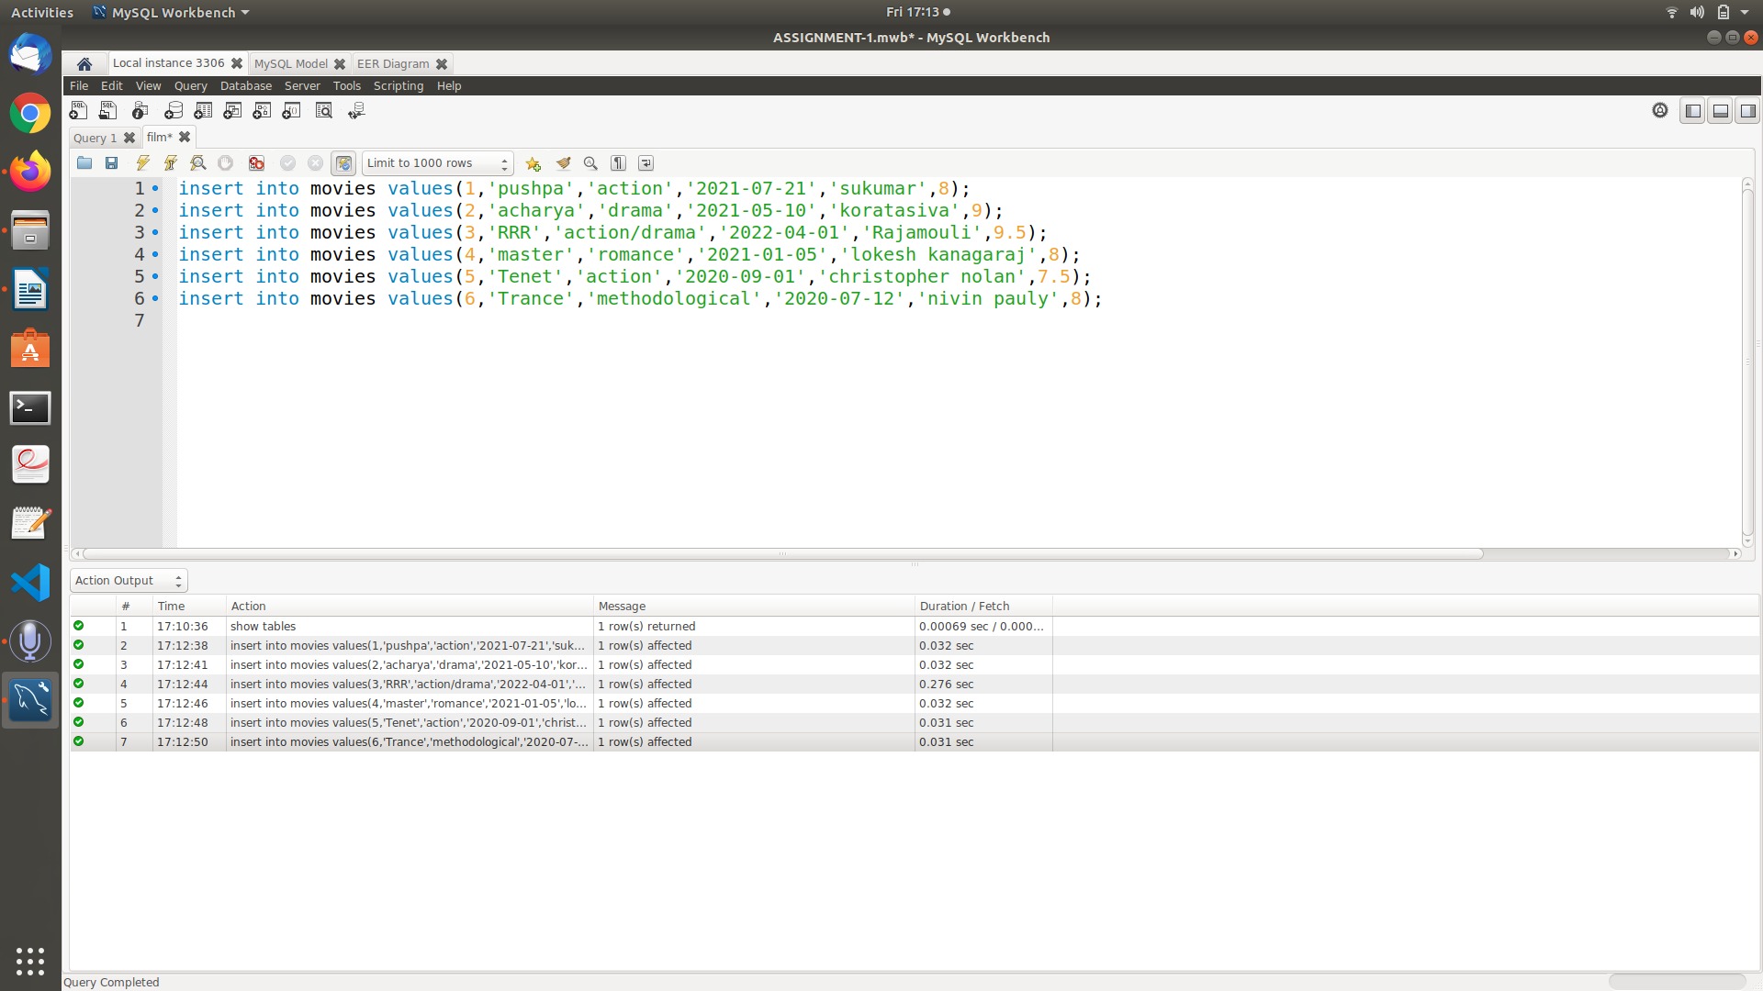

**9. Show usage of Simple Select Statement**

**SQL Query** : select * from movies;

**Output** :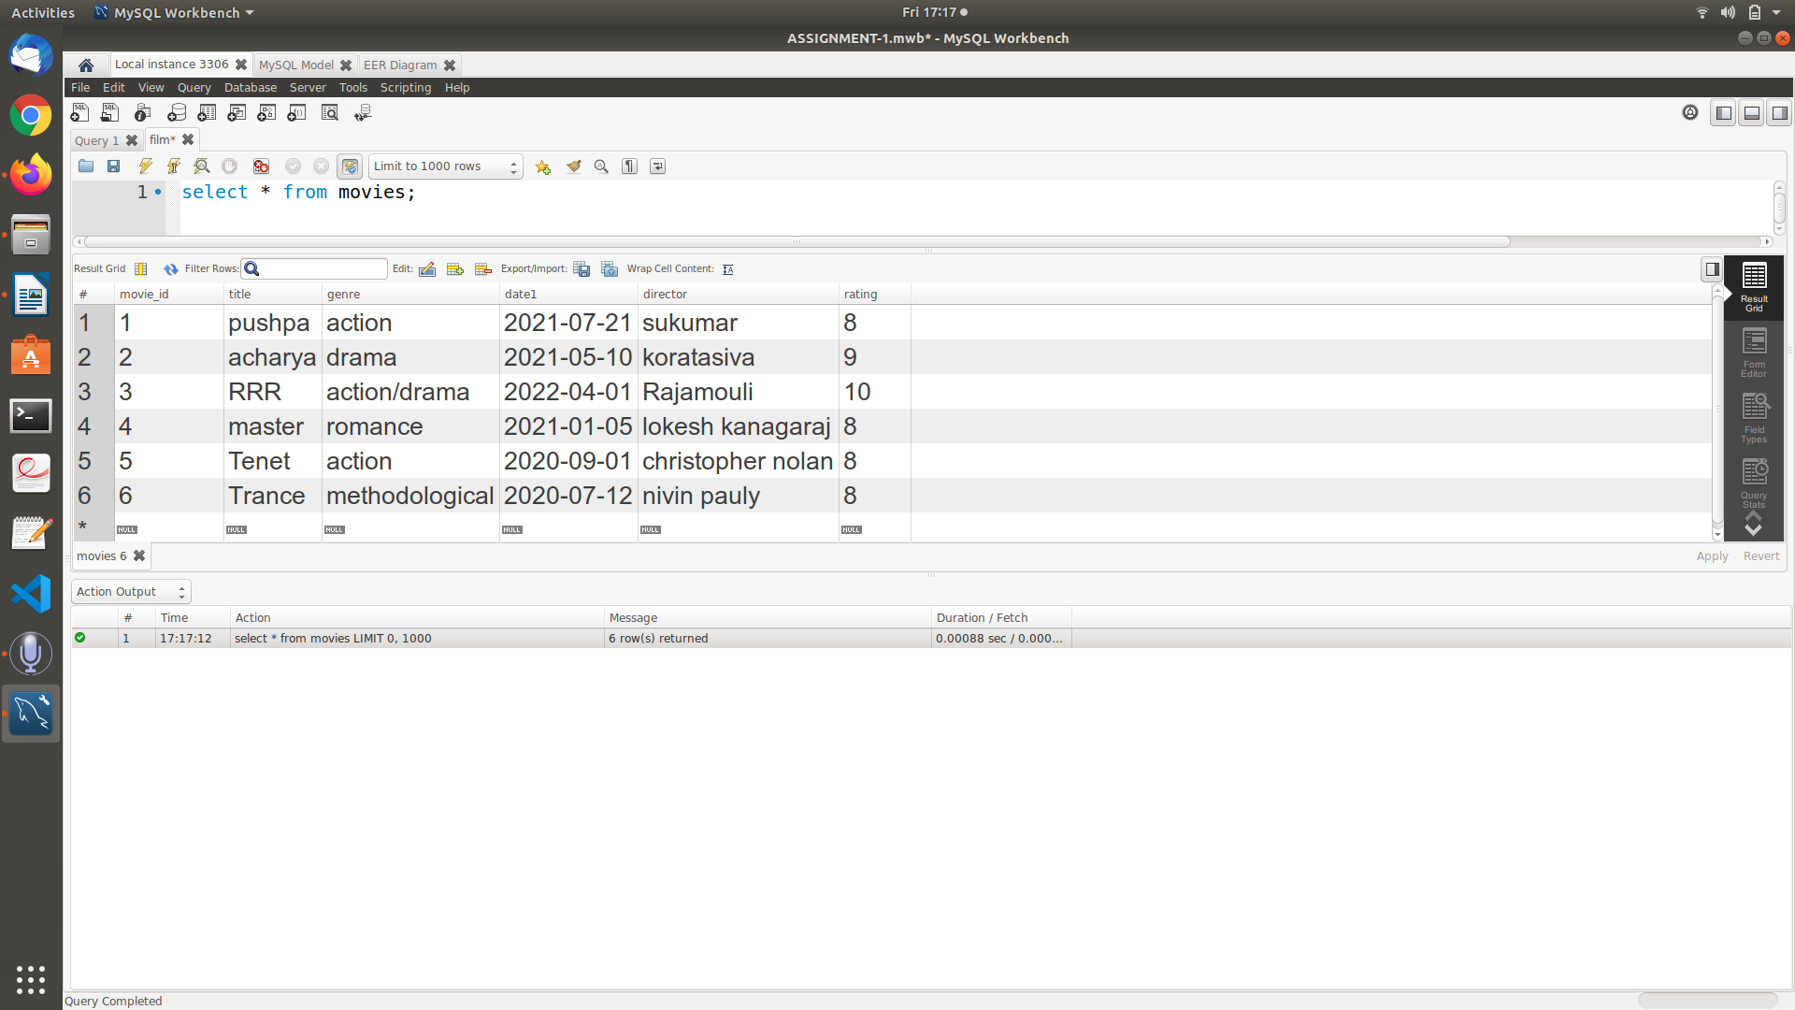

**10. Select Statement using Relational and Logical operators.**

**SQL Query** : select * from movies where rating>=8 and genre='action';

**Output** :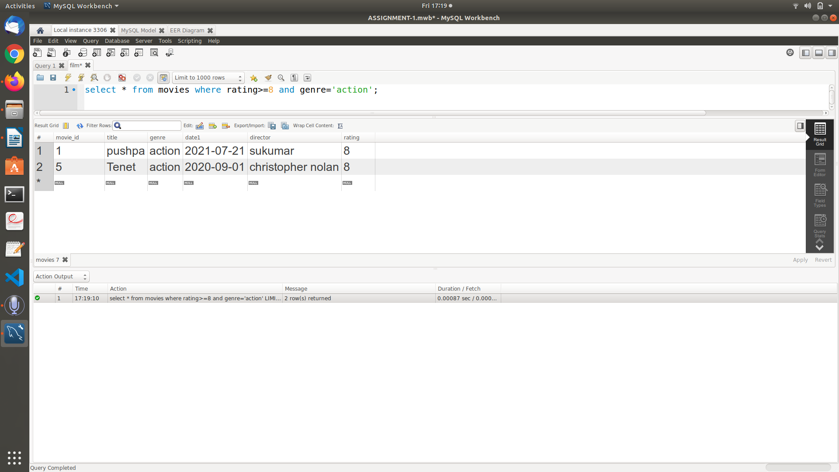

**11. One simple Subquery using select**

**SQL Query** : select * from movies where title IN(select title from movies where title='RRR');

**Output** :