**ASSIGNMENT-4**

**1. Order by Clause**

**SQL Query** : select * from movies order by date1;

**Output** : 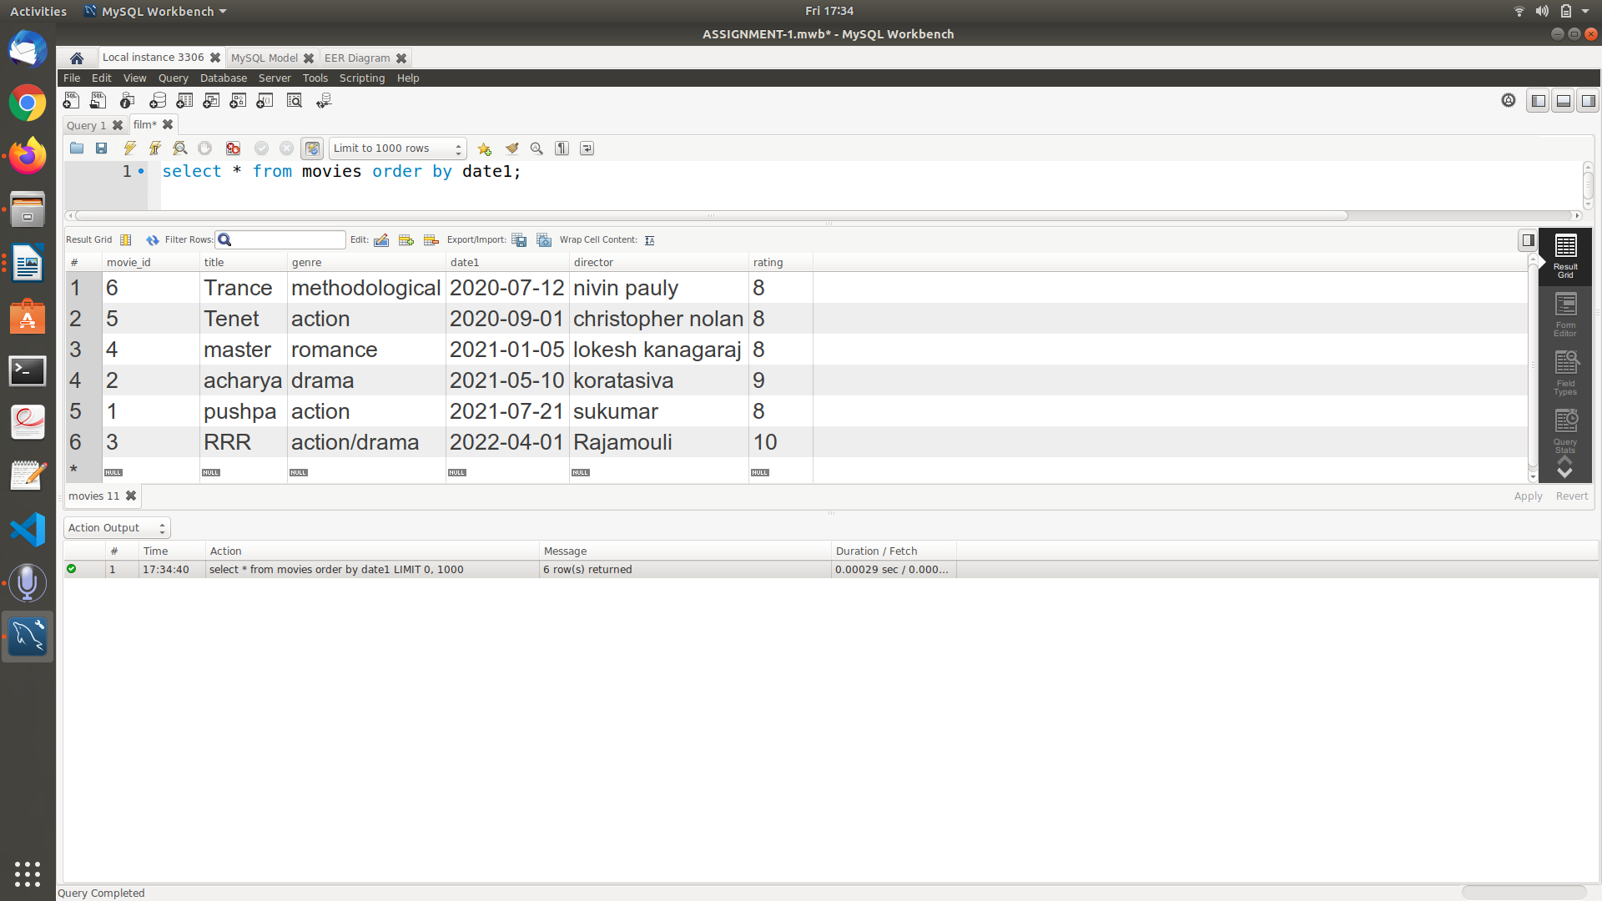

**2. Group by and having**

**SQL Query** : select * from movies group by genre having rating>8;

**Output** :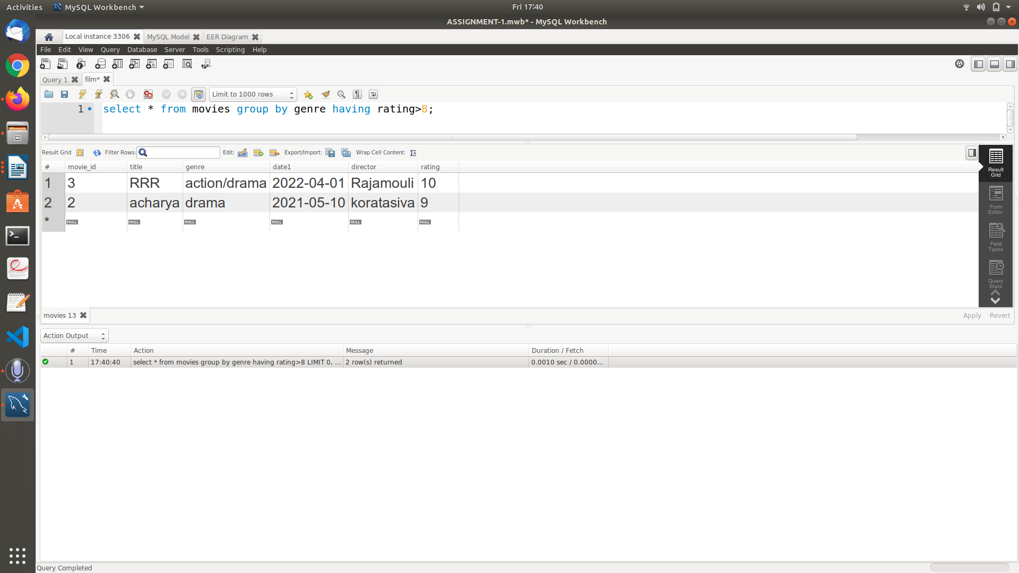

**3. Aggregate functions  
 SQL Query** : select avg(rating) from movies where left(date1,4)=2020;

**Output** :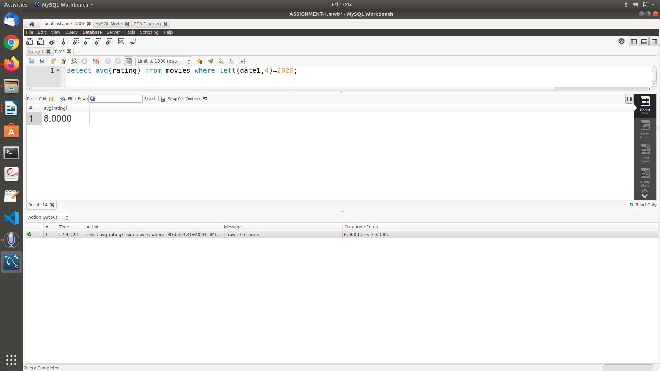

**4. Logical operators especially with LIKE**

**SQL Query** : select * from movies where title like 't%';

**Output** :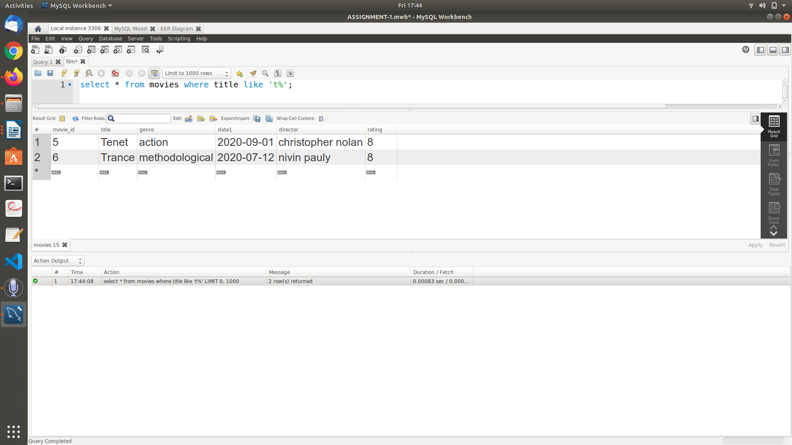

**5. At least 4 Nested queries specific to your Database, out of which at least 2 should have multiple subquery.**

**i)** **SQL Query** :select m.title, s.songname from songs s,movies m where m.movie_id in (select m.movie_id where m.movie_id=s.movie_id);

**Output**: 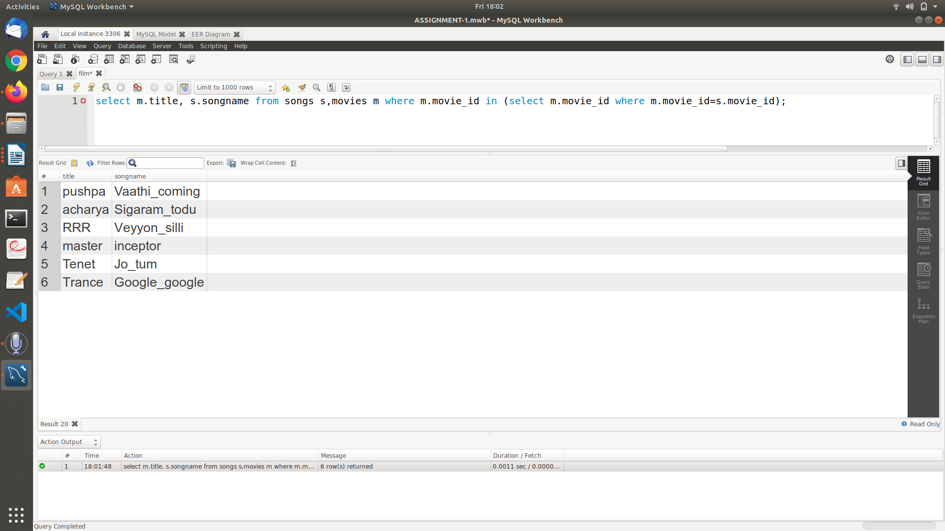

**ii)SQL Query** :

select m.title , s.songname from songs s, movies m where m.movie_id=(select m.movie_id where m.movie_id=s.movie_id and m.title="pushpa");

**Output:**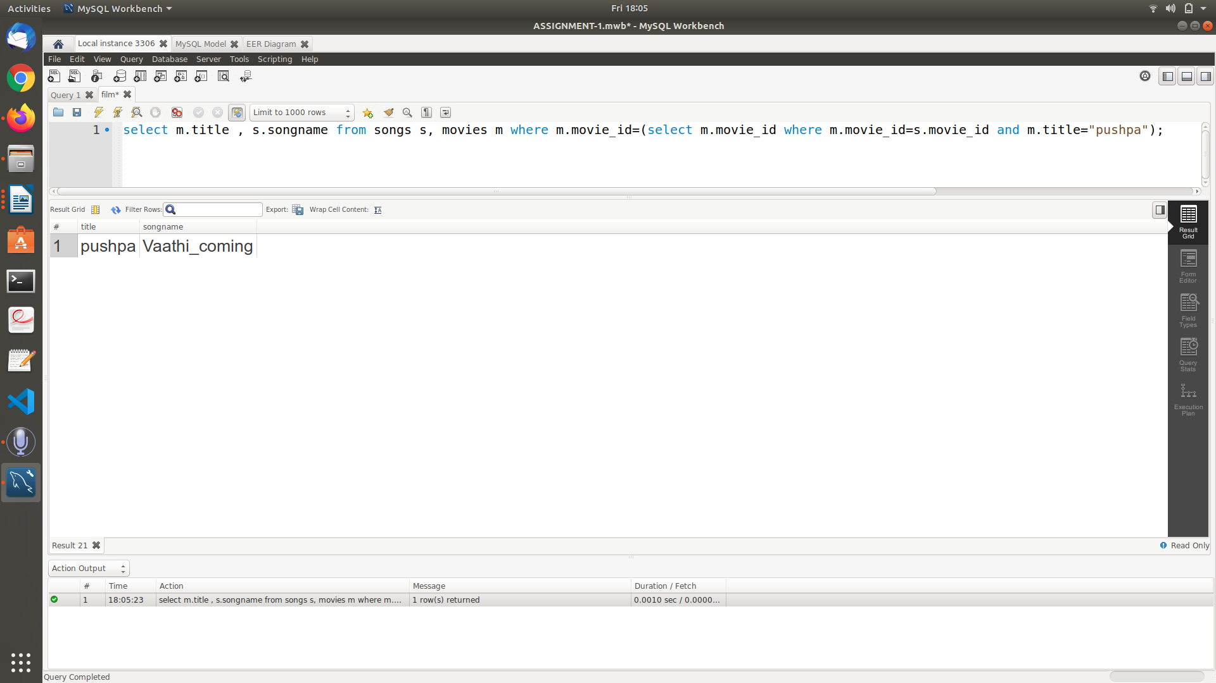

**iii)SQL Query :**

select movie_id,title from movies where rating>=(select avg(rating) from movies where genre=(select genre from movies where movies.movie_id=5)) and genre=(select genre from movies where movies.movie_id=5);

**Explanation :**

It selects the genre of movie_id=5 and then finds the average of ratings corresponding to that particular genre ,now the outer queries displays the details of movies having rating greater than equal to the value returned by inner query and genre same as the one with movie_id=5

**Output**: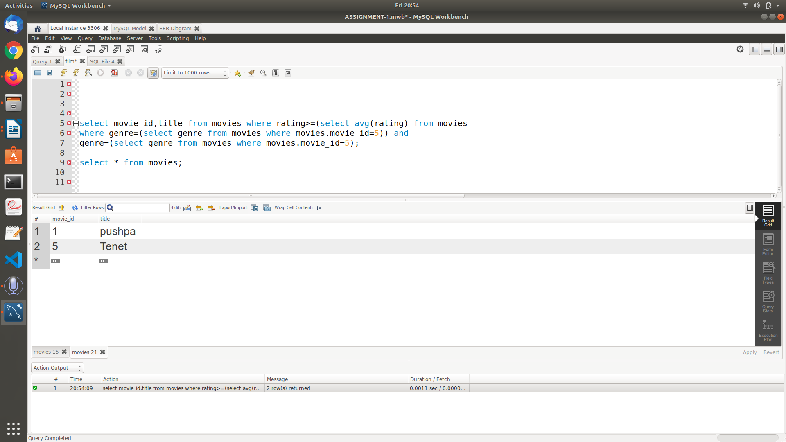

‘**iv)SQL Query**

select songs.songname,songs.singer from songs where songs.movie_id in(select movie_id from directors where no_of_flops in (select min(no_of_flops)from directors));

**Explanation :**

Displays song name and singer from songs table where number_of_flops directed by particular director is minimum

**Output :**