**ASSIGNMENT-5**

**1. INNER JOIN**

**a)SQL Query**

select title,genre,rating,director_name,no_of_movies from movies

inner join directors on movies.director_id=directors.director_id

where no_of_hits<=no_of_flops;

**Output :**

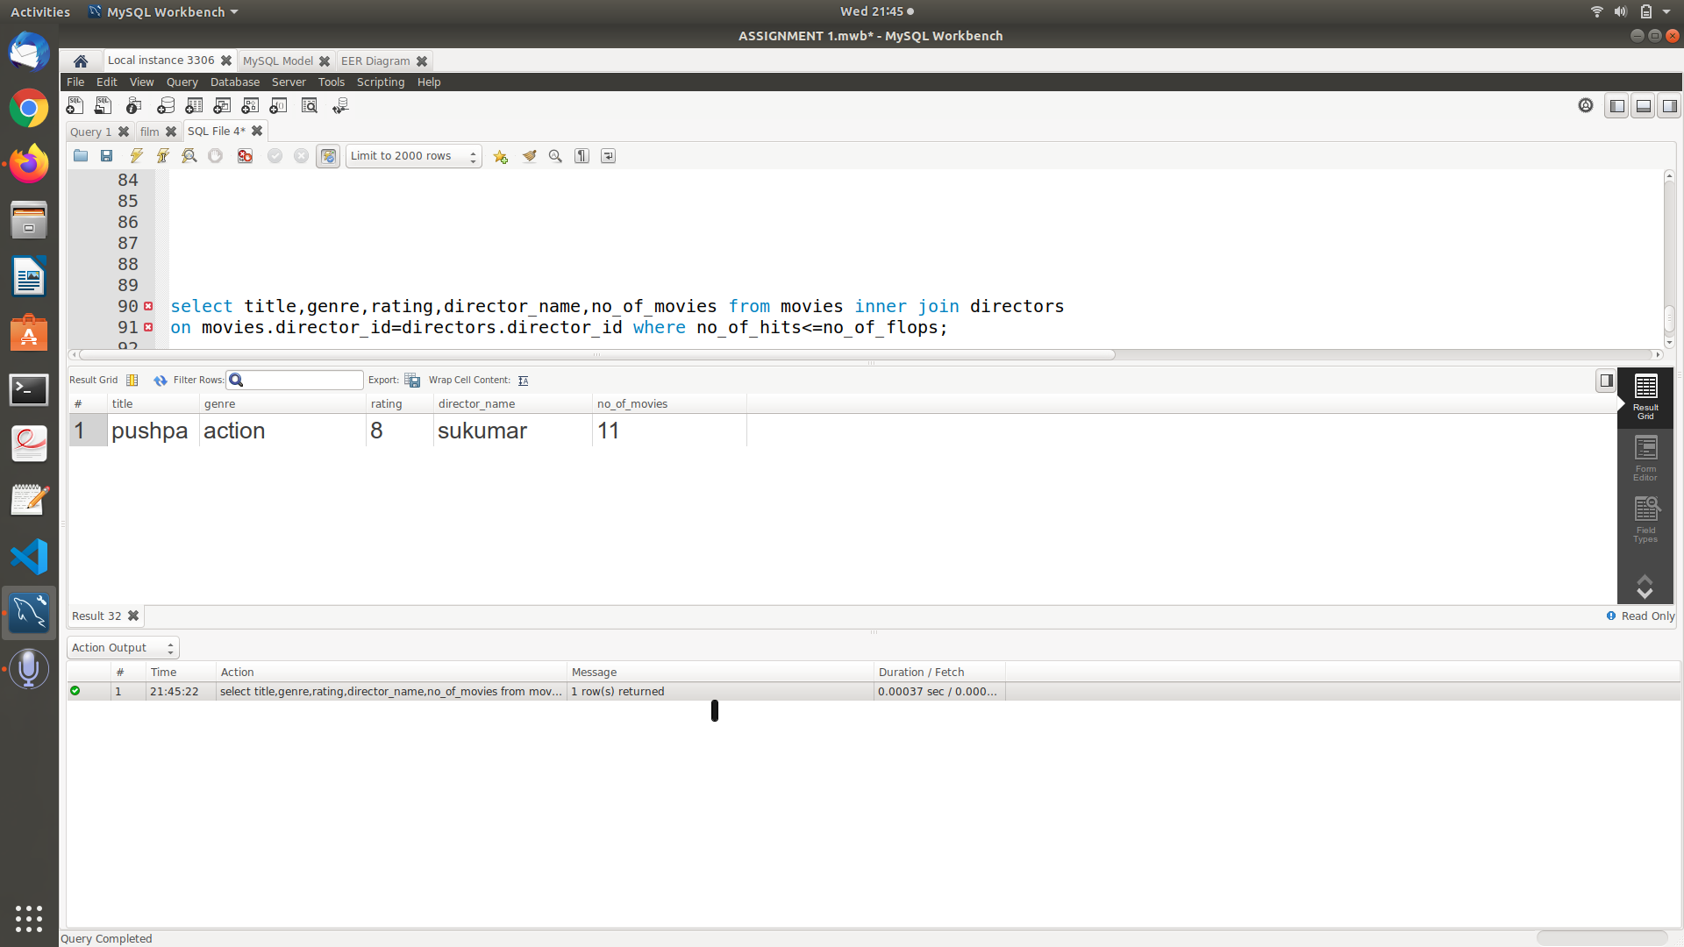

**b)SQL Query**

select title,producer_name,genre,rating from movies inner join production

on movies.producer_id=production.producer_id where production.budget in

(select max(budget) from production);

**Output :**

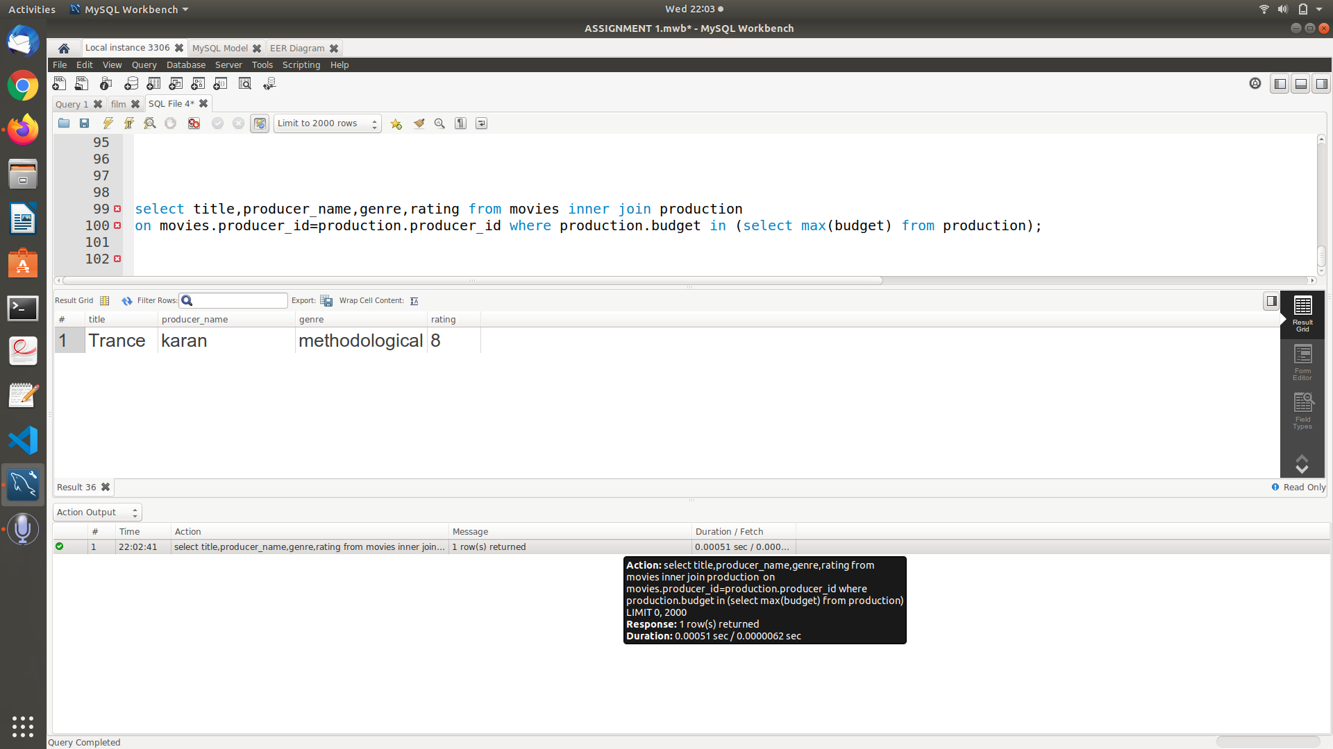

**c)SQL Query**

select title,actor_name,director_name,producer_name from(((movies inner join

actors on movies.actor_id=actors.actor_id and actors.actor_name like 'c%')

inner join directors on movies.director_id=directors.director_id)inner join

production on movies.producer_id=production.producer_id);

**Output :**

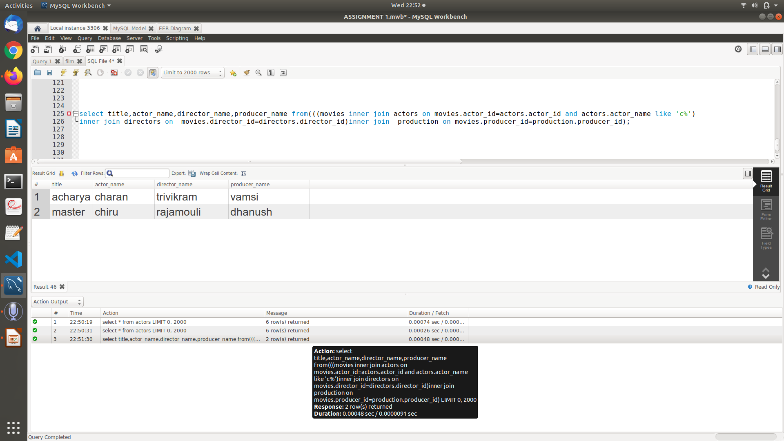

**2. LEFT OUTER JOIN**

**a)SQL Query**

select actor_name,role_type,title,genre from actors left join movies on

actors.actor_id=movies.actor_id order by actors.actor_name;

**Output :**

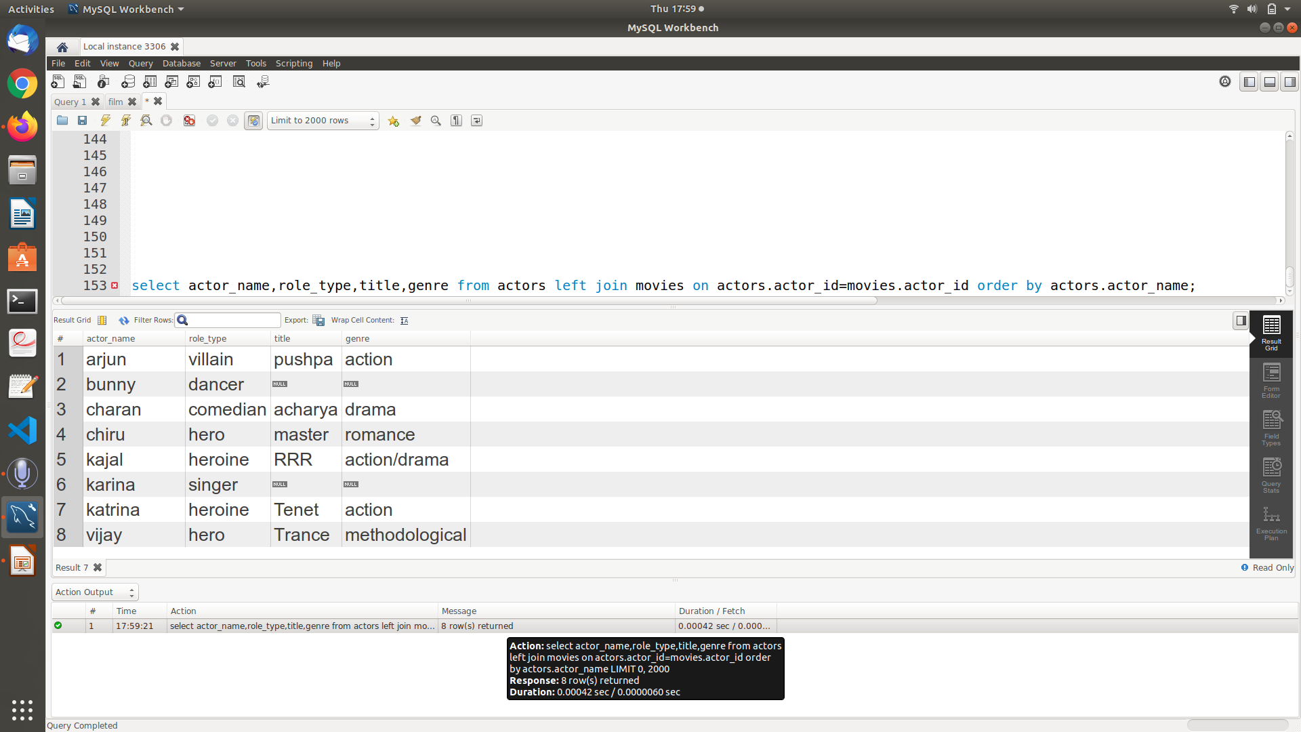

**b)SQL Query**

select title,producer_name,director_name from movies left join production on

movies.producer_id=production.producer_id and production.budget>200000 left

join directors on movies.director_id=directors.director_id and no_of_movies>5;

**Output :**

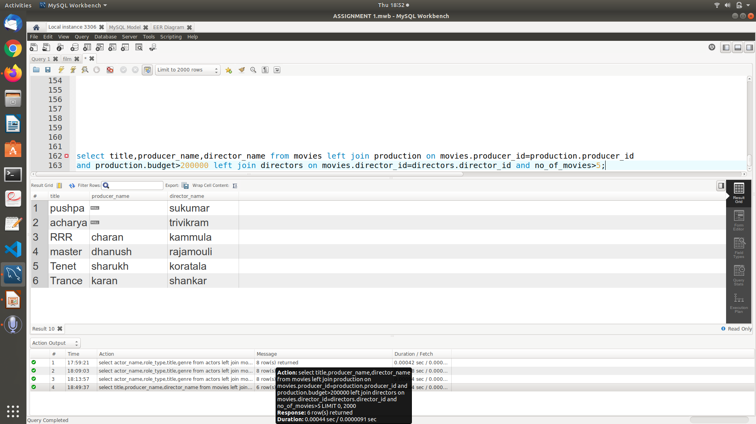

**c)SQL Query**

select title,songname,actor_name,director_name from movies left join songs on

movies.movie_id=songs.movie_id and songs.movie_id=1 left join

actors on movies.actor_id=actors.actor_id left join directors on

movies.director_id=directors.director_id;

**Output :**

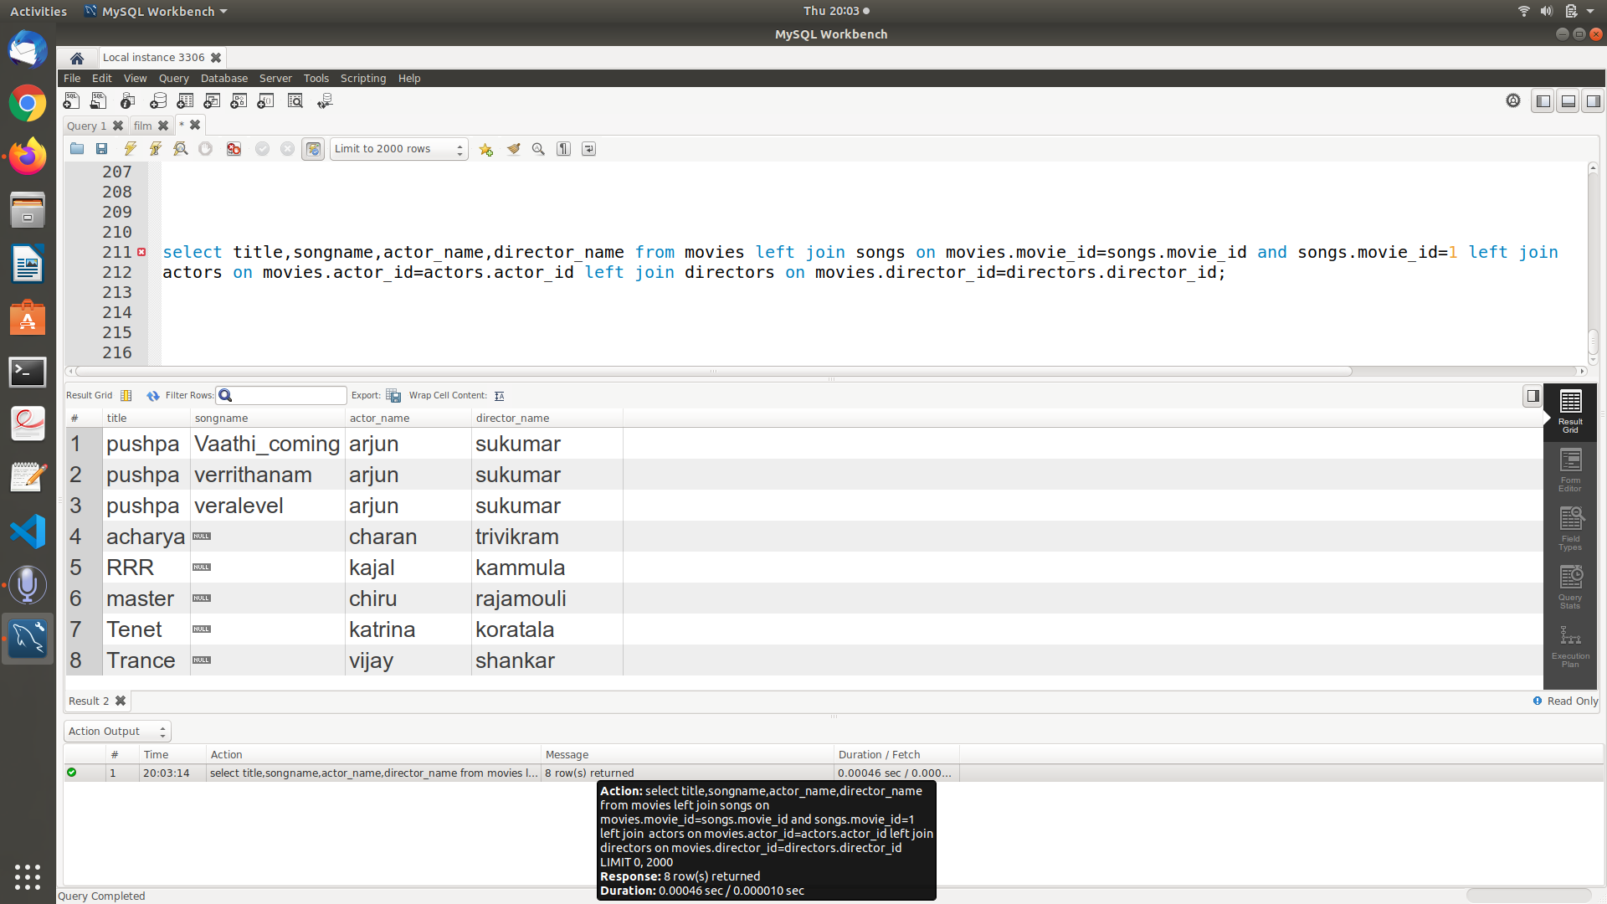

**3.RIGHT OUTER JOIN**

**a)SQL Query**

select title,producer_name,budget from movies right join production1 on

movies.producer_id=production1.producer_id and budget between 200000 and

1000000;

**Output :**

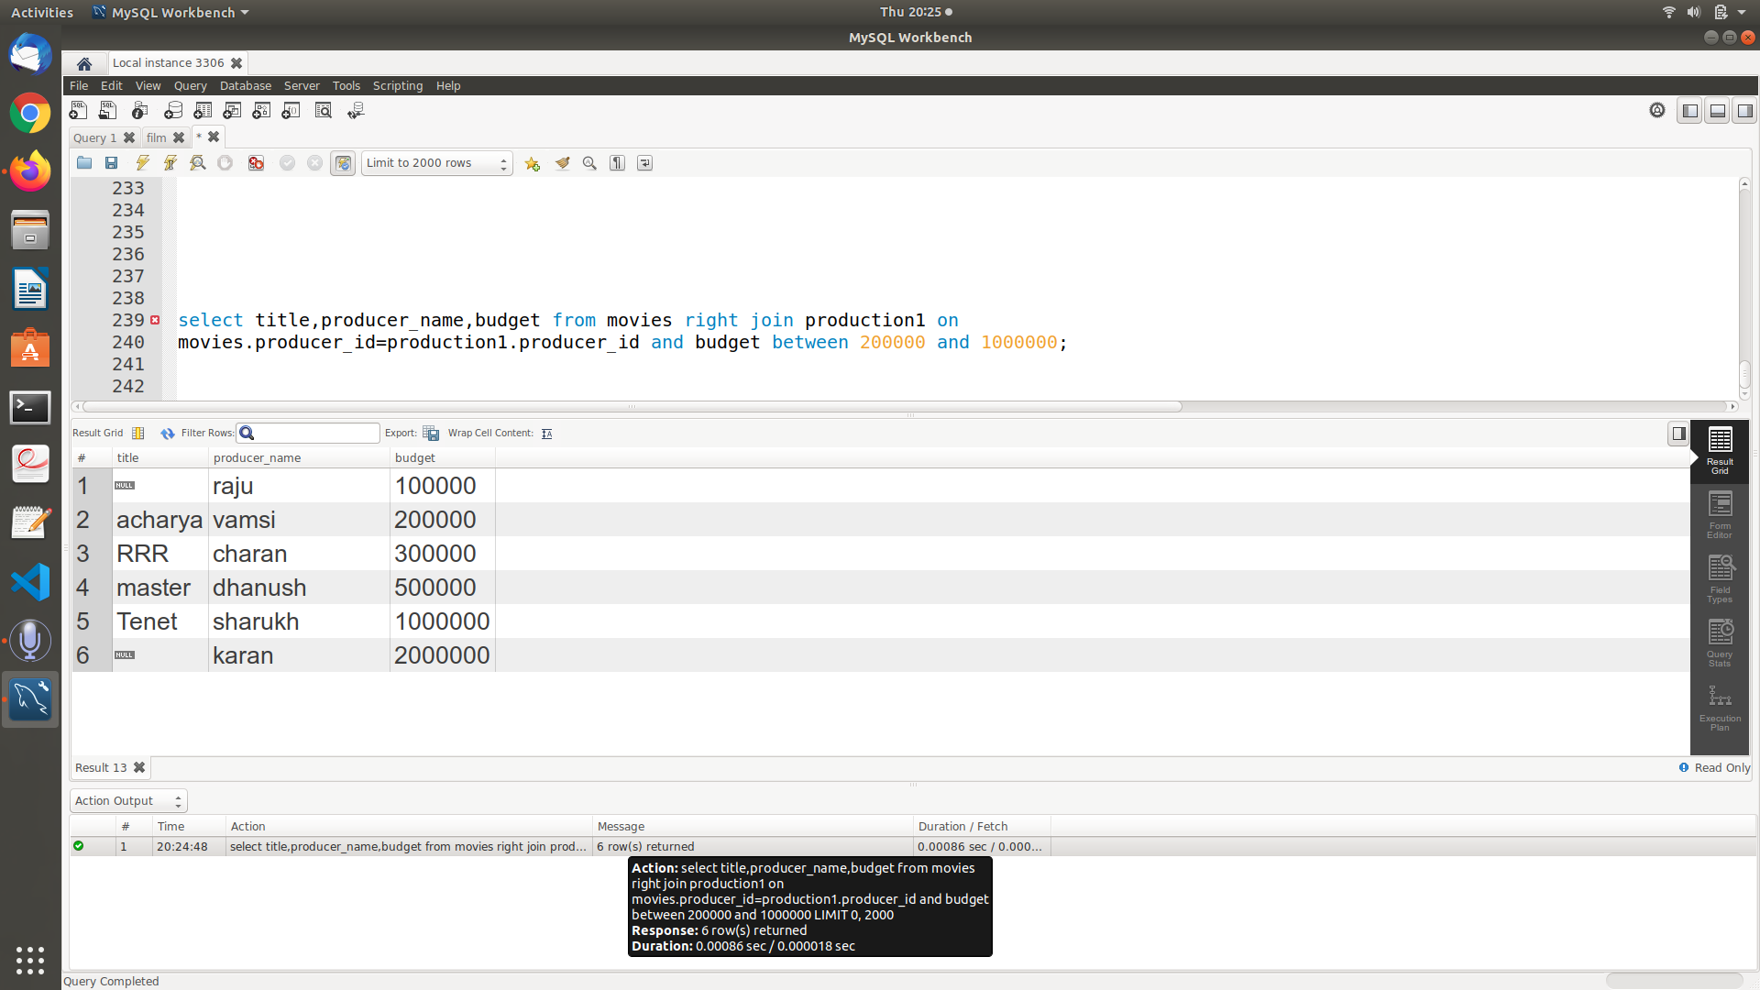

**b)SQL Query**

select title,actor_name,role_type,producer_name from((movies right outer join

actors on movies.actor_id=actors.actor_id and actors.role_type = "Hero")right

outer join production1 on movies.producer_id=production1.producer_id);

**Output :**

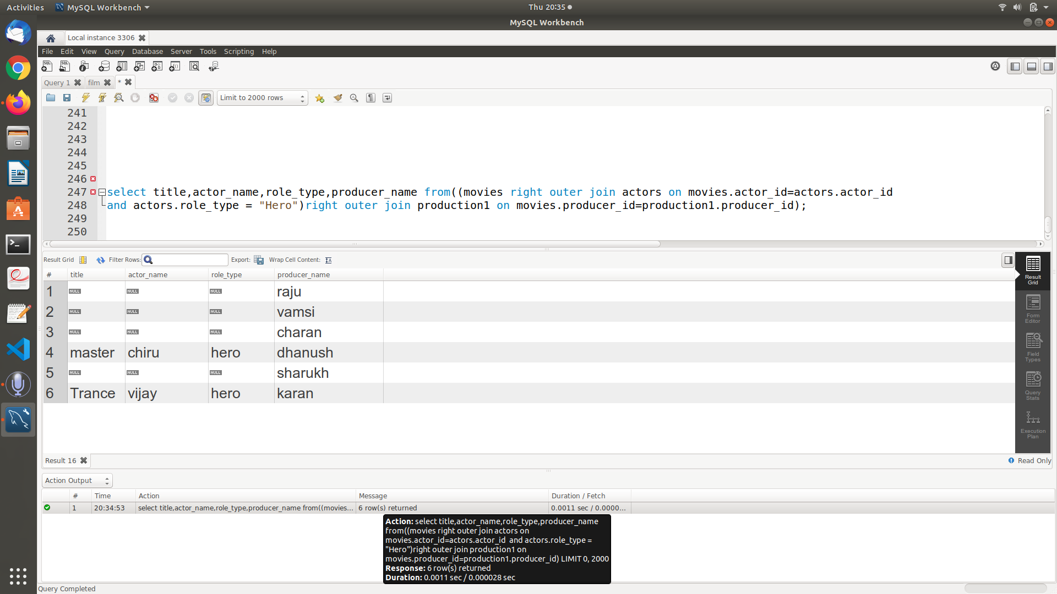

**c)SQL Query**

select distinct title,songname,actor_name,director_name,producer_name

from((((movies right outer join songs on

movies.movie_id=songs.movie_id)right outer join actors on

movies.actor_id=actors.actor_id) right outer join directors on

movies.director_id=directors.director_id)right outer join production1 on

movies.producer_id=production1.producer_id)where movies.genre="Action"

order by movies.title desc;

**Output :**

