A CASE-STUDY BASED REPORT
ON
Climate Pattern Analysis Using K-Means Clustering and PCA
submitted in partial fulfilment of the requirements for the Course
MACHINE LEARNING
BACHELOR OF TECHNOLOGY
in
A.Y.: 2026-27
by
GUNDLA LAXMI SRI - 2520030264
KALAVALA CHAITANYA – 2520030266
AKKINEPALLY RAGHAVA KOUNDINYA - 2520030271
Under the Esteemed guidance of
Dr. Y. Lakshmi Prasanna
Asst. Professor, Dept. of CS&IT




INDEX
Abstract
Introduction
Background
Motivation for the Project
Overview of the Work Carried Out
Scope and Responsible-Use Statement
Problem Statement
Case-Study Scenario
Central Case-Study Question
Formal Problem Definition
Objectives that Guide the Study
Assumptions and Limitations
Dataset and Exploratory Data Analysis
About the Dataset
Purpose of EDA
Preparation Steps Actually Performed
EDA Exploration - Implementation
Summary of EDA Findings
Algorithm Selection and Implementation

Conclusion

Signature of the Team Members

CLIMATE PATTERN ANALYSIS USING K-MEANS CLUSTERING AND PCA
Machine Learning Case Study | Academic Year 2026–27

1. Abstract
Climate change and weather variation motivate the identification of meaningful patterns across regions. This case study analyzes the Indian Climate Dataset (2024–2025), which contains approximately 7,310 daily observations and 13 original columns. Eight numerical climate features—Temperature_Max, Temperature_Min, Temperature_Avg, Humidity, Rainfall, Wind_Speed, Pressure, and Cloud_Cover—are selected for clustering. The dataset was checked for duplicate records, completely empty rows and columns, and missing values; none were found. The selected features are standardized because they use different units and numerical ranges. Principal Component Analysis (PCA) transforms the original features into principal components, retaining important information while reducing dimensionality and enabling two-dimensional visualization. K-Means clustering is then applied. Candidate cluster counts from K = 2 to K = 10 are considered using the Elbow Method, Inertia, and Silhouette Score. The highest reported Silhouette Score is approximately 0.453 for K = 2; however, the final solution is K = 3 because it provides three more interpretable climate regimes and is consistent with the elbow region. The final groups are Hot-Humid (2,425 observations), Cool-Rainy (2,385), and Moderate-Dry/Windy (2,500). The case study demonstrates how unsupervised learning can support environmental monitoring, agriculture, climate research, and exploratory, data-driven decision-making.

2. Introduction

2.1 Background
Climate observations contain several related measurements, including temperature, humidity, rainfall, wind speed, atmospheric pressure, and cloud cover. Examining these measurements together can help reveal recurring combinations of climate conditions. When observations do not have predefined labels, unsupervised machine learning can be used to discover structure in the data. This project uses PCA to transform a multi-feature dataset and K-Means to group observations with similar climate characteristics.

2.2 Motivation for the Project
A large collection of daily climate records can be difficult to interpret by inspecting individual variables separately. Temperature measures are strongly related in this dataset, while humidity, rainfall, wind speed, pressure, and cloud cover provide additional information. A clustering workflow offers a structured way to explore these combinations without assuming that each observation already belongs to a known climate category.

2.3 Overview of the Work Carried Out
The workflow follows the project pipeline: Dataset → Preprocessing → Feature Selection → Standardization → PCA → Elbow Method + Silhouette Score → K-Means → 3 Clusters → Climate Pattern Interpretation. The data structure and quality checks were reviewed first. Eight numerical features were selected and standardized. PCA was used for dimensionality reduction and two-dimensional visualization. Candidate K values from 2 through 10 were considered, and the final K = 3 solution was interpreted using cluster characteristics and cluster sizes.

2.4 Scope and Responsible-Use Statement
This is an exploratory, unsupervised analysis of daily observations in the supplied 2024–2025 dataset. The cluster names are descriptive interpretations of the reported characteristics, not official climate classifications. The results should not be treated as forecasts, causal explanations, or a substitute for expert climate assessment. The limited time span and lack of geographic coordinates among the clustering features constrain how broadly the patterns can be generalized.

3. Problem Statement

3.1 Case-Study Scenario
A climate analyst has a large collection of daily climate observations from India. The observations contain multiple weather measurements, but there is no predefined label telling the analyst which climate regime each observation belongs to. The analyst wants to discover whether the observations can naturally be grouped according to similar climate characteristics. This case study therefore applies PCA and K-Means clustering to discover meaningful climate patterns.

3.2 Central Case-Study Question
"Can unsupervised machine learning, using PCA and K-Means clustering, identify meaningful and interpretable climate patterns from Indian climate observations without a predefined target label?"

3.3 Formal Problem Definition
Given climate observations represented by eight numerical climate features, the objective is to standardize the features, reduce dimensionality using PCA, and partition the observations into clusters such that observations within a cluster have similar climate characteristics. The appropriate number of clusters is selected using clustering-oriented evaluation methods and domain interpretability rather than classification accuracy.

3.4 Objectives that Guide the Study

Analyze the Indian climate dataset.
Check the dataset for missing values and duplicates.
Select relevant numerical climate features.
Standardize features with different scales.
Apply PCA for dimensionality reduction.
Visualize the climate observations using principal components.
Evaluate candidate cluster counts using the Elbow Method.
Evaluate cluster separation using Silhouette Score.
Apply K-Means clustering.
Identify meaningful climate patterns.
Interpret the characteristics of each cluster.
Discuss limitations and future scope.

3.5 Assumptions and Limitations
The dataset covers 2024–2025 only and may not represent long-term climate behavior.
Geographic coordinates were not used as clustering features.
Seasonal and multi-year analysis can be expanded in future work.
K-Means represents each cluster using a centroid and may not fit every possible cluster shape.
Cluster names are descriptive interpretations, not official climate classifications.
The project discovers patterns; it does not predict future weather.

4. Dataset and Exploratory Data Analysis

4.1 About the Dataset
The project uses the Indian Climate Dataset (2024–2025), sourced from Kaggle. Its approximate size is 7,310 daily records and 13 original columns.
No. | Original column | Role / description
1 | Date | Date of observation; not used as a numerical clustering feature
2 | City | Geographic identifier; not used as a numerical clustering feature
3 | State | Geographic identifier; not used as a numerical clustering feature
4 | Temperature_Max | Maximum temperature
5 | Temperature_Min | Minimum temperature
6 | Temperature_Avg | Average temperature
7 | Humidity | Humidity measurement
8 | Rainfall | Rainfall measurement
9 | Wind_Speed | Wind speed measurement
10 | AQI | Air Quality Index field
11 | AQI_Category | Categorical air-quality field
12 | Pressure | Atmospheric pressure
13 | Cloud_Cover | Cloud cover measurement

The eight numerical climate features used for clustering are Temperature_Max, Temperature_Min, Temperature_Avg, Humidity, Rainfall, Wind_Speed, Pressure, and Cloud_Cover. City, State, Date, AQI category, and other non-selected fields are not included as numerical clustering features because the focus is grouping observations according to climate characteristics.

4.2 Purpose of EDA
Exploratory Data Analysis (EDA) was carried out before applying machine learning to understand the dataset structure, check data quality, inspect relationships among variables, and support feature preparation. EDA also helped identify strong relationships among temperature variables and reinforced the need to standardize features with different scales.

4.3 Preparation Steps Actually Performed
Preparation check | Reported result
Dataset structure inspected | Approximately 7,310 rows and 13 columns
Duplicate records checked | 0
Completely empty rows checked | 0
Completely empty columns checked | 0
Missing values checked | 0
Column names standardized | Performed
Relevant numerical features selected | 8 climate features
Numerical features standardized | Performed before PCA and K-Means

No missing-value imputation was required because no missing values were reported. No rows were reported as deleted because of missing values.

4.4 EDA Exploration – Implementation
The reported temperature correlations show that the three temperature variables contain closely related information. Temperature_Max and Temperature_Min have an approximate correlation of 0.90; Temperature_Max and Temperature_Avg, 0.97; and Temperature_Min and Temperature_Avg, 0.98. These values indicate strong positive relationships among the temperature features.
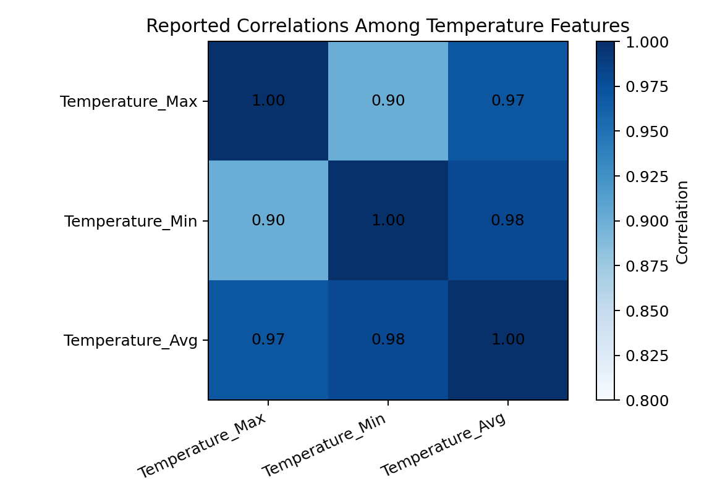
Figure 1. Reported pairwise correlations among the three temperature features. Correlations for other feature pairs were not provided.
The selected features use different units and numerical ranges. Temperature is measured in degrees, humidity is a percentage, rainfall has its own scale, and pressure has a larger numerical magnitude. Since K-Means relies on distances between observations, variables with larger scales could dominate the distance calculation. Standardization puts the features on a comparable scale so that one variable does not dominate clustering just because of its numerical range.

4.5 Summary of EDA Findings
The dataset contains approximately 7,310 daily records and 13 columns.
No duplicate records, completely empty rows, completely empty columns, or missing values were reported.
Temperature_Max, Temperature_Min, and Temperature_Avg are strongly correlated (approximately 0.90, 0.97, and 0.98 for the reported pairs).
Humidity, rainfall, wind speed, pressure, and cloud cover contribute additional climate information.
Standardization is appropriate before PCA and K-Means because the selected variables have different units and scales.

5. Algorithm Selection and Implementation

5.1 Type of Machine Learning
This is an UNSUPERVISED MACHINE LEARNING project. There is no predefined target label, and the workflow does not require a train/test split. It is not a classification, regression, or supervised-prediction task. Therefore, Accuracy, Precision, Recall, F1-score, and ROC-AUC are not appropriate primary performance measures.

5.2 Standardization
The eight selected numerical features are standardized before PCA and K-Means. This reduces the influence of differences in measurement units and numerical ranges. Standardization is particularly important for distance-based clustering because otherwise a variable with a larger numeric scale could disproportionately influence assignments.

5.3 Principal Component Analysis (PCA)
PCA stands for Principal Component Analysis. It transforms the original features into principal components and reduces dimensionality while retaining important information. In this project, the original eight climate features are transformed into principal components. PCA simplifies the feature space and supports visualization of observations in two dimensions.
The first principal component (PC1) explains 36.20% of the variance, and the second principal component (PC2) explains 12.93%. Together, PC1 and PC2 explain 49.13% of the variance. These two components are used for two-dimensional visualization; the combined percentage also means that the first two components do not represent all variance in the original data.
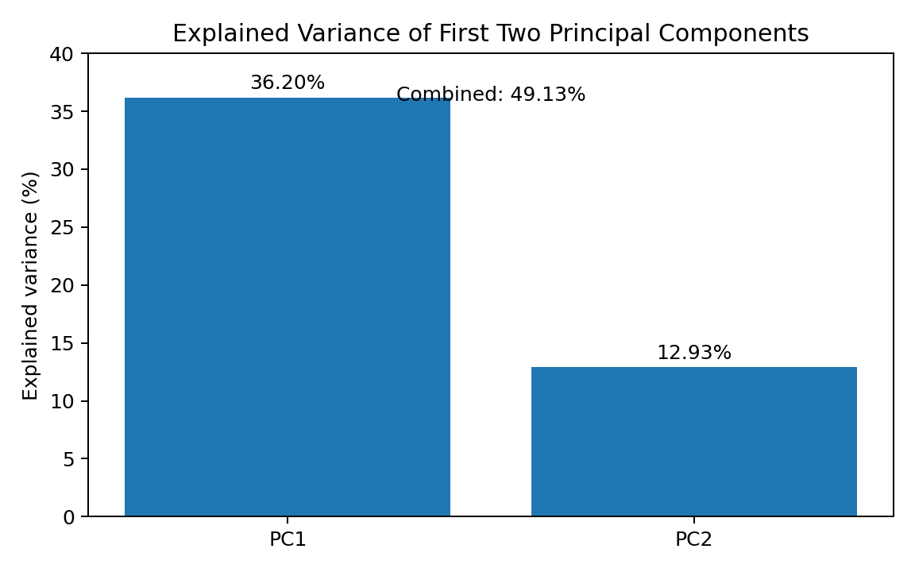
Figure 2. Reported explained variance for PC1 and PC2.

5.4 K-Means Clustering
K-Means is an unsupervised clustering algorithm. It groups observations that are similar to each other and represents each group using a centroid. Its basic procedure is:
Choose K, the number of clusters.
Initialize cluster centroids.
Assign each observation to the nearest centroid.
Recalculate the centroids based on the assigned observations.
Repeat assignment and centroid update.
Stop when cluster assignments become stable.

5.5 Selection of the Number of Clusters
Candidate values from K = 2 to K = 10 were considered using the Elbow Method and Silhouette Score. Inertia measures the within-cluster sum of squared distances to centroids and generally decreases as K increases. The reported elbow region was around K = 3–4, where adding more clusters begins to provide diminishing improvement.
The highest reported Silhouette Score was approximately 0.453 for K = 2. Exact silhouette values for K = 3 through K = 10 were not reported and are not inferred here. Although K = 2 had the highest reported score, the final solution is K = 3 because it provides more interpretable climate regimes and is consistent with the elbow region.
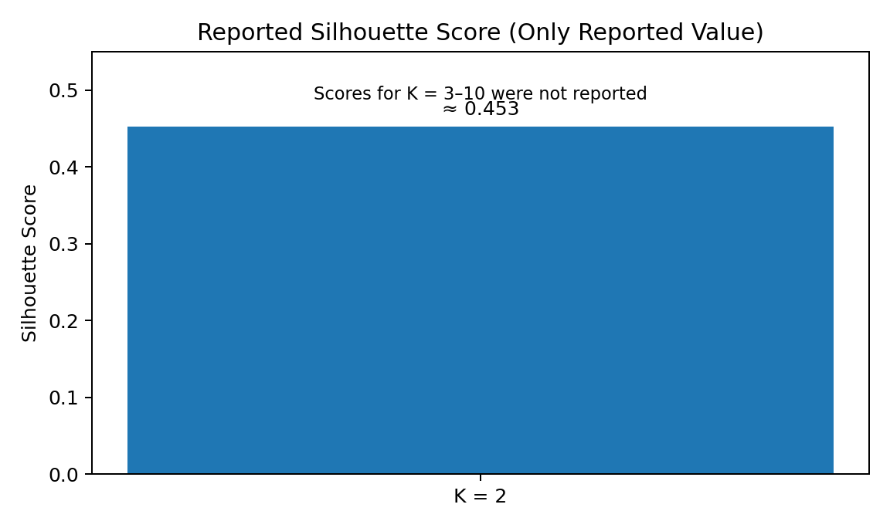
Figure 3. The only reported silhouette value. No values are shown for K = 3–10 because they were not reported.
Model / K | Silhouette Score | Elbow observation | Interpretation | Decision
K = 2 | ≈ 0.453 | Before elbow | Two broad groups | Not selected
K = 3 | Not reported | Elbow region | Three interpretable climate patterns | Selected
K = 4 | Not reported | Elbow region | More detailed grouping | Not selected
K = 5–10 | Not reported | After elbow | Increasing number of groups | Not selected
Final K = 3 | Not reported | Elbow-consistent | Hot-Humid, Cool-Rainy, Moderate-Dry/Windy | Final

5.6 Final Cluster Results and Interpretation
The final K-Means solution uses K = 3 and assigns all 7,310 observations to three climate-pattern groups. The names below are descriptive labels based on the reported cluster characteristics.
Cluster | Pattern name | Reported characteristics | Observations
Cluster 0 | Hot-Humid | Higher temperature, higher humidity, lower rainfall, lower wind | 2,425
Cluster 1 | Cool-Rainy | Cooler conditions, rainy characteristics, relatively higher pressure | 2,385
Cluster 2 | Moderate-Dry/Windy | Moderate temperature, lower humidity, lower rainfall, stronger winds, lower cloud cover | 2,500
Total | — | Three relatively balanced clusters | 7,310

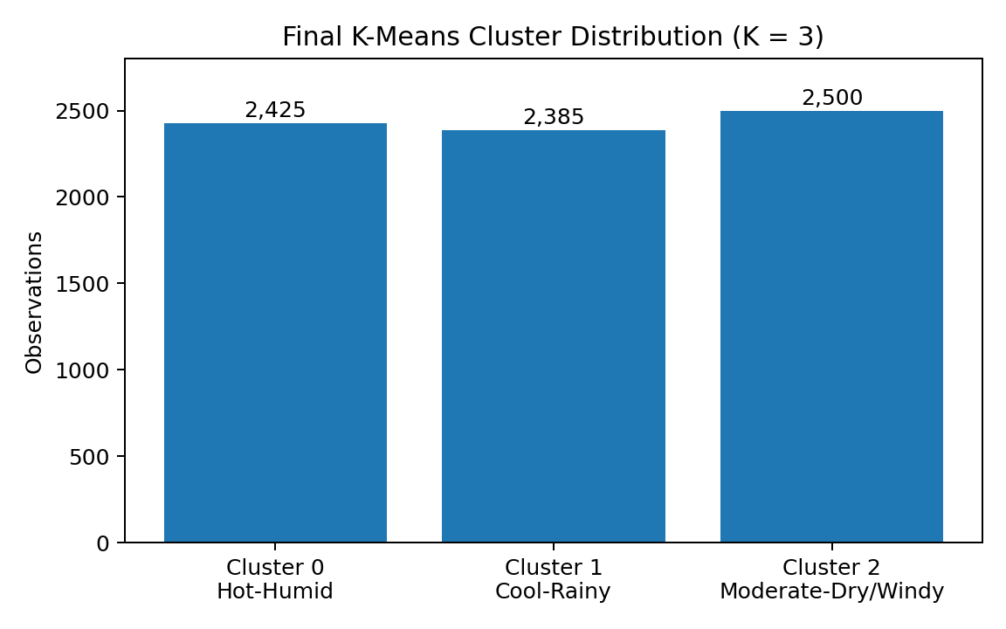
Figure 4. Distribution of observations across the final three clusters.
The cluster counts sum to 7,310 (2,425 + 2,385 + 2,500). Their sizes are relatively balanced, with each group representing a substantial portion of the dataset.

5.7 End-to-End Implementation Pipeline
Stage | Purpose
1. Dataset | Load the Indian Climate Dataset (2024–2025).
2. Preprocessing | Inspect structure, duplicates, empty rows/columns, and missing values; standardize column names.
3. Feature selection | Select the eight numerical climate features.
4. Standardization | Put features on a comparable scale.
5. PCA | Transform original features into principal components; use PC1 and PC2 for 2D visualization.
6. Cluster-count evaluation | Consider K = 2–10 using the Elbow Method, Inertia, and Silhouette Score.
7. K-Means | Fit the final clustering solution with K = 3.
8. Interpretation | Describe the three clusters and examine their distribution.

5.8 Model Evaluation Approach
Clustering is evaluated using the Elbow Method, Inertia, Silhouette Score, cluster distribution, and interpretability. Classification metrics are not applicable because there are no predefined target labels. The exact inertia values and silhouette scores beyond K = 2 were not provided, so they are not fabricated in this report.

6. Conclusion
This case study demonstrates the use of unsupervised machine learning for climate-pattern discovery. After data-quality checks, selection of eight numerical features, and standardization, PCA was used to transform the feature space and support two-dimensional visualization. K-Means clustering was evaluated over candidate values of K, and the final K = 3 solution was selected because it yielded three interpretable climate regimes and was consistent with the elbow region.
The resulting clusters were Hot-Humid (2,425 observations), Cool-Rainy (2,385), and Moderate-Dry/Windy (2,500). PCA helped reduce dimensionality while retaining important information, and K-Means identified groups of observations with similar climate characteristics. These patterns can support exploratory environmental monitoring, agriculture, climate research, and data-driven decision-making. The findings should be interpreted within the limits of the dataset and should not be treated as future-weather predictions.

