Exercise 1:
- In an inventory system, there are thousands or even millions of products. We need to organise this data efficiently for it’s faster retrieval, to check it’s availability for sale, and better organization of data. Without proper data structures, operations like finding a product, updating stock, or checking availability can become slow and inefficient.

- According to needs and convenience of the users, different data structures can be used, some of them can be:
    - ArrayList- for storing data in order.
    - HashMap-to store the unique products and products can be accessed via product id. It allows faster retrieval of products, add new delete products or update if any product goes out of stock.
    - TreeMap – It sorts the data in sorted order, widely used for analysis of stocks.
    - PriorityQueue – productIds and their stock can be stored, to keep the stocks record in ascending or descending order according to need of the system.
These data structures and collections would make the inventory system fast, organised and scalable.

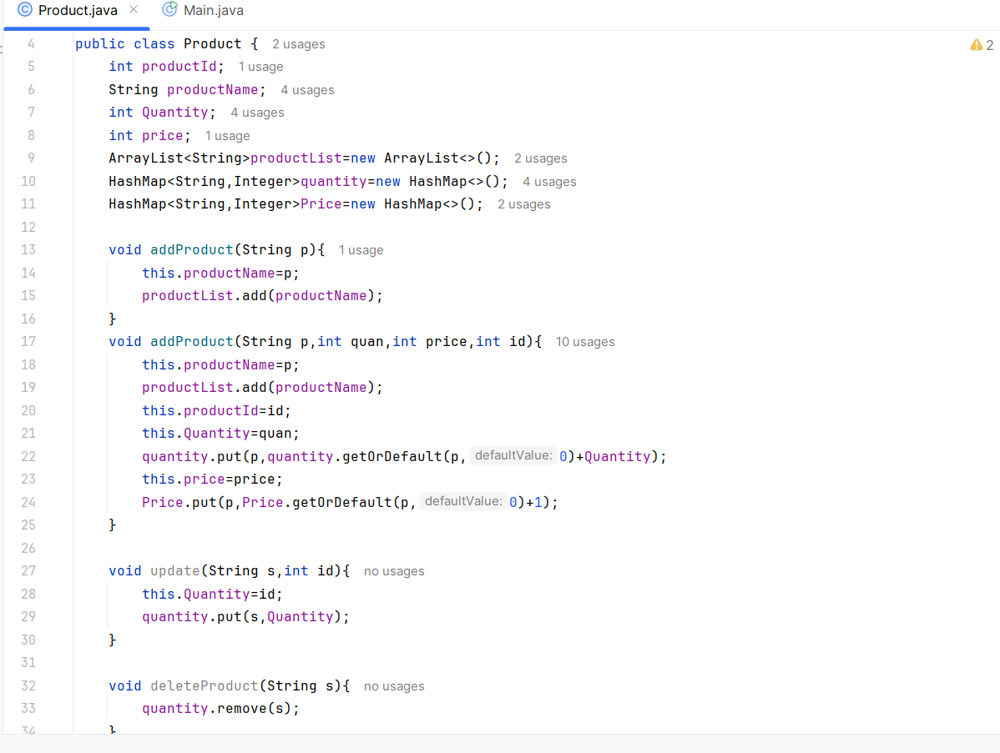
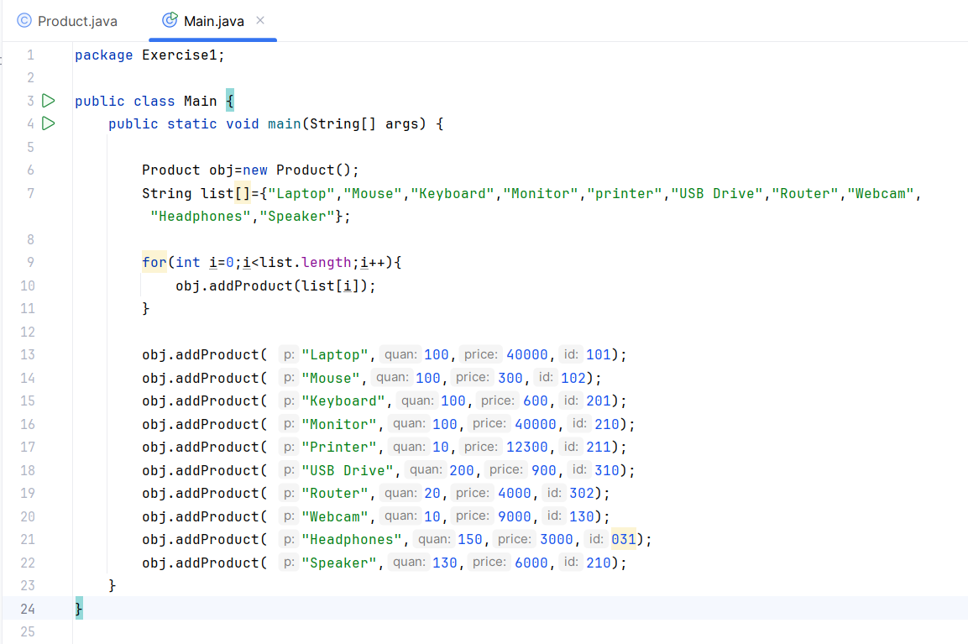

- Time complexities of each operation:
- Add Product:
Average Case - O(1) –
Worst Case: O(n)
- Update Quantity:
Average Case - O(1) –
Worst Case: O(n)
- Delete Quantity:
Average Case - O(1) –
Worst Case: O(n)

- We can optimize these operations by:
- Store Complete Product Objects
For eg. –
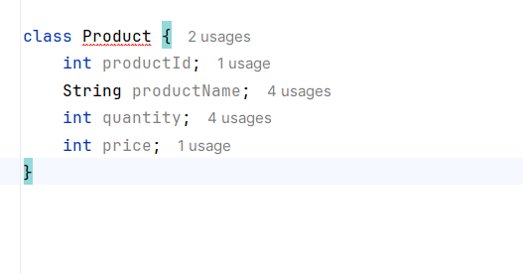

- Avoid Duplicate Storage:
Currently a product is stored in:
- productList
- quantity
- Price
The same information exists in multiple places.

We can use –
HashMap<Integer, Product> inventory;

- Use treemap when sorted data is needed:

TreeMap<Integer, Product> inventory = new TreeMap<>();

Exercise 2:

1.Understanding Asymptotic Notation

Big O Notation
Big O notation is used to measure the performance of an algorithm by describing how its execution time grows as the input size increases. It helps compare different algorithms and determine which one is more efficient for large datasets.
For example:
- O(1) → Constant Time
- O(log n) → Logarithmic Time
- O(n) → Linear Time
- O(n²) → Quadratic Time
In an e-commerce platform, Big O notation helps determine how quickly products can be searched when the inventory contains thousands or millions of products.
Best, Average, and Worst Case Scenarios
Linear Search
- Best Case: O(1)
  - The product is found at the first position.
- Average Case: O(n)
  - The product is found somewhere in the middle.

- Worst Case: O(n)
  - The product is at the last position or not present.
Binary Search
- Best Case: O(1)
  - The product is found at the middle position in the first comparison.
- Average Case: O(log n)
  - The search space is repeatedly divided into halves.
- Worst Case: O(log n)
  - The product is found after several divisions or is not present.

2.Setup
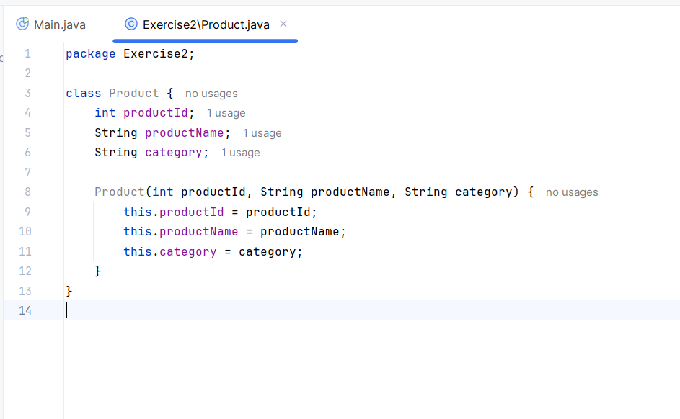

3.Implementation
Linear search and binary search implementation
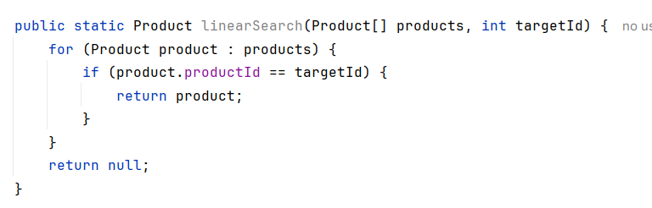
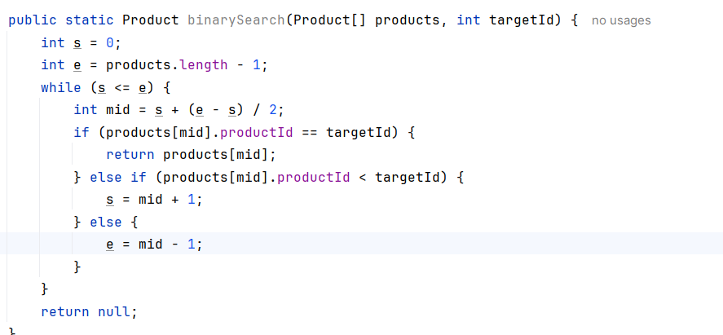

4.Analysis:
complexity of linear and binary search algorithms.
Algorithm | Best Case | Average Case | Worst Case
Linear Search | O(1) | O(n) | O(n)
Binary Search | O(1) | O(log n) | O(log n)

Linear search checks every element sequentially, making it slower for large datasets.
Whereas, binary search, it reduces the search operations by half in each iteration. So, it is optimal for searching in large datasets.

Exercise 3:
1. Understand Sorting Algorithms
Bubble Sort
- Repeatedly compares adjacent elements and swaps them if they are in the wrong order.
- Largest element "bubbles up" to its correct position in each pass.
Time Complexity
- Best Case: O(n)
- Average Case: O(n²)
- Worst Case: O(n²)

Insertion Sort
- Builds the sorted array one element at a time.
- Inserts each element into its correct position in the already sorted part.
Time Complexity
- Best Case: O(n)
- Average Case: O(n²)
- Worst Case: O(n²)

Quick Sort
- Uses a pivot element.
- Partitions the array into elements smaller and larger than the pivot.
- Recursively sorts both partitions.
Time Complexity
- Best Case: O(n log n)
- Average Case: O(n log n)
- Worst Case: O(n²)

Merge Sort
- Divides the array into two halves.
- Recursively sorts each half.
- Merges the sorted halves.
Time Complexity
- Best Case: O(n log n)
- Average Case: O(n log n)
- Worst Case: O(n log n)

2.Setup
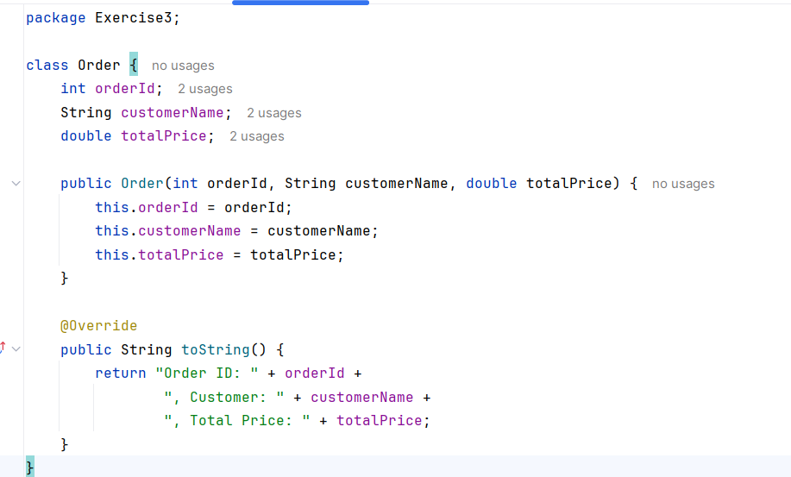

3.Implementation:
Bubble sort to sort orders by price:
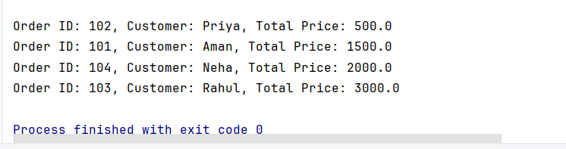

Quick sort to sort orders by price:
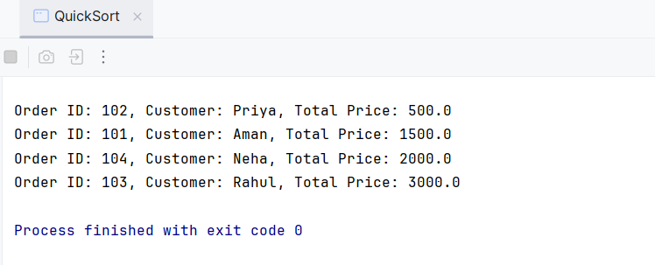

4.Analysis:
- Time Complexity Comparison:
Algorithm | Best Case | Average Case | Worst Case
Linear Search | O(1) | O(n) | O(n)
Binary Search | O(1) | O(log n) | O(log n)

- Quick Sort is generally preferred over Bubble Sort because it is much more efficient for large datasets and follows the Divide and Conquer strategy.

Exercise 4
1. Understanding Array Representation
An array is a collection of elements stored in contiguous memory locations.
Example:
Index: 0 1 2 3
Data: [ Emp1, Emp2, Emp3, Emp4 ]
Advantages of Arrays-
- Fast access using index (O(1))
- Easy to traverse
- Memory efficient
- Suitable when the number of elements is fixed
2.Setup:
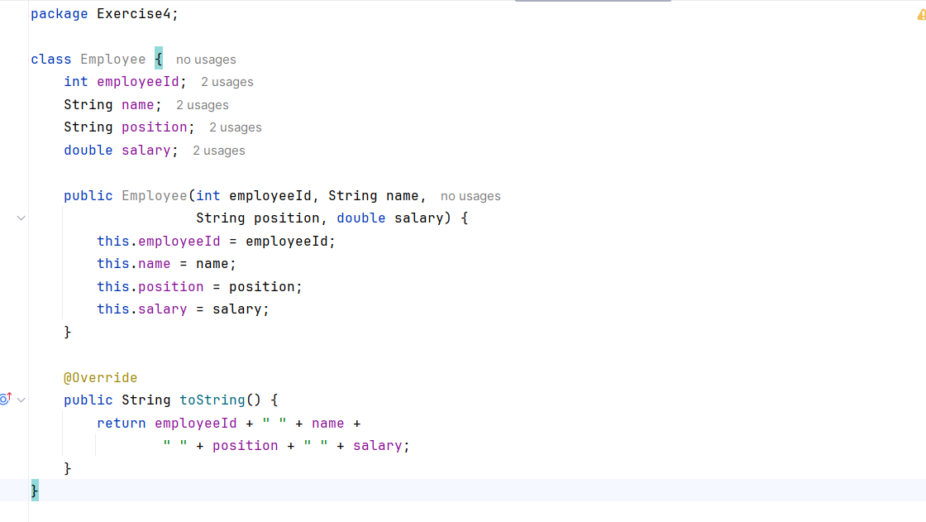

3.Implementation:
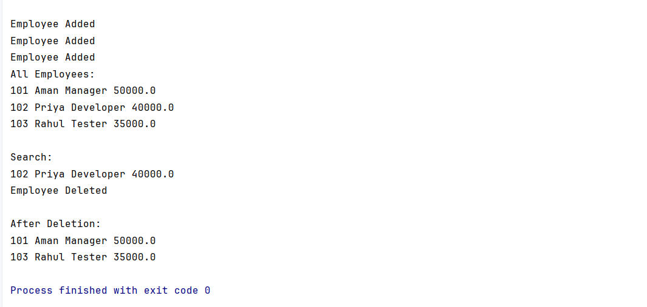

4.Analysis:
Operation | Time Complexity
Add | O(1)
Search | O(n)
Traverse | O(n)
Delete | O(n)
-Limitations of Arrays
- Fixed size
- Insertion and deletion are costly
- Wastage of memory if array is not fully utilized
- Requires contiguous memory
-When to Use Arrays?
- Number of elements is known beforehand.
- Frequent indexing/access is required.
- Insertions and deletions are infrequent.

Exercise 5
1. Understanding Linked Lists
Singly Linked List
Each node contains:
- Data
- Address of next node
[Task1| ] -> [Task2| ] -> [Task3| ] -> null

Doubly Linked List
Each node contains:
- Previous pointer
- Data
- Next pointer
null <- [Task1] <-> [Task2] <-> [Task3] -> null

Difference
Singly Linked List | Doubly Linked List
One pointer | Two pointers
Less memory | More memory
Forward traversal only | Forward and backward traversal
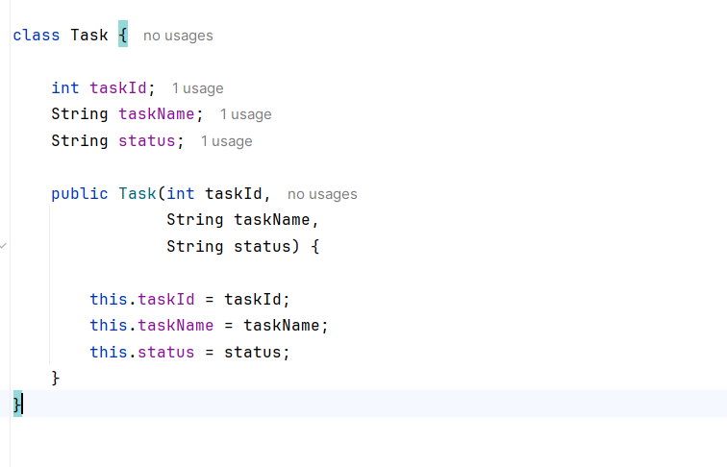
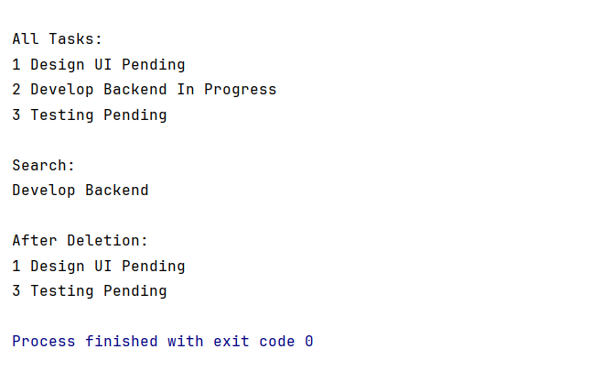

4.Analysis:
Advantages of Linked Lists Over Arrays
1. Dynamic Size
Linked lists grow and shrink at runtime.
Array → Fixed Size
Linked List → Dynamic Size

2. Efficient Insertions and Deletions
No shifting of elements is required.
Array deletion:
[10,20,30,40]
Delete 20
Shift:
[10,30,40]
Linked list deletion:
10 -> 20 -> 30 -> 40
Change pointer:
10 -> 30 -> 40

3. Better Memory Utilization
Memory is allocated as needed.

Exercise 6

1. Understanding Search Algorithms
Linear Search-
Linear Search checks each element one by one until the target is found or the list ends.

Binary Search
Binary Search repeatedly divides the search space into two halves.
Requirement: The books must be sorted by title.
Steps
- Find the middle element.
- Compare it with the target title.
- If equal, return it.
- If target is smaller, search left half.
- If target is larger, search right half.
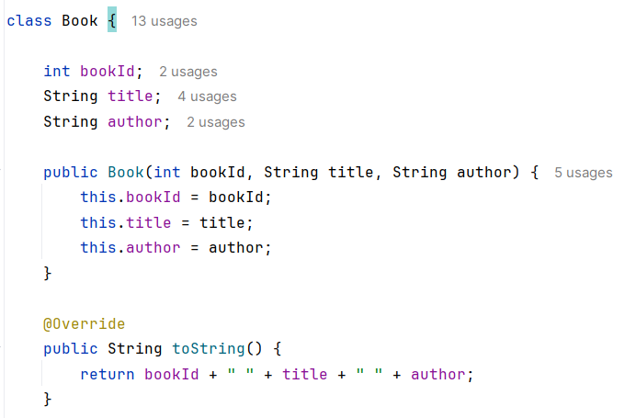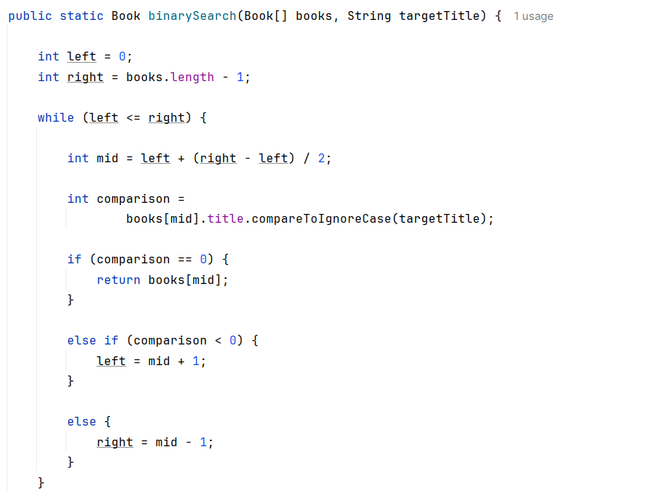

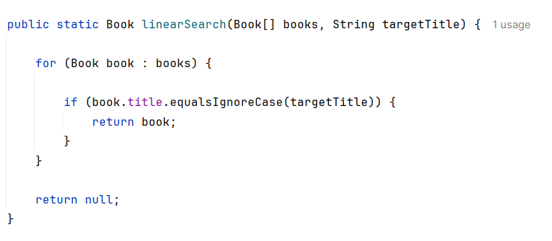

4. Analysis
Time Complexity Comparison
Algorithm | Best | Average | Worst
Linear Search | O(1) | O(n) | O(n)
Binary Search | O(1) | O(log n) | O(log n)

- Linear search can be used when the data is small, unsorted and only a few searches are needed.
- Binary search would be used when data is too large to make sequential searches, and data is sorted.

Exercise 7
1. Understanding Recursion
What is Recursion?
Recursion is a technique where a method calls itself to solve a smaller version of the same problem.
Every recursive solution has:
- Base Case (stopping condition)
- Recursive Case (self-call)

2. Setup
Suppose:
- Current Value = ₹10,000
- Annual Growth Rate = 10%
- Years = 3
Formula:
$$FutureValue=PresentValue×(1+GrowthRate)^{n}$$
Instead of using a loop, we can use recursion.

3.Implementaion:
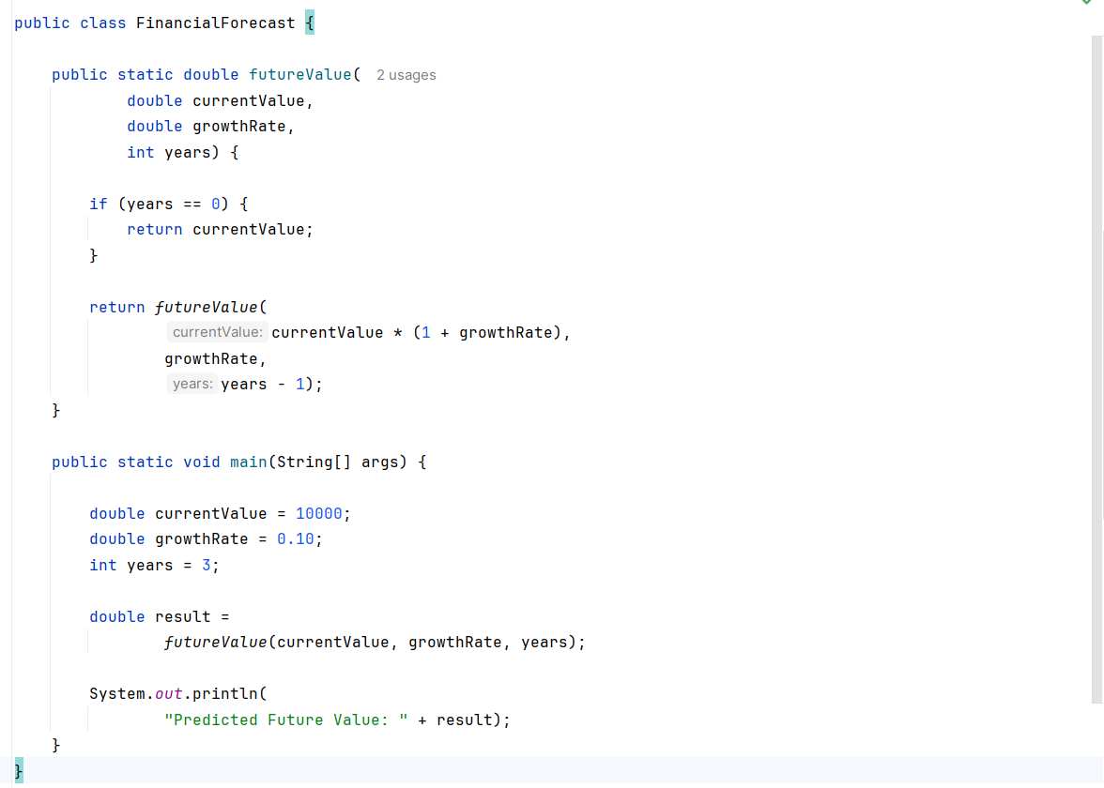

4.Analysis:
Time Complexity
For each year, one recursive call is made.
T(n) = T(n-1) + O(1)
Therefore:$T(n)=O(n)$
Space Complexity
Because of the recursion stack:$O(n)$
--Optimize Recursive Solutions Problem
Recursion creates function call overhead.
For very large values of n:
futureValue(..., 100000)
many stack frames are created.

