Project Title:
Design and Implementation of an Inventory and Sales Management System for a Retail Store

Problem Identification:
In many retail stores and supermarkets, daily operations such as inventory tracking, product sales, supplier purchases, payment handling and stock adjustments are often managed using manual registers or loosely connected software systems. This leads to several issues:
- Inaccurate inventory records due to delayed updates
- Errors in purchase and sales calculations
- Lack of centralized supplier and customer data
- Poor visibility into stock shortages, overstocking, and losses
- Inefficient report generation for management decisions
As the number of products, customers, and transactions increases, the existing system becomes unreliable, time-consuming, and prone to data inconsistency.

Problem Statement:
The absence of a centralized and integrated database system in retail stores makes it difficult to accurately manage inventory, sales, purchases, payments, and stock adjustments. Manual and fragmented systems fail to maintain data integrity, resulting in inconsistent records, delayed updates, and limited reporting capabilities.

Therefore, there is a need to develop a database-driven Inventory and Sales Management System that can efficiently store, manage, and process large volumes of retail data while ensuring data accuracy, integrity, and consistency.

Proposed Solution Overview:
The proposed system is a centralized database application designed to manage the complete lifecycle of products in a retail store—from procurement and storage to sales and payment processing.
The system uses a relational database model to:
- Maintain structured data for products, suppliers, employees, and customers
- Track inventory levels in real time
- Record purchase orders and sales transactions
- Automatically compute derived values such as totals and stock balances
- Support accurate reporting and decision-making

Objectives of the System:
1) To design a normalized relational database for retail operations
2) To ensure data integrity and consistency using primary and foreign key constraints
3) To minimize data redundancy and eliminate update anomalies
4) To support efficient processing of sales transactions, purchase orders, and stock adjustments
5) To enable generation of reliable business and inventory reports for management decision-making

Software used:
yEd - graph editor - is a desktop application for creating, editing, and analyzing graphs and diagrams. It’s a powerful, flexible tool used for visualizing relationships, workflows, and network-type structures — from simple flowcharts to complex network diagrams.

System Modules:
1) Category & Product Management Module
- Manages product categories and product master data
- Allows creation, update, and deletion of categories
- Assigns each product to a category and supplier
- Maintains product details such as barcode and unit price
- Ensures every product belongs to a valid category and supplier
2) Supplier Management Module
- Maintains supplier information such as name, address, email, and phone numbers
- Supports multiple phone numbers per supplier
- Enables tracking of suppliers associated with purchase orders
- Ensures supplier data consistency across procurement operations
3) Inventory Management Module
- Tracks inventory for each product
- Maintains stock-in, stock-out, current stock, and reorder levels
- Ensures one-to-one mapping between product and inventory
- Helps identify low-stock and reorder requirements
- Supports real-time inventory updates after sales and purchases
4) Purchase Order Management Module
- Handles creation and management of purchase orders
- Associates each purchase order with a supplier
- Records order date and order status
- Maintains purchase order details such as products ordered, quantities, unit prices, and batch numbers
- Automatically derives total purchase amount from purchase order details
5) Purchase Order Details Module
- Acts as a line-item module for purchase orders
- Resolves the M:N relationship between products and purchase orders
- Records quantity ordered, unit price, and batch information for each product in an order
- Ensures each purchase order contains at least one product

6) Customer Management Module
- Stores customer information such as name, phone, and email
- Allows customers to exist independently of sales transactions
- Supports customer-based sales tracking and reporting
7) Sales Transaction Management Module
- Records sales transactions processed in the store
- Associates each transaction with a customer and an employee
- Stores transaction date and transaction-level details
- Automatically derives grand total from transaction details
- Ensures every sales transaction is linked to at least one product
8) Sales Transaction Details Module
- Represents individual product line items within a sales transaction
- Resolves the M:N relationship between products and sales transactions
- Records quantity sold and unit price for each product
- Ensures that sales transaction details cannot exist without a sales transaction
9) Payment Management Module
- Handles payment details for sales transactions
- Supports different payment methods
- Records payment amount and payment date
- Ensures one-to-one relationship between sales transactions and payments
- Confirms transaction settlement and payment integrity

ER Model Entities:
1. Category
- Category_iD (Primary Key)
- Category_name
- Description
2. Product
- Product_iD (Primary Key)
- Product_name
- Unit_Price
- barcode
- Category_id (Foreign Key)
- Supplier_id (Foreign Key)

3. Supplier
- Supplier_id (Primary Key)
- Supplier_name
- Phone – Multivalued attribute
- Address – Composite attribute
- Email
4. Inventory
- Inventory_iD (Primary Key)
- Product_id (Foreign Key)
- Stock_in
- Stock_out
- Current_stock
- Reorder_level
5)PURCHASE_ORDER
- po_id (Primary Key)
- supplier_id (Foreign Key)
- order_date
- total_amount: Derived Attribute Calculated from PurchaseOrderDetails
- status
6) PURCHASE_ORDER_DETAILS ENTITY - weak entity
- po_id (Foreign Key)
- product_id (Foreign Key)
- quantity_ordered
- unit_price
- line_total – Derived attribute
- batch_no
7) Employee
- EmployeeID (Primary Key)
- EmployeeName
- Role
- PhoneNumber
- Email
- Address – Composite attribute

8) Customer
- customer_id (Primary Key)
- customer_name
- phone
- email
9)SALES_TRANSACTION
- transaction_id (Primary Key)
- customer_id (Foreign Key)
- employee_id (Foreign Key)
- transaction_date
- grand_total - Derived Attribute
10) SALES_TRANSACTION_DETAILS ENTITY - weak entity
- transaction_id (Foreign Key)
- product_id (Foreign Key)
- quantity_sold
- unit_price
- line_total – derived attribute
11) PAYMENT
- payment_id (Primary Key)
- transaction_id (Foreign Key)
- payment_method
- amount_paid
- payment_date
12) Stock adjustment
AdjustmentID (Primary Key)
ProductID (Foreign Key)
EmployeeID (Foreign Key)
AdjustmentType
QuantityAdjusted
Reason

ER Model Relationships:
1) CATEGORY – PRODUCT
Relationship Name
Category “Categorizes” Product
Type
Strong Binary Relationship
Mapping Cardinality
Category → Product = 1 : N
Participation Constraint
Category → Partial (a category may exist without products)
Product → Total (every product must belong to a category)

2) PRODUCT– SUPPLIER
Relationship Name
Supplier “Suppplied_by” Product
Type
Strong Binary Relationship
Mapping Cardinality
Product→ Supplier = N : 1
Participation Constraint
Supplier → Partial (a supplier may exist without currently supplying products)
Product → Total (every product must have a supplier)
3) PRODUCT – INVENTORY
Relationship Name
Product “HAS” Inventory
Type
Strong Binary Relationship
Mapping Cardinality
Product → Inventory = 1 : 1
Participation Constraint
Product → Total (every product must have inventory tracking)
Inventory → Total (every inventory record must track a product)

4) SUPPLIER – PURCHASE_ORDER
Relationship Name
Supplier “RECEIVES” Purchase_Order
Type
Strong Binary Relationship
Mapping Cardinality
Supplier → Purchase_Order = 1 : N
Participation Constraint
Supplier → Partial (a supplier may not have any orders yet)
Purchase_Order → Total (every purchase order must be associated with a supplier)

5) PURCHASE_ORDER – PURCHASE_ORDER_DETAILS
(Weak Entity Relationship)
Relationship Name
Purchase_Order “CONTAINS” Purchase_Order_Details
Type
Identifying (Weak) Relationship
Mapping Cardinality
Purchase_Order → Purchase_Order_Details = 1 : N
Participation Constraint
Purchase_Order → Total
Purchase_Order_Details → Total
Purchase_Order has total participation because a purchase order is meaningful only if it contains at least one purchase order detail, and Purchase_Order_Details has total participation because it cannot exist without being linked to a purchase order.

6) PRODUCT – PURCHASE_ORDER
Relationship Name
Product “ORDERED_IN” Purchase_Order
Mapping Cardinality
- Product → Purchase_Order = M : N
Explanation
- One product can appear in many purchase orders
- One purchase order can include many products
Participation Contraint
Product → Partial participation
A product may exist in the system even if it has not yet appeared in any purchase order.
Purchase_Order → Total participation
Every purchase order must reference a product, otherwise it cannot exist.

7) CUSTOMER – SALES_TRANSACTION
Relationship Name
Customer “MAKES” Sales_Transaction
Type
Strong Binary Relationship
Mapping Cardinality
Customer → Sales_Transaction = 1 : N
Participation Constraint
Customer → Partial (a customer may exist without making purchases)
Sales_Transaction → Total (Each sales_Transaction should have a customer)

8) SALES_TRANSACTION - EMPLOYEE
Relationship Name
Employee “PROCESSES” Sales_Transaction
Type
Strong Binary Relationship
Mapping Cardinality
Sales_Transaction→ Employee = N : 1
Participation Constraint
Employee → Partial (not all employees may have processed transactions)
Sales_Transaction → Total (every transaction must be processed by an employee)

9) SALES_TRANSACTION_DETAILS - SALES_TRANSACTION
(Weak Entity Relationship)
Relationship Name
Sales_Transaction “INCLUDES” Sales_Transaction_Details
Type
Identifying (Weak) Relationship
Mapping Cardinality
Details → Sales_Transaction = N : 1
Participation Constraint
Sales_Transaction → Total
Sales_Transaction_Details → Total
Sales_Transaction has total participation because a sales transaction must include at least one product sold, and Sales_Transaction_Details has total participation because it cannot exist independently without being associated with a sales transaction.

10) PRODUCT – SALES_TRANSACTION
Relationship Name
Product “SOLD_IN” Sales_Transaction
Mapping Cardinality
Product → Sales_Transaction = M : N
Explanation
One product can be sold in many sales transactions
One sales transaction can include many products
Participation Constraint
Product → Partial (a product may not have been sold yet)
Sales_Transaction → Total (Every sales transaction includes at least one product)

11) SALES_TRANSACTION – PAYMENT
Relationship Name
Sales_Transaction “PAID_BY” Payment
Type
Strong Binary Relationship
Mapping Cardinality
Sales_Transaction → Payment = 1 : 1
Participation Constraint
Sales_Transaction → Total
Payment → Total

12) PRODUCT – STOCK_ADJUSTMENT
Relationship Name
Product “UNDERGOES” Stock_Adjustment
Type
Strong Binary Relationship
Mapping Cardinality
Product → Stock_Adjustment = 1 : N
Participation Constraint
Product → Partial (not all products may have adjustments)
Stock_Adjustment → Total (every adjustment must reference a product

13) STOCK_ADJUSTMENT - EMPLOYEE
Relationship Name
Employee “PERFORMS” Stock_Adjustment
Type
Strong Binary Relationship
Mapping Cardinality
Stock_Adjustment → Employee = N : 1
Participation Constraint
Employee → Partial (not all employees may perform adjustments)
Stock_Adjustment → Total (every adjustment must be recorded by an employee)

ER – DIAGRAM – Full Diagram -> Attached PDF

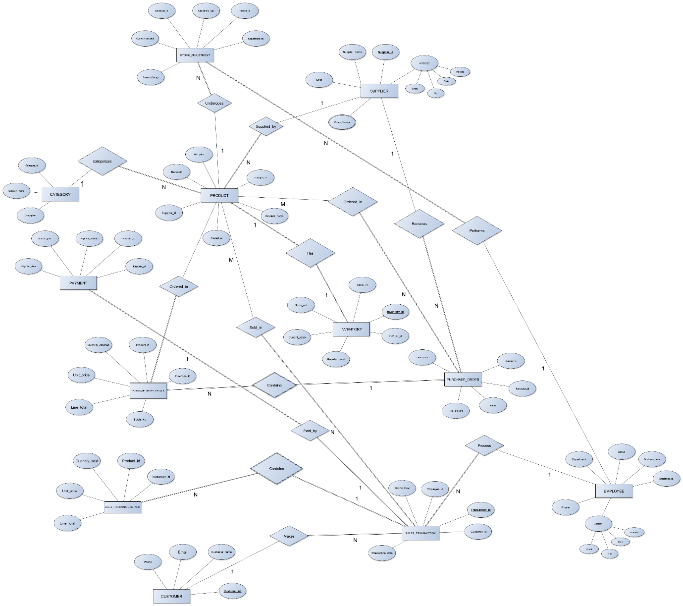

RELATIONAL SCHEMA
